Lecture 10 - Multiple Regression
Bill Perry

Lecture 09: Review
Covered
- Regression T-Test Anova
- Regression Assumptions
- sum of squared allocation and subdivision from total sums of squares
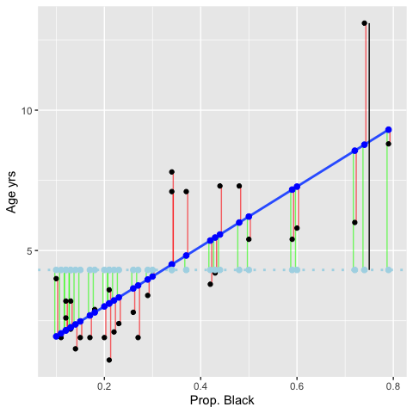

Lecture 10: Overview
Multiple Linear Regression model
- Regression parameters
- Analysis of variance
- Null hypotheses
- Explained variance
- Assumptions and diagnostics
- Collinearity
- Interactions
- Dummy variables
- Model selection
- Importance of predictors

Lecture 10: Analyses
What if more than one predictor (X) variable?
- If predictors continuous
- Mix between categorical and continuous
- Can use multiple linear regression
 | Independent variable
Dependent variable | Continuous | Categorical
Continuous | Regression | ANOVA
Categorical | Logistic regression

Lecture 10: Analyses
Abundance of ants can be modeled as function of
- latitude
- longitude
- both
Instead of line, modeled with (hyper)plane
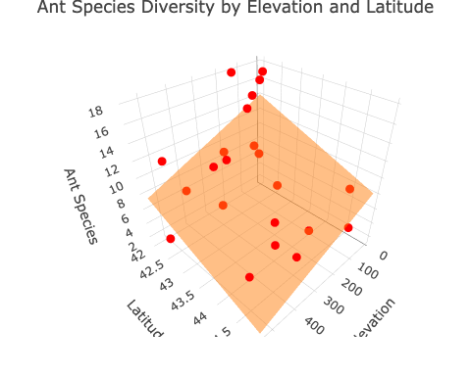

Lecture 10: Analyses
Used in similar way to simple linear regression:
- Describe nature of relationship between Y and X’s
- Determine explained / unexplained variation in Y
- Predict new Ys from X
- Find the “best” model


Lecture 10: Analyses
Crawley 2012: “Multiple regression models provide some of the most profound challenges faced by the analyst”:
- Overfitting
- Parameter proliferation
- Multicollinearity
- Model selection


Lecture 10: Analyses
Multiple Regression:
- Set of i= 1 to n observations
- fixed X-values for p predictor variables (X1, X2…Xp)
- random Y-values:
$$y_{i}=β_{0}+β_{1}x_{i1}+β_{2}x_{i2}+...+β_{p}x_{ip}+ϵ_{i}$$
- y_{i}: value of Y for i^{th} observation X₁ = x_{i1}, X₂ = x_{i2},…, x_{p} = x_{ip}
- β₀: population intercept, the mean value of Y when X₁= 0, X₂ = 0,…, X_{p} = 0

Lecture 10: Multiple linear regression model
Multiple Regression:
$$y_{i}=β_{0}+β_{1}x_{i1}+β_{2}x_{i2}+...+β_{p}x_{ip}+ϵ_{i}$$
- β₁: partial regression slope, change in Y per unit change in X₁ holding other X-vars constant
- β₂: partial regression slope, change in Y per unit change in X₂ holding other X-vars constant
- β_{p}: partial regression slope, change in Y per unit change in X_{p} holding other X-vars constant
What is partial - the relationship between a predictor variable and the response variable while holding all other predictor variables constant. It tells you the isolated effect of one variable, controlling for the influence of others.

Lecture 10: Partial regression slopes
model: ant_spp ~ elevation + latitude
- The partial slope for elevation tells you how ant species richness changes with elevation when latitude is held constant
  - 1-m increase in elevation - ant spp decrease by 0.012 spp, holding latitude constant
  - Or 100-meter increase in elevation, lose 1.2 spp
- The partial slope for latitude tells you how ant species richness changes with latitude when elevation is held constant
  - 1-degree increase in latitude, ant spp decrease by 2 species, holding elevation constant
  - Moving north = fewer ant spp, even when comparing sites at same elevation
model <- lm(ant_spp ~ elevation + latitude, data = ant_df)
summary(model)
Call:
lm(formula = ant_spp ~ elevation + latitude, data = ant_df)
Residuals:
Min 1Q Median 3Q Max
-6.1180 -2.3759 0.3218 1.9070 5.8369
Coefficients:
Estimate Std. Error t value Pr(>|t|)
(Intercept) 98.49651 26.50701 3.716 0.00147 **
elevation -0.01226 0.00411 -2.983 0.00765 **
latitude -2.00981 0.61956 -3.244 0.00427 **
---
Signif. codes: 0 '***' 0.001 '**' 0.01 '*' 0.05 '.' 0.1 ' ' 1
Residual standard error: 3.022 on 19 degrees of freedom
Multiple R-squared: 0.5543, Adjusted R-squared: 0.5074
F-statistic: 11.82 on 2 and 19 DF, p-value: 0.000463

Lecture 10: Regression parameters
Multiple Regression:
$$y_{i}=β_{0}+β_{1}x_{i1}+β_{2}x_{i2}+...+β_{p}x_{ip}+ϵ_{i}$$
- ε_{i}: unexplained error - difference between y_{i} and value predicted by model (ŷ_{i})
- ant_spp = β₀ + β₁(lat) + β₂(elevation) + ε_{i}

Lecture 10: Regression parameters
Multiple Regression:
$$y_{i}=β_{0}+β_{1}x_{i1}+β_{2}x_{i2}+...+β_{p}x_{ip}+ϵ_{i}$$
- Estimate multiple regression parameters (intercept, partial slopes) using OLS to fit the regression line
- OLS minimize ∑(y_{i}-ŷ_{i})², the SS (vertical distance) between observed y_{i} and predicted ŷ_{i} for each x_{ij}
- ε estimated as residuals: ε_{i} = y_{i}-ŷ_{i}
- Calculation solves set of simultaneous normal equations with matrix algebra

Lecture 10: Regression parameters
Regression equation can be used for prediction by subbing new values for predictor (X) variables
- Confidence intervals calculated for parameters
- Confidence and prediction intervals depend on number of observations and number of predictors
  - More observations decrease interval width
  - More predictors increase interval width
- Prediction should be restricted to within range of X variables

Lecture 10: Analyses of variance or sums of squares
Variance - SS_{total} partitioned into SS_{regression} and SS_{residual}
- SS_{regression} is variance in Y explained by model
- SS_{residual} is variance not explained by model
Source of variation | SS | df | MS | Interpretation
Regression | $\sum_{i=1}^{n}{(}y_{i}−\overset{‾}{y})^{2}$ | $p$ | $\frac{\sum_{i=1}^{n}{(}y_{i}−\overset{‾}{y})^{2}}{p}$ | Difference between predicted observation and mean
Residual | $\sum_{i=1}^{n}{(}y_{i}−{\hat{y}}_{i})^{2}$ | $n−p−1$ | $\frac{\sum_{i=1}^{n}{(}y_{i}−{\hat{y}}_{i})^{2}}{n−p−1}$ | Difference between each observation and predicted
Total | $\sum_{i=1}^{n}{(}y_{i}−\overset{‾}{y})^{2}$ | $n−1$ |  | Difference between each observation and mean

Lecture 10: Analyses

SS converted to non-additive MS=(SS/df)
- MS_{residual}: estimate population variance
- MS_{regression}: estimate population variance + variation due to strength of X-Y relationships
- MS is an estimate of variance that doesn’t increase with sample size the way Sum of Squares (SS) does
Source of variation | SS | df | MS
Regression | $\sum_{i=1}^{n}{(}y_{i}−\overset{‾}{y})^{2}$ | $p$ | $\frac{\sum_{i=1}^{n}{(}y_{i}−\overset{‾}{y})^{2}}{p}$
Residual | $\sum_{i=1}^{n}{(}y_{i}−{\hat{y}}_{i})^{2}$ | $n−p−1$ | $\frac{\sum_{i=1}^{n}{(}y_{i}−{\hat{y}}_{i})^{2}}{n−p−1}$
Total | $\sum_{i=1}^{n}{(}y_{i}−\overset{‾}{y})^{2}$ | $n−1$

Lecture 10: Hypotheses

Two Null Hypotheses usually tested in MLR:
- “Basic” H_{o}: all partial regression slopes equal 0; β₁ = β₂ = … = β_{p} = 0
- If “basic” H_{o} true, MS_{regression} and MS_{residual} estimate variance and their ratio (F-ratio) = 1
- If “basic” H_{o} false (at least one β ≠ 0) MS_{regression} estimates variance + partial regression slope and their ratio (F-ratio) will be > 1 - F-ratio compared to F-distribution for p-value

Lecture 10: Hypotheses

Also: is any specific β = 0 (explanatory role)?
- E.g., does LAT have effect on Ant species?
- These H’s tested through model comparison
- Model 1 - model with 2 predictors X₁, X₂:
  - yi= β₀ +β₁x_{i1}+β₂x_{i2}+ ε_{i}
- Model 2 - To test H_{o} that β₂ = 0 compare fit of model 1 to model 2 with 1 predictor:
  - y_{i}= β₀ +β₁x_{i1}+ ε_{i}

Lecture 10: Hypotheses
- If SS_{regression} of model₁=model₂, cannot reject H_{o} β₁ = 0
  - adding X₂ did not explain any additional variance
- If SS_{regression} of mod1 > mod2, evidence to reject H_{o} β₁ = 0
  - adding X2 explains more variance
  - evidence to reject H0: β₂ = 2
- SS for β₁ is SS_{extra}β₁ = Full SS_{regression} - Reduced SS_{regression}
  - This quantifies how much additional variance X₂ explains
- Use partial F-test to test Ho β₁ = 0 :
$$F_{w,n−p}=\frac{MS_{Extra}}{FULL MS_{Residual}}$$
Can also use t-test (R provides this value)

Lecture 10: Explained variance
Explained variance (r²) is calculated the same way as for simple regression:
$$r^{2}=\frac{SS_{Regression}}{SS_{Total}}=1−\frac{SS_{Residual}}{SS_{Total}}$$
- r² values can not be used to directly compare models
- r² values will always increase as predictors added
- r² values with different transformation will differ

Lecture 10: Assumptions and diagnostics
- Assume fixed Xs; unrealistic in most biological settings
- No major (influential) outliers
- Check leverage, influence- Cook’s Di
# Plot Cook's distance
plot(model, which = 4)
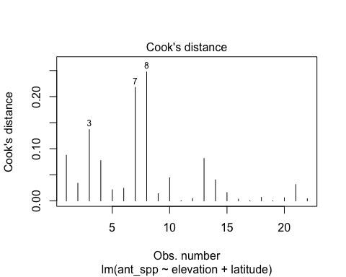

Lecture 10: Assumptions and diagnostics
- Normality, equal variance, independence
- Residual QQ-plots, residuals vs. predicted values plot
- Distribution/variance often corrected by transforming Y
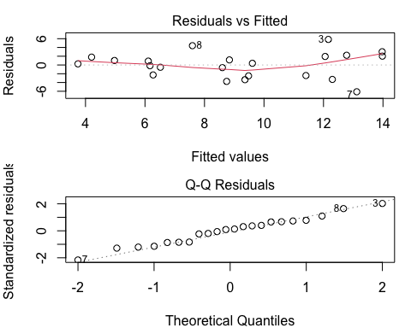

Lecture 10: Assumptions and diagnostics
- More observations than predictor variables
  - Ideally at least 10x observations than predictors to avoid “overfitting” 10:1
    - 2 predictors = 20 observations!!!
- No colinearity
  - Need Uncorrelated predictor variables (assessed using scatterplot matrix; VIFs)
- Each X has linear relationship with Y after accounting for other predictors
  - Added Variable (AV) plots (also called partial regression plots)
    - These show the relationship between Y and X₁ after removing the linear effects of all other predictors
    - Create AV plots for all predictors - avPlots(model)
    - Or for just one predictor - avPlot(model, variable = "proportion_black")

Lecture 10: Analyses
Regression of Y vs. each X does not consider effect of other predictors:
want to know shape of relationship while holding other predictors constant
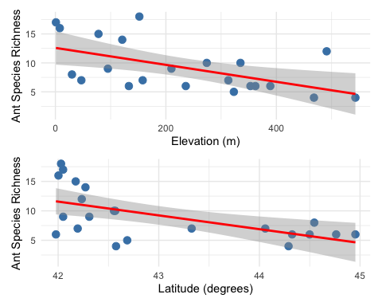

Lecture 10: Collinearity
- Potential predictor variables are often correlated (e.g., morphometrics, nutrients, climatic parameters)
- Multicollinearity (strong correlation between predictors) causes problems for parameter estimates
- Severe collinearity causes unstable parameter estimates: small change in a single value can result in large changes in βp - estimates
- Inflates partial slope error estimates, loss of power
elevation latitude ant_spp
elevation 1.0000000 0.1787454 -0.5545244
latitude 0.1787454 1.0000000 -0.5879407
ant_spp -0.5545244 -0.5879407 1.0000000

Lecture 10: Collinearity

Collinearity can be detected by:
- Variance inflation Factors (VIF):
  - VIF for X_{j}=1/ (1-r² )
  - VIF > 10 = bad
- Best/simplest solution:
  - exclude variables that are highly correlated with other variables
  - they are probably measuring similar things and are redundant

Lecture 10: Interactions

Predictors can be modeled as:
- additive (effect of temp, plus precip, plus fertility) or
- multiplicative (interactive)
- Interaction: effect of Xi depends on levels of Xj
- The partial slope of Y vs. X₁ is different for different levels of X₂ (and vice versa); measured by β₃
$$y_{i}=β_{0}+β_{1}X_{i1}+β_{2}X_{i2}+ϵ_{i} \text{vs.} y_{i}=β_{0}+β_{1}X_{i1}+β_{2}X_{i2}+β_{3}X_{i1}*X_{i2}ϵ_{i}$$
This leads to “Curvature” of the regression (hyper)plane

Lecture 10: Analyses
Interaction terms lead to “Curvature” of the regression (hyper)plane
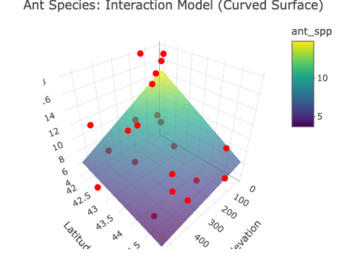

Lecture 10: Analyses
Adding interactions:
- many more predictors (“parameter proliferation”):
- 2^{n} is required; 6 parameters = 64 terms; 7 parameters= 128
- interpretation more complex
- When to include interactions? When they make biological sense!!!

Lecture 10: Dummy variables
Multiple Linear Regression accommodates continuous and categorical variables (gender, vegetation type, etc.) Categorical vars as “dummy vars”, n of dummy variables = n-1 categories
- Sex M/F:
  - Need 1 dummy var with two values (0, 1)
- Fertility L/M/H:
  - Need 2 dummy var, each with two values (0, 1): fert1 (0 if L or H, 1 if M), fert2 (1 if H, 0 if L or M)
Fertility | fert1 | fert2
Low | 0 | 0
Med | 1 | 0
High | 0 | 1

Lecture 10: Analyses

Coefficients interpreted relative to reference condition
- R codes dummy variables automatically
- picks “reference” level alphabetically
- Dummy variables with more than 2 levels add extra predictor variables to model
Fertility | fert1 | fert2
Low | 0 | 0
Med | 1 | 0
High | 0 | 1

Lecture 10: Analyses
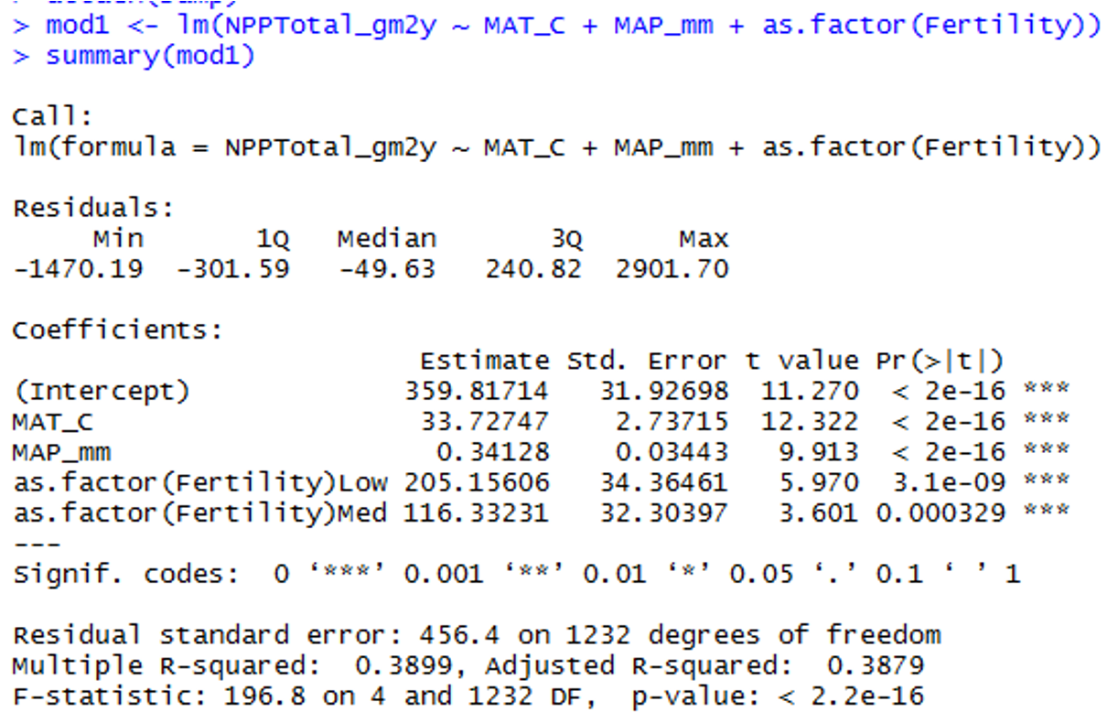
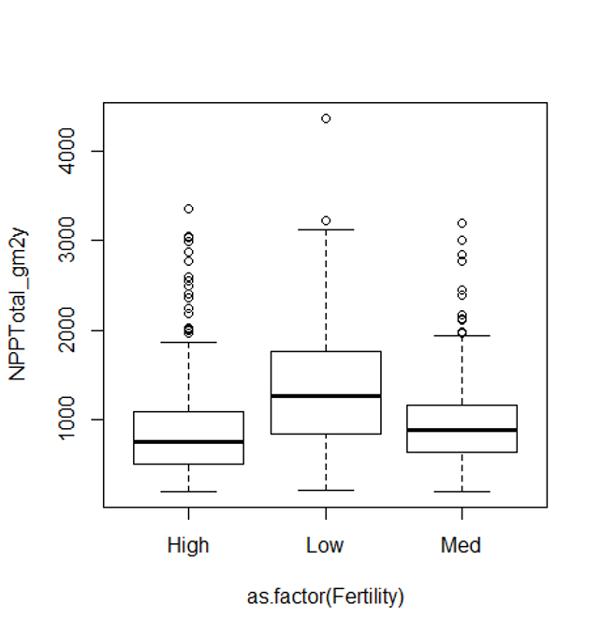

Lecture 10: Comparing models
- When have multiple predictors (and interactions!)
  - how to choose “best” model?
  - Which predictors to include?
  - Occam’s razor: “best” model balances complexity with fit to data
- To chose:
  - compare “nested” models
- Overfitting
  - getting high r2 just by having more (useless predictors)
  - so r2 is not a good way of choosing between nested models

Lecture 10: Comparing models

Need to account for increase in fit with added predictors:
- Adjusted r2
- Akaike’s information criterion (AIC)
- Both “penalize” models for extra predictors
- Higher adjusted r2 and lower AIC are better when comparing models
  - p = predictors
  - n = #
$$\text{Adjusted }r^{2}=1−\frac{SS_{\text{Residual}}/(n−(p+1))}{SS_{\text{Total}}/(n−1)}$$
$$\text{Akaike Information Criterion (AIC)}=n[ln(SS_{\text{Residual}})]+2(p+1)−nln(n)$$

Lecture 10: Comparing models
- But how to compare models?
  - Can fit all possible models
    - compare AICs or adj- r2,
    - tedious w lots of predictors
  - Automated forward (and backward) stepwise procedures: start w no terms (all terms), add (remove) terms w largest (smallest)
    - partial F statistic
- We will use manual form of backward selection

Lecture 10: Analyses
========== FULL MODEL (Both Variables) ==========
Call:
lm(formula = ant_spp ~ elevation + latitude, data = ant_df)
Residuals:
Min 1Q Median 3Q Max
-6.1180 -2.3759 0.3218 1.9070 5.8369
Coefficients:
Estimate Std. Error t value Pr(>|t|)
(Intercept) 98.49651 26.50701 3.716 0.00147 **
elevation -0.01226 0.00411 -2.983 0.00765 **
latitude -2.00981 0.61956 -3.244 0.00427 **
---
Signif. codes: 0 '***' 0.001 '**' 0.01 '*' 0.05 '.' 0.1 ' ' 1
Residual standard error: 3.022 on 19 degrees of freedom
Multiple R-squared: 0.5543, Adjusted R-squared: 0.5074
F-statistic: 11.82 on 2 and 19 DF, p-value: 0.000463

Lecture 10: Analyses
========== ELEVATION ONLY MODEL ==========
Call:
lm(formula = ant_spp ~ elevation, data = ant_df)
Residuals:
Min 1Q Median 3Q Max
-4.9010 -2.6947 -0.9502 2.9657 7.6363
Coefficients:
Estimate Std. Error t value Pr(>|t|)
(Intercept) 12.589088 1.385615 9.086 1.55e-08 ***
elevation -0.014641 0.004913 -2.980 0.0074 **
---
Signif. codes: 0 '***' 0.001 '**' 0.01 '*' 0.05 '.' 0.1 ' ' 1
Residual standard error: 3.671 on 20 degrees of freedom
Multiple R-squared: 0.3075, Adjusted R-squared: 0.2729
F-statistic: 8.881 on 1 and 20 DF, p-value: 0.0074

Lecture 10: Analyses
========== LATITUDE ONLY MODEL ==========
Call:
lm(formula = ant_spp ~ latitude, data = ant_df)
Residuals:
Min 1Q Median 3Q Max
-6.2223 -2.1188 0.0599 2.1267 6.4990
Coefficients:
Estimate Std. Error t value Pr(>|t|)
(Intercept) 109.8532 30.9803 3.546 0.00203 **
latitude -2.3401 0.7199 -3.251 0.00401 **
---
Signif. codes: 0 '***' 0.001 '**' 0.01 '*' 0.05 '.' 0.1 ' ' 1
Residual standard error: 3.569 on 20 degrees of freedom
Multiple R-squared: 0.3457, Adjusted R-squared: 0.313
F-statistic: 10.57 on 1 and 20 DF, p-value: 0.004006

Lecture 10: Analyses
========== MODEL COMPARISON TABLE ==========
Model Adjusted_R2 AIC R2_vs_Full AIC_vs_Full
1 Both Variables 0.5074180 115.8646 0.0000000 0.000000
2 Elevation Only 0.2728722 123.5608 -0.2345459 7.696164
3 Latitude Only 0.3129580 122.3132 -0.1944600 6.448613
========== KEY FINDINGS ==========
Full Model AIC: 115.86 (Adjusted R²: 0.5074)
Elevation Only AIC: 123.56 (Adjusted R²: 0.2729)
Latitude Only AIC: 122.31 (Adjusted R²: 0.3130)
--- Differences from Full Model ---
Removing latitude: AIC increases by 7.70, Adj R² decreases by -0.2345
Removing elevation: AIC increases by 6.45, Adj R² decreases by -0.1945
========== CONCLUSION ==========
✓ Full model has LOWEST AIC (best fit)
✓ Full model has HIGHEST Adjusted R² (explains most variance)
✗ Removing either variable worsens model performance
Both elevation and latitude are important predictors of ant species diversity!

Lecture 10: Predictors
Usually want to know relative importance of predictors to explaining Y
- Three general approaches:
- Using F-tests (or t-tests) on partial regression slopes
- Using coefficient of partial determination
- Using standardized partial regression slopes

Lecture 10: Predictors
Using F-tests (or t-tests) on partial regression slopes:
- Conduct F tests of Ho that each partial regression slope = 0
- If cannot reject Ho, discard predictor
- Can get additional clues from relative size of F-values
- Does not tell us absolute importance of predictor (usually can not directly compare slope parameters)

Lecture 10: Predictors
Using coefficient of partial determination:
- the reduction in variation of Y due to addition of predictor (Xj)
$$r_{X_{j}}^{2}=\frac{SS_{\text{Extra}}}{\text{Reduced }SS_{\text{Residual}}}$$
SSextra
- Increased in SSregression when Xj is added to model
- Reduced SSresidual is the unexplained SS from model without Xj

Lecture 10: Predictors

Using standardized partial regression slopes:
- predictors of predictor variables can not be directly compared
- Why?
  - Standardize all vars (mean = 0, sd= 1)
  - Scales are identical and larger PRS mean more important variable

Lecture 10: Predictors
- Using partial r² values
  - pEta_sqr (Partial Eta Squared):
    - Elevation: 0.3189 (31.9%) - Elevation explains 31.9% of the variance after controlling for latitude
    - Latitude: 0.3564 (35.6%) - Latitude explains 35.6% of the variance after controlling for elevation
    - Both are important predictors! Latitude is slightly stronger
- dR_sqr (Delta R Squared / Semi-partial R²):
  - Elevation: 0.2087 (20.9%)
    - If you removed elevation from the model, R² would drop by 20.9%
  - Latitude: 0.2468 (24.7%)
  - If you removed latitude from the model, R² would drop by 24.7%
- Shows the unique contribution of each predictor to the total variance explained
== Method 2: Type II ANOVA (car package) ==
Anova Table (Type II tests)
Response: ant_spp
Sum Sq Df F value Pr(>F)
elevation 81.224 1 8.8955 0.007652 **
latitude 96.085 1 10.5231 0.004272 **
Residuals 173.487 19
---
Signif. codes: 0 '***' 0.001 '**' 0.01 '*' 0.05 '.' 0.1 ' ' 1
== Coefficients Table ==
Coefficients SSR df pEta_sqr dR_sqr
elevation 81.22 1 0.3189 0.2087
latitude 96.09 1 0.3564 0.2468
Residuals 173.49 19 0.5000 0.4457
== Summary Statistics ==
Sum of squared errors (SSE): 173.5
Sum of squared total (SST): 389.3
Model R²: 0.5543

