

Project EDDIE: LAKE MIXING
Figures for Activity A and C

This module was initially developed by Carey, C.C., J.L. Klug, and R.L. Fuller. 1 August 2015. Project EDDIE: Dynamics of Lake Mixing. Project EDDIE Module 3, Version 1. http://cemast.illinoisstate.edu/data-for-students/modules/lake-mixing.shtml. Module development was supported by NSF DEB 1245707.

This file contains the figures to be used for Activity A and Activity C.

Activity A Figures
Acton Lake 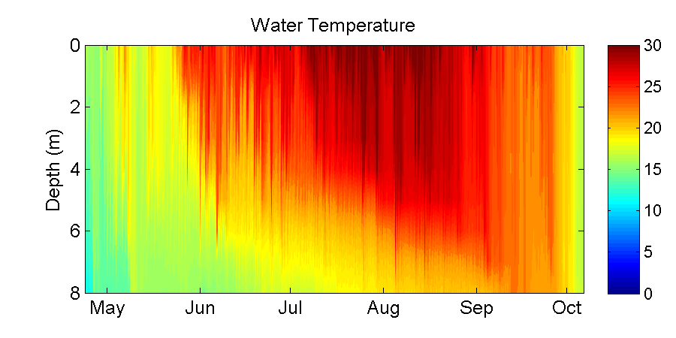
Lake Annie
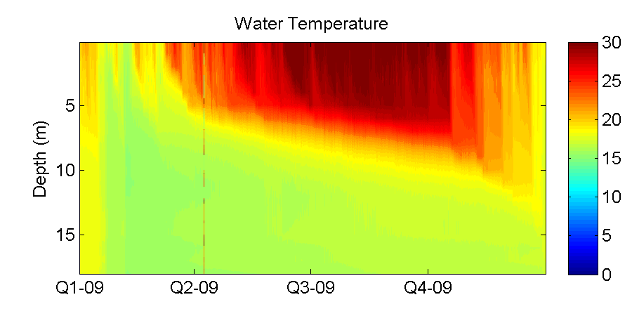
Lough Feeagh
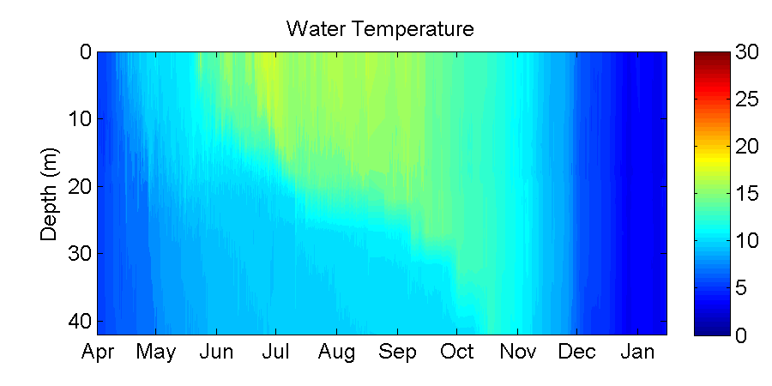

Lake Lacawac
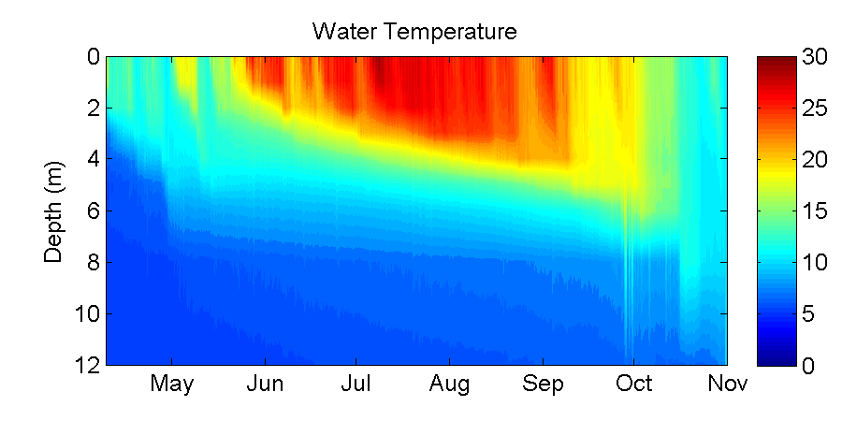

Lake Lillinonah
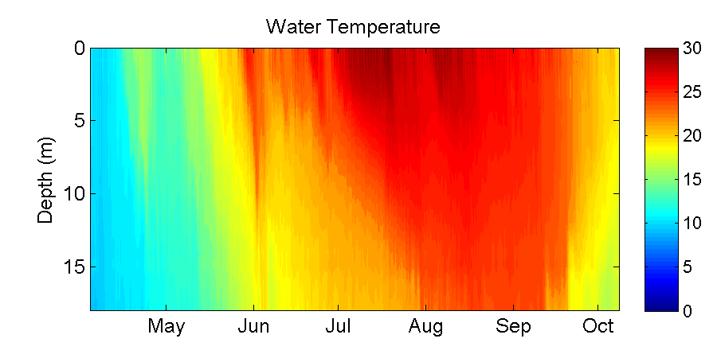

Müggelsee
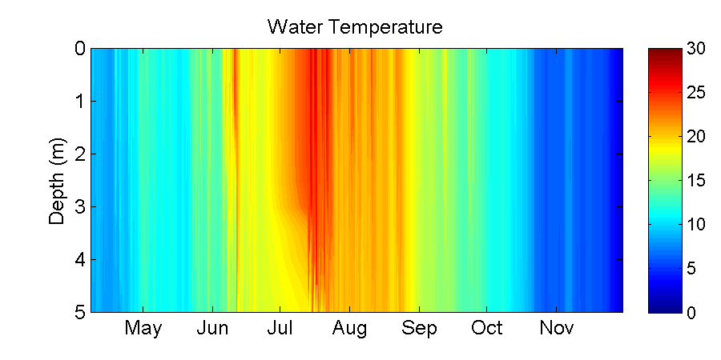

Activity C Figures
Lake Mendota – Baseline scenario (2011 air temperature)
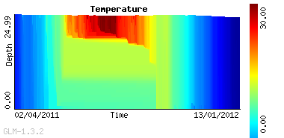
Lake Mendota – Air Temperature +3°C scenario
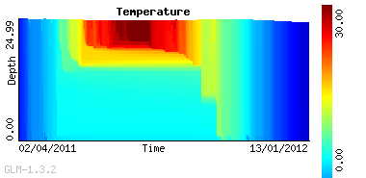
Lake Mendota – Air Temperature +5°C scenario
