   

**Project EDDIE: LAKE MIXING**

**Student Handout**

This module was initially developed by Carey, C.C., J.L. Klug, and R.L. Fuller. 1 August 2015. Project EDDIE: Dynamics of Lake Mixing. Project EDDIE Module 3, Version 1. <http://cemast.illinoisstate.edu/data-for-students/modules/lake-mixing.shtml>. Module development was supported by NSF DEB 1245707.

Learning objectives:

* Interpret variability in lake thermal depth profiles over a year.
* Identify lake mixing regimes based on figures of water temperature.
* Compare and contrast lake mixing regimes across lakes of different depths, size, and latitude.
* Understand the drivers of lake mixing and thermal stratification.
* Predict how climate change will affect lake thermal stratification and mixing.

Why this matters: At any given time, lakes are either thermally stratified or exhibit isothermal temperature profiles. When a lake exhibits isothermal temperature profiles, we assume that the lake is mixing. Mixing allows oxygen to reach the bottom waters and nutrients to reach surface waters, as well as promotes the movement of microbes and plankton between different lake layers. When a lake is stratified, the nutrient and oxygen concentrations in different lake layers can diverge, resulting in different water quality conditions with important consequences for lake organisms. For example, in a stratified lake, nutrient concentrations may be high in the bottom waters but low enough in the surface water to limit phytoplankton growth. Consequently, it is critical to understand the drivers of lake mixing and thermal stratification, especially because of the sensitivity of lake thermal conditions to altered climate.

Required readings:

O’Reilly, C.M., S.R. Alin, P.-D. Pilsnier, A.S. Cohen, and B.A. McKee. 2003. Climate change decreases aquatic ecosystem productivity of Lake Tanganyika, Africa. Nature 424:766-768.

Types of stratification

Lakes in different geographic regions (tropical, temperate, and polar areas) will have different seasonal temperature regimes, which will impact whether or not a lake forms ice and for how long. The terminology for lake mixing regimes is determined by how many times a lake’s water column mixes on an annual basis and at what temperature it stratifies. In the figure below, you can see a flow diagram from Lewis (1983) describing how to identify a lake’s mixing regime. As you work through the flow diagram, think about where lakes might be found geographically with these different mixing regimes.

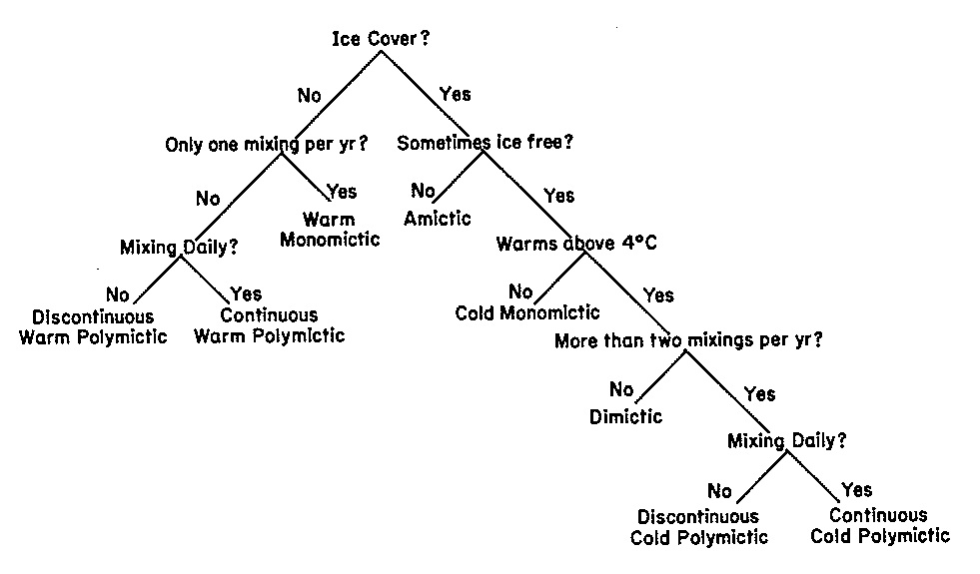

Figure from Lewis, W.M. 1983. A revised classification of lakes based on mixing. Canadian Journal of Fisheries and Aquatic Sciences. 40: 1779-1787.

Stability of thermal stratification

The formation of different lake layers during thermal stratification occurs because different water temperatures have different densities. To create an isothermal temperature profile and mix the lake, energy is required to disrupt the density gradients among layers. We can calculate the energy required to disrupt the density gradients by calculating Schmidt stability, which takes into account the difference in density at intervals over the entire water column based on temperature differences. The higher the Schmidt stability, the more thermally stratified a lake is and hence more energy is needed to mix the water column.

The equation for Schmidt stability is:

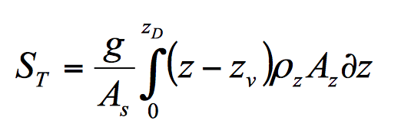

where *ST* is Schmidt stability, *g* is acceleration due to gravity, *AS* is the surface area of the lake, *zD* is the maximum depth of the lake, *z* is the depth of the lake at any given interval, *zv* is the depth to the center volume of the lake, *ρz* is the density of water at depth *z*, and *Az* is the area of the lake at depth *z* (Idso 1973). Schmidt stability is calculated in J/m2 and requires bathymetric data for a lake as well as thermal profiles.

What is the Schmidt stability of a lake that is perfectly mixed?

Outline:

1. Discussion of lake mixing regimes all together.
2. *Activity A*: Break up into groups and compare heat maps of lakes with different mixing regimes. The lakes we will analyze are shown in the table below: a) Acton Lake, Ohio; b) Lake Annie, Florida, c) Lough Feeagh, Ireland; d) Lake Lacawac, Pennsylvania, e) Lake Lillinonah, Connecticut, and f) Lake Müggelsee, Germany.
3. *Activity B.* Analyze patterns of Schmidt stability for your lake, both over a year as well as within a few specific days.
4. *Activity C.* Analyze output data from model simulations of what could happen to lake thermal stratification if air temperatures increased by 3oC or 5oC for an entire year.

|  |  |  |  |  |  |
| --- | --- | --- | --- | --- | --- |
| Table 1. The lakes with thermal data analyzed in this module. | | | | | |
| **Lake Name** | **Latitude** | **Max depth (zmax, in m)** | **Surface area (km2)** | **Ice cover? (y/n)** | **Data provider** |
| Acton | 39.57oN | 8 | 2.5 | Yes | M. Vanni |
| Annie | 28.71oN | 18 | 0.4 | No | E. Gaiser |
| Feeagh | 53.95oN | 50 | 4.0 | No | E. de Eyto |
| Lacawac | 41.38oN | 13 | 0.2 | Yes | B. Hargreaves |
| Lillinonah | 41.47oN | 33 | 6.26 | Yes | J. Klug |
| Müggelsee | 52.43oN | 8 | 7.4 | No | R. Adrian |
| Mendota | 43.12oN | 25 | 39.4 | Yes | P. Hanson |

**Activity A:** Compare heat maps of lakes with different mixing regimes

Open the colored temperature time series figure for your lake in the ‘EDDIE Lake Mixing Figures’ pdf file. What type of mixing regime does the lake represent? How can you tell? Share your explanation with the group next to you. What lake do they have? What is their mixing regime?

**Activity B:**Analyze patterns of Schmidt stability for your lake

1. Open up the ‘EDDIE Lake Mixing student dataset’ Excel spreadsheet. All of these datasets were collected by high-frequency data buoys as part of the Global Lakes Ecological Observatory Network (GLEON; gleon.org) and graciously shared by GLEON colleagues for this module (see Table 1).

Note that each lake has a different tab in the spreadsheet. Within each tab, you will find that the data are organized with each row being a separate timepoint, and columns representing water temperatures for different depths (m). These water temperature data are plotted in the colored figures. To the right of the water temperature data columns are three additional columns, labeled ‘St’, ‘airt’ and ‘windsp’. These represent Schmidt stability (J/m2), air temperature (oC), and wind speed (m/s), respectively.

1. Plot Schmidt stability vs. time for your lake. What is the maximum Schmidt stability value and when does it occur?
2. Think about the variability in Schmidt stability. Are there any seasonal patterns or daily patterns? Plot the air temperature data and wind speed data vs. time for your lake to explore whether any of the changes in Schmidt stability from day to day are related to weather.
3. Record the mixing regime for your lake and the maximum observed Schmidt stability value and its date on the board.
4. Using the class data, plot maximum depth vs. maximum Schmidt stability. What does the relationship look like? Can you explain why the pattern looks the way it does? Are there any outliers? Why?
5. If you are waiting for the other groups to finish, choose a day that shows little stratification. Then find a day with stronger stratification. Make one graph that presents the two thermal profiles for each day together. Plot temperature on the x-axis and depth on the y-axis, with 0 m at the top of the y-axis in the figure. Do you see a thermocline for either profile? If so, at what depth?

Discussion questions for Activities A and B

1. Which lakes had the highest Schmidt stability? What factors might relate to stability?
2. What were the mixing regimes for each lake?
3. How would climate change affect stratification?
4. What are the implications of altered stratification for the six study lakes?

**Activity C**: Analyze output data from model simulations of changes in temperatures

How will lake thermal structure change in response to altered climate? To address this question, we are going to use an open-source hydrodynamic model called GLM (the General Lake Model) (Hipsey et al. 2014). First, we will use real lake and weather data observed for Lake Mendota, Wisconsin, USA during 2011 to show “baseline” conditions. Second, we will manipulate air temperatures in two model simulations (one in which we add a constant +3oC and +5oC to all observed air temperatures in the entire year) to explore the effects of warmer weather on thermal stratification and mixing. The GLM model uses inputs of several different weather variables (including air temperature, solar radiation, wind, and precipitation) as well as inflow data for all of the incoming tributaries; we will only be manipulating air temperature in the simulations in this module. From these input data, the model will simulate water temperature over time. For more info about GLM, see: http://aed.see.uwa.edu.au/research/models/GLM

1. We used GLM to determine the effects of a constant 3oC and 5oC increase in hourly air temperatures for an entire year and created thermal heat maps from these scenarios in comparison to the observed data. In groups, open up the ‘Project EDDIE Lake Mixing Figures’ pdf file and access the figures for the three scenarios (simulated 2011, simulated 2011 +3oC, simulated 2011 +5oC).
2. Answer these discussion questions:
3. Compare the thermal heat maps for 2011, 2011 +3oC and 2011 +5oC. How are they similar, and how are they different?
4. What are the effects of the 3 and 5oC increases in air temperatures on water temperature over time at 0m? 20m? What limnological mechanisms might explain these patterns?
5. What are some of the assumptions that went into this model output? Are they realistic?
6. In the Project EDDIE Lake Mixing student dataset, open up the Activity C tab, which shows the Schmidt stability values for each of the three simulations on every day in 2011. Create a figure that shows three time series of Schmidt stability on the same plot (do not forget to include a legend which identifies which line is which and axis labels).
7. Answer these discussion questions
8. What is the effect of increased air temperatures on Schmidt stability? Why?
9. As air temperature continues to increase, are the effects on water temperature and stability likely to be linear? Why or why not?
10. What are the implications of higher temperature on lake oxygen concentrations? Phytoplankton? Zooplankton? Fish?

**References:**

Hipsey, M.R., Bruce, L.C., and Hamilton, D.P. 2014. GLM - General Lake Model: Model overview and user information. AED Report #26, The University of Western Australia, Perth, Australia. 42pp. <http://aed.see.uwa.edu.au/research/models/GLM/>

Hutchinson, G.E., and H. Löffler. 1956. The thermal classification of lakes. PNAS. 42:84-86. Open access: <http://www.pnas.org/content/42/2/84.full.pdf>

Idso, S.B. 1973. On the concept of lake stability. Limnology and Oceanography. 18: 681-683. Open access: <http://www.aslo.org/lo/toc/vol_18/issue_4/0681.pdf>

Lewis, W.R., Jr. 1983. A revised classification scheme of lakes based on mixing. Canadian Journal of Fisheries and Aquatic Sciences 40: 1779-1787.