Lecture 13 - Multifactor ANOVA
Bill Perry

Lecture 13: Review
Multifactor ANOVA
- Example
- Linear model
- Analysis of variance
- Null hypotheses
- Interactions and main effects
- Unequal sample size
- Assumptions
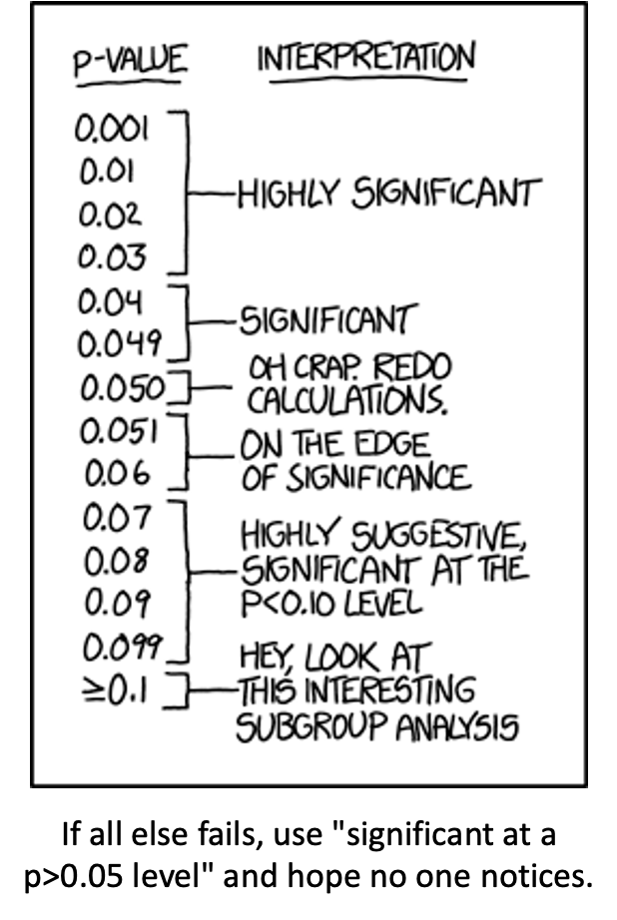

Lecture 13: 2 Factor or 2 Way ANOVA
Often consider more than 1 factor (independent categorical variable):
- reduce unexplained variance
- look at interactions
2-factor designs (2-way ANOVA) very common in ecology
- Can have more factors (e.g., 3-way ANOVA)
  - interpretation tricky…
Most multifactor designs: nested or factorial
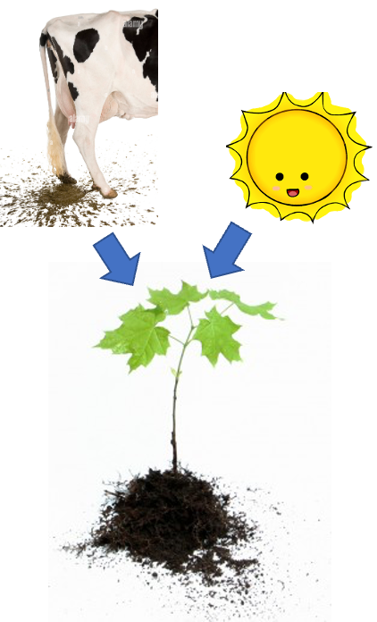

Factorial Versus Nested Designs
Consider two factors: A and B
- Factorial/crossed: every level of B in every level of A
- Nested/hierarchical: levels of B occur only in 1 level of A
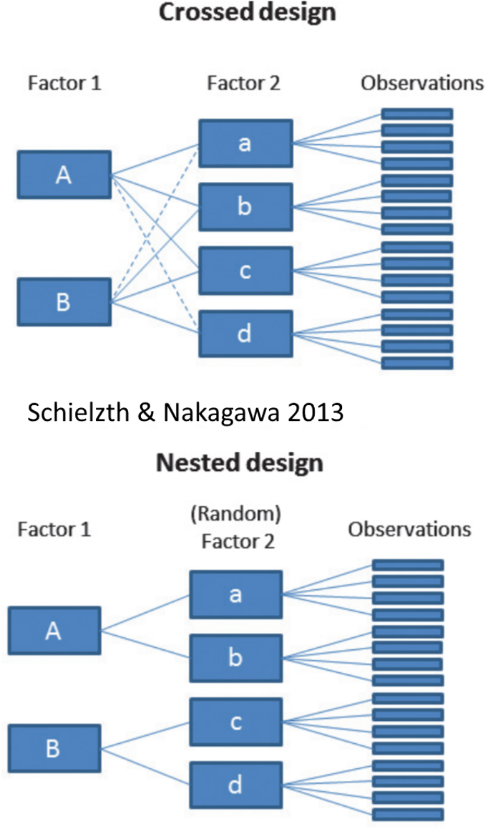

Lecture 13: Nested ANOVA Overview
Nested design examples
- Nested designs
- Linear model
- Analysis of variance
- Null hypotheses
- Unbalanced designs
- Assumptions

Nested Designs Overview
Nested Designs:
- Factor A usually fixed
- Factor B usually random
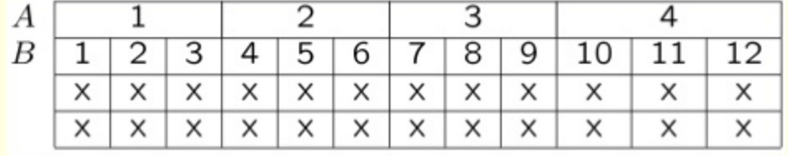

Factorial Designs Overview
Factorial Designs:
- Both factors typically fixed (but not always)
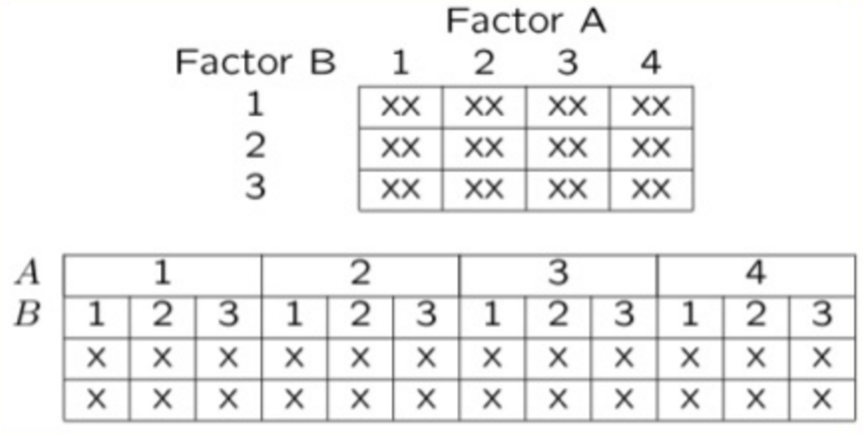

Nested Design Example: Limpet Growth
Study on effects of enclosure size on limpet growth:
- 2 enclosure sizes (factor A)
- 5 replicate enclosures (factor B)
- 5 replicate limpets per enclosure
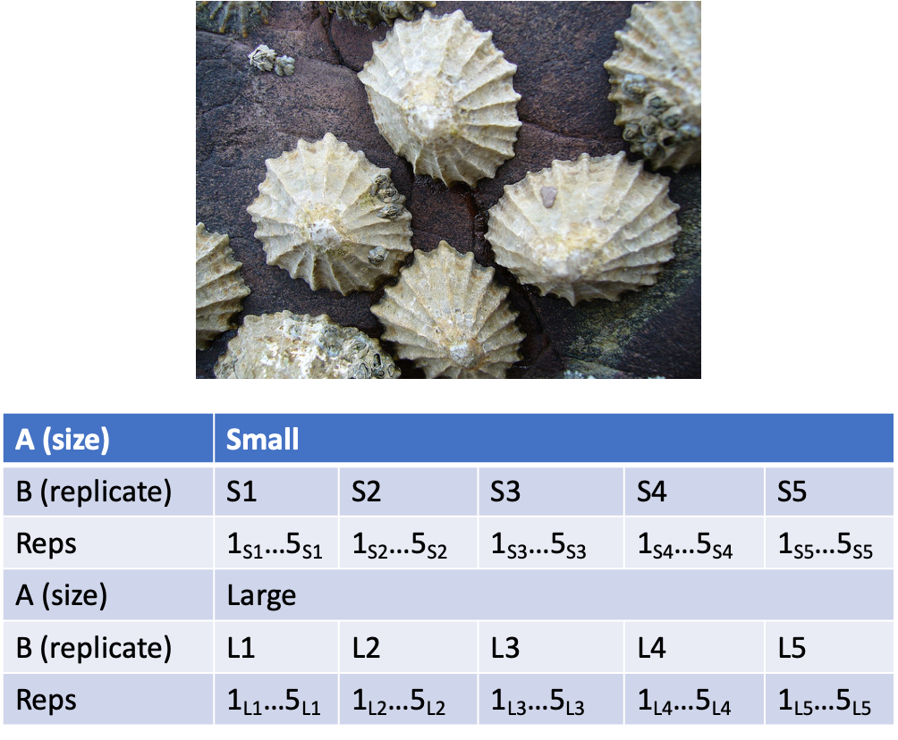

Nested Design Example: Reef Fish
Study on reef fish recruitment: 5 sites (factor A) 6 transects at each site (factor B) replicate observations along each transect
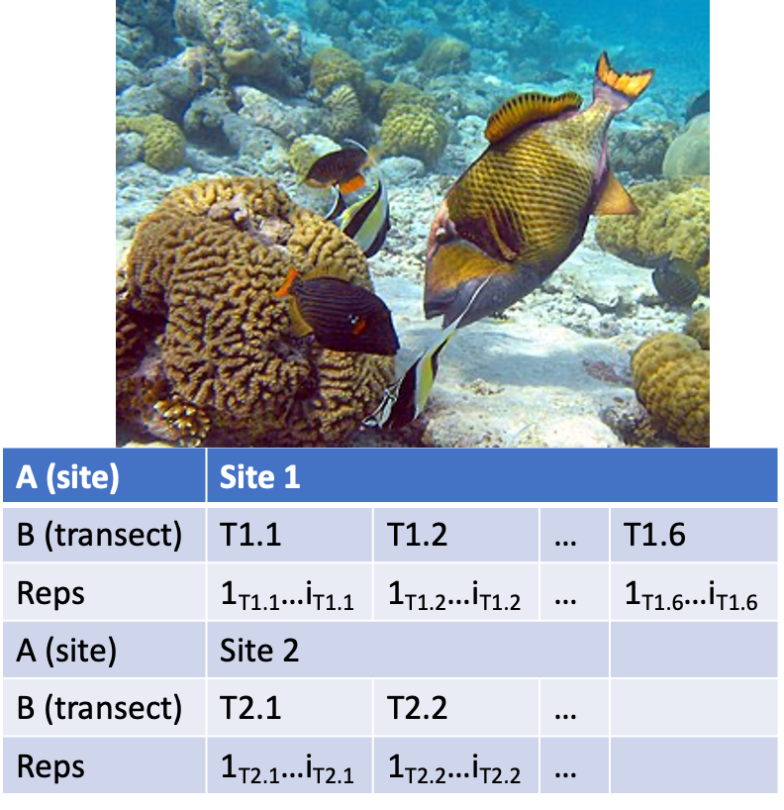

Nested Design Example: Sea Urchin Grazing
Effects of sea urchin grazing on biomass of filamentous algae:
- 4 levels of urchin grazing: none, L, M, H
- 4 patches of rocky bottom (3-4 m2) nested in each level of grazing
- 5 replicate quadrats per patch
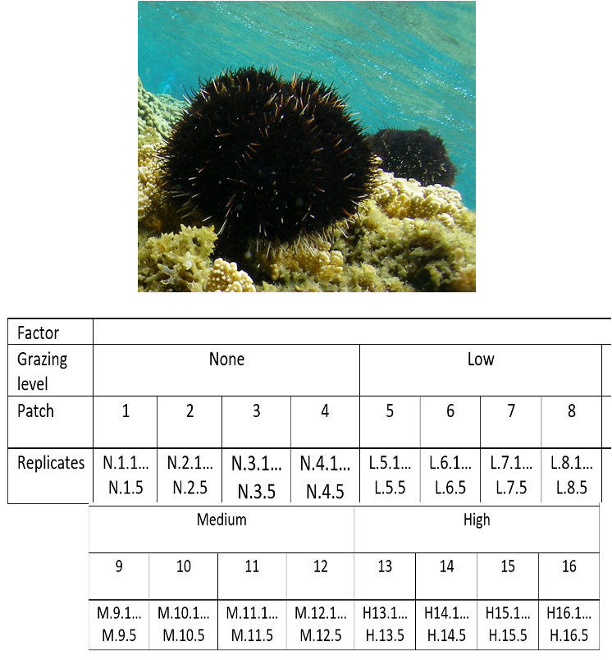

Factorial Design Example: Seedling Growth
Effects of light level on growth of seedlings of different size:
- 3 light levels (factor A)
- 3 size classes (factor B)
- 5 replicate seeding in each cell
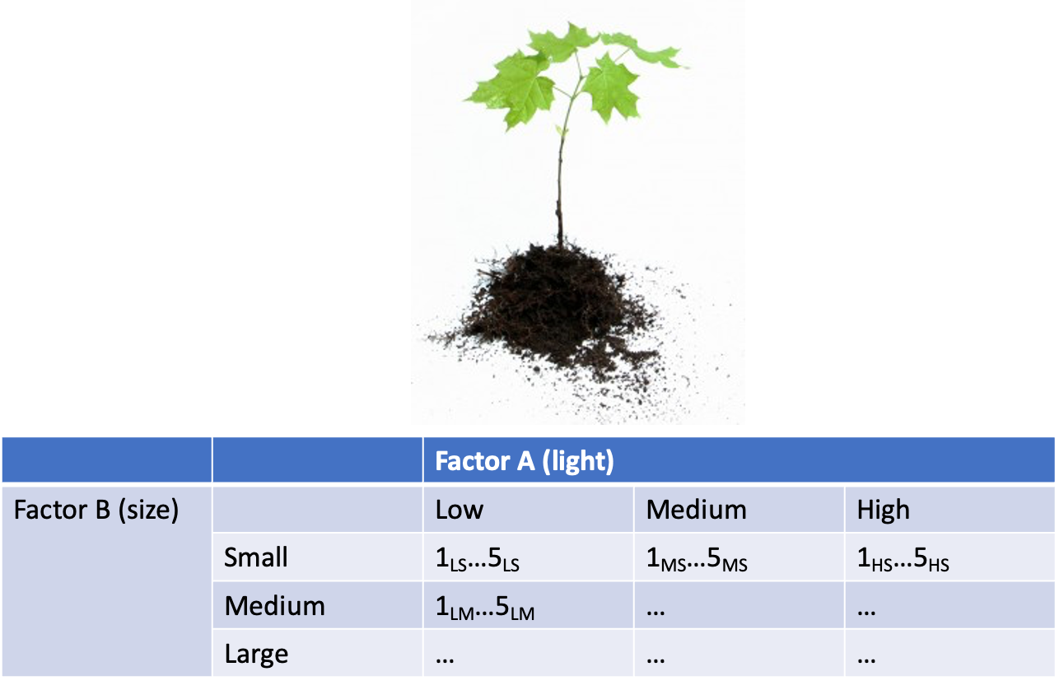

Factorial Design Example: Salamander Growth
Effects of food level and tadpole presence on larval salamander growth
- 2 food levels (factor A)
- presence/absence of tadpoles (factor B)
- 8 replicates in each cell
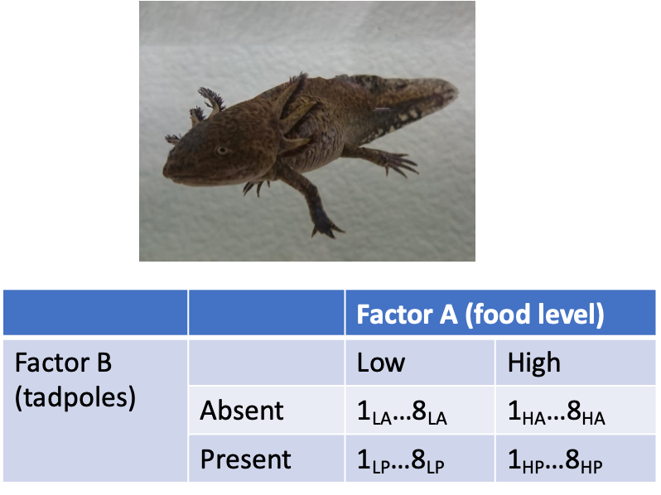

Factorial Design Example: Limpet Fecundity
Effect of season and density on limpet fecundity.
- 2 seasons (factor A)
- 4 density treatments (factor B)
- 3 replicates in each cell
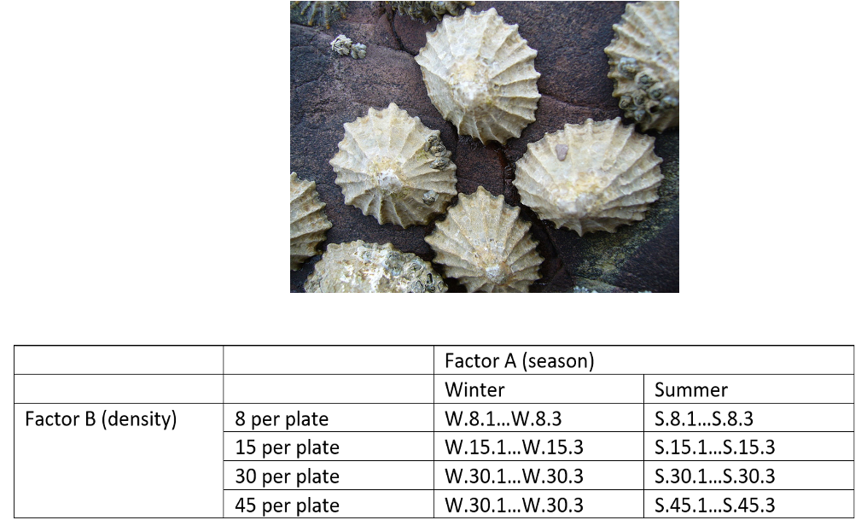

Nested Design: Linear Model Structure
Consider a nested design with:
- p levels of factor A (i= 1…p) (e.g., 4 grazing levels)
- q levels of factor B (j= 1…q), nested within each level of A (e.g., 4 - diff. patches per grazing level)
- n replicates (k= 1…n) in each combination of A and B (5 replicate - quadrats in each patch in each grazing level)
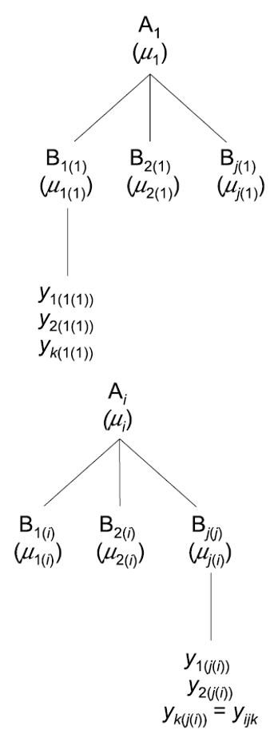

Calculating Means in Nested Design
Can calculate several means:
- overall mean (across all levels of A and B)= ȳ;
- a mean for each level of A (across all levels of B in that A)= ȳi;
- a mean for each level of B within each A= ȳj(i)
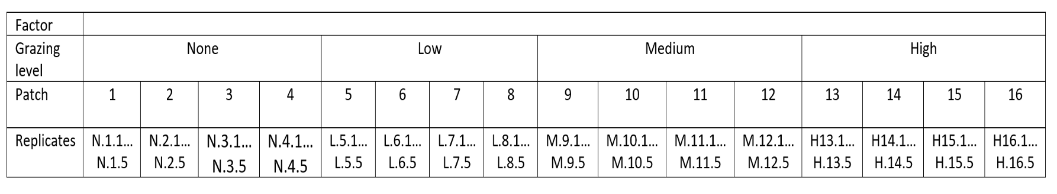

Nested Design Means Visualization
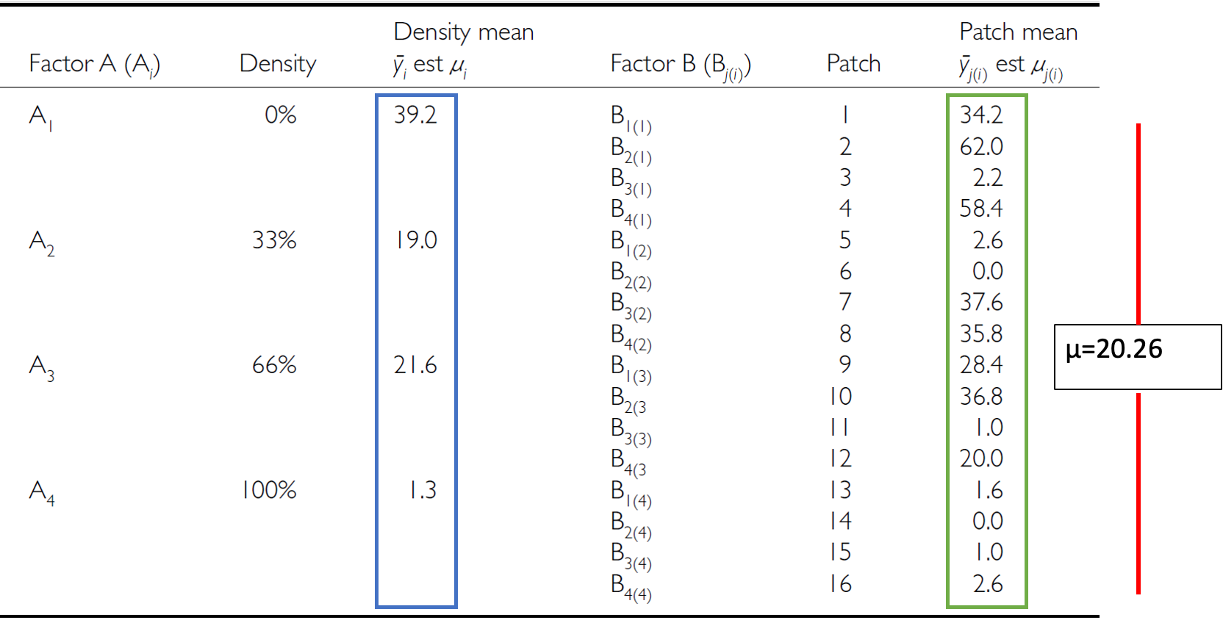

Nested Design Linear Model
The linear model for a nested design is:

$$y_{ijk}=μ+α_{i}+β_{j\left(i\right)}+ε_{ijk}$$
Where:
- $y_{ijk}$ is the response variable
  - value of the k-th replicate in j-th level of B in the i-th level of A
  - (algal biomass in 3rd quadrat, in 2nd patch in low grazing treatment)
- $μ$ is the overall mean
  - (overall average algal biomass)

Fixed Effects in Nested Model
The linear model for a nested design is:

$$y_{ijk}=μ+α_{i}+β_{j\left(i\right)}+ε_{ijk}$$
- $α_{i}$ is the fixed effect of factor $i$
- (difference between average biomass in all low grazing level quadrats and overall mean)
- $β_{j\left(i\right)}$ is the random effect of factor $j$ nested within factor $i$
- usually random variable, measuring variance among all possible levels of B within each level of A
- (variance among all possible patches that may have been used in the low grazing treatment)

Error Term in Nested Model
The linear model for a nested design is:

$$y_{ijk}=μ+α_{i}+β_{j\left(i\right)}+ε_{ijk}$$
- $ε_{ijk}$ is the error term
- αi: is the effect of the ith level of A: µi- µ
- unexplained variance associated with the kth replicate in jth level of B in the ith level of A
- (difference bw observed algal biomass in 3rd quadrat in 2nd patch in low grazing treatment and predicted biomass - average biomass in 2nd patch in low grazing treatment)

Analysis of Variance: SSA
As before, partition the variance in the response variable using SS SSA is SS of differences between means in each level of A and overall mean
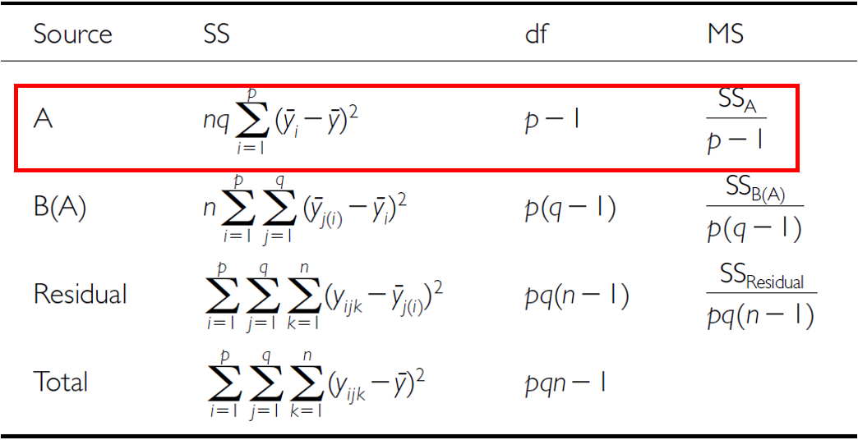

Analysis of Variance: SSB
SSB is SS of difference between means in each level of B and the mean of corresponding level of A summed across levels of A
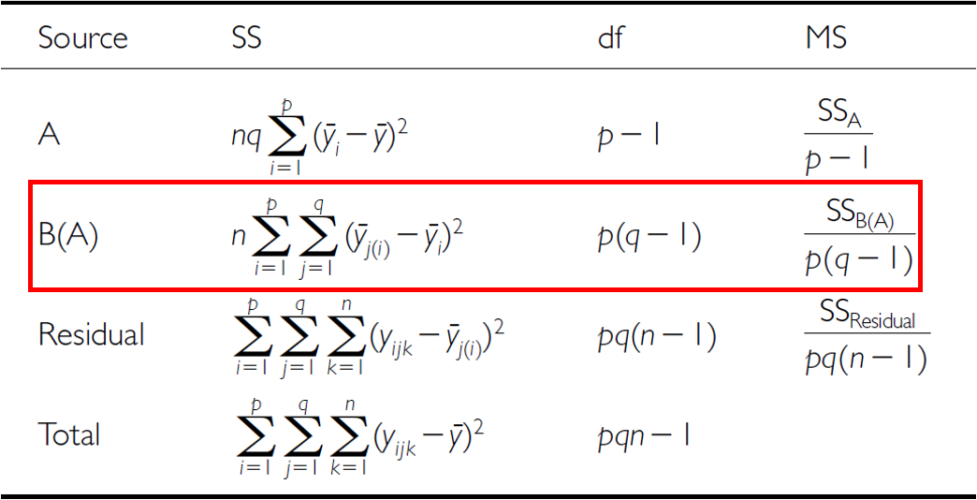

Analysis of Variance: Residual and Total
- SSresid is difference bw each observation and mean for its level of factor B, summed over all observations
- SStotal = SSA + SSB + SSresid
- SS can be turned into MS by dividing by appropriate df
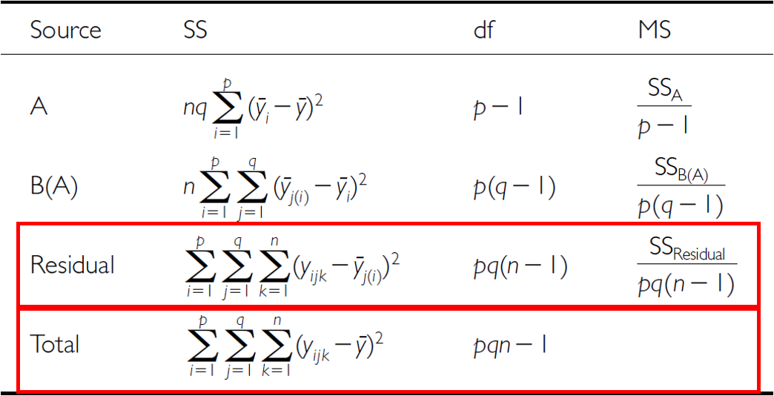

Analysis of Variance Table
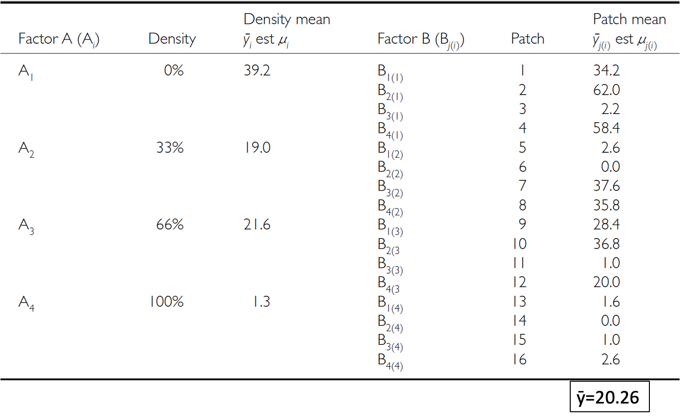

Null Hypotheses: Factor A
Two hypotheses tested on values of MS:
- no effects of factor A
- Assuming A is fixed:
- Ho(A): µ1= µ2= µ3=…. µi= µ
- Same as in 1-factor ANOVA, using means from B factors nested within each - level of A
- (no difference in algal biomass across all levels of grazing: µnone= - µlow= µmed= µhigh)
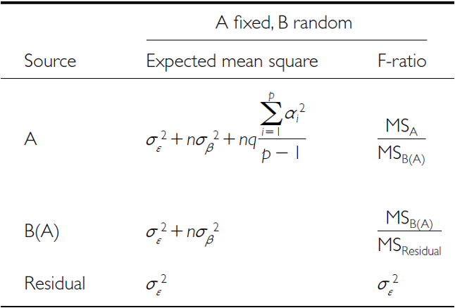

Null Hypotheses: Factor B
Two hypotheses tested on values of MS:
- No effects of factor B nested in A
- Assuming B is random:
- Ho(B): σβ2= 0 (no variance added due to differences between all possible - levels of B)
- (no variance added due to differences between patches)


Conclusions from Analysis
Conclusions?
“significant variation between replicate patches within each treatment, but no significant difference in amount of filamentous algae between treatments”
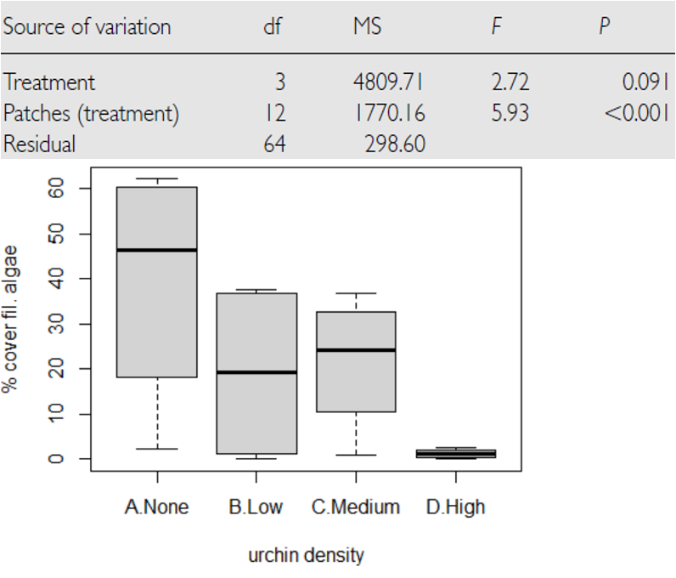

Unbalanced Nested Designs
Unequal sample sizes can be because of:
- uneven number of B levels within each A
- uneven number of replicates within each level of B
Not a problem, unless have unequal variance or large deviation from - normality
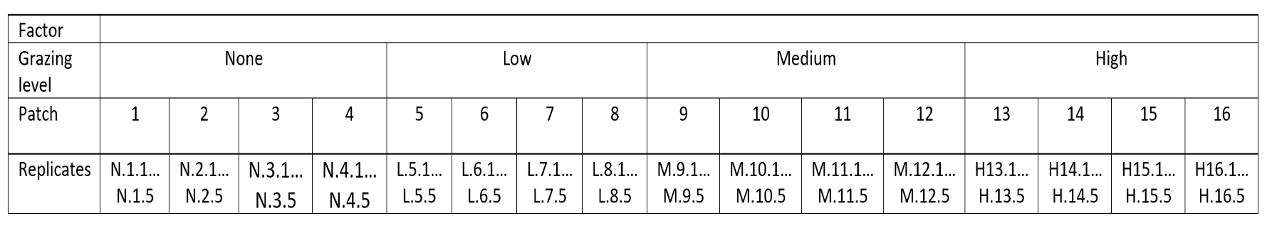

Nested Design Assumptions
As usual, we assume
- equal variance
- normality
- independence of observations
Equal variance + normality need to be assessed at both levels:
- Since means for each level of B within each A are used for the H-test about A, need to assess whether those means meet normality and equal variance
- Examine residuals for H-test about B
- Transformations can be used

