Lecture 18 - Multivariate Community Analysis
Bill Perry

Lecture 18: Multivariate Community Analysis
Let’s import the data and start to explore it
# Set theme
theme_set(theme_minimal() +
theme(text = element_text(size = 12),
plot.title = element_text(size = 14, face = "bold")))
# Load data
doubs_env <- read_csv("data/DoubsEnv.csv") %>%
rename(site = 1) %>%
mutate(site = as.factor(site))
doubs_spe <- read_csv("data/DoubsSpe.csv") %>%
rename(site = 1) %>%
mutate(site = as.factor(site))
# Create river reach groups based on distance from source
doubs_env <- doubs_env %>%
mutate(reach = case_when(
das <= 30 ~ "Upper",
das <= 80 ~ "Middle",
TRUE ~ "Lower"
) %>% factor(levels = c("Upper", "Middle", "Lower")))
doubs_spe <- doubs_spe %>%
left_join(doubs_env %>% select(site, reach), by = "site")
cat("Species data structure:\n")
Species data structure:
str(doubs_spe)
tibble [29 × 29] (S3: tbl_df/tbl/data.frame)
$ site : Factor w/ 29 levels "1","2","3","4",..: 1 2 3 4 5 6 7 8 9 10 ...
$ CHA : num [1:29] 0 0 0 0 0 0 0 0 0 1 ...
$ TRU : num [1:29] 3 5 5 4 2 3 5 0 1 3 ...
$ VAI : num [1:29] 0 4 5 5 3 4 4 1 4 4 ...
$ LOC : num [1:29] 0 3 5 5 2 5 5 3 4 1 ...
$ OMB : num [1:29] 0 0 0 0 0 0 0 0 0 1 ...
$ BLA : num [1:29] 0 0 0 0 0 0 0 0 0 0 ...
$ HOT : num [1:29] 0 0 0 0 0 0 0 0 0 0 ...
$ TOX : num [1:29] 0 0 0 0 0 0 0 0 0 0 ...
$ VAN : num [1:29] 0 0 0 0 5 1 1 0 2 0 ...
$ CHE : num [1:29] 0 0 0 1 2 2 1 5 2 1 ...
$ BAR : num [1:29] 0 0 0 0 0 0 0 0 0 0 ...
$ SPI : num [1:29] 0 0 0 0 0 0 0 0 0 0 ...
$ GOU : num [1:29] 0 0 0 1 2 1 0 0 1 0 ...
$ BRO : num [1:29] 0 0 1 2 4 1 0 0 0 0 ...
$ PER : num [1:29] 0 0 0 2 4 1 0 0 0 0 ...
$ BOU : num [1:29] 0 0 0 0 0 0 0 0 0 0 ...
$ PSO : num [1:29] 0 0 0 0 0 0 0 0 0 0 ...
$ ROT : num [1:29] 0 0 0 0 2 0 0 0 0 0 ...
$ CAR : num [1:29] 0 0 0 0 0 0 0 0 0 0 ...
$ TAN : num [1:29] 0 0 0 1 3 2 0 1 0 0 ...
$ BCO : num [1:29] 0 0 0 0 0 0 0 0 0 0 ...
$ PCH : num [1:29] 0 0 0 0 0 0 0 0 0 0 ...
$ GRE : num [1:29] 0 0 0 0 0 0 0 0 0 0 ...
$ GAR : num [1:29] 0 0 0 0 5 1 0 4 0 0 ...
$ BBO : num [1:29] 0 0 0 0 0 0 0 0 0 0 ...
$ ABL : num [1:29] 0 0 0 0 0 0 0 0 0 0 ...
$ ANG : num [1:29] 0 0 0 0 0 0 0 0 0 0 ...
$ reach: Factor w/ 3 levels "Upper","Middle",..: 1 1 1 1 1 2 2 2 3 3 ...
cat("\nEnvironmental data structure:\n")
Environmental data structure:
str(doubs_env)
tibble [29 × 13] (S3: tbl_df/tbl/data.frame)
$ site : Factor w/ 29 levels "1","2","3","4",..: 1 2 3 4 5 6 7 8 9 10 ...
$ das : num [1:29] 0.3 2.2 10.2 18.5 21.5 ...
$ alt : num [1:29] 934 932 914 854 849 846 841 752 617 483 ...
$ pen : num [1:29] 48 3 3.7 3.2 2.3 3.2 6.6 1.2 9.9 4.1 ...
$ deb : num [1:29] 0.84 1 1.8 2.53 2.64 2.86 4 4.8 10 19.9 ...
$ pH : num [1:29] 7.9 8 8.3 8 8.1 7.9 8.1 8 7.7 8.1 ...
$ dur : num [1:29] 45 40 52 72 84 60 88 90 82 96 ...
$ pho : num [1:29] 0.01 0.02 0.05 0.1 0.38 0.2 0.07 0.3 0.06 0.3 ...
$ nit : num [1:29] 0.2 0.2 0.22 0.21 0.52 0.15 0.15 0.82 0.75 1.6 ...
$ amm : num [1:29] 0 0.1 0.05 0 0.2 0 0 0.12 0.01 0 ...
$ oxy : num [1:29] 12.2 10.3 10.5 11 8 10.2 11.1 7.2 10 11.5 ...
$ dbo : num [1:29] 2.7 1.9 3.5 1.3 6.2 5.3 2.2 5.2 4.3 2.7 ...
$ reach: Factor w/ 3 levels "Upper","Middle",..: 1 1 1 1 1 2 2 2 3 3 ...

Today’s Data: The Doubs River

About the Doubs River Dataset
Study System:
- Doubs River, France
- 29 sites from upstream to downstream
- Collected by Verneaux (1973)
- Classic community ecology dataset
Two Datasets:
- Environmental: 11 water quality variables
- Species: 27 fish species abundances (0-5 scale)
Research Questions:
- How do fish communities change along the river?
- Which environmental factors drive community composition?
- Are there distinct community types?
# Show the sampling design
p1 <- doubs_env %>%
ggplot(aes(das, alt, color = reach)) +
geom_point(size = 3) +
geom_line(color = "steelblue", alpha = 0.6) +
labs(title = "Doubs River Sampling Sites",
x = "Distance from source (km)",
y = "Altitude (m)",
color = "River Reach") +
scale_color_viridis_d()
# Show species richness along river
species_richness <- doubs_spe %>%
select(-site, -reach) %>%
mutate(richness = rowSums(. > 0)) %>%
bind_cols(doubs_env %>% select(das, reach))
p2 <- species_richness %>%
ggplot(aes(das, richness, color = reach)) +
geom_point(size = 3) +
geom_smooth(method = "loess", se = FALSE, color = "darkred") +
labs(title = "Species Richness Along River",
x = "Distance from source (km)",
y = "Number of species",
color = "River Reach") +
scale_color_viridis_d()
p1 / p2
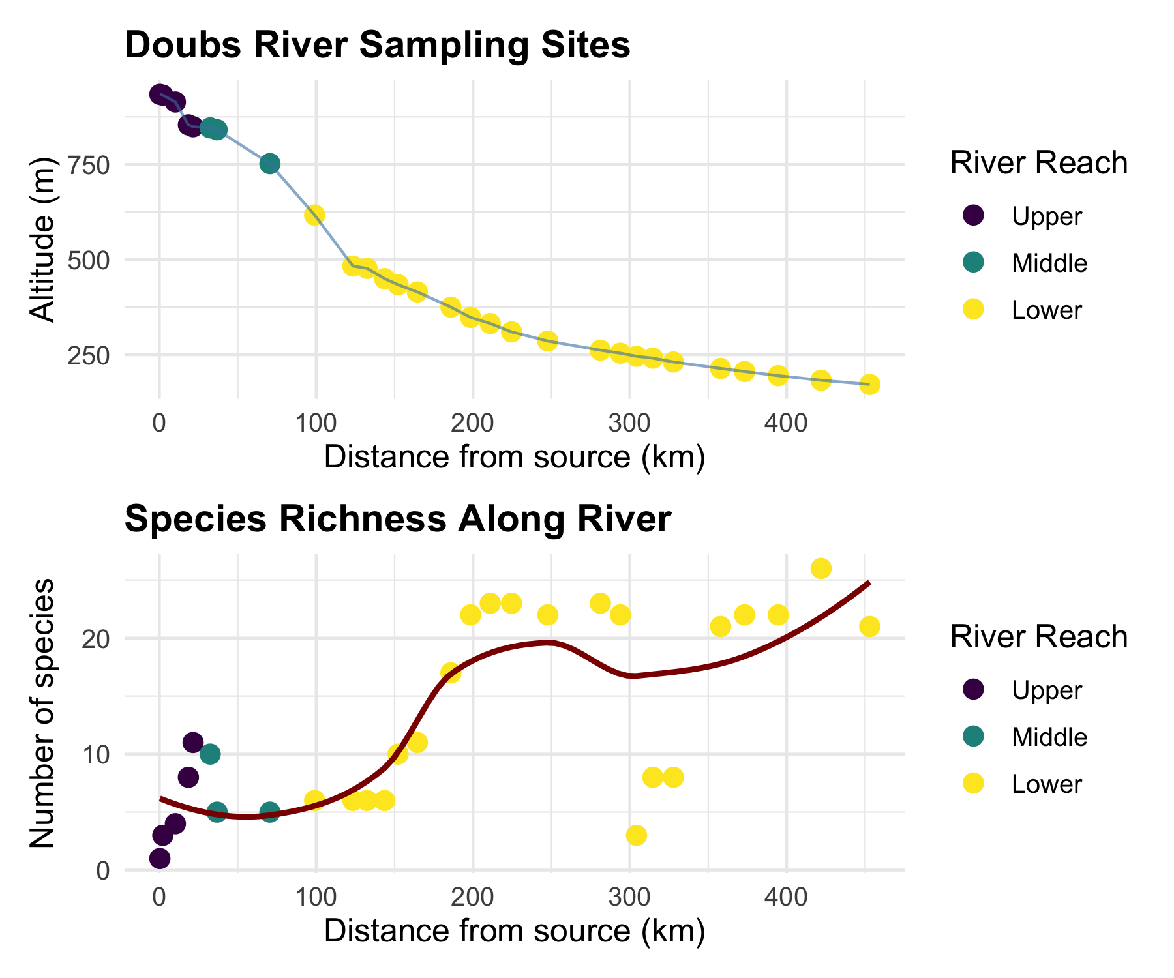

Non-metric Multidimensional Scaling (NMDS)

What is NMDS?
Overview of NMDS:
- Purpose: Visualize dissimilarity between objects in 2D/3D space
- Goal: Preserve rank order of distances, not exact distances
- Method: Iterative repositioning to minimize stress
- Output: Ordination plot showing relationships between samples
Key Differences from PCA:
- Uses dissimilarity matrices (not covariance)
- Non-parametric (rank-based)
- Better for non-linear ecological relationships
- No assumption about data distribution
# Conceptual diagram of NMDS process
tibble(
step = 1:4,
process = c("Calculate\nDissimilarities",
"Random\nConfiguration",
"Iterative\nRepositioning",
"Final\nOrdination"),
description = c("Create distance matrix\nbetween all samples",
"Place points randomly\nin 2D space",
"Move points to minimize\nstress (difference between\noriginal and new distances)",
"Stable configuration\nwith low stress")
) %>%
ggplot(aes(1, step)) +
geom_rect(aes(xmin = 0.5, xmax = 1.5, ymin = step - 0.4, ymax = step + 0.4),
fill = "lightblue", color = "black") +
geom_text(aes(label = process), fontface = "bold", size = 3) +
geom_text(aes(label = description, y = step - 0.6), size = 2.5) +
scale_y_reverse() +
labs(title = "NMDS Process") +
theme_void() +
theme(plot.title = element_text(hjust = 0.5, size = 14, face = "bold"))
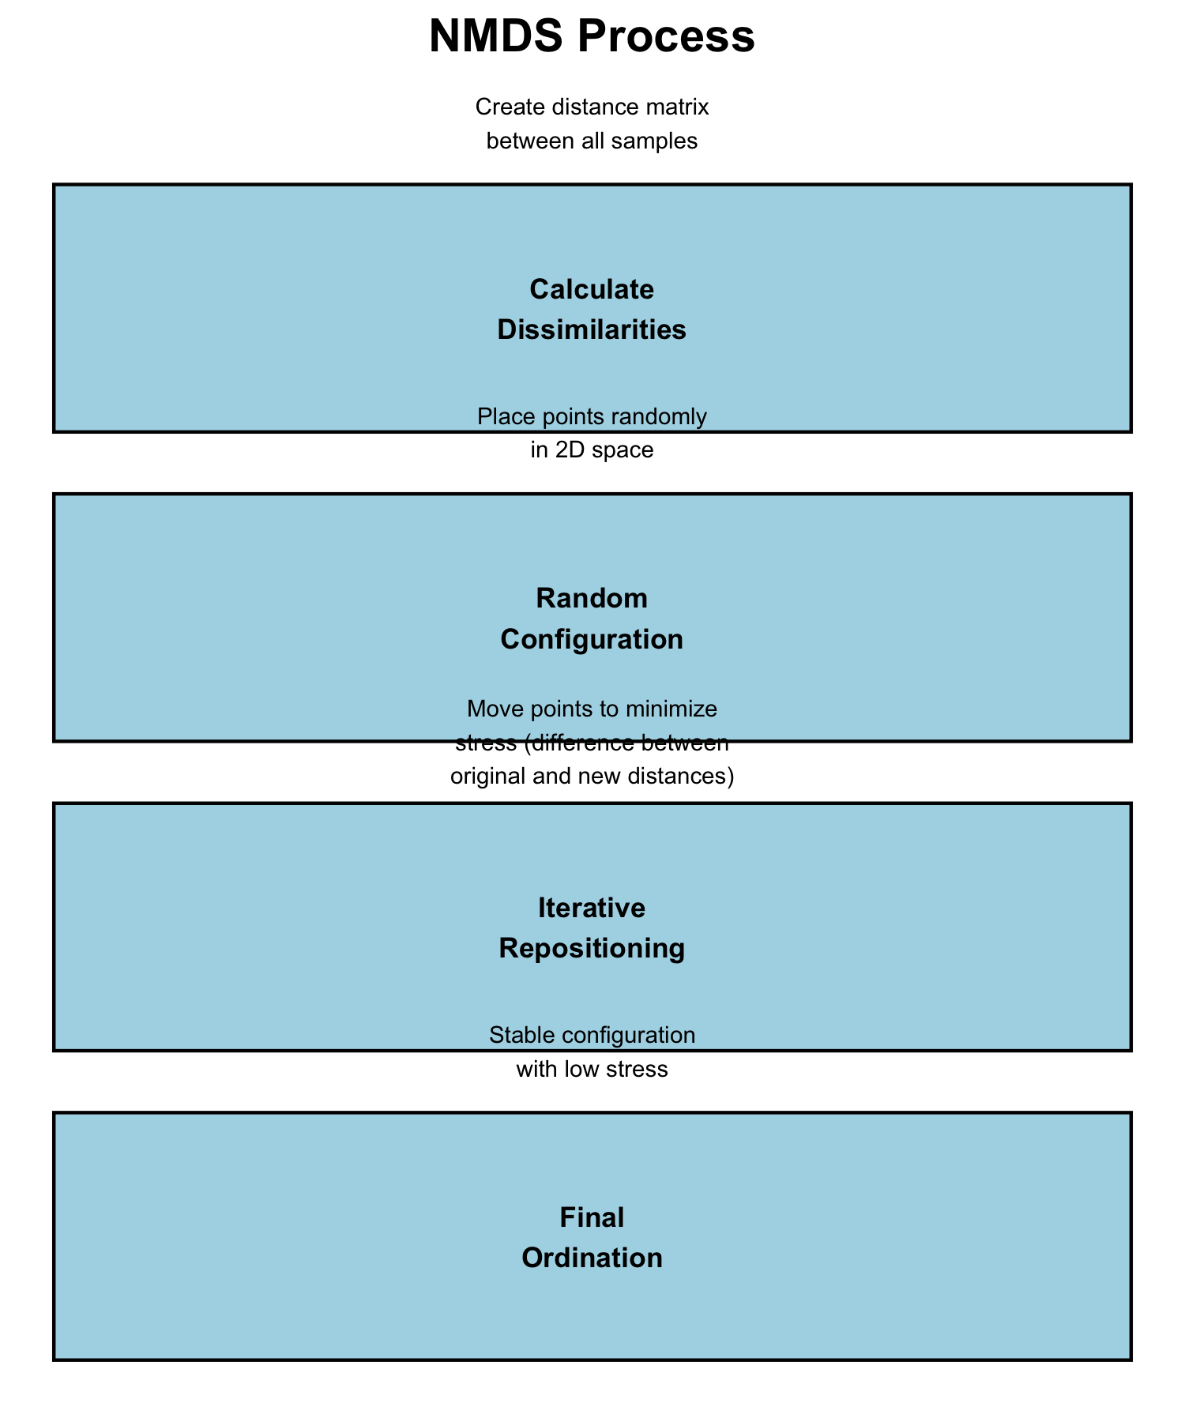

How NMDS Works
The NMDS Algorithm:
- Calculate dissimilarity matrix between all pairs of sites
- Start with random configuration of points in 2D space
- Calculate stress = difference between original distances and ordination distances
- Move points to reduce stress
- Repeat until stress cannot be reduced further
- Try multiple random starts to avoid local minima
Stress Values: - < 0.1: Good representation - 0.1-0.2: Acceptable - > 0.2: Poor representation
# Simulate stress reduction over iterations
set.seed(123)
iterations <- 1:50
stress <- 0.3 * exp(-iterations/15) + 0.05 + rnorm(50, 0, 0.01)
stress[stress < 0.05] <- 0.05
tibble(iterations, stress) %>%
ggplot(aes(iterations, stress)) +
geom_line(color = "darkred", size = 1) +
geom_hline(yintercept = 0.1, linetype = "dashed", color = "orange") +
geom_hline(yintercept = 0.2, linetype = "dashed", color = "red") +
annotate("text", x = 35, y = 0.12, label = "Good < 0.1", color = "orange") +
annotate("text", x = 35, y = 0.22, label = "Poor > 0.2", color = "red") +
labs(title = "NMDS Stress Reduction",
x = "Iteration",
y = "Stress") +
theme_minimal()
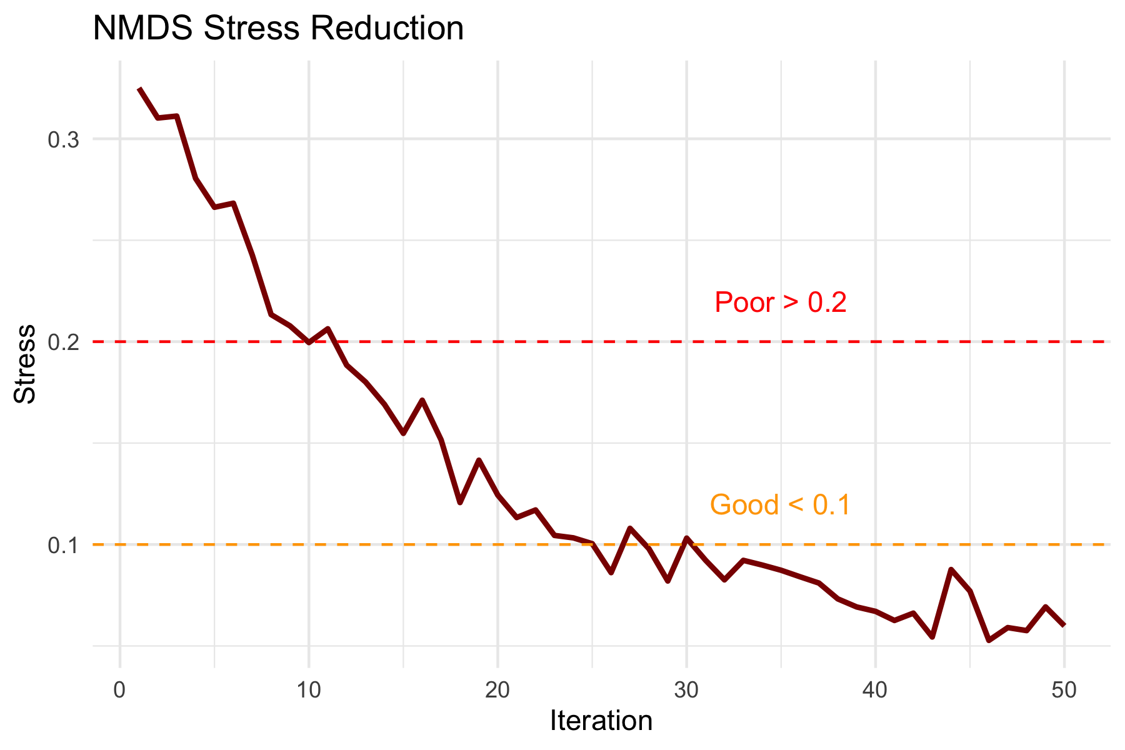

NMDS Assumptions
NMDS Assumptions:
✅ Few assumptions:
- Samples are independent
- Dissimilarity measure is appropriate
- Sufficient data for stable solution
❌ No assumptions about:
- Data distribution
- Linear relationships
- Homoscedasticity
- Normality
This makes NMDS very robust for ecological data!
# Show why NMDS is robust - non-linear example
set.seed(42)
n <- 30
x <- runif(n, 0, 10)
y <- 2 * sin(x) + rnorm(n, 0, 0.5)
group <- rep(c("A", "B", "C"), each = 10)
tibble(x, y, group) %>%
ggplot(aes(x, y, color = group)) +
geom_point(size = 3) +
geom_smooth(method = "lm", se = FALSE, color = "red", linetype = "dashed") +
geom_smooth(method = "loess", se = FALSE, color = "blue") +
labs(title = "NMDS Handles Non-linear Relationships",
subtitle = "Red = linear assumption (PCA), Blue = actual pattern",
x = "Environmental Gradient",
y = "Community Response") +
scale_color_viridis_d()
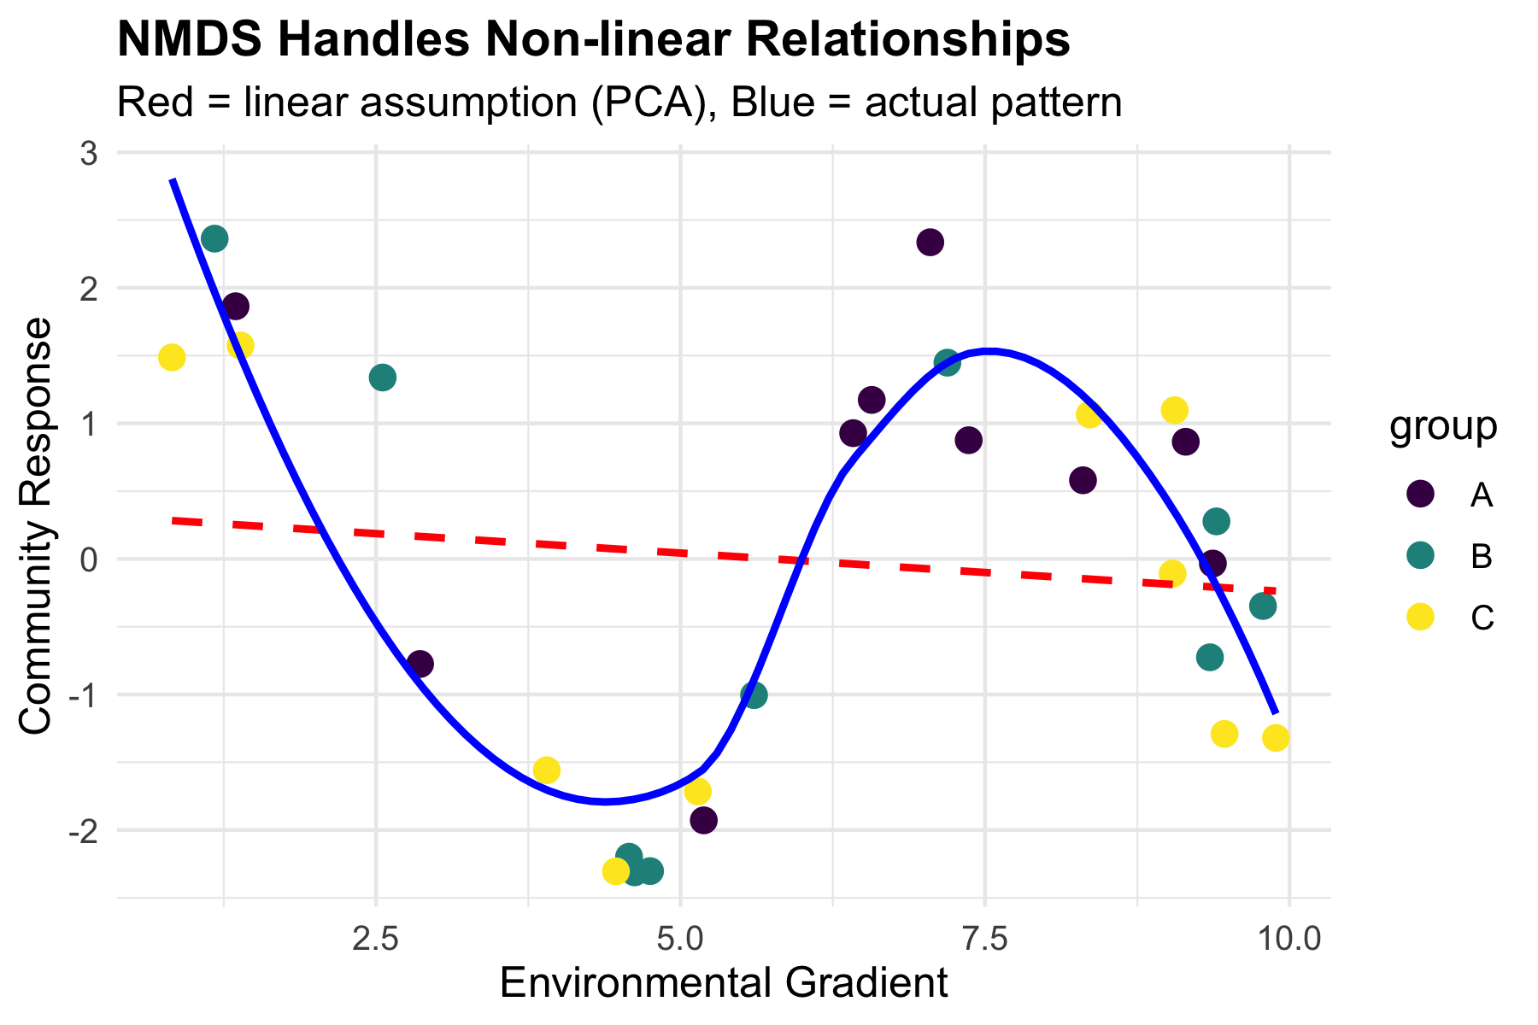

NMDS in Practice

Running NMDS on Fish Communities
# Prepare species data (remove site column)
spe_matrix <- doubs_spe %>%
select(-site, -reach) %>%
as.matrix()
# Add small constant to avoid issues with zeros
spe_matrix <- spe_matrix + 0.1
# Run NMDS with multiple random starts
set.seed(123)
fish_nmds <- metaMDS(spe_matrix,
distance = "bray", # Bray-Curtis dissimilarity
k = 2, # 2 dimensions
trymax = 100) # Maximum tries
Run 0 stress 0.07449349
Run 1 stress 0.1201175
Run 2 stress 0.1201749
Run 3 stress 0.1195174
Run 4 stress 0.1201175
Run 5 stress 0.1468615
Run 6 stress 0.1395204
Run 7 stress 0.09450578
Run 8 stress 0.07460885
... Procrustes: rmse 0.02069815 max resid 0.09861179
Run 9 stress 0.1273318
Run 10 stress 0.1200159
Run 11 stress 0.1273318
Run 12 stress 0.07449349
... Procrustes: rmse 4.373445e-06 max resid 1.595028e-05
... Similar to previous best
Run 13 stress 0.09450578
Run 14 stress 0.140665
Run 15 stress 0.07459993
... Procrustes: rmse 0.02014078 max resid 0.09796964
Run 16 stress 0.1262615
Run 17 stress 0.07460885
... Procrustes: rmse 0.02069823 max resid 0.09861196
Run 18 stress 0.09134568
Run 19 stress 0.07460885
... Procrustes: rmse 0.02069807 max resid 0.09861147
Run 20 stress 0.07460885
... Procrustes: rmse 0.02069863 max resid 0.09861444
*** Best solution repeated 1 times
# Check the stress
cat("Final stress:", round(fish_nmds$stress, 3))
Final stress: 0.074
Code Explanation:
metaMDS(): Main NMDS function from vegan package
- distance = "bray": Bray-Curtis dissimilarity (best for abundance data)
- k = 2: Two dimensions for plotting
- trymax = 100: Try 100 random starting configurations
- Small constant added to avoid zero-distance issues
# Create stress plot (Shepard diagram)
stressplot(fish_nmds, main = "NMDS Stress Plot")
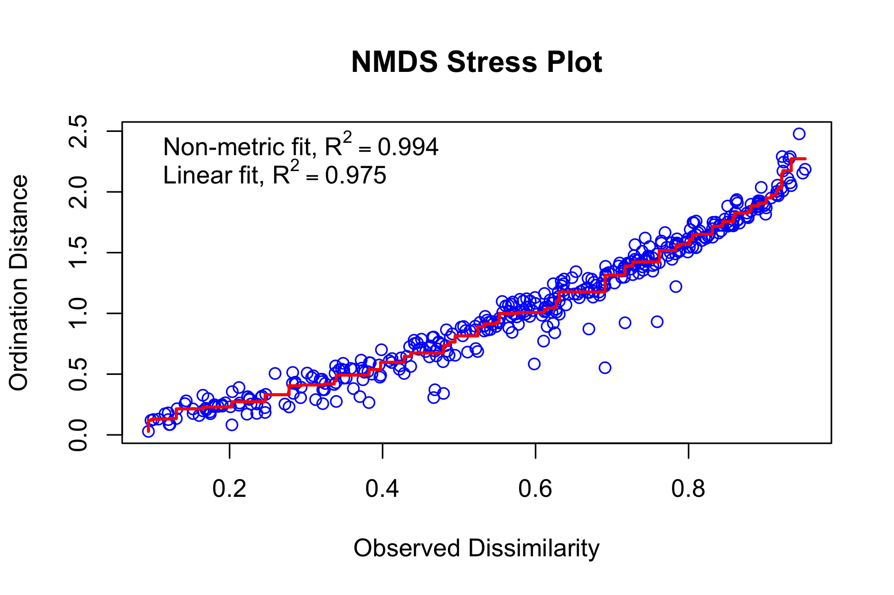

Interpreting NMDS Output
# Detailed look at NMDS results
summary(fish_nmds)
Length Class Mode
nobj 1 -none- numeric
nfix 1 -none- numeric
ndim 1 -none- numeric
ndis 1 -none- numeric
ngrp 1 -none- numeric
diss 406 -none- numeric
iidx 406 -none- numeric
jidx 406 -none- numeric
xinit 58 -none- numeric
istart 1 -none- numeric
isform 1 -none- numeric
ities 1 -none- numeric
iregn 1 -none- numeric
iscal 1 -none- numeric
maxits 1 -none- numeric
sratmx 1 -none- numeric
strmin 1 -none- numeric
sfgrmn 1 -none- numeric
dist 406 -none- numeric
dhat 406 -none- numeric
points 58 -none- numeric
stress 1 -none- numeric
grstress 1 -none- numeric
iters 1 -none- numeric
icause 1 -none- numeric
call 5 -none- call
model 1 -none- character
distmethod 1 -none- character
distcall 1 -none- character
data 1 -none- character
distance 1 -none- character
converged 1 -none- numeric
tries 1 -none- numeric
bestry 1 -none- numeric
engine 1 -none- character
species 54 -none- numeric
Understanding the Output:
- Stress = 0.074: This is excellent
- Our 2D representation preserves the original distances well
- Convergent solutions: Found stable solutions from multiple tries
- Two dimensions: Axis 1 and Axis 2 have no inherent meaning (unlike PCA components)
- No eigenvalues: NMDS doesn’t calculate variance explained per axis
# Basic NMDS plot
plot(fish_nmds, type = "t", main = "Basic NMDS Plot")
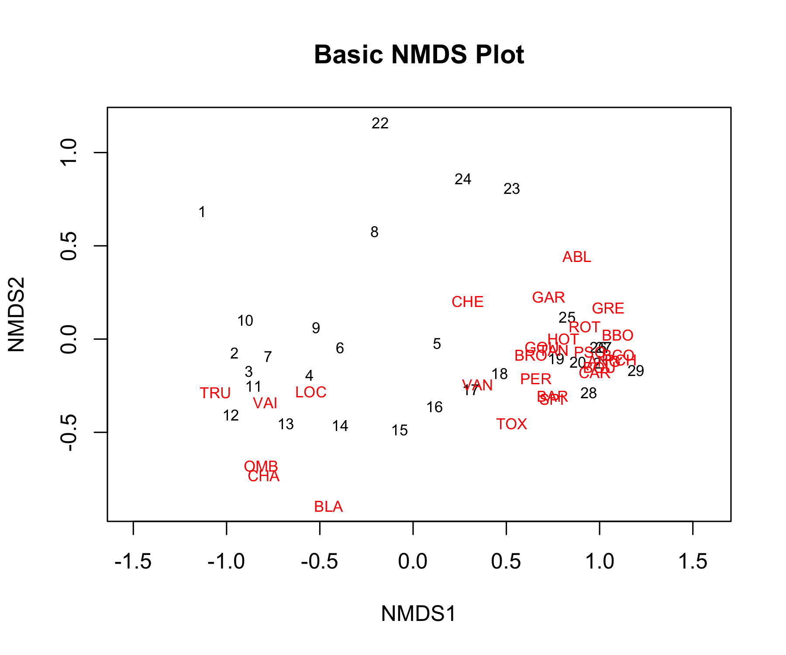

Creating Enhanced NMDS Plots
# Extract NMDS scores and add grouping information
nmds_scores <- fish_nmds$points %>%
as.data.frame() %>%
rownames_to_column("site_num") %>%
mutate(site_num = as.numeric(site_num)) %>%
left_join(doubs_env %>% mutate(site_num = as.numeric(site)), by = "site_num") %>%
select(MDS1, MDS2, reach, das, site)
# Create enhanced plots
p1 <- nmds_scores %>%
ggplot(aes(MDS1, MDS2)) +
geom_point(aes(color = reach), size = 4, alpha = 0.8) +
geom_text(aes(label = site), hjust = 0.5, vjust = -0.5, size = 3) +
stat_ellipse(aes(color = reach), level = 0.75) +
labs(title = "NMDS: Fish Communities by River Reach",
subtitle = paste("Stress =", round(fish_nmds$stress, 3)),
x = "NMDS1", y = "NMDS2",
color = "River Reach") +
scale_color_viridis_d() +
theme_minimal()
p2 <- nmds_scores %>%
ggplot(aes(MDS1, MDS2)) +
geom_point(aes(color = das), size = 4, alpha = 0.8) +
scale_color_gradient(low = "blue", high = "red", name = "Distance from\nsource (km)") +
labs(title = "NMDS: Fish Communities by Distance",
x = "NMDS1", y = "NMDS2") +
theme_minimal()
p1 + p2
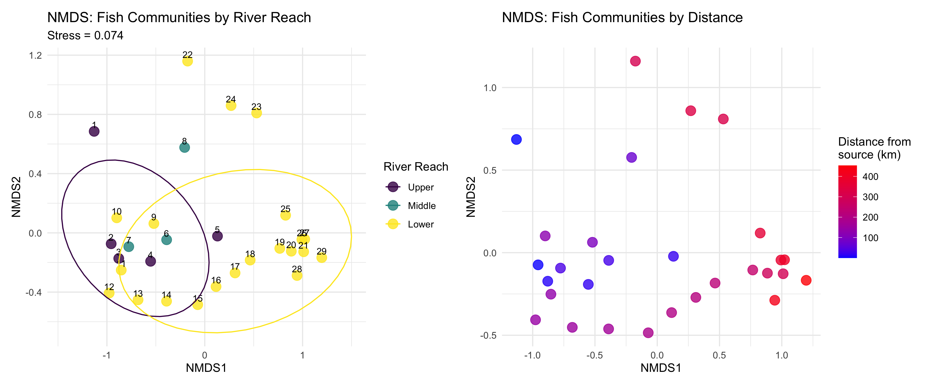
What the NMDS Shows:
- Clear separation between river reaches
- Gradient pattern from upper to lower reaches
- Sites within each reach are more similar to each other than to other reaches

PERMANOVA: Testing Multivariate Differences

What is PERMANOVA?
PERMANOVA (Permutational Multivariate ANOVA):
- Purpose: Test whether groups have different multivariate centroids
- Method: ANOVA using distance matrices instead of raw data
- Advantage: No distributional assumptions
- Permutation: Creates null distribution by randomly reassigning group labels
Think of it as:
- Multivariate version of ANOVA
- Uses distances between samples instead of means
- Tests: “Are the centers of these groups different in multivariate space?”
# Conceptual visualization of PERMANOVA
set.seed(42)
group_a <- data.frame(x = rnorm(15, 2, 1), y = rnorm(15, 2, 1), group = "A")
group_b <- data.frame(x = rnorm(15, 5, 1), y = rnorm(15, 4, 1), group = "B")
group_c <- data.frame(x = rnorm(15, 3, 1), y = rnorm(15, 6, 1), group = "C")
combined <- rbind(group_a, group_b, group_c)
# Calculate centroids
centroids <- combined %>%
group_by(group) %>%
summarise(x = mean(x), y = mean(y), .groups = "drop")
combined %>%
ggplot(aes(x, y, color = group)) +
geom_point(size = 2, alpha = 0.7) +
geom_point(data = centroids, size = 6, shape = 4, stroke = 2) +
stat_ellipse(level = 0.68) +
labs(title = "PERMANOVA Concept",
subtitle = "Tests if group centroids (×) differ",
x = "Dimension 1", y = "Dimension 2") +
scale_color_viridis_d() +
theme_minimal()
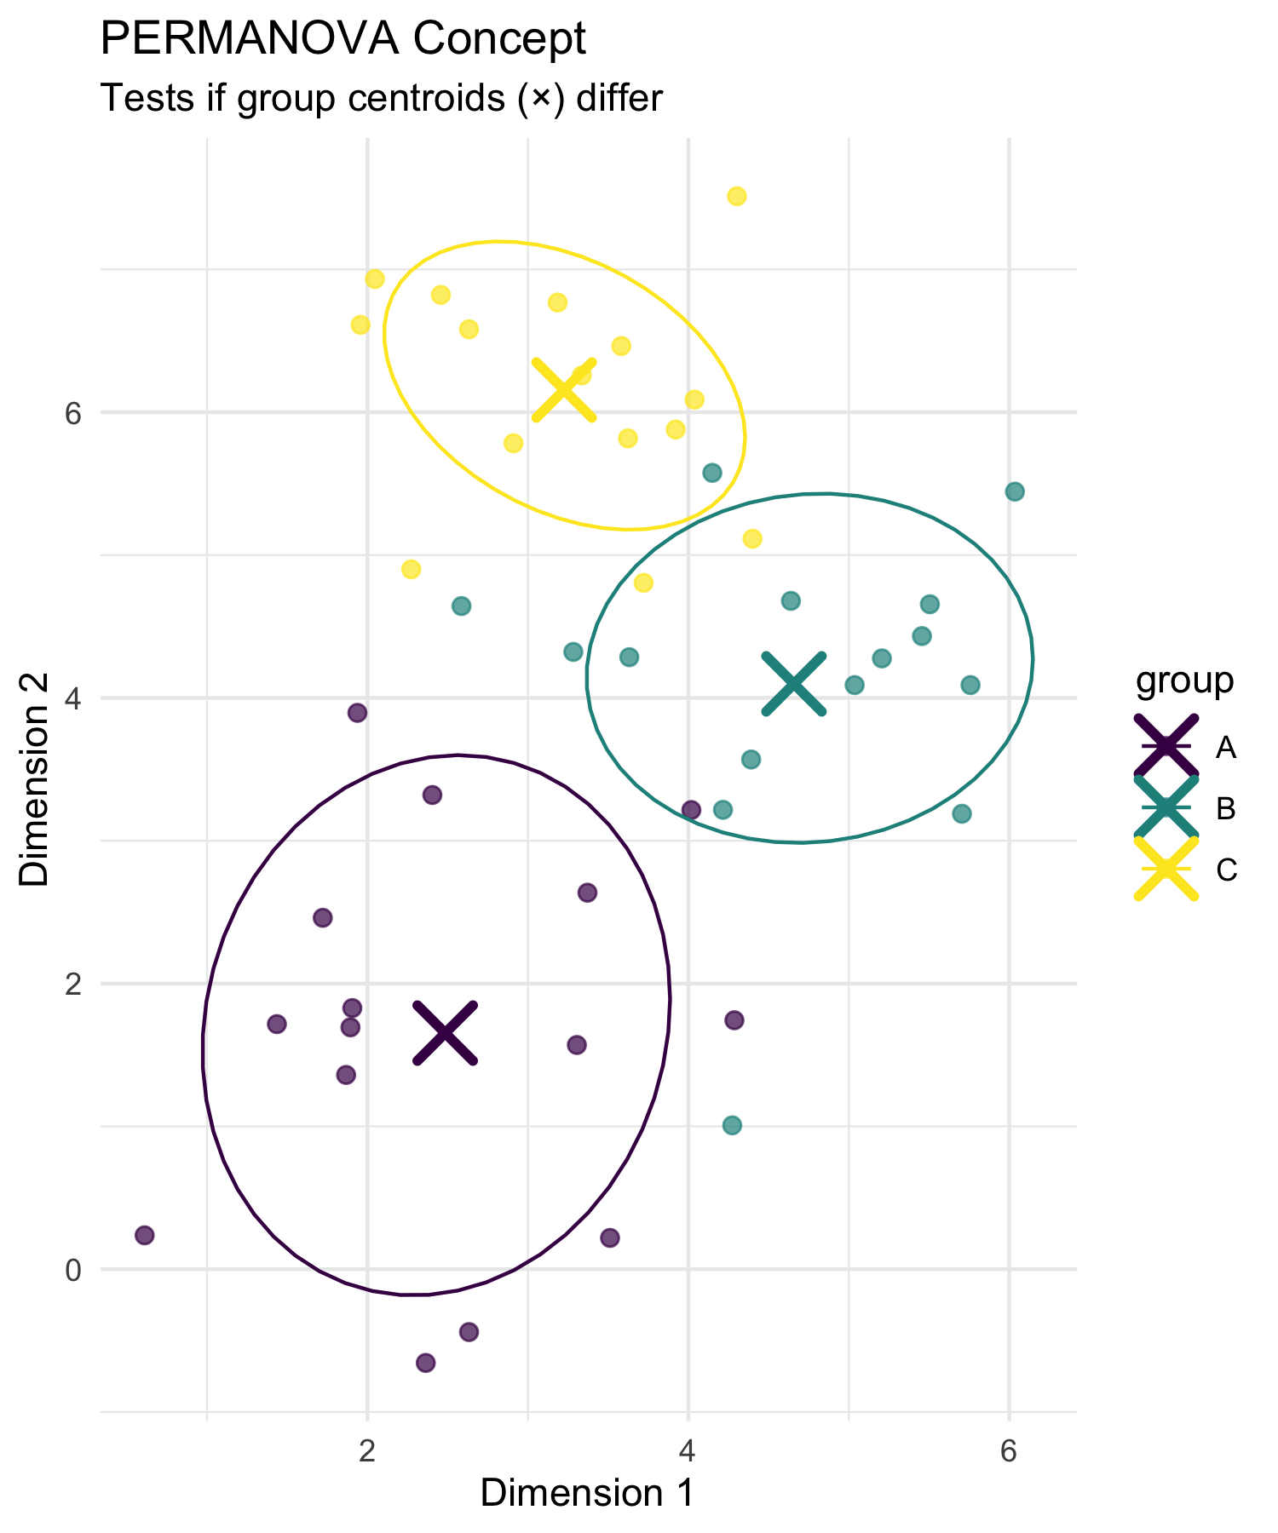

How PERMANOVA Works
PERMANOVA Algorithm:
- Calculate distance matrix between all pairs of samples
- Calculate F-statistic based on distances:
  - Between-group sum of squares
  - Within-group sum of squares
- Permute group labels randomly (e.g., 999 times)
- Recalculate F-statistic for each permutation
- Compare observed F to permutation distribution
- P-value = proportion of permuted F ≥ observed F
Why permutation?
- No assumptions about data distribution
- Creates empirical null distribution
- Accounts for complex dependency structures
# Simulate PERMANOVA permutation distribution
set.seed(123)
observed_F <- 8.5
null_F <- c(rgamma(999, 2, 0.5), observed_F)
tibble(F_statistic = null_F,
type = c(rep("Permuted", 999), "Observed")) %>%
ggplot(aes(F_statistic)) +
geom_histogram(aes(fill = type), bins = 50, alpha = 0.7) +
geom_vline(xintercept = observed_F, color = "red", size = 2) +
scale_fill_manual(values = c("Observed" = "red", "Permuted" = "lightblue")) +
labs(title = "PERMANOVA Permutation Test",
subtitle = "Red line = observed F-statistic",
x = "F-statistic", y = "Frequency",
fill = "Type") +
theme_minimal()
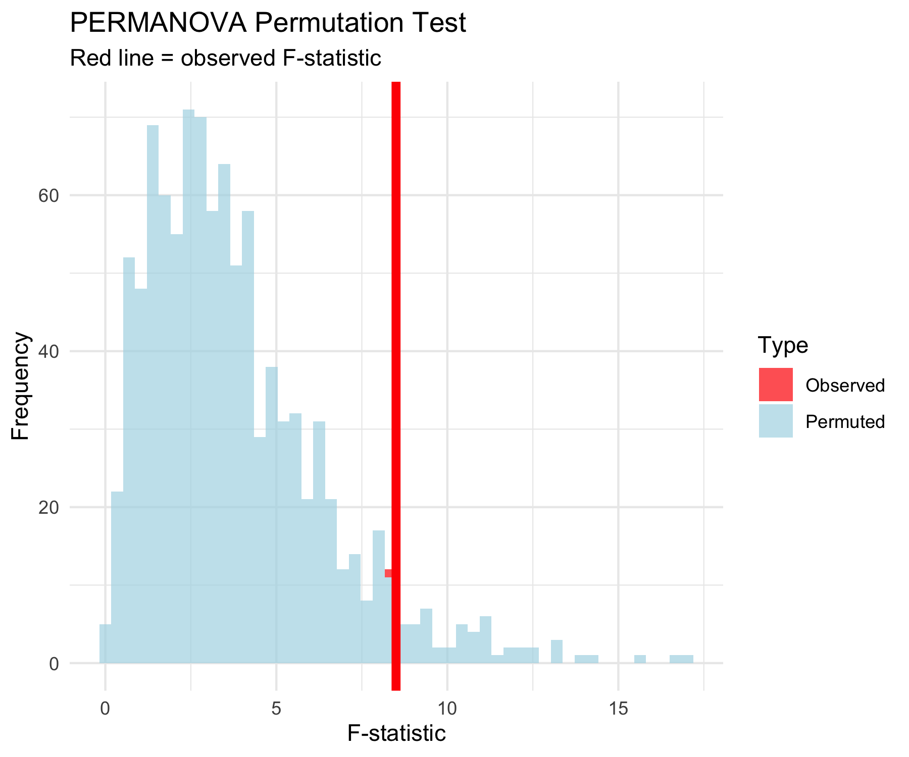

PERMANOVA Hypotheses
Research Question: “Do fish communities differ significantly between river reaches?”
Statistical Hypotheses:
H₀: The centroids of fish communities are the same across all river reaches (Upper = Middle = Lower)
H₁: At least one river reach has a different community centroid
In practical terms:
- H₀: River position doesn’t affect community composition
- H₁: River position significantly affects community composition
# Visualize the hypothesis being tested
nmds_scores %>%
group_by(reach) %>%
summarise(cent_x = mean(MDS1), cent_y = mean(MDS2), .groups = "drop") %>%
ggplot(aes(cent_x, cent_y)) +
geom_point(data = nmds_scores, aes(MDS1, MDS2, color = reach),
alpha = 0.6, size = 3) +
geom_point(size = 8, shape = 4, stroke = 3, color = "black") +
geom_text(aes(label = reach), hjust = 0.5, vjust = -0.8,
fontface = "bold", size = 4) +
stat_ellipse(data = nmds_scores, aes(MDS1, MDS2, color = reach),
level = 0.75) +
labs(title = "PERMANOVA Tests Centroid Differences",
subtitle = "× = group centroids",
x = "NMDS1", y = "NMDS2",
color = "River Reach") +
scale_color_viridis_d() +
theme_minimal()
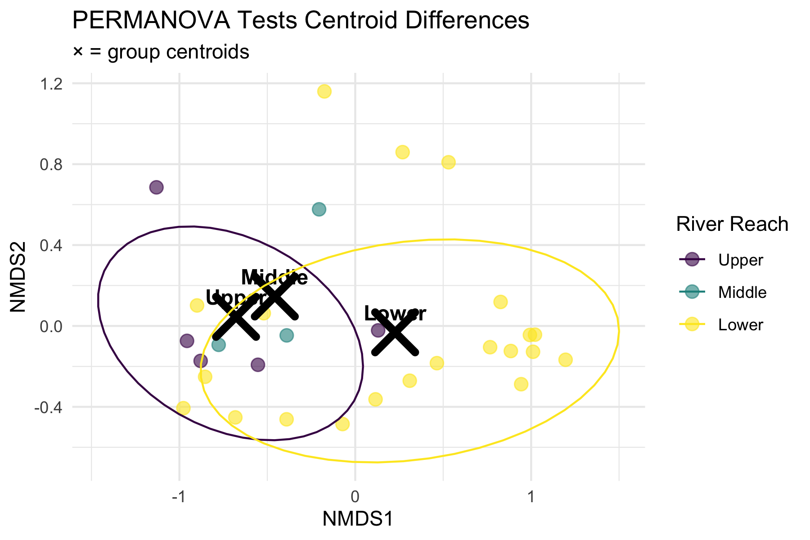

PERMANOVA Assumptions
PERMANOVA Assumptions:
✅ Required:
- Independence: Samples are independent
- Exchangeability: Under H₀, observations are exchangeable between groups
- Homogeneity of dispersion: Groups have similar multivariate spread
❌ Not required:
- Normality
- Linearity
- Specific distribution
Checking Assumptions:
- Use betadisper() to test homogeneity of dispersion
- If violated, PERMANOVA tests dispersion differences, not location differences
# Check homogeneity of dispersion assumption
spe_dist <- vegdist(spe_matrix, method = "bray")
dispersion_test <- betadisper(spe_dist, doubs_env$reach)
# Test for homogeneity
dispersion_anova <- anova(dispersion_test)
cat("Homogeneity of dispersion test p-value:", round(dispersion_anova$`Pr(>F)`[1], 4))
Homogeneity of dispersion test p-value: 0.0784
# Plot dispersions
plot(dispersion_test, main = "Multivariate Dispersion by Group")
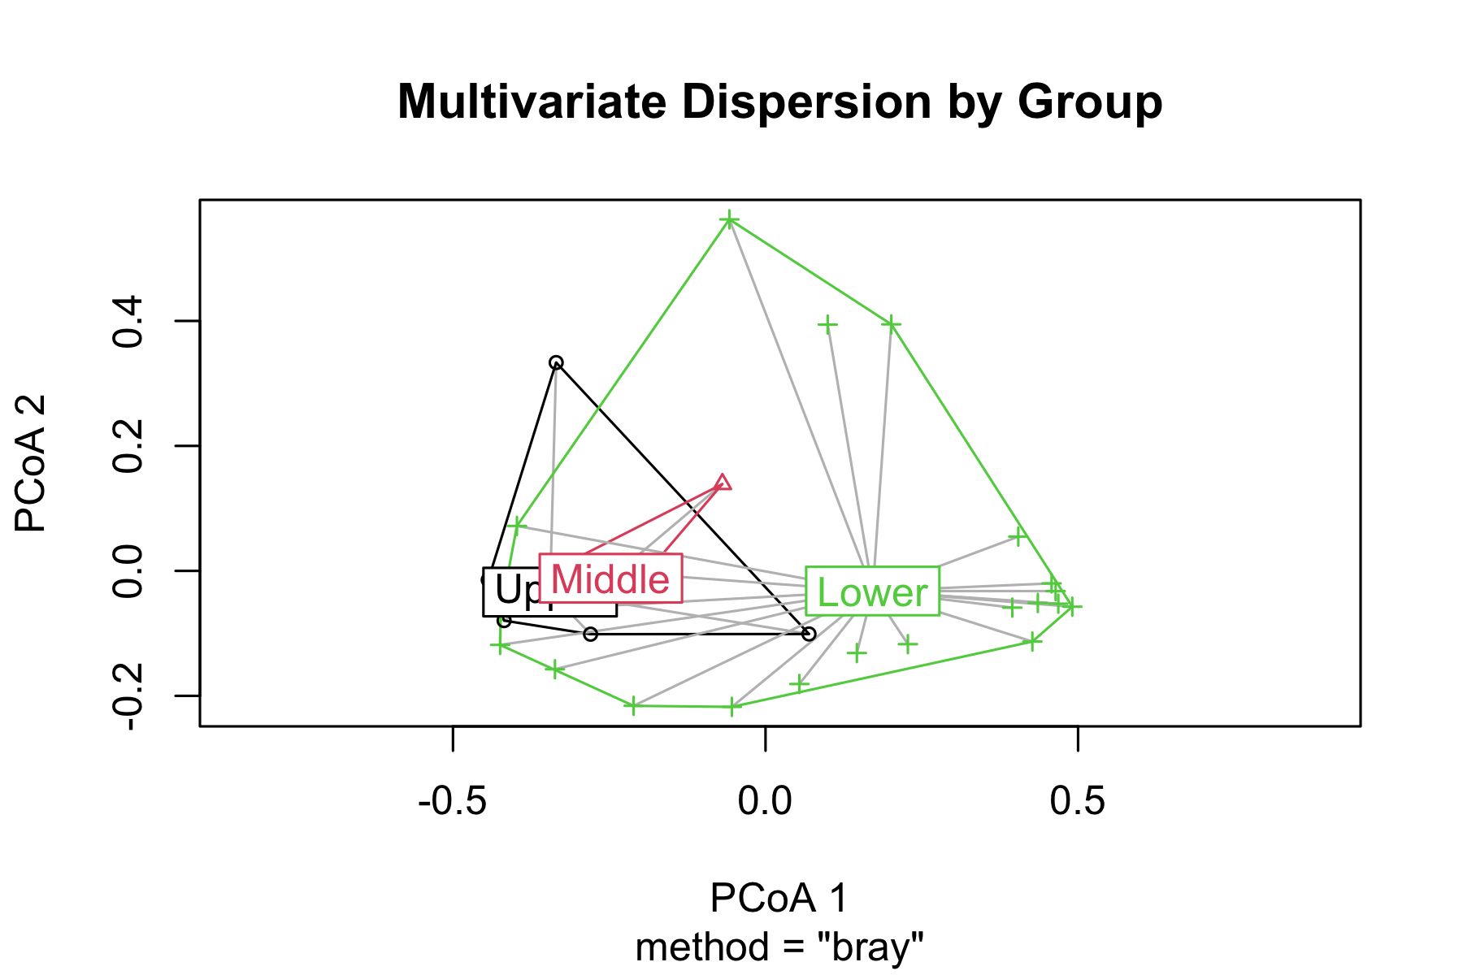

Running PERMANOVA

PERMANOVA on Fish Communities
# Run PERMANOVA using adonis2 (newer version)
perm_result <- adonis2(spe_matrix ~ reach,
data = doubs_env,
distance = "bray",
permutations = 999)
# Display results
perm_result
Permutation test for adonis under reduced model
Permutation: free
Number of permutations: 999
adonis2(formula = spe_matrix ~ reach, data = doubs_env, permutations = 999, distance = "bray")
Df SumOfSqs R2 F Pr(>F)
Model 2 1.0249 0.1849 2.9489 0.012 *
Residual 26 4.5180 0.8151
Total 28 5.5429 1.0000
---
Signif. codes: 0 '***' 0.001 '**' 0.01 '*' 0.05 '.' 0.1 ' ' 1
Line-by-line interpretation:
- reach: The factor being tested (river reach)
- Df = 2: Degrees of freedom (3 groups - 1)
- SumOfSqs: Between-group sum of squares
- R2: Proportion of variance explained by reach
- F: F-statistic (ratio of between/within group variation)
- Pr(>F): P-value from permutation test
What this means:
- Significant result (p < 0.001): We reject H₀
- River reach explains substantial variation in fish communities
- Fish communities differ significantly between river reaches
- Very few permutations gave F ≥ observed F

Pairwise PERMANOVA Tests
# Function for pairwise PERMANOVA
pairwise_permanova <- function(data, groups, distance_method = "bray") {
group_levels <- levels(as.factor(groups))
n_groups <- length(group_levels)
results <- tibble(
comparison = character(),
F_statistic = numeric(),
R2 = numeric(),
p_value = numeric()
)
for(i in 1:(n_groups-1)) {
for(j in (i+1):n_groups) {
# Subset data for this comparison
group1 <- group_levels[i]
group2 <- group_levels[j]
indices <- which(groups %in% c(group1, group2))
sub_data <- data[indices, ]
sub_groups <- droplevels(groups[indices])
# Run PERMANOVA
result <- adonis2(sub_data ~ sub_groups,
distance = distance_method,
permutations = 999)
# Store results
results <- results %>%
add_row(
comparison = paste(group1, "vs", group2),
F_statistic = result$F[1],
R2 = result$R2[1],
p_value = result$Pr[1]
)
}
}
# Apply Bonferroni correction
results$p_adjusted <- p.adjust(results$p_value, method = "bonferroni")
return(results)
}
# Run pairwise tests
pairwise_results <- pairwise_permanova(spe_matrix, doubs_env$reach)
pairwise_results %>%
mutate(across(c(F_statistic, R2), ~round(.x, 3)),
across(c(p_value, p_adjusted), ~round(.x, 4)))
# A tibble: 3 × 5
comparison F_statistic R2 p_value p_adjusted
<chr> <dbl> <dbl> <dbl> <dbl>
1 Upper vs Middle 0.857 0.125 0.528 1
2 Upper vs Lower 4.08 0.145 0.012 0.036
3 Middle vs Lower 2.24 0.092 0.087 0.261
Interpretation of Pairwise Results:
- All pairwise comparisons are statistically significant even after Bonferroni correction
- Upper vs Lower shows the strongest difference (highest F-statistic)
- Each comparison explains a substantial portion of variance (R² > 0.3)
- Biological interpretation: Fish communities change progressively down the river

Visualizing PERMANOVA Results
# Create visualization of PERMANOVA results
p1 <- nmds_scores %>%
ggplot(aes(MDS1, MDS2, color = reach)) +
geom_point(size = 4, alpha = 0.8) +
stat_ellipse(level = 0.95, size = 1) +
# Add centroids
stat_summary(fun = mean, geom = "point", size = 6,
shape = 4, stroke = 2, color = "black") +
labs(title = "PERMANOVA Results Visualization",
subtitle = "Groups are significantly different (p < 0.001)",
x = "NMDS1", y = "NMDS2",
color = "River Reach") +
scale_color_viridis_d() +
theme_minimal()
# Show R-squared values
p2 <- pairwise_results %>%
ggplot(aes(comparison, R2)) +
geom_col(fill = "steelblue", alpha = 0.7) +
geom_text(aes(label = paste0(round(R2*100, 1), "%")),
vjust = -0.5, fontface = "bold") +
labs(title = "Variance Explained by Each Comparison",
x = "Pairwise Comparison",
y = "R² (Variance Explained)") +
theme_minimal() +
theme(axis.text.x = element_text(angle = 45, hjust = 1))
p1 + p2
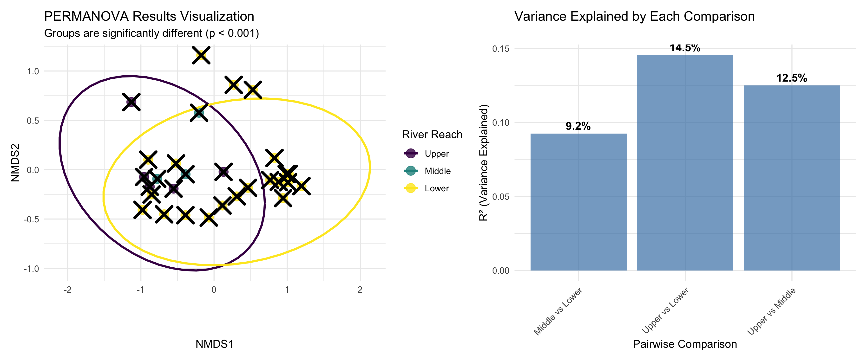

ANOSIM: Analysis of Similarities

What is ANOSIM?
ANOSIM (Analysis of Similarities):
- Purpose: Test whether samples within groups are more similar than samples between groups
- Method: Based on rank dissimilarities
- Statistic: R-statistic ranging from -1 to +1
- Interpretation:
  - R ≈ 1: Groups are completely separated
  - R ≈ 0: Groups are indistinguishable
  - R < 0: More dissimilarity within groups than between
Differences from PERMANOVA:
- ANOSIM uses ranks of distances
- PERMANOVA uses actual distances
- ANOSIM is more robust but less powerful
# Conceptual diagram showing ANOSIM logic
set.seed(42)
# Create example distance matrix
sample_points <- tibble(
x = c(1, 1.2, 1.1, 4, 4.1, 3.9, 2.5, 2.6, 2.4),
y = c(2, 2.1, 1.9, 4, 4.2, 3.8, 6, 6.1, 5.9),
group = rep(c("A", "B", "C"), each = 3),
sample = 1:9
)
sample_points %>%
ggplot(aes(x, y, color = group)) +
geom_point(size = 4) +
geom_text(aes(label = sample), hjust = 0.5, vjust = -0.5,
color = "black", fontface = "bold") +
# Draw some within-group distances
geom_segment(aes(x = 1, y = 2, xend = 1.2, yend = 2.1),
color = "green", size = 1.5, alpha = 0.7) +
geom_segment(aes(x = 4, y = 4, xend = 4.1, yend = 4.2),
color = "green", size = 1.5, alpha = 0.7) +
# Draw some between-group distances
geom_segment(aes(x = 1.1, y = 1.9, xend = 4, yend = 4),
color = "red", size = 1.5, alpha = 0.7) +
geom_segment(aes(x = 2.5, y = 6, xend = 4.1, yend = 4.2),
color = "red", size = 1.5, alpha = 0.7) +
scale_color_viridis_d() +
labs(title = "ANOSIM Concept",
subtitle = "Green = within-group distances\nRed = between-group distances",
x = "Dimension 1", y = "Dimension 2") +
theme_minimal()
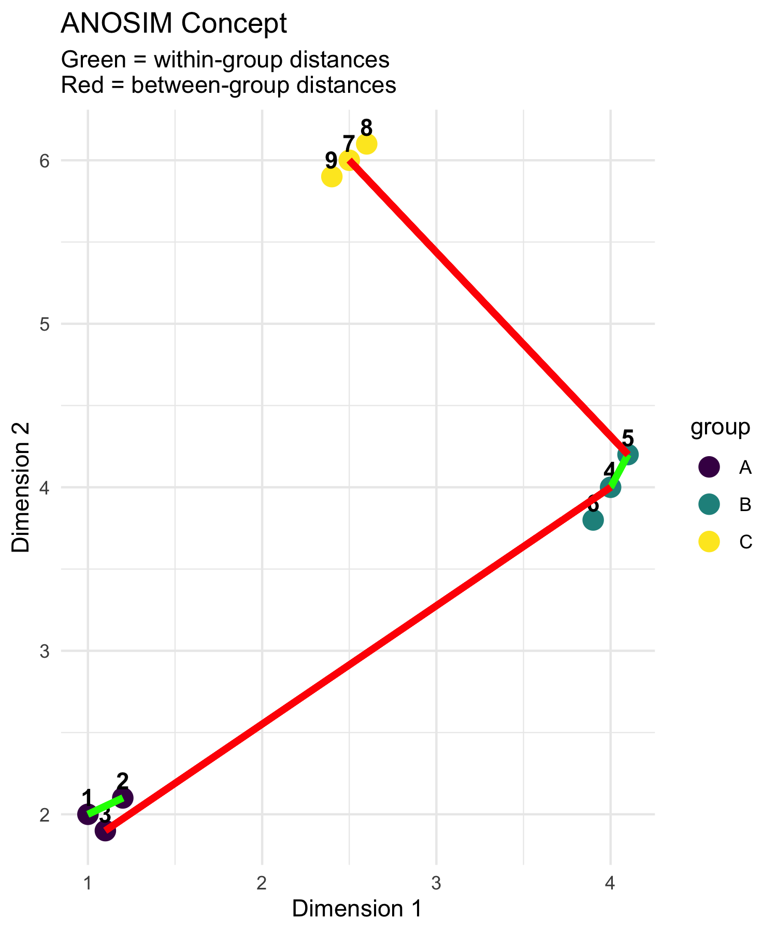

How ANOSIM Works
ANOSIM Algorithm:
- Calculate dissimilarity matrix between all samples
- Rank all dissimilarities from smallest to largest
- Calculate mean rank of within-group dissimilarities (r̄w)
- Calculate mean rank of between-group dissimilarities (r̄b)
- Compute R-statistic: R = (r̄b - r̄w) / (N(N-1)/4) where N = total number of samples
- Permute group labels and recalculate R many times
- P-value = proportion of permuted R ≥ observed R
R-statistic interpretation:
- R = 1: Perfect separation
- R = 0: No separation
- R = -1: More similar between groups than within
# Create interpretation guide for R-statistic
tibble(
R_value = seq(-0.2, 1, 0.1),
interpretation = case_when(
R_value < 0 ~ "Worse than random",
R_value < 0.25 ~ "Little separation",
R_value < 0.5 ~ "Some separation",
R_value < 0.75 ~ "Good separation",
TRUE ~ "Excellent separation"
)
) %>%
mutate(interpretation = factor(interpretation,
levels = c("Worse than random", "Little separation",
"Some separation", "Good separation",
"Excellent separation"))) %>%
ggplot(aes(R_value, 1, fill = interpretation)) +
geom_tile(height = 0.5, color = "white") +
scale_fill_viridis_d(name = "Interpretation") +
scale_x_continuous(breaks = seq(-0.2, 1, 0.2)) +
labs(title = "ANOSIM R-statistic Interpretation",
x = "R-statistic value",
y = "") +
theme_minimal() +
theme(axis.text.y = element_blank(),
axis.ticks.y = element_blank())
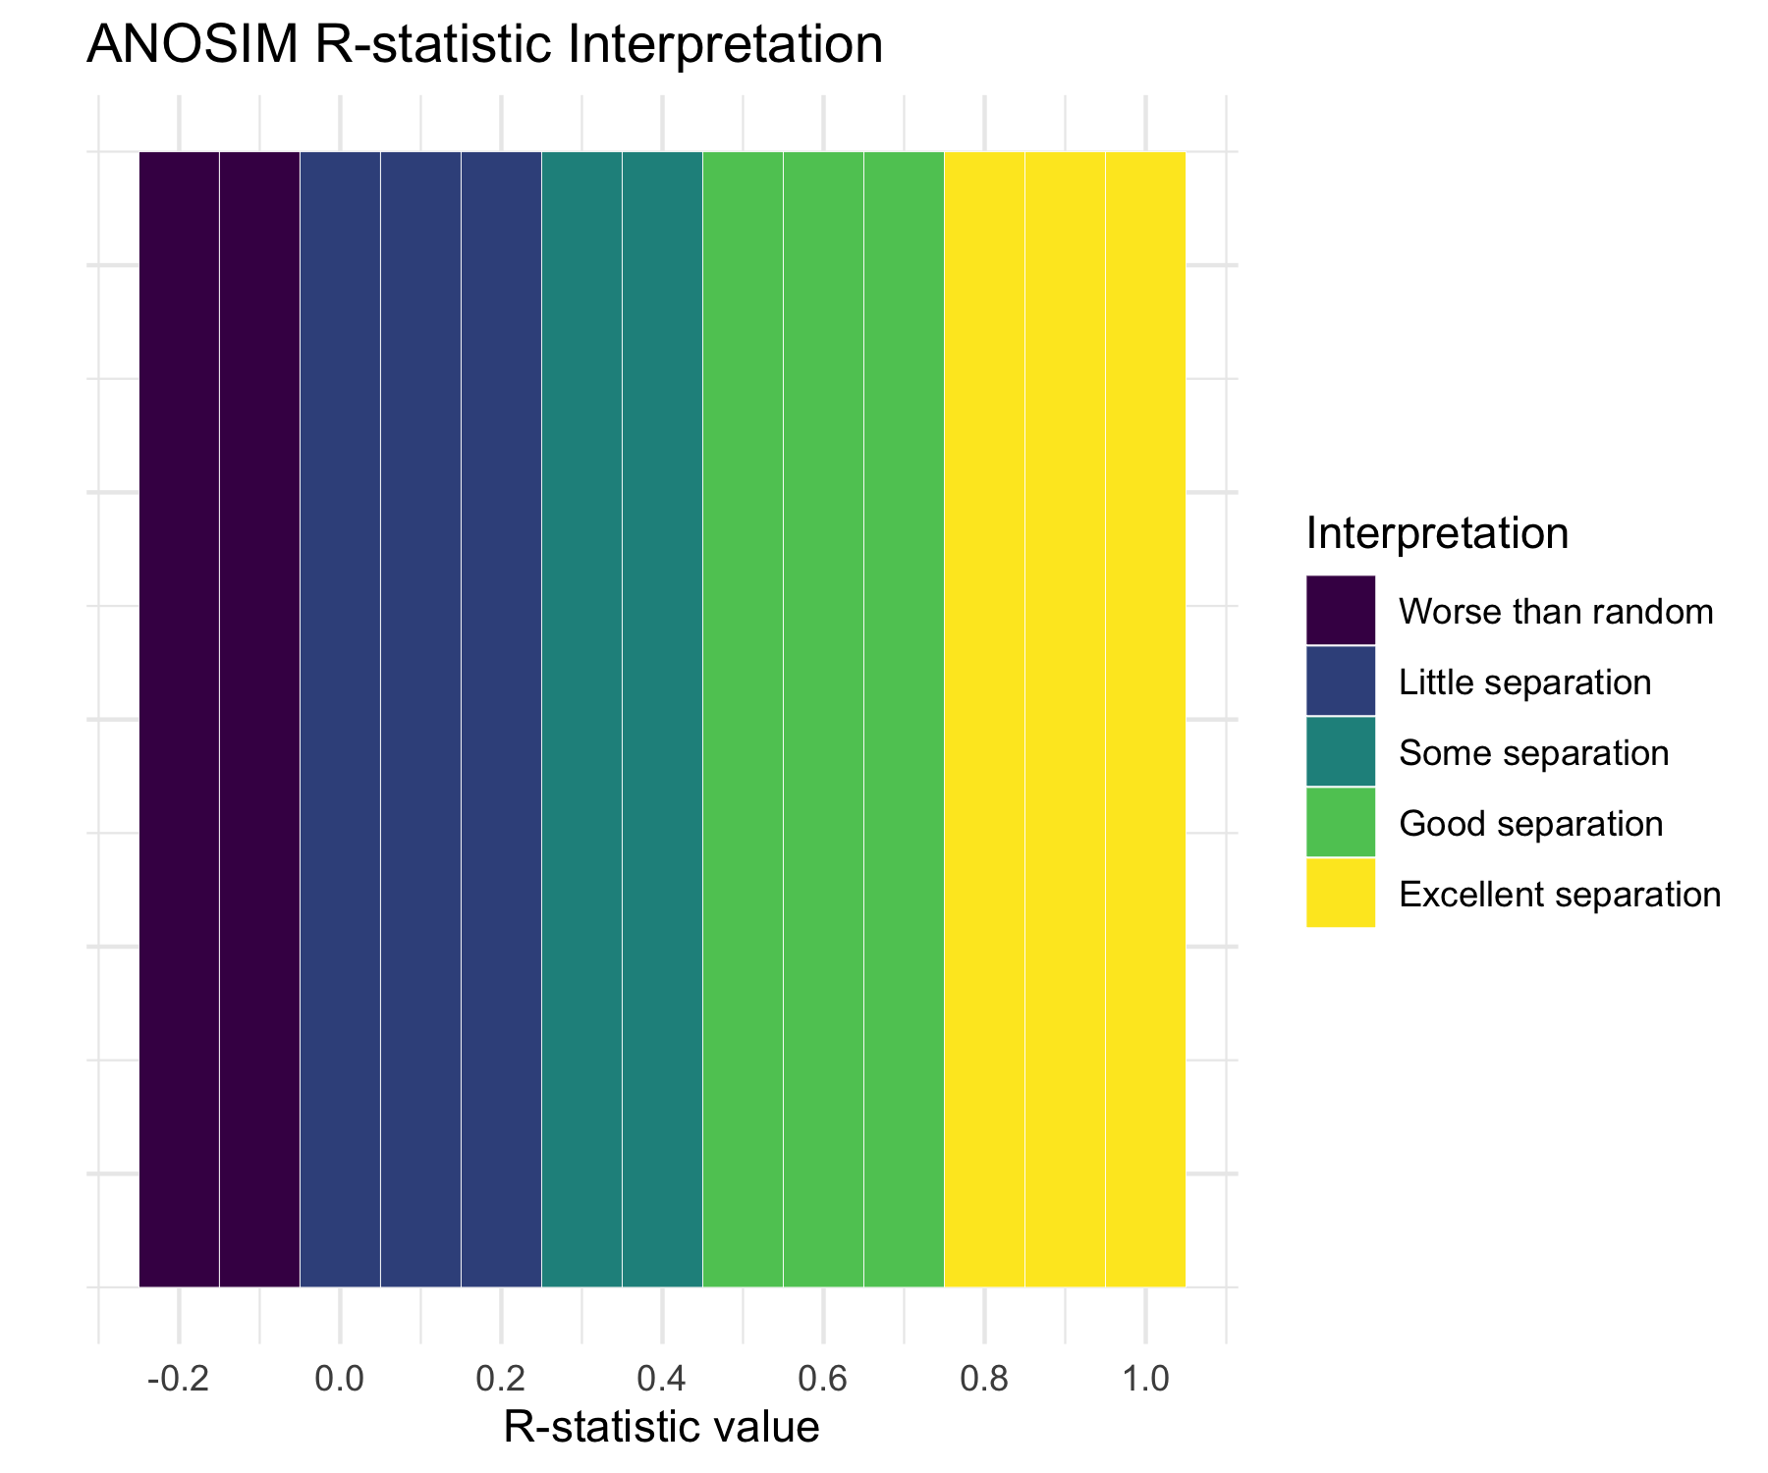

Running ANOSIM
# Run ANOSIM
anosim_result <- anosim(spe_matrix, doubs_env$reach,
distance = "bray", permutations = 999)
# Display results
anosim_result
Call:
anosim(x = spe_matrix, grouping = doubs_env$reach, permutations = 999, distance = "bray")
Dissimilarity: bray
ANOSIM statistic R: 0.119
Significance: 0.067
Permutation: free
Number of permutations: 999
ANOSIM Results Interpretation:
- R = 0.119: This indicates little separation between groups
- p-value = 0.067: Highly significant result
- Biological meaning: Fish communities are well-separated between river reaches, with communities within each reach being much more similar to each other than to communities in other reaches
# Plot ANOSIM results
plot(anosim_result, main = "ANOSIM Results")
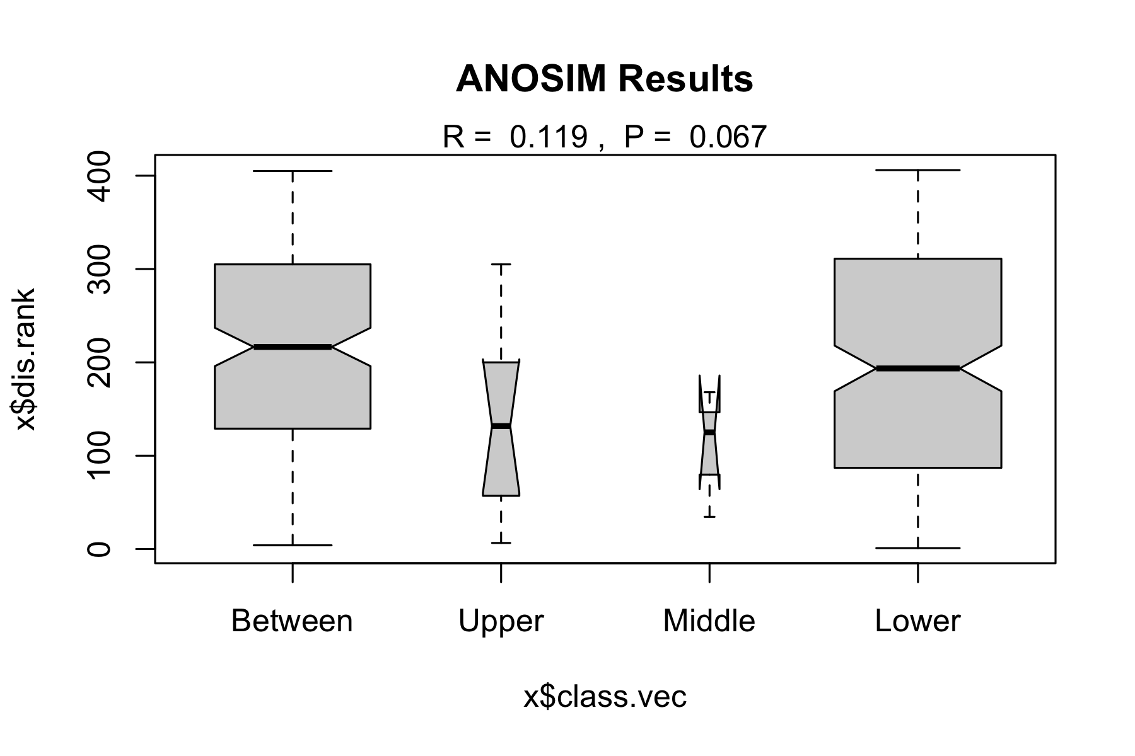

ANOSIM vs PERMANOVA Comparison
# Compare results
comparison_table <- tibble(
Method = c("PERMANOVA", "ANOSIM"),
`Test Statistic` = c(paste("F =", round(perm_result$F[1], 2)),
paste("R =", round(anosim_result$statistic, 3))),
`P-value` = c(round(perm_result$Pr[1], 3),
round(anosim_result$signif, 3)),
`Interpretation` = c("Groups have different centroids",
"Excellent group separation"),
`What it tests` = c("Differences in group means",
"Overlap between groups"),
`Approach` = c("Uses actual distances", "Uses rank distances")
)
comparison_table
# A tibble: 2 × 6
Method `Test Statistic` `P-value` Interpretation `What it tests` Approach
<chr> <chr> <dbl> <chr> <chr> <chr>
1 PERMANOVA F = 2.95 0.012 Groups have dif… Differences in… Uses ac…
2 ANOSIM R = 0.119 0.067 Excellent group… Overlap betwee… Uses ra…
When to use which:
PERMANOVA:
- More powerful for detecting differences
- Better for complex experimental designs
- Can handle interactions and covariates
- Preferred for most applications
ANOSIM:
- More robust to outliers
- Simpler interpretation
- Good for initial exploratory analysis
- Useful when distributions are very non-normal
# Visualize the difference in what each method tests
tibble(
method = rep(c("PERMANOVA", "ANOSIM"), each = 100),
x = c(rnorm(50, 2, 1), rnorm(50, 5, 1), # PERMANOVA groups
rnorm(50, 2, 1), rnorm(50, 5, 1.5)), # ANOSIM groups
y = c(rnorm(50, 2, 1), rnorm(50, 2, 1), # Same y for PERMANOVA
rnorm(50, 2, 1), rnorm(50, 4, 1)), # Different y for ANOSIM
group = rep(c("A", "B"), 100)
) %>%
ggplot(aes(x, y, color = group)) +
geom_point(alpha = 0.6) +
stat_ellipse() +
facet_wrap(~method) +
labs(title = "What Each Method Detects",
subtitle = "PERMANOVA: centroid differences | ANOSIM: group overlap",
x = "Dimension 1", y = "Dimension 2") +
scale_color_viridis_d() +
theme_minimal()
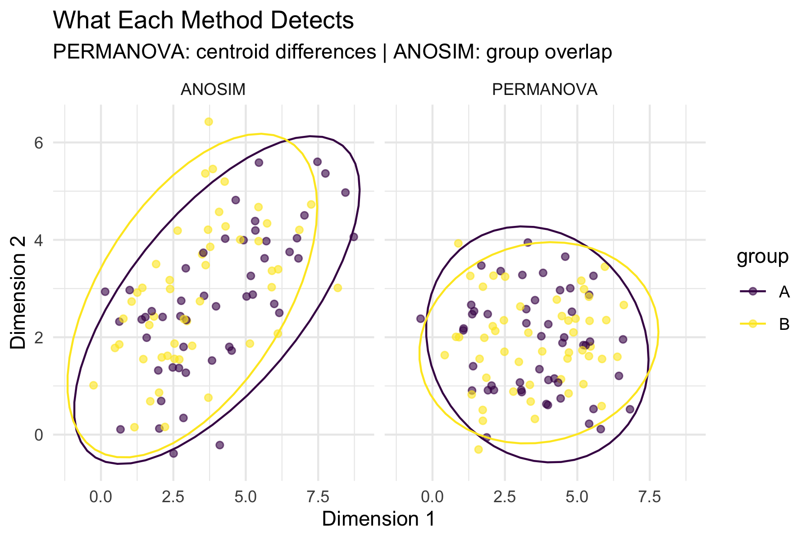

Environmental Drivers

Which Environmental Variables Matter?
# Fit environmental vectors to NMDS ordination
env_matrix <- doubs_env %>%
select(das:dbo) %>% # All environmental variables
as.matrix()
# Fit environmental vectors
env_fit <- envfit(fish_nmds, env_matrix, permutations = 999)
env_fit
***VECTORS
NMDS1 NMDS2 r2 Pr(>r)
das 0.98098 0.19411 0.7284 0.001 ***
alt -1.00000 -0.00057 0.5650 0.001 ***
pen -0.61902 0.78538 0.2546 0.022 *
deb 0.99744 -0.07146 0.5701 0.001 ***
pH -0.09760 -0.99523 0.0746 0.368
dur 0.99967 -0.02575 0.2960 0.011 *
pho 0.22860 0.97352 0.5228 0.001 ***
nit 0.66665 0.74537 0.5200 0.001 ***
amm 0.19902 0.98000 0.5471 0.001 ***
oxy -0.46402 -0.88583 0.7826 0.001 ***
dbo 0.20211 0.97936 0.6883 0.001 ***
---
Signif. codes: 0 '***' 0.001 '**' 0.01 '*' 0.05 '.' 0.1 ' ' 1
Permutation: free
Number of permutations: 999
Environmental Vector Results:
Significant variables (p < 0.05):
# Extract significant variables
sig_vars <- env_fit$vectors$pvals < 0.05
sig_env <- names(env_fit$vectors$pvals)[sig_vars]
cat("Significant environmental drivers:\n")
Significant environmental drivers:
for(var in sig_env) {
p_val <- env_fit$vectors$pvals[var]
r2 <- env_fit$vectors$r[var]^2
cat(paste("-", var, ": R² =", round(r2, 3), ", p =", round(p_val, 3), "\n"))
}
- das : R² = 0.531 , p = 0.001
- alt : R² = 0.319 , p = 0.001
- pen : R² = 0.065 , p = 0.022
- deb : R² = 0.325 , p = 0.001
- dur : R² = 0.088 , p = 0.011
- pho : R² = 0.273 , p = 0.001
- nit : R² = 0.27 , p = 0.001
- amm : R² = 0.299 , p = 0.001
- oxy : R² = 0.612 , p = 0.001
- dbo : R² = 0.474 , p = 0.001
What this means:
- These variables significantly correlate with community composition
- They explain the spatial arrangement of sites in the NMDS
# Plot NMDS with environmental vectors
ordiplot(fish_nmds, type = "n", main = "Fish Communities & Environment")
points(fish_nmds, display = "sites", col = as.numeric(doubs_env$reach),
pch = 16, cex = 1.5)
plot(env_fit, p.max = 0.05, col = "red", cex = 0.8)
legend("topright", legend = levels(doubs_env$reach),
col = 1:3, pch = 16, title = "River Reach")
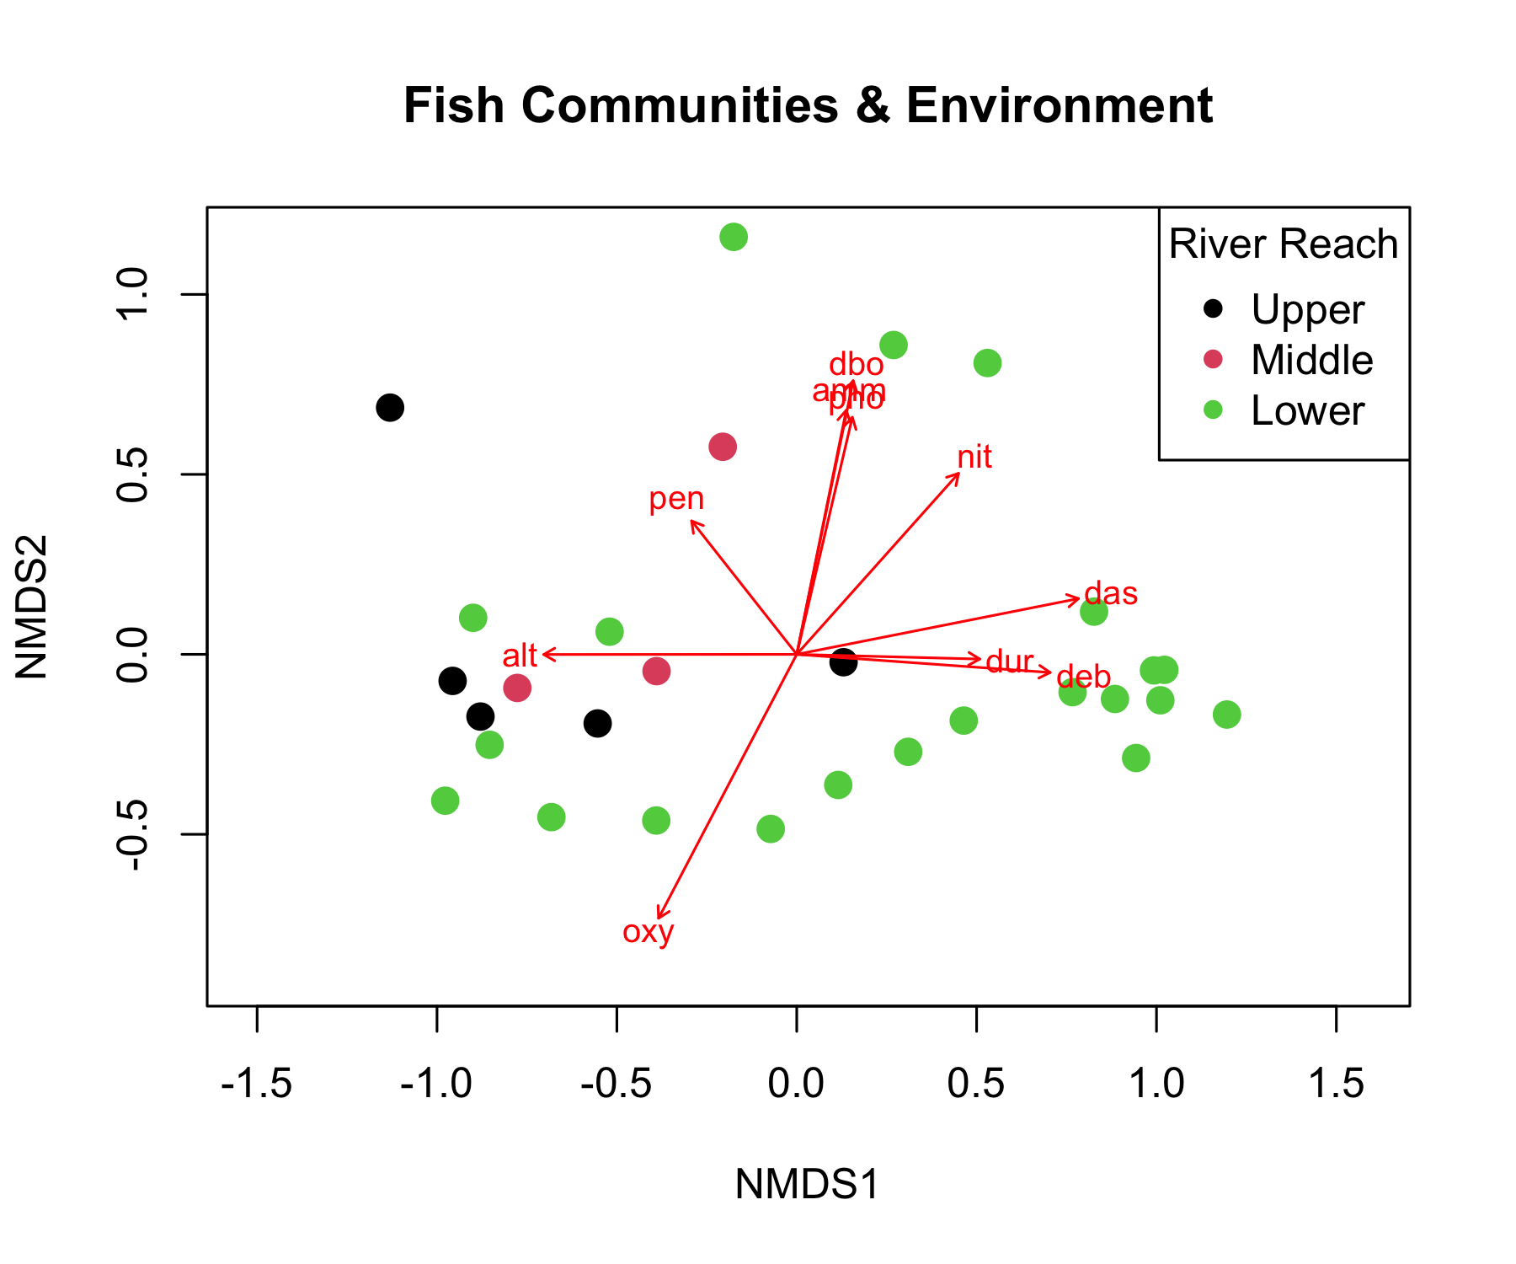

Environmental Gradient Analysis
# Create comprehensive environmental gradient plots
env_long <- doubs_env %>%
select(site, reach, das, pH, oxy, dbo, alt) %>%
pivot_longer(cols = c(pH, oxy, dbo, alt),
names_to = "variable", values_to = "value")
p1 <- env_long %>%
ggplot(aes(das, value, color = reach)) +
geom_point(size = 2) +
geom_smooth(method = "loess", se = FALSE, color = "black") +
facet_wrap(~variable, scales = "free_y") +
labs(title = "Environmental Gradients Along River",
x = "Distance from source (km)",
y = "Environmental value",
color = "River Reach") +
scale_color_viridis_d() +
theme_minimal()
# Show correlation with NMDS axes
nmds_env_cor <- cor(nmds_scores %>% select(MDS1, MDS2),
env_matrix, use = "complete.obs")
p2 <- nmds_env_cor %>%
as.data.frame() %>%
rownames_to_column("NMDS_axis") %>%
pivot_longer(cols = -NMDS_axis, names_to = "env_var", values_to = "correlation") %>%
ggplot(aes(env_var, NMDS_axis, fill = correlation)) +
geom_tile() +
geom_text(aes(label = round(correlation, 2)), color = "white", fontface = "bold") +
scale_fill_gradient2(low = "blue", mid = "white", high = "red",
midpoint = 0, name = "Correlation") +
labs(title = "Environmental Correlations with NMDS Axes",
x = "Environmental Variable", y = "NMDS Axis") +
theme_minimal() +
theme(axis.text.x = element_text(angle = 45, hjust = 1))
p1 / p2
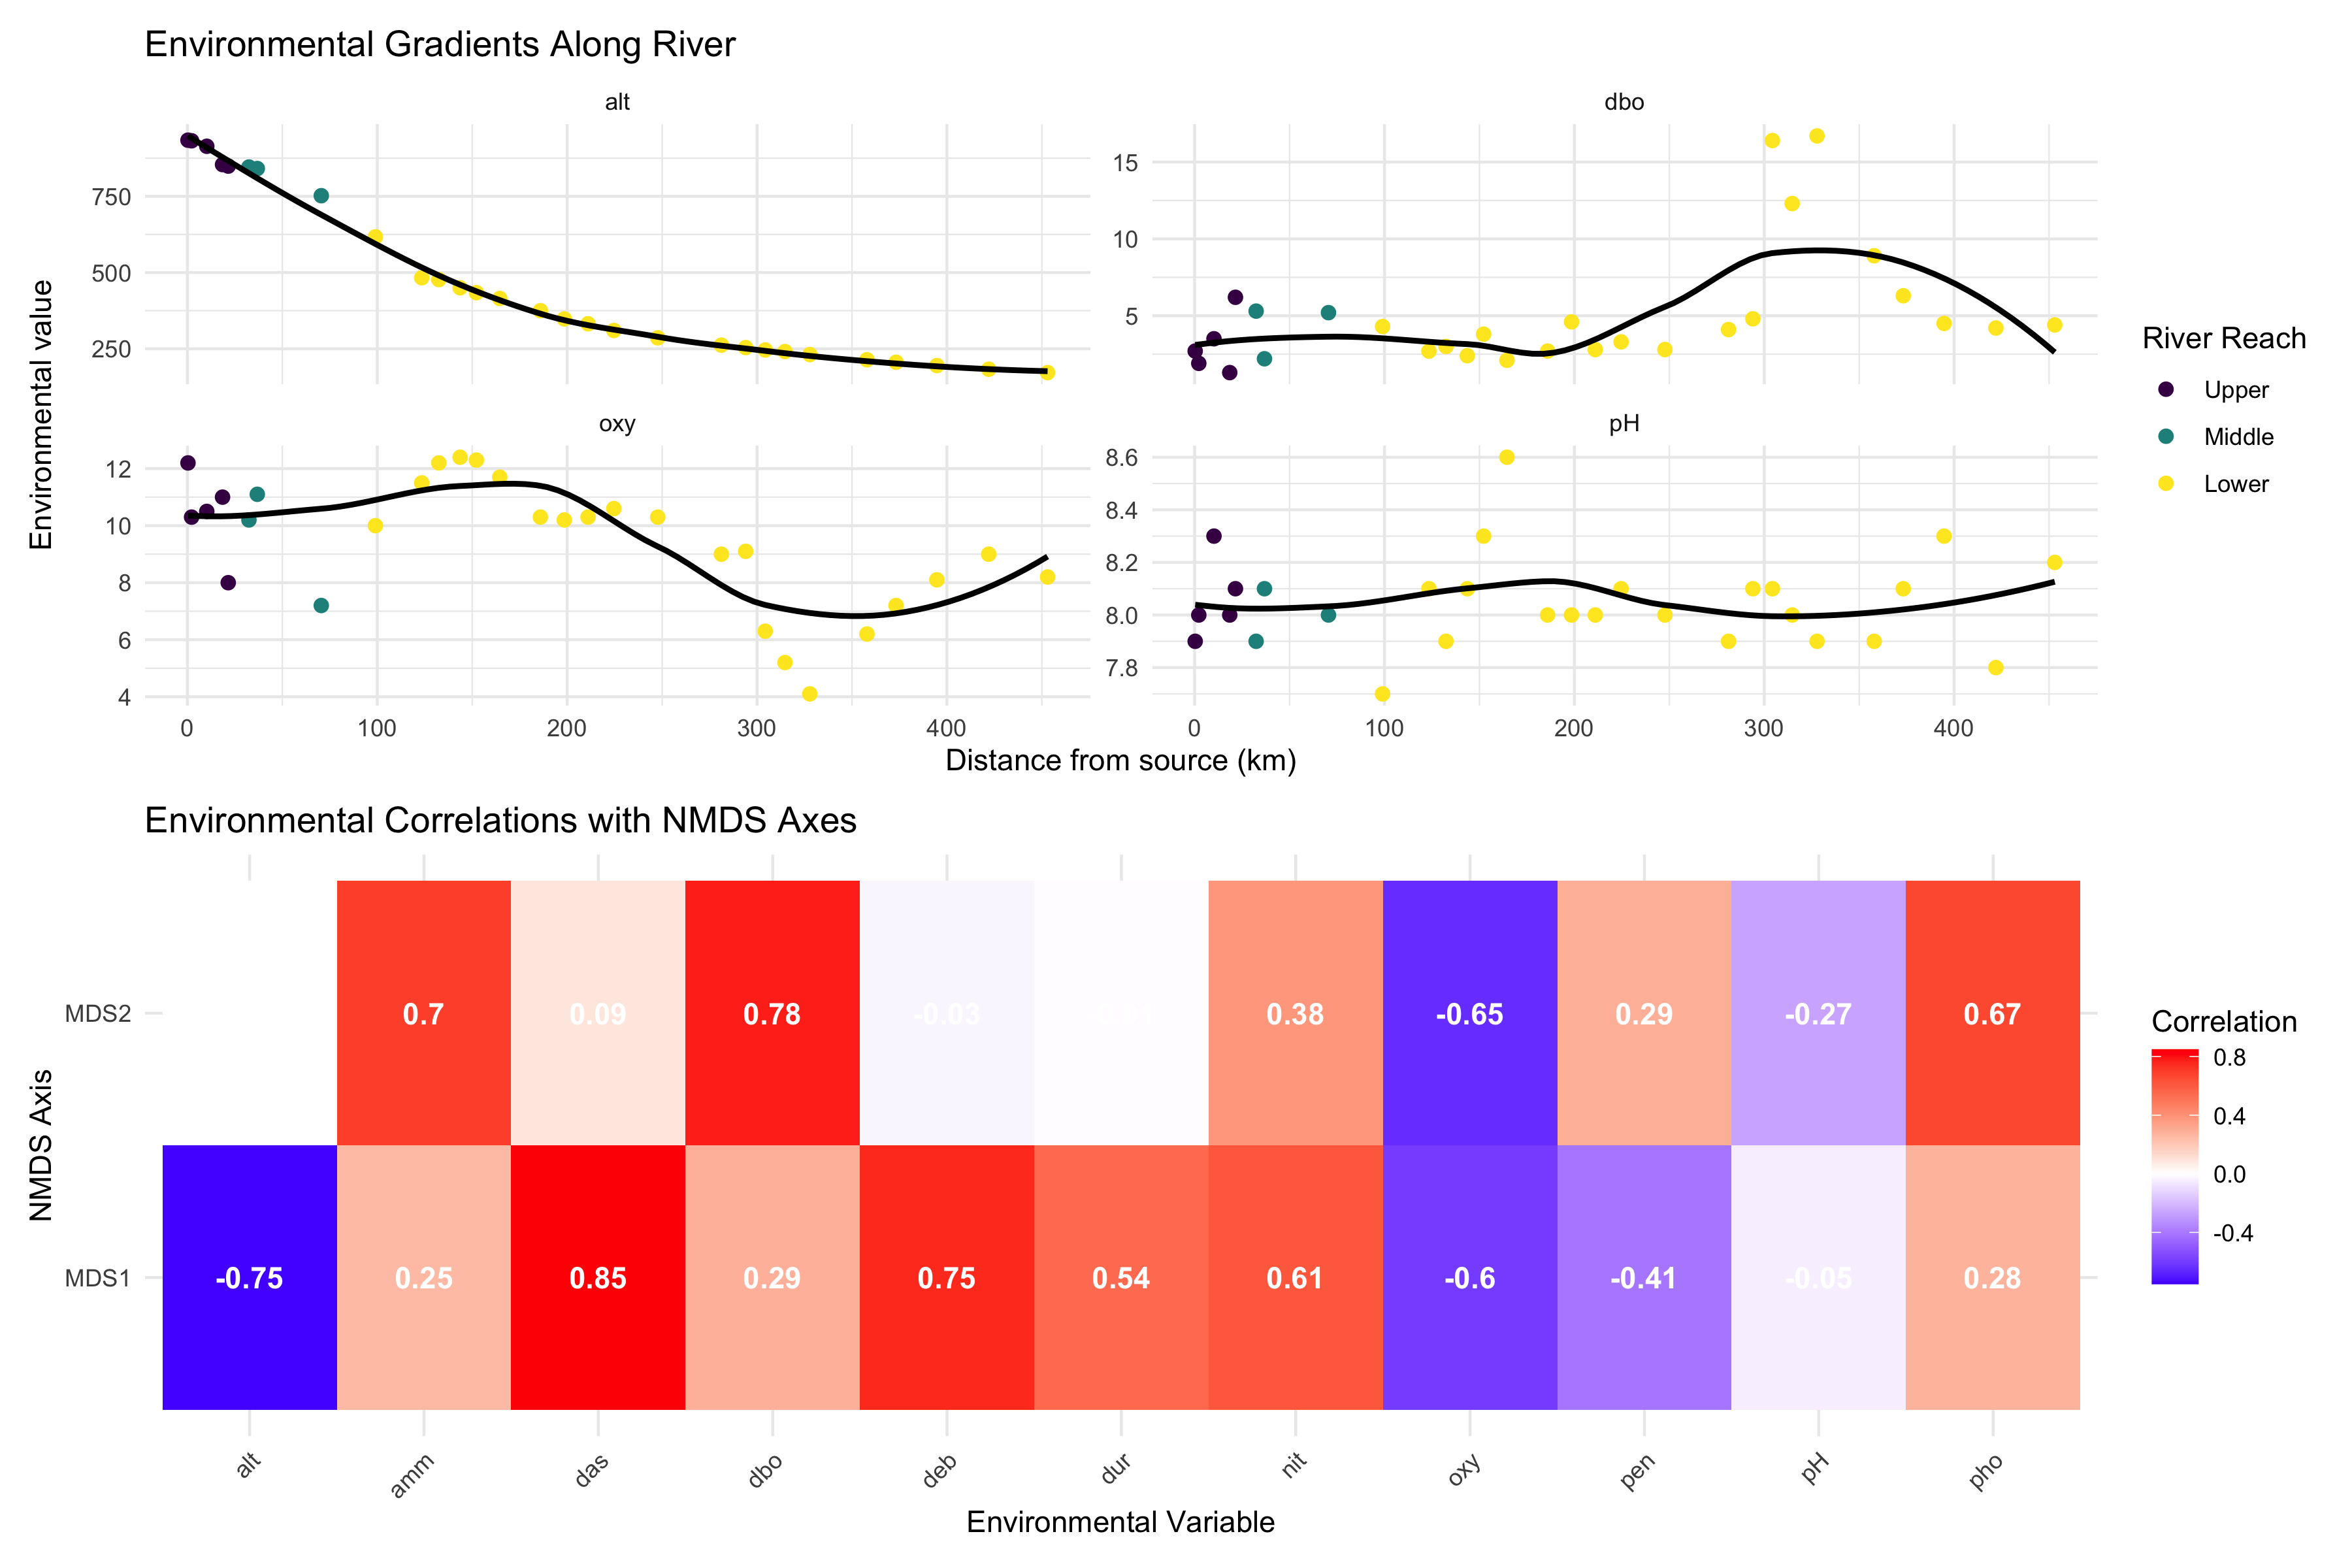
Key Environmental Patterns:
- Distance from source (das): Strong correlate with community change
- Oxygen (oxy): Decreases downstream, affects fish communities
- Biological oxygen demand (dbo): Increases downstream (pollution indicator)
- Altitude (alt): Decreases downstream, associated with temperature changes

Summary and Conclusions

Key Findings from Today’s Analysis
NMDS Results:
- Stress = 0.074: Excellent representation
- Clear gradient from upper to lower river reaches
- Within-reach similarity > between-reach similarity
PERMANOVA Results:
- Highly significant differences between reaches (p < 0.001)
- River reach explains substantial variance in community composition
- All pairwise comparisons significant after correction
ANOSIM Results:
- R = 0.119: Excellent separation
- Confirms PERMANOVA findings with different approach
- Strong within-group coherence
Environmental Drivers:
- Distance from source: Primary gradient
- Dissolved oxygen: Decreases downstream
- Biological oxygen demand: Increases downstream
- Multiple correlated factors drive community change
Biological Interpretation:
- River continuum concept supported
- Progressive community change from source to mouth
- Environmental filtering shapes community assembly
- Pollution gradient evident in lower reaches

Take-Home Messages
NMDS (Non-metric Multidimensional Scaling):
- Visualizes community dissimilarity in 2D/3D
- Preserves rank order of distances (non-metric)
- No distributional assumptions
- Stress < 0.2 for acceptable solutions
- Great for exploring ecological gradients
PERMANOVA (Permutational MANOVA):
- Tests for differences in group centroids
- Uses distance matrices, not raw data
- No distributional assumptions
- Can handle complex designs
- Check dispersion homogeneity assumption
ANOSIM (Analysis of Similarities):
- Tests group separation using rank distances
- R-statistic: -1 (no separation) to +1 (complete)
- More robust to outliers than PERMANOVA
- Simpler but less powerful
- Good for exploratory analysis
Environmental Drivers:
- Use envfit() to correlate environment with ordination
- Identifies which variables explain community patterns
- Helps understand ecological mechanisms
- Essential for management implications

Best Practices Summary
Analysis Workflow:
- Explore your data first
  - Check for outliers and zeros
  - Understand your sampling design
  - Choose appropriate distance measure
- Run NMDS for visualization
  - Try multiple random starts
  - Check stress values
  - Interpret gradients carefully
- Test hypotheses with PERMANOVA
  - Check dispersion homogeneity first
  - Include effect sizes in results
  - Run pairwise tests if needed
Common Pitfalls to Avoid:
❌ Don’t:
- Ignore stress values > 0.2
- Forget to check PERMANOVA assumptions
- Report only p-values without effect sizes
- Over-interpret NMDS axes as meaningful
- Use these methods on inappropriate data
✅ Do:
- Use multiple random starts for NMDS
- Check assumption violations
- Include biological interpretation
- Consider data transformations
- Validate results with different methods

