06_Class_Activity
Bill Perry

In class activity 6:

What did we do last time in activity 5?
- Understanding standard normal distributions and z-scores
- Calculating and interpreting standard error
- Creating confidence intervals
- Working with the Student’s t-distribution

Today’s focus:
- Review more r code
- understand α alpha and β beta errors
- do more
  - 1 sample t tests
  - 2 sample t tests

Goes with Lecture 6
# Install packages if needed (uncomment if necessary)
# install.packages("readr")
# install.packages("tidyverse")
# install.packages("car")
# install.packages("here")
# Load libraries
library(patchwork)
library(car) # For diagnostic tests
Loading required package: carData
library(tidyverse) # For data manipulation and visualization
── Attaching core tidyverse packages ──────────────────────── tidyverse 2.0.0 ──
✔ dplyr 1.1.4 ✔ readr 2.1.5
✔ forcats 1.0.0 ✔ stringr 1.5.1
✔ ggplot2 3.5.2 ✔ tibble 3.3.0
✔ lubridate 1.9.4 ✔ tidyr 1.3.1
✔ purrr 1.1.0
── Conflicts ────────────────────────────────────────── tidyverse_conflicts() ──
✖ dplyr::filter() masks stats::filter()
✖ dplyr::lag() masks stats::lag()
✖ dplyr::recode() masks car::recode()
✖ purrr::some() masks car::some()
ℹ Use the conflicted package (<http://conflicted.r-lib.org/>) to force all conflicts to become errors
# Load the pine needle data
# Use here() function to specify the path
pine_data <- read_csv("data/pine_needles.csv")
Rows: 48 Columns: 6
── Column specification ────────────────────────────────────────────────────────
Delimiter: ","
chr (4): date, group, n_s, wind
dbl (2): tree_no, length_mm
ℹ Use `spec()` to retrieve the full column specification for this data.
ℹ Specify the column types or set `show_col_types = FALSE` to quiet this message.
# Examine the first few rows
head(pine_data)
# A tibble: 6 × 6
date group n_s wind tree_no length_mm
<chr> <chr> <chr> <chr> <dbl> <dbl>
1 3/20/25 cephalopods n lee 1 20
2 3/20/25 cephalopods n lee 1 21
3 3/20/25 cephalopods n lee 1 23
4 3/20/25 cephalopods n lee 1 25
5 3/20/25 cephalopods n lee 1 21
6 3/20/25 cephalopods n lee 1 16

Part 1: Exploratory Data Analysis
Before conducting hypothesis tests, we should always explore our data to understand its characteristics.
Let’s calculate summary statistics and create visualizations.
Activity: Calculate basic summary statistics for pine needle length
# YOUR TASK: Calculate summary statistics for pine needle length
# Hint: Use summarize() function to calculate mean, sd, n, etc.
# Create a summary table for all pine needles
pine_summary <- pine_data %>%
group_by(wind) %>%
summarize(
mean_length = mean(length_mm, na.rm=TRUE),
sd_length = sd(length_mm, na.rm=TRUE),
n = sum(!is.na(length_mm)),
se_length = sd_length / (n^0.5),
t_critical = qt(0.975, df = n - 1), # 95% CI uses 0.975 (two-tailed)
ci_lower = mean_length - t_critical * se_length,
ci_upper = mean_length + t_critical * se_length
)
print(pine_summary)
# A tibble: 2 × 8
wind mean_length sd_length n se_length t_critical ci_lower ci_upper
<chr> <dbl> <dbl> <int> <dbl> <dbl> <dbl> <dbl>
1 lee 20.4 2.45 24 0.500 2.07 19.4 21.5
2 wind 14.9 1.91 24 0.390 2.07 14.1 15.7
# Now calculate summary statistics by wind exposure
# YOUR CODE HERE

Part 1: Visualizing the Data
Activity: Create visualizations of pine needle length
Create a histogram and a boxplot to visualize the distribution of pine needle length values.
Effective data visualization helps us understand:
- The central tendency
- The spread of the data
- Potential outliers
- Shape of distribution

Your Task
# YOUR TASK: Create a histogram of pine needle length
# Hint: Use ggplot() and geom_histogram()
# Histogram of all pine needle lengths
ggplot(pine_data, aes(x = length_mm)) +
geom_histogram(binwidth = 2, fill = "steelblue", color = "black") +
labs(title = "Distribution of Pine Needle Length",
x = "Length (mm)",
y = "Frequency") +
theme_minimal()
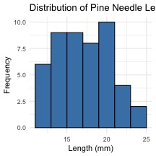
# how can you do this by wind to see both plots
# Boxplot of pine needle length by wind exposure
# YOUR CODE HERE

Can you plot the density distributions for the two samples
# Histogram of all pine needle lengths
pine_data %>%
ggplot(aes(x = length_mm, fill=wind)) +
geom_density(color = "black", alpha=0.3, trim = TRUE) +
labs(title = "Pine Needle Lengths by Wind Exposure",
x = "Position",
y = "Length (mm)",
fill = "Wind Position") +
scale_fill_manual(values = c("lee" = "forestgreen", "wind" = "skyblue"),
labels = c("lee" = "Leeward", "wind" = "Windward"))
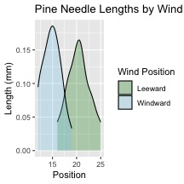

what is the Effect size or difference in means?
 Practice Exercise: Calculate Effect size
We could also look at the difference in means… some cool code here
# Assuming your dataframe is called df
pine_summary %>%
summarize(difference = mean_length[wind == "lee"] -mean_length[wind == "wind"])
# A tibble: 1 × 1
difference
<dbl>
1 5.5

Part 1: Two Sample T-Test
Now, let’s compare pine needle lengths between windward and leeward sides of trees.
Question: Is there a significant difference in needle length between the windward and leeward sides?
This requires a two-sample t-test.
Two-sample t-test compares means from two independent groups.

$t=\frac{{\overset{‾}{x}}_{1}−{\overset{‾}{x}}_{2}}{S_{p}\sqrt{\frac{1}{n_{1}}+\frac{1}{n_{2}}}}$
where:
- x̄₁ and x̄₂: These represent the sample means of the two groups you’re comparing
- s²ₚ: This is the pooled variance, calculated as: s²ₚ = [(n₁ - 1)s₁² + (n₂ - 1)s₂²] / (n₁ + n₂ - 2), where s₁² and s₂² are the sample variances of the two groups.
- n₁ and n₂: These are the sample sizes of the two groups.
- √(1/n₁ + 1/n₂): This represents the pooled standard error.

Part 1: Testing Assumptions for Two-Sample T-Test
Activity: Test assumptions for two-sample t-test
For a two-sample t-test, we need to check:
- Normality within each group
- Equal variances between groups (for standard t-test)
- Independent observations
If assumptions are violated:
- Welch’s t-test (unequal variances)
- Non-parametric alternatives (Mann-Whitney U test)

Your task
# YOUR TASK: Test normality of windward pine needle lengths
# QQ Plot
qqPlot(pine_data$length_mm,
main = "QQ Plot for Windward Pine Needles",
ylab = "Sample Quantiles")
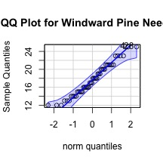
[1] 4 28
# Testing normality for each group
# Leeward group
lee_data <- pine_data %>% filter(wind == "lee")
shapiro_lee <- shapiro.test(lee_data$length_mm)
print("Shapiro-Wilk test for leeward data:")
[1] "Shapiro-Wilk test for leeward data:"
print(shapiro_lee)
Shapiro-Wilk normality test
data: lee_data$length_mm
W = 0.95477, p-value = 0.3425

windward group
# Windward group
# YOUR CODE HERE for windward group normality test

Remember you can always do it in one go
# there are always two ways
# Test for normality using Shapiro-Wilk test for each wind group
# All in one pipeline using tidyverse approach
normality_results <- pine_data %>%
group_by(wind) %>%
summarize(
shapiro_stat = shapiro.test(length_mm)$statistic,
shapiro_p_value = shapiro.test(length_mm)$p.value,
normal_distribution = if_else(shapiro_p_value > 0.05, "Normal", "Non-normal")
)
# Print the results
print(normality_results)
# A tibble: 2 × 4
wind shapiro_stat shapiro_p_value normal_distribution
<chr> <dbl> <dbl> <chr>
1 lee 0.955 0.343 Normal
2 wind 0.961 0.451 Normal

Conduct a Levene’s Test
# Test for equal variances
# YOUR TASK: Conduct Levene's test for equality of variances
levene_test <- leveneTest(length_mm ~ wind, data = pine_data)
Warning in leveneTest.default(y = y, group = group, ...): group coerced to
factor.
print(levene_test)
Levene's Test for Homogeneity of Variance (center = median)
Df F value Pr(>F)
group 1 1.2004 0.2789
46
# Visual check for normality with QQ plots
# YOUR CODE HERE

Part 2: Conducting the Two-Sample T-Test
Activity: Conduct a two-sample t-test
Now we can compare the mean pine needle lengths between windward and leeward sides.
H₀: μ₁ = μ₂ (The mean needle lengths are equal)
H₁: μ₁ ≠ μ₂ (The mean needle lengths are different)
Deciding between:
- Standard t-test (equal variances)
- Welch’s t-test (unequal variances)

Based on our Levene’s test result.
# YOUR TASK: Conduct a two-sample t-test
# Use var.equal=TRUE for standard t-test or var.equal=FALSE for Welch's t-test
# Standard t-test (if variances are equal)
t_test_result <- t.test(length_mm ~ wind, data = pine_data, var.equal = TRUE)
print("Standard two-sample t-test:")
[1] "Standard two-sample t-test:"
print(t_test_result)
Two Sample t-test
data: length_mm by wind
t = 8.6792, df = 46, p-value = 3.01e-11
alternative hypothesis: true difference in means between group lee and group wind is not equal to 0
95 percent confidence interval:
4.224437 6.775563
sample estimates:
mean in group lee mean in group wind
20.41667 14.91667
# Calculate t-statistic manually (optional - uggg - maybe )
# YOUR CODE HERE: t = (mean1 - mean2) / sqrt((s1^2/n1) + (s2^2/n2))

Part 2: Interpreting and Reporting Two-Sample T-Test Results
Activity: Interpret the results of the two-sample t-test
What can we conclude about the needle lengths on windward vs. leeward sides?
How to report this result in a scientific paper:
“A two-tailed, two-sample t-test at α=0.05 showed [a significant/no significant] difference in needle length between windward (M = …, SD = …) and leeward (M = …, SD = …) sides of pine trees, t(…) = …, p = ….”
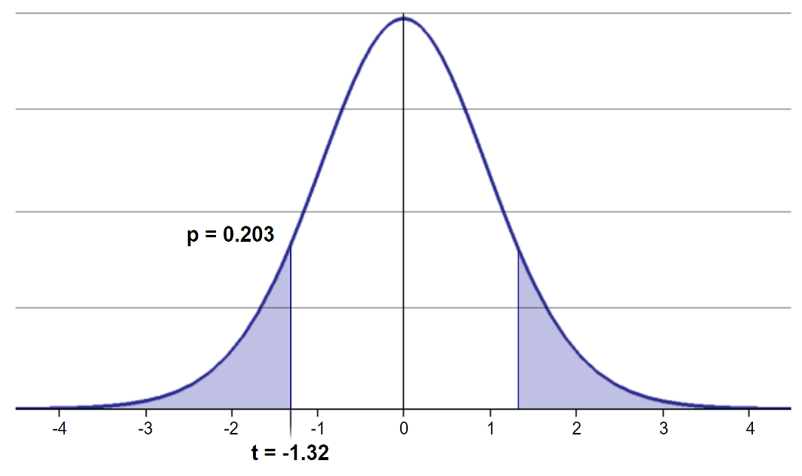

What is Power
Statistical power represents the probability of detecting a true effect (rejecting the null hypothesis when it is false). In this case, with a power of 97%, there’s a 97% chance of detecting a true difference of 30 units between the means of the two groups if such a difference actually exists.
A power analysis like this is typically done for one of these purposes:
- Before data collection to determine required sample size
- After a study to evaluate if the sample size was adequate
- To determine the minimum detectable effect size with the given sample
With 97% power, this test has excellent ability to detect the specified effect size. Generally, 80% power is considered acceptable, so 97% indicates a very well-powered study for detecting a difference of 30mm between the groups.
lee_df <- pine_data %>% filter(wind == "lee")
wind_df <- pine_data %>% filter(wind == "wind")
# Calculate power for detecting a 1 mm difference
wind_diff = 1
lee_n <- nrow(lee_df)
wind_n <- nrow(wind_df)
wind_sd_pooled <- sqrt((var(lee_df$length_mm) * (lee_n-1) +
var(wind_df$length_mm) * (wind_n-1)) /
(lee_n + wind_n - 2))
# Calculate power
wind_effect_size <- wind_diff / wind_sd_pooled # Cohen's d
wind_df <- lee_n + wind_n - 2
wind_alpha <- 0.05
wind_power <- power.t.test(n = min(lee_n,wind_n),
delta = wind_effect_size,
sd = 1, # Using standardized effect size
sig.level = 0.5,
type = "two.sample",
alternative = "two.sided")
# Display results
wind_power
Two-sample t test power calculation
n = 24
delta = 0.4555423
sd = 1
sig.level = 0.5
power = 0.8158402
alternative = two.sided
NOTE: n is number in *each* group

Now to make a final plot
Typically we will make a plot that has the mean and standard error on it to represent the data

your Task is to make this plot
pine_mean_se <- pine_data %>%
ggplot(aes(wind, length_mm, color = wind))+
stat_summary(fun = "mean", na.rm=TRUE, geom="point", size = 3)+
stat_summary(fun.data = "mean_se", width = 0.2, geom = "errorbar")
pine_mean_se
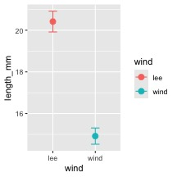

Summary and Conclusions
In this activity, we’ve:
- Formulated hypotheses about pine needle length
- Tested assumptions for parametric tests
- Conducted a two-sample t-tests
- Visualized data using appropriate methods
- Learned how to interpret and report t-test results
Key takeaways:
- Always check assumptions before conducting tests
- Visualize your data to understand patterns
- Report results comprehensively
- Consider alternatives when assumptions are violated

Reflection Questions
After completing the activities, discuss these questions with your group:
- How does sample size affect our confidence in estimating the population mean?
- Why is the t-distribution more appropriate than the normal distribution when working with small samples?
- When comparing two populations, what can we learn from looking at confidence intervals versus performing a t-test?
- How would you explain the concept of statistical significance to someone who has never taken a statistics course?
- What do we do if assumptions FAIL!!!

