Lecture 16 - Multivariate Statistics
Bill Perry

Introduction to Multivariate Statistics

Overview
- Multivariate data: multiple variables per object
- Types of multivariate analyses
  - Functional vs. structural methods
  - R-mode vs. Q-mode analyses
- Eigenvectors, eigenvalues, and components
- Distance and dissimilarity measures
- Data transformations and standardization
- Screening multivariate data
- MANOVA
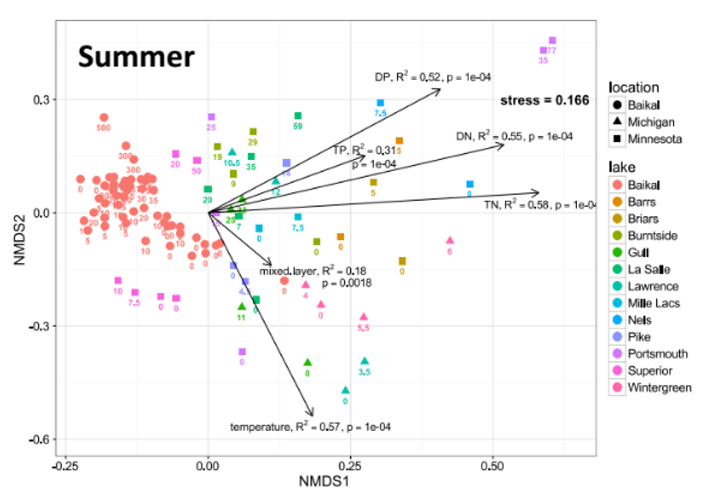

Multivariate Data Structure
- Multiple variables recorded about each object (individual, quadrat, site, etc.)
  - or responses that are from the same treatment factor
  - length, weight, width, color, spines, etc
- Objects: rows (i = 1 to n)
- Variables: columns (j = 1 to p)
- Examples:
  - Stream sites with multiple chemical parameters
  - Species with multiple morphological traits
  - Sample units with multiple species abundances
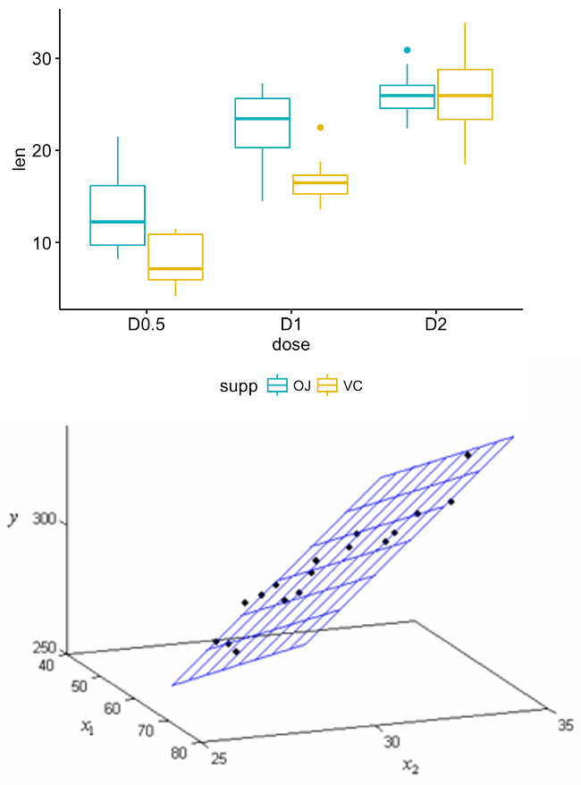
 Multivariate data vs. multivariate analysis
We’ve already seen multivariate data in multiple regression and multi-factor ANOVA
Now we’ll look at cases with multiple response variables.

Functional vs. Structural Methods

Functional vs. Structural Methods
Functional methods: - Clear response and predictor variables - Goal: relate Y’s to X’s - Examples: MANOVA, PERMANOVA
Structural methods: - Find patterns/structure in data - Often no clear predictors - Examples: PCA, NMDS, Cluster Analysis
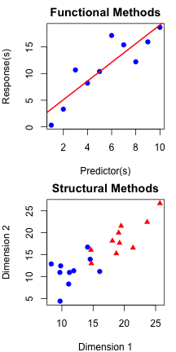

Functional Methods Examples
Example 1:
- sample 30 stream sites (objects)
- record TP, TN, pH, DO, chloride concentration, etc.
- each parameter is a variable
Example 2:
- sample 30 stream sites (objects)
- collect benthic invertebrates
- each species is now a variable
Sometimes combine both…
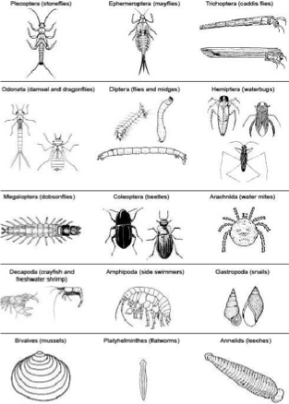

Functional Methods Visualization
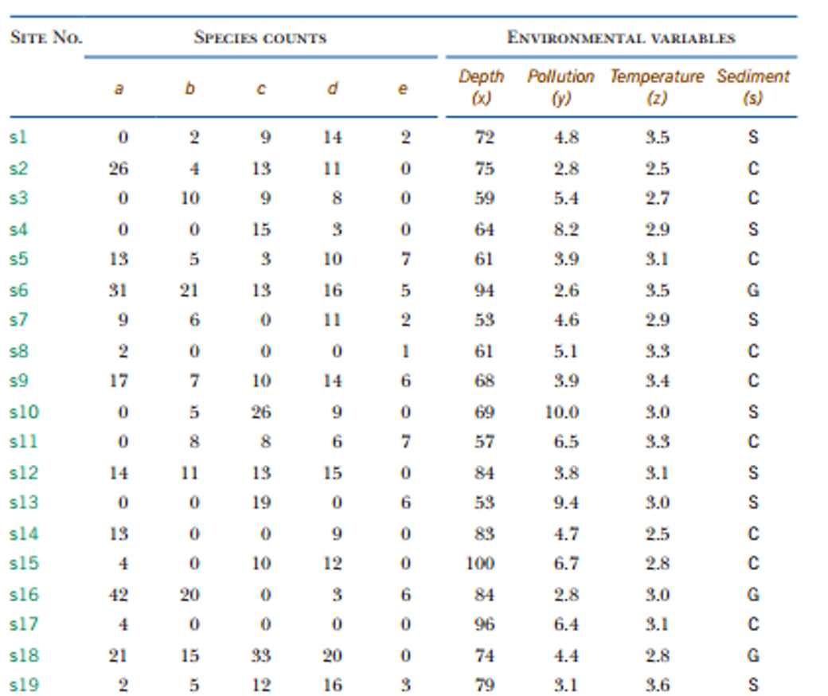


Ecological Multivariate Methods Overview
Can divide ecological MV methods into “functional” and “structural”
- Functional methods: clear response variable(s) and predictor variables. Goal is to relate Ys to Xs (regression, MANOVA, ANOSIM, PERMANOVA).
- Structural methods: concerned with finding structure /pattern in the data. Often no clear predictor variables (PCA, NMDS, Cluster analysis).
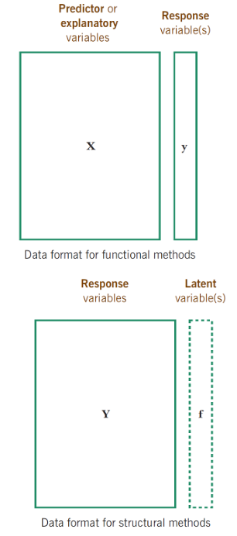

Structural Methods: Two Approaches

Two Main Approaches
Scaling/Ordination Methods: - Reduce dimensions with new derived variables - Summarize patterns in data - Examples: PCA, CCA
Dissimilarity-Based Methods: - Measure dissimilarity between objects - Visualize relationships between objects - Examples: NMDS, Cluster Analysis
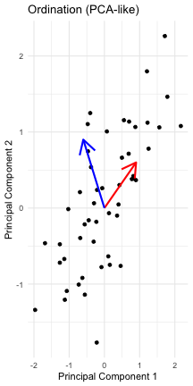

Structural Methods: Scaling/Ordination
Structural methods can be divided further into:
Methods based on scaling or ordination
Goal: reduce number of vars by deriving new variables that summarize data.
Examples include PCA, CCA
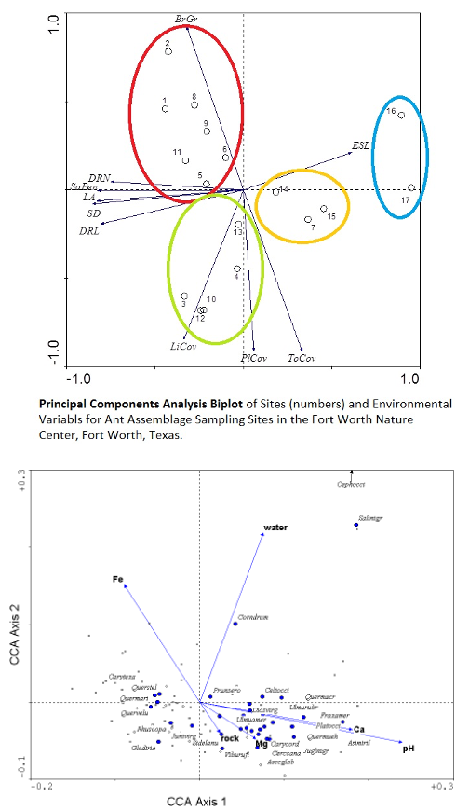

Structural Methods: Dissimilarity-Based
Structural methods can be divided further into:
- Methods based on dissimilarity measurements
- Goal: measure and graphically show degree of dissimilarity between objects.
- Examples include (N)MDS and cluster analysis
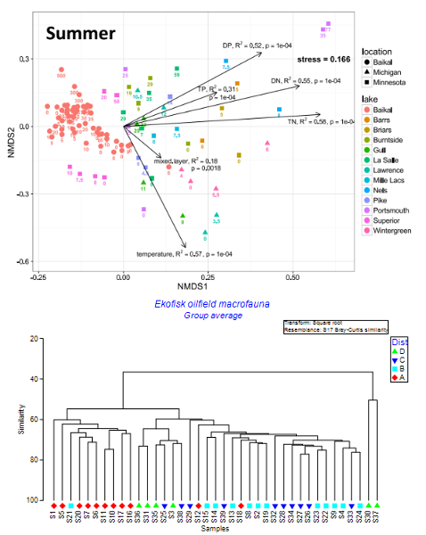

Eigenvectors, Eigenvalues, and Components: Concept
- Goal: derive new variables (principal components) that explain variation in data
- Components are linear combinations of original variables:
  - zik = c1yi1 + c2yi2 + … + cpyip
- Properties of derived variables:
  - First component explains most variation
  - Second explains most remaining variation
  - Components are uncorrelated with each other
  - As many components as original variables
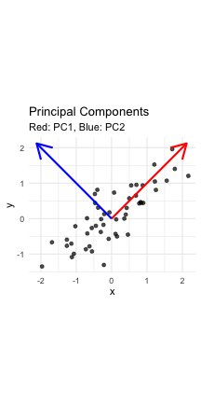

Eigenvectors and Components: Interpretation
How to think about the new values
- zik is value of new variable k for object I
- yi1- yip are values of original variables for object i
- c1-cp are coefficients that show importance of the original variables to new derived variable

 Key concept
Eigenvalues (λ) represent the amount of variation explained by each new derived variable, while eigenvectors contain the coefficients showing how original variables contribute to each component.

Eigenvalues and Components: Properties
Derived variables are found so that:
- First derived variable explains most of the variation in the data
- Second most of the remaining variation
- And so on…
- As many derived variables as original variables (p)
- Derived variables are uncorrelated with each other
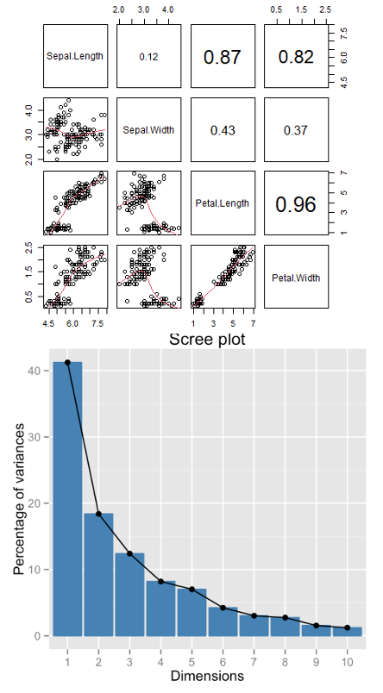

Eigenvalues and Eigenvectors: Mathematical Details
- Eigenvalues (latent roots) represent amount of variation in data explained by the new k= 1 to p derived variables (λ1, λ2 …λp).
- Eigenvalues are population parameters and are estimated using ML to get sample statistics (l1, l2…lp)
- Eigenvectors are lists of coefficients (c) that show contribution of original variables to new, derived variables
- Each new variable has an eigenvalue and an eigenvector
- New variables (components) are derived from a p x p covariance or correlation matrix of original variables

Eigenvalue Matrix Representation
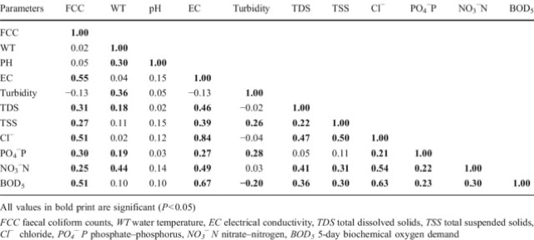

Distance and Dissimilarity Measures: Concept
- Measure how different objects are in multivariate space
- Common measures:
  - Euclidean distance: direct geometric distance
  - Manhattan distance: sum of absolute differences
  - Bray-Curtis: good for species abundance data
  - Kulczynski: for abundance data with zeros
- Used in cluster analysis, MDS, and other techniques
- Create dissimilarity matrices for analysis
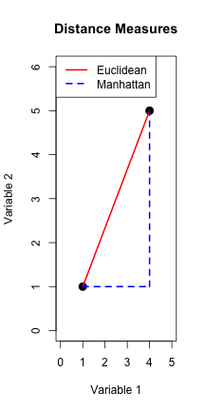

Distance and Dissimilarity: Background
- Previous approach relies on analysis of covariance/ correlation bw variables
- Another class of MV analysis uses measures of similarity/dissimilarity bw objects (MDS, cluster analysis)
- Similarity/dissimilarity indices measure how alike/different objects (e.g. Lakes) are in MV space
- Many measures of dissimilarity (Euclidean, Manhattan, Bray-Curtis, etc, etc)
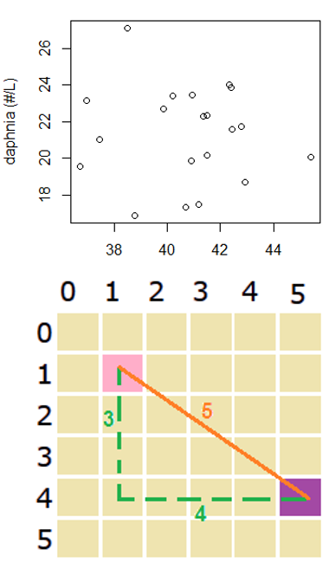

Dissimilarity Matrix Representation
Dissimilarity is often represented as a dissimilarity matrix
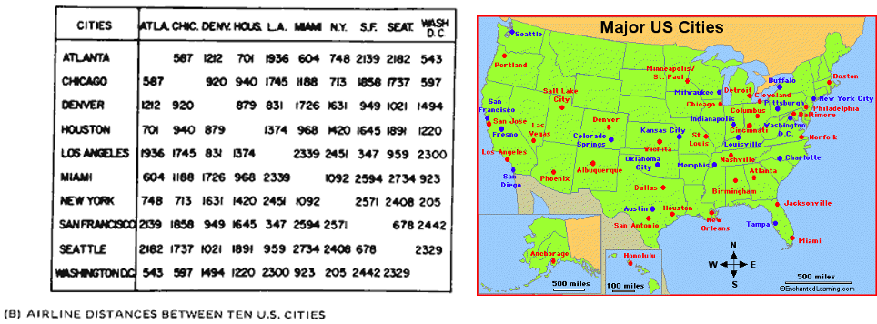

Data Transformations: Common Approaches
Data transformation is common and useful in MV analyses
- Log transformation is common in PCA/CCA analyses based on eigenvectors, since linearizing relationships bw variables will improve extraction of eigenvectors
- Fourth root transform is very common and sometimes “blanket recommended” for analysis of species composition data (each variable is a species w counts- MDS, cluster analysis). Idea is to lessen importance of common and abundant species

Data Standardization: Methods
- Data standardization is also common; adjusts data so all variables have same means and/or variance
  - Centering- mean subtracted from each value (new mean=0)
  - Standardization- centered observations divided by SD (mean=0, sd=1)
- Crucial for analyses of variables measured in different units
- More ambiguous for species abundance data
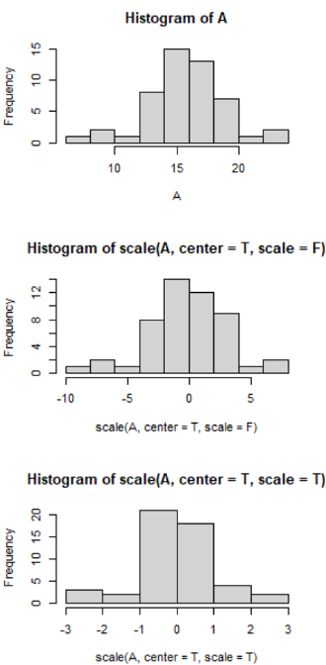

Data Transformations & Standardization: Visual

Common Approaches
Transformations: - Log transformation for skewed data - Root transformations for count data
- Fourth-root for species abundance data
Standardization: - Centering: subtract mean (mean = 0) - Standardization: divide by SD (SD = 1) - Crucial for variables with different units - May not be appropriate for species data
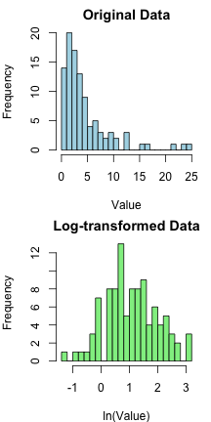
 Why standardize?
Standardization ensures all variables contribute equally to the analysis regardless of their original units or scales of measurement. Without it, variables with larger values or variances would dominate the results.

Multivariate Graphics Options

Visual Representation Methods
- SPLOMS/Scatterplot Matrices: show bivariate relationships
- Star plots: display multiple variables per object
- Chernoff faces: represent variables as facial features
- Heatmaps: visualize data matrices with color
- Biplots: show objects and variables together
- Ordination plots: visualize relationships in reduced dimensions
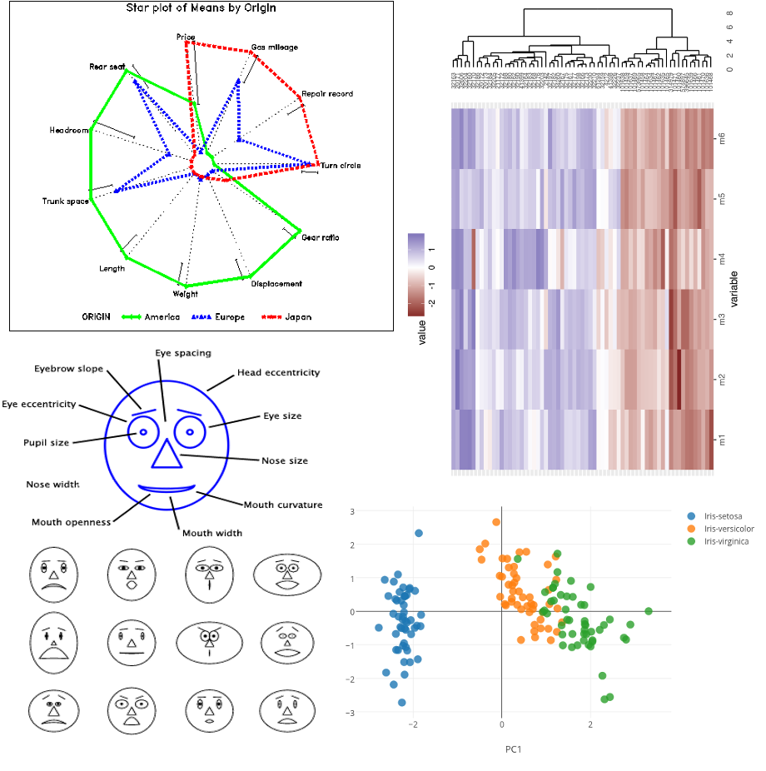

Screening Multivariate Data: Outliers and Missing Data

Key Issues to Check
Multivariate Outliers: - Objects with unusual patterns across variables - Detected with Mahalanobis distance (d²) - Test against χ² distribution with p df
Missing Observations: - Common approaches: - Deletion: remove affected object or variable - Imputation: estimate missing values - Maximum likelihood methods - Multiple imputation
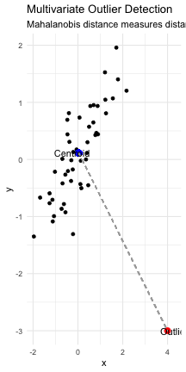

MANOVA: Introduction
- Multivariate extension of ANOVA
- Tests for differences in group centroids based on multiple response variables
- Advantages over multiple ANOVAs:
  - Controls family-wise error rate
  - Accounts for correlations between variables
  - More powerful when variables are correlated
- Common test statistics:
  - Wilk’s lambda (λ)
  - Pillai’s trace
  - Hotelling-Lawley trace
- Famous dataframe built into R is the iris dataset


MANOVA: Iris Dataset Example
Morphometric measurements on n=150 flowers
Response vars: Septal length + width, petal length + width
Predictor variable: species
Question: are there differences bw species?


MANOVA: Data Structure
Morphometric measurements on n=150 flowers
Response vars: Septal length + width, petal length + width
Predictor variable: species
Question: are there differences bw species?
iris_df <- iris %>% clean_names()
iris_long_df <- iris_df %>% pivot_longer(cols = -species,
names_to = "variable",
values_to = "measure")
write_csv(iris_df, "data/iris.csv")
head(iris_df)
sepal_length sepal_width petal_length petal_width species
1 5.1 3.5 1.4 0.2 setosa
2 4.9 3.0 1.4 0.2 setosa
3 4.7 3.2 1.3 0.2 setosa
4 4.6 3.1 1.5 0.2 setosa
5 5.0 3.6 1.4 0.2 setosa
6 5.4 3.9 1.7 0.4 setosa

MANOVA: Data Visualization
Morphometric measurements on n=150 flowers
Response vars: Septal length + width, petal length + width
Predictor variable: species
Question: are there differences bw species?
iris_long_df %>% ggplot(aes(species, measure, fill=species))+
geom_boxplot()+
facet_wrap(.~variable)
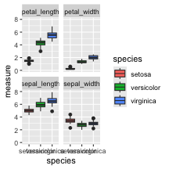

MANOVA vs. Multiple ANOVAs
One approach:
series of 1-way ANOVAs
for example —>
But:
- Variables and tests are not independent
- Multiple testing problem can reduce power
- MANOVA considers all response variables simultaneously
sepal_model <- aov(sepal_length~species, data = iris_df)
Anova(sepal_model, type = 3)
Anova Table (Type III tests)
Response: sepal_length
Sum Sq Df F value Pr(>F)
(Intercept) 1253.00 1 4728.16 < 2.2e-16 ***
species 63.21 2 119.26 < 2.2e-16 ***
Residuals 38.96 147
---
Signif. codes: 0 '***' 0.001 '**' 0.01 '*' 0.05 '.' 0.1 ' ' 1

MANOVA: Centroids vs. Means
Instead of means compare centroids
but for all of the variables not just two
mean_points <- iris_df %>%
group_by(species) %>%
summarise(mean_length = mean(petal_length),
mean_width = mean(petal_width),
.groups = 'drop')
iris_plot<-iris_df %>%
ggplot(aes(x=petal_length, y=petal_width, color=species)) +
geom_point(alpha = 0.85, size = 2) +
geom_point(data=mean_points,
aes(x=mean_length, y=mean_width, fill=species),
shape=23, color="black", stroke=1.2,alpha = .7,
size=6) +
theme_light()
iris_plot
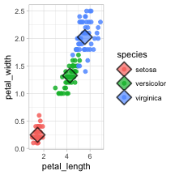

MANOVA: SSCP Matrices
A one-way MANOVA tests the Ho that there are no differences in population centroids
- Ho tested by partitioning variance, but instead of SS, use SSCP matrices:
- H matrix: between group SSCP
- E matrix: within group SSCP
- T matrix: total SSCP
iris_plot


MANOVA: Test Statistics
Several test statistics can be determined:
- Wilk’s λ: ratio of matrix determinants:|E|/|T|
- Smaller values: larger group differences
- Can be converted to approximate F ratios, compared to F distribution to find p
iris_plot

 MANOVA Assumptions
- Normal distribution:
  - response vars should be normally distributed within groups (relatively robust - No outliers (use di2 to diagnose; very sensitive to this assumption
  - Equal variance of the response variables across groups
  - Linearity: response variables linearly related to each other
  - No strong multicollinearity in response variables
  - Best performance in balances designs

MANOVA: Model Fitting
iris_manova_model <- manova(cbind(sepal_length, sepal_width, petal_length, petal_width) ~ species, data = iris_df)
summary(iris_manova_model)
Df Pillai approx F num Df den Df Pr(>F)
species 2 1.1919 53.466 8 290 < 2.2e-16 ***
Residuals 147
---
Signif. codes: 0 '***' 0.001 '**' 0.01 '*' 0.05 '.' 0.1 ' ' 1

MANOVA: Assumption Testing - Normality
Assumption test
- Multivariate Normality
# Test multivariate normality for all data together
response_matrix <- iris_df %>%
dplyr::select(sepal_length, sepal_width, petal_length, petal_width) %>%
as.matrix()
# Multivariate Shapiro-Wilk test for entire dataset
mshapiro.test(t(response_matrix))
Shapiro-Wilk normality test
data: Z
W = 0.97935, p-value = 0.02342

MANOVA: Assumption Testing - Homogeneity
Assumption test
- Homogeneity of Covariance Matrices (Box’s M Test)
response_vars <- iris_df %>%
dplyr::select(sepal_length, sepal_width, petal_length, petal_width)
# Box's M test for equality of covariance matrices
box_m_result <- boxM(response_vars, iris_df$species)
print(box_m_result)
Box's M-test for Homogeneity of Covariance Matrices
data: response_vars
Chi-Sq (approx.) = 140.94, df = 20, p-value < 2.2e-16

MANOVA: Visual Assumption Assessment
Assumption test
- Visual Assessment of Assumptions
# Create Q-Q plots for each variable by species
iris_long <- iris_df %>%
pivot_longer(cols = c(sepal_length, sepal_width, petal_length, petal_width),
names_to = "variable",
values_to = "value")
iris_long %>%
ggplot(aes(sample = value)) +
geom_qq() +
geom_qq_line() +
facet_grid(variable ~ species, scales = "free") +
labs(title = "Q-Q Plots by Species and Variable") +
theme_light()
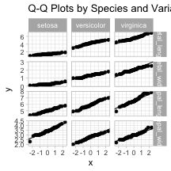

MANOVA: Follow-up Univariate ANOVAs

Follow-up Univariate ANOVAs
# Univariate ANOVAs for each response variable
# Sepal Length ANOVA
sepal_length_aov <- aov(sepal_length ~ species, data = iris_df)
summary(sepal_length_aov)
Df Sum Sq Mean Sq F value Pr(>F)
species 2 63.21 31.606 119.3 <2e-16 ***
Residuals 147 38.96 0.265
---
Signif. codes: 0 '***' 0.001 '**' 0.01 '*' 0.05 '.' 0.1 ' ' 1
# Sepal Width ANOVA
sepal_width_aov <- aov(sepal_width ~ species, data = iris_df)
summary(sepal_width_aov)
Df Sum Sq Mean Sq F value Pr(>F)
species 2 11.35 5.672 49.16 <2e-16 ***
Residuals 147 16.96 0.115
---
Signif. codes: 0 '***' 0.001 '**' 0.01 '*' 0.05 '.' 0.1 ' ' 1
# Petal Length ANOVA
petal_length_aov <- aov(petal_length ~ species, data = iris_df)
summary(petal_length_aov)
Df Sum Sq Mean Sq F value Pr(>F)
species 2 437.1 218.55 1180 <2e-16 ***
Residuals 147 27.2 0.19
---
Signif. codes: 0 '***' 0.001 '**' 0.01 '*' 0.05 '.' 0.1 ' ' 1
# Petal Width ANOVA
petal_width_aov <- aov(petal_width ~ species, data = iris_df)
summary(petal_width_aov)
Df Sum Sq Mean Sq F value Pr(>F)
species 2 80.41 40.21 960 <2e-16 ***
Residuals 147 6.16 0.04
---
Signif. codes: 0 '***' 0.001 '**' 0.01 '*' 0.05 '.' 0.1 ' ' 1

MANOVA: Post-hoc Comparisons

Post-hoc Comparisons using emmeans
# Sepal Length comparisons
print("Sepal Length comparisons")
[1] "Sepal Length comparisons"
sepal_length_emm <- emmeans(sepal_length_aov, ~ species)
pairs(sepal_length_emm)
contrast estimate SE df t.ratio p.value
setosa - versicolor -0.930 0.103 147 -9.033 <.0001
setosa - virginica -1.582 0.103 147 -15.366 <.0001
versicolor - virginica -0.652 0.103 147 -6.333 <.0001
P value adjustment: tukey method for comparing a family of 3 estimates
# Sepal Width comparisons
print("Sepal Width comparisons")
[1] "Sepal Width comparisons"
sepal_width_emm <- emmeans(sepal_width_aov, ~ species)
pairs(sepal_width_emm)
contrast estimate SE df t.ratio p.value
setosa - versicolor 0.658 0.0679 147 9.685 <.0001
setosa - virginica 0.454 0.0679 147 6.683 <.0001
versicolor - virginica -0.204 0.0679 147 -3.003 0.0088
P value adjustment: tukey method for comparing a family of 3 estimates
# Petal Length comparisons
print("Petal Length comparisons")
[1] "Petal Length comparisons"
petal_length_emm <- emmeans(petal_length_aov, ~ species)
pairs(petal_length_emm)
contrast estimate SE df t.ratio p.value
setosa - versicolor -2.80 0.0861 147 -32.510 <.0001
setosa - virginica -4.09 0.0861 147 -47.521 <.0001
versicolor - virginica -1.29 0.0861 147 -15.012 <.0001
P value adjustment: tukey method for comparing a family of 3 estimates
# Petal Width comparisons
print("Petal Width comparisons")
[1] "Petal Width comparisons"
petal_width_emm <- emmeans(petal_width_aov, ~ species)
pairs(petal_width_emm)
contrast estimate SE df t.ratio p.value
setosa - versicolor -1.08 0.0409 147 -26.387 <.0001
setosa - virginica -1.78 0.0409 147 -43.489 <.0001
versicolor - virginica -0.70 0.0409 147 -17.102 <.0001
P value adjustment: tukey method for comparing a family of 3 estimates

Canonical Discriminant Analysis: Eigenvalues

Eigenvalues and Canonical Variates
# Perform canonical discriminant analysis
iris_candisc <- candisc(iris_manova_model)
# Display eigenvalues and canonical correlations
cat("Canonical Discriminant Analysis Results:\n\n")
Canonical Discriminant Analysis Results:
print(iris_candisc)
Canonical Discriminant Analysis for species:
CanRsq Eigenvalue Difference Percent Cumulative
1 0.96987 32.19193 31.907 99.12126 99.121
2 0.22203 0.28539 31.907 0.87874 100.000
Test of H0: The canonical correlations in the
current row and all that follow are zero
LR test stat approx F numDF denDF Pr(> F)
1 0.02344 199.145 8 288 < 2.2e-16 ***
2 0.77797 13.794 3 145 5.794e-08 ***
---
Signif. codes: 0 '***' 0.001 '**' 0.01 '*' 0.05 '.' 0.1 ' ' 1
# Extract eigenvalues
eigenvalues <- iris_candisc$eigenvalues
cat("\nEigenvalues:\n")
Eigenvalues:
print(eigenvalues)
[1] 3.219193e+01 2.853910e-01 -7.801056e-17 -1.398429e-15
# Calculate proportion of variance explained
prop_variance <- eigenvalues / sum(eigenvalues)
cat("\nProportion of variance explained by each canonical variate:\n")
Proportion of variance explained by each canonical variate:
print(prop_variance)
[1] 9.912126e-01 8.787395e-03 -2.402001e-18 -4.305862e-17
# Cumulative proportion
cumulative_prop <- cumsum(prop_variance)
cat("\nCumulative proportion of variance explained:\n")
Cumulative proportion of variance explained:
print(cumulative_prop)
[1] 0.9912126 1.0000000 1.0000000 1.0000000

Canonical Discriminant Analysis: Coefficients

Canonical Coefficients (Eigenvectors)
# Display canonical coefficients (eigenvectors)
cat("Raw Canonical Coefficients (Eigenvectors):\n")
Raw Canonical Coefficients (Eigenvectors):
print(iris_candisc$coeffs.raw)
Can1 Can2
sepal_length 0.8293776 0.02410215
sepal_width 1.5344731 2.16452123
petal_length -2.2012117 -0.93192121
petal_width -2.8104603 2.83918785
cat("\nStandardized Canonical Coefficients:\n")
Standardized Canonical Coefficients:
print(iris_candisc$coeffs.std)
Can1 Can2
sepal_length 0.4269548 0.01240753
sepal_width 0.5212417 0.73526131
petal_length -0.9472572 -0.40103782
petal_width -0.5751608 0.58103986
# Structure coefficients (correlations between original variables and canonical variates)
cat("\nStructure Coefficients (Variable-Canonical Variate Correlations):\n")
Structure Coefficients (Variable-Canonical Variate Correlations):
print(iris_candisc$structure)
Can1 Can2
sepal_length -0.7918878 0.21759312
sepal_width 0.5307590 0.75798931
petal_length -0.9849513 0.04603709
petal_width -0.9728120 0.22290236

Multivariate Visualization
Multivariate Visualization
# Extract canonical scores using the correct method
# Alternative simpler approach - use lda from MASS package
# library(MASS)
iris_lda <- MASS::lda(species ~ sepal_length + sepal_width + petal_length + petal_width, data = iris_df)
lda_pred <- predict(iris_lda)
# Create dataframe with LDA scores (equivalent to canonical scores)
canonical_df_plot <- data.frame(
Can1 = lda_pred$x[, 1],
Can2 = lda_pred$x[, 2],
species = iris_df$species
)
# Calculate group centroids
centroids_plot <- canonical_df_plot %>%
group_by(species) %>%
summarise(Can1_mean = mean(Can1),
Can2_mean = mean(Can2),
.groups = 'drop')
# Create ggplot
canonical_df_plot %>%
ggplot(aes(x = Can1, y = Can2, color = species)) +
geom_point(size = 3, alpha = 0.7) +
geom_point(data = centroids_plot,
aes(x = Can1_mean, y = Can2_mean, fill = species),
shape = 23, color = "black", size = 8, stroke = 2) +
labs(title = "Canonical Discriminant Analysis",
subtitle = "Iris Species in Optimal Multivariate Space",
x = "Linear Discriminant 1",
y = "Linear Discriminant 2",
color = "Species",
fill = "Species") +
theme_light() +
theme(legend.position = "bottom")
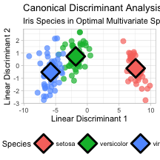

MANOVA Results: Key Interpretation

Interpretation of MANOVA

Key Interpretation
Pillai’s Trace (1.1919): This is large, indicating substantial group differences across the multivariate space.
F-statistic (53.466): Very large F-value indicates strong evidence against the null hypothesis.
P-value: Essentially zero, meaning we reject the null hypothesis that all three species have the same multivariate means.
Conclusion: The three iris species are significantly different when considering all four morphological measurements simultaneously in multivariate space.
# MANOVA Test Results
summary(iris_manova_model)
Df Pillai approx F num Df den Df Pr(>F)
species 2 1.1919 53.466 8 290 < 2.2e-16 ***
Residuals 147
---
Signif. codes: 0 '***' 0.001 '**' 0.01 '*' 0.05 '.' 0.1 ' ' 1

MANOVA Results: Wilks’ Lambda

Interpretation of MANOVA
Wilks’ Lambda (0.023439): Very small value (close to 0) indicates:
- Only about 2.3% of the total variance is unexplained by group differences
- About 97.7% of the multivariate variance is explained by species differences
- Extremely strong group separation in multivariate space
Effect Size: Partial η² ≈ 1 - 0.023439 = 0.977 (very large effect size)
F-statistic (199.15): Much larger than Pillai’s F-value because Wilks’ Lambda is often more powerful when assumptions are met
Conclusion: The three iris species show extremely large multivariate differences - they are very well separated in the 4-dimensional morphological space, with species explaining nearly 98% of the multivariate variance.
Wilks’ vs Pillai’s: Wilks’ Lambda is generally preferred when assumptions are met, while Pillai’s trace is more robust to assumption violations.
# Get Wilks' Lambda from manova for effect size
manova_summary <- summary(iris_manova_model, test = "Wilks")
manova_summary
Df Wilks approx F num Df den Df Pr(>F)
species 2 0.023439 199.15 8 288 < 2.2e-16 ***
Residuals 147
---
Signif. codes: 0 '***' 0.001 '**' 0.01 '*' 0.05 '.' 0.1 ' ' 1

MANOVA Results: Effect Size

Interpretation of MANOVA
Meaning: Approximately 97.7% of the total multivariate variance is explained by species differences.
Effect Size Guidelines: - Small effect: η² ≈ 0.01 (1% of variance explained) - Medium effect: η² ≈ 0.06 (6% of variance explained) - Large effect: η² ≈ 0.14 (14% of variance explained) - Our result: η² = 0.977 (extremely large effect)
Practical Interpretation: - Species are almost perfectly separated in multivariate morphological space - Only 2.3% of the variation in the four measurements is due to within-species differences - Species membership explains nearly all the multivariate variation - This represents one of the strongest group separations possible in real biological data
Conclusion: The iris species show dramatically different morphological profiles - they are essentially non-overlapping in the 4-dimensional space of sepal/petal measurements. This effect size indicates that species is an extremely powerful predictor of morphological characteristics.
# Effect Size (Partial Eta-squared approximation)
wilks_lambda <- manova_summary$stats[1, "Wilks"]
partial_eta_sq <- 1 - wilks_lambda
partial_eta_sq
[1] 0.9765614

Canonical Variates: Variance Explained

Interpretation of manova
Element [1] = 0.9912: - First canonical variate explains 99.12% of the between-group variance - This dimension captures almost all the multivariate group differences
Element [2] = 0.0088: - Second canonical variate explains 0.88% of the between-group variance - This dimension captures the remaining small group differences

Interpretation
Dimensionality: The group differences are essentially one-dimensional - 99% of separation occurs along the first canonical axis.
Biological Meaning: There’s one primary “direction” in morphological space that best separates the three iris species, with a very minor secondary pattern.
Practical Implication: You could visualize almost all the group separation using just the first canonical variate, though plotting both dimensions shows the complete picture.
# Canonical Analysis Summary
prop_variance
[1] 9.912126e-01 8.787395e-03 -2.402001e-18 -4.305862e-17
sum(prop_variance)
[1] 1

Linear Discriminant Analysis: Detailed Results

Interpretation of manova
Group means: - Setosa: Smallest overall, widest sepals, tiny petals - Versicolor: Medium-sized in most dimensions - Virginica: Largest overall, especially in petal dimensions - Clear size progression: setosa < versicolor < virginica
Coefficients of linear discriminants: - LD1: Positive weights for sepal measurements, negative for petal measurements - Separates small-petaled from large-petaled species - LD2: Mainly contrasts sepal width vs petal width - Fine-tunes separation between versicolor and virginica
Proportion of trace: - LD1: Explains 99.12% of between-group discrimination - LD2: Explains 0.88% of between-group discrimination - Confirms the separation is essentially one-dimensional (petal vs sepal contrast)
# LDA results for interpretation
iris_lda
Call:
lda(species ~ sepal_length + sepal_width + petal_length + petal_width,
data = iris_df)
Prior probabilities of groups:
setosa versicolor virginica
0.3333333 0.3333333 0.3333333
Group means:
sepal_length sepal_width petal_length petal_width
setosa 5.006 3.428 1.462 0.246
versicolor 5.936 2.770 4.260 1.326
virginica 6.588 2.974 5.552 2.026
Coefficients of linear discriminants:
LD1 LD2
sepal_length 0.8293776 -0.02410215
sepal_width 1.5344731 -2.16452123
petal_length -2.2012117 0.93192121
petal_width -2.8104603 -2.83918785
Proportion of trace:
LD1 LD2
0.9912 0.0088

MANOVA Advantages over Multiple ANOVAs

Advantages of MANOVA over Multiple ANOVAs

Statistical Advantages
- Controls family-wise error rate (no need for Bonferroni correction)
- Accounts for correlations between response variables
- More powerful when variables are correlated
- Tests the ‘global’ null hypothesis

Interpretational Advantages
- Reveals patterns in multivariate space that univariate tests miss
- Canonical variates show optimal linear combinations for group separation
- Provides insight into which variables work together to discriminate groups
- Shows the dimensionality of group differences

Biological Relevance
- Organisms function as integrated wholes, not independent traits
- Natural selection acts on trait combinations, not isolated traits
- Multivariate approaches better reflect biological reality

