01_Homework

Bill Perry

# Homework for Week 1:

This is an assignment for you to practice the code and all the work we do in class on a different dataframe. We will assign one of these each week for you to do that encompasses all fo the work we do. We give it out on Monday so you can start early and see how this work.

# 

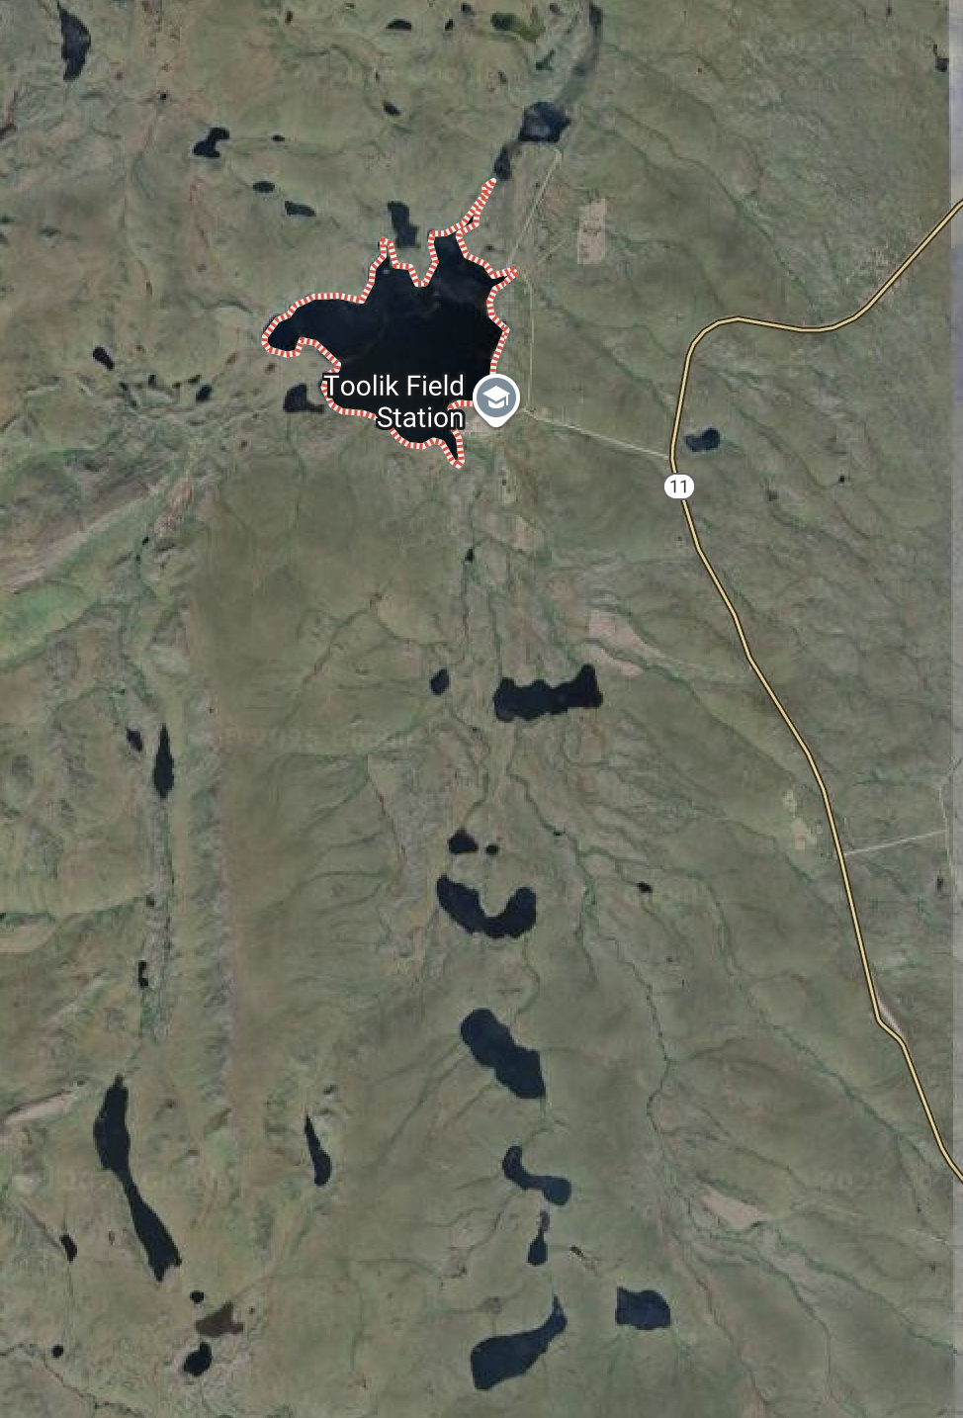

# Objectives and goals

* Make a new Project in RStudio.
* Create directories
  + data, scripts, output, figures, documents
* Create a quarto markdown file and open it
* Put this in the top in place of what is there and add your info
* ---  
  title: "Grayling in Lake I-8" # Title of the file  
  author: "YOUR NAME" # who you are  
  format: # this is the formats that it will render to  
   html:  
   default: true  
   embed-resources: true # makes everything go into the html file  
  editor: visual # type of editing  
  project:  
   execute-dir: project # where it will look for files  
  execute:  
   keep-md: true # retains the images when you start again  
   cache: true  
   echo: true  
  ---
* Load the libraries

# Load the libraries ----  
library(readxl) # allows to read in excel files  
library(tidyverse) # provides utilities seen in console

* Read in the file grayling_lakes_I3_I8.csv as a dataframe
* Read in the file grayling_lakes_I3_I8.xlsx as a separate dataframe
* Annotate your code in the code block as what what is going on and why
* Annotate the HTML code as you see fit.
* Visualize the data as the lengths of fish in lakes I_3 and I_8 as points
  + remember position = position_dodge2(width=0.2)
* Visualize the data as box and whisker plots
* Provide summary statistics grouped by lake
  + n, mean, standard deviation, standard error
* Visualize the data as mean plus or minus error in ggplot
  + be sure to have proper axis labels and units where necessary

## What to turn in -

1. a zipped or compressed folder of the entire project folder
2. a self-contained html file showing the output
3. annotations in the quarto file that shows or tells what is being done like in the class activities