05_Class_Activity

Bill Perry

# In class activity 4:

## What did we do last time in activity 3?

* Created and interpreted frequency distributions with histograms
* Compared lakes using side-by-side histograms
* Explored how sample size affects our view of a population
* Created density plots and calculated probabilities

## Today’s focus:

* Understanding standard normal distributions and z-scores
* Calculating and interpreting standard error
* Creating confidence intervals
* Working with the Student’s t-distribution

# Introduction

In this active learning module, we’ll explore statistical inference using the sculpin fish dataset from Alaska. We’ll focus on:

* Converting raw data to standardized z-scores
* Calculating standard error and confidence intervals
* Understanding the Student’s t-distribution
* Making statistical comparisons between lakes

We’ll use the tidyverse package for data manipulation and visualization, along with patchwork for combining plots.

## Setup

First, let’s load the packages we need and the dataset:

# Load required packages  
library(tidyverse)

── Attaching core tidyverse packages ──────────────────────── tidyverse 2.0.0 ──  
✔ dplyr 1.1.4 ✔ readr 2.1.5  
✔ forcats 1.0.0 ✔ stringr 1.5.1  
✔ ggplot2 3.5.1 ✔ tibble 3.2.1  
✔ lubridate 1.9.4 ✔ tidyr 1.3.1  
✔ purrr 1.0.4   
── Conflicts ────────────────────────────────────────── tidyverse_conflicts() ──  
✖ dplyr::filter() masks stats::filter()  
✖ dplyr::lag() masks stats::lag()  
ℹ Use the conflicted package (<http://conflicted.r-lib.org/>) to force all conflicts to become errors

library(patchwork)  
  
# Read in the data file  
sculpin_df <- read_csv("data/sculpin.csv")

Rows: 1052 Columns: 5  
── Column specification ────────────────────────────────────────────────────────  
Delimiter: ","  
chr (2): lake, species  
dbl (3): site, total_length_mm, mass_g  
  
ℹ Use `spec()` to retrieve the full column specification for this data.  
ℹ Specify the column types or set `show_col_types = FALSE` to quiet this message.

# Look at the first few rows  
head(sculpin_df)

# A tibble: 6 × 5  
 site lake species total_length_mm mass_g  
 <dbl> <chr> <chr> <dbl> <dbl>  
1 146 E 01 slimy sculpin 53 1.25  
2 146 E 01 slimy sculpin 61 1.9   
3 146 E 01 slimy sculpin 53 1.75  
4 146 E 01 slimy sculpin 77 4.25  
5 146 E 01 slimy sculpin 45 0.9   
6 146 E 01 slimy sculpin 48 0.9

Let’s calculate some basic statistics for Toolik Lake fish:

# Calculate basic statistics for Toolik Lake  
toolik_stats <- sculpin_df %>%   
 filter(lake == "Toolik") %>%   
 summarize(  
 mean_length = mean(total_length_mm, na.rm = TRUE),  
 sd_length = sd(total_length_mm, na.rm = TRUE),  
 n = sum(!is.na(total_length_mm)),  
 se_length = sd_length / sqrt(n)  
 )  
  
# Display the statistics  
toolik_stats

# A tibble: 1 × 4  
 mean_length sd_length n se_length  
 <dbl> <dbl> <int> <dbl>  
1 51.7 12.0 208 0.834

# Part 1: Understanding the Standard Normal Distribution

## Converting to Z-scores

Z-scores tell us how many standard deviations a data point is from the mean. The formula is:

$$Z=\frac{X−μ}{σ}$$

Let’s calculate z-scores for the Toolik Lake fish:

# Add a z-score column to our Toolik Lake data  
toolik_z <- sculpin_df %>%  
 filter(lake == "Toolik") %>%  
 mutate(z_score = (total_length_mm - toolik_stats$mean_length) / toolik_stats$sd_length)  
  
# Display the first few rows with z-scores  
head(toolik_z)

# A tibble: 6 × 6  
 site lake species total_length_mm mass_g z_score  
 <dbl> <chr> <chr> <dbl> <dbl> <dbl>  
1 100 Toolik slimy sculpin 12.5 0.0152 -3.26   
2 100 Toolik slimy sculpin 13 0.0104 -3.22   
3 100 Toolik slimy sculpin 74 2.3 1.85   
4 100 Toolik slimy sculpin 42 0.5 -0.806  
5 100 Toolik slimy sculpin 39 0.4 -1.06   
6 100 Toolik slimy sculpin 71 3 1.61

Now, let’s create a histogram of the original data and the z-scores side by side:

# Create histogram of original data  
p1 <- toolik_z %>%  
 ggplot(aes(total_length_mm)) +  
 geom_histogram(binwidth = 2, fill = "blue", alpha = 0.7) +  
 labs(title = "Original Scale",  
 x = "Length (mm)",  
 y = "Count")  
  
# Create histogram of z-scores  
p2 <- toolik_z %>%  
 ggplot(aes(z_score)) +  
 geom_histogram(binwidth = 0.2, fill = "red", alpha = 0.7) +  
 geom_vline(xintercept = 0, linewidth = 1) +  
 geom_vline(xintercept = c(-1, 1), color = "black", linetype = "dashed") +  
 labs(title = "Z-Score Scale",  
 x = "Standard deviations from mean (z-score)",  
 y = "Count")  
  
# Combine plots  
p1 / p2

Warning: Removed 79 rows containing non-finite outside the scale range (`stat_bin()`).  
Removed 79 rows containing non-finite outside the scale range (`stat_bin()`).

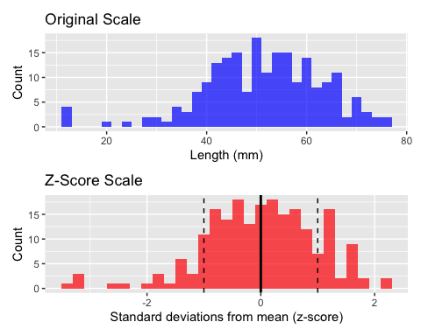

|  |
| --- |
| Activity 1 |
| Calculate the z-score for a fish with a length of 30mm from Toolik Lake. Is this fish length common or unusual?  # Calculate the z-score for a 30mm fish fish_length <- 30 z_score_30mm <- (fish_length - toolik_stats$mean_length) / toolik_stats$sd_length  # Print the result z_score_30mm  [1] -1.804193  # Determine if this is common or unusual # A z-score beyond -2 or 2 is generally considered unusual |

## Understanding Areas Under the Standard Normal Curve

The standard normal distribution has known probabilities associated with z-scores. We can calculate these probabilities in R:

# Calculate probability of z-score less than 1  
pnorm(1) # This gives us the area under the standard normal curve to the left of z=1

[1] 0.8413447

# Calculate probability of z-score between -1 and 1  
pnorm(1) - pnorm(-1) # This is approximately 68% (the 68-95-99.7 rule)

[1] 0.6826895

|  |
| --- |
| Activity 2 |
| Using the pnorm() function, answer: 1. What proportion of fish in Toolik Lake are shorter than 40mm?  # First, convert 40mm to a z-score z_score_40mm <- (40 - toolik_stats$mean_length) / toolik_stats$sd_length z_score_40mm  [1] -0.9725651  # Then, find the proportion of fish shorter than 40mm proportion_less_than_40mm <- pnorm(z_score_40mm) proportion_less_than_40mm  [1] 0.1653847 |

# Part 2: Standard Error and Sampling Distributions

## Taking Multiple Samples

When we take multiple samples from a population, each sample gives a slightly different estimate of the population mean. Let’s see this in action:

# Set seed for reproducibility  
set.seed(123)  
  
# Take a small sample  
small_sample <- sculpin_df %>%  
 filter(lake == "Toolik") %>%  
 sample_n(10)  
  
# Calculate the mean of this sample  
small_sample_mean <- mean(small_sample$total_length_mm, na.rm = TRUE)  
  
# Print the result  
cat("Sample mean (n=10):", small_sample_mean, "mm\n")

Sample mean (n=10): 50.42857 mm

cat("Population mean:", toolik_stats$mean_length, "mm\n")

Population mean: 51.69471 mm

cat("Difference:", abs(small_sample_mean - toolik_stats$mean_length), "mm\n")

Difference: 1.26614 mm

Let’s take multiple small samples and see how their means vary:

# Function to take a sample and calculate its mean  
get_sample_mean <- function() {  
 sculpin_df %>%  
 filter(lake == "Toolik") %>%  
 sample_n(10) %>%  
 summarize(mean_length = mean(total_length_mm, na.rm = TRUE)) %>%  
 pull(mean_length)  
}  
  
# Take 20 samples  
sample_means <- replicate(20, get_sample_mean())  
  
# Create a histogram of the sample means  
tibble(sample_means = sample_means) %>%  
 ggplot(aes(sample_means)) +  
 geom_histogram(bins = 10, fill = "green", alpha = 0.7) +  
 geom_vline(xintercept = toolik_stats$mean_length, color = "red", linewidth = 1) +  
 labs(title = "Distribution of Sample Means (n = 10)",  
 subtitle = paste("Red line = population mean =", round(toolik_stats$mean_length, 1), "mm"),  
 x = "Sample Mean (mm)",  
 y = "Frequency")

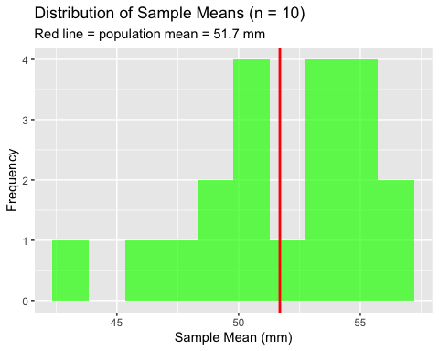

## Standard Error

The standard error of the mean tells us how much we expect sample means to vary:

$$SE=\frac{s}{\sqrt{n}}$$

# Calculate the standard error from our samples  
sample_se <- sd(sample_means)  
  
# Calculate the theoretical standard error  
theoretical_se <- toolik_stats$sd_length / sqrt(10)  
  
# Display both values  
cat("Standard Error from samples:", round(sample_se, 2), "mm\n")

Standard Error from samples: 3.55 mm

cat("Standard Error from formula:", round(theoretical_se, 2), "mm\n")

Standard Error from formula: 3.8 mm

|  |
| --- |
| Activity 3 |
| Let’s see how sample size affects the standard error. Run the code below to take samples of size 5 and size 20.  # Function to take multiple samples of a given size take_samples <- function(sample_size, n_samples = 20) {  replicate(n_samples, {  sculpin_df %>%  filter(lake == "Toolik") %>%  sample_n(sample_size) %>%  summarize(mean_length = mean(total_length_mm, na.rm = TRUE)) %>%  pull(mean_length)  }) }  # Take samples of size 5 and calculate SE sample_means_5 <- take_samples(5) se_5 <- sd(sample_means_5)  # Take samples of size 20 and calculate SE sample_means_20 <- take_samples(20) se_20 <- sd(sample_means_20)  # Print results cat("SE with n=5:", round(se_5, 2), "mm\n")  SE with n=5: 5.07 mm  cat("SE with n=20:", round(se_20, 2), "mm\n")  SE with n=20: 3.21 mm  # How does SE change as sample size increases? |

# Part 3: Confidence Intervals

## Calculating Confidence Intervals

A confidence interval gives us a range of values that likely contains the true population mean. For a 95% confidence interval:

$$95\%\text{ CI}=\overset{‾}{x}±1.96×SE$$

Let’s calculate the 95% confidence interval for the mean length of Toolik Lake fish:

# Calculate 95% confidence interval using z (normal distribution)  
ci_lower <- toolik_stats$mean_length - 1.96 * toolik_stats$se_length  
ci_upper <- toolik_stats$mean_length + 1.96 * toolik_stats$se_length  
  
# Display the confidence interval  
cat("95% Confidence Interval:",   
 round(ci_lower, 1), "to", round(ci_upper, 1), "mm\n")

95% Confidence Interval: 50.1 to 53.3 mm

## Visualizing Confidence Intervals

# Create a data frame with our statistics  
toolik_ci <- data.frame(  
 lake = "Toolik",  
 mean = toolik_stats$mean_length,  
 lower = ci_lower,  
 upper = ci_upper  
)  
  
# Plot the mean with error bars showing the 95% CI  
ggplot(toolik_ci, aes(x = lake, y = mean)) +  
 geom_point(size = 3) +  
 geom_errorbar(aes(ymin = lower, ymax = upper), width = 0.2) +  
 labs(title = "Mean Fish Length with 95% Confidence Interval",  
 x = NULL,  
 y = "Mean Length (mm)")

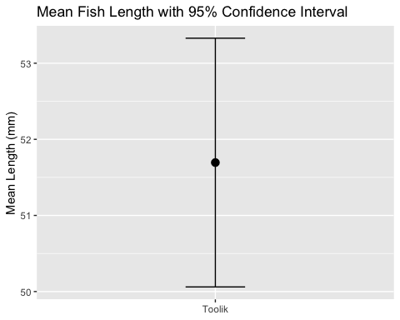

|  |
| --- |
| Activity 4 |
| Calculate and visualize the 95% confidence interval for another lake of your choice.  # Choose another lake other_lake <- "E 01" # You can change this to any lake in the dataset  # Calculate statistics for your chosen lake other_lake_stats <- sculpin_df %>%  filter(lake == other_lake) %>%  summarize(  mean_length = mean(total_length_mm, na.rm = TRUE),  sd_length = sd(total_length_mm, na.rm = TRUE),  n = sum(!is.na(total_length_mm)),  se_length = sd_length / sqrt(n)  )  # Display the statistics other_lake_stats  # A tibble: 1 × 4  mean_length sd_length n se_length  <dbl> <dbl> <int> <dbl> 1 58.2 15.3 79 1.72  # Calculate 95% confidence interval other_ci_lower <- other_lake_stats$mean_length - 1.96 * other_lake_stats$se_length other_ci_upper <- other_lake_stats$mean_length + 1.96 * other_lake_stats$se_length  # Display the confidence interval cat("95% Confidence Interval for", other_lake, ":",   round(other_ci_lower, 1), "to", round(other_ci_upper, 1), "mm\n")  95% Confidence Interval for E 01 : 54.8 to 61.6 mm  # Create a visualization # Add your code here to create a similar errorbar plot |

# Part 4: Student’s t-Distribution

When our sample size is small (n < 30), we should use the Student’s t-distribution instead of the normal distribution to calculate confidence intervals:

$$95\%\text{ CI}=\overset{‾}{x}±t_{\left(n−1,0.025\right)}×SE$$

# Calculate 95% CI using t-distribution  
n <- toolik_stats$n  
t_critical <- qt(0.975, df = n - 1) # Two-tailed, so 0.975 for 95% CI  
  
t_ci_lower <- toolik_stats$mean_length - t_critical * toolik_stats$se_length  
t_ci_upper <- toolik_stats$mean_length + t_critical * toolik_stats$se_length  
  
# Compare with z-based CI  
cat("95% CI using z:", round(ci_lower, 1), "to", round(ci_upper, 1), "mm\n")

95% CI using z: 50.1 to 53.3 mm

cat("95% CI using t:", round(t_ci_lower, 1), "to", round(t_ci_upper, 1), "mm\n")

95% CI using t: 50.1 to 53.3 mm

|  |
| --- |
| Activity 5 |
| Let’s see how t-critical values change with sample size. The smaller the sample size, the larger the t-critical value.  # Create a table of t-critical values for different sample sizes sample_sizes <- c(5, 10, 30, 100) t_critical_values <- qt(0.975, df = sample_sizes - 1)  # Create a data frame t_critical_df <- data.frame(  sample_size = sample_sizes,  t_critical = t_critical_values )  # Display the table t_critical_df  sample_size t_critical 1 5 2.776445 2 10 2.262157 3 30 2.045230 4 100 1.984217  # The z-critical value for 95% confidence is 1.96 # Which sample sizes have t-critical values close to 1.96? |

# Part 5: Testing Hypotheses

## Two-Sample t-test

Now let’s compare fish lengths between two lakes:

# Get data for Toolik and E 01 lakes  
toolik_fish <- sculpin_df %>%   
 filter(lake == "Toolik", !is.na(total_length_mm)) %>%  
 pull(total_length_mm)  
  
e01_fish <- sculpin_df %>%   
 filter(lake == "E 01", !is.na(total_length_mm)) %>%  
 pull(total_length_mm)  
  
# Perform a two-sample t-test  
t_test_result <- t.test(toolik_fish, e01_fish)  
  
# Display the result  
t_test_result

Welch Two Sample t-test  
  
data: toolik_fish and e01_fish  
t = -3.4051, df = 116.36, p-value = 0.0009082  
alternative hypothesis: true difference in means is not equal to 0  
95 percent confidence interval:  
 -10.313036 -2.727921  
sample estimates:  
mean of x mean of y   
 51.69471 58.21519

# Create a boxplot comparison  
sculpin_df %>%  
 filter(lake %in% c("Toolik", "E 01"), !is.na(total_length_mm)) %>%  
 ggplot(aes(x = lake, y = total_length_mm, fill = lake)) +  
 geom_boxplot() +  
 labs(title = "Comparing Fish Lengths Between Lakes",  
 subtitle = paste("t-test p-value =", round(t_test_result$p.value, 4)),  
 x = "Lake",  
 y = "Length (mm)")

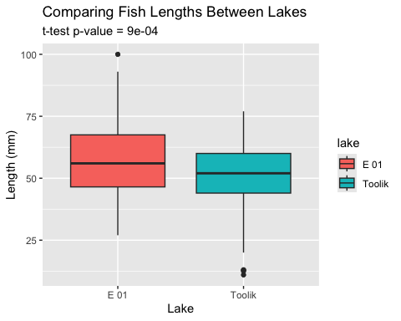

|  |
| --- |
| Activity 6 |
| Run a t-test to compare fish lengths between two different lakes of your choice.  # Choose two lakes to compare lake1 <- "S 06" # You can change this lake2 <- "Toolik" # You can change this  # Get the data for both lakes lake1_fish <- sculpin_df %>%   filter(lake == lake1, !is.na(total_length_mm)) %>%  pull(total_length_mm)  lake2_fish <- sculpin_df %>%   filter(lake == lake2, !is.na(total_length_mm)) %>%  pull(total_length_mm)  # Run the t-test my_t_test <- t.test(lake1_fish, lake2_fish)  # Display the result my_t_test  Welch Two Sample t-test  data: lake1_fish and lake2_fish t = 1.8374, df = 298.76, p-value = 0.06714 alternative hypothesis: true difference in means is not equal to 0 95 percent confidence interval:  -0.1648305 4.8057105 sample estimates: mean of x mean of y   54.01515 51.69471  # Interpret your results: # - What is the p-value? # - Is there a significant difference between the lakes at α = 0.05? # - Which lake has longer fish on average? |

# Part 6: Guided Challenges

Now it’s your turn to apply what you’ve learned. Work with your partner to complete these challenges:

|  |
| --- |
| Challenge 1 |
| Create boxplots of fish lengths for three lakes of your choice. Include the sample size in the labels. |

# Your code here for Challenge 1

|  |
| --- |
| Challenge 2 |
| Calculate and compare the standard errors for fish lengths in three different lakes. Which lake has the smallest standard error and why? |

# Your code here for Challenge 2

|  |
| --- |
| Challenge 3 |
| Create a bar plot showing the mean fish lengths for all lakes with at least 20 fish, and add error bars showing the 95% confidence intervals. |

# Your code here for Challenge 3

# Reflection Questions

After completing the activities, discuss these questions with your group:

1. How does sample size affect our confidence in estimating the population mean?
2. Why is the t-distribution more appropriate than the normal distribution when working with small samples?
3. When comparing two populations, what can we learn from looking at confidence intervals versus performing a t-test?
4. How would you explain the concept of statistical significance to someone who has never taken a statistics course?