Lecture 07

Bill Perry

# Lecture 6 - A Brief review

* Hypotheses
* 1- and 2-sided T tests
* **Assumptions of parametric tests**

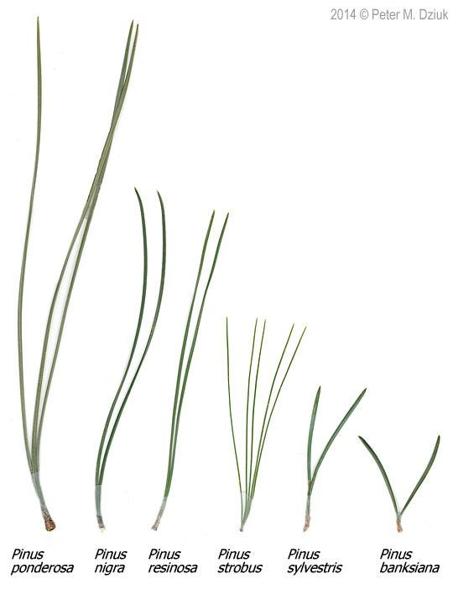

# Lecture 7 overview

What we will cover today:

* What are the assumptions again and how do you assess them
* What to do when assumptions fail
  + Robust tests
  + Rank-based tests
  + Permutation tests

Lets work with the Lake Trout data as the weights are pretty cool and the assumptions may or may not hold

This is easily translated into any of the other dataframes you might want to use

lake trout



# Install packages if needed (uncomment if necessary)  
# install.packages("readr")  
# install.packages("tidyverse")  
# install.packages("car")  
# install.packages("here")  
  
# Load libraries  
library(car) # For diagnostic tests  
library(patchwork)  
library(tidyverse) # For data manipulation and visualization

# the stuff above controls the output and is also set at the top so dont need here  
# Load the pine needle data  
# Use here() function to specify the path  
lt_df <- read_csv("data/lake_trout.csv")  
  
# Examine the first few rows  
head(df)

1 function (x, df1, df2, ncp, log = FALSE)   
2 {   
3 if (missing(ncp))   
4 .Call(C_df, x, df1, df2, log)   
5 else .Call(C_dnf, x, df1, df2, ncp, log)  
6 }

# Parametric versus non-parametric tests

T-tests are **parametric** tests

* Parametric tests:
  + specify/assume probability distribution from which parameters came
  + Basic assumptions of parametric t-tests:
    - Random sampling
    - Normality
    - Equal variance
    - No outliers
* Non-parametric tests: no assumption about probability distribution
  + Mukasa et al 2021 DOI: 10.4236/ojbm.2021.93081

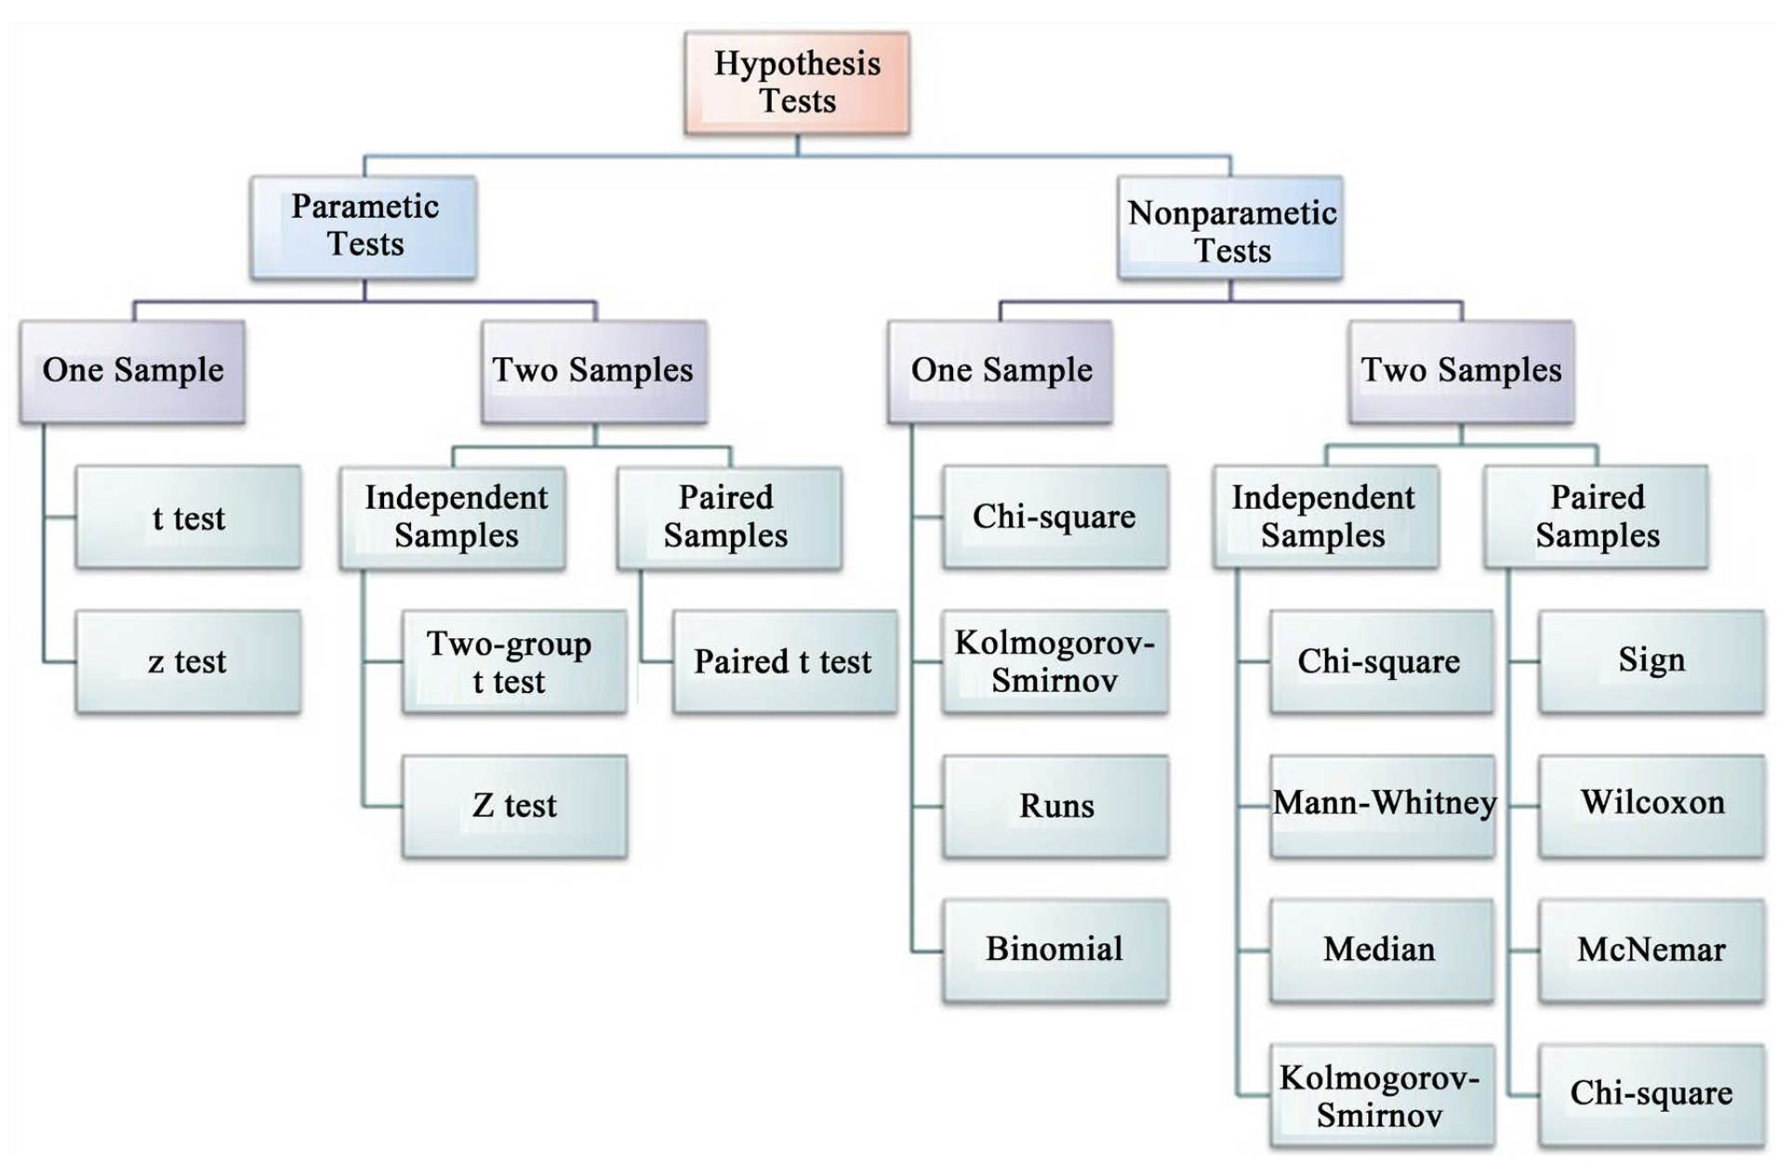

# Assumptions of parametric tests

* If assumptions of parametric test violated, test becomes unreliable
* This is because test statistic may no longer follow distribution
* Most parametric tests robust to mild/moderate violations of below assumptions

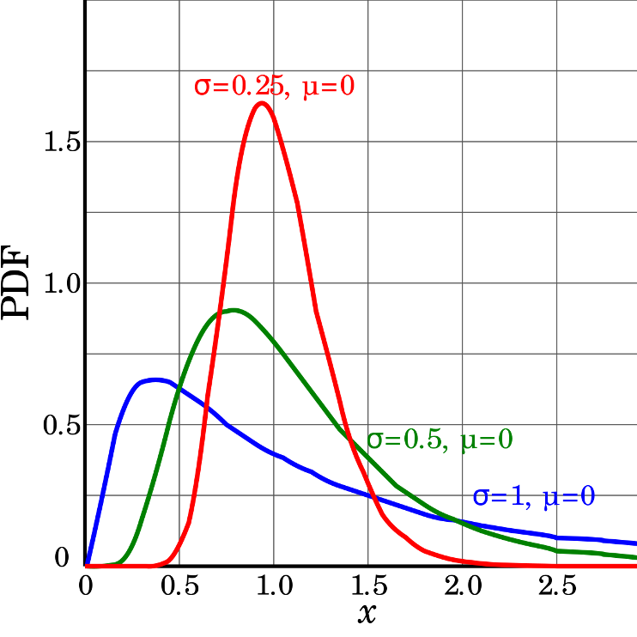

# Assumptions of parametric tests

* Basic assumptions of parametric t-tests:
  + Random sampling
  + Normality
  + Equal variance
  + No outliers
* Random sampling:
  + samples are randomly collected from populations; part of experimental design
  + Necessary for sample -> population inference

<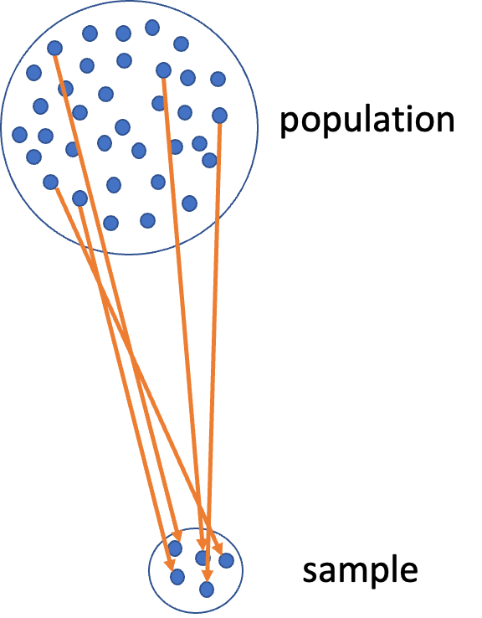>

# Assumptions of parametric tests

Basic assumptions of parametric t-tests:

* Normality
* equal variance
* random sampling
* no outliers
* Lets do the above for one lake - NE 12 as if we were going to do a one sample T Test
  + we need to make a new dataframae with NE 12 data only called ne12_data
  + how do you do this?
* Normality: Samples from normally distributed population
  + Graphical tests: histograms, dotplots, boxplots, **qq-plots**
  + “Formal” tests: **Shapiro-Wilk test** - sometimes not useful

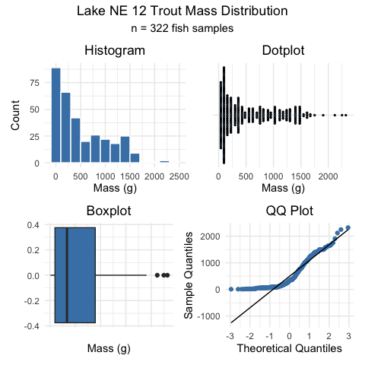

# Assumptions of parametric tests

Basic assumptions of parametric t-tests:

* Normality
* equal variance
* random sampling
* no outliers
* Lets do the above for one lake - NE 12 as if we were going to do a one sample T Test
  + we need to make a new dataframae with NE 12 data only called ne12_data
  + how do you do this?
* Normality: Samples from normally distributed population
  + Graphical tests: histograms, dotplots, boxplots, **qq-plots**
  + “Formal” tests: **Shapiro-Wilk test** - sometimes not useful

“Null hypothesis is that data is normally distributed”

[1] "Null hypothesis is that data is normally distributed"

Shapiro-Wilk normality test  
  
data: ne12_data$length_mm  
W = 0.94528, p-value = 1.56e-09

# Assumptions of parametric tests

Basic assumptions of parametric t-tests:

* Normality
* equal variance
* random sampling
* no outliers

Equal variance: samples are from populations with similar degree of variability

* Graphical tests: boxplots
* “Formal” tests: F-ratio test
* When samples sizes equal
  + Parametric tests most robust to violations of normality
  + Less so for equal variation assumptions

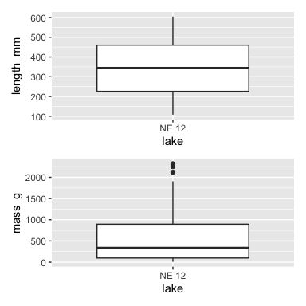

# Assumptions of parametric tests

* Basic assumptions of parametric t-tests: - Normality

- equal variance  
  
- random sampling  
  
- no outliers

* No outliers: no “extreme” values that are very different from rest of sample
  + Graphical tests: boxplots, histograms
  + “Formal tests”: Grubb’s test - no one really does this
  + **Note: outliers a problem for non-parametric tests as well**

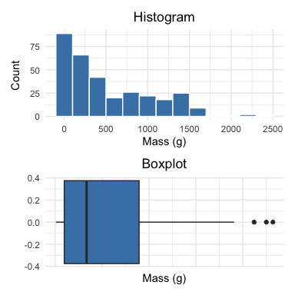

# Nonparametric test

* What if T Test assumptions fail?
* Alternative tests, with more relaxed assumptions, are available
* In which case would you use the following tests?
  + Welch’s t-test: *when distribution normal but variance unequal*
  + Mann-Whitney-Wilcoxon test: *when distribution not normal and/or outliers are present (but both groups should still have similar distributions and ~equal variance)*
  + Permutation test for two samples: *when distribution not normal (but both groups should still have similar distributions and ~equal variance)*

< –

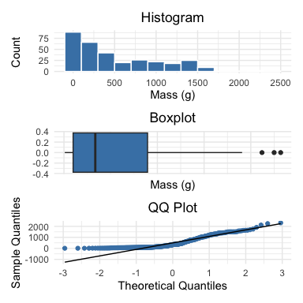

# Assumptions of parametric tests

* QQ-plots: tool for assessing normality
  + On x- theoretical quantiles from SND
  + On y- ordered sample values
  + Deviation from normal can be detected as deviation from straight line

isl_ne12_df <- lt_df %>% filter(lake %in% c("NE 12", "Island Lake"))  
  
ne12_island_box_plot <- isl_ne12_df %>%   
 ggplot(aes(x=lake, y = mass_g, color=lake)) +  
 geom_boxplot()+  
 theme_minimal()  
# ne12_island_box_plot  
  
ne12_island_qq_plot <- isl_ne12_df %>%   
 # filter(lake =="NE 12") %>%  
 ggplot(aes(sample = mass_g , color=lake)) +  
 stat_qq() +  
 stat_qq_line() +  
 labs( x = "Theoretical Quantiles", y = "Sample Quantiles") +  
 theme_minimal()   
  
ne12_island_box_plot +ne12_island_qq_plot+plot_layout(guides="collect")

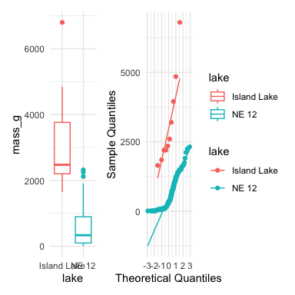

# Assumptions of parametric tests

* In some cases, data can be mathematically “transformed” to meet assumptions of parametric tests
* this can be done in r and usually involves
  + log10 transformations
  + square root transformations
  + and many others… I will have a description soon

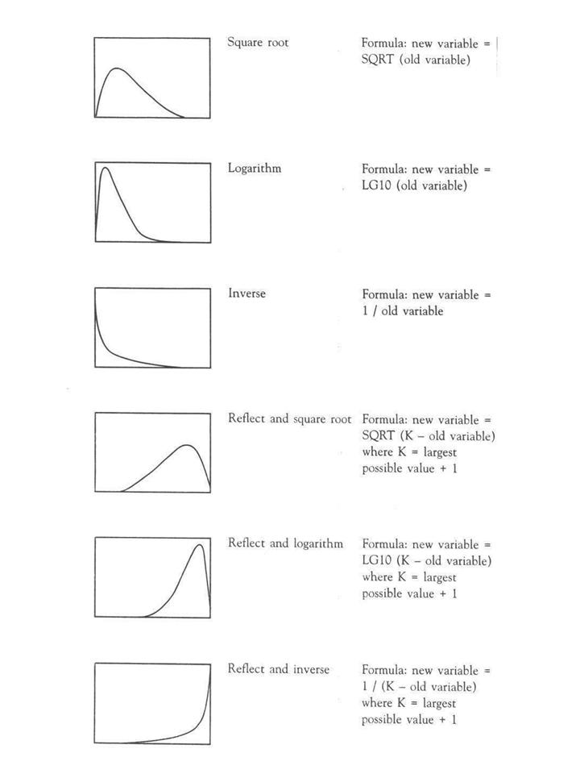

[source](https://www.elsblog.org/the_empirical_legal_studi/2006/08/variable_transf.html)

# Robust tests

* **Welch’s t-test**
  + common “robust” test for means of two populations
  + Robust to violation of equal variance assumption, deals better with unequal sample size
  + Parametric test (assumes normal distribution)
  + Calculates a t statistic but recalculates df based on samples sizes and s

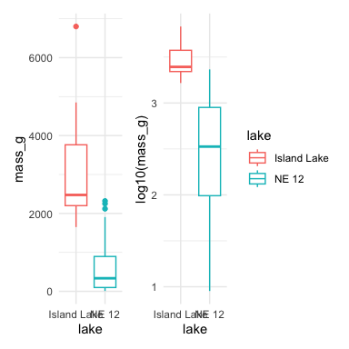

# Robust tests

* **Lets compare a parametric T-Test to a Welch’s t-test**
  + T-Test is:
    - **t.test(y1, y2, var.equal = TRUE, paired = FALSE)**
  + Welch’s T-Test is:
    - **t.test(y1, y2, var.equal = FALSE, paired = FALSE)**

[1] "Standard t-test results for lenght_mm:"

Two Sample t-test  
  
data: mass_g by lake  
t = 14.181, df = 330, p-value < 2.2e-16  
alternative hypothesis: true difference in means between group Island Lake and group NE 12 is not equal to 0  
95 percent confidence interval:  
 2266.304 2996.360  
sample estimates:  
mean in group Island Lake mean in group NE 12   
 3165.0000 533.6677

[1] "Welch's t-test results for lenght_mm:"

Welch Two Sample t-test  
  
data: mass_g by lake  
t = 5.1368, df = 9.0578, p-value = 0.0006016  
alternative hypothesis: true difference in means between group Island Lake and group NE 12 is not equal to 0  
95 percent confidence interval:  
 1473.676 3788.989  
sample estimates:  
mean in group Island Lake mean in group NE 12   
 3165.0000 533.6677

# Rank based tests

Rank-based tests: no assumptions about distribution (non-parametric)

* Ranks of data: observations assigned ranks, sums (and signs for paired tests) of ranks for groups compared
* **Mann-Whitney U test** common alternative to independent samples t-test
* **Wilcoxon signed-rank** test is alternative to paired t-test
* Assumptions: similar distributions for groups, equal variance
* Less power than parametric tests
* Best when normality assumption can not be met by transformation (weird distribution) or large outliers

[1] "Mann-Whitney U test results length:"

Wilcoxon rank sum test with continuity correction  
  
data: mass_g by lake  
W = 3205.5, p-value = 9.506e-08  
alternative hypothesis: true location shift is not equal to 0

# Permutation tests

* Permutation tests based on resampling: reshuffling of original data
* Resampling allows parameter estimation when distribution unknown, including SEs and CIs of statistics (means, medians)
* Common approach is bootstrap: resample sample with replacement many times, recalculate sample stats
* Use the perm package
* Ho: µA = µB
* Ha: µA ≠µB
* Calculates the difference ∆ in means between two groups

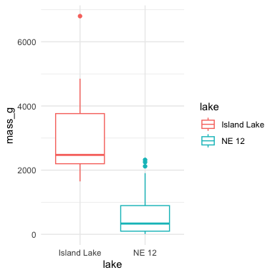

# Permutation tests

* Randomly reshuffle observations between groups (keeping nNE 12=323 and nIsland=10), calculate ∆
* Repeat >1,000 times
* Record proportion of the different means i
* This is equivalent to p-value and can be used in “traditional” H test framework
* For a graphical explanation:
  + [Graphical Explanation](https://www.jwilber.me/permutationtest/)

# Permutation tests

* In R (using ‘perm’ package):
* Assumptions: both groups have similar distribution; equal variance

library(perm)   
  
# Prepare data for permutation test  
ne12_perm_data <- isl_ne12_df %>%   
 filter(lake == "NE 12") %>%   
 pull(length_mm)  
  
# Randomly sample exactly 25 observations from NE 12 (set seed for reproducibility)  
set.seed(123)  
ne12_perm_data <- sample(ne12_perm_data, size = 25, replace = FALSE)  
  
island_perm_data <- isl_ne12_df %>%   
 filter(lake == "Island Lake") %>%   
 pull(length_mm)  
  
# Calculate the observed difference in means  
observed_diff <- mean(ne12_perm_data, na.rm = TRUE) - mean(island_perm_data, na.rm = TRUE)  
  
# Perform permutation test for difference in means using perm package  
permTS(ne12_perm_data, island_perm_data,   
 alternative = "two.sided",   
 method = "exact.mc",   
 control = permControl(nmc = 10000))

Exact Permutation Test Estimated by Monte Carlo  
  
data: GROUP 1 and GROUP 2  
p-value = 2e-04  
alternative hypothesis: true mean GROUP 1 - mean GROUP 2 is not equal to 0  
sample estimates:  
mean GROUP 1 - mean GROUP 2   
 -333.08   
  
p-value estimated from 10000 Monte Carlo replications  
99 percent confidence interval on p-value:  
 0.000000000 0.001059383

# Summary

## Testing Assumptions of Parametric Tests

### Key Assumptions

* **Random sampling**: Samples are randomly collected from populations
* **Normality**: Data follows a normal distribution
* **Equal variance**: Samples come from populations with similar variability
* **No outliers**: No extreme values that can skew results

### Assessing Assumptions

* Key to do every time
* Should acknowledge in manuscript

## Data Transformations

When assumptions aren’t met, transformations may help normalize data:

* **Log transformation**: log10(x) - Useful for right-skewed data, multiplicative effects
* **Square root**: sqrt(x) - Useful for count data, moderately right-skewed distributions
* **Box-Cox**: More flexible family of power transformations
* **More specialized transformations** especially for percentages o proportions

## Statistical Test Options

### 1. Standard T-Test

**Strengths:** - High statistical power when assumptions are met - Well understood and widely accepted

**Weaknesses:** - Sensitive to violations of normality, equal variance - Heavily influenced by outliers

### 2. Welch’s T-Test

**Strengths:** - Robust to violations of equal variance assumption - Handles unequal sample sizes well - Still parametric (assumes normality)

**Weaknesses:** - Slightly less powerful than standard t-test when variances are equal - Still assumes normal distribution

### 3. Mann-Whitney-Wilcoxon Test

**Strengths:** - Non-parametric: doesn’t assume normal distribution - Robust against outliers - Works with ordinal data

**Weaknesses:** - Less statistical power than parametric tests - Still assumes similar distributions and approximate equal variance - Tests median differences rather than mean differences

### 4. Permutation Tests

**Strengths:** - Distribution-free: doesn’t assume a specific distribution - Can be applied to many types of test statistics - Handles small sample sizes well - Directly estimates p-values through resampling

**Weaknesses:** - Computationally intensive - Assumes exchangeability under the null hypothesis - Requires similar distributions and equal variance

## Key Takeaway

Statistical tests have different strengths and assumptions. The choice should be guided by your data characteristics, not just convenience. Always visualize your data before deciding on the appropriate test.