Lecture 09

Bill Perry

# 1. Lecture 8: Review

Covered

* Study design
* Causality in ecology
* Experimental design:
  + Replication, controls, randomization, independence
* Sampling in field studies
* Power analysis: *a priori* and *post hoc*
* Study design and analysis

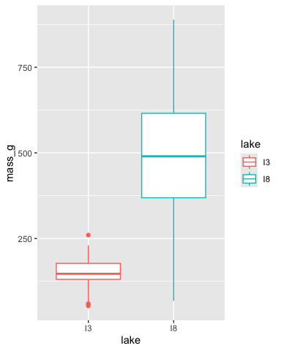

# 2. **Lecture 9:** Overview

## 2.1 The objectives:

This lecture covers two fundamental statistical techniques in biology: correlation and regression analysis. Based on Chapters 16-17 from Whitlock & Schluter’s *The Analysis of Biological Data* (3rd edition), we’ll explore:

* Correlation analysis: measuring relationships between variables
* The distinction between correlation and regression
* Simple linear regression: predicting one variable from another
* Estimating and interpreting regression parameters
* Testing assumptions and handling violations
* Analysis of variance in regression
* Model selection and comparison

# 3. **Lecture 9:** Correlation vs. Regression:

## 3.1 What’s the Difference?

**Correlation Analysis:**

* Measures the strength and direction of a relationship between two numerical variables
* Both X and Y are random variables (both measured, neither manipulated)
* Variables are typically on equal footing (either could be X or Y)
* No cause-effect relationship implied
* Quantifies the degree to which variables are related
* Expressed as a correlation coefficient (r) from -1 to +1

**Regression Analysis:**

* Predicts one variable (Y) from another (X)
* X is often fixed or controlled (manipulated)
* Y is the response variable of interest
* Often implies a cause-effect relationship
* Produces an equation for prediction
* Estimates slope and intercept parameters

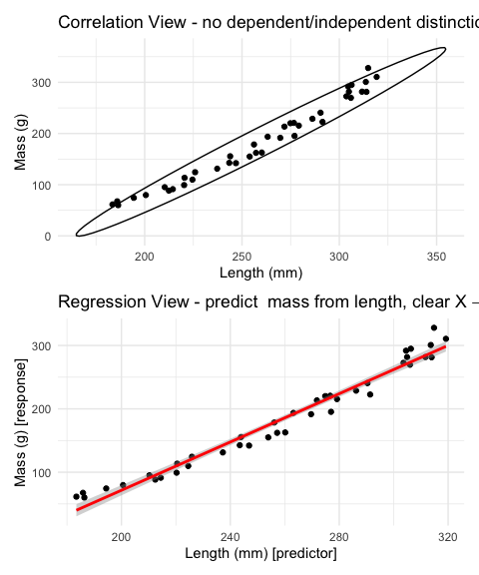

# 4. **Lecture 9:** Correlation Analysis

## 4.1 What Is Correlation?

**Correlation analysis** measures the strength and direction of a relationship between two numerical variables:

* Ranges from -1 to +1
* +1 indicates perfect positive correlation
* 0 indicates no correlation
* -1 indicates perfect negative correlation

The **Pearson correlation coefficient (r)** is defined as:

This can be simplified as:

Where and are the standard deviations of X and Y.

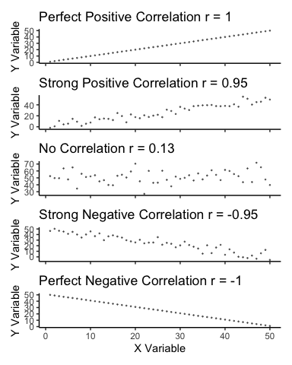

# 5. **Lecture 9:** Correlation Analysis

## 5.1 Example 16.1: Flipping the Bird

Nazca boobies (*Sula granti*) - Do aggressive behaviors as a chick predict future aggressive behavior as an adult?

* correlation is r = 0.534 - moderate positive relationship
* p-value = 0.007 correlation is statistically significant.

For a Pearson correlation coefficient (r) of 0.53372:

* This is r (not rho as Spearman nonparticipant below), as indicated by “cor” in your output
* To determine the amount of variation explained, you square this value: r² = 0.53372² = 0.2849 (or approximately 28.49%)
* means about 28.49% of the variance in one variable can be explained by the other variable

## 5.2 Note

[1] 0.5337225

Pearson's product-moment correlation  
  
data: booby_data$visits_as_nestling and booby_data$future_aggression  
t = 2.9603, df = 22, p-value = 0.007229  
alternative hypothesis: true correlation is not equal to 0  
95 percent confidence interval:  
 0.1660840 0.7710999  
sample estimates:  
 cor   
0.5337225

# 6. **Lecture 9:** Correlation Analysis

## 6.1 Example 16.1: Flipping the Bird

**Interpretation:** The correlation coefficient of r = 0.534 suggests that Nazca boobies who experienced more visits from non-parent adults as nestlings tend to display more aggressive behavior as adults. This supports the hypothesis that early experiences influence adult behavior patterns in this species.

**Standard Error:**

## 6.2

## 6.3 SE = 0.180

Need to be sure relationship is not curved - note below

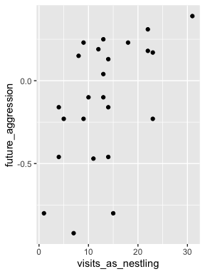

# 7. **Lecture 9:** Correlation Analysis

## 7.1 Testing Assumptions for Correlation

As described in Section 16.3, correlation analysis has key assumptions:

1. **Random sampling**: Observations should be a random sample from the population
2. **Bivariate normality**: Both variables follow a normal distribution, and their joint distribution is bivariate normal
3. **Linear relationship**: The relationship between variables is linear, not curved

Let’s check these assumptions using the lion data from Example 17.1 Lion Noses:

Shapiro-Wilk normality test  
  
data: lion_data$proportion_black  
W = 0.88895, p-value = 0.003279

Shapiro-Wilk normality test  
  
data: lion_data$age_years  
W = 0.87615, p-value = 0.001615

# 8. **Lecture 9:** Correlation Analysis

## 8.1 Testing Assumptions for Correlation

As described in Section 16.3, correlation analysis has key assumptions:

1. **Random sampling**: Observations should be a random sample from the population
2. **Bivariate normality**: Both variables follow a normal distribution, and their joint distribution is bivariate normal
3. **Linear relationship**: The relationship between variables is linear, not curved

Let’s check these assumptions using the lion data from Example 17.1 Lion Noses:

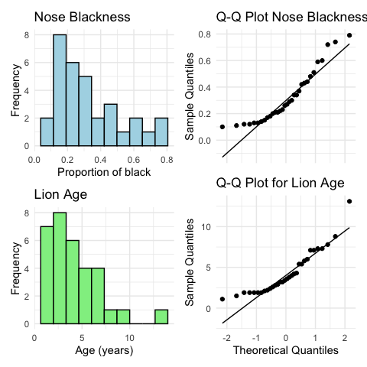

# 9. **Lecture 9:** Correlation Analysis

## 9.1 **What to do if assumptions are violated:**

Transform one or both variables (log, square root, etc.)

Use non-parametric correlation (**Spearman’s rank correlation**) or Kendall’s tau 𝛕

Examine the data for outliers or influential points

To understand the amount of variation explained, you can square the Spearman’s rho value.

For your value of 0.74485:

ρ² = 0.74485² = 0.5548

This means approximately 55.48% of the variance in ranks of one variable can be explained by the ranks of the other variable. This is similar to how R² works in linear regression, but specifically for ranked data.

Spearman's rank correlation rho  
  
data: lion_data$proportion_black and lion_data$age_years  
S = 1392.1, p-value = 1.013e-06  
alternative hypothesis: true rho is not equal to 0  
sample estimates:  
 rho   
0.7448561

# 10. **Lecture 9:** Correlation Analysis

## 10.1 Correlation: Important Considerations

**The correlation coefficient depends on the range**

* Restricting range of values can reduce the correlation coefficient
* Comparing correlations between studies requires similar ranges of values

**Measurement error affects correlation**

* Measurement error in X or Y tends to weaken observed correlation
* This bias is called **attenuation**
* True correlation typically stronger than observed correlation

**Correlation vs. Causation**

* Correlation does not imply causation
* Three possible explanations for correlation:
  1. X causes Y
  2. Y causes X
  3. Z (a third variable) causes both X and Y

**Correlation significance test**

* H₀: ρ = 0 (no correlation in population)
* H₁: ρ ≠ 0 (correlation exists in population)
* **Test statistic: t = r / SE(r) with df = n-2**

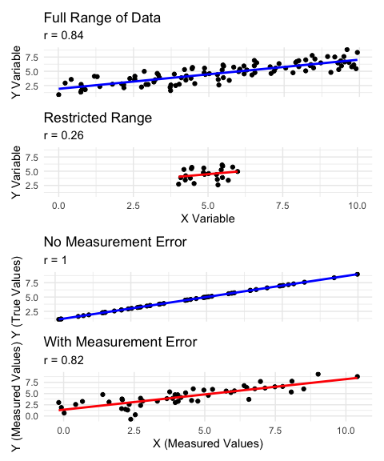

# 11. **Lecture 9:** Linear Regression

## 11.1 Simple Linear Regression Model

**Simple linear regression** models the relationship between a response variable (Y) and a predictor variable (X).

The **population** regression model

Where:

* Y is the response variable
* X is the predictor variable
* α (alpha) is the intercept (value of Y when X=0)
* β (beta) is the slope (change in Y per unit change in X)
* ε (epsilon) is the error term (random deviation from the line)

The **sample** regression equation is:

Where:

* is the predicted value of Y
* a is the estimate of α (intercept)
* b is the estimate of β (slope)

**Method of Least Squares**: The line is chosen to minimize the sum of squared vertical distances (residuals) between observed and predicted Y values.

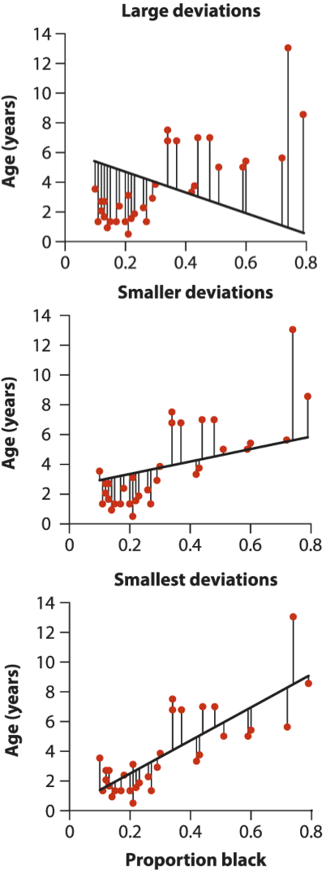

# 12. **Lecture 9:** Linear Regression

## 12.1 Simple Linear Regression Model

**Simple linear regression** models the relationship between a response variable (Y) and a predictor variable (X).

The **population** regression model is:

Where:

* Y is the response variable
* X is the predictor variable
* α (alpha) is the intercept (value of Y when X=0)
* β (beta) is the slope (change in Y per unit change in X)
* ε (epsilon) is the error term (random deviation from the line)

The **sample** regression equation is:

Where:

* is the predicted value of Y
* a is the estimate of α (intercept)
* b is the estimate of β (slope)

**Method of Least Squares**: The line is chosen to minimize the sum of squared vertical distances (residuals) between observed and predicted Y values.

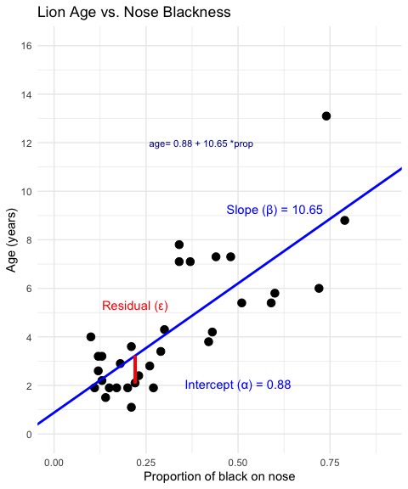

# 13. **Lecture 9:** Linear Regression

From Example 17.1 in the textbook the regression line for the lion data is:

## 13.1

This means: - When a lion has no black on its nose (proportion = 0), its predicted age is 0.88 years - For each 0.1 increase in the proportion of black, age increases by 1.065 years - The slope (10.65) indicates that lions with more black on their noses tend to be older



# 14. **Lecture 9:** Linear Regression

## 14.1 Simple Linear Regression Model

* male lions develop more black pigmentation on their noses as they age.
* can be used to estimate the age of lions in the field.

Call:  
lm(formula = age_years ~ proportion_black, data = lion_data)  
  
Residuals:  
 Min 1Q Median 3Q Max   
-2.5449 -1.1117 -0.5285 0.9635 4.3421   
  
Coefficients:  
 Estimate Std. Error t value Pr(>|t|)   
(Intercept) 0.8790 0.5688 1.545 0.133   
proportion_black 10.6471 1.5095 7.053 7.68e-08 ***  
---  
Signif. codes: 0 '***' 0.001 '**' 0.01 '*' 0.05 '.' 0.1 ' ' 1  
  
Residual standard error: 1.669 on 30 degrees of freedom  
Multiple R-squared: 0.6238, Adjusted R-squared: 0.6113   
F-statistic: 49.75 on 1 and 30 DF, p-value: 7.677e-08

# 15. **Lecture 9:** Linear Regression

## 15.1 Simple Linear Regression Model

The calculation for slope (b) is:

Given: - - - -

b = 13.0123 / 1.2221 = 10.647

Intercept (a):

**Making predictions:**

To predict the age of a lion with 0.50 proportion of black on its nose:

**Confidence intervals vs. Prediction intervals:**

* **Confidence interval**: Range for the mean age of all lions with 0.50 black
* **Prediction interval**: Range for an individual lion with 0.50 black

Both intervals are narrowest near and widen as X moves away from the mean.

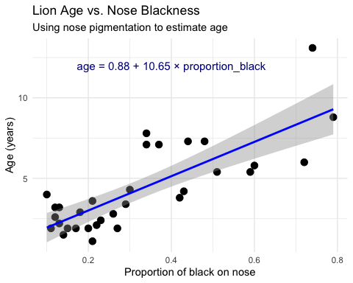

# 16. **Lecture 9:** Linear Regression

## 16.1 Example Prairie Home Companion

* Does biodiversity affect ecosystem stability?
* Tilman et al. (2006) investigated using experimental plots varying plant species

# A tibble: 6 × 2  
 species_number log_stability  
 <dbl> <dbl>  
1 1 0.763  
2 1 1.45   
3 1 1.51   
4 1 0.747  
5 1 0.983  
6 1 1.12

Call:  
lm(formula = log_stability ~ species_number, data = prairie_data)  
  
Residuals:  
 Min 1Q Median 3Q Max   
-0.82774 -0.25344 -0.00426 0.27498 0.75240   
  
Coefficients:  
 Estimate Std. Error t value Pr(>|t|)   
(Intercept) 1.252629 0.041023 30.535 < 2e-16 ***  
species_number 0.025984 0.004926 5.275 4.28e-07 ***  
---  
Signif. codes: 0 '***' 0.001 '**' 0.01 '*' 0.05 '.' 0.1 ' ' 1  
  
Residual standard error: 0.3433 on 159 degrees of freedom  
Multiple R-squared: 0.149, Adjusted R-squared: 0.1436   
F-statistic: 27.83 on 1 and 159 DF, p-value: 4.276e-07

[1] "rsquared is: 0.148953385305455"

Analysis of Variance Table  
  
Response: log_stability  
 Df Sum Sq Mean Sq F value Pr(>F)   
species_number 1 3.2792 3.2792 27.829 4.276e-07 ***  
Residuals 159 18.7358 0.1178   
---  
Signif. codes: 0 '***' 0.001 '**' 0.01 '*' 0.05 '.' 0.1 ' ' 1

# 17. **Lecture 9:** Linear Regression

The hypothesis test asks whether the slope equals zero:

* H₀: β = 0 (species number does not affect stability)
* H₁: β ≠ 0 (species number does affect stability)

## 17.1 The test statistic is:

With df = n - 2 = 161 - 2 = 159

**Interpretation:**

The slope estimate is 0.033, indicating that log stability increases by 0.033 units for each additional plant species in the plot.

The p-value is very small (2.73e-10), providing strong evidence to reject the null hypothesis that species number has no effect on ecosystem stability.

R² = 0.222, meaning that approximately 22.2% of the variation in log stability is explained by the number of plant species.

This supports the biodiversity-stability hypothesis: more diverse plant communities have more stable biomass production over time.

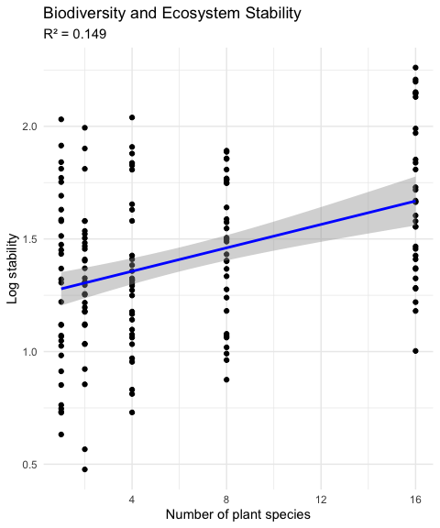

# 18. **Lecture 9:** Linear Regression

## 18.1 Testing Regression Assumptions

linear regression has four key assumptions:

1. **Linearity**: The relationship between X and Y is linear
2. **Independence**: Observations are independent
3. **Homoscedasticity**: Equal variance across all values of X
4. **Normality**: Residuals are normally distributed

Let’s check these assumptions for the lion regression model:  
  
Assume that **error 𝞮 i**s

* normally distributed for each xi
* has the same variance
* has a mean of 0 at each xi

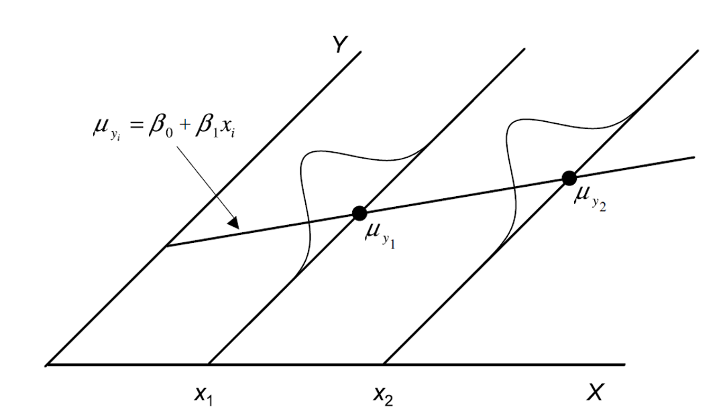

# 19. **Lecture 9:** Linear Regression

## 19.1 Testing Regression Assumptions

linear regression has four key assumptions:

1. **Linearity**: The relationship between X and Y is linear
2. **Independence**: Observations are independent
3. **Homoscedasticity**: Equal variance across all values of X
4. **Normality**: Residuals are normally distributed

Let’s check these assumptions for the lion regression model:  
  
Assume that **error 𝞮 i**s - estimated as the residuals:

* ordinary lease square estimates a and b or slope and intercept to minimize the sum of the residuals squared or Mean Squared Error (MSE) as

## 19.2

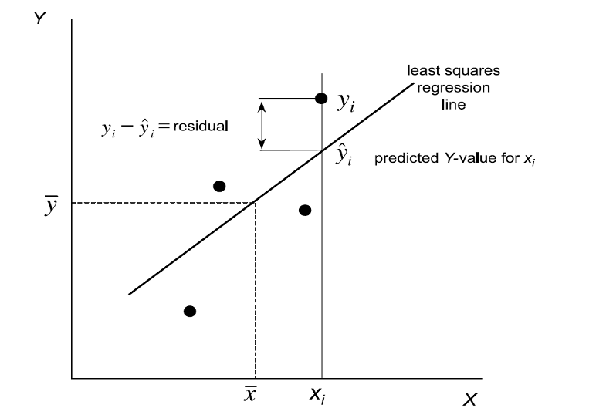

# 20.

# 21. **Lecture 9:** Linear Regression

## 21.1 Testing Regression Assumptions

linear regression has four key assumptions:

1. **Linearity**: The relationship between X and Y is linear
2. **Independence**: Observations are independent
3. **Homoscedasticity**: Equal variance across all values of X
4. **Normality**: Residuals are normally distributed

Let’s check these assumptions for the lion regression model:

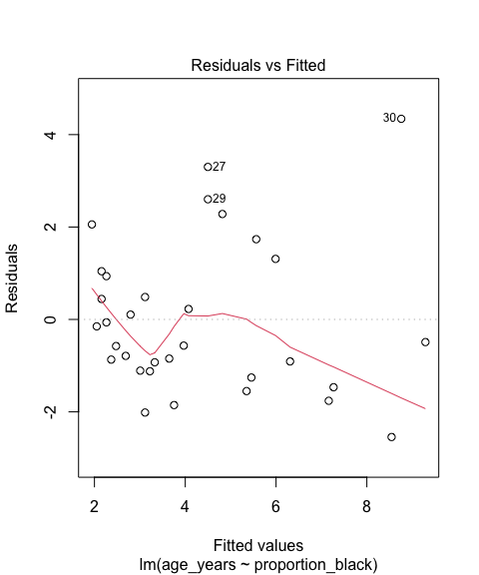

# 22. **Lecture 9:** Linear Regression

## 22.1 Testing Regression Assumptions

linear regression has four key assumptions:

1. **Linearity**: The relationship between X and Y is linear
2. **Independence**: Observations are independent
3. **Homoscedasticity**: Equal variance across all values of X
4. **Normality**: Residuals are normally distributed

Let’s check these assumptions for the lion regression model:

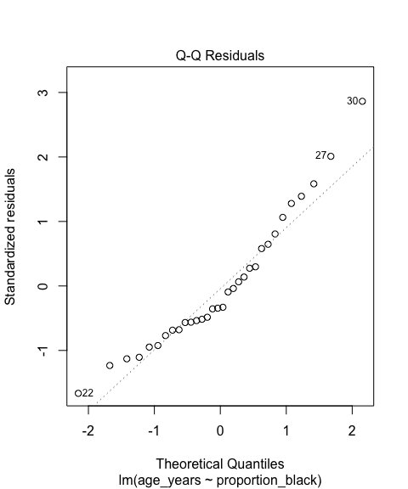

# 23. **Lecture 9:** Linear Regression

## 23.1 Testing Regression Assumptions

linear regression has four key assumptions:

1. **Linearity**: The relationship between X and Y is linear
2. **Independence**: Observations are independent
3. **Homoscedasticity**: Equal variance across all values of X
4. **Normality**: Residuals are normally distributed

Let’s check these assumptions for the lion regression model:

Shapiro-Wilk normality test  
  
data: residuals(lion_model)  
W = 0.93879, p-value = 0.0692

# 24. **Lecture 9:** Linear Regression

## 24.1 Simple Linear Regression Model

linear regression has four key assumptions:

1. **Linearity**: The relationship between X and Y is linear
2. **Independence**: Observations are independent
3. **Homoscedasticity**: Equal variance across all values of X
4. **Normality**: Residuals are normally distributed

If assumptions are violated: 1. Transform the data (Section 17.6) 2. Use weighted least squares for heteroscedasticity 3. Consider non-linear models (Section 17.8)

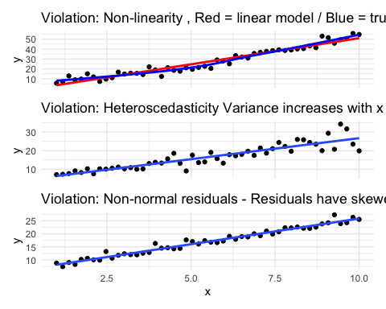

# 25. **Lecture 9:** Linear Regression - estimates of error and significance

* Estimates of standard error and confidence intervals for slow and intercept to determine confidence bands
* the 95% confidence band will contain the true population line 95/100 under repeated sampling
* this is usually done in R

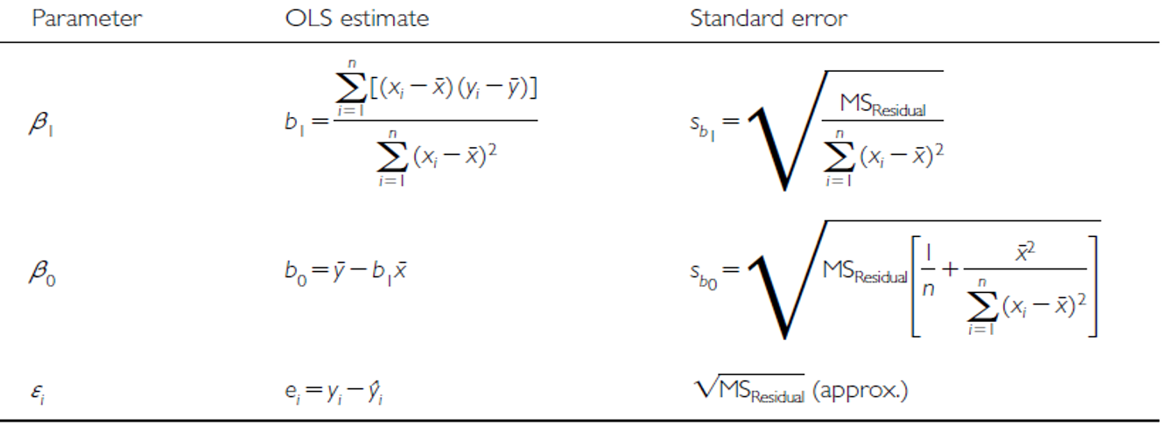

# 26. **Lecture 9:** Linear Regression - estimates of error and significance

In addition to getting estimates of population parameters (β0 , β1), want to test hypotheses about them

* This is accomplished by analysis of variance
* Partition variance in Y: due to variation in X, due to other things (error)

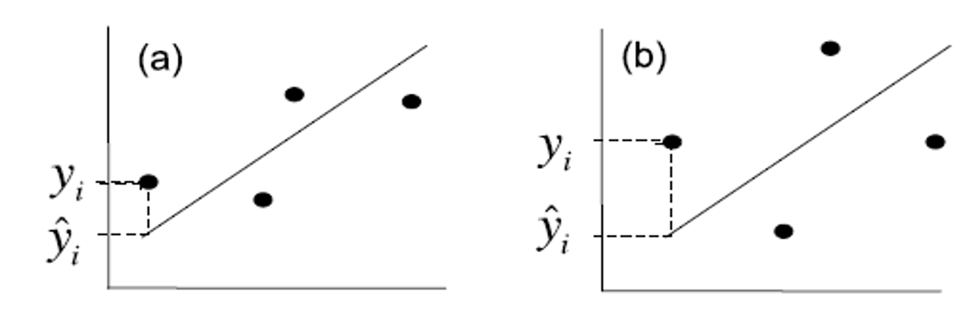

# 27. **Lecture 9:** Linear Regression - estimates of variance

Total variation in Y is “partitioned” into 3 components:

* : variation explained by regression
  + difference between predicted values (ŷi ) and mean y (ȳ)
  + dfs= 1 for simple linear (parameters-1)
* : variation not explained by regression
  + difference between observed () and predicted () values
  + dfs= n-2
* : total variation
  + sum of squared deviations of each observation () from mean ()
  + dfs = n-1



# 28. **Lecture 9:** Linear Regression - estimates of variance

Total variation in Y is “partitioned” into 3 components:

* : variation explained by regression
  + difference between predicted values (ŷi ) and mean y (ȳ)
  + dfs= 1 for simple linear (parameters-1)
* : variation not explained by regression
  + difference between observed () and predicted () values
  + dfs= n-2
* : total variation
  + sum of squared deviations of each observation () from mean ()
  + dfs = n-1

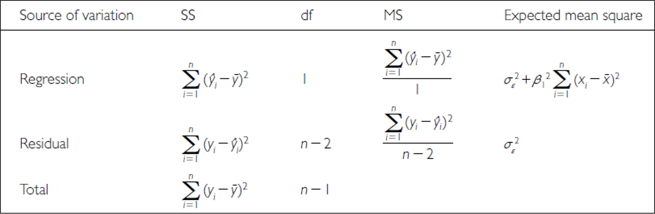

# 29. **Lecture 9:** Linear Regression - estimates of variance

Total variation in Y is “partitioned” into 3 components:

* : variation explained by regression
  + GREATER IN C than D
* : variation not explained by regression
  + GREATER IN B THAN A
* : total variation

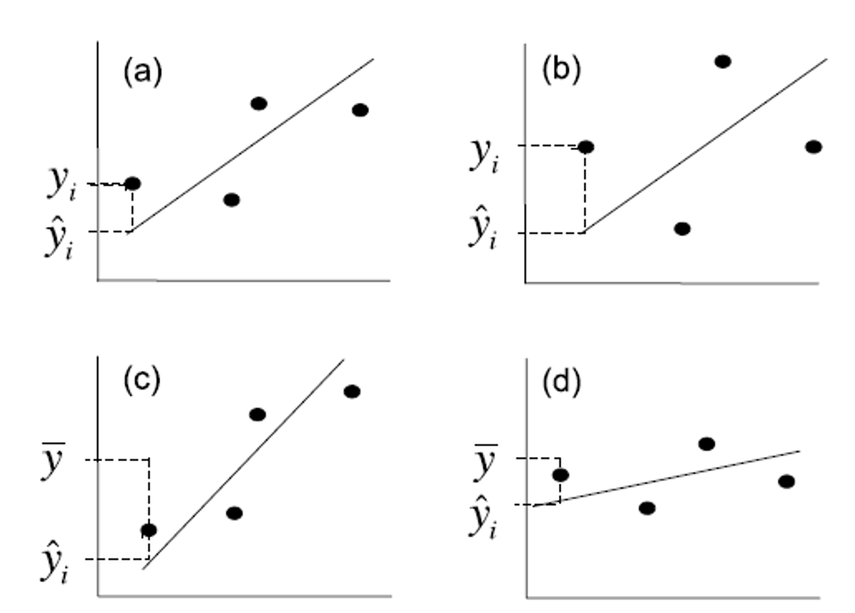

# 30. **Lecture 9:** Linear Regression - estimates of variance

Sums of Squares and degress of freedome are:

* Sums of Squares depends on n
* We need a different estimate of variance

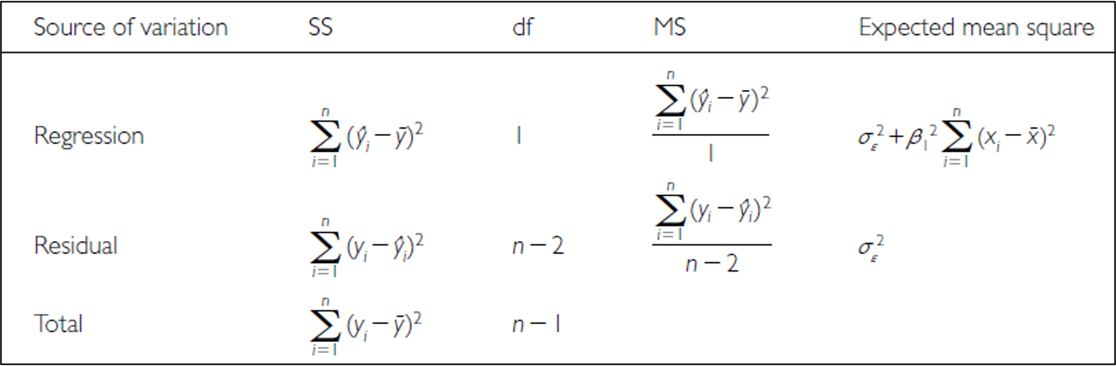

# 31. **Lecture 9:** Linear Regression - estimates of variance

Sums of Squares converted to Mean Squares

* Sums of Squares divided by degrees of freedom - does not depend on n
* : estimate population variation
* : estimate pop variation and variation due to X-Y relationship
* Mean Squares are not additive

