Lecture 09 - Class Activity

Your Name

# In class activity 9: Correlation and Linear Regression

## Introduction

This document demonstrates key concepts in correlation and regression analysis using ecological examples, focusing on:

1. **Understanding correlation vs. regression**
2. **Calculating and interpreting correlation coefficients**
3. **Testing correlation assumptions**
4. **Performing simple linear regression**
5. **Checking regression assumptions**
6. **Interpreting regression output and ANOVA tables**

We’ll work with real ecological datasets to practice these concepts.

# **Part 1:** Load Required Packages and Data

# Load required packages  
library(tidyverse) # For data manipulation and visualization  
library(patchwork) # For combining plots  
library(car) # For regression diagnostics  
library(broom) # For tidy model output  
  
# Set seed for reproducible results  
set.seed(123)  
  
# Create the datasets from the lecture  
# Lion data from Example 17.1  
lion_data <- tibble(  
 proportion_black = c(0.21, 0.14, 0.11, 0.13, 0.12, 0.13, 0.12, 0.18, 0.23, 0.22,   
 0.20, 0.17, 0.15, 0.27, 0.26, 0.21, 0.30, 0.42, 0.43, 0.59,   
 0.60, 0.72, 0.29, 0.10, 0.48, 0.44, 0.34, 0.37, 0.34, 0.74, 0.79, 0.51),  
 age_years = c(1.1, 1.5, 1.9, 2.2, 2.6, 3.2, 3.2, 2.9, 2.4, 2.1,   
 1.9, 1.9, 1.9, 1.9, 2.8, 3.6, 4.3, 3.8, 4.2, 5.4,   
 5.8, 6.0, 3.4, 4.0, 7.3, 7.3, 7.8, 7.1, 7.1, 13.1, 8.8, 5.4)  
)  
  
# Booby data from Example 16.1  
booby_data <- tibble(  
 visits_as_nestling = c(1, 7, 15, 4, 11, 14, 23, 14, 9, 5, 4, 10,   
 13, 13, 14, 12, 13, 9, 8, 18, 22, 22, 23, 31),  
 future_aggression = c(-0.80, -0.92, -0.80, -0.46, -0.47, -0.46, -0.23, -0.16,   
 -0.23, -0.23, -0.16, -0.10, -0.10, 0.04, 0.13, 0.19,   
 0.25, 0.23, 0.15, 0.23, 0.31, 0.18, 0.17, 0.39)  
)  
  
# Prairie stability data from Example 17.3  
prairie_data <- tibble(  
 species_number = rep(c(1, 2, 4, 8, 16), times = c(32, 32, 32, 32, 33)),  
 log_stability = 1.20 + 0.033 * species_number + rnorm(161, 0, 0.35)  
)

|  |
| --- |
| Package Overview |
| * **tidyverse**: Collection of packages for data science * **patchwork**: Combine multiple ggplot2 plots easily * **car**: Companion to Applied Regression (diagnostic tools) * **broom**: Convert statistical objects into tidy data frames |

# **Part 2:** Correlation Analysis

|  |
| --- |
| Correlation Analysis: Data Types and Assumptions |
| **Data Types Required:**   * - **X variable**: Continuous numerical * - **Y variable**: Continuous numerical - Both variables should be measured (not manipulated)   **Assumptions for Pearson Correlation:**   * - Random sampling from the population * - Bivariate normality (both variables normally distributed) * - Linear relationship between variables * - No extreme outliers |

## Calculating Correlation Coefficients

Let’s start with the Nazca booby data to explore correlation:

# Calculate Pearson correlation coefficient  
booby_corr <- cor(booby_data$visits_as_nestling, booby_data$future_aggression)  
print(paste("Correlation coefficient (r):", round(booby_corr, 3)))

[1] "Correlation coefficient (r): 0.534"

# Perform correlation test  
booby_cor_test <- cor.test(booby_data$visits_as_nestling, booby_data$future_aggression)  
print(booby_cor_test)

Pearson's product-moment correlation  
  
data: booby_data$visits_as_nestling and booby_data$future_aggression  
t = 2.9603, df = 22, p-value = 0.007229  
alternative hypothesis: true correlation is not equal to 0  
95 percent confidence interval:  
 0.1660840 0.7710999  
sample estimates:  
 cor   
0.5337225

# Calculate R-squared (variance explained)  
r_squared <- booby_corr^2  
print(paste("R-squared (variance explained):", round(r_squared * 100, 1), "%"))

[1] "R-squared (variance explained): 28.5 %"

## Visualizing the Correlation

# Create scatterplot with correlation  
booby_plot <- ggplot(booby_data, aes(x = visits_as_nestling, y = future_aggression)) +  
 geom_point(size = 3, alpha = 0.7) +  
 # geom_smooth(method = "lm", se = TRUE, color = "blue", alpha = 0.2) +  
 labs(title = "Nazca Booby: Early Experience vs. Adult Aggression",  
 subtitle = paste("r =", round(booby_corr, 3), ", p =", round(booby_cor_test$p.value, 3)),  
 x = "Visits by Non-parent Adults (as nestling)",  
 y = "Future Aggression Score") +  
 theme_minimal()  
  
booby_plot

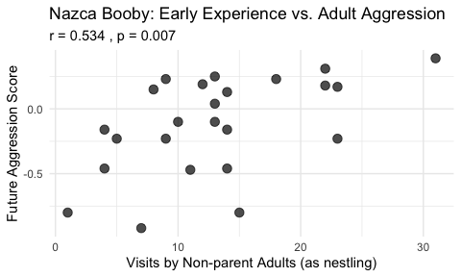

|  |
| --- |
| Activity 1: Interpret the Correlation |
| Based on the output above, answer these questions:   1. **Direction**: Is the correlation positive or negative? What does this mean biologically?    * Your answer: _________________________________ 2. **Strength**: How would you classify this correlation (weak, moderate, strong)?    * Your answer: _________________________________ 3. **Significance**: Is the correlation statistically significant? What is the p-value?    * Your answer: _________________________________ 4. **Variance explained**: What percentage of variance in adult aggression is explained by nestling visits?    * Your answer: _________________________________ |

## Testing Correlation Assumptions

# Test normality of each variable  
shapiro_visits <- shapiro.test(booby_data$visits_as_nestling)  
shapiro_aggression <- shapiro.test(booby_data$future_aggression)  
shapiro_visits

Shapiro-Wilk normality test  
  
data: booby_data$visits_as_nestling  
W = 0.95783, p-value = 0.3965

shapiro_aggression

Shapiro-Wilk normality test  
  
data: booby_data$future_aggression  
W = 0.91575, p-value = 0.04709

# print("Normality Tests:")  
# print(paste("Visits as nestling - Shapiro-Wilk p-value:", round(shapiro_visits$p.value, 4)))  
# print(paste("Future aggression - Shapiro-Wilk p-value:", round(shapiro_aggression$p.value, 4)))

# Create diagnostic plots  
p1 <- ggplot(booby_data, aes(x = visits_as_nestling)) +  
 geom_histogram(bins = 10, fill = "lightblue", color = "black") +  
 labs(title = "Distribution of Visits", x = "Visits as Nestling", y = "Count") +  
 theme_minimal()  
  
p2 <- ggplot(booby_data, aes(x = future_aggression)) +  
 geom_histogram(bins = 10, fill = "lightgreen", color = "black") +  
 labs(title = "Distribution of Aggression", x = "Future Aggression", y = "Count") +  
 theme_minimal()  
  
p3 <- ggplot(booby_data, aes(sample = visits_as_nestling)) +  
 stat_qq() + stat_qq_line() +  
 labs(title = "Q-Q Plot: Visits", x = "Theoretical", y = "Sample") +  
 theme_minimal()  
  
p4 <- ggplot(booby_data, aes(sample = future_aggression)) +  
 stat_qq() + stat_qq_line() +  
 labs(title = "Q-Q Plot: Aggression", x = "Theoretical", y = "Sample") +  
 theme_minimal()  
  
# Combine plots  
(p1 + p2) / (p3 + p4)

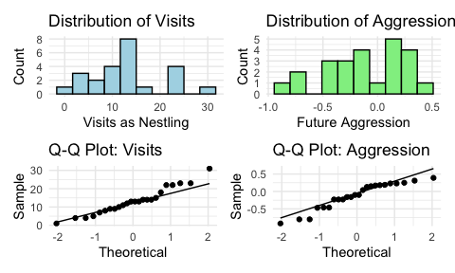

|  |
| --- |
| When Assumptions Are Violated |
| If normality assumptions are violated (p < 0.05 in Shapiro-Wilk test), consider:   1. **Spearman’s rank correlation** (non-parametric alternative) 2. **Data transformation** (log, square root, etc.) 3. **Removing outliers** (if justified)   Let’s try Spearman’s correlation: |

# Calculate Spearman's rank correlation  
spearman_test <- cor.test(booby_data$visits_as_nestling,   
 booby_data$future_aggression,   
 method = "spearman")

Warning in cor.test.default(booby_data$visits_as_nestling,  
booby_data$future_aggression, : Cannot compute exact p-value with ties

print(spearman_test)

Spearman's rank correlation rho  
  
data: booby_data$visits_as_nestling and booby_data$future_aggression  
S = 1213.5, p-value = 0.01976  
alternative hypothesis: true rho is not equal to 0  
sample estimates:  
 rho   
0.472374

# Compare with Pearson  
print(paste("Pearson r:", round(booby_corr, 3)))

[1] "Pearson r: 0.534"

print(paste("Spearman rho:", round(spearman_test$estimate, 3)))

[1] "Spearman rho: 0.472"

# **Part 3:** Simple Linear Regression

Now let’s move from correlation to regression using the lion nose data.

|  |
| --- |
| Linear Regression: Data Types and Assumptions |
| **Data Types Required:**   * - **X variable (predictor)**: Continuous numerical * - **Y variable (response)**: Continuous numerical - X can be fixed/controlled, Y is the outcome of interest   **Assumptions for Linear Regression:**   * - **Linearity**: Relationship between X and Y is linear * - **Independence**: Observations are independent * - **Homoscedasticity**: Constant variance of residuals * - **Normality**: Residuals are normally distributed * - **No influential outliers** |

## Fitting a Linear Regression Model

# Fit linear regression model  
lion_model <- lm(age_years ~ proportion_black, data = lion_data)  
  
# Get model summary  
summary(lion_model)

Call:  
lm(formula = age_years ~ proportion_black, data = lion_data)  
  
Residuals:  
 Min 1Q Median 3Q Max   
-2.5449 -1.1117 -0.5285 0.9635 4.3421   
  
Coefficients:  
 Estimate Std. Error t value Pr(>|t|)   
(Intercept) 0.8790 0.5688 1.545 0.133   
proportion_black 10.6471 1.5095 7.053 7.68e-08 ***  
---  
Signif. codes: 0 '***' 0.001 '**' 0.01 '*' 0.05 '.' 0.1 ' ' 1  
  
Residual standard error: 1.669 on 30 degrees of freedom  
Multiple R-squared: 0.6238, Adjusted R-squared: 0.6113   
F-statistic: 49.75 on 1 and 30 DF, p-value: 7.677e-08

# Get tidy output  
tidy_output <- tidy(lion_model)  
print(tidy_output)

# A tibble: 2 × 5  
 term estimate std.error statistic p.value  
 <chr> <dbl> <dbl> <dbl> <dbl>  
1 (Intercept) 0.879 0.569 1.55 0.133   
2 proportion_black 10.6 1.51 7.05 0.0000000768

# Get model fit statistics  
glance_output <- glance(lion_model)  
print(glance_output)

# A tibble: 1 × 12  
 r.squared adj.r.squared sigma statistic p.value df logLik AIC BIC  
 <dbl> <dbl> <dbl> <dbl> <dbl> <dbl> <dbl> <dbl> <dbl>  
1 0.624 0.611 1.67 49.8 0.0000000768 1 -60.8 128. 132.  
# ℹ 3 more variables: deviance <dbl>, df.residual <int>, nobs <int>

|  |
| --- |
| Activity 2: Interpret the Regression Output |
| From the regression output above:   1. **Regression equation**: Write the equation in the form: age = ___ + ___ × proportion_black    * Your answer: _________________________________ 2. **Slope interpretation**: What does the slope value mean in biological terms?    * Your answer: _________________________________ 3. **R-squared**: What percentage of variation in age is explained by nose blackness?    * Your answer: _________________________________ 4. **Significance**: Is the relationship statistically significant? How do you know?    * Your answer: _________________________________ |

## Visualizing the Regression

# Create regression plot with confidence interval  
lion_plot <- ggplot(lion_data, aes(x = proportion_black, y = age_years)) +  
 geom_point(size = 3, alpha = 0.7) +  
 geom_smooth(method = "lm", se = TRUE, color = "red", fill = "pink", alpha = 0.3) +  
 labs(title = "Lion Age Prediction from Nose Pigmentation",  
 subtitle = paste("R² =", round(glance_output$r.squared, 3),   
 ", p <", round(glance_output$p.value, 4)),  
 x = "Proportion of Black on Nose",  
 y = "Age (years)") +  
 theme_minimal()  
  
lion_plot

`geom_smooth()` using formula = 'y ~ x'

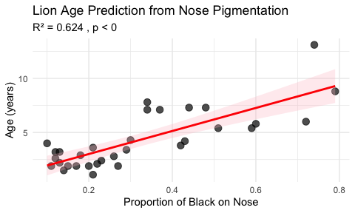

|  |
| --- |
| Confidence vs. Prediction Intervals |
| * **Confidence Interval**: Range for the mean age of ALL lions with that nose blackness * **Prediction Interval**: Range for an INDIVIDUAL lion with that nose blackness * Prediction intervals are always wider than confidence intervals |

# **Part 4:** Testing Regression Assumptions

## Diagnostic Plots

# Create diagnostic plots  
par(mfrow = c(2, 2))  
plot(lion_model)

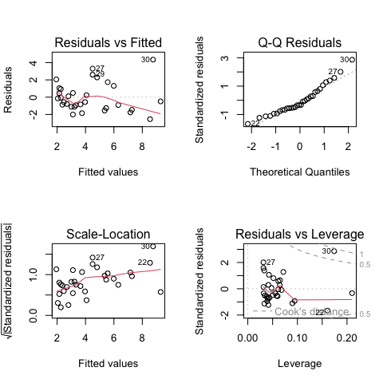

par(mfrow = c(1, 1))

## Interpreting Diagnostic Plots

|  |
| --- |
| Understanding Regression Diagnostic Plots |
| 1. **Residuals vs Fitted**:    * Look for: Random scatter around horizontal line at 0    * Problems: Patterns indicate non-linearity or heteroscedasticity 2. **Q-Q Plot**:    * Look for: Points following the diagonal line    * Problems: Deviations indicate non-normal residuals 3. **Scale-Location**:    * Look for: Random scatter with horizontal trend line    * Problems: Increasing spread indicates heteroscedasticity 4. **Residuals vs Leverage**:    * Look for: Points within Cook’s distance lines    * Problems: Points outside indicate influential observations |

## Formal Tests of Assumptions

# Test for normality of residuals  
shapiro_residuals <- shapiro.test(residuals(lion_model))  
print(paste("Shapiro-Wilk test for residuals: p =", round(shapiro_residuals$p.value, 4)))

[1] "Shapiro-Wilk test for residuals: p = 0.0692"

# Test for homoscedasticity (Breusch-Pagan test)  
library(lmtest)

Loading required package: zoo

Attaching package: 'zoo'

The following objects are masked from 'package:base':  
  
 as.Date, as.Date.numeric

bp_test <- bptest(lion_model)  
print(bp_test)

studentized Breusch-Pagan test  
  
data: lion_model  
BP = 6.8946, df = 1, p-value = 0.008646

|  |
| --- |
| Activity 3: Assess Assumption Violations |
| Based on the diagnostic plots and tests:   1. **Linearity**: Does the relationship appear linear? (Check Residuals vs Fitted plot)    * Your answer: _________________________________ 2. **Normality**: Are the residuals normally distributed? (Check Q-Q plot and Shapiro test)    * Your answer: _________________________________ 3. **Homoscedasticity**: Is the variance constant? (Check Scale-Location plot and BP test)    * Your answer: _________________________________ 4. **Influential points**: Are there any concerning influential observations?    * Your answer: _________________________________ |

# **Part 5:** ANOVA for Regression

## Understanding Variance Partitioning

# Get ANOVA table for regression  
anova_table <- anova(lion_model)  
print("ANOVA Table for Lion Regression:")

[1] "ANOVA Table for Lion Regression:"

print(anova_table)

Analysis of Variance Table  
  
Response: age_years  
 Df Sum Sq Mean Sq F value Pr(>F)   
proportion_black 1 138.544 138.544 49.75 7.677e-08 ***  
Residuals 30 83.543 2.785   
---  
Signif. codes: 0 '***' 0.001 '**' 0.01 '*' 0.05 '.' 0.1 ' ' 1

# Calculate sums of squares manually to understand partitioning  
ss_total <- sum((lion_data$age_years - mean(lion_data$age_years))^2)  
ss_residual <- sum(residuals(lion_model)^2)  
ss_regression <- ss_total - ss_residual  
  
print("\nManual calculation of sums of squares:")

[1] "\nManual calculation of sums of squares:"

print(paste("SS Total:", round(ss_total, 2)))

[1] "SS Total: 222.09"

print(paste("SS Regression:", round(ss_regression, 2)))

[1] "SS Regression: 138.54"

print(paste("SS Residual:", round(ss_residual, 2)))

[1] "SS Residual: 83.54"

print(paste("SS Regression + SS Residual:", round(ss_regression + ss_residual, 2)))

[1] "SS Regression + SS Residual: 222.09"

## Visualizing Variance Components

# Create a plot showing variance components  
# Get predicted values  
lion_data$predicted <- predict(lion_model)  
mean_age <- mean(lion_data$age_years)  
  
# Select one point to illustrate  
example_point <- 10  
  
# Create the visualization  
variance_plot <- ggplot(lion_data, aes(x = proportion_black, y = age_years)) +  
 geom_point(size = 3, alpha = 0.5) +  
 geom_smooth(method = "lm", se = FALSE, color = "blue", size = 1) +  
 geom_hline(yintercept = mean_age, linetype = "dashed", color = "darkgreen") +  
 # Add lines for one example point  
 geom_segment(aes(x = proportion_black[example_point],   
 y = age_years[example_point],  
 xend = proportion_black[example_point],   
 yend = predicted[example_point]),  
 color = "red", size = 1) +  
 geom_segment(aes(x = proportion_black[example_point],   
 y = predicted[example_point],  
 xend = proportion_black[example_point],   
 yend = mean_age),  
 color = "darkgreen", size = 1) +  
 # Add labels  
 annotate("text", x = 0.15, y = mean_age + 0.5,   
 label = "Mean", color = "darkgreen") +  
 annotate("text", x = lion_data$proportion_black[example_point] + 0.05,   
 y = (lion_data$age_years[example_point] + lion_data$predicted[example_point])/2,  
 label = "Residual", color = "red") +  
 annotate("text", x = lion_data$proportion_black[example_point] + 0.05,   
 y = (lion_data$predicted[example_point] + mean_age)/2,  
 label = "Regression", color = "darkgreen") +  
 labs(title = "Variance Components in Regression",  
 subtitle = "Total variation = Regression + Residual",  
 x = "Proportion Black", y = "Age (years)") +  
 theme_minimal()

Warning: Using `size` aesthetic for lines was deprecated in ggplot2 3.4.0.  
ℹ Please use `linewidth` instead.

variance_plot

Warning in geom_segment(aes(x = proportion_black[example_point], y = age_years[example_point], : All aesthetics have length 1, but the data has 32 rows.  
ℹ Please consider using `annotate()` or provide this layer with data containing  
 a single row.

Warning in geom_segment(aes(x = proportion_black[example_point], y = predicted[example_point], : All aesthetics have length 1, but the data has 32 rows.  
ℹ Please consider using `annotate()` or provide this layer with data containing  
 a single row.

`geom_smooth()` using formula = 'y ~ x'

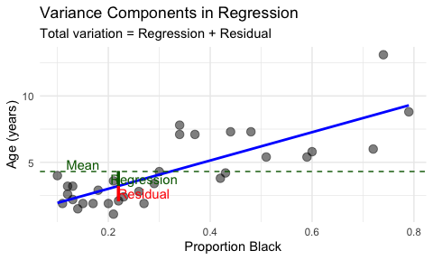

# **Part 6:** Comparing Multiple Datasets

Let’s practice regression with the prairie biodiversity data:

# Fit regression for prairie data  
prairie_model <- lm(log_stability ~ species_number, data = prairie_data)  
  
# Get summary  
summary(prairie_model)

Call:  
lm(formula = log_stability ~ species_number, data = prairie_data)  
  
Residuals:  
 Min 1Q Median 3Q Max   
-0.8146 -0.2165 -0.0094 0.2228 0.7780   
  
Coefficients:  
 Estimate Std. Error t value Pr(>|t|)   
(Intercept) 1.222902 0.039094 31.281 < 2e-16 ***  
species_number 0.028881 0.004694 6.153 5.94e-09 ***  
---  
Signif. codes: 0 '***' 0.001 '**' 0.01 '*' 0.05 '.' 0.1 ' ' 1  
  
Residual standard error: 0.3271 on 159 degrees of freedom  
Multiple R-squared: 0.1923, Adjusted R-squared: 0.1872   
F-statistic: 37.86 on 1 and 159 DF, p-value: 5.94e-09

# Create plot  
prairie_plot <- ggplot(prairie_data, aes(x = species_number, y = log_stability)) +  
 geom_point(alpha = 0.5) +  
 geom_smooth(method = "lm", se = TRUE, color = "darkgreen", fill = "lightgreen") +  
 labs(title = "Biodiversity-Stability Relationship",  
 subtitle = paste("R² =", round(glance(prairie_model)$r.squared, 3)),  
 x = "Number of Plant Species",  
 y = "Log(Stability)") +  
 theme_minimal()  
  
prairie_plot

`geom_smooth()` using formula = 'y ~ x'

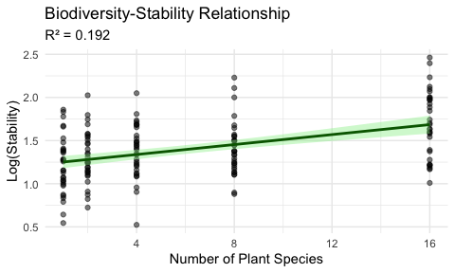

|  |
| --- |
| Activity 4: Compare the Two Regressions |
| Compare the lion and prairie regression models:   1. **Which model explains more variance?** (Compare R² values)    * Your answer: _________________________________ 2. **Which has a stronger relationship?** (Compare standardized slopes or correlation)    * Your answer: _________________________________ 3. **Which has more precise estimates?** (Compare standard errors relative to estimates)    * Your answer: _________________________________ |

# **Summary and Key Takeaways**

|  |
| --- |
| What We Learned Today |
| 1. **Correlation vs. Regression:**    * Correlation: Measures association between two variables    * Regression: Predicts one variable from another 2. **Assumptions Matter:**    * Always check assumptions before interpreting results    * Use appropriate alternatives when assumptions are violated 3. **Interpretation:**    * R² tells us proportion of variance explained    * Slopes tell us rate of change    * P-values tell us if relationships are statistically significant 4. **Practical Considerations:**    * Correlation ≠ Causation    * Outliers can have major impacts    * Sample size affects power to detect relationships |

|  |
| --- |
| Common Mistakes to Avoid |
| 1. **Using correlation when you mean regression** (or vice versa) 2. **Ignoring assumption violations** 3. **Extrapolating beyond the range of data** 4. **Confusing confidence and prediction intervals** 5. **Over-interpreting R² values** 6. **Forgetting about biological significance vs. statistical significance** |

## Additional Resources

* Whitlock & Schluter Chapter 16 (Correlation)
* Whitlock & Schluter Chapter 17 (Regression)
* R for Data Science: <https://r4ds.had.co.nz/>
* Quick-R Regression: <https://www.statmethods.net/stats/regression.html>