Lecture 14 - NESTED ANOVA Visualization

Bill Perry

# Load necessary libraries  
library(tidyverse)  
library(patchwork)  
library(cowplot)  
library(car)  
library(lme4)  
library(lmerTest)  
library(emmeans)  
library(knitr)  
  
library(viridis)  
  
# Set theme for consistent plotting  
theme_set(theme_cowplot())  
  
# Custom theme for consistent plotting  
my_theme <- theme_minimal() +  
 theme(  
 legend.position = "none",  
 plot.title = element_text(face = "bold", size = 10),  
 axis.title = element_text(size = 9),  
 axis.text = element_text(size = 8)  
 )

# 1. Introduction

This document provides a comparison between one-way ANOVA and nested ANOVA using the andrew dataset from Quinn & Keough (2002). This tutorial aims to help students understand how the partitioning of variance differs between these two approaches and why accounting for nested factors is crucial in certain experimental designs.

In the andrew dataset, the experimental design consists of:

* Four urchin density **treatments** (TREAT): Control, 66% Density, 33% Density, and Removed
* Each treatment was replicated within four random **patches** (PATCH)
* Five replicate **quadrats** were measured within each treatment-patch combination
* The response variable is percentage cover of filamentous **algae**

## 1.1 Dataset Overview

First, let’s load and explore the dataset:

# Read in the andrew dataset  
andrew <- read_csv("data/andrew.csv")  
  
# Convert TREAT to factor with meaningful labels  
andrew$TREAT <- factor(andrew$TREAT,   
 levels = c("con", "t0.66", "t0.33", "rem"),  
 labels = c("Control", "66% Density", "33% Density", "Removed"))  
  
# Convert PATCH to factor  
andrew$PATCH <- factor(andrew$PATCH)  
  
# Display the first few rows of the dataset  
head(andrew)

# A tibble: 6 × 4  
 TREAT PATCH QUAD ALGAE  
 <fct> <fct> <dbl> <dbl>  
1 Control 1 1 0  
2 Control 1 2 0  
3 Control 1 3 0  
4 Control 1 4 6  
5 Control 1 5 2  
6 Control 2 1 0

# Calculate summary statistics  
summary_stats <- andrew %>%  
 group_by(TREAT) %>%  
 summarise(  
 n = n(),  
 mean = mean(ALGAE),  
 sd = sd(ALGAE),  
 se = sd / sqrt(n),  
 min = min(ALGAE),  
 max = max(ALGAE)  
 )  
  
# Display summary statistics  
summary_stats

# A tibble: 4 × 7  
 TREAT n mean sd se min max  
 <fct> <int> <dbl> <dbl> <dbl> <dbl> <dbl>  
1 Control 20 1.3 3.18 0.711 0 13  
2 66% Density 20 21.6 25.1 5.62 0 79  
3 33% Density 20 19 25.7 5.74 0 71  
4 Removed 20 39.2 28.7 6.41 0 83

Let’s visualize the data distribution by treatment:

# Create boxplot of algae cover by treatment  
ggplot(andrew, aes(x = TREAT, y = ALGAE, fill = TREAT)) +  
 geom_boxplot(alpha = 0.7, outlier.shape = NA) +  
 geom_jitter(width = 0.2, alpha = 0.4, size = 1) +  
 scale_fill_viridis_d(option = "D", end = 0.85) +  
 labs(  
 title = "Effect of Urchin Density on Filamentous Algae Cover",  
 x = "Urchin Density Treatment",  
 y = "Filamentous Algae Cover (%)"  
 ) +  
 theme(legend.position = "none")

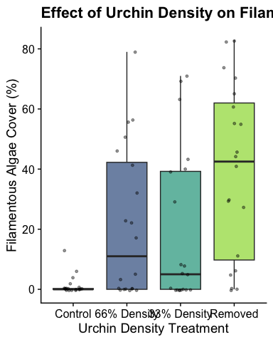

# 2. One-way ANOVA

In a one-way ANOVA, we ignore the nested structure of the data and simply compare the means of the four treatment groups.

# 1. Fit one-way ANOVA  
oneway_model <- aov(ALGAE ~ TREAT, data = andrew)  
oneway_summary <- summary(oneway_model)  
  
# Display one-way ANOVA results  
oneway_summary

Df Sum Sq Mean Sq F value Pr(>F)   
TREAT 3 14429 4810 9.059 3.36e-05 ***  
Residuals 76 40352 531   
---  
Signif. codes: 0 '***' 0.001 '**' 0.01 '*' 0.05 '.' 0.1 ' ' 1

In this one-way ANOVA, we find a significant effect of treatment on algae cover (F(3, 76) = 9.06, p = 0).

# 3. Nested ANOVA

Now, let’s run a nested ANOVA that accounts for the hierarchical structure where patches are nested within treatments.

# 2. Fit nested ANOVA model  
nested_model <- aov(ALGAE ~ TREAT + TREAT:PATCH, data = andrew)  
nested_summary <- summary(nested_model)  
  
# Display nested ANOVA results  
nested_summary

Df Sum Sq Mean Sq F value Pr(>F)   
TREAT 3 14429 4810 16.108 6.58e-08 ***  
TREAT:PATCH 12 21242 1770 5.928 8.32e-07 ***  
Residuals 64 19110 299   
---  
Signif. codes: 0 '***' 0.001 '**' 0.01 '*' 0.05 '.' 0.1 ' ' 1

**Important Note**: The ANOVA table above does not use the correct error terms for testing the treatment effect. In a nested design, the treatment effect should be tested against the patch variation, not the residual error.

## 3.1 Corrected Nested ANOVA with Proper F-tests

Let’s calculate the correct F-ratios and p-values for the nested design:

# Extract MS values  
MS_treat <- nested_summary[[1]]["TREAT ", "Mean Sq"]   
MS_patch <- nested_summary[[1]]["TREAT:PATCH", "Mean Sq"]  
MS_residual <- nested_summary[[1]]["Residuals", "Mean Sq"]  
  
# Extract df values  
df_treat <- nested_summary[[1]]["TREAT ", "Df"]  
df_patch <- nested_summary[[1]]["TREAT:PATCH", "Df"]  
df_residual <- nested_summary[[1]]["Residuals", "Df"]  
  
# Calculate correct F ratios for nested design  
F_treat <- MS_treat / MS_patch  
F_patch <- MS_patch / MS_residual  
  
# Calculate p-values using the correct denominator df  
p_treat <- pf(F_treat, df_treat, df_patch, lower.tail = FALSE)  
p_patch <- pf(F_patch, df_patch, df_residual, lower.tail = FALSE)  
  
# Create ANOVA table with corrected F-tests  
anova_table <- data.frame(  
 Source = c("Treatment", "Patches (within treatment)", "Residual"),  
 df = c(df_treat, df_patch, df_residual),  
 SS = c(nested_summary[[1]]["TREAT ", "Sum Sq"],   
 nested_summary[[1]]["TREAT:PATCH", "Sum Sq"],   
 nested_summary[[1]]["Residuals", "Sum Sq"]),  
 MS = c(MS_treat, MS_patch, MS_residual),  
 F = c(F_treat, F_patch, NA),  
 p = c(p_treat, p_patch, NA)  
)  
  
# Format p-values  
anova_table$p <- ifelse(anova_table$p < 0.001, "<0.001",   
 ifelse(is.na(anova_table$p), NA,   
 format(anova_table$p, digits = 3)))  
  
# Display corrected ANOVA table  
anova_table

Source df SS MS F p  
1 Treatment 3 14429.14 4809.712 2.717102 9.13e-02  
2 Patches (within treatment) 12 21241.95 1770.162 5.928207 <0.001  
3 Residual 64 19110.40 298.600 NA <NA>

With the corrected nested ANOVA, we find:

1. The treatment effect is not significant (F = 2.72, p = 0.0913) when tested against the patch variation.
2. There is significant variation among patches within treatments (F = 5.93, p < 0.001)

This is a different conclusion than the one-way ANOVA, which found a significant treatment effect.

# 4. Variance Decomposition Comparison

## 4.1 Visual Decomposition of Variance Components

First, let’s create a visual representation of how variance is partitioned in a standard one-way ANOVA, and then contrast it with how a nested ANOVA further divides the variance components.

[1] "Treatment means:"

# A tibble: 4 × 2  
 TREAT treat_mean  
 <fct> <dbl>  
1 Control 1.3  
2 66% Density 21.6  
3 33% Density 19   
4 Removed 39.2

[1] "First few rows of joined patch_means:"

# A tibble: 6 × 4  
 TREAT PATCH patch_mean treat_mean  
 <fct> <fct> <dbl> <dbl>  
1 Control 1 1.6 1.3  
2 Control 2 0 1.3  
3 Control 3 1 1.3  
4 Control 4 2.6 1.3  
5 66% Density 5 28.4 21.6  
6 66% Density 6 36.8 21.6

[1] "treat_mean column is present in patch_means"

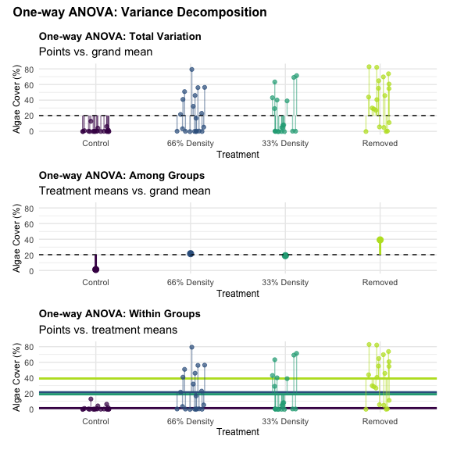

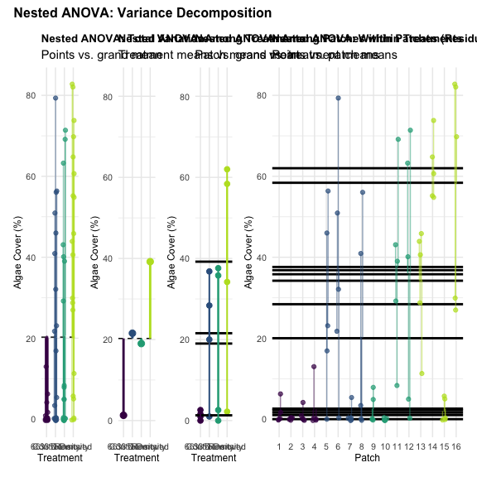

The plots above visually demonstrate the key differences in how variance is partitioned between one-way and nested ANOVA:

1. **One-way ANOVA** (first plot):
   * Total variance is split into just two components: Among Groups (Treatment) and Within Groups (Error)
   * The Within Groups component includes all variation not explained by treatments
2. **Nested ANOVA** (second plot):
   * Total variance is split into three components: Among Treatments, Among Patches within Treatments, and Within Patches (Residual Error)
   * The important addition is the “Among Patches within Treatments” component, which captures the spatial heterogeneity
   * The actual residual error (Within Patches) is smaller than the Within Groups error in one-way ANOVA

This visualization demonstrates why we get different conclusions: in one-way ANOVA, the patch-to-patch variation is incorrectly included in the error term, leading to an artificially inflated F-ratio for treatments.

## 4.2 Numerical Decomposition of Variance

# Calculate sums of squares for both models  
SS_Total <- sum(nested_summary[[1]][, "Sum Sq"])  
SS_Treatment <- nested_summary[[1]]["TREAT ", "Sum Sq"]  
SS_Patch_within_Treatment <- nested_summary[[1]]["TREAT:PATCH", "Sum Sq"]  
SS_Error_Nested <- nested_summary[[1]]["Residuals", "Sum Sq"]  
SS_Error_OneWay <- oneway_summary[[1]]["Residuals", "Sum Sq"]  
  
# Calculate percentages for visualization  
percent_treatment_oneway <- (SS_Treatment / SS_Total) * 100  
percent_error_oneway <- (SS_Error_OneWay / SS_Total) * 100  
  
percent_treatment_nested <- (SS_Treatment / SS_Total) * 100  
percent_patch_nested <- (SS_Patch_within_Treatment / SS_Total) * 100  
percent_error_nested <- (SS_Error_Nested / SS_Total) * 100  
  
# Create data frame for visualization  
ss_comparison <- data.frame(  
 Model = c(  
 rep("One-way ANOVA", 2),   
 rep("Nested ANOVA", 3)  
 ),  
 Source = c(  
 "Treatment", "Error (within)",  
 "Treatment", "Patch(Treatment)", "Error"  
 ),  
 Percent = c(  
 percent_treatment_oneway, percent_error_oneway,  
 percent_treatment_nested, percent_patch_nested, percent_error_nested  
 ),  
 SS = c(  
 SS_Treatment, SS_Error_OneWay,  
 SS_Treatment, SS_Patch_within_Treatment, SS_Error_Nested  
 )  
)  
  
# Add factor levels for ordering  
ss_comparison$Source <- factor(  
 ss_comparison$Source,  
 levels = c("Treatment", "Patch(Treatment)", "Error", "Error (within)")  
)  
  
# Create colors for the sources  
source_colors <- c(  
 "Treatment" = "#1b9e77",   
 "Patch(Treatment)" = "#d95f02",   
 "Error" = "#7570b3",  
 "Error (within)" = "#7570b3"  
)  
  
# Create the stacked bar plot  
p1 <- ggplot(ss_comparison, aes(x = Model, y = Percent, fill = Source)) +  
 geom_bar(stat = "identity", position = "stack", color = "black") +  
 scale_fill_manual(values = source_colors) +  
 labs(  
 title = "Comparison of Variance Partitioning",  
 subtitle = "One-way vs. Nested ANOVA",  
 x = "",  
 y = "Percentage of Total Variance",  
 fill = "Source of Variation"  
 ) +  
 geom_text(  
 aes(label = sprintf("%.1f%%", Percent)),  
 position = position_stack(vjust = 0.5),  
 color = "white",  
 fontface = "bold"  
 ) +  
 theme(  
 plot.title = element_text(face = "bold", size = 14),  
 legend.position = "right",  
 axis.text.x = element_text(face = "bold", size = 12)  
 )  
  
# Create a pie chart version for one-way ANOVA  
oneway_data <- ss_comparison %>% filter(Model == "One-way ANOVA")  
oneway_data$ypos <- cumsum(oneway_data$Percent) - 0.5 * oneway_data$Percent  
  
p2 <- ggplot(oneway_data, aes(x = "", y = Percent, fill = Source)) +  
 geom_bar(stat = "identity", width = 1, color = "black") +  
 coord_polar("y", start = 0) +  
 labs(  
 title = "One-way ANOVA",  
 subtitle = "Variance Components",  
 fill = "Source of Variation"  
 ) +  
 scale_fill_manual(values = source_colors) +  
 geom_text(  
 aes(y = ypos, label = sprintf("%.1f%%", Percent)),  
 color = "white",  
 fontface = "bold"  
 ) +  
 theme_void() +  
 theme(  
 plot.title = element_text(face = "bold", size = 14, hjust = 0.5),  
 plot.subtitle = element_text(hjust = 0.5),  
 legend.position = "bottom"  
 )  
  
# Create a pie chart version for nested ANOVA  
nested_data <- ss_comparison %>% filter(Model == "Nested ANOVA")  
nested_data$ypos <- cumsum(nested_data$Percent) - 0.5 * nested_data$Percent  
  
p3 <- ggplot(nested_data, aes(x = "", y = Percent, fill = Source)) +  
 geom_bar(stat = "identity", width = 1, color = "black") +  
 coord_polar("y", start = 0) +  
 labs(  
 title = "Nested ANOVA",  
 subtitle = "Variance Components",  
 fill = "Source of Variation"  
 ) +  
 scale_fill_manual(values = source_colors) +  
 geom_text(  
 aes(y = ypos, label = sprintf("%.1f%%", Percent)),  
 color = "white",  
 fontface = "bold"  
 ) +  
 theme_void() +  
 theme(  
 plot.title = element_text(face = "bold", size = 14, hjust = 0.5),  
 plot.subtitle = element_text(hjust = 0.5),  
 legend.position = "bottom"  
 )  
  
# Display all plots  
p1

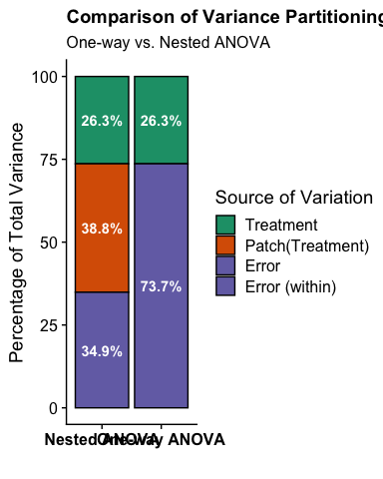

# Combine the pie charts  
p2 + p3 + plot_layout(ncol = 2)

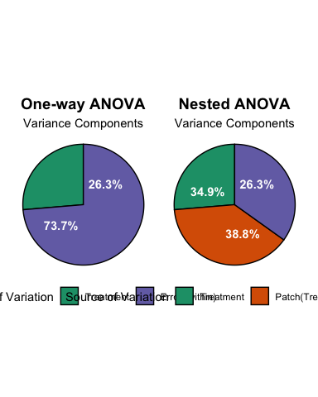

# 5. Mixed-Effects Model Approach

A modern way to analyze nested designs is to use mixed-effects models. Let’s compare the results with our previous analyses:

# Fit linear mixed model with PATCH nested in TREAT  
mixed_model <- lmer(ALGAE ~ TREAT + (1|TREAT:PATCH), data = andrew)  
  
# Show model summary  
summary(mixed_model)

Linear mixed model fit by REML. t-tests use Satterthwaite's method [  
lmerModLmerTest]  
Formula: ALGAE ~ TREAT + (1 | TREAT:PATCH)  
 Data: andrew  
  
REML criterion at convergence: 682.2  
  
Scaled residuals:   
 Min 1Q Median 3Q Max   
-1.9808 -0.3106 -0.1093 0.2831 2.5910   
  
Random effects:  
 Groups Name Variance Std.Dev.  
 TREAT:PATCH (Intercept) 294.3 17.16   
 Residual 298.6 17.28   
Number of obs: 80, groups: TREAT:PATCH, 16  
  
Fixed effects:  
 Estimate Std. Error df t value Pr(>|t|)   
(Intercept) 1.300 9.408 12.000 0.138 0.8924   
TREAT66% Density 20.250 13.305 12.000 1.522 0.1539   
TREAT33% Density 17.700 13.305 12.000 1.330 0.2081   
TREATRemoved 37.900 13.305 12.000 2.849 0.0147 *  
---  
Signif. codes: 0 '***' 0.001 '**' 0.01 '*' 0.05 '.' 0.1 ' ' 1  
  
Correlation of Fixed Effects:  
 (Intr) TREAT6D TREAT3D  
TREAT66%Dns -0.707   
TREAT33%Dns -0.707 0.500   
TREATRemovd -0.707 0.500 0.500

# ANOVA-style results  
anova(mixed_model, type = 3, ddf = "Satterthwaite")

Type III Analysis of Variance Table with Satterthwaite's method  
 Sum Sq Mean Sq NumDF DenDF F value Pr(>F)   
TREAT 2434 811.33 3 12 2.7171 0.09126 .  
---  
Signif. codes: 0 '***' 0.001 '**' 0.01 '*' 0.05 '.' 0.1 ' ' 1

The mixed model approach gives us similar conclusions to the correctly specified nested ANOVA. The treatment effect is non-significant when accounting for the nested structure of patches within treatments.

# 6. Visualizing the Nested Structure

One way to understand why we get different results is to visualize the data by patch within treatment:

# Calculate means for each patch  
patch_means <- andrew %>%  
 group_by(TREAT, PATCH) %>%  
 summarize(ALGAE_mean = mean(ALGAE), .groups = "drop")  
  
# Plot patch means  
ggplot() +  
 # Plot patch means  
 geom_point(data = patch_means,   
 aes(x = TREAT, y = ALGAE_mean, color = PATCH),  
 position = position_jitterdodge(jitter.width = 0.1, dodge.width = 0.7),  
 size = 3) +  
 # Add treatment means  
 geom_point(data = summary_stats,   
 aes(x = TREAT, y = mean),  
 size = 5, shape = 18, color = "black") +  
 # Add error bars for treatment means  
 geom_errorbar(data = summary_stats,  
 aes(x = TREAT, ymin = mean - se, ymax = mean + se),  
 width = 0.2, color = "black", linewidth = 1) +  
 # Plot styling  
 scale_color_viridis_d(option = "plasma", end = 0.9) +  
 labs(  
 title = "Nested Structure: Patch Means within Treatments",  
 subtitle = "Large symbols show treatment means (± SE)",  
 x = "Urchin Density Treatment",  
 y = "Mean Filamentous Algae Cover (%)",  
 color = "Patch"  
 ) +  
 theme(  
 legend.position = "right",  
 plot.title = element_text(face = "bold")  
 )

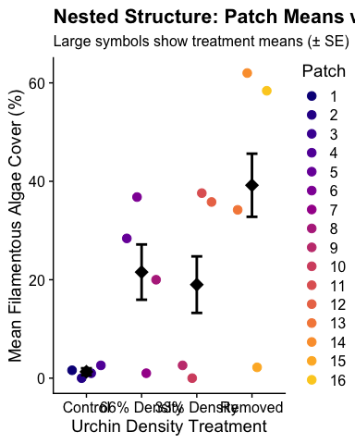

This plot clearly shows the high variation among patches within each treatment. This patch-to-patch variation contributes substantially to the total variance, which is not accounted for in the one-way ANOVA.

# 7. F-ratio Demonstration

Let’s illustrate how the F-ratio for treatments differs between one-way and nested ANOVA:

# Create a data frame for comparison  
f_ratio_comparison <- data.frame(  
 Model = c("One-way ANOVA", "Nested ANOVA"),  
 F_numerator = c("MS Treatment", "MS Treatment"),  
 F_denominator = c("MS Residual", "MS Patch(Treatment)"),  
 F_value = c(oneway_summary[[1]][1, "F value"], F_treat),  
 p_value = c(oneway_summary[[1]][1, "Pr(>F)"], p_treat)  
)  
  
# Display the comparison  
f_ratio_comparison

Model F_numerator F_denominator F_value p_value  
1 One-way ANOVA MS Treatment MS Residual 9.058658 3.362391e-05  
2 Nested ANOVA MS Treatment MS Patch(Treatment) 2.717102 9.126200e-02

# 8. Key Differences and Implications

The comparison between one-way ANOVA and nested ANOVA reveals several important differences:

1. **Variance Partitioning**:
   * In one-way ANOVA, all variation not explained by treatments is lumped into the “Error” term.
   * In nested ANOVA, this variation is partitioned into “Patch(Treatment)” and “Error” components.
2. **F-ratio for Testing Treatment Effects**:
   * One-way ANOVA tests treatments against residual error (MS Treatment / MS Residual).
   * Nested ANOVA tests treatments against patch variation (MS Treatment / MS Patch(Treatment)).
3. **Biological Interpretation**:
   * One-way ANOVA suggests significant treatment effects (p = 0).
   * Nested ANOVA reveals that most variation is among patches, with non-significant treatment effects (p = 0.0913).
   * The substantial patch variability (38.8% of total variation) masks the treatment effect when properly accounted for.
4. **Statistical Power and Type I Error**:
   * Ignoring the nested structure leads to pseudoreplication and inflated Type I error rates.
   * The one-way ANOVA effectively treats each quadrat as an independent sample, inflating the degrees of freedom for the error term.

# 9. Conclusion

This demonstration illustrates why accounting for hierarchical or nested structures in experimental designs is crucial for valid statistical inference. Failure to account for such structures can lead to:

1. Pseudoreplication (treating non-independent samples as independent)
2. Inflation of Type I error rates (finding spurious “significant” effects)
3. Incorrect partitioning of variance sources
4. Misleading biological interpretations

In the andrew dataset, the nested ANOVA reveals that spatial heterogeneity (patch-to-patch variation) is the dominant factor influencing algae cover, not the experimental treatment. This insight would be missed if only a one-way ANOVA were used.

## 9.1 Alternative Code for Mixed Models

For advanced users, we could also fit this as a mixed model with lmerTest:

library(lmerTest)  
  
# Mixed model with patches nested within treatments  
mixed_model_alt <- lmer(ALGAE ~ TREAT + (1|TREAT:PATCH), data = andrew)  
anova(mixed_model_alt, type = 3, ddf = "Satterthwaite")

Type III Analysis of Variance Table with Satterthwaite's method  
 Sum Sq Mean Sq NumDF DenDF F value Pr(>F)   
TREAT 2434 811.33 3 12 2.7171 0.09126 .  
---  
Signif. codes: 0 '***' 0.001 '**' 0.01 '*' 0.05 '.' 0.1 ' ' 1

# We could also try a simpler random effects structure  
simple_mixed_model <- lmer(ALGAE ~ TREAT + (1|PATCH), data = andrew)  
anova(simple_mixed_model, type = 3, ddf = "Satterthwaite")

Type III Analysis of Variance Table with Satterthwaite's method  
 Sum Sq Mean Sq NumDF DenDF F value Pr(>F)   
TREAT 2434 811.33 3 12 2.7171 0.09126 .  
---  
Signif. codes: 0 '***' 0.001 '**' 0.01 '*' 0.05 '.' 0.1 ' ' 1

Mixed models provide a more flexible approach to handle nested designs and are the recommended approach in modern statistical practice.