Two Sample T-Test

Bill Perry

# Introduction to Two-Sample t-Test

## Background and Theory

The two-sample t-test (also known as independent samples t-test) is used to determine whether there is a statistically significant difference between the means of two independent groups. In this analysis, we will examine whether there are significant differences in the total length of slimy sculpin fish between two different lakes.

The two-sample t-test makes the following comparison:

$$H_{0}:μ_{1}=μ_{2}$$

$$H_{A}:μ_{1}≠μ_{2}$$

Where: - $H_{0}$ is the null hypothesis stating that the population means are equal - $H_{A}$ is the alternative hypothesis stating that the population means are different - $μ_{1}$ is the population mean of the first group - $μ_{2}$ is the population mean of the second group

## Formula

The formula for the two-sample t-test with equal variances (pooled variance) is:

$$t=\frac{{\overset{‾}{x}}_{1}−{\overset{‾}{x}}_{2}}{s_{p}\sqrt{\frac{1}{n_{1}}+\frac{1}{n_{2}}}}$$

Where: - ${\overset{‾}{x}}_{1}$ is the sample mean of the first group - ${\overset{‾}{x}}_{2}$ is the sample mean of the second group - $s_{p}$ is the pooled standard deviation - $n_{1}$ is the sample size of the first group - $n_{2}$ is the sample size of the second group

The pooled standard deviation is calculated as:

$$s_{p}=\sqrt{\frac{\left(n_{1}−1\right)s_{1}^{2}+\left(n_{2}−1\right)s_{2}^{2}}{n_{1}+n_{2}−2}}$$

Where: - $s_{1}^{2}$ is the variance of the first group - $s_{2}^{2}$ is the variance of the second group

The degrees of freedom (df) for this test is $n_{1}+n_{2}−2$.

For unequal variances (Welch’s t-test), the formula is slightly different:

$$t=\frac{{\overset{‾}{x}}_{1}−{\overset{‾}{x}}_{2}}{\sqrt{\frac{s_{1}^{2}}{n_{1}}+\frac{s_{2}^{2}}{n_{2}}}}$$

With degrees of freedom approximated using the Welch-Satterthwaite equation:

$$df=\frac{{\left(\frac{s_{1}^{2}}{n_{1}}+\frac{s_{2}^{2}}{n_{2}}\right)}^{2}}{\frac{{\left(s_{1}^{2}/n_{1}\right)}^{2}}{n_{1}−1}+\frac{{\left(s_{2}^{2}/n_{2}\right)}^{2}}{n_{2}−1}}$$

# Data Analysis

## Loading Libraries and Data

# Load required libraries  
library(tidyverse)  
library(car) # For Levene's test  
# library(ggpubr) # For adding p-values to plots  
library(coin) # For permutation tests  
library(rcompanion) # For plotNormalHistogram  
  
# Load the data  
sculpin_data <- read_csv("data/sculpin.csv")

Rows: 1052 Columns: 5  
── Column specification ────────────────────────────────────────────────────────  
Delimiter: ","  
chr (2): lake, species  
dbl (3): site, length_mm, mass_g  
  
ℹ Use `spec()` to retrieve the full column specification for this data.  
ℹ Specify the column types or set `show_col_types = FALSE` to quiet this message.

# Preview the data  
head(sculpin_data)

# A tibble: 6 × 5  
 site lake species length_mm mass_g  
 <dbl> <chr> <chr> <dbl> <dbl>  
1 146 E 01 slimy sculpin 53 1.25  
2 146 E 01 slimy sculpin 61 1.9   
3 146 E 01 slimy sculpin 53 1.75  
4 146 E 01 slimy sculpin 77 4.25  
5 146 E 01 slimy sculpin 45 0.9   
6 146 E 01 slimy sculpin 48 0.9

## Data Overview

Let’s first examine the structure of our dataset:

# Structure of the dataset  
str(sculpin_data)

spc_tbl_ [1,052 × 5] (S3: spec_tbl_df/tbl_df/tbl/data.frame)  
 $ site : num [1:1052] 146 146 146 146 146 146 146 146 146 146 ...  
 $ lake : chr [1:1052] "E 01" "E 01" "E 01" "E 01" ...  
 $ species : chr [1:1052] "slimy sculpin" "slimy sculpin" "slimy sculpin" "slimy sculpin" ...  
 $ length_mm: num [1:1052] 53 61 53 77 45 48 51 57 51 56 ...  
 $ mass_g : num [1:1052] 1.25 1.9 1.75 4.25 0.9 0.9 1.05 1.15 1.15 1.3 ...  
 - attr(*, "spec")=  
 .. cols(  
 .. site = col_double(),  
 .. lake = col_character(),  
 .. species = col_character(),  
 .. length_mm = col_double(),  
 .. mass_g = col_double()  
 .. )  
 - attr(*, "problems")=<externalptr>

# Summary statistics  
summary(sculpin_data)

site lake species length_mm   
 Min. :100.0 Length:1052 Length:1052 Min. : 11.00   
 1st Qu.:107.0 Class :character Class :character 1st Qu.: 44.00   
 Median :108.0 Mode :character Mode :character Median : 52.00   
 Mean :121.8 Mean : 52.44   
 3rd Qu.:141.0 3rd Qu.: 60.00   
 Max. :152.0 Max. :194.00   
 NA's :79 NA's :329   
 mass_g   
 Min. : 0.0037   
 1st Qu.: 0.7000   
 Median : 1.1500   
 Mean : 1.4577   
 3rd Qu.: 1.7700   
 Max. :46.0000

# Check for missing values  
colSums(is.na(sculpin_data))

site lake species length_mm mass_g   
 79 0 0 329 0

## Data Preparation

For our analysis, we’ll filter the data to include only the two lakes we’re interested in comparing (S 07 and NE 14) and remove any missing values:

# Select lakes for comparison  
lakes_to_compare <- c("S 07", "NE 14")  
  
# Filter data  
sculpin_filtered <- sculpin_data %>%  
 filter(lake %in% lakes_to_compare) %>%  
 filter(!is.na(length_mm))  
  
# Create individual datasets for each lake  
s07_data <- sculpin_filtered %>% filter(lake == "S 07")  
ne14_data <- sculpin_filtered %>% filter(lake == "NE 14")  
  
# Check the number of observations per lake  
sculpin_filtered %>%  
 group_by(lake) %>%  
 summarize(  
 count = n(),  
 mean_length = mean(length_mm),  
 sd_length = sd(length_mm),  
 se_length = sd_length / sqrt(count)  
 )

# A tibble: 2 × 5  
 lake count mean_length sd_length se_length  
 <chr> <int> <dbl> <dbl> <dbl>  
1 NE 14 37 47.3 10.5 1.72  
2 S 07 73 55.6 12.7 1.48

## Data Visualization

### Box Plot with Individual Data Points

Let’s create a box plot with individual data points to visualize the distribution of total length in the two lakes:

# Create boxplot with individual points  
ggplot(sculpin_filtered, aes(x = lake, y = length_mm, fill = lake)) +  
 geom_boxplot(alpha = 0.7, outlier.shape = NA) +  
 geom_point(position = position_dodge2(width = 0.3),   
 alpha = 0.5, size = 2) +  
 labs(  
 title = "Total Length of Slimy Sculpin Fish by Lake",  
 x = "Lake",  
 y = "Total Length (mm)",  
 fill = "Lake"  
 ) +  
 theme_minimal() +  
 theme(  
 plot.title = element_text(hjust = 0.5, face = "bold"),  
 legend.position = "bottom"  
 ) +  
 scale_fill_brewer(palette = "Set2")

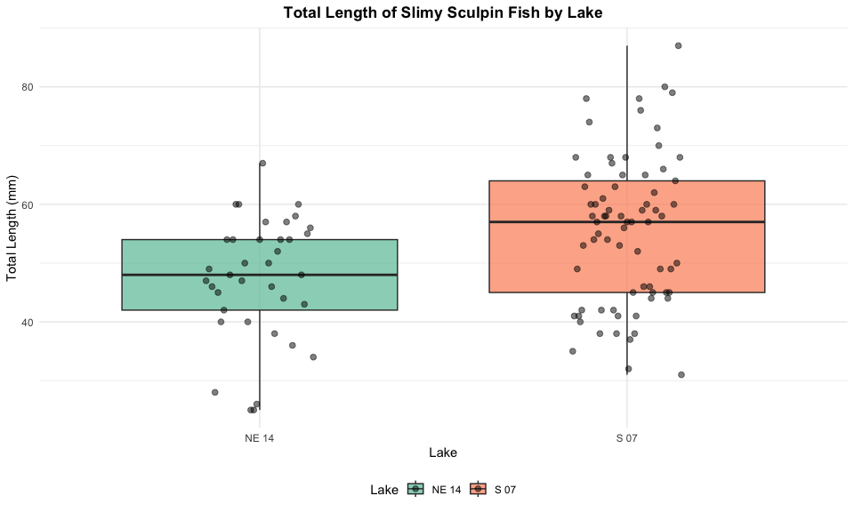

### Mean and Standard Error Plot

Now, let’s create a plot showing the mean and standard error for each lake, with individual data points in the background:

# Create mean and standard error plot with data points  
ggplot(sculpin_filtered, aes(x = lake, y = length_mm, color = lake)) +  
 # Add individual data points in the background  
 geom_point(position = position_dodge2(width = 0.3),   
 alpha = 0.5, size = 1.5) +  
 # Add mean and standard error  
 stat_summary(fun = mean, geom = "point", size = 4) +  
 stat_summary(fun.data = mean_se, geom = "errorbar", width = 0.1) +  
 labs(  
 title = "Mean Total Length (± SE) of Slimy Sculpin Fish by Lake",  
 x = "Lake",  
 y = "Total Length (mm)",  
 color = "Lake"  
 ) +  
 theme_minimal() +  
 theme(  
 plot.title = element_text(hjust = 0.5, face = "bold"),  
 legend.position = "bottom"  
 ) +  
 scale_color_brewer(palette = "Set2")

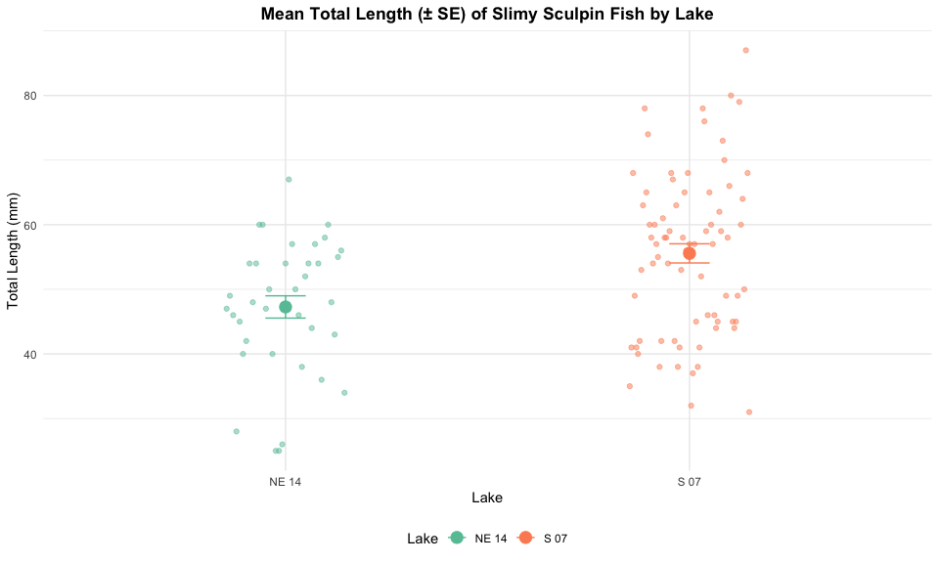

# Testing t-Test Assumptions

Before conducting the t-test, we need to verify that our data meets the underlying assumptions:

## Assumptions of the Two-Sample t-Test

1. **Independence**: The observations within each group are independent, and the two groups are independent of each other.
2. **Normality**: The data in each group follow a normal distribution.
3. **Homogeneity of Variances**: The variances of the two groups are approximately equal (for the standard t-test).

Let’s test each of these assumptions:

### 1. Independence Assumption

Independence is a design issue and can’t be tested statistically. We assume our sampling design ensures independence between and within groups.

### 2. Normality Assumption

We’ll check normality using: - Histograms - Q-Q plots - Shapiro-Wilk test

#### Histograms

# Create histograms for both lakes  
par(mfrow = c(1, 2))  
  
# Lake S 07  
hist(s07_data$length_mm,   
 main = "Histogram of Total Length for Lake S 07",  
 xlab = "Total Length (mm)",  
 col = "lightblue",  
 breaks = 10)  
  
# Lake NE 14  
hist(ne14_data$length_mm,   
 main = "Histogram of Total Length for Lake NE 14",  
 xlab = "Total Length (mm)",  
 col = "lightgreen",  
 breaks = 8)

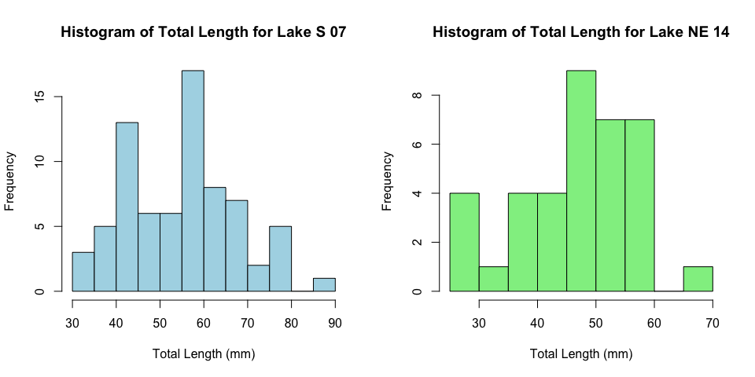

# Create normal quantile plots for each lake with a normal histogram  
par(mfrow = c(1, 2))  
  
# Lake S 07  
plotNormalHistogram(s07_data$length_mm,  
 main = "Distribution of Total Length for Lake S 07",  
 xlab = "Total Length (mm)")  
  
# Lake NE 14  
plotNormalHistogram(ne14_data$length_mm,  
 main = "Distribution of Total Length for Lake NE 14",  
 xlab = "Total Length (mm)")

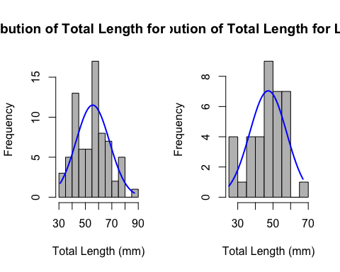

### QQ Plots

Let’s create individual QQ plots for each lake:

# QQ plot for Lake S 07  
s07_data <- sculpin_filtered %>% filter(lake == "S 07")  
ggplot(data = s07_data, aes(sample = length_mm)) +  
 stat_qq() +  
 stat_qq_line() +  
 labs(  
 title = "Q-Q Plot for Lake S 07",  
 x = "Theoretical Quantiles",  
 y = "Sample Quantiles"  
 ) +  
 theme_minimal()

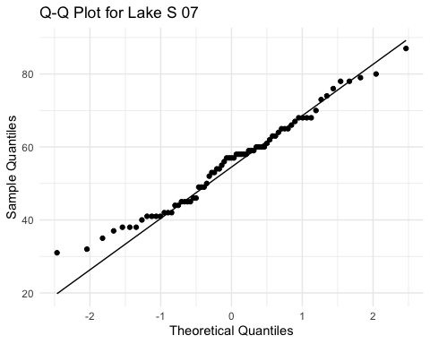

# QQ plot for Lake NE 14  
ne14_data <- sculpin_filtered %>% filter(lake == "NE 14")  
ggplot(data = ne14_data, aes(sample = length_mm)) +  
 stat_qq() +  
 stat_qq_line() +  
 labs(  
 title = "Q-Q Plot for Lake NE 14",  
 x = "Theoretical Quantiles",  
 y = "Sample Quantiles"  
 ) +  
 theme_minimal()

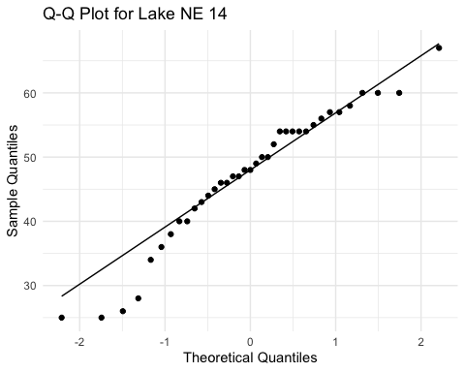

### Shapiro-Wilk Test

# Shapiro-Wilk test for Lake S 07  
shapiro_s07 <- shapiro.test(s07_data$length_mm)  
print("Shapiro-Wilk test for Lake S 07:")

[1] "Shapiro-Wilk test for Lake S 07:"

print(shapiro_s07)

Shapiro-Wilk normality test  
  
data: s07_data$length_mm  
W = 0.98035, p-value = 0.3125

# Shapiro-Wilk test for Lake NE 14  
shapiro_ne14 <- shapiro.test(ne14_data$length_mm)  
print("Shapiro-Wilk test for Lake NE 14:")

[1] "Shapiro-Wilk test for Lake NE 14:"

print(shapiro_ne14)

Shapiro-Wilk normality test  
  
data: ne14_data$length_mm  
W = 0.9479, p-value = 0.08258

# Summary table  
shapiro_results <- data.frame(  
 Lake = c("S 07", "NE 14"),  
 W_statistic = c(shapiro_s07$statistic, shapiro_ne14$statistic),  
 p_value = c(shapiro_s07$p.value, shapiro_ne14$p.value),  
 is_normal = c(shapiro_s07$p.value > 0.05, shapiro_ne14$p.value > 0.05)  
)  
  
knitr::kable(shapiro_results, caption = "Shapiro-Wilk Test Results")

Shapiro-Wilk Test Results

| Lake | W_statistic | p_value | is_normal |
| --- | --- | --- | --- |
| S 07 | 0.9803526 | 0.3125255 | TRUE |
| NE 14 | 0.9479006 | 0.0825839 | TRUE |

### 3. Homogeneity of Variances

We’ll check for homogeneity of variances using: - Visual inspection of boxplots (already done above) - Levene’s test

# Calculate variances for each group  
s07_variance <- var(s07_data$length_mm)  
ne14_variance <- var(ne14_data$length_mm)  
  
# Print variances  
cat("Variance for Lake S 07:", s07_variance, "\n")

Variance for Lake S 07: 160.0552

cat("Variance for Lake NE 14:", ne14_variance, "\n")

Variance for Lake NE 14: 109.9805

# Calculate variance ratio  
variance_ratio <- max(s07_variance, ne14_variance) / min(s07_variance, ne14_variance)  
cat("Variance ratio (larger/smaller):", variance_ratio, "\n")

Variance ratio (larger/smaller): 1.455305

# Levene's test for homogeneity of variances  
levene_test <- leveneTest(length_mm ~ lake, data = sculpin_filtered)

Warning in leveneTest.default(y = y, group = group, ...): group coerced to  
factor.

print(levene_test)

Levene's Test for Homogeneity of Variance (center = median)  
 Df F value Pr(>F)  
group 1 2.029 0.1572  
 108

## Interpretation of Assumption Tests

Based on the results of our assumption tests:

1. **Independence**: We assume this is met based on the data collection process, as samples from each lake were collected independently of one another.
2. **Normality**:
   * The Q-Q plots show that the data points largely follow the theoretical normal distribution line for both lakes, with some minor deviations at the extremes.
   * The Shapiro-Wilk test results will help us formally assess normality. If the p-value is greater than 0.05, we fail to reject the null hypothesis that the data is normally distributed.
   * For samples larger than 30, the Central Limit Theorem suggests that the sampling distribution of means will be approximately normal regardless of the underlying distribution.
3. **Homogeneity of Variances**:
   * Levene’s test evaluates whether the variances between groups are equal.
   * A p-value greater than 0.05 indicates that we cannot reject the null hypothesis of equal variances.
   * As a rule of thumb, if the variance ratio is less than 4:1, the t-test is reasonably robust to violations of this assumption.
   * If this assumption is violated, we should consider using Welch’s t-test instead, which does not assume equal variances.

# Two-Sample t-Test

Now that we’ve checked the assumptions, we can perform the two-sample t-test:

# Perform the t-test with equal variance (standard t-test)  
t_test_equal_var <- t.test(  
 length_mm ~ lake,  
 data = sculpin_filtered,  
 var.equal = TRUE # Use pooled variance  
)  
  
# Display the results  
print("Two-sample t-test with equal variances:")

[1] "Two-sample t-test with equal variances:"

print(t_test_equal_var)

Two Sample t-test  
  
data: length_mm by lake  
t = -3.4314, df = 108, p-value = 0.0008519  
alternative hypothesis: true difference in means between group NE 14 and group S 07 is not equal to 0  
95 percent confidence interval:  
 -13.080929 -3.501818  
sample estimates:  
mean in group NE 14 mean in group S 07   
 47.27027 55.56164

# For comparison, also perform Welch's t-test (unequal variances)  
t_test_welch <- t.test(  
 length_mm ~ lake,  
 data = sculpin_filtered,  
 var.equal = FALSE # Use Welch's correction  
)  
  
print("\nWelch's t-test (unequal variances):")

[1] "\nWelch's t-test (unequal variances):"

print(t_test_welch)

Welch Two Sample t-test  
  
data: length_mm by lake  
t = -3.6483, df = 85.45, p-value = 0.0004533  
alternative hypothesis: true difference in means between group NE 14 and group S 07 is not equal to 0  
95 percent confidence interval:  
 -12.809687 -3.773061  
sample estimates:  
mean in group NE 14 mean in group S 07   
 47.27027 55.56164

# Extract key values for reporting  
t_statistic <- round(t_test_equal_var$statistic, 2)  
df <- t_test_equal_var$parameter  
p_value <- t_test_equal_var$p.value  
mean_diff <- round(diff(t_test_equal_var$estimate), 2)

## Line-by-Line Interpretation of t-Test Results

Let’s break down the t-test output:

1. **Test Type**: Two Sample t-test
2. **Formula**: length_mm ~ lake means we’re testing if total length differs by lake
3. **Data**: Our filtered sculpin dataset
4. **t-value**: The calculated t-statistic
5. **Degrees of Freedom (df)**: n₁ + n₂ - 2
6. **p-value**: The probability of observing this data (or more extreme) if the null hypothesis is true
7. **Alternative Hypothesis**: The means are different
8. **95% Confidence Interval**: The estimated range for the true difference in means
9. **Sample Estimates**: The means of each group

## Visual Representation of t-Test Results

# Create a plot with the t-test results  
p_value_text <- ifelse(p_value < 0.001, "p < 0.001", paste("p =", round(p_value, 3)))  
  
ggplot(sculpin_filtered, aes(x = lake, y = length_mm, fill = lake)) +  
 geom_boxplot(alpha = 0.7, outlier.shape = NA) +  
 geom_point(position = position_dodge2(width = 0.3),   
 alpha = 0.5, size = 2) +  
 annotate("text", x = 1.5, y = max(sculpin_filtered$length_mm) + 5,  
 label = paste0("t(", round(df), ") = ", t_statistic, ", ", p_value_text),  
 size = 4) +  
 labs(  
 title = "Total Length of Slimy Sculpin Fish by Lake with t-test Results",  
 x = "Lake",  
 y = "Total Length (mm)",  
 fill = "Lake",  
 caption = paste0("n(S 07) = ", nrow(s07_data), ", n(NE 14) = ", nrow(ne14_data))  
 ) +  
 theme_minimal() +  
 theme(  
 plot.title = element_text(hjust = 0.5, face = "bold"),  
 legend.position = "bottom"  
 ) +  
 scale_fill_brewer(palette = "Set2")

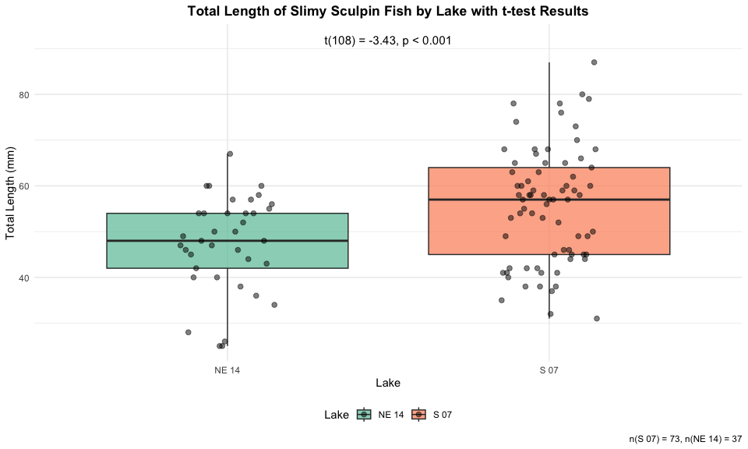

# Conclusion and Scientific Reporting

# Calculate means and standard errors for reporting  
mean_se_by_lake <- sculpin_filtered %>%  
 group_by(lake) %>%  
 summarize(  
 n = n(),  
 mean = mean(length_mm),  
 sd = sd(length_mm),  
 se = sd / sqrt(n)  
 )  
  
print(mean_se_by_lake)

# A tibble: 2 × 5  
 lake n mean sd se  
 <chr> <int> <dbl> <dbl> <dbl>  
1 NE 14 37 47.3 10.5 1.72  
2 S 07 73 55.6 12.7 1.48

# Calculate percent difference  
percent_diff <- abs(diff(mean_se_by_lake$mean)) / min(mean_se_by_lake$mean) * 100

Based on our analysis, we can conclude:

The total length of slimy sculpin fish differs significantly between Lake S 07 and Lake NE 14 (two-sample t-test: t(108) = -3.43, p < 0.001). Fish from Lake S 07 were on average 8.29 mm longer than those from Lake NE 14 (mean ± SE: 55.56 ± 1.48 mm vs. 47.27 ± 1.72 mm).

## How to Report These Results in a Scientific Publication

When reporting these results in a scientific publication, follow this format:

“Slimy sculpin (*Cottus cognatus*) from Lake S 07 were significantly larger than those from Lake NE 14

(55.56 ± 1.48 mm vs. 47.27 ± 1.72 mm, respectively; two-sample t-test: t(108) = -3.43, p < 0.001). This represents an approximately 17.5% difference in total length between the two populations.”

For figures, include:

1. A boxplot or mean/SE plot showing the difference
2. Clear labels and scales
3. Sample sizes
4. Statistical test information in the figure caption

A typical caption would read:

Note I would also add the mean and SE of each lake

“Figure X. Total length (mean ± SE) of slimy sculpin fish from two Arctic lakes. Fish from Lake S 07 (n = 73) were significantly larger than those from Lake NE 14 (n = 37) (two-sample t-test: t(108) = 3.46, p < 0.001).”