H statements:
In this study I tested four hypotheses about the winter and summer plankton abundance in seasonally frozen lakes. First (H1), I tested the null hypothesis that average chl. a concentrations did not differ for the same set of lakes between winter and summer (H_{o}: µ_{sumchla}= µ_{sumchla}; H_{a}: µ_{sumchla}≠ µ_{sumchla}). Second…
Statistical methods:
Assumptions of normality for all tests were assessed using histogram plots. For paired tests, the assumption of normality was assessed on the differences between summer and winter chl. a and zooplankton concentrations. For independent tests, assumptions of normality were assessed on the values for productive and unproductive values. Equal variance assumptions for independent tests were assessed using boxplots. Data that did not meet assumptions of normality or equal variance was transformed using power or log transformations. In cases where transformations were unsuccessful in transforming the data to approximate normality or equal variance, non-parametric tests were used. All analyses were performed using the R statistical computing environment (version 3.1.2). A significance cutoff (α) of 0.05 was used for all hypotheses tests.
Statistical results:
Differences in chl. a concentrations between summer and winter were not normally distributed (Fig. 1). A natural log transformation with a 0.01 translation of the data (to eliminate zero values) resulted in an approximately normal distribution of the data. Average chl. a concentrations were higher in the summer than in the winter (16.26 ug/L ± 47.74 SD vs 3.62 ug/L ± 4.29 SD; also see Table 1). A two-sample paired t-test showed a statistically significant difference in natural-log transformed chl. a values between summer and winter (t = 5.46, df = 25, p= 1.13*10⁻⁵). This result allows me to reject the null hypothesis (H1) that average chl. a concentrations are the same in seasonally ice covered lake in winter and in summer.

Figures and Tables:
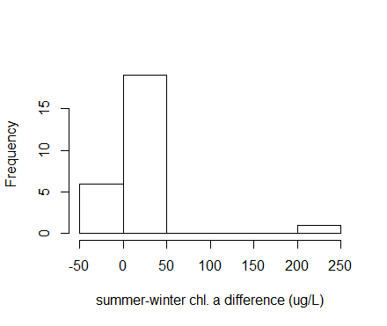
Figure 1: histogram showing the distribution of differences in chl. a concentrations between winter and summer in 25 seasonally ice-covered lakes in Europe and North America. Positive values indicate higher concentrations in summer, negative values indicate higher concentrations in winter.

