Lecture 04 — GGPlot II
  - New data, safe zooming, distributions, themes, and patchwork
Bill Perry
2026-10-08

Where we left off (Lecture 03 — GGPlot I)
- Piping straight into a plot: leaf_df %>% ggplot(...)
- scale_color_manual() / scale_fill_manual() — colors you choose
- facet_wrap() and facet_grid() — one panel per group
- stat_summary() — mean and mean ± SE, drawn from raw data
 Note
✅ Key idea from Lecture 03
You already know how to build a grouped, colored, faceted figure — but only on leaf_df. Today’s real test: can you do it on data you’ve never seen before?

Goals for Today
- Practice your plotting skills on a brand-new dataset, and see where you’d find one yourself
- Zoom into a plot without silently dropping data — coord_cartesian()
- Build a histogram and a density plot — two views of one distribution
- Apply a reusable theme file, and combine panels with patchwork
 Tip
🖐 Try it yourself
By the end you will recognize the single most common ggplot mistake — zooming with ylim() / scale_y_continuous(limits = ) — before you ever make it yourself.

References:
- 📖 Whitlock & Schluter, Ch. 2 — Displaying Data
- 📖 R4DS Ch 1 — Data Visualization
Both PDFs are in the course readings/ folder.

How to Use These Slides — Predict · Type · Run
This lecture runs in five short chunks. After each chunk you switch to the activity and type the code yourself into your R script.
Note
✅ Why bother?
ylim() and coord_cartesian() produce plots that look identical for a simple scatter — the difference only shows up once you compute something (a boxplot, a smooth). Typing both yourself and comparing outputs is the only way this sticks.

🧩 Chunk 1 of 5 · New Data, Same Skills
We will cover: loading palmerpenguins, and rebuilding the two plot types you already know on data you’ve never seen.
🛑 After this chunk you will do Activity Parts 1–2.

A Dataset You Didn’t Collect
# Load all packages at the top of every script ----------
library(tidyverse) # data wrangling + ggplot2
library(palmerpenguins) # penguins data, Palmer Station LTER
# palmerpenguins ships the data already clean -----------
penguins_df <- penguins %>%
drop_na(species, bill_length_mm, bill_depth_mm,
flipper_length_mm, body_mass_g)
glimpse(penguins_df)
Rows: 342
Columns: 8
$ species <fct> Adelie, Adelie, Adelie, Adelie, Adeli…
$ island <fct> Torgersen, Torgersen, Torgersen, Torg…
$ bill_length_mm <dbl> 39.1, 39.5, 40.3, 36.7, 39.3, 38.9, 3…
$ bill_depth_mm <dbl> 18.7, 17.4, 18.0, 19.3, 20.6, 17.8, 1…
$ flipper_length_mm <int> 181, 186, 195, 193, 190, 181, 195, 19…
$ body_mass_g <int> 3750, 3800, 3250, 3450, 3650, 3625, 4…
$ sex <fct> male, female, female, female, male, f…
$ year <int> 2007, 2007, 2007, 2007, 2007, 2007, 2…
- penguins comes inside the package — no read_excel() needed, just library(palmerpenguins)
- 344 penguins, 3 species, Palmer Station, Antarctica
- drop_na() removes the handful of rows missing a measurement — same idea as the NAs in leaf_df

The Same Simple XY Plot — On New Data
Note
🔮 Predict first: longer flippers, heavier birds. Will the three species separate into three clouds, or overlap into one?

# The exact same recipe you used on leaf_df ------------
penguins_df %>%
ggplot(aes(x = flipper_length_mm, y = body_mass_g,
color = species)) +
geom_point(alpha = 0.7, size = 2) +
labs(title = "Body Mass vs. Flipper Length",
x = "Flipper Length (mm)", y = "Body Mass (g)",
color = "Species") +
theme_minimal()
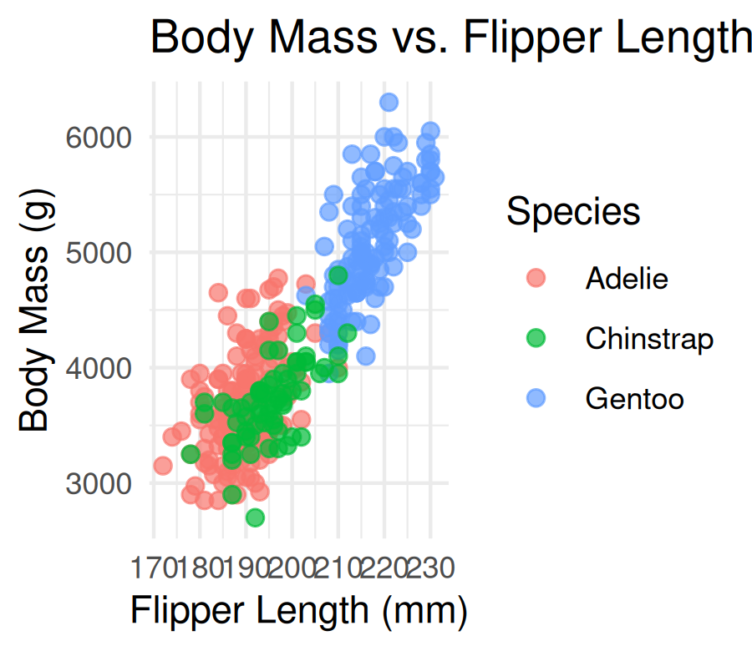
- Same aes() + geom_point() + labs() + theme_minimal() you already typed for leaves
- The dataset changed, the recipe didn’t — that’s the point
- Nothing here is new syntax; it’s proof you can already do this on any data

The Same Simple Categorical Plot — On New Data
# boxplot + jitter, exactly like the leaf_df pattern ---
penguins_df %>%
ggplot(aes(x = species, y = body_mass_g, fill = species)) +
geom_boxplot(alpha = 0.6, outlier.shape = NA) +
geom_jitter(width = 0.15, alpha = 0.4) +
labs(x = "Species", y = "Body Mass (g)",
title = "Body Mass by Species") +
theme_minimal() +
theme(legend.position = "none")
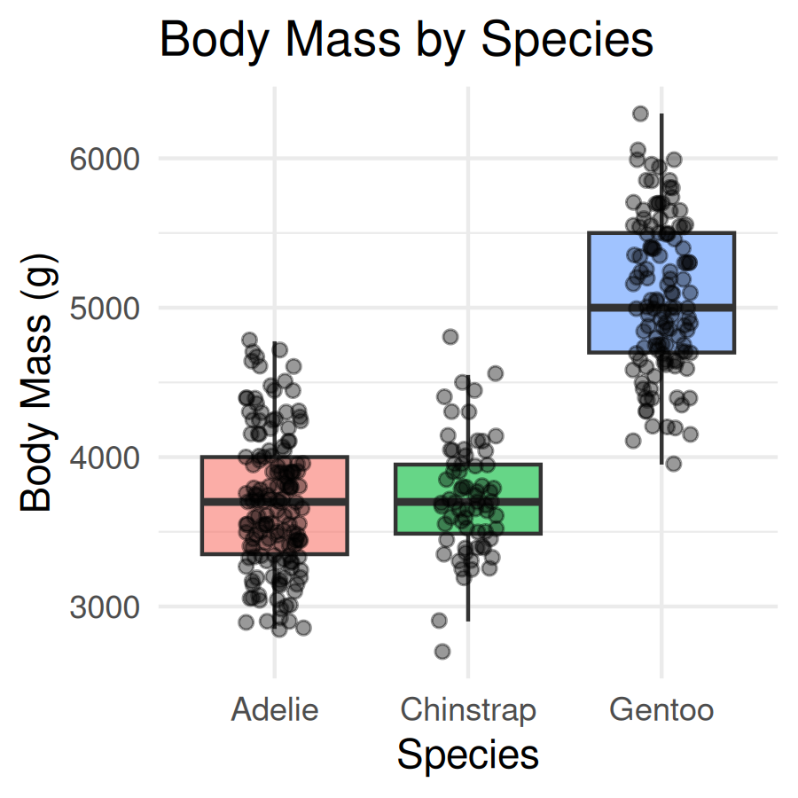
Tip
💡 Where would you find a dataset like this on your own?
- library(palmerpenguins) or library(FSA) (fish data, Derek Ogle) — real data bundled inside an R package, zero downloading
- Kaggle — search “UFO sightings” or Kaggle — search “Bigfoot sightings” — download a .csv, load it with read_csv() like any other file
Both a simple XY numeric plot and a simple categorical plot (like today’s two) work on almost any tidy dataset you find.

→ ACTIVITY 4 Parts 1–2 now
🛑 Do Activity Parts 1–2 now
Load palmerpenguins, then rebuild the XY scatter and the boxplot+jitter — same recipe, new data. Predict, type, run.

🧩 Chunk 2 of 5 · Zooming In Safely
We will cover: coord_cartesian() to zoom — and the ylim() / scale_y_continuous(limits = ) trap to avoid.
🛑 After this chunk you will do Activity Part 3.

coord_cartesian() — Zoom the View, Keep the Data
# coord_cartesian() zooms the VIEW, keeps all the data -
penguins_df %>%
ggplot(aes(x = species, y = body_mass_g, fill = species)) +
geom_boxplot(alpha = 0.6, outlier.shape = NA) +
coord_cartesian(ylim = c(3000, 5000)) +
labs(x = "Species", y = "Body Mass (g)",
title = "Zoomed with coord_cartesian()") +
theme_minimal() +
theme(legend.position = "none")
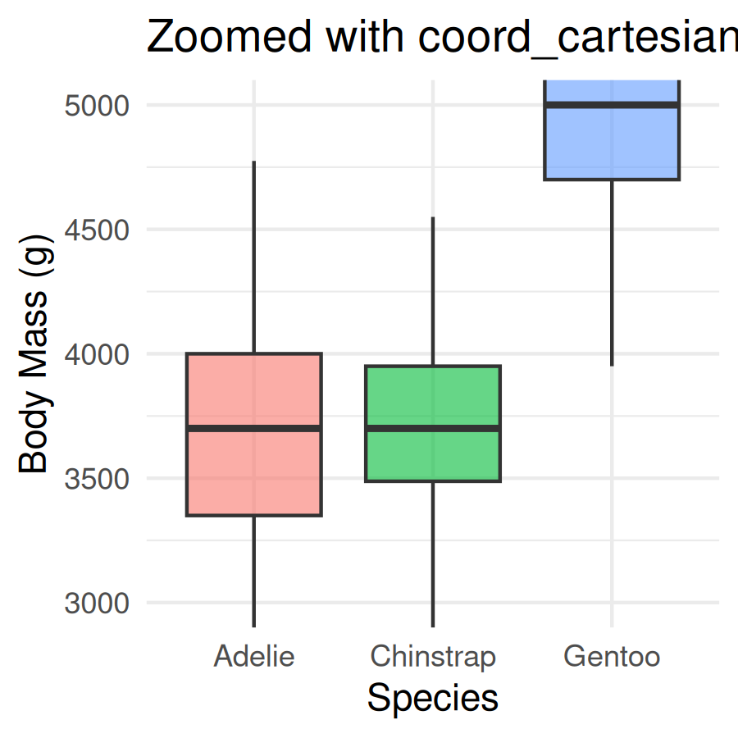
- Zooms the view — every penguin still contributes to each box’s median and quartiles
- The window just crops what you can see afterward
- This is the one to reach for whenever you just want a closer look

The Trap — ylim() / scale_y_continuous(limits = ) Delete Rows First
Note
🔮 Predict first: Many Gentoos sit above 5000 g. If we drop every penguin outside 3000–5000 g before drawing the boxes, what happens to the Gentoo box?

# ylim() DELETES rows outside the range first ----------
penguins_df %>%
ggplot(aes(x = species, y = body_mass_g, fill = species)) +
geom_boxplot(alpha = 0.6, outlier.shape = NA) +
ylim(3000, 5000) +
labs(x = "Species", y = "Body Mass (g)",
title = "ylim() — boxes recomputed on fewer penguins") +
theme_minimal() +
theme(legend.position = "none")
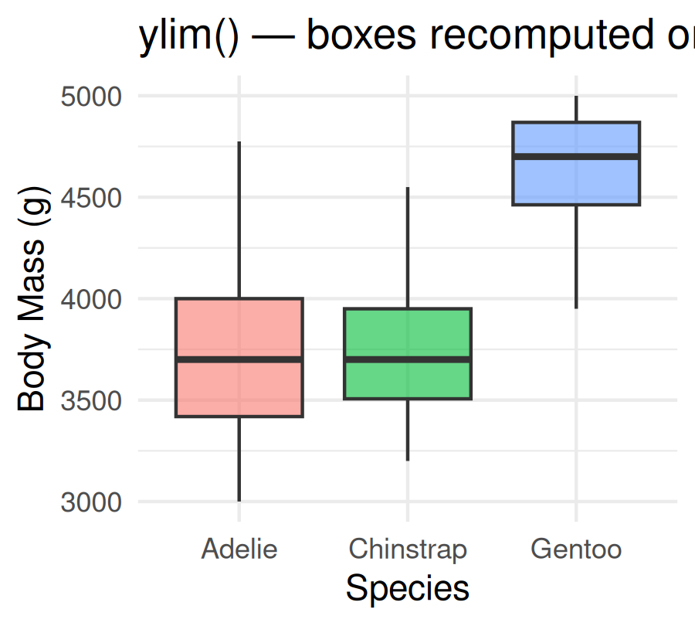
 Warning
⚠️ Watch out!
ylim() — and scale_y_continuous(limits = ...) — silently delete every row outside the range before anything is computed. Compare the Gentoo box to the coord_cartesian() version: same window, different box.

Rule: zoom with coord_cartesian(). Only use ylim() / scale_y_continuous(limits = ) when you actually want those rows gone from the analysis.

→ ACTIVITY 4 Part 3 now
🛑 Do Activity Part 3 now
Zoom with coord_cartesian(), then run the ylim() version and count exactly how many penguins it drops. Predict, type, run.

🧩 Chunk 3 of 5 · Two Views of One Distribution
We will cover: geom_histogram() and geom_density() — the two standard ways to show how one numeric variable is distributed.
🛑 After this chunk you will do Activity Part 4.

geom_histogram() — Bars of Counts
# geom_histogram() bins the data and counts rows per bin
penguins_df %>%
ggplot(aes(x = body_mass_g)) +
geom_histogram(binwidth = 200, fill = "steelblue",
color = "white") +
labs(x = "Body Mass (g)", y = "Count",
title = "Distribution of Body Mass") +
theme_minimal()
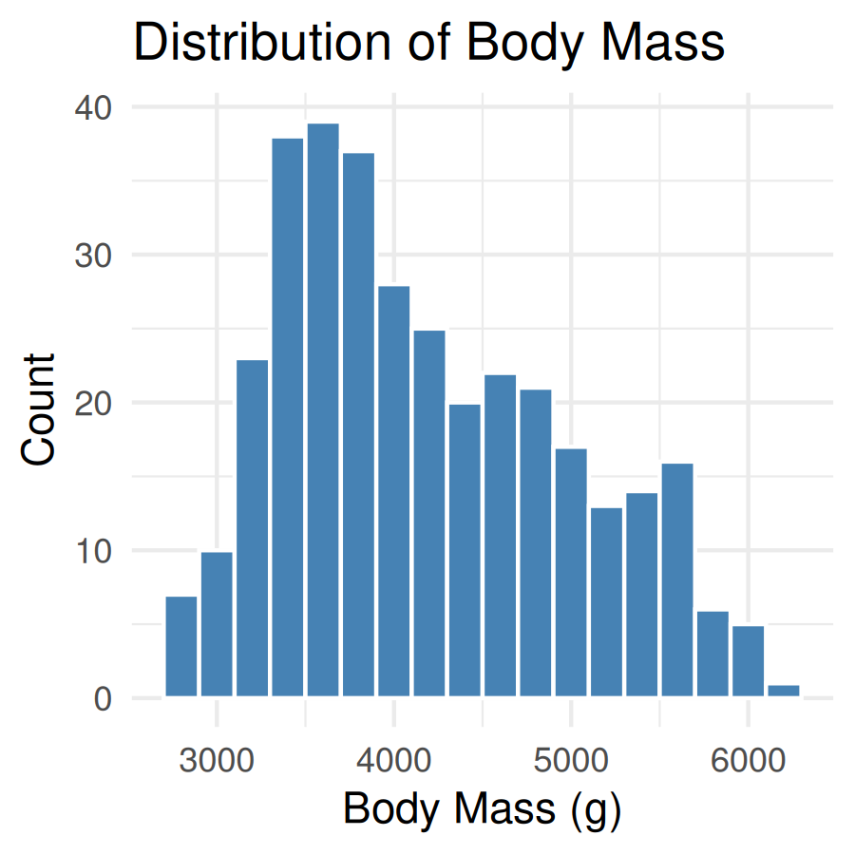
- binwidth sets the width of each bar in the units of x — here, 200 g per bin
- Too narrow → noisy, spiky bars. Too wide → real structure gets smoothed away
- Try a few binwidth values before settling on one

geom_density() — a Smooth Curve Instead of Bars
# geom_density() smooths the same shape into a curve ---
penguins_df %>%
ggplot(aes(x = body_mass_g)) +
geom_density(fill = "steelblue", alpha = 0.5) +
labs(x = "Body Mass (g)", y = "Density",
title = "Density of Body Mass") +
theme_minimal()
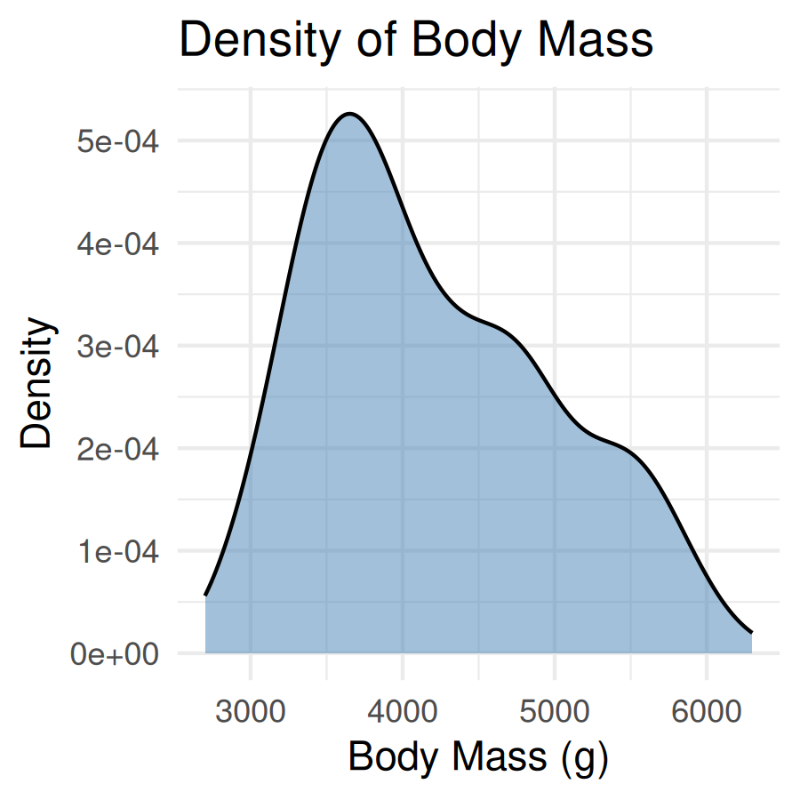
- Same variable, same shape — a density curve is a smoothed histogram, area under the curve sums to 1
- The y-axis is no longer a count — it’s a density, which is why the numbers look small
- 📖 Whitlock & Schluter, Ch. 2 — Displaying Data
Tip
Coming soon: in the Summary Statistics lecture we’ll come back to this exact curve and shade in the 95% range underneath it. Today, just get comfortable building both plot types.

→ ACTIVITY 4 Part 4 now
🛑 Do Activity Part 4 now
Build a histogram and a density plot of the same variable. Predict, type, run.

🧩 Chunk 4 of 5 · A Reusable Theme File
We will cover: sourcing a custom theme file and applying it — no need to build one from scratch today.
🛑 After this chunk you will do Activity Part 5.

source() a Theme File Instead of Repeating theme()
# source() loads functions from another .R file -------
source("themes/r_themes_for_3_sizes.R")
penguins_df %>%
ggplot(aes(x = species, y = body_mass_g, fill = species)) +
geom_boxplot(alpha = 0.6, outlier.shape = NA) +
labs(x = "Species", y = "Body Mass (g)",
title = "Body Mass by Species") +
theme_regular() +
theme(legend.position = "none")
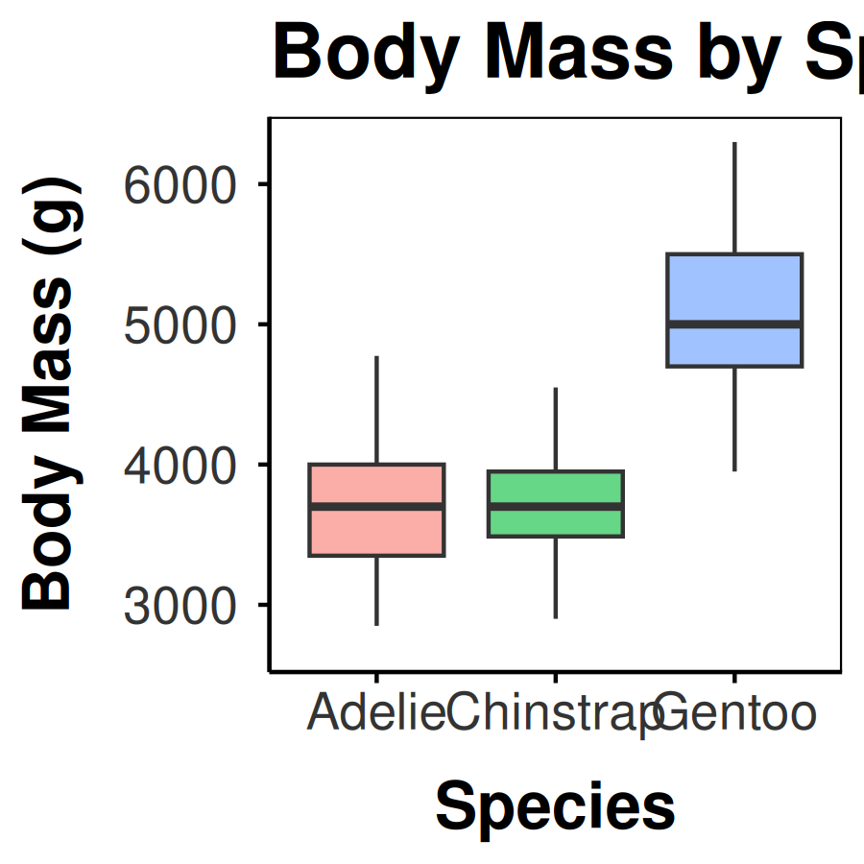
- source("themes/r_themes_for_3_sizes.R") runs that file once and loads theme_small(), theme_regular(), theme_large() into your session
- You don’t need to understand every line inside the file today — just how to call it
- Pick the size that matches where the figure is going: slides/report → theme_regular()

Tweaking Fonts and Colors on Top
# theme() and scale_fill_manual() still work as usual --
penguins_df %>%
ggplot(aes(x = species, y = body_mass_g, fill = species)) +
geom_boxplot(alpha = 0.6, outlier.shape = NA) +
scale_fill_manual(values = c(
"Adelie" = "darkorange", "Chinstrap" = "purple",
"Gentoo" = "cyan4"
)) +
labs(x = "Species", y = "Body Mass (g)",
title = "Body Mass by Species") +
theme_regular() +
theme(
legend.position = "none",
plot.title = element_text(size = rel(1.4), face = "bold")
)
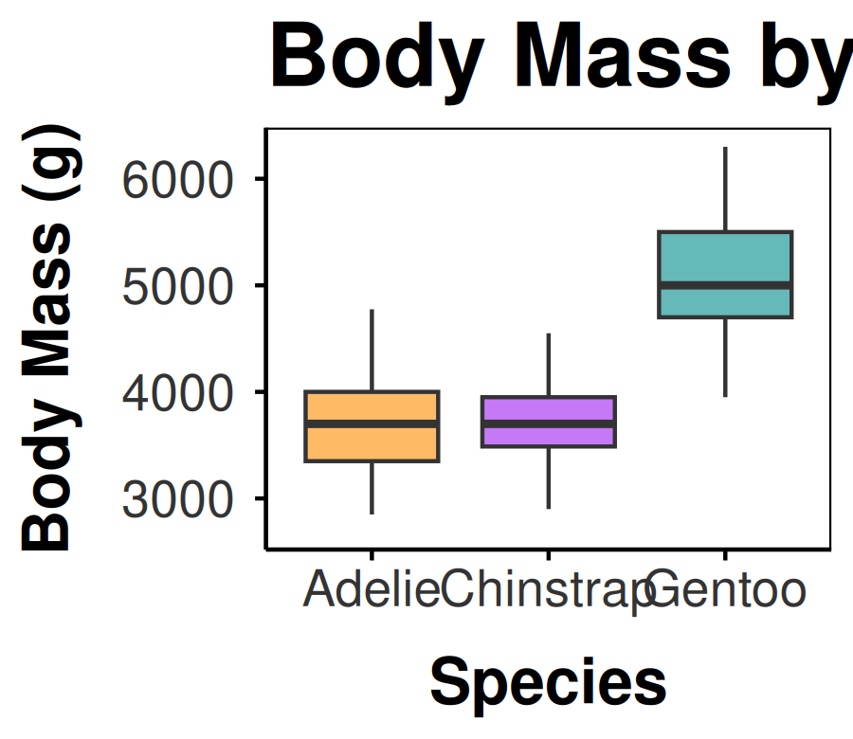
- A sourced theme is just a theme() call — + theme(...) after it overrides single pieces
- scale_fill_manual() still controls colors; the theme controls fonts, lines, margins
Note
✅ Key idea: one theme file sourced at the top of every script keeps a project consistent — change it once, every plot updates.

→ ACTIVITY 4 Part 5 now
🛑 Do Activity Part 5 now
Download the theme file, source it, and apply theme_regular() to one of your plots. Then tweak a font size and a color. Predict, type, run.

🧩 Chunk 5 of 5 · Combining Panels with patchwork
We will cover: patchwork — putting two ggplot objects side by side as one figure.
🛑 After this chunk you will do Activity Part 6.

patchwork — Two Plots, One Figure
library(patchwork) # combine ggplot objects with + and /
xy_plot <- penguins_df %>%
ggplot(aes(x = flipper_length_mm, y = body_mass_g,
color = species)) +
geom_point(alpha = 0.7) +
labs(x = "Flipper Length (mm)", y = "Body Mass (g)",
color = "Species") +
theme_regular()
box_plot <- penguins_df %>%
ggplot(aes(x = species, y = body_mass_g, fill = species)) +
geom_boxplot(alpha = 0.6, outlier.shape = NA) +
labs(x = "Species", y = "Body Mass (g)") +
theme_regular() +
theme(legend.position = "none")
xy_plot + box_plot +
plot_annotation(
title = "Penguin Body Mass, Two Ways",
tag_levels = "A"
)
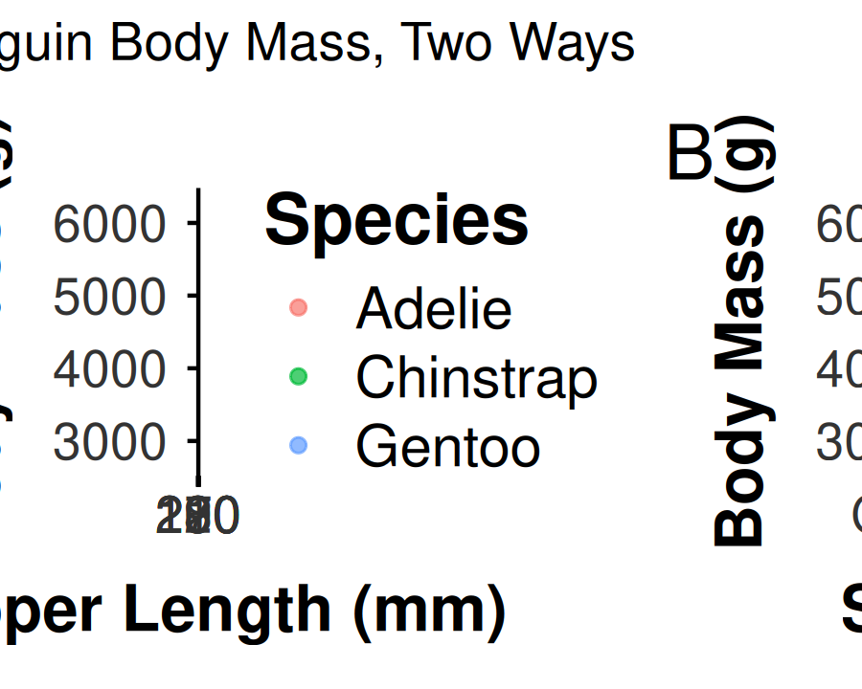
- Each panel is an ordinary saved ggplot object — build them separately first
- + places two plots side by side; / stacks them
- plot_annotation() adds one title and A/B/C tags across the whole figure

→ ACTIVITY 4 Part 6 now
🛑 Go to Activity 4 — Part 6
Close the slides. Combine two of your plots with patchwork and plot_annotation(), then save the combined figure.

What We Learned Today
- The XY-scatter / boxplot+jitter recipe you already know works on any tidy dataset — palmerpenguins, FSA, or a .csv from Kaggle
- coord_cartesian() zooms safely; ylim() / scale_y_continuous(limits = ) silently deletes rows first
- geom_histogram() and geom_density() — two views of one distribution
- source() a theme file once, then call theme_regular() (or _small() / _large()) everywhere
- patchwork (+ / /) combines saved plots; plot_annotation() titles and tags the whole figure
References:
- 📖 Whitlock & Schluter, Ch. 2 — Displaying Data
- 📖 R4DS Ch 1 — Data Visualization
Up next — Lecture 05, Wrangling:
- filter(), select(), mutate(), arrange()
- Chaining verbs into one pipeline

