Lecture 12 — Real Climate Data in R
  - How fast is your city warming? (regression on time)
Bill Perry
2026-10-08

Where we left off (Lecture 11 — Regression)
- lm(Y ~ X, data = df) fits a straight line through a cloud of points
- summary(model) gives you:
  - the slope — how much Y changes per 1 unit of X
  - its p-value — is that slope real, or could it be chance?
  - R² — how tightly the points follow the line
- geom_smooth(method = "lm") draws the line
- plot(model) checks the residuals
 Note
✅ Where today comes in
- Last time X was paper mass and the slope converted grams into cm²
- Today X is time
  - the slope becomes a rate of change — degrees per year
  - and that is exactly what a “warming rate” is

Goals for Today
- Download real weather station data from inside R — no Excel, no copy-paste
- Clean the names with janitor so the code stays easy to type
- Summarize ~25,000 daily records into one mean per year
- Fit lm(temp ~ year) and read the warming rate straight off summary()
- Split by season — is winter warming faster than summer?
- Find a station for a city you choose and run the whole thing again
 Tip
🖐 Where this is going
- The analysis is the same four lines every time
- Change the station, and it is a new city
- That is your out-of-class extension

Tools today:
- GSODR — NOAA station data (Duluth)
- nasapower — data by lat/long (your city)
- janitor — clean_names()
- tidyverse — summarize and plot
- lm() — the slope is the answer
Reading:
- 📖 R for Data Science 2e
  - Ch. 3 Data transformation
- 📖 Whitlock & Schluter Ch. 17 — Regression
Naming conventions:
- data frames → _df
- plots → _plot
- models → _model

🧩 Chunk 1 of 3 · The Question
We will cover: where the data comes from, why the slope of a regression on time is a warming rate, and why you have to summarize before you can see it. No code in this chunk.

Where Does This Data Come From?
- GSOD = Global Surface Summary of the Day, run by NOAA
  - daily weather from thousands of stations worldwide
  - many records reach back to the 1940s
  - free, and no account needed
- The GSODR package pulls it straight into R
  - you give it a station ID and a range of years
  - it hands back a data frame
  - it warns GSOD retired in Aug 2025 — expected; the archive still works
Our station to start:
- Duluth International Airport
- Station ID 727450-14913
- Daily records 1948–2024
  - 1965–1972 missing — a different station ID back then
- Why this matters:
  - this is the same messy, real-world data you will meet in your own project
  - the workflow — download → summarize → model — is the one you will reuse all term
- And it is yours to reuse:
  - every city with a long station record can be run through the exact same code
  - you will pick one later today

The Slope Is the Warming Rate
Last lecture:
$$\hat{\text{area}}=a+b×\text{mass}$$
- b was cm² per gram — a conversion factor
Today:
$$\hat{\text{temp}}=a+b×\text{year}$$
- b is °C per year — a rate of change
Nothing about the code changes. Only what X means.
- Reading the slope:
  - b positive → warming
  - b negative → cooling
  - b near 0 → no trend
- Make it human: °C per year is a tiny number
  - multiply it by 10 → °C per decade
  - 0.027 °C/year → about 0.27 °C per decade
- The p-value still does the same job
  - H₀: the slope is 0 — no trend at all
  - small p → the trend is real, not chance

Why You Must Summarize First
- A station reports one row per day
  - 69 years × 365 days ≈ 25,000 rows
- Every one of those days carries the seasonal cycle
  - January is 30 °C colder than July, every single year
  - that swing is enormous compared with a few tenths of a degree of warming
- So the trend you want is buried in the noise you don’t
Summary level | group_by() | Rows left
Daily (raw) | none | ~25,000
Yearly | year | 69
 Important
Summarizing is not throwing data away.
- It is choosing which question you are answering
- Want to study a heat wave? Use daily
- Want to study climate? Use yearly

- One group_by(year) %>% summarize() — the same two lines from Summary Statistics
- That is the whole fix

🧩 Chunk 2 of 3 · Duluth’s Warming Rate
We will cover: downloading the Duluth record, cleaning the names, summarizing to yearly means, and fitting lm(temp ~ year).
🛑 After this chunk: Activity Parts 1–5 (download, summarize, plot, fit, read the slope).

Load Libraries and Download the Data
# Load packages at the top -----------------------------
library(tidyverse) # dplyr + ggplot2
library(janitor) # clean_names()
library(GSODR) # NOAA station data - Duluth
library(nasapower) # NASA data by lat/long - your city
# Download daily Duluth weather, 1948-2024 -------------
# 1965-1972 are missing for this station, so skip them
gap_years <- 1965:1972
duluth_df <- get_GSOD(years = setdiff(1948:2024, gap_years),
station = "727450-14913") %>%
clean_names()
- get_GSOD() takes years and a station and goes and gets the data
  - 1948:2024 is a vector — “every year in this range”
  - setdiff() removes the 8 missing years from that vector
    - ask for a year the station does not have and the whole download fails
  - it takes a minute; 69 years of daily data is a lot
- clean_names() is the important habit here
  - NOAA ships columns as TEMP, YEARMODA, MXSPD
  - R is case-sensitive, so temp would error
  - clean_names() makes everything lower case and snake case, once, at the top
Tip
Clean the names as you load the data, and you never think about capitals again.

What Did We Get?
# How big is it, and what is in it? --------------------
dim(duluth_df)
[1] 25441 47
names(duluth_df)[13:18]
[1] "yearmoda" "year" "month" "day" "yday" "temp"
- ~25,000 rows — one per day
- 47 columns — temperature, dew point, wind, precipitation, flags…
- The handful we care about:
  - yearmoda — the date
  - year, month, day
  - temp — daily mean temperature in °C
Note
names(df) is how you find out what a downloaded data set actually calls things. Always look before you type.

Trim to What We Need
# Keep only the columns we actually use ----------------
dlh_df <- duluth_df %>%
select(name, yearmoda, year, month, temp)
head(dlh_df, 3)
name yearmoda year month temp
<char> <Date> <int> <int> <num>
1: DULUTH INTERNATIONAL AIRPORT 1948-01-01 1948 1 -8.2
2: DULUTH INTERNATIONAL AIRPORT 1948-01-02 1948 1 -4.1
3: DULUTH INTERNATIONAL AIRPORT 1948-01-03 1948 1 -8.4
- 47 columns is more than anyone needs to look at
- select() keeps the five that answer our question
- Same select() from the Wrangling lecture — just on a much wider real file
Tip
Trim early. Every later line is easier to read when the data frame has 5 columns instead of 47.

Look at the Raw Daily Data
# Every single daily temperature -----------------------
raw_temp_plot <- dlh_df %>%
ggplot(aes(x = yearmoda, y = temp)) +
geom_point(alpha = 0.2, size = 0.5)
raw_temp_plot
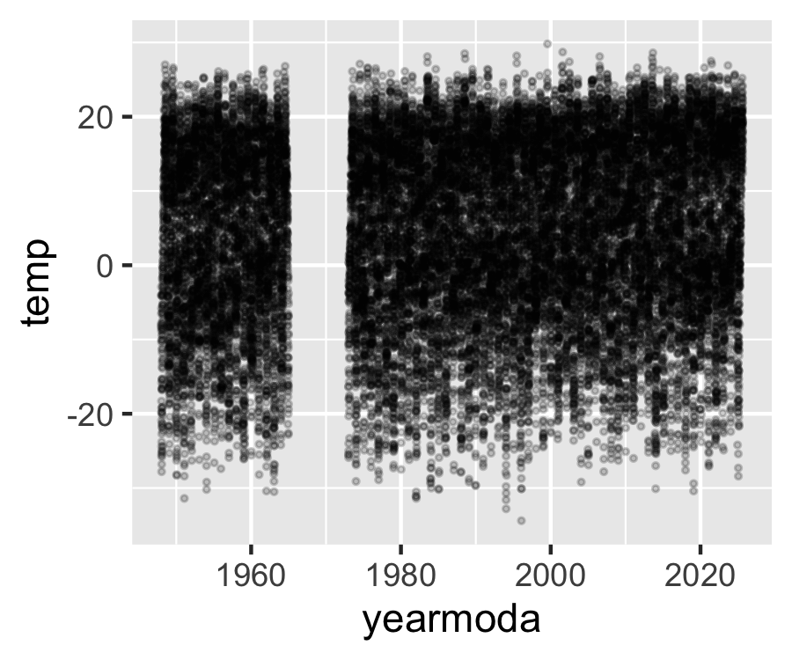
- A solid band about 60 °C tall — that is summer vs winter, repeated 69 times
- ~25,000 points on top of each other
- Any warming trend is in there, but it is a fraction of a degree against a 60 °C swing
So you cannot see it. That is not a plotting problem — it is a summarizing problem.

Summarize to One Mean per Year
# Mean temperature per year ----------------------------
dlh_year_df <- dlh_df %>%
group_by(year) %>%
summarize(temp = mean(temp, na.rm = TRUE))
head(dlh_year_df, 3)
# A tibble: 3 × 2
year temp
<int> <dbl>
1 1948 3.76
2 1949 4.10
3 1950 1.60
- group_by(year) — one group per year
- summarize(temp = mean(temp)) — one number per group
- 25,000 rows become 69
- na.rm = TRUE ignores days the station missed
Note
Reusing the name temp on the left means every line below keeps working — the same trick from T-Tests II.

Plot the Yearly Means
# Yearly means with the regression line ----------------
yearly_temp_plot <- dlh_year_df %>%
ggplot(aes(x = year, y = temp)) +
geom_point() +
geom_smooth(method = "lm")
yearly_temp_plot
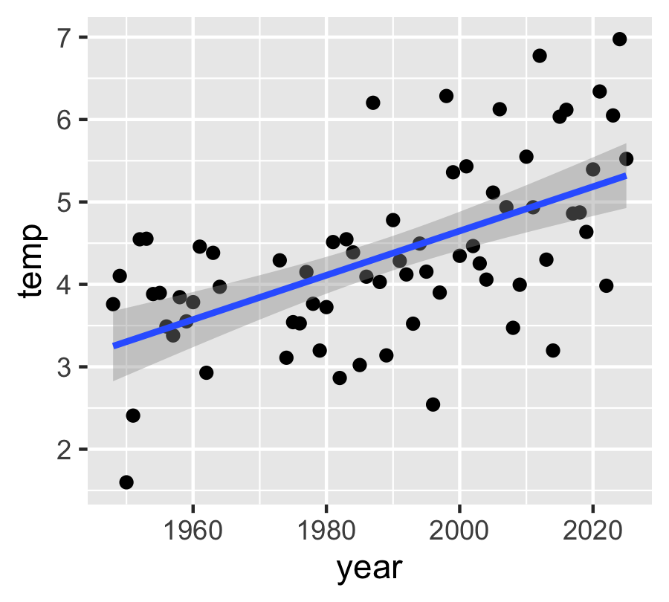
- Now you can see it. The line clearly rises
- 69 points instead of 25,000 — and the story is clearer, not weaker
- Still plenty of scatter: single years are weather, the line is climate
- Exactly the same geom_smooth(method = "lm") as the Regression lecture
But “it looks like it goes up” is not a result. We need the number.

Fit the Trend
# Temperature predicted by year ------------------------
dlh_year_model <- lm(temp ~ year,
data = dlh_year_df)
summary(dlh_year_model)
Call:
lm(formula = temp ~ year, data = dlh_year_df)
Residuals:
Min 1Q Median 3Q Max
-1.99794 -0.51059 0.00688 0.49950 1.90458
Coefficients:
Estimate Std. Error t value Pr(>|t|)
(Intercept) -49.096842 9.119103 -5.384 9.77e-07 ***
year 0.026872 0.004585 5.860 1.49e-07 ***
---
Signif. codes: 0 '***' 0.001 '**' 0.01 '*' 0.05 '.' 0.1 ' ' 1
Residual standard error: 0.8774 on 68 degrees of freedom
Multiple R-squared: 0.3356, Adjusted R-squared: 0.3258
F-statistic: 34.34 on 1 and 68 DF, p-value: 1.489e-07
- lm(temp ~ year) reads “temperature is predicted by year”
- Y on the left, X on the right — same as always
- The three numbers you want are all in this output:
  - the slope (year → Estimate)
  - its p-value (year → Pr(>|t|))
  - R² (Multiple R-squared)

Reading the Warming Rate
Look at the year row of the Coefficients table.
- Estimate ≈ 0.027 — that is the slope
  - units: °C per year
  - positive → Duluth is warming
  - ×10 → about 0.27 °C per decade
  - over ~77 years → roughly 2 °C
- Pr(>|t|) is tiny (far below 0.001)
  - the warming is real, not year-to-year luck
- Multiple R-squared ≈ 0.32
  - year explains about a third of the variation in annual temperature
  - the other two thirds is weather — some years are just cold
  - a modest R² next to a rock-solid p is completely normal in climate data
Important
The intercept looks absurd — about −49 °C.
- That is the predicted temperature at “year 0”
- Year 0 is 2,000 years outside the data
- The intercept is bookkeeping; the slope is the science

→ ACTIVITY 12 Parts 1–5 now
🛑 Do Activity Parts 1–5 now
- Download the Duluth record and clean_names() it
- Trim the columns and plot the raw daily data
- Summarize to one mean per year and plot it
- Fit lm(temp ~ year) and read the slope, p, and R² off summary()

🧩 Chunk 3 of 3 · Seasons, and Your Own City
We will cover: labelling each day with a season, fitting a separate model for summer and winter, and finding the station ID for a city you choose.
🛑 After this chunk: Activity Parts 6–10 (seasons, two models, your own city).

A Better Question — Which Season Is Warming?
- The annual mean says Duluth warmed about 0.27 °C per decade
- But an annual mean hides which part of the year moved
- That distinction is the biologically interesting one:
  - ice-out dates and frozen soil depend on winter
  - heat stress and drought depend on summer
  - growing season length depends on the shoulders
The plan — three steps you already know:
- mutate() + case_when() to label each day
- group_by(year, season) + summarize()
- One lm() per season
Important
⚠️ Seasons are not months — they are hemispheres.
- June–August is summer north of the equator
- June–August is winter south of it
- If you pick Melbourne, Santiago or Cape Town later, you must swap the labels

- A station’s latitude column tells you which hemisphere you are in
  - positive → northern
  - negative → southern

Label Each Day with a Season
# Northern hemisphere seasons --------------------------
# SOUTHERN hemisphere: swap summer and winter
dlh_season_df <- dlh_df %>%
mutate(season = case_when(
month %in% c(6, 7, 8) ~ "summer",
month %in% c(12, 1, 2) ~ "winter",
TRUE ~ "shoulder"
))
# Did it work? -----------------------------------------
dlh_season_df %>% count(season)
season n
<char> <int>
1: shoulder 12718
2: summer 6436
3: winter 6287
- case_when() reads top to bottom: condition ~ answer
  - the first matching line wins
- month %in% c(6, 7, 8) = “is month 6, 7 or 8?”
- TRUE ~ "shoulder" is the catch-all for everything left over — spring and fall
- count() is the check: roughly a quarter of the days in each of summer and winter, half in the shoulder
📖 R4DS §3.4 — case_when()

Summarize by Year and Season
# Drop the shoulder, then one mean per year per season -
season_year_df <- dlh_season_df %>%
filter(season != "shoulder") %>%
group_by(year, season) %>%
summarize(temp = mean(temp, na.rm = TRUE),
.groups = "drop")
head(season_year_df, 4)
# A tibble: 4 × 3
year season temp
<int> <chr> <dbl>
1 1948 summer 17.4
2 1948 winter -12.6
3 1949 summer 18.4
4 1949 winter -11.4
- filter(season != "shoulder") — != means “is not”
  - keeps only the two extremes
- group_by(year, season) — two grouping columns
  - one row per year per season
  - 69 years × 2 seasons = 138 rows
- .groups = "drop" tidies up afterwards
This is the same two-column group_by() from T-Tests II.

Plot Both Seasons
# One line per season ----------------------------------
season_temp_plot <- season_year_df %>%
ggplot(aes(x = year, y = temp, color = season)) +
geom_point() +
geom_smooth(method = "lm")
season_temp_plot
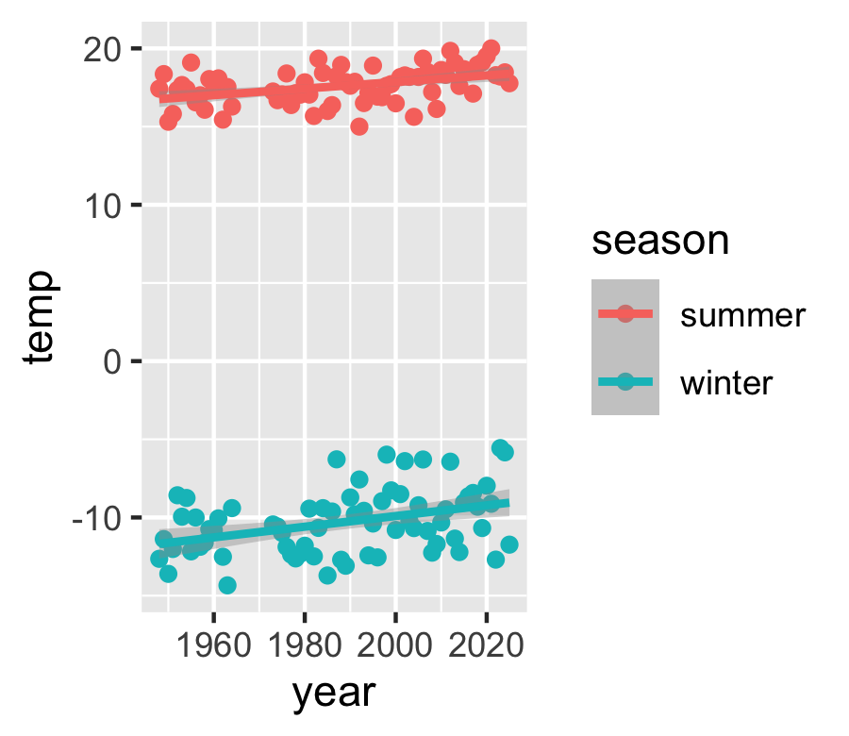
- color = season inside aes() does two jobs at once:
  - colors the points by season
  - makes geom_smooth() fit a separate line per season
- Two bands, far apart — winter near −11 °C, summer near 18 °C
- Don’t compare the heights. Compare the steepness.
  - the height is just “winter is cold”
  - the slope is the warming rate
- Winter’s line looks steeper — but we need the numbers

A Model for Summer
# Summer only ------------------------------------------
summer_df <- season_year_df %>%
filter(season == "summer")
summer_model <- lm(temp ~ year, data = summer_df)
summary(summer_model)
Call:
lm(formula = temp ~ year, data = summer_df)
Residuals:
Min 1Q Median 3Q Max
-2.6841 -0.7543 0.1585 0.6622 2.1918
Coefficients:
Estimate Std. Error t value Pr(>|t|)
(Intercept) -24.267149 10.815992 -2.244 0.028116 *
year 0.021059 0.005439 3.872 0.000245 ***
---
Signif. codes: 0 '***' 0.001 '**' 0.01 '*' 0.05 '.' 0.1 ' ' 1
Residual standard error: 1.041 on 68 degrees of freedom
Multiple R-squared: 0.1807, Adjusted R-squared: 0.1686
F-statistic: 14.99 on 1 and 68 DF, p-value: 0.0002448
- filter() first, then the same lm() as before
- Two small models are far easier to read than one complicated one
Summer slope ≈ 0.022 °C/year
- ×10 → about 0.22 °C per decade
- p = 0.0002 → real
Now do exactly the same thing for winter.

A Model for Winter
# Winter only ------------------------------------------
winter_df <- season_year_df %>%
filter(season == "winter")
winter_model <- lm(temp ~ year, data = winter_df)
summary(winter_model)
Call:
lm(formula = temp ~ year, data = winter_df)
Residuals:
Min 1Q Median 3Q Max
-3.5398 -1.3901 0.0164 1.1662 4.0695
Coefficients:
Estimate Std. Error t value Pr(>|t|)
(Intercept) -78.24857 20.10231 -3.893 0.000229 ***
year 0.03417 0.01011 3.380 0.001202 **
---
Signif. codes: 0 '***' 0.001 '**' 0.01 '*' 0.05 '.' 0.1 ' ' 1
Residual standard error: 1.934 on 68 degrees of freedom
Multiple R-squared: 0.1439, Adjusted R-squared: 0.1313
F-statistic: 11.43 on 1 and 68 DF, p-value: 0.001202
Winter slope ≈ 0.037 °C/year
- ×10 → about 0.37 °C per decade
- p = 0.0006 → real
Winter is warming about 1.7× as fast as summer.
- This is the expected pattern across the northern continents
- Fewer extreme-cold nights, shorter ice seasons, earlier thaw
- The annual mean — 0.27 °C/decade — sat right between the two and told you neither

Reading Two Models Side by Side
Both slopes come straight off the year row of each summary():
Model | Slope (°C/yr) | ×10 (°C/decade) | p
Annual | 0.027 | 0.27 | 0.0000003
Summer | 0.022 | 0.22 | 0.0002
Winter | 0.037 | 0.37 | 0.0006
- Winter’s slope has a bigger standard error too — winters are more variable than summers
- A bigger p with a bigger slope is not a contradiction; it is noisier data
How to write it up:
Mean annual temperature at Duluth rose significantly from 1948 to 2024 (linear regression: slope = 0.027 °C yr⁻¹, equivalent to 0.27 °C per decade; F(1, 67) = 32.1, p < 0.001, R² = 0.32). Winter warmed roughly 1.7 times faster than summer (0.37 vs 0.22 °C per decade).
- Give the slope with units
- Convert to per decade so a reader can feel it
- Report p and R² the same way as any regression

Now Do It for Your City
# NASA POWER - lon and lat, no station -----------------
city_df <- get_power(community = "ag",
lonlat = c(-0.13, 51.51),
pars = "T2M",
dates = c("1981-01-01",
"2024-12-31"),
temporal_api = "daily") %>%
clean_names() %>%
rename(month = mm, temp = t2m)
dim(city_df)
[1] 16071 8
- Why switch packages?
  - GSODR needs a station ID
  - most stations outside the US have missing years
  - Melbourne’s nearest long station is missing 48 of 59
- nasapower needs only coordinates
  - anywhere on Earth, 1981 to now, no gaps
  - watch the order: longitude first
- rename() makes the columns match Duluth’s

Swap Two Numbers, Get a New City
# The ONLY numbers that change ------------------
lonlat = c(-0.13, 51.51)
# Everything below is identical -----------------
city_year_df <- city_df %>%
group_by(year) %>%
summarize(temp = mean(temp, na.rm = TRUE))
city_model <- lm(temp ~ year, data = city_year_df)
summary(city_model)
- That is the whole point of today
  - two numbers name the place
  - the rest of the analysis never changes
- Look up lat/long in any search engine
  - south of the equator → negative latitude
  - west of Greenwich → negative longitude
Important
Southern hemisphere? Swap the season labels in case_when():
- month %in% c(12, 1, 2) → summer
- month %in% c(6, 7, 8) → winter

Are the Two Slopes Different?
# Stack the two yearly summaries ----------------
both_df <- bind_rows(duluth_year_df,
city_labeled_df)
# One slope per station -------------------------
slope_model <- lm(temp ~ year * station,
data = both_df)
summary(slope_model)
Your city and Duluth gave different numbers. Different-looking slopes are not always different slopes.
- year * station fits a separate slope for each place
- Read the year:stationmy_city row
  - Estimate — how much your slope differs
  - Pr(>|t|) — is that difference real?
- This is a t-test on two slopes, in the same two columns you have read all class
  - p < 0.05 → rates really differ
  - p > 0.05 → cannot tell them apart
Important
Pull Duluth from the same source and years as your city — or you are comparing place plus source plus years.

→ ACTIVITY 12 Parts 6–10 now
🛑 Do Activity Parts 6–10 now
- Label the seasons with case_when() and summarize by year and season
- Plot both seasons, then fit a model for each
- Write the warming rates in °C per decade
- Get the coordinates for a city you choose — the analysis is your homework

What We Learned Today
The ideas:
- A regression on time makes the slope a rate of change — ×10 per decade
- Raw daily data hides the trend; group_by(year) %>% summarize() is the fix
- An annual mean hides which season moved — Duluth’s winter warms ~1.7× faster
- Seasons are set by hemisphere, not by month number
- A modest R² with a tiny p is normal — real trend, weather scatter
The code:
- get_GSOD() — Duluth, by station ID
- get_power() — anywhere, by coordinates
- clean_names() — lower-case names, once
- group_by() + summarize() — the right level
- case_when() — build the season
- lm(temp ~ year), lm(temp ~ year * station)
Hand in: your finished activity script, plus the homework — your own city’s warming rate and how it compares with Duluth’s.
References:
- 📖 R4DS Ch. 3 — Data transformation
- 📖 W&S Ch. 17 — Regression
- NOAA GSOD — ncei.noaa.gov
- NASA POWER — power.larc.nasa.gov
Up next:
- The final project — the same pipeline, on data you choose
- Download → clean → summarize → plot → model → report

