Leaf Mass on the Sunny and Shady Sides of a Tree
Your Name
2026-11-03
Table of contents

is a comment in the quarto file 1. Save this file at the TOP of your project folder (next to data/, themes/, figures/, scripts/) and name it leaf_report.qmd 2. Press Preview in the upper left of the editor window right away — it should build before you add anything. 3. The analysis code is already here and runs. Your job: add the finishing touches marked # TODO: (colors, labels, theme, table formatting), write the text sections, and render as you go.
KEEP THIS FILE. For any future analysis, copy it, change the data file in the load-data chunk and the column names, and rewrite the text.
Paths like “data/…” work because Quarto runs the code from the folder this file is saved in — the top of your project. —>

1. Introduction
- Null hypothesis:
- Alternate hypothesis:

2. Methods

3. Results

3.1 Box plot
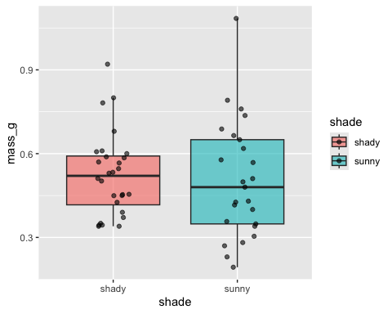
Figure 1: Leaf mass by side; each point is one leaf.

3.2 Mean ± SE
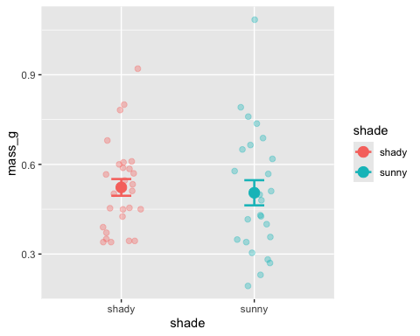
Figure 2: Mean leaf mass (± 1 SE) by side.

3.3 Histogram
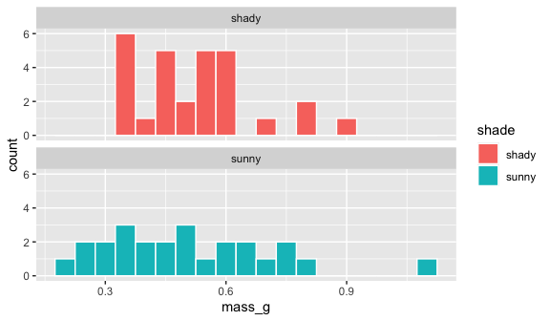
Figure 3: Distribution of leaf mass on each side.

3.4 Summary statistics
Table 1: Summary statistics for leaf mass (g) by side.
shade | n | mean | variance | sd | se | ci_lower | ci_upper
shady | 28 | 0.5230357 | 0.0219048 | 0.1480026 | 0.0279699 | 0.4656463 | 0.5804251
sunny | 25 | 0.5050640 | 0.0442281 | 0.2103048 | 0.0420610 | 0.4182544 | 0.5918736

3.5 Welch’s t-test
Welch Two Sample t-test
data: mass_g by shade
t = 0.35579, df = 42.527, p-value = 0.7238
alternative hypothesis: true difference in means between group shady and group sunny is not equal to 0
95 percent confidence interval:
-0.08392774 0.11987117
sample estimates:
mean in group shady mean in group sunny
0.5230357 0.5050640
Table 2: Welch’s t-test of leaf mass by side of the tree.
estimate1 | estimate2 | statistic | parameter | p.value | conf.low
0.5230357 | 0.505064 | 0.3557927 | 42.52693 | 0.7237547 | -0.0839277

4. Discussion

