Lecture 07 — Wide, Long, and Wild: Pivoting Real Data
  - Reshaping Lake Superior ice cover data with pivot_longer() and pivot_wider()
Bill Perry
2026-07-02

Where We Left Off (Lecture 06)
- Downloaded real data from inside R — NOAA’s GSODR package, Duluth station
- Raw vs. summarized data — daily data hides trends; group_by() %>% summarize() reveals them
- Reused lm() to estimate a rate of change — °C per year, converted to °C per decade
- case_when() to build a new categorical variable — summer vs. winter
- Compared two group-specific models — found winter warming faster than summer
 Note
✅ Transition
- Duluth’s weather data came to us already tidy
  - one row per day, one column per variable.
- Today’s dataset will not be tidy.
- We’ll learn how to fix that.

Goals for Today
- Download a genuinely messy, wide real-world dataset — Lake Superior daily ice cover
- Understand why wide data is hard for R (and great for humans)
- Learn pivot_longer() — turn wide data into tidy long data
- Learn pivot_wider() — turn long data back into a human-readable summary table
- Handle a tricky real-world wrinkle: winter seasons that cross the new year
- Recreate NOAA’s own “spaghetti plot” comparing every year of ice cover
- Ask: is Lake Superior’s maximum ice cover changing over time?
 Tip
🖐 Try it yourself
By the end you’ll have reshaped real NOAA ice data and built the same kind of plot NOAA scientists publish.

Tools today:
- tidyverse, janitor
Textbook:
- 📖 R4DS 2e — Hadley Wickham
  - Ch. 5 Data tidying
  - Ch. 17 Dates and times
- 📖 Data Carpentry — R for Ecologists

Meet the Data: Lake Superior Ice Cover
NOAA-GLERL (Great Lakes Environmental Research Laboratory) has tracked daily Great Lakes ice cover since 1973 — over 50 years of satellite-derived ice charts.
Today’s dataset: daily percent ice cover for Lake Superior, one row per day-of-winter, one column per year.
Source:
https://www.glerl.noaa.gov/data/ice/glicd/daily/sup.txt
 Important
This is a plain text file living on a government server — not a tidy CSV. This is what real environmental data often looks like.

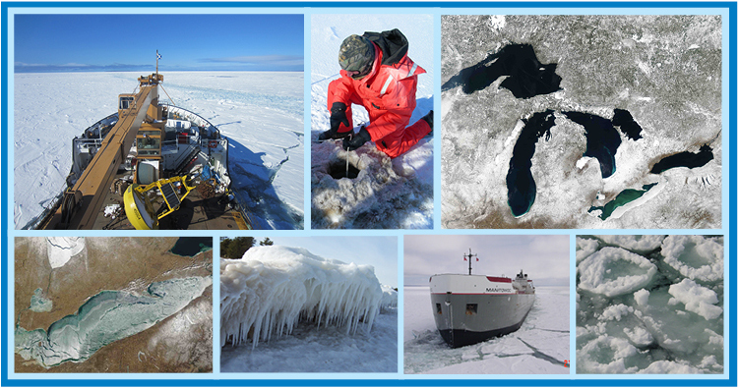
Great Lakes ice cover monitoring includes satellite imagery, field sampling, and decades of charts.

What Does “Wide” Data Look Like?
1973 1974 1975 ... 2024 2025
Nov-10 NA NA NA NA NA
Nov-11 NA NA NA NA NA
...
Jan-15 2.1 4.0 1.8 8.2 6.5
...
- One row per calendar day-of-winter (Nov 10 → ~May)
- One column per year — 53 columns, one for each ice season since 1973
- Lots of NA — many days simply had no ice that year or that month
This format is perfect for a human scanning a printed table. It’s terrible for R and ggplot.
Why this breaks tidy tools:
- ggplot() wants one column to map to x, one to y
- Here, “year” is hiding as 53 separate column names, not as data values
- group_by(year) is impossible — there’s no year column to group by!
📖 R4DS Ch. 5.2 — “every value in its own cell”

Load Libraries and Read the Raw File
# Load packages at the top — always -------------------
library(tidyverse) # data manipulation + ggplot2
library(janitor) # clean_names() and friends
# Read the messy text file directly from the web -------
url <- "https://www.glerl.noaa.gov/data/ice/glicd/daily/sup.txt"
ice_raw <- read.table(
url,
header = TRUE,
na.strings = c("-999", "-99.00", "NA")
) %>%
rownames_to_column(var = "date") %>%
as_tibble()
head(ice_raw)
# A tibble: 6 × 55
date X1973 X1974 X1975 X1976 X1977 X1978 X1979 X1980 X1981 X1982 X1983 X1984
<chr> <dbl> <dbl> <dbl> <dbl> <dbl> <dbl> <dbl> <dbl> <dbl> <dbl> <dbl> <dbl>
1 Nov-10 NA NA NA NA NA NA NA NA NA NA NA NA
2 Nov-11 NA NA NA NA NA NA NA NA NA NA NA NA
3 Nov-12 NA NA NA NA NA NA NA NA NA NA NA NA
4 Nov-13 NA NA NA NA NA NA NA NA NA NA NA NA
5 Nov-14 NA NA NA NA NA NA NA NA NA NA NA NA
6 Nov-15 NA NA NA NA NA NA NA NA NA NA NA NA
# ℹ 42 more variables: X1985 <dbl>, X1986 <dbl>, X1987 <dbl>, X1988 <dbl>,
# X1989 <dbl>, X1990 <dbl>, X1991 <dbl>, X1992 <dbl>, X1993 <dbl>,
# X1994 <dbl>, X1995 <dbl>, X1996 <dbl>, X1997 <dbl>, X1998 <dbl>,
# X1999 <dbl>, X2000 <dbl>, X2001 <dbl>, X2002 <dbl>, X2003 <dbl>,
# X2004 <dbl>, X2005 <dbl>, X2006 <dbl>, X2007 <dbl>, X2008 <dbl>,
# X2009 <dbl>, X2010 <dbl>, X2011 <dbl>, X2012 <dbl>, X2013 <dbl>,
# X2014 <dbl>, X2015 <dbl>, X2016 <dbl>, X2017 <dbl>, X2018 <dbl>, …
What’s happening here:
- read.table() (base R) handles this better than read_csv() since the file isn’t comma-separated
- na.strings tells R which placeholder values actually mean “missing”
- The day-of-winter labels (Nov-10, Nov-11…) were row names, not a real column — rownames_to_column() fixes that
 Important
Look at the column names: X1973, X1974… R adds an X because column names can’t start with a number!

pivot_longer() — Collapsing Wide to Long
# Collapse all year columns into year + ice_cover ------
ice_long <- ice_raw %>%
pivot_longer(
cols = -date,
names_to = "year",
names_prefix = "X",
values_to = "ice_cover"
)
ice_long <- ice_long %>%
arrange(year, date)
head(ice_long)
# A tibble: 6 × 3
date year ice_cover
<chr> <chr> <dbl>
1 Apr-01 1973 3
2 Apr-02 1973 2.7
3 Apr-03 1973 2.4
4 Apr-04 1973 2
5 Apr-05 1973 1.7
6 Apr-06 1973 1.4
Reading the arguments:
- cols = -date — pivot every column except date
- names_to = "year" — the old column names become values in a new year column
- names_prefix = "X" — strip the X that R glued onto the numbers
- values_to = "ice_cover" — the old cell values become a new ice_cover column
📖 R4DS Ch. 5.3 — pivot_longer() for wide-to-long

Before and After: Same Data, Different Shape
Wide (ice_raw):
date | X1973 | X1974 | X1975
Nov-10 | NA | NA | NA
Jan-15 | 2.1 | 4.0 | 1.8
Long (ice_long):
date | year | ice_cover
Jan-15 | 1973 | 2.1
Jan-15 | 1974 | 4.0
Jan-15 | 1975 | 1.8
Same information. Completely different shape.
- Wide: 53 columns, ~190 rows
- Long: 3 columns, ~190 × 53 rows
- The long version has one row per observation — exactly what ggplot() and group_by() expect
 Tip
This is the single most important reshaping skill in all of data science — almost every messy dataset needs this.

A Tricky Real-World Wrinkle: Winters Cross the New Year
The problem: an ice season runs Nov → May, but NOAA labels the whole season by the year winter ends in. So Nov-10 under column 1974 actually happened in November 1973.
# Assign Nov/Dec to the PREVIOUS calendar year ----------
ice_clean <- ice_long %>%
mutate(
year = as.numeric(year),
calendar_year = if_else(
str_starts(date, "Nov|Dec"),
year - 1,
year
),
full_date = ymd(paste(calendar_year, date, sep = "-")),
month = month(full_date, label = TRUE)
) %>%
drop_na(ice_cover, full_date)
head(ice_clean)
# A tibble: 6 × 6
date year ice_cover calendar_year full_date month
<chr> <dbl> <dbl> <dbl> <date> <ord>
1 Apr-01 1973 3 1973 1973-04-01 Apr
2 Apr-02 1973 2.7 1973 1973-04-02 Apr
3 Apr-03 1973 2.4 1973 1973-04-03 Apr
4 Apr-04 1973 2 1973 1973-04-04 Apr
5 Apr-05 1973 1.7 1973 1973-04-05 Apr
6 Apr-06 1973 1.4 1973 1973-04-06 Apr
Reading the logic:
- str_starts(date, "Nov|Dec") — does this row’s day-of-winter text start with “Nov” or “Dec”?
- If yes, subtract 1 from year to get the real calendar year
- ymd() (from lubridate) glues the pieces into one real R Date
- drop_na() removes rows with no real date or no ice reading
📖 R4DS Ch. 17 — working with dates and times

Summarize Now That We’re Long
# Mean ice cover per year-month --------------------------
monthly_avg <- ice_clean %>%
group_by(year, month) %>%
summarize(
mean_ice = mean(ice_cover, na.rm = TRUE),
.groups = "drop"
)
monthly_avg <- monthly_avg %>%
mutate(month_date = ymd(paste(year, month, "01", sep = "-")))
head(monthly_avg)
# A tibble: 6 × 4
year month mean_ice month_date
<dbl> <ord> <dbl> <date>
1 1973 Jan 18.1 1973-01-01
2 1973 Feb 32.8 1973-02-01
3 1973 Mar 28.2 1973-03-01
4 1973 Apr 2.2 1973-04-01
5 1973 Dec 12.0 1973-12-01
6 1974 Jan 24.1 1974-01-01
This should look familiar.
- Exactly the same group_by() %>% summarize() pattern from Lecture 06’s Duluth weather data
- We could not have written this on the wide data — there was no year or month column to group by until we pivoted
The reshape wasn’t just cosmetic — it unlocked every tidyverse tool we already know.

pivot_wider() — Going Back the Other Direction
# Turn long data into a year-by-month summary table ------
ice_pivot_table <- ice_clean %>%
pivot_wider(
id_cols = year,
names_from = month,
values_from = ice_cover,
values_fn = mean
)
print(ice_pivot_table)
# A tibble: 54 × 9
year Apr Dec Feb Jan Mar May Nov Jun
<dbl> <dbl> <dbl> <dbl> <dbl> <dbl> <dbl> <dbl> <dbl>
1 1973 2.2 12.0 32.8 18.1 28.2 NA NA NA
2 1974 23.9 8.4 58.4 24.1 64.0 3.3 NA NA
3 1975 8.70 NA 35.9 10.7 17.2 NA NA NA
4 1976 6.52 5.48 27.8 15.4 32.3 NA NA NA
5 1977 24.2 19.1 92.0 61.1 78.0 2.15 NA NA
6 1978 9.67 5.98 55.4 17.3 63.7 2.57 NA NA
7 1979 48.5 3.31 85.4 36.8 87.6 21.3 NA NA
8 1980 15.6 NA 58.8 8.95 41.9 NA NA NA
9 1981 11.7 14.2 74.5 30.7 41.3 NA NA NA
10 1982 14.5 1.91 66.5 25.2 54.1 2.5 NA NA
# ℹ 44 more rows
pivot_wider() is the mirror image of pivot_longer():
- id_cols = year — one row per year
- names_from = month — month values become new column headers
- values_from = ice_cover — fills the cells
- values_fn = mean — averages if multiple days land in the same year-month cell
This recreates an Excel-style pivot table — but computed, not copy-pasted.
📖 R4DS Ch. 5.4 — pivot_wider()

Why Learn Both Directions?
Direction | When to use it
pivot_longer() | Data arrives wide (one column per year/site/etc.) and you need it tidy for ggplot() or group_by()
pivot_wider() | You have tidy long data but need a human-readable summary table — for a report, a colleague, or Excel
Real data rarely arrives tidy. Spreadsheets from agencies, field data sheets, and government text files are almost always shaped for human eyes, not for R.
 Important
You will use pivot_longer() constantly in your own research. This is one of the most-used functions in the entire tidyverse.

NOAA’s Own “Spaghetti Plot”
NOAA publishes a live version of this exact plot every winter, comparing the current year (black), the historical average (red), and every past year (thin blue lines):
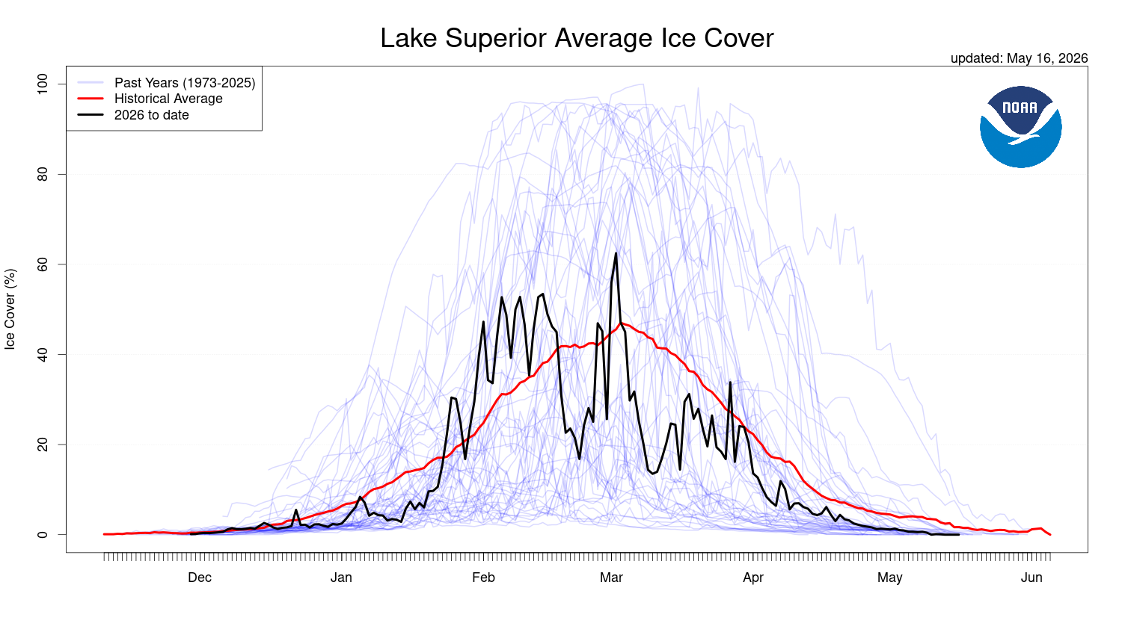
NOAA’s live Lake Superior ice cover comparison — current season vs. historical average vs. all past years.
Today, we’ll build our own version of this plot from the raw data we just tidied.
Why “spaghetti plot”?
- Dozens of thin overlapping lines look like noodles
- Each line is one year’s entire ice season, Nov → May
- The pattern that emerges — or doesn’t — tells the real climate story
This is a great example of how the same chart type appears in real published science.

Prep: Put Every Winter on One Shared Axis
# Force every date onto one fake shared year -------------
ice_plot_data <- ice_clean %>%
mutate(
plot_date = if_else(
month(full_date) >= 10,
update(full_date, year = 1999),
update(full_date, year = 2000)
)
)
# Historical average for each day-of-winter ---------------
historical_avg <- ice_plot_data %>%
group_by(plot_date) %>%
summarize(avg_ice = mean(ice_cover, na.rm = TRUE))
current_yr <- max(ice_plot_data$year)
past_years <- ice_plot_data %>% filter(year < current_yr)
current_year_data <- ice_plot_data %>% filter(year == current_yr)
The trick: every winter spans two real calendar years (e.g. Nov 1973–May 1974). To overlay them, we relabel every date onto one fake shared year (1999 for fall, 2000 for spring) — only the month/day matters for the x-axis.
This is a common trick for any seasonal, cyclical time series.

Build the Spaghetti Plot
ice_spaghetti_plot <- ggplot() +
geom_line(
data = past_years,
aes(x = plot_date, y = ice_cover, group = year),
color = "blue",
alpha = 0.15
) +
geom_line(
data = historical_avg,
aes(x = plot_date, y = avg_ice),
color = "red",
linewidth = 1.2
) +
geom_line(
data = current_year_data,
aes(x = plot_date, y = ice_cover),
color = "black",
linewidth = 1.2
) +
scale_x_date(date_labels = "%b", date_breaks = "1 month") +
labs(
title = "Lake Superior Average Ice Cover",
subtitle = paste("Comparing", current_yr, "to Historical Data"),
x = NULL,
y = "Ice Cover (%)"
) +
theme_bw()
ice_spaghetti_plot
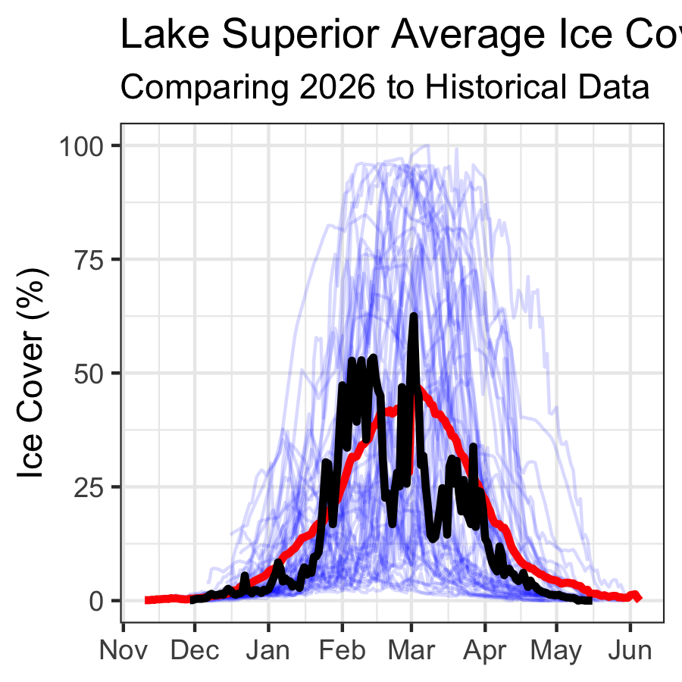
Three layers, three geom_line() calls:
- Thin, transparent blue lines — every past year, faded so patterns (not individual years) stand out
- Thick red line — the 50+ year historical average
- Thick black line — this year, drawn last so it’s on top
Compare your version to NOAA’s published plot — did we recreate it?

A New Question: Is Maximum Ice Cover Changing?
So far: we’ve visualized the shape of each ice season.
New question: has the peak (maximum) ice cover of each winter changed over the last 50 years?
# Find the single highest ice-cover day each year --------
max_ice_per_year <- ice_clean %>%
group_by(year) %>%
slice_max(order_by = ice_cover, n = 1, with_ties = FALSE)
head(max_ice_per_year %>% arrange(ice_cover))
# A tibble: 6 × 6
# Groups: year [6]
date year ice_cover calendar_year full_date month
<chr> <dbl> <dbl> <dbl> <date> <ord>
1 Jan-22 2012 8.2 2012 2012-01-22 Jan
2 Mar-17 2002 10.3 2002 2002-03-17 Mar
3 Jan-16 1998 11.1 1998 1998-01-16 Jan
4 Feb-19 2024 12 2024 2024-02-19 Feb
5 Jan-25 1987 14.5 1987 1987-01-25 Jan
6 Mar-02 2006 16.7 2006 2006-03-02 Mar
slice_max() keeps only the single row with the highest value in each group — here, one row per year: the date and value of that winter’s ice peak.
This also gives us the “ice-on/ice-off” story:
- The date of each year’s maximum is itself meaningful — an early peak (Jan) vs. a late peak (Mar/Apr) tells you something about how long the ice season lasted
- 1998’s max ice cover was only ~11%, on Jan 16 — a nearly ice-free winter
- 1979’s max was ~97%, on Feb 25 — almost total coverage

Model the Trend in Maximum Ice Cover
# Fit a regression: max ice cover by year -----------------
max_ice_model <- lm(ice_cover ~ year, data = max_ice_per_year)
summary(max_ice_model)
Call:
lm(formula = ice_cover ~ year, data = max_ice_per_year)
Residuals:
Min 1Q Median 3Q Max
-53.692 -24.810 3.811 20.982 48.599
Coefficients:
Estimate Std. Error t value Pr(>|t|)
(Intercept) 1427.4557 498.1910 2.865 0.00600 **
year -0.6841 0.2492 -2.746 0.00827 **
---
Signif. codes: 0 '***' 0.001 '**' 0.01 '*' 0.05 '.' 0.1 ' ' 1
Residual standard error: 28.54 on 52 degrees of freedom
Multiple R-squared: 0.1266, Adjusted R-squared: 0.1098
F-statistic: 7.539 on 1 and 52 DF, p-value: 0.008274
max_ice_plot <- max_ice_per_year %>%
ggplot(aes(x = year, y = ice_cover)) +
geom_point(size = 2) +
geom_smooth(method = "lm", color = "firebrick") +
labs(
title = "Lake Superior — Annual Maximum Ice Cover",
x = "Year",
y = "Max Ice Cover (%)"
) +
theme_minimal()
max_ice_plot
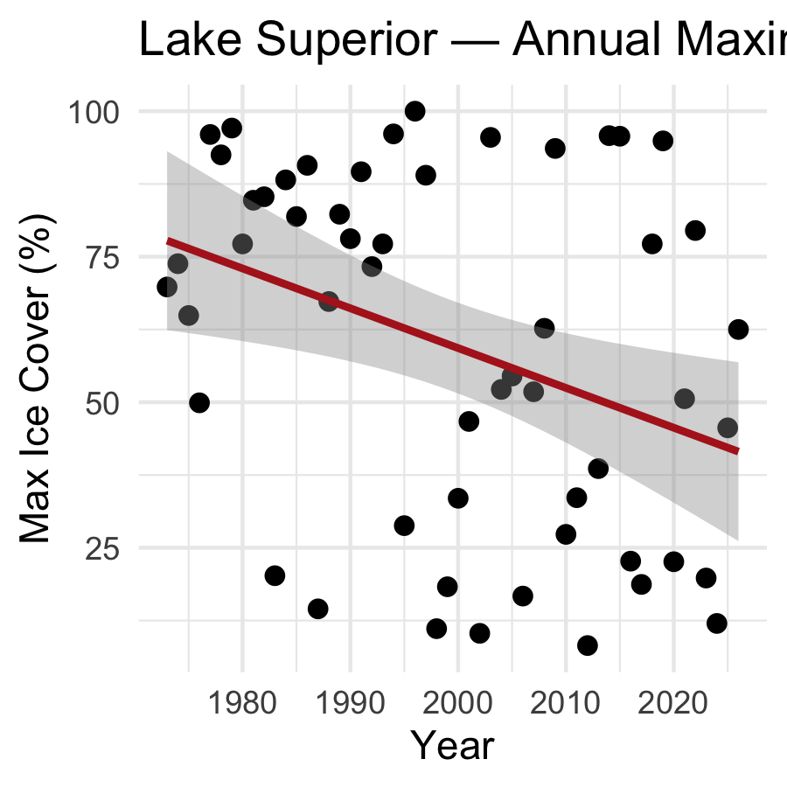
Same lm() syntax as Lecture 06 — only now X = year and Y = ice_cover (the yearly peak, not a daily or monthly mean).
- The slope tells us °C-equivalent: percentage points of max ice cover, per year
- Notice the huge year-to-year scatter — Great Lakes ice cover is famously variable, driven by short-term weather patterns like ENSO and the polar vortex, not just a steady climate trend
This is real data — the story is messier (and more honest) than a clean line.

What We Learned Today
Concepts:
- Real-world data is often wide — shaped for human eyes, not for R
- pivot_longer() collapses many columns into key-value pairs — unlocking group_by(), summarize(), and ggplot()
- pivot_wider() does the reverse — builds a readable summary table from tidy data
- Seasonal data that crosses the calendar year boundary needs careful date logic
- slice_max() pulls out the single extreme value per group — useful for “ice-on/ice-off” type questions
- The same lm() workflow from Lecture 06 applies to any time-indexed variable, including a yearly maximum
R skills:
- read.table() + rownames_to_column() for messy text files
- pivot_longer() / pivot_wider()
- str_starts(), if_else(), ymd(), update() for date wrangling
- slice_max(order_by = ..., n = 1)
References:
- 📖 R4DS Ch. 5 — Data tidying
- 📖 R4DS Ch. 17 — Dates and times
- 📖 Data Carpentry — R for Ecologists
Data source:
- NOAA-GLERL Great Lakes Ice Cover Database
glerl.noaa.gov/data/ice
Up next — Homework:
- Apply the same wide-to-long pivot workflow to a Great Lake of your choice
- Compare your lake’s maximum ice trend to Lake Superior’s

