Lecture 03 — GGPlot I
  - Grouped summaries, facets, and the pipe into ggplot
Bill Perry
2026-10-05

Where we left off (Lecture 02 — Meeting R)
- Project structure — data/, scripts/, figures/
- Packages — install.packages() once, library() every session
- Loading data — read_excel(), clean_names() into leaf_df
- The pipe — %>% reads as “then”
- Our first plot — a bare geom_point()
 Note
✅ Key idea from Lecture 02
You can already load data and make one honest point on a page. Today that one geom becomes a whole toolkit: custom colors, side-by-side panels, and a proper mean ± SE summary.

Goals for Today
- Start every plot with the pipe: leaf_df %>% ggplot(...)
- Assign colors on purpose with scale_color_manual()
- Split one plot into panels with facet_wrap() and facet_grid()
- Build a mean ± SE plot with stat_summary()
 Tip
🖐 Try it yourself
By the end you will make a publication-style figure: raw leaf data, grouped and colored on purpose, with the mean and its uncertainty layered on top.

References:
- 📖 Whitlock & Schluter, Ch. 2 — Displaying Data
- 📖 R4DS Ch 1 — Data Visualization
- 📖 R4DS Ch 9 — Layers
Both PDFs are in the course readings/ folder.
Naming conventions:
- data frames → _df
- plots → _plot

How to Use These Slides — Predict · Type · Run
This lecture runs in three short chunks. After each chunk you switch to the activity and type the code yourself into your R script.
For every code block, do three things:
- Predict — before it runs, say what you think the output will be
- Type it out by hand — do not copy-paste
- Run it and compare to your prediction
Note
✅ Why bother?
- facet_wrap() and facet_grid() look interchangeable until you’ve typed both and watched one wrap into rows while the other insists on a strict grid.
- Typing scale_color_manual(values = c(...)) yourself is what makes you notice the color names have to match your group names exactly.

Load Libraries and Data
# Load all packages at the top of every script ----------
library(readxl) # reading Excel files
library(tidyverse) # data wrangling + ggplot2
library(janitor) # cleans up messy column names
# Read the leaf data from the data folder ---------------
leaf_df <-
read_excel("data/2026_09_03_data_sci_leaf_area.xlsx") %>%
clean_names()
glimpse(leaf_df)
Rows: 53
Columns: 8
$ twig_id <chr> NA, NA, NA, NA, NA, NA, NA, NA, NA, NA, NA…
$ leaf_id <chr> NA, NA, NA, NA, NA, NA, NA, NA, NA, NA, NA…
$ teams <chr> "12345", "12345", "12345", "12345", "12345…
$ shade <chr> "sunny", "sunny", "sunny", "sunny", "sunny…
$ mass_g <dbl> 0.4000, 0.4800, 0.3400, 0.6500, 0.2700, 0.…
$ petiole_mm <dbl> 79.0000, 63.0000, 68.0000, 35.0000, 34.000…
$ thickness_mm <dbl> 0.15, 0.14, 0.14, 0.15, 0.11, 0.16, 0.14, …
$ paper_mass_g <dbl> 0.2100, 0.2100, 0.2100, 0.2400, 0.1500, 0.…

🧩 Chunk 1 of 3 · Piping into ggplot, on Purpose
We will cover: starting a plot with the pipe, and choosing colors with scale_color_manual().
🛑 After this chunk you will do Activity Parts 1–2.

Every Plot Starts the Same Way
# Pipe the data frame straight into ggplot() -----------
leaf_df %>%
ggplot(aes(x = shade, y = mass_g, fill = shade)) +
geom_boxplot(alpha = 0.6, outlier.shape = NA) +
geom_jitter(width = 0.15, alpha = 0.6) +
labs(title = "Leaf Mass by Shade", x = "Shade",
y = "Leaf Mass (g)", fill = "Shade") +
theme_minimal()
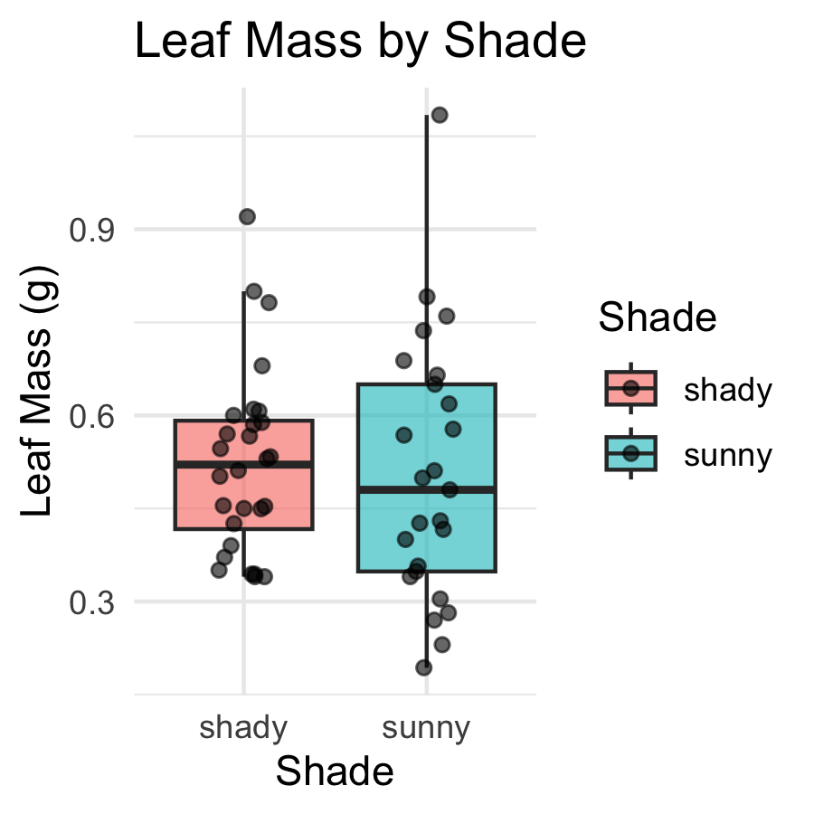
- leaf_df %>% ggplot(...) = “take leaf_df, then plot it”
- Everything after ggplot() is added with +, not %>%
- fill = shade maps a column to color — ggplot picks the colors
 Warning
⚠️ Watch out!
%>% connects data-wrangling steps. + connects plot layers. Mixing them up is the single most common ggplot error.

Choosing Colors on Purpose — scale_color_manual()
Note
🔮 Predict first: scale_fill_manual() needs one color per group. We have two groups — how many colors do we supply?

# scale_fill_manual() assigns exact colors to exact groups
leaf_df %>%
ggplot(aes(x = shade, y = mass_g, fill = shade)) +
geom_boxplot(alpha = 0.6, outlier.shape = NA) +
geom_jitter(width = 0.15, alpha = 0.6) +
scale_fill_manual(values = c("sunny" = "goldenrod",
"shady" = "forestgreen")) +
labs(title = "Leaf Mass by Shade", x = "Shade",
y = "Leaf Mass (g)", fill = "Shade") +
theme_minimal() +
theme(legend.position = "none")
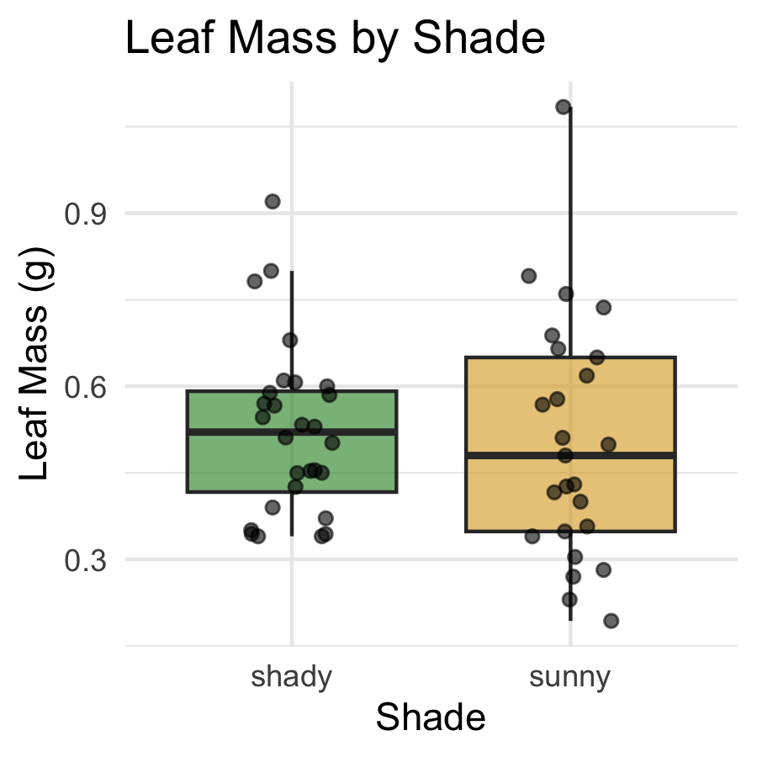
- scale_fill_manual() — for fill = aesthetics (boxes, bars, columns)
- scale_color_manual() — for color = aesthetics (points, lines)
- The names in c() must exactly match your data’s values — case and spelling count
Warning
⚠️ Watch out! A name that doesn’t match falls back to grey, with a warning.

→ ACTIVITY 3 Parts 1–2 now
🛑 Do Activity Parts 1–2 now
Pipe into ggplot(), then assign sunny/shady their own colors with scale_fill_manual(). Predict, type, run.

🧩 Chunk 2 of 3 · Small Multiples with Facets
We will cover: facet_wrap() and facet_grid() — splitting one plot into a panel per group.
🛑 After this chunk you will do Activity Part 3.

facet_wrap() — One Panel per Group
# facet_wrap() splits into one panel per level ---------
leaf_df %>%
ggplot(aes(x = mass_g, fill = shade)) +
geom_histogram(binwidth = 0.05, color = "white") +
facet_wrap(~shade) +
scale_fill_manual(values = c("sunny" = "goldenrod",
"shady" = "forestgreen")) +
labs(x = "Leaf Mass (g)", y = "Count",
title = "Mass Distribution by Shade") +
theme_minimal() +
theme(legend.position = "none")
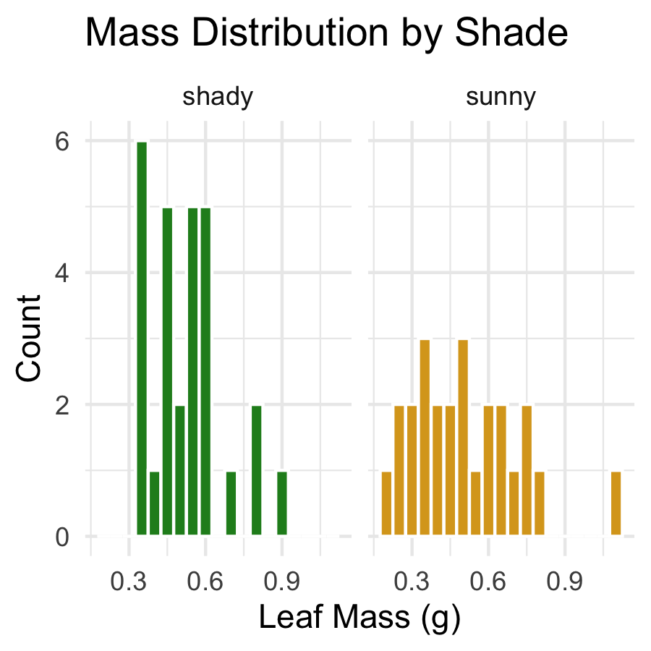
- ~shade reads as “by shade” — the ~ is required
- Each panel gets its own copy of the plot, filtered to that group
- facet_wrap(~shade, scales = "free_y") lets each panel’s y-axis rescale independently
📖 R4DS §9 — Layers

facet_grid() — a Strict Rows-and-Columns Grid
# facet_grid(rows ~ cols) — use "." for "no grouping" --
leaf_df %>%
ggplot(aes(x = mass_g, fill = shade)) +
geom_histogram(binwidth = 0.05, color = "white") +
facet_grid(shade ~ .) +
scale_fill_manual(values = c("sunny" = "goldenrod",
"shady" = "forestgreen")) +
labs(x = "Leaf Mass (g)", y = "Count") +
theme_minimal() +
theme(legend.position = "none")
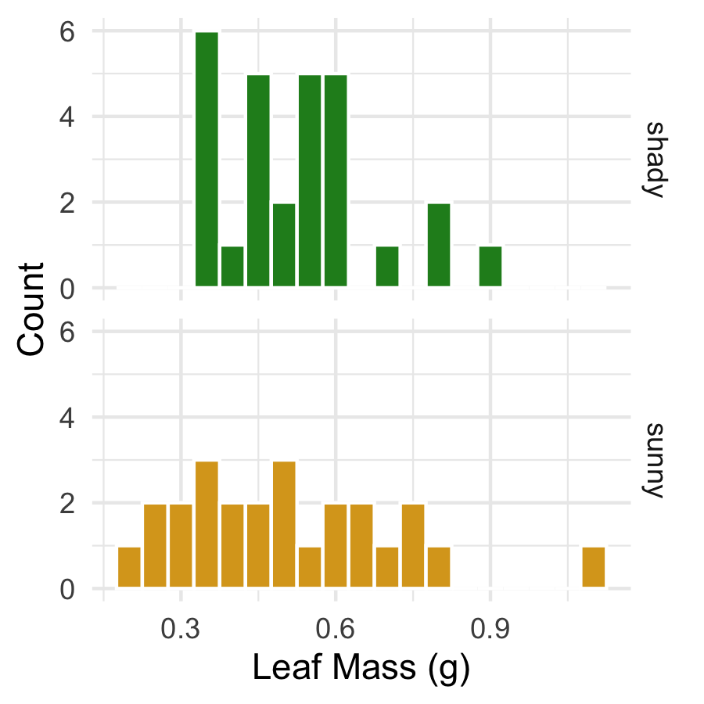
- facet_grid(shade ~ .) stacks panels in rows; facet_grid(. ~ shade) arranges them in columns
- The dot . means “nothing on this side of the grid”
- facet_grid() really shines with two grouping variables (rows ~ cols) — we only have one (shade) today, but you’ll use the two-variable form the moment your data has a second grouping column
Note
💡 facet_wrap vs facet_grid
Use facet_wrap() for one grouping variable — it wraps panels into a grid automatically. Use facet_grid() when you have two variables and want rows and columns to each mean something specific.

→ ACTIVITY 3 Part 3 now
🛑 Do Activity Part 3 now
Build both a facet_wrap() and a facet_grid() version of the histogram. Predict, type, run.

🧩 Chunk 3 of 3 · Mean ± SE with stat_summary()
We will cover: layering a group mean and its standard error directly on top of raw data — no summary table needed.
🛑 After this chunk you will do Activity Parts 4–5.

stat_summary() — the Mean as a Layer
# stat_summary() computes the mean straight from the data
leaf_df %>%
ggplot(aes(x = shade, y = mass_g, color = shade)) +
geom_jitter(width = 0.15, alpha = 0.4, size = 2) +
stat_summary(fun = mean, geom = "point", size = 4,
color = "black") +
scale_color_manual(values = c("sunny" = "goldenrod",
"shady" = "forestgreen")) +
labs(title = "Leaf Mass with Group Means",
x = "Shade", y = "Leaf Mass (g)") +
theme_minimal() +
theme(legend.position = "none")
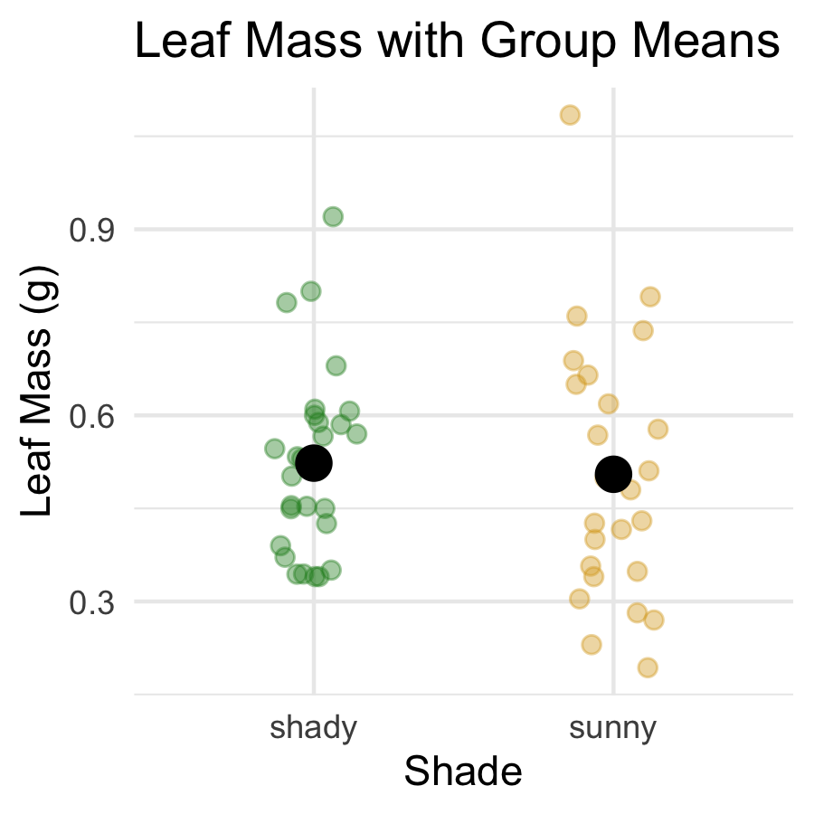
- Computes a statistic from the raw data — no summary table needed
- fun = mean — any function returning one number (median, max, …)
- geom = "point" — draw it as a point
- Put geom_jitter() before stat_summary() so the mean sits on top

stat_summary() — Mean ± SE
# fun.data = returns THREE values: y, ymin, ymax -------
leaf_mean_se_plot <- leaf_df %>%
ggplot(aes(x = shade, y = mass_g, color = shade)) +
geom_jitter(width = 0.15, alpha = 0.35, size = 2) +
stat_summary(fun = mean, geom = "point", size = 4) +
stat_summary(fun.data = mean_se, geom = "errorbar",
width = 0.15, linewidth = 0.9) +
scale_color_manual(values = c("sunny" = "goldenrod",
"shady" = "forestgreen")) +
labs(title = "Mean ± SE Leaf Mass by Shade",
x = "Shade", y = "Leaf Mass (g)") +
theme_minimal() +
theme(legend.position = "none")
leaf_mean_se_plot
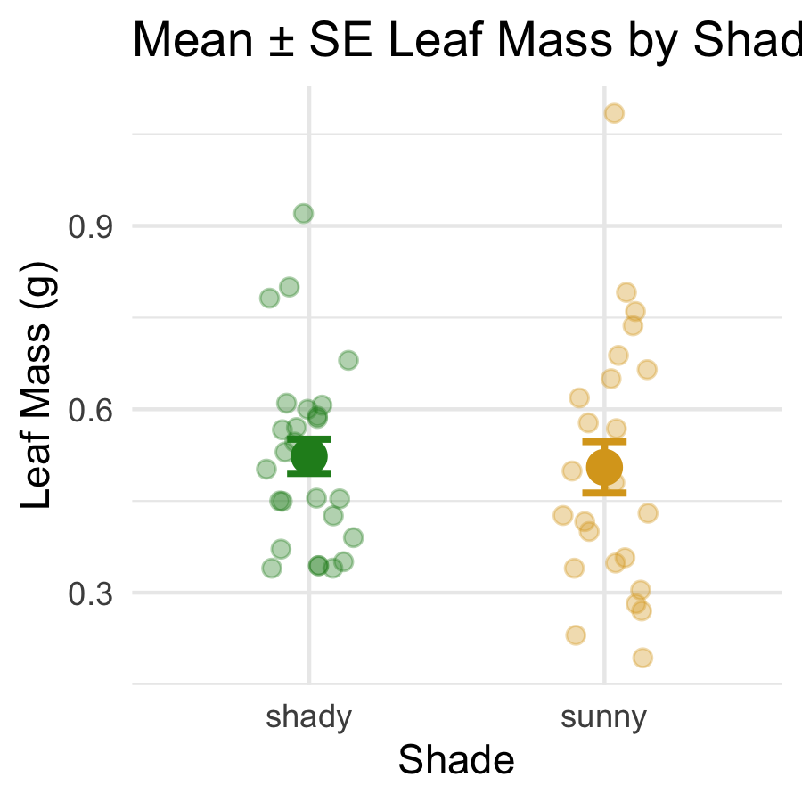
🔮 Predict first: fun.data = mean_se returns three numbers per group, not one — what are they?
Two stat_summary() layers, stacked:
call | what it draws
fun = mean | a point at the mean
fun.data = mean_se | error bars for ± 1 SE
- Raw points in the background, mean as a larger point, bars = ± 1 SE
📖 Whitlock & Schluter, Ch. 3 — Describing Data

→ ACTIVITY 3 Parts 4–5 now
🛑 Go to Activity 3 — Parts 4–5
Close the slides. Build your own mean ± SE plot, then save it to figures/.

What We Learned Today
- Pipe straight into a plot: leaf_df %>% ggplot(...)
- scale_color_manual() / scale_fill_manual() — colors you choose, not colors ggplot guesses
- facet_wrap(~var) — one panel per group, wraps automatically
- facet_grid(rows ~ cols) — strict grid, best with two grouping variables
- stat_summary() — mean and mean ± SE, drawn directly from raw data
References:
- 📖 Whitlock & Schluter, Ch. 2 — Displaying Data
- 📖 R4DS Ch 1 — Data Visualization
- 📖 R4DS Ch 9 — Layers
Up next — Lecture 04, GGPlot II:
- Practicing on a brand-new dataset
- coord_cartesian() vs. ylim()
- Histograms, density plots, themes, and patchwork

