Lecture 14 — One-Way ANOVA II: Running & Reporting the Test
  - Reading the F table, finding which groups differ, and writing it up
Bill Perry
2026-10-05

Where we left off (Lecture 13 — One-Way ANOVA I)
- mass_model <- lm(body_mass_g ~ species, data = penguins_df) — fit
- Normality checked — Q-Q panel + Shapiro-Wilk on the residuals
- Equal variance checked — Levene’s test
- Decision: assumptions look fine, proceed with classic ANOVA
 Note
✅ Transition
The model is fit and its assumptions are checked. Today we actually read the F table, find which species differ, and turn the result into a sentence a reader can trust.

Goals for today
- Run the ANOVA two ways: aov() and car::Anova()
- Understand why Type II sums of squares matter for unbalanced data
- Find which groups differ with emmeans post-hoc tests
- Read a compact letter display (CLD)
- Plot the estimated means ± CI
- Write a complete, reportable results sentence
Tools today:
- car — Anova()
- emmeans, multcomp — post-hoc, CLD
Textbook:
- 📖 Whitlock & Schluter, Ch. 15 — ANOVA
- 📖 emmeans vignettes
Naming: models → _model, plots → _plot

How to Use These Slides — Predict · Type · Run
This lecture runs in two short chunks. After each chunk you switch to the activity and type the code yourself.
For every code block, do three things:
- Predict — before it runs, say what you think the output will be
- Type it out by hand — do not copy-paste
- Run it and compare to your prediction
Note
✅ Why bother? (the evidence)
- Predicting the p-value before you see it forces you to reason from the boxplot’s separation, not just read a number off a screen.
- Typing type = "II" yourself in Anova() is what makes you notice it’s there — paste the line and you’ll never ask why it matters for unbalanced groups.
- Letters in a compact letter display only mean something if you’ve watched them get built from the pairwise table above them.

🧩 Chunk 1 of 2 · Run the ANOVA & Read the F Table
We will cover: the ANOVA table two ways — base aov() and car::Anova() — and why the difference matters for unbalanced data.
 Tip
🖐 After this chunk: Activity Parts 7–8 (run both, read F / df / p).

Run the ANOVA — aov() and summary()
Note
🔮 Predict first: The boxplot from Lecture 13 looked very separated. Predict the p-value — closer to 0.5, 0.05, or far below 0.001?

# Load packages at the top — always -------------------
library(tidyverse) # wrangling + ggplot2
library(palmerpenguins) # the penguins data
library(car) # Anova()
library(emmeans) # post-hoc pairwise tests
# Same model fit at the end of Lecture 13 --------------
penguins_df <- penguins %>%
drop_na(body_mass_g, species)
mass_model <- lm(body_mass_g ~ species, data = penguins_df)
# Classic ANOVA table (Type I sums of squares) --------
mass_aov <- aov(body_mass_g ~ species, data = penguins_df)
summary(mass_aov)
Df Sum Sq Mean Sq F value Pr(>F)
species 2 146864214 73432107 343.6 <2e-16 ***
Residuals 339 72443483 213698
---
Signif. codes: 0 '***' 0.001 '**' 0.01 '*' 0.05 '.' 0.1 ' ' 1
Reading the table:
Column | Meaning
Df | groups − 1, and residual df
F value | between ÷ within variance
Pr(>F) | the p-value for H₀
p < 0.05 → reject H₀ → at least one species differs. But which? Chunk 2.

Live Demo — Watch It Break (on purpose)
For unbalanced data we prefer car::Anova(). I’ll reach for it but type lowercase, and forget the package:
anova(mass_model) # base R — Type I, one model at a time
Anova(mass_model) # capital A — but car isn't loaded!
R stops:
Error in Anova(mass_model) :
could not find function "Anova"
The fix — load car, and mind the capital A:
library(car)
Anova(mass_model, type = "II")
Tip
✅ Why show a broken run?
anova() and Anova() are two entirely different functions that happen to differ by one capital letter — R will not guess which one you meant. Watching the exact error message land here means you’ll recognize it instantly instead of re-checking your spelling three times when it happens mid-assignment.

car::Anova() — Type II for Unbalanced Data
# Type II sums of squares — the right call here -------
Anova(mass_model, type = "II")
Anova Table (Type II tests)
Response: body_mass_g
Sum Sq Df F value Pr(>F)
species 146864214 2 343.63 < 2.2e-16 ***
Residuals 72443483 339
---
Signif. codes: 0 '***' 0.001 '**' 0.01 '*' 0.05 '.' 0.1 ' ' 1
Why Type II?
- Our groups have different n (unbalanced)
- With one predictor the F is the same, but Type II is the habit you want before you meet two-way ANOVA, where the type genuinely changes the answer
Note
anova() = Type I (order-dependent). Anova(type = "II") = order-independent.

🛑 Pause — Do Activity Parts 7–8 Now
Run aov() + summary(), then car::Anova(type = "II"). Predict the F and p before you read them, and confirm both tables agree.

🧩 Chunk 2 of 2 · Which Groups Differ? Post-Hoc with emmeans
We will cover: ANOVA says “some differ” — emmeans says which, with the comparisons properly adjusted.
Tip
🖐 After this chunk: Activity Parts 9–11 (pairwise tests, letters, plot, report).

Post-Hoc — Pairwise Comparisons with emmeans
Note
🔮 Predict first: From the boxplot, predict — will all three species differ from each other, or will two be statistically tied?

# Estimated marginal means + Tukey-adjusted pairs -----
mass_emm <- emmeans(mass_model, pairwise ~ species)
mass_emm$contrasts
contrast estimate SE df t.ratio p.value
Adelie - Chinstrap -32.4 67.5 339 -0.480 0.8807
Adelie - Gentoo -1375.4 56.1 339 -24.495 <0.0001
Chinstrap - Gentoo -1342.9 69.9 339 -19.224 <0.0001
P value adjustment: tukey method for comparing a family of 3 estimates
Reading it:
- emmeans(..., pairwise ~ species) gives each group’s mean and every pairwise comparison
- The p-values are Tukey-adjusted — they already correct for multiple comparisons, so the family-wise error stays at 0.05
📖 W&S §15.4 — planned vs. unplanned comparisons

Compact Letter Display — Who Shares a Letter?
# Groups that SHARE a letter are NOT different --------
multcomp::cld(mass_emm$emmeans, Letters = letters)
species emmean SE df lower.CL upper.CL .group
Adelie 3701 37.6 339 3627 3775 a
Chinstrap 3733 56.1 339 3623 3843 a
Gentoo 5076 41.7 339 4994 5158 b
Confidence level used: 0.95
P value adjustment: tukey method for comparing a family of 3 estimates
significance level used: alpha = 0.05
NOTE: If two or more means share the same grouping symbol,
then we cannot show them to be different.
But we also did not show them to be the same.
How to read letters:
- Same letter → not significantly different
- Different letters → significantly different
This is the compact summary you see in published figures — one letter above each bar.
Tip
Install once: install.packages("multcomp")

Plot the Result — Means ± CI
mass_emm_plot <- as.data.frame(mass_emm$emmeans) %>%
ggplot(aes(x = species, y = emmean, color = species)) +
geom_point(size = 3) +
geom_errorbar(
aes(ymin = lower.CL, ymax = upper.CL),
width = 0.15, linewidth = 0.9
) +
labs(x = "Species", y = "Estimated mean mass (g)") +
theme_minimal() +
theme(legend.position = "none")
mass_emm_plot
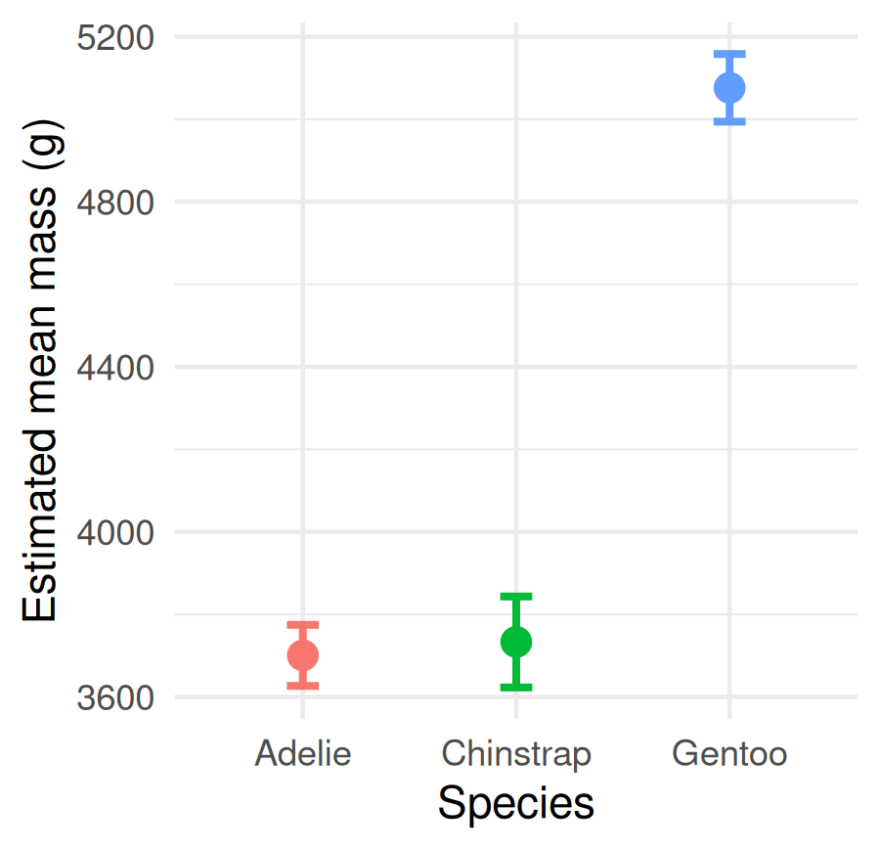
Estimated marginal means with 95% confidence intervals.
- Non-overlapping intervals hint at real differences
- Pair this plot with the letters for a publication-ready figure
The emmeans plot is the ANOVA cousin of Lecture 03’s mean ± SE plot.

How to Report an ANOVA
# Pull the F table values for reporting ---------------
mass_tab <- Anova(mass_model, type = "II")
mass_tab
Anova Table (Type II tests)
Response: body_mass_g
Sum Sq Df F value Pr(>F)
species 146864214 2 343.63 < 2.2e-16 ***
Residuals 72443483 339
---
Signif. codes: 0 '***' 0.001 '**' 0.01 '*' 0.05 '.' 0.1 ' ' 1
“Body mass differed significantly among the three penguin species (one-way ANOVA: F(2, 339) = 343.6, p < 0.001). Tukey-adjusted comparisons showed all three species differed, with Gentoo heaviest and Adelie lightest.”
Always include:
- Test type (one-way ANOVA)
- F, both df, and the p-value
- The post-hoc result (which groups differ)
- Group means ± SE or CI
Never write “p = 0.000” — use “p < 0.001”.

🛑 Pause — Do Activity Parts 9–11 Now
Run the emmeans pairwise test, get the letters, plot the means ± CI, and write your results sentence. Predict which species differ before you run the comparisons.

What We Learned Today
Concepts:
- ANOVA rejects H₀ for the group, but post-hoc finds which pairs differ
- Tukey adjustment keeps the family-wise error at 0.05
- A compact letter display turns a pairwise table into one glance
R skills:
- aov() + summary()
- car::Anova(model, type = "II")
- emmeans(model, pairwise ~ group) + multcomp::cld()
References:
- 📖 W&S Ch. 15 — ANOVA
- 📖 emmeans vignettes
Up next — Lecture 15:
- Kicking off the final project
- Applying this whole toolkit — wrangling, plotting, and a test — to a dataset you choose

