Lecture 06 — Summary Statistics
  - Mean, median, spread, and describing groups the tidy way
Bill Perry
2026-10-09

Where we left off (Lecture 05 — Wrangling)
- filter(), select(), mutate(), arrange() — the core wrangling verbs
- Chaining verbs into one pipeline with %>%
- Our leaf data: leaf_df — shade, mass_g, petiole_mm, thickness_mm, paper_mass_g
 Note
✅ Key idea from Lecture 05
You can already reshape the data into exactly the rows and columns you need. Today we learn to describe what’s in it — one number at a time, then all at once.

Our Scientific Question
Biological prediction: Leaves on the shady side of a tree will be larger and heavier to capture more of the limited light.
 | Hypothesis
H₀ — null | No difference in leaf size between sunny and shady sides
Hₐ — alternate | Leaf size differs between sunny and shady sides
Plan for this unit:
- Today — describe the data
- Lecture 09 — formally test the hypotheses with a t-test
Statistics helps us decide which hypothesis is better supported by the data.
References:
- 📖 Whitlock & Schluter, Ch. 3 — Describing Data
- 📖 Whitlock & Schluter, Ch. 4 — Estimating with Uncertainty
- 📖 R4DS Ch 13 — Numbers
- 📖 R4DS Ch 18 — Missing Values
Both W&S PDFs are in the course readings/ folder.

How to Use These Slides — Predict · Type · Run
This lecture runs in two chunks. After each chunk you switch to the activity and type the code yourself into your R script.
For every code block, do three things:
- Predict — before it runs, say what you think the output will be
- Type it out by hand — do not copy-paste
- Run it and compare to your prediction
Note
✅ Why bother?
- A single mean or SD looks obvious once it’s on the slide — predicting it first is what tells you whether you actually understand where the number comes from.
- Typing sum(!is.na(x)) yourself, instead of pasting it, is what makes you notice why it’s there instead of length(x).

Load Libraries and Data
# Load all packages at the top of every script ----------
library(readxl) # reading Excel files
library(tidyverse) # data wrangling + ggplot2
library(janitor) # clean_names()
library(skimr) # fast descriptive summaries
# Read the leaf data from the data folder ---------------
leaf_df <-
read_excel("data/2026_09_03_data_sci_leaf_area.xlsx") %>%
clean_names()
Note
Install once — load every session
- Run in the Console one time only: install.packages("skimr")
- Then every session: library(skimr) activates it.

 Tip
📂 Activity skeleton: 06_summary_stats_skeleton.R has this loading step, plus both source() lines below, already done for you.

🧩 Chunk 1 of 2 · Build and Use summary_stats()
We will cover: finding NAs in real data, counting correctly with sum(!is.na()), writing the summary by hand with group_by() + summarize(), and only then packaging it into a reusable summary_stats() helper.

What Is the Mean?
$$\overset{‾}{x}=\frac{\sum_{i=1}^{n}{x_{i}}}{n}$$
- Add up all values, divide by n
- The balance point of the distribution
- Sensitive to outliers — one very large value pulls the mean up
Example:
Values: 5, 6, 7, 8, 50 → mean = 15.2
Is 15.2 a fair summary? Not really — the outlier dominates!
Why it matters:
- The most commonly reported statistic
- Used in every t-test, ANOVA, and regression
- Always pair it with a measure of spread (SD or SE)
📖 Whitlock & Schluter, Ch. 3 — Describing Data; R4DS §13 — Numbers

What Is the Median?
The middle value when data are sorted
Sorted data | Median
5, 6, 7, 8, 50 | 7
5, 6, 7, 8, 50, 51 | (7 + 8) / 2 = 7.5
- Not pulled by outliers → robust
- If mean ≫ median → right-skewed
- If mean ≈ median → roughly symmetric
- skim() reports the median for us later today — no code to type by hand

Counting Correctly — sum(!is.na())
# length() counts ALL positions — including NAs -------
x <- c(4, 3, NA, 7, NA) # a vector with missing values
length(x) # returns 5 — but 2 are NA!
[1] 5
sum(!is.na(x)) # sum() counts the TRUEs = real values
[1] 3
- length(x) counts all positions — including NA
- is.na(x) → TRUE for each NA; !is.na(x) flips it to TRUE for real values
- sum(!is.na(x)) counts those TRUEs → the correct n
- This is a silent error — R never warns you
- Our leaf data has real NAs too: not every leaf got a paper_mass_g measurement
📖 R4DS §18 — Missing Values
Tip
Best practice: always use sum(!is.na(x)) when you need n — even when you think there are no NAs.

Finding the NAs in Real Data
# Which rows are MISSING a paper_mass_g value? ---------
leaf_df %>%
filter(is.na(paper_mass_g)) %>%
select(teams, shade, mass_g, paper_mass_g)
# A tibble: 13 × 4
teams shade mass_g paper_mass_g
<chr> <chr> <dbl> <dbl>
1 fighting_mongooses shady 0.920 NA
2 Oscar_Karl shady 0.454 NA
3 Oscar_Karl shady 0.371 NA
4 Oscar_Karl shady 0.351 NA
5 Oscar_Karl shady 0.453 NA
6 Oscar_Karl shady 0.344 NA
7 Oscar_Karl shady 0.426 NA
8 Oscar_Karl sunny 0.357 NA
9 Oscar_Karl sunny 0.348 NA
10 Oscar_Karl sunny 0.511 NA
11 Oscar_Karl sunny 0.230 NA
12 Oscar_Karl sunny 0.304 NA
13 Oscar_Karl sunny 0.282 NA
# Flip it with ! — keep only rows that HAVE a value ----
leaf_df %>%
filter(!is.na(paper_mass_g)) %>%
nrow()
[1] 40
- filter(is.na(paper_mass_g)) shows you the problem — every row where the measurement is missing
- filter(!is.na(paper_mass_g)) keeps the rows with real values — the same ! idea as sum(!is.na())
- The two counts add back up to nrow(leaf_df)
- Do this before any statistics — you cannot trust a mean until you know what is missing
📖 R4DS §18 — Missing Values

What Is Variance?
$$s^{2}=\frac{\sum_{i=1}^{n}{(}x_{i}−\overset{‾}{x})^{2}}{n−1}$$
- For each value, compute distance from mean: $(x_{i}−\overset{‾}{x})$
- Square those distances → all positive
- Sum them up, divide by $n−1$, not $n$
Larger variance = more spread = more uncertainty
Note
Why $n−1$, not $n$?
Estimating $\overset{‾}{x}$ already used up one piece of information, leaving only $n−1$ degrees of freedom to estimate spread. Dividing by $n−1$ instead of $n$ corrects for that, so $s^{2}$ comes out an unbiased estimate of the population variance.

What Is Standard Deviation?
$$s=\sqrt{s^{2}}=\sqrt{\frac{∑(x_{i}−\overset{‾}{x})^{2}}{n−1}}$$
- The square root of variance → back in original units (g) ✓
- Reports how spread out individual data points are
- Variance is in squared units (g²) — hard to interpret. That is why we use SD.
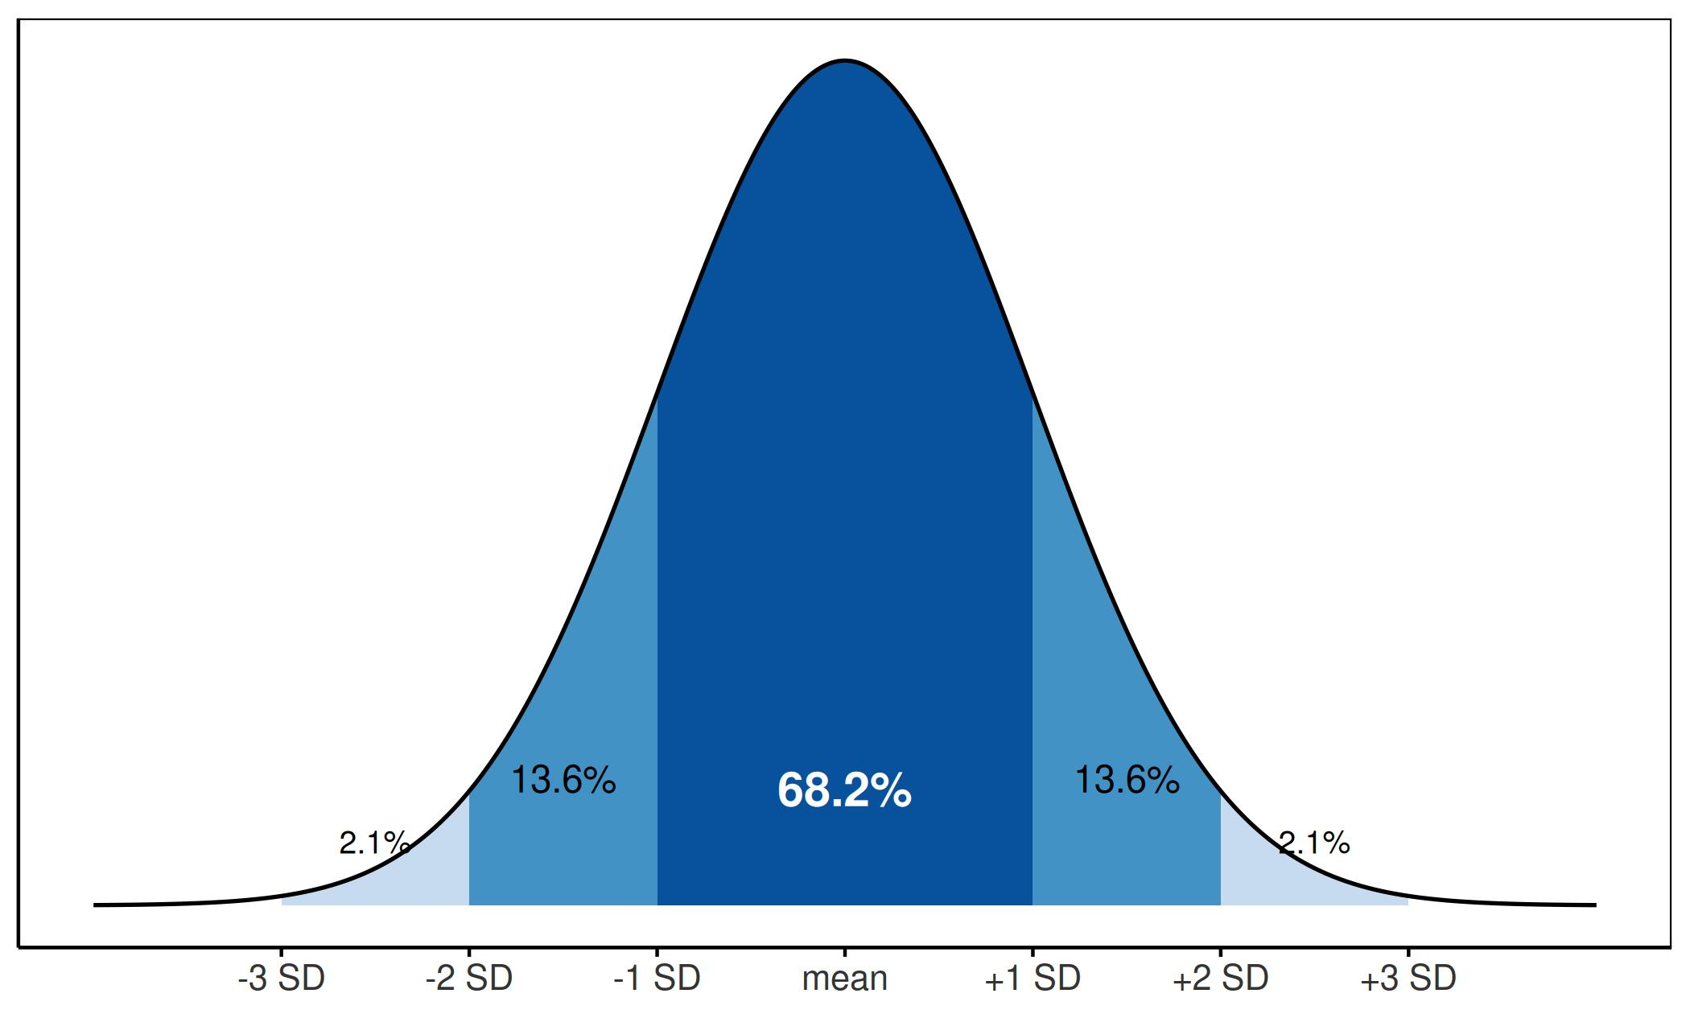
For a normal distribution, each band is a fixed percent of the data — no matter what the mean or SD actually are.

What Is Standard Error?
$$SE=\frac{s}{\sqrt{n}}$$
- Measures how precisely we know the mean
- Not the spread of raw data — the uncertainty of the mean itself
- Gets smaller as n increases → more data = more precise estimate
 | Describes
SD | spread of individual data points
SE | precision of the sample mean
We report SE when making claims about group means.
📖 Whitlock & Schluter, Ch. 4 — Estimating with Uncertainty

Do It By Hand First — One Group
# Every statistic, written out, for the sunny leaves ----
leaf_df %>%
filter(shade == "sunny") %>%
summarize(
mean = mean(mass_g, na.rm = TRUE),
variance = var(mass_g, na.rm = TRUE),
sd = sd(mass_g, na.rm = TRUE),
n = sum(!is.na(mass_g)),
se = sd / sqrt(n)
)
# A tibble: 1 × 5
mean variance sd n se
<dbl> <dbl> <dbl> <int> <dbl>
1 0.505 0.0442 0.210 25 0.0421
- summarize() collapses many rows down to one row of statistics
- Every function gets na.rm = TRUE — otherwise one NA makes the whole answer NA
- n = sum(!is.na(mass_g)) — the correct count, not n()
- se = sd / sqrt(n) — you can reuse sd and n later in the same summarize(), because they are already columns by then
- The result is a data frame, so it pipes onward into ggplot() or write_csv()

Do It By Hand — Every Group at Once
Note
🔮 Predict first: How many rows will this return? (Hint: how many values does shade take?)

# group_by() splits the data; summarize() runs per group
leaf_df %>%
group_by(shade) %>%
summarize(
mean = mean(mass_g, na.rm = TRUE),
variance = var(mass_g, na.rm = TRUE),
sd = sd(mass_g, na.rm = TRUE),
n = sum(!is.na(mass_g)),
se = sd / sqrt(n)
)
# A tibble: 2 × 6
shade mean variance sd n se
<chr> <dbl> <dbl> <dbl> <int> <dbl>
1 shady 0.523 0.0219 0.148 28 0.0280
2 sunny 0.505 0.0442 0.210 25 0.0421
- Exactly the same summarize() — the only new line is group_by(shade)
- One row per group instead of one row overall
- This is the workhorse pattern for the rest of the course
Note
✅ Key idea
Running this once for sunny and again for shady is exactly the repetition group_by() exists to remove.

Now Package It — summary_stats()
summary_stats <- function(data, variable) {
data %>%
summarize(
n = sum(!is.na({{ variable }})),
mean = mean({{ variable }}, na.rm = TRUE),
variance = var({{ variable }}, na.rm = TRUE),
sd = sd({{ variable }}, na.rm = TRUE),
se = sd / sqrt(n),
ci_lower = mean - qt(0.975, df = n - 1) * se,
ci_upper = mean + qt(0.975, df = n - 1) * se,
.groups = "drop"
)
}
- It is the same summarize() you just wrote by hand — wrapped in function() so you type it once, not once per variable
- Plus a 95% confidence interval for the mean, for free
- { variable } lets you pass a bare column name in, like mass_g
- Works on one group or, if the data are already group_by()-ed, every group at once
- Source: themes/summary_stats_function.R — same themes/ folder as your ggplot theme file
# source() loads summary_stats() from another .R file --
source("themes/summary_stats_function.R")

One Group at a Time — filter() + summary_stats()
# Filter to one side, then hand it straight to the function
leaf_df %>%
filter(shade == "sunny") %>%
summary_stats(mass_g)
# A tibble: 1 × 7
n mean variance sd se ci_lower ci_upper
<int> <dbl> <dbl> <dbl> <dbl> <dbl> <dbl>
1 25 0.505 0.0442 0.210 0.0421 0.418 0.592
- filter(shade == "sunny") — keeps only sunny rows
- Pipe the filtered data straight into summary_stats(mass_g) — no pull(), no vector, no hand-written math
- Swap "sunny" for "shady" to get the other side
📖 R4DS §3 — Data Transformation

🛑 Pause — Do Activity Parts 1–3 Now
🛑 Do Activity Parts 1–3 now
Load the data, find the NAs, write the summary by hand with group_by() + summarize(), then source summary_stats() and use it on one group. Predict each output, type it, then run it.

🧩 Chunk 2 of 2 · Every Group, Every Column, Fast
We will cover: group_by() + summary_stats() for every group at once, fast overviews with skimr, and — if time allows — across() for many columns at once.
🛑 After this chunk: Activity Parts 4–6.

Stats the Tidy Way — group_by() + summary_stats()
Note
🔮 Predict first: How many rows will this return? (Hint: how many values does shade take?) Predict the number before you run it.

# Group first, then call the SAME function -------------
stats_df <- leaf_df %>%
group_by(shade) %>%
summary_stats(mass_g)
stats_df
# A tibble: 2 × 8
shade n mean variance sd se ci_lower ci_upper
<chr> <int> <dbl> <dbl> <dbl> <dbl> <dbl> <dbl>
1 shady 28 0.523 0.0219 0.148 0.0280 0.466 0.580
2 sunny 25 0.505 0.0442 0.210 0.0421 0.418 0.592
- group_by(shade) splits the data by the shade column
- summary_stats() doesn’t change at all — it runs once per group
- You get both groups, every statistic, in one clean table
📖 R4DS §3.5 — summarize()

Multiple Variables at Once
# summary_stats() handles ONE variable, so for several
# measurements at once we still write summarize() directly
size_stats_df <- leaf_df %>%
group_by(shade) %>%
summarize(
n = sum(!is.na(mass_g)),
mean_mass = mean(mass_g, na.rm = TRUE),
mean_pet = mean(petiole_mm, na.rm = TRUE),
mean_thick = mean(thickness_mm, na.rm = TRUE)
)
size_stats_df
# A tibble: 2 × 5
shade n mean_mass mean_pet mean_thick
<chr> <int> <dbl> <dbl> <dbl>
1 shady 28 0.523 56.7 0.356
2 sunny 25 0.505 54.4 0.290
Do the numbers support our hypothesis?
- Shady heavier? → check mean_mass
- Shady leaves thicker? → check mean_thick
- Shady petioles longer? → check mean_pet

Fast Summaries with skimr
# skim() grouped by shade — mass only -------------------
leaf_df %>%
select(shade, mass_g) %>%
group_by(shade) %>%
skim()
Data summary
Name | Piped data
Number of rows | 53
Number of columns | 2
_______________________
Column type frequency:
numeric | 1
________________________
Group variables | shade
Variable type: numeric
skim_variable | shade | n_missing | complete_rate | mean | sd | p0 | p25 | p50 | p75 | p100 | hist
mass_g | shady | 0 | 1 | 0.52 | 0.15 | 0.34 | 0.42 | 0.52 | 0.59 | 0.92 | ▇▅▃▁▁
mass_g | sunny | 0 | 1 | 0.51 | 0.21 | 0.19 | 0.35 | 0.48 | 0.65 | 1.08 | ▇▇▆▃▁
skim() is your fastest first look — n_missing, mean, SD, percentiles, and a mini histogram, per group, in one line.

The Fast Way — across()
# Apply the SAME function to every numeric column -----
mean_all_df <- leaf_df %>%
group_by(shade) %>%
summarize(
across(
c(mass_g, petiole_mm, thickness_mm),
~ mean(.x, na.rm = TRUE)
)
)
mean_all_df
# A tibble: 2 × 4
shade mass_g petiole_mm thickness_mm
<chr> <dbl> <dbl> <dbl>
1 shady 0.523 56.7 0.356
2 sunny 0.505 54.4 0.290
- across(columns, function) applies one function to many columns at once
- .x is a stand-in for “whichever column we’re on right now”
- Same idea as mean_mass/mean_thick/mean_pet above — just without typing each one out
Tip
Once you have more than 3–4 measurement columns, across() saves real typing — and real typos.

→ ACTIVITY 6 starts now
🛑 Go to Activity 6 — Summary Statistics
Close the slides. Finish Activity Parts 4–6, then Part 7 (review and checkpoint) on your own.

What We Learned Today
- Statistics concepts:
  - Mean — balance point; sensitive to outliers
  - Median — middle value; robust
  - Variance / SD — spread of individual data; $n−1$ makes $s^{2}$ unbiased
  - SE — precision of the sample mean
- R skills:
  - filter(is.na()) / filter(!is.na()) — see the missing data before you summarize
  - sum(!is.na()) — the right way to count n
  - group_by() + summarize() by hand — mean, variance, sd, n, se
  - The same code packaged as a reusable summary_stats() function, sourced from themes/
  - group_by() — run the same summary on every group at once
  - skim() — instant full dataset overview
  - across() — one function, many columns
References:
- 📖 Whitlock & Schluter, Ch. 3 — Describing Data
- 📖 Whitlock & Schluter, Ch. 4 — Estimating with Uncertainty
- 📖 R4DS §13 — Numbers
- 📖 R4DS §18 — Missing Values
Both W&S PDFs are in the course readings/ folder.
Up next — Lecture 07, Quarto:
- Writing reproducible reports
- Mixing prose, code, and results in one document

