Leaf Morphology: Sunny vs. Shady Sides of a Tree
  - A reproducible report built in Quarto
Your Name Here
2026-09-22
Table of contents

1. Introduction
Leaves on the shady side of a tree may grow larger to capture more of the limited light. In this study we measured leaf mass on the sunny and shady sides of a tree and tested whether the two sides differ.
- Null hypothesis (H₀): there is no difference in mean leaf mass between sides.
- Alternate hypothesis (Hₐ): mean leaf mass differs between sides.

2. Methods
We recorded the mass (g) of leaves sampled from each side of the tree. All analysis was done in R with the tidyverse, and this report was produced in Quarto so that every number and figure below is computed directly from the raw data.

3. Results
Table 1 shows the summary statistics for each side of the tree.
Table 1. Leaf mass (g) by shade.
shade | n | mean_mass | sd_mass | se_mass
shady | 28 | 0.523 | 0.148 | 0.028
sunny | 25 | 0.505 | 0.210 | 0.042
Read the mean mass for each side straight from the mean_mass column of Table 1. Because the table is built from the data every time the document renders, the numbers update themselves whenever the data file changes — nothing is typed by hand.
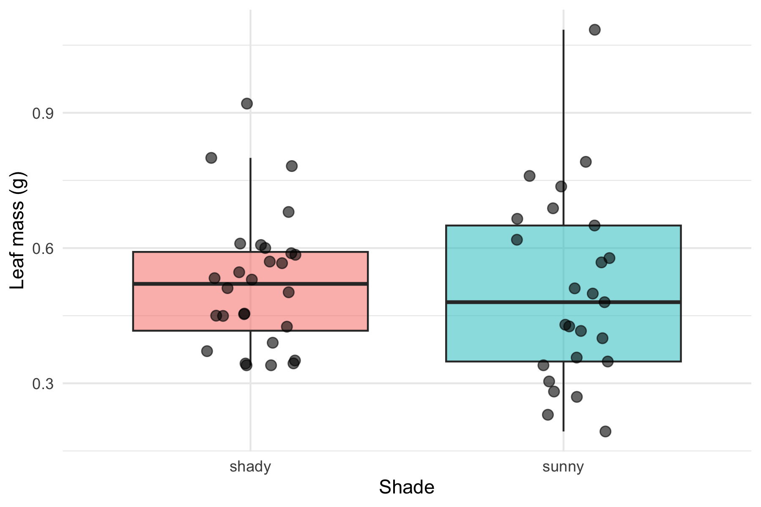
Figure 1. Leaf mass by shade, with individual leaves shown.

4. Discussion
Write one short paragraph here: did the data support the hypothesis? Were shady leaves heavier? Mention the size of the difference and anything you noticed in Figure 1. In Activity 10 you will add the formal t-test result to this section.

5. References
- Wickham, H. R for Data Science (2nd ed.) — https://r4ds.hadley.nz/
- Data Carpentry — https://datacarpentry.github.io/R-ecology-lesson/

