Lecture 12 - Factorial ANOVA of Penguin Mass Balanced
Bill Perry

Lecture 11: Review

ANOVA
- Analysis of variance: single and multi-factor designs
- Examples: diatoms, circadian rhythms
- Predictor variables: fixed vs. random
- ANOVA model
- Analysis and partitioning of variance
- Null hypothesis
- Assumptions and diagnostics
- Post F Tests - Tukey and others
- Reporting the results
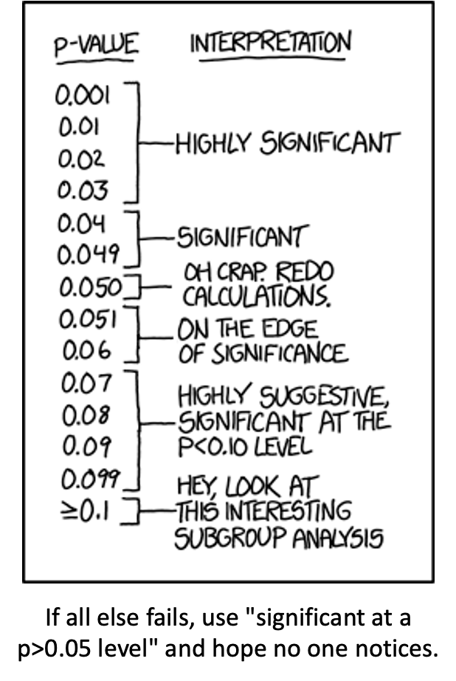

Lecture 12: Factorial ANOVA

2-factor designs (2-way ANOVA)
- very common in ecology
- can have more factors (e.g., 3-way ANOVA) but interpretation gets very challenging…
- Most multifactor designs: are factorial or nested
- We will cover a 2 Factor Anova - this could be fertilizer and sunlight for plant biomass produced…
  - each can have an effect independently
  - the effect of one factor may interact with the other factor
  - in this example…
    - a low light and high light treatment might affect biomass
    - fertilizer also might affect plant biomass
    - but when you have higher light the high fertilizer treatment may grow better than expected
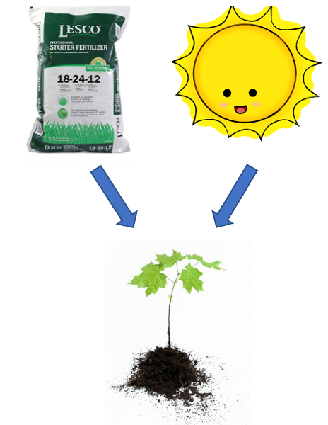


Factorial ANOVA: Design Structure

Consider two factors:
- Factorial/crossed:
  - every level of B in every level of A
  - 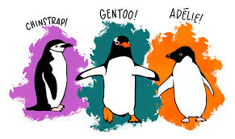
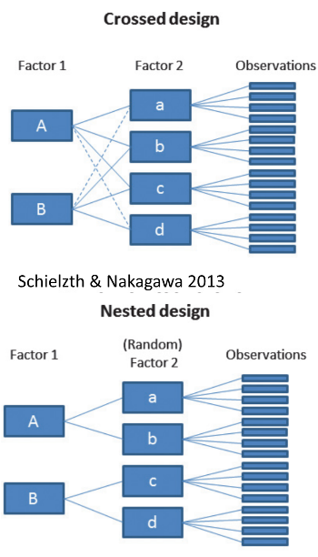

Factorial ANOVA: Effect Types

In factorial designs
- look at two types of factor effects:
  - Main effect of each factor (polling across other factor)
  - Interaction effects; is there synergistic/ antagonistic effect of factors?
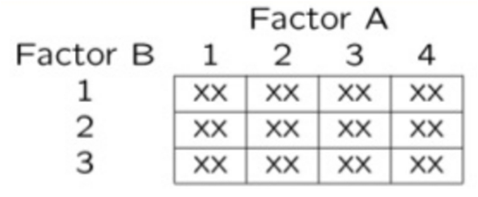

Introduction to Two-Way ANOVA

Factorial Designs
Two-way ANOVA examines:
- Main effect of Factor A (Species)
- Main effect of Factor B (Sex)
- Interaction between A × B
- Balanced design: equal sample sizes in all cells
- Type III sums of squares for unbiased estimates - if balanced it does not matter
## # A tibble: 6 × 6
## species sex n mean_mass sd_mass se_mass
## <fct> <fct> <int> <dbl> <dbl> <dbl>
## 1 Adelie female 73 3369. 269. 31.5
## 2 Adelie male 73 4043. 347. 40.6
## 3 Chinstrap female 34 3527. 285. 48.9
## 4 Chinstrap male 34 3939. 362. 62.1
## 5 Gentoo female 58 4680. 282. 37.0
## 6 Gentoo male 61 5485. 313. 40.1

Data Preparation - Creating Balanced Design

Balancing the Penguin Data
The dataframe of penguins is unbalanced - there are unequal samples per cell
## # A tibble: 3 × 3
## species female male
## <fct> <int> <int>
## 1 Adelie 73 73
## 2 Chinstrap 34 34
## 3 Gentoo 58 61
## Minimum n = 34
## # A tibble: 3 × 3
## species female male
## <fct> <int> <int>
## 1 Adelie 34 34
## 2 Chinstrap 34 34
## 3 Gentoo 34 34
Statistical Mode $Y_{ijk}=μ+α_{i}+β_{j}+(αβ)_{ij}+ε_{ijk}$
Where:
$μ$ = grand mean
$α_{i}$ = effect of species i
$β_{j}$ = effect of sex j
$(αβ)_{ij}$ = interaction effect
$ε_{ijk}$ = random error

Descriptive Statistics

Summary Statistics by Groups
## # A tibble: 6 × 6
## species sex n mean_mass sd_mass se_mass
## <fct> <fct> <int> <dbl> <dbl> <dbl>
## 1 Adelie female 34 3335. 260. 44.5
## 2 Adelie male 34 4049. 318. 54.5
## 3 Chinstrap female 34 3527. 285. 48.9
## 4 Chinstrap male 34 3939. 362. 62.1
## 5 Gentoo female 34 4681. 309. 53.0
## 6 Gentoo male 34 5525 274. 47.0
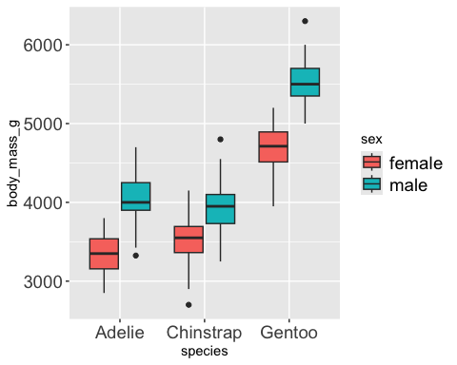

Factorial ANOVA Models
Factorial designs can be of 3 types:
- Model 1 - 2 fixed factors - the focus for today….
- Model 2 - 2 random
- Model 3 - 1 fixed, 1 random (mixed model) - often nested
Model 1 ANOVA:

$$y_{ijk}=μ+α_{i}+β_{j}+(αβ)_{ij}+ε_{ijk}$$

Model Components Explained

$$y_{ijk}=μ+α_{i}+β_{j}+(αβ)_{ij}+ε_{ijk}$$
- $y_{ijk}$: value of the k_{th} observation from jth and ith combination of B and A (sex m of species y)
- µ: overall mean (overall mass)
- αi: effect of the ith level of A, pooling across all levels of B: µi- µ (difference between average mass in all “males” for species x and overall mean)

Interaction Effects

$$y_{ijk}=μ+α_{i}+β_{j}+(αβ)_{ij}+ε_{ijk}$$
- Βj: effect of jth level of B, pooling across all levels of A: µj- µ (difference between average mass in all males treatments and overall mean)
- (αβ)ij: effect of interaction of ith level of A and jth level of B (µij - µi - µj + µ).
  - Does effect of B depend on level of A? (is effect of sex different in the 3 species?)

Model Types and Interpretation

$$y_{ijk}=μ+α_{i}+β_{j}+(αβ)_{ij}+ε_{ijk}$$
- Model 2 ANOVA rare in ecology
- Model 3 interpretation is different:
  - βj: random variable measuring variance in y across all possible levels of B, pooling across all levels of A
  - (αβ)ij is random variable measuring variance of interaction between A and B across all possible levels of B (“is effect of A consistent across all possible levels of B that could have been chosen?”)

Estimated Marginal Means
- Before we go further we need to define what estimated marginal means are
- Balanced data - it is just the means of the groups… easy
- Unbalanced data - it is the mean of cells that represent the lowest average of the groups
## Combined table with means and counts:
## # A tibble: 3 × 5
## species female_mean male_mean female_n male_n
## <fct> <dbl> <dbl> <int> <int>
## 1 Adelie 3369. 4043. 73 73
## 2 Chinstrap 3527. 3939. 34 34
## 3 Gentoo 4680. 5485. 58 61
##
##
## Regular means (WRONG for marginal means):
## # A tibble: 3 × 3
## species total_n regular_mean
## <fct> <int> <dbl>
## 1 Adelie 146 3706.
## 2 Chinstrap 68 3733.
## 3 Gentoo 119 5092.
## Estimated Marginal Means for Species (CORRECT):
## # A tibble: 3 × 3
## species emm_mean calculation
## <fct> <dbl> <chr>
## 1 Adelie 3706. (3368.8 + 4043.5) / 2 = 3706.2
## 2 Chinstrap 3733. (3527.2 + 3939) / 2 = 3733.1
## 3 Gentoo 5082. (4679.7 + 5484.8) / 2 = 5082.3
##
##
## Comparison showing EMM calculation:
## # A tibble: 3 × 6
## species cell_mean_female cell_mean_male species_emm regular_mean difference
## <fct> <dbl> <dbl> <dbl> <dbl> <dbl>
## 1 Adelie 3369. 4043. 3706. 3706. 4.55e-13
## 2 Chinstrap 3527. 3939. 3733. 3733. 0
## 3 Gentoo 4680. 5485. 5082. 5092. -1.01e+ 1

Estimated Marginal Means
- Before we go further we need to define what estimated marginal means are
- Balanced data - it is just the means of the groups… easy
- Unbalanced data - it is the mean of cells that represent the lowest average of the groups
## Combined table with means and counts:
## # A tibble: 3 × 5
## species female_mean male_mean female_n male_n
## <fct> <dbl> <dbl> <int> <int>
## 1 Adelie 3369. 4043. 73 73
## 2 Chinstrap 3527. 3939. 34 34
## 3 Gentoo 4680. 5485. 58 61
##
## Regular means sex (WRONG for marginal means):
## # A tibble: 2 × 3
## sex total_n regular_mean
## <fct> <int> <dbl>
## 1 female 165 3862.
## 2 male 168 4546.
##
##
## Estimated Marginal Means for Sex (CORRECT):
## # A tibble: 2 × 3
## sex emm_mean calculation
## <fct> <dbl> <chr>
## 1 female 3859. (3368.8 + 3527.2 + 4679.7) / 3 = 3858.6
## 2 male 4489. (4043.5 + 3939 + 5484.8) / 3 = 4489.1
## \n
## Comparison showing difference between regular and marginal means:
## # A tibble: 2 × 5
## sex total_n regular_mean emm_mean difference
## <fct> <int> <dbl> <dbl> <dbl>
## 1 female 165 3862. 3859. -3.68
## 2 male 168 4546. 4489. -56.6

ANOVA Table Structure
- SStotal = SSA + SSB + SSAB + SSresidual
- SStotal = (Y - Grand Mean Y)^2
- SSresidual = (Y -Yhat)^2 or the difference between each observation and the appropriate cell mean, summed over all observations
Source | SS | df | MS
A | $nq\sum_{i=1}^{p}{(}{\overset{‾}{y}}_{i.}−\overset{‾}{y})^{2}$ | $p−1$ | $\frac{SS_{A}}{p−1}$
B | $np\sum_{j=1}^{q}{(}{\overset{‾}{y}}_{.j}−\overset{‾}{y})^{2}$ | $q−1$ | $\frac{SS_{B}}{q−1}$
AB | $n\sum_{i=1}^{p}{\sum_{j=1}^{q}{(}} bary_{ij}−{\overset{‾}{y}}_{i.}−{\overset{‾}{y}}_{.j}+\overset{‾}{y})^{2}$ | $(p−1)(q−1)$ | $\frac{SS_{AB}}{(p−1)(q−1)}$
Residual | $\sum_{i=1}^{p}{\sum_{j=1}^{q}{\sum_{k=1}^{n}{(}}}y_{ijk}−{\overset{‾}{y}}_{ij})^{2}$ | $pq(n−1)$ | $\frac{SS_{ textResidual}}{pq(n−1)}$
Total | $\sum_{i=1}^{p}{\sum_{j=1}^{q}{\sum_{k=1}^{n}{(}}}y_{ijk}−\overset{‾}{y})^{2}$ | $pqn−1$

SSA: Factor A Effects
- SSA is SS of differences between each marginal mean of A and overall mean
- If A is species then get the emmeans for factor A down and subtract from overall mean
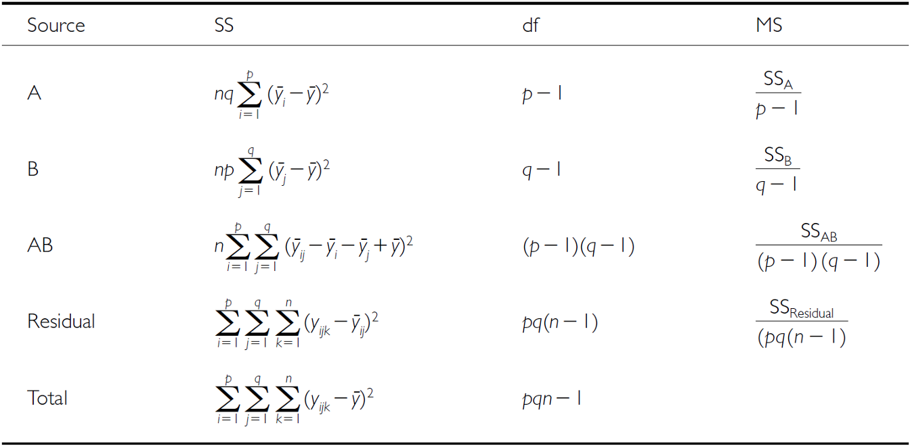
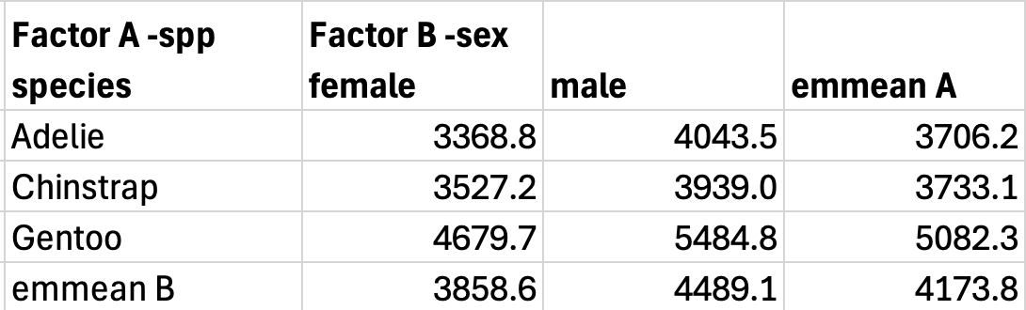

SSB: Factor B Effects
- SSB is SS of differences between each marginal mean of B and overall mean
- If B is sex then get the emmeans for factor B across and subtract from overall mean



SSAB: Interaction Effects
- SSAB is SS of cell means minus marginal means plus overall mean
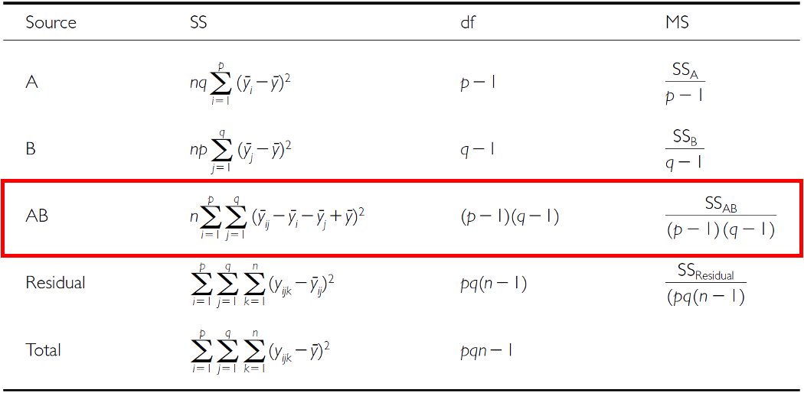


F-ratio Calculations
- SS converted to MS;
- F-ratio calculations are different depending on whether factors are fixed, random or mixed
Source | A and B fixed | A and B random | A fixed, B random
A | $\frac{MS_{A}}{MS_{Residual}}$ | $\frac{MS_{A}}{MS_{AB}}$ | $\frac{MS_{A}}{MS_{AB}}$
B | $\frac{MS_{B}}{MS_{Residual}}$ | $\frac{MS_{B}}{MS_{AB}}$ | $\frac{MS_{B}}{MS_{AB}}$
AB | $\frac{MS_{AB}}{MS_{Residual}}$ | $\frac{MS_{AB}}{MS_{Residual}}$ | $\frac{MS_{AB}}{MS_{Residual}}$

Hypotheses: Fixed Factors
- 3 hypotheses are tested in a two-way factorial ANOVA:
- A, B, A*B Both factors fixed:
  - Ho(A): µ1= µ2= µ3=…. µi= µp (no diff. in marginal means of A, pooling across all levels of B)
  - Ho(B): µ1= µ2= µ3=…. µj= µq (no diff. in marginal means of B, pooling across all levels of A)
  - Ho(AB): µij- µi - µj + µ = 0 (no effect of interaction)

Hypotheses: Mixed Model
- 3 hypotheses are tested in a two-way factorial ANOVA: A, B, A*B
- One fixed, one random:
  - Ho(A): µ1= µ2= µ3=…. µi= µp (no diff. in marginal means of A, pooling across all levels of B)
  - Ho(B): σB2= 0 (no added variance due to levels of B that could have been used)
  - Ho(AB): σAB2= 0 (no added variance due to interaction between all levels of A and B that could have been used)

Example Study Details
So lets try the example with the penguin data that is in the package penguin
- Effect of species and sex on body_mass_g
  - 3 species (factor A)
  - 2 sexes (factor B)
  - 34 replicates in each cell
  - This analysis examines the effects of species and sex on the body mass of penguins.


Two-Way ANOVA with Type III Sums of Squares

Fitting the Model
##
## Call:
## lm(formula = body_mass_g ~ species * sex, data = balanced_df)
##
## Residuals:
## Min 1Q Median 3Q Max
## -827.21 -178.13 6.25 175.00 861.03
##
## Coefficients:
## Estimate Std. Error t value Pr(>|t|)
## (Intercept) 4175.86 21.23 196.727 < 2e-16 ***
## species1 -484.31 30.02 -16.134 < 2e-16 ***
## species2 -442.77 30.02 -14.750 < 2e-16 ***
## sex1 -328.31 21.23 -15.467 < 2e-16 ***
## species1:sex1 -28.68 30.02 -0.955 0.341
## species2:sex1 122.43 30.02 4.078 6.57e-05 ***
## ---
## Signif. codes: 0 '***' 0.001 '**' 0.01 '*' 0.05 '.' 0.1 ' ' 1
##
## Residual standard error: 303.2 on 198 degrees of freedom
## Multiple R-squared: 0.8596, Adjusted R-squared: 0.856
## F-statistic: 242.4 on 5 and 198 DF, p-value: < 2.2e-16
## Type III Sums of Squares ANOVA:
## Anova Table (Type III tests)
##
## Response: body_mass_g
## Sum Sq Df F value Pr(>F)
## (Intercept) 3557308900 1 38701.5271 < 2.2e-16 ***
## species 87725999 2 477.2049 < 2.2e-16 ***
## sex 21988483 1 239.2224 < 2.2e-16 ***
## species:sex 1672776 2 9.0994 0.0001657 ***
## Residuals 18199467 198
## ---
## Signif. codes: 0 '***' 0.001 '**' 0.01 '*' 0.05 '.' 0.1 ' ' 1

Understanding Type III SS
Type III sums of squares test each effect after adjusting for all other effects in the model:
- Species effect: Tested after adjusting for sex and interaction
- Sex effect: Tested after adjusting for species and interaction
- Interaction: Tested after adjusting for both main effects
This is especially important for unbalanced designs, but we’re using it here for consistency with the next analysis.
## Effect Sizes (Eta-squared):
## Effect Eta_Squared
## 1 Species 0.67696748
## 2 Sex 0.16968160
## 3 Interaction 0.01290854

Checking Model Assumptions
Assumption Plots
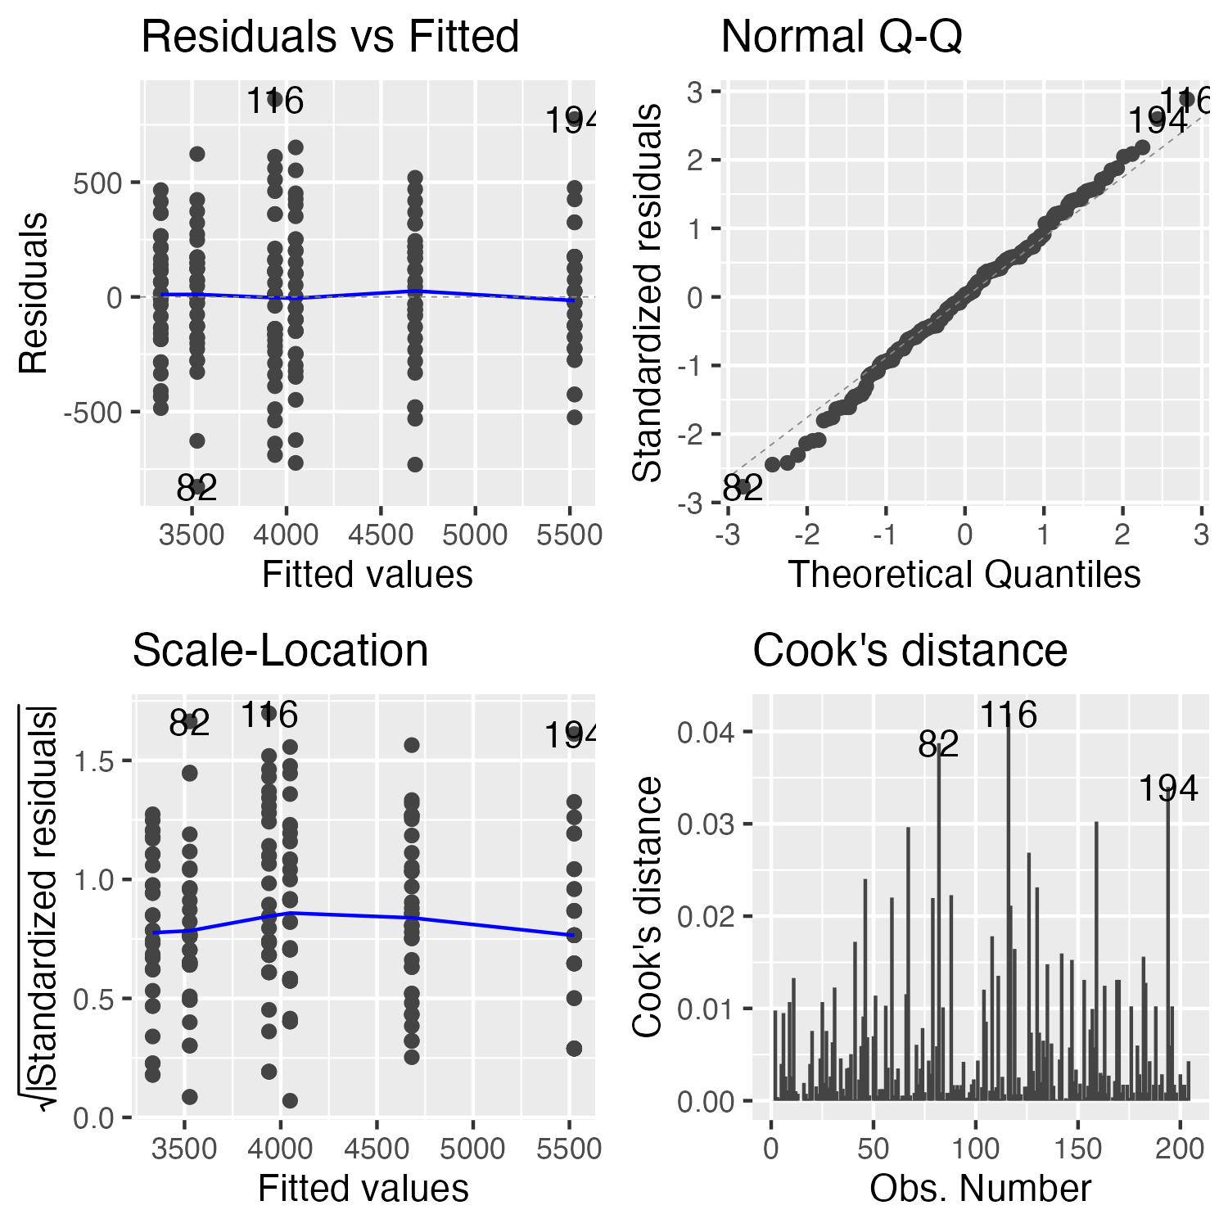
should be the plot of the 4 assumption plots

Formal Tests
- These are the formal tests of
  - normality of residuals
  - homogeneity of variances
## Shapiro-Wilk Normality Test:
##
## Shapiro-Wilk normality test
##
## data: residuals(anova_model)
## W = 0.99612, p-value = 0.8886
## Levene's Test for Homogeneity:
## Levene's Test for Homogeneity of Variance (center = median)
## Df F value Pr(>F)
## group 5 0.7841 0.5622
## 198
## Number of outliers (|z| > 3): 0

Estimated Marginal Means (EMMs)

Computing EMMs
## Species EMMs:
## species emmean SE df lower.CL upper.CL
## Adelie 3692 36.8 198 3619 3764
## Chinstrap 3733 36.8 198 3661 3806
## Gentoo 5103 36.8 198 5030 5175
##
## Results are averaged over the levels of: sex
## Confidence level used: 0.95
## Sex EMMs:
## sex emmean SE df lower.CL upper.CL
## female 3848 30 198 3788 3907
## male 4504 30 198 4445 4563
##
## Results are averaged over the levels of: species
## Confidence level used: 0.95
## Species by Sex EMMs:
## species sex emmean SE df lower.CL upper.CL
## Adelie female 3335 52 198 3232 3437
## Chinstrap female 3527 52 198 3425 3630
## Gentoo female 4681 52 198 4578 4783
## Adelie male 4049 52 198 3946 4151
## Chinstrap male 3939 52 198 3836 4042
## Gentoo male 5525 52 198 5422 5628
##
## Confidence level used: 0.95

Pairwise Comparisons
## [1] "Species pairwise comparisons:\n"
## contrast estimate SE df t.ratio p.value
## Adelie - Chinstrap -41.5 52 198 -0.799 0.7041
## Adelie - Gentoo -1411.4 52 198 -27.145 <0.0001
## Chinstrap - Gentoo -1369.9 52 198 -26.346 <0.0001
##
## Results are averaged over the levels of: sex
## P value adjustment: tukey method for comparing a family of 3 estimates
## [1] "Species comparisons within sex:"
## sex = female:
## contrast estimate SE df t.ratio p.value
## Adelie - Chinstrap -193 73.5 198 -2.620 0.0256
## Adelie - Gentoo -1346 73.5 198 -18.310 <0.0001
## Chinstrap - Gentoo -1154 73.5 198 -15.690 <0.0001
##
## sex = male:
## contrast estimate SE df t.ratio p.value
## Adelie - Chinstrap 110 73.5 198 1.490 0.2979
## Adelie - Gentoo -1476 73.5 198 -20.079 <0.0001
## Chinstrap - Gentoo -1586 73.5 198 -21.569 <0.0001
##
## P value adjustment: tukey method for comparing a family of 3 estimates

Post F Test of the interaction
What we need to do if the interaction is significant is to test the overall interaction and ignore the main effects!!!

Interaction tests continued
## species sex emmean SE df lower.CL upper.CL .group
## Adelie female 3334.559 51.99448 198 3196.378 3472.740 a
## Adelie male 4048.529 51.99448 198 3910.349 4186.710 b
## Chinstrap female 3527.206 51.99448 198 3389.025 3665.387 a
## Chinstrap male 3938.971 51.99448 198 3800.790 4077.151 b
## Gentoo female 4680.882 51.99448 198 4542.702 4819.063 c
## Gentoo male 5525.000 51.99448 198 5386.819 5663.181 d
##
## Confidence level used: 0.95
## Conf-level adjustment: sidak method for 6 estimates
## P value adjustment: sidak method for 15 tests
## significance level used: alpha = 0.05
## NOTE: If two or more means share the same grouping symbol,
## then we cannot show them to be different.
## But we also did not show them to be the same.

interaction plot
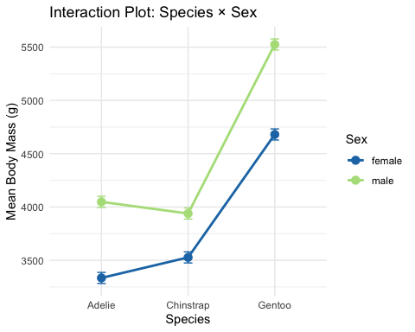

Introduction to Unbalanced Designs
The Challenge of Unbalanced Data
- Real-world data is often unbalanced:
  - Unequal sample sizes across groups
  - Missing data patterns
  - Natural variation in sampling
- Key Issues:
  - Type I, II, and III SS give different results
  - Order of terms matters for Type I SS
  - Marginal means ≠ Simple averages Interpretation becomes complex
Statistical Model (same as balanced):
$$Y_{ijk}=μ+α_{i}+β_{j}+(αβ)_{ij}+ε_{ijk}$$
But parameter estimation differs!

Data Preparation - Using Natural Unbalanced Data
## [1] "Unbalanced sample sizes:"
## # A tibble: 6 × 3
## species sex n
## <fct> <fct> <int>
## 1 Adelie female 73
## 2 Adelie male 73
## 3 Chinstrap female 34
## 4 Chinstrap male 34
## 5 Gentoo female 58
## 6 Gentoo male 61
## [1] "Total N = 333"
## [1] "Imbalance ratio = 2.15"

Visualizing Imbalance
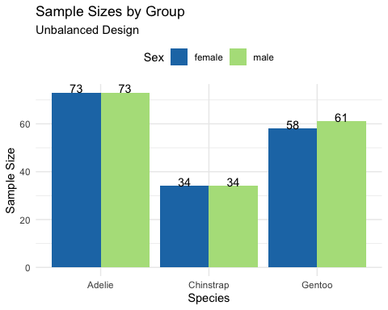

Understanding Sums of Squares Types

Type I (Sequential) SS
## Type I SS (Species → Sex → Interaction):
## Analysis of Variance Table
##
## Response: body_mass_g
## Df Sum Sq Mean Sq F value Pr(>F)
## species 2 145190219 72595110 758.358 < 2.2e-16 ***
## sex 1 37090262 37090262 387.460 < 2.2e-16 ***
## species:sex 2 1676557 838278 8.757 0.0001973 ***
## Residuals 327 31302628 95727
## ---
## Signif. codes: 0 '***' 0.001 '**' 0.01 '*' 0.05 '.' 0.1 ' ' 1
##
##
## Type I SS (Sex → Species → Interaction):
## Analysis of Variance Table
##
## Response: body_mass_g
## Df Sum Sq Mean Sq F value Pr(>F)
## sex 1 38878897 38878897 406.145 < 2.2e-16 ***
## species 2 143401584 71700792 749.016 < 2.2e-16 ***
## sex:species 2 1676557 838278 8.757 0.0001973 ***
## Residuals 327 31302628 95727
## ---
## Signif. codes: 0 '***' 0.001 '**' 0.01 '*' 0.05 '.' 0.1 ' ' 1
##
##
## Type I SS depends on order:
## Effect Order1_SS Order2_SS
## 1 Species 145190219 143401584
## 2 Sex 37090262 38878897

How Type I SS Works
Sequential decomposition:
- First term gets all SS it can explain
- Second term gets SS after removing first
- Third term gets SS after removing first two
- Example calculation:
  - SS(Species) = reduction in SS from null to species-only model
  - SS(Sex|Species) = additional reduction adding sex
  - SS(Interaction|Species,Sex) = additional reduction adding interaction
- Problems with unbalanced data:
  - Order dependency
  - Biased if factors are correlated
  - Not invariant to coding

Type III Sums of Squares

Type III (Marginal) SS
## [1] "Type III Sums of Squares:"
## Anova Table (Type III tests)
##
## Response: body_mass_g
## Sum Sq Df F value Pr(>F)
## (Intercept) 5232595969 1 54661.828 < 2.2e-16 ***
## species 143001222 2 746.924 < 2.2e-16 ***
## sex 29851220 1 311.838 < 2.2e-16 ***
## species:sex 1676557 2 8.757 0.0001973 ***
## Residuals 31302628 327
## ---
## Signif. codes: 0 '***' 0.001 '**' 0.01 '*' 0.05 '.' 0.1 ' ' 1
## [1] "Comparison of F-values:"
## Effect Type_I_F Type_III_F
## 1 Species 758.36 746.92
## 2 Sex 387.46 311.84
## 3 Interaction 8.76 8.76

How Type III SS Works
- Marginal decomposition:
  - Each effect tested after adjusting for all others:
    - SS(Species|Sex,Interaction)
    - SS(Sex|Species,Interaction)
    - SS(Interaction|Species,Sex)
- Advantages:
  - Order invariant
  - Tests hypotheses about unweighted means
  - Standard in most software
- Disadvantages:
  - Lower power with missing cells
  - Tests may not be orthogonal
  - Requires careful interpretation
## [1] "Effect Sizes (Type III):"
## Effect Eta_Squared
## 1 Species 0.6947
## 2 Sex 0.1450
## 3 Interaction 0.0081

Manual SS Calculation Demonstration

Computing SS Step-by-Step
## [1] "Grand mean: 4207.1"
## [1] "Total SS: 215259666"
## [1] "Between-groups SS: 183957038"
## [1] "Within-groups SS: 31302628"
## [1] "Check: Between + Within = 215259666"

Decomposing Between-Group SS
## SS(Species alone): 145190219
## SS(Sex alone): 38878897
##
##
## Sum of main effects: 184069116
## Actual between SS: 183957038
##
##
## Difference (due to correlation): -112078

Estimated Marginal Means - Unbalanced Data

Computing EMMs
## Species EMMs (model-based):
## species emmean SE df lower.CL upper.CL
## Adelie 3706 25.6 327 3656 3757
## Chinstrap 3733 37.5 327 3659 3807
## Gentoo 5082 28.4 327 5026 5138
##
## Results are averaged over the levels of: sex
## Confidence level used: 0.95
##
##
## Sex EMMs (model-based):
## sex emmean SE df lower.CL upper.CL
## female 3859 25.3 327 3809 3908
## male 4489 25.2 327 4440 4539
##
## Results are averaged over the levels of: species
## Confidence level used: 0.95
## contrast estimate SE df t.ratio p.value
## Adelie female - Chinstrap female -193 73.5 198 -2.620 0.0973
## Adelie female - Gentoo female -1346 73.5 198 -18.310 <0.0001
## Adelie female - Adelie male -714 73.5 198 -9.710 <0.0001
## Adelie female - Chinstrap male -604 73.5 198 -8.220 <0.0001
## Adelie female - Gentoo male -2190 73.5 198 -29.789 <0.0001
## Chinstrap female - Gentoo female -1154 73.5 198 -15.690 <0.0001
## Chinstrap female - Adelie male -521 73.5 198 -7.090 <0.0001
## Chinstrap female - Chinstrap male -412 73.5 198 -5.600 <0.0001
## Chinstrap female - Gentoo male -1998 73.5 198 -27.169 <0.0001
## Gentoo female - Adelie male 632 73.5 198 8.600 <0.0001
## Gentoo female - Chinstrap male 742 73.5 198 10.090 <0.0001
## Gentoo female - Gentoo male -844 73.5 198 -11.480 <0.0001
## Adelie male - Chinstrap male 110 73.5 198 1.490 0.6711
## Adelie male - Gentoo male -1476 73.5 198 -20.079 <0.0001
## Chinstrap male - Gentoo male -1586 73.5 198 -21.569 <0.0001
##
## P value adjustment: tukey method for comparing a family of 6 estimates

Interaction tests continued
## species sex emmean SE df lower.CL upper.CL .group
## Adelie female 3368.836 36.21222 327 3272.980 3464.692 a
## Adelie male 4043.493 36.21222 327 3947.637 4139.349 b
## Chinstrap female 3527.206 53.06120 327 3386.749 3667.662 a
## Chinstrap male 3938.971 53.06120 327 3798.514 4079.427 b
## Gentoo female 4679.741 40.62586 327 4572.202 4787.281 c
## Gentoo male 5484.836 39.61427 327 5379.975 5589.698 d
##
## Confidence level used: 0.95
## Conf-level adjustment: sidak method for 6 estimates
## P value adjustment: sidak method for 15 tests
## significance level used: alpha = 0.05
## NOTE: If two or more means share the same grouping symbol,
## then we cannot show them to be different.
## But we also did not show them to be the same.

Pairwise Comparisons

Tukey HSD Comparisons
## Species pairwise comparisons (Tukey):
## contrast estimate SE df t.ratio p.value
## Adelie - Chinstrap -26.9 45.4 327 -0.593 0.8241
## Adelie - Gentoo -1376.1 38.2 327 -36.007 <0.0001
## Chinstrap - Gentoo -1349.2 47.0 327 -28.682 <0.0001
##
## Results are averaged over the levels of: sex
## P value adjustment: tukey method for comparing a family of 3 estimates
##
##
## Sex effect within each species:
## species = Adelie:
## contrast estimate SE df t.ratio p.value
## female - male -675 51.2 327 -13.174 <0.0001
##
## species = Chinstrap:
## contrast estimate SE df t.ratio p.value
## female - male -412 75.0 327 -5.487 <0.0001
##
## species = Gentoo:
## contrast estimate SE df t.ratio p.value
## female - male -805 56.7 327 -14.188 <0.0001

Interaction Contrasts
## Sex effect (Male - Female) by species:
## Species Sex_Effect
## 1 Adelie -675
## 2 Chinstrap -412
## 3 Gentoo -805
##
##
## Interaction interpretation:
## [1] "Sex effects differ across species"

Diagnostic Plots - Unbalanced Design

Model Diagnostics
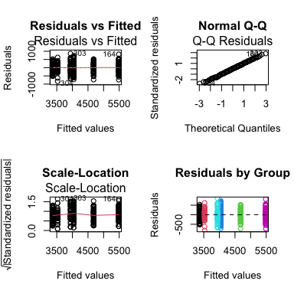

Assumption Tests
## [1] "Shapiro-Wilk test:"
##
## Shapiro-Wilk normality test
##
## data: residuals(model_u)
## W = 0.99776, p-value = 0.9367
## [1] "\nLevene's test:"
## Levene's Test for Homogeneity of Variance (center = median)
## Df F value Pr(>F)
## group 5 1.3908 0.2272
## 327
## [1] "\nResidual SD by group:"
## # A tibble: 6 × 3
## species sex sd_resid
## <fct> <fct> <dbl>
## 1 Adelie female 269.
## 2 Adelie male 347.
## 3 Chinstrap female 285.
## 4 Chinstrap male 362.
## 5 Gentoo female 282.
## 6 Gentoo male 313.

Comparing Balanced vs Unbalanced Results

Side-by-Side Comparison
## Balanced vs Unbalanced Results:
## Effect Balanced_F Balanced_p Unbalanced_F Unbalanced_p
## 1 Species 477.20 0e+00 746.92 0e+00
## 2 Sex 239.22 0e+00 311.84 0e+00
## 3 Interaction 9.10 2e-04 8.76 2e-04
##
##
## Sample sizes:
## Balanced total N: 204
## Unbalanced total N: 333
## Data discarded: 129 observations

Visual Comparison
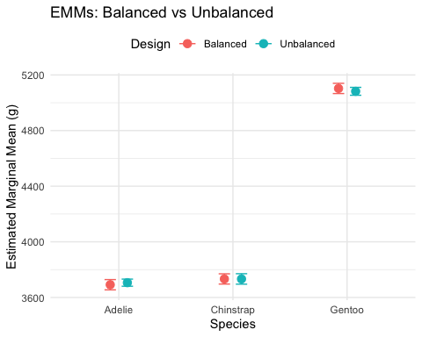

Summary and Best Practices

Key Takeaways

Unbalanced Designs:
Challenges: - Type I SS depends on order - Simple means ≠ EMMs - Reduced power for interactions - Complex interpretation
Solutions: - Use Type III SS for main effects - Report EMMs, not simple means - Check assumptions carefully - Consider impact of imbalance

Recommendations:
- Always report:
  - Sample sizes per cell
  - Type of SS used
  - EMMs with CIs
- Visualization:
  - Show actual data points
  - Include error bars
  - Note unequal sample sizes
- Interpretation:
  - Focus on effect sizes
  - Consider practical significance
  - Acknowledge limitations

Final Recommendations
For Experimental Studies: - Design for balance when possible - Randomize allocation - Plan for attrition
For Observational Studies: - Accept imbalance as reality - Use Type III SS - Report EMMs - Consider covariates (ANCOVA)
Statistical Software Defaults: - R: Type I (sequential) - SAS: Type III (marginal) - SPSS: Type III (marginal)
Always specify which type you’re using!

