Lecture 10 — Factors: Taming Categorical Data
  - Ordering, renaming, and lumping categories with forcats — and cleaner ggplots
Bill Perry
2026-07-05

Where we left off — Pivoting real data
- pivot_longer() / pivot_wider() — reshaped the messy Lake Superior ice data
- group_by() + summarize() and lm() on the tidied result
- But every plot still put categories in alphabetical order
 Note
✅ Transition
Why alphabetical? Because a categorical column is a factor, and its levels default to alphabetical. Today we take control of that order — and of the labels — with the forcats package. You’ll lean on it again next week when you run a one-way ANOVA.

Goals for today (a 2-day lecture)
- What a factor is and why R uses them
- Create & inspect — factor(), levels(), fct_count()
- Reorder for plots — fct_reorder(), fct_infreq(), fct_rev()
- Rename & simplify — fct_recode(), fct_collapse(), fct_lump()
- Set a model’s reference level — fct_relevel()
- Drop unused levels and dodge the classic traps
Tools today:
- tidyverse (includes forcats)
- palmerpenguins
Textbook:
- 📖 R4DS Ch. 16 — Factors
- 📖 R4DS Ch. 9 — Layers
 Tip
Day 1: create, inspect, reorder. Day 2: rename, lump, model.

How to Use These Slides — Predict · Type · Run
This lecture runs in four short chunks over two days. After each chunk you switch to the activity and type the code yourself.
For every code block, do three things:
- Predict — before it runs, say what the plot or output will look like
- Type it out by hand — do not copy-paste
- Run it and compare to your prediction
 Note
✅ Why bother? (the evidence)
- Predicting the order of a plot forces you to reason about levels — the whole point of factors.
- Typing by hand builds the muscle memory for the fct_ family.
- Chunk → practice keeps each idea in working memory long enough to stick.

🧩 Chunk 1 of 4 · What a Factor Is (Day 1)
We will cover: what factors are, why alphabetical order is a problem, and how to create and inspect them.
 Tip
🖐 After this chunk: Activity Parts 1–3 (inspect the penguin factors).

What Is a Factor?
A factor is a categorical variable with a fixed, known set of values — its levels — stored in a specific order.
- Under the hood: integer codes (1, 2, 3…) plus a labels table
- The order of the levels controls plot axes, legends, and model baselines
- Different from a plain character string, which has no built-in order
 Note
📖 New word
forcats = “for categorical variables” — the tidyverse package (loaded with library(tidyverse)) for working with factors. Every function starts with fct_.

The Problem Factors Solve — Alphabetical Order
 Note
🔮 Predict first: If we make a bar chart of penguin species with no other instructions, in what order will the three bars appear?

# Load packages + data --------------------------------
library(tidyverse) # includes forcats
library(palmerpenguins)
# Swap this one line to use your own data later -------
penguins_df <- penguins %>% drop_na(species, body_mass_g)
# ggplot uses the factor's level order = ALPHABETICAL -
penguins_df %>%
ggplot(aes(x = species)) +
geom_bar() +
theme_minimal()
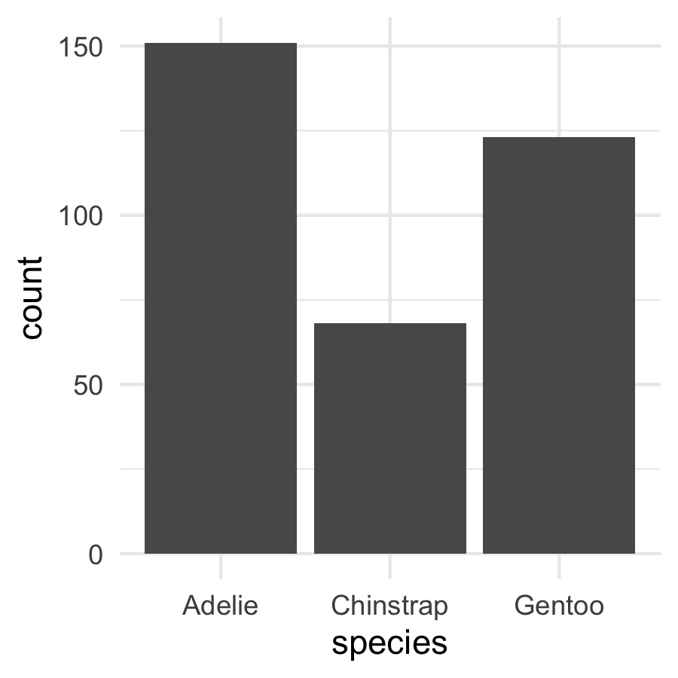
Adelie, Chinstrap, Gentoo — alphabetical, because that is the default level order.
Alphabetical is almost never the order you want to show. Factors let you fix that in one line.
📖 R4DS §16.5 — modifying factor order

Create & Inspect Factors
# What type is species, and what are its levels? ------
class(penguins_df$species)
[1] "factor"
levels(penguins_df$species)
[1] "Adelie" "Chinstrap" "Gentoo"
# fct_count() = a factor-aware count -------------------
fct_count(penguins_df$species)
# A tibble: 3 × 2
f n
<fct> <int>
1 Adelie 151
2 Chinstrap 68
3 Gentoo 123
- class() — confirms it’s a factor
- levels() — the ordered set of categories
- fct_count() — how many rows per level (even levels with zero rows show up!)
 Tip
Make a factor from a string with factor(x) or as_factor(x).

🛑 Pause — Do Activity Parts 1–3 Now
Load the penguins, confirm species and island are factors, list their levels, and make the default (alphabetical) bar chart. Predict the order before you run it.

🧩 Chunk 2 of 4 · Reorder for Readable Plots (Day 1)
We will cover: the payoff — reordering factor levels so plots tell the story, with fct_infreq(), fct_reorder(), and fct_rev().
 Tip
🖐 After this chunk: Activity Parts 4–6 (reorder bars and boxplots).

fct_infreq() — Order by Frequency
# Order bars from most to least common ----------------
penguins_df %>%
mutate(species = fct_infreq(species)) %>%
ggplot(aes(x = species)) +
geom_bar() +
theme_minimal()
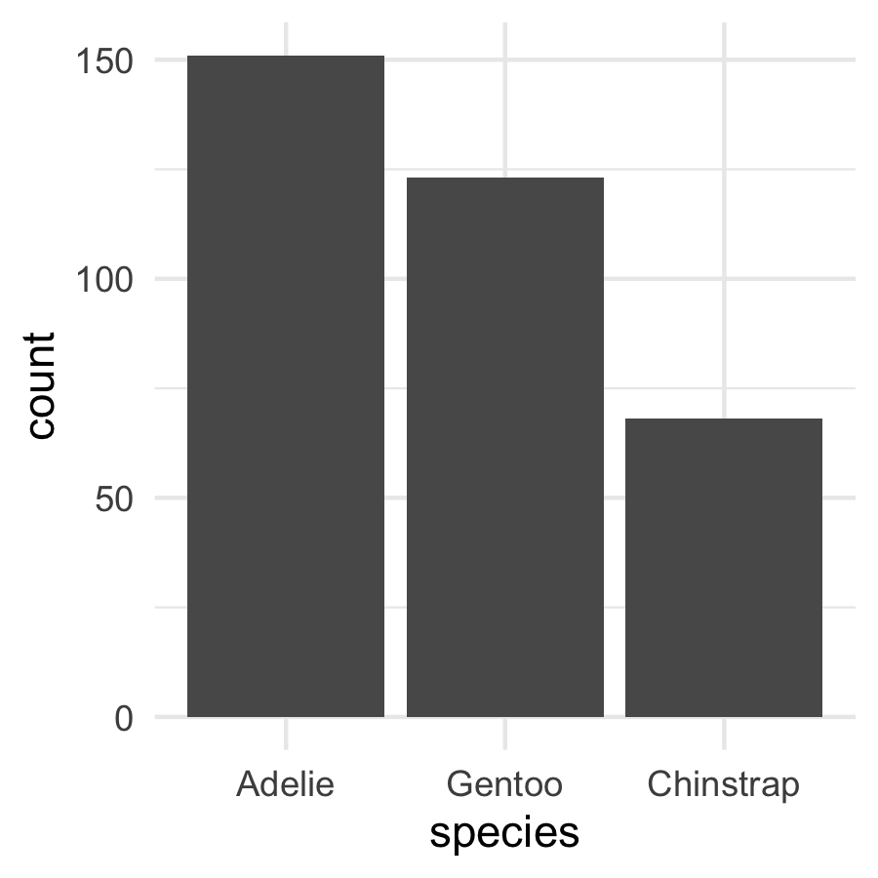
- fct_infreq() — biggest group first
- Add fct_rev() to flip to smallest-first
- Perfect for bar charts of counts — the reader sees the ranking instantly
 Note
You reorder inside mutate(), then plot. The data itself is unchanged elsewhere.

fct_reorder() — Order by Another Variable
 Note
🔮 Predict first: We’ll reorder species by their median body mass. Which species ends up last (heaviest)?

# Order species by MEDIAN body mass, low -> high ------
penguins_df %>%
mutate(species = fct_reorder(species, body_mass_g, .fun = median)) %>%
ggplot(aes(x = species, y = body_mass_g, fill = species)) +
geom_boxplot(alpha = 0.6) +
theme_minimal() +
theme(legend.position = "none")
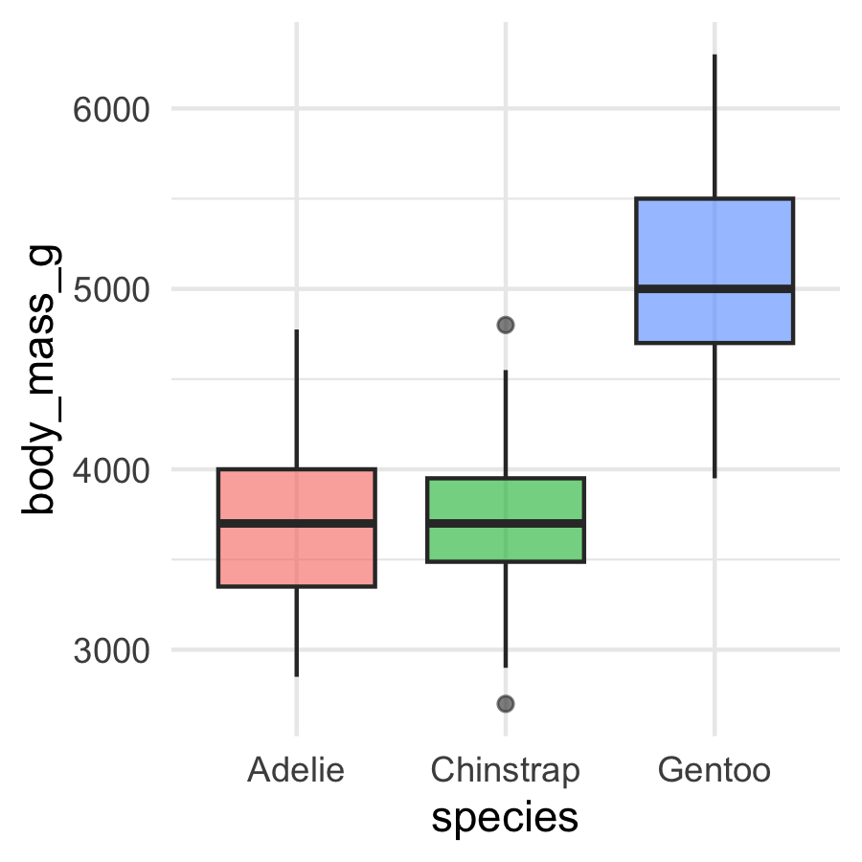
This is the one you’ll use constantly.
- fct_reorder(f, x, .fun) — order the factor f by a summary of x
- Boxplots, dot plots, lollipop charts all read better ordered by value, not alphabet
📖 R4DS §16.4 — fct_reorder()

fct_rev() and Ordered Summary Plots
# Mean mass per species, ordered high -> low ----------
penguins_df %>%
group_by(species) %>%
summarize(mean_mass = mean(body_mass_g)) %>%
mutate(species = fct_reorder(species, mean_mass) %>% fct_rev()) %>%
ggplot(aes(x = mean_mass, y = species)) +
geom_col(fill = "steelblue") +
labs(x = "Mean mass (g)", y = NULL) +
theme_minimal()
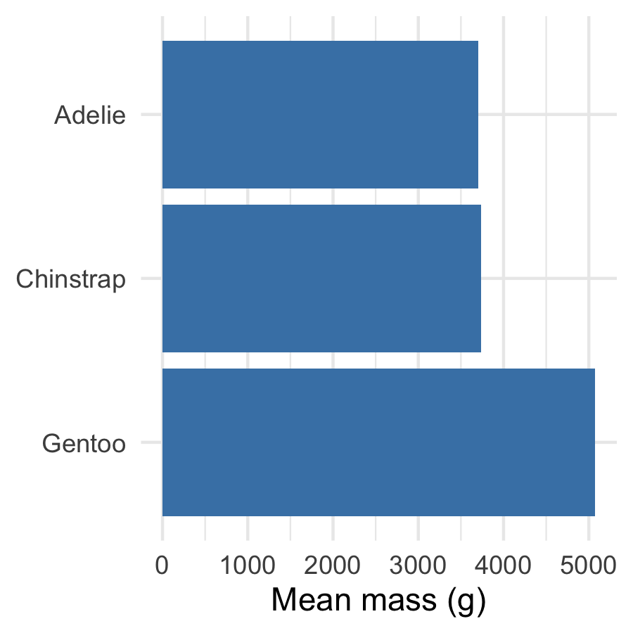
- fct_rev() — reverse the current order
- Horizontal bars ordered by value = the cleanest ranking plot there is
- Chaining fct_reorder() %>% fct_rev() puts the biggest bar on top

🛑 End of Day 1 · Start Day 2 Here
Day 1 recap — you can now:
- Say what a factor is and why level order matters
- Inspect levels with levels() and fct_count()
- Reorder for plots with fct_infreq(), fct_reorder(), fct_rev()
Day 2 — the deeper cuts:
- Rename, collapse, and lump levels
- Set the reference group for a model
- Drop ghost levels, and dodge the classic traps

🧩 Chunk 3 of 4 · Rename, Collapse, Lump (Day 2)
We will cover: cleaning up messy level labels — fct_recode(), fct_collapse(), fct_lump().
 Tip
🖐 After this chunk: Activity Parts 7–9 (rename and lump levels).

fct_recode() — Rename Levels
# Give levels cleaner display names -------------------
penguins_df %>%
mutate(species = fct_recode(species,
"Adélie penguin" = "Adelie",
"Chinstrap penguin" = "Chinstrap",
"Gentoo penguin" = "Gentoo"
)) %>%
count(species)
# A tibble: 3 × 2
species n
<fct> <int>
1 Adélie penguin 151
2 Chinstrap penguin 68
3 Gentoo penguin 123
- fct_recode(f, "new" = "old", ...) — rename one or more levels
- New name on the left, old on the right
- Great for turning codes or abbreviations into report-ready labels
 Warning
⚠️ Watch out! A misspelled old name is silently ignored — check your levels after.

fct_collapse() — Merge Levels into Groups
# Combine several levels into one ---------------------
penguins_df %>%
mutate(size_group = fct_collapse(species,
"smaller" = c("Adelie", "Chinstrap"),
"larger" = "Gentoo"
)) %>%
count(size_group)
# A tibble: 2 × 2
size_group n
<fct> <int>
1 smaller 219
2 larger 123
- fct_collapse() — map many old levels onto a few new ones
- Useful for turning fine categories into the groups your question needs
- The reverse of splitting — you’re coarsening the variable

fct_lump() — Bundle Rare Levels into “Other”
# Keep the 2 most common islands, lump the rest -------
penguins %>%
drop_na(island) %>%
mutate(island = fct_lump_n(island, n = 2)) %>%
count(island)
# A tibble: 3 × 2
island n
<fct> <int>
1 Biscoe 168
2 Dream 124
3 Other 52
- fct_lump_n(f, n) — keep the top n, everything else → “Other”
- fct_lump_min(f, min) — lump any level with fewer than min rows
- Essential when a variable has a long tail of rare categories
📖 R4DS §16.6 — lumping

Live Demo — Watch It Break (quietly)
Factors look like their labels, but underneath they’re integer codes. So this quietly gives the wrong answer:
years <- factor(c("2010", "2011", "2012"))
as.numeric(years)
#> [1] 1 2 3 # the level CODES, not the years!
The fix — go through character first:
as.numeric(as.character(years))
#> [1] 2010 2011 2012
 Important
✅ Why show a quiet break?
No error, just wrong numbers. as.numeric() on a factor returns the 1, 2, 3 level codes, not the labels. Any time a factor holds numbers you need to compute with, convert to character first.

🛑 Pause — Do Activity Parts 7–9 Now
Rename the species to full names, collapse them into size groups, lump the islands, and try the as.numeric() trap yourself. Predict each output before you run it.

🧩 Chunk 4 of 4 · Factors in Models & Cleanup (Day 2)
We will cover: how level order sets the model baseline (fct_relevel), dropping unused levels, and one clean final figure.
 Tip
🖐 After this chunk: Activity Parts 10–12 (relevel a model, drop levels, build the final plot).

fct_relevel() — Set the Reference Level
 Note
🔮 Predict first: When you fit a model — the regression from Lecture 06, or the ANOVA coming next week — R compares everything to the first level (Adelie here). If we make Gentoo the reference, what changes — the overall test, or the coefficients?

# Default reference = Adelie (alphabetical first) -----
coef(lm(body_mass_g ~ species, data = penguins_df))
(Intercept) speciesChinstrap speciesGentoo
3700.66225 32.42598 1375.35401
# Make Gentoo the reference group ---------------------
penguins_relevel <- penguins_df %>%
mutate(species = fct_relevel(species, "Gentoo"))
coef(lm(body_mass_g ~ species, data = penguins_relevel))
(Intercept) speciesAdelie speciesChinstrap
5076.016 -1375.354 -1342.928
- fct_relevel(f, "x") — move level x to the front (the reference)
- The (Intercept) becomes that group’s mean; other coefficients are differences from it
- The overall F-test and p-value don’t change — only the baseline you compare to
📖 R4DS §16.5

Drop Unused Levels After Filtering
# Filter out Gentoo... but the level lingers ----------
two_species <- penguins_df %>% filter(species != "Gentoo")
levels(two_species$species) # Gentoo is STILL a level!
[1] "Adelie" "Chinstrap" "Gentoo"
# Remove empty levels ---------------------------------
two_species <- two_species %>% mutate(species = fct_drop(species))
levels(two_species$species)
[1] "Adelie" "Chinstrap"
- filter() removes rows, not levels — a “ghost” level remains
- Ghost levels leave empty gaps in plots and empty groups in models
- fct_drop() (or droplevels()) clears them out
 Warning
⚠️ Watch out! An empty factor level is the #1 cause of a stray blank space on a boxplot axis.

Put It All Together — One Clean Figure
# Reordered + relabeled in one pipeline ---------------
penguins_df %>%
mutate(
species = fct_recode(species, "Adélie" = "Adelie"),
species = fct_reorder(species, body_mass_g, .fun = median)
) %>%
ggplot(aes(x = species, y = body_mass_g, fill = species)) +
geom_boxplot(alpha = 0.6, outlier.shape = NA) +
geom_point(position = position_jitter(width = 0.15, seed = 42),
alpha = 0.3, size = 1.4) +
labs(x = NULL, y = "Body mass (g)") +
theme_minimal() +
theme(legend.position = "none")
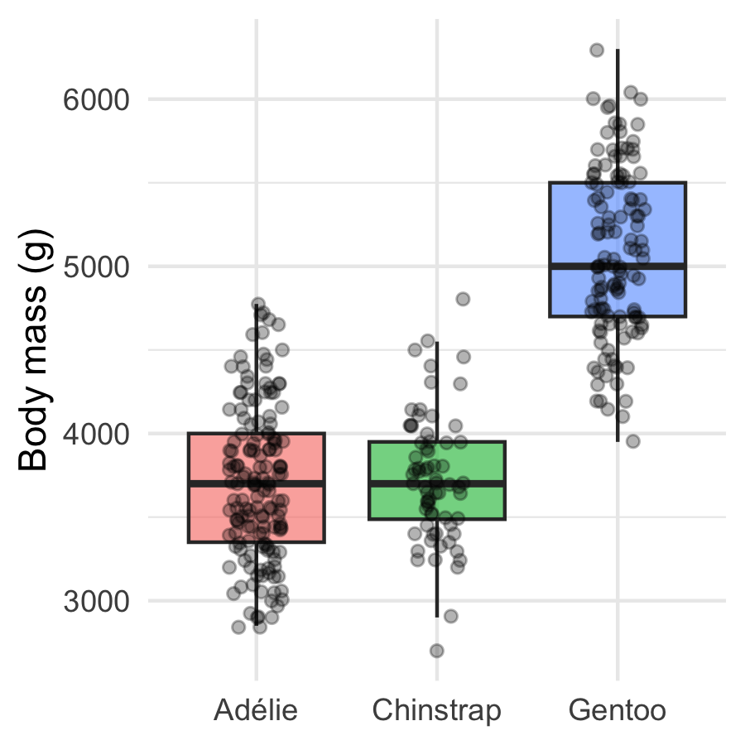
Ordered by mass, relabeled, publication-ready — and the code that made it is three fct_ calls inside one mutate().
This is the everyday payoff: factors are how you make categorical plots say what you mean.

🛑 Pause — Do Activity Parts 10–12 Now
Relevel a model to a new reference, drop an unused level, and build your own reordered + relabeled figure. Predict the reference change before you run it.

What We Learned Today
Concepts:
- A factor = categories + a stored order of levels
- Level order drives plot axes, legends, and model baselines
- Reorder for readable plots: fct_reorder(), fct_infreq(), fct_rev()
- Tidy the labels: fct_recode(), fct_collapse(), fct_lump()
- Set the model reference with fct_relevel(); clear ghosts with fct_drop()
- as.numeric() on a factor returns codes — convert to character first
References:
- 📖 R4DS Ch. 16 — Factors
- 📖 common_code/15_factors
Up next — Lecture 11:
- One-way ANOVA — compare a numeric response across three or more groups
- Your factor levels are now in order, so the group comparisons read cleanly

