Lecture 13 — Mapping: Where Is Bigfoot?
  - Spatial data, sf, and geom_sf with real Bigfoot sighting reports
Bill Perry
2026-07-05

Where we left off — Factors & Joins
- Factors — reordered and relabeled categories for readable plots
- Joins — combined a measurements table with a second table by a shared key
- Both skills come back today: we’ll join sighting counts onto a map
 Note
✅ Transition
You can wrangle, summarize, model, and join. Today we put data on a map — the single most fun payoff in the toolkit. Our dataset: 4,000+ real Bigfoot sightings across the US, each with a latitude and longitude. 🦶

Goals for today (a 2-day lecture)
- Understand spatial data — points, polygons, and coordinate systems
- Meet sf — a data frame with a geometry column
- Turn latitude/longitude into a map with geom_sf()
- Draw sighting points on a map of US states
- Build a choropleth — sightings per state — by joining counts to the map
- Reproject to a proper US look
Tools today:
- tidyverse, sf, maps
Data:
- bfro_reports_geocoded.csv from Kaggle — save it to your data/ folder
Reference:
- 📖 R4DS + sf docs (Geocomputation with R)
- 🌐 sf package
 Tip
Day 1: points on a map. Day 2: choropleth + polish.

How to Use These Slides — Predict · Type · Run
This lecture runs in four chunks over two days. After each chunk you switch to the activity and type the code yourself.
For every map, do three things:
- Predict — before it draws, say where the points or the dark states will be
- Type the code by hand — do not copy-paste
- Run it and compare to your prediction
 Note
✅ Why bother?
- Predicting the pattern (“Pacific Northwest?”) makes the map mean something when it appears.
- Typing builds the sf + geom_sf muscle memory.
- Chunk → practice keeps each new idea from piling up.

🧩 Chunk 1 of 4 · Spatial Data & the sf Object (Day 1)
We will cover: what spatial data is, coordinate systems, and turning latitude/longitude into an sf object.
 Tip
🖐 After this chunk: Activity Parts 1–3 (load the sightings, make them spatial).

What Is Spatial Data?
Two shapes cover almost everything:
- Points — a single location: one Bigfoot sighting = (longitude, latitude)
- Polygons — an area: the outline of a state or country
Both need a coordinate reference system (CRS) — the rulebook that says what the numbers mean.
- EPSG:4326 (WGS84) — plain longitude/latitude, what GPS and our CSV use
 Note
📖 New word
CRS = Coordinate Reference System. Two maps won’t line up unless they share one. Lat/long is crs = 4326.

The sf Package — a Data Frame with Geometry
# Load packages + the sighting data ------------------
library(tidyverse)
library(sf) # simple features = spatial data frames
library(maps) # ready-made state/country outlines
# Swap this path for your download -------------------
bigfoot_df <- read_csv("data/bfro_reports_geocoded.csv")
bigfoot_df %>% select(title, state, latitude, longitude, classification) %>% head()
# A tibble: 6 × 5
title state latitude longitude classification
<chr> <chr> <dbl> <dbl> <chr>
1 <NA> Alab… NA NA Class B
2 <NA> Alas… NA NA Class A
3 Report 6496: Bicycling student has ni… Rhod… 41.4 -71.5 Class A
4 <NA> Penn… NA NA Class B
5 <NA> Oreg… NA NA Class B
6 Report 9765: Motorist and children ha… Okla… 35.3 -99.2 Class A
- sf = “simple features” — the standard for spatial data in R
- An sf object is a normal tibble plus a geometry column
- Everything you know — filter(), mutate(), group_by() — still works

Clean the Coordinates First
# Drop missing coords + keep the lower 48 ------------
bigfoot_df <- bigfoot_df %>%
filter(!is.na(latitude), !is.na(longitude)) %>%
filter(longitude > -125, longitude < -66,
latitude > 24, latitude < 50)
nrow(bigfoot_df)
[1] 4031
- Real coordinate data always has some missing values
- We also trim to the continental US so the map isn’t dominated by a few far-flung points
 Warning
⚠️ Watch out! The next step (st_as_sf) errors if any latitude/longitude is NA — clean first, always.

Make It Spatial — st_as_sf()
 Note
🔮 Predict first: We’re about to turn 4,000+ rows of lat/long into points and plot them with no basemap. What shape do you think the cloud of points will make?

# Build the geometry column from lon/lat -------------
bigfoot_sf <- bigfoot_df %>%
st_as_sf(coords = c("longitude", "latitude"), crs = 4326)
# Just the points — the USA appears on its own -------
ggplot(bigfoot_sf) +
geom_sf(alpha = 0.2, size = 0.5) +
theme_minimal()
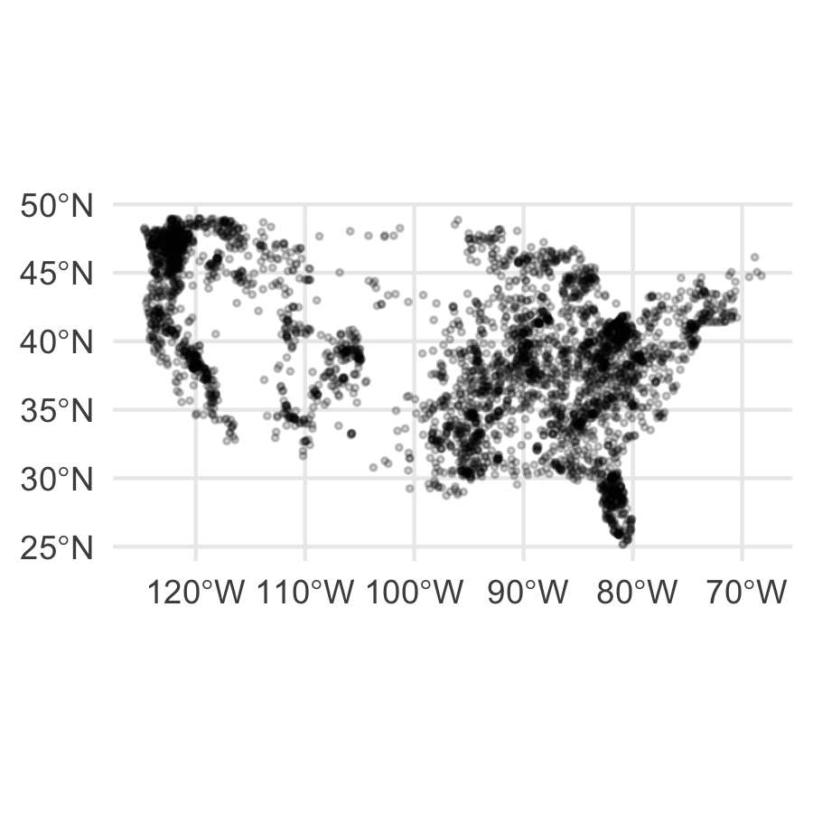
- coords = c("longitude", "latitude") — x first, then y
- crs = 4326 — tells sf these are lon/lat degrees
- The points alone trace the outline of the country — that’s the “aha” of spatial data
📖 sf: st_as_sf()

🛑 Pause — Do Activity Parts 1–3 Now
Load the sightings, clean the coordinates, make an sf object, and plot the bare points. Predict the shape before you run it.

🧩 Chunk 2 of 4 · Points on a Real Map (Day 1)
We will cover: adding a basemap of US states and layering the sightings on top, colored by class.
 Tip
🖐 After this chunk: Activity Parts 4–6 (draw the states + points).

Get a Basemap — US States as sf
# Turn the built-in state outlines into sf ----------
states_sf <- st_as_sf(
maps::map("state", plot = FALSE, fill = TRUE)
) %>%
st_set_crs(4326)
states_sf %>% head(3)
Simple feature collection with 3 features and 1 field
Geometry type: MULTIPOLYGON
Dimension: XY
Bounding box: xmin: -114.8093 ymin: 30.24071 xmax: -84.90089 ymax: 37.00161
Geodetic CRS: WGS 84
ID geom
alabama alabama MULTIPOLYGON (((-87.46201 3...
arizona arizona MULTIPOLYGON (((-114.6374 3...
arkansas arkansas MULTIPOLYGON (((-94.05103 3...
- maps::map("state", fill = TRUE) — polygon outlines of the lower 48, no download
- st_as_sf() converts them to spatial features
- st_set_crs(4326) — same lat/long system as our points, so they line up
 Note
The ID column holds the state name (lowercase) — we’ll use it to join later.

Layer the Sightings on the Map
 Note
🔮 Predict first: Where do you expect the densest cluster of sightings — the Pacific Northwest, the Southeast, the Plains? Commit before it draws.

# Basemap first, then points on top ------------------
ggplot() +
geom_sf(data = states_sf, fill = "grey96", color = "grey75") +
geom_sf(data = bigfoot_sf, aes(color = classification),
alpha = 0.3, size = 0.6) +
labs(title = "Bigfoot Sightings Across the Lower 48",
color = "Report class") +
theme_void()
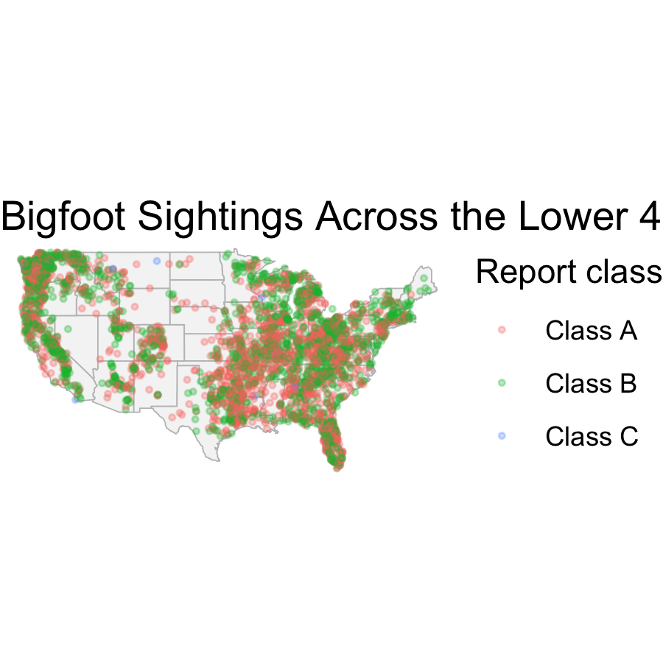
- Order matters: draw states first, points second (on top)
- aes(color = classification) — colors Class A / B / C reports
- theme_void() — drop the axes and grid for a clean map
Notice the clusters — the Pacific Northwest lights up. 👀

🛑 End of Day 1 · Start Day 2 Here
Day 1 recap — you can now:
- Explain points, polygons, and CRS
- Turn lat/long into an sf object with st_as_sf()
- Draw a basemap of states and layer points with geom_sf()
Day 2 — the choropleth:
- Count sightings per state
- Join those counts onto the map
- Shade each state, then reproject for a proper US look

🧩 Chunk 3 of 4 · Choropleth by State (Day 2)
We will cover: counting sightings per state and joining them to the map to shade each state.
 Tip
🖐 After this chunk: Activity Parts 7–9 (count, join, shade).

Step 1 — Count Sightings per State
 Note
🔮 Predict first: Which state do you think has the most Bigfoot reports? Write your guess before you run count().

# Sightings per state — lowercase to match the map --
sightings_by_state <- bigfoot_df %>%
mutate(state = str_to_lower(state)) %>%
count(state, name = "sightings") %>%
arrange(desc(sightings))
head(sightings_by_state)
# A tibble: 6 × 2
state sightings
<chr> <int>
1 washington 538
2 ohio 283
3 florida 281
4 california 277
5 texas 218
6 illinois 210
- count(state) — one row per state with its total
- str_to_lower(state) — the map’s state names are lowercase, so we match them now
- This is a plain summary table — next we glue it to the geometry
📖 R4DS §16 — factors/strings for tidy keys

Live Demo — Watch It Break (a blank map)
If I skip the lowercase step, the join keys don’t match — "Washington" ≠ "washington":
states_sf %>%
mutate(state = ID) %>%
left_join(count(bigfoot_df, state), by = "state") # "Washington" vs "washington"
Every state gets NA sightings → the whole map renders grey. No error, just a blank choropleth.
The fix — make both keys the same case before joining (str_to_lower()).
 Important
✅ Why show a blank map?
A join only matches keys that are exactly equal. "Washington", "washington", and " Washington" are three different keys. A silent all-NA result is almost always a key-mismatch — check case and spelling first.

Step 2 — Join Counts onto the Map
# Join sightings to the state polygons ---------------
states_map <- states_sf %>%
mutate(state = str_remove(ID, ":.*")) %>% # drop ":north" etc.
left_join(sightings_by_state, by = "state")
ggplot(states_map) +
geom_sf(aes(fill = sightings), color = "white") +
scale_fill_viridis_c(option = "magma", direction = -1) +
labs(title = "Bigfoot Sightings by State", fill = "Sightings") +
theme_void()
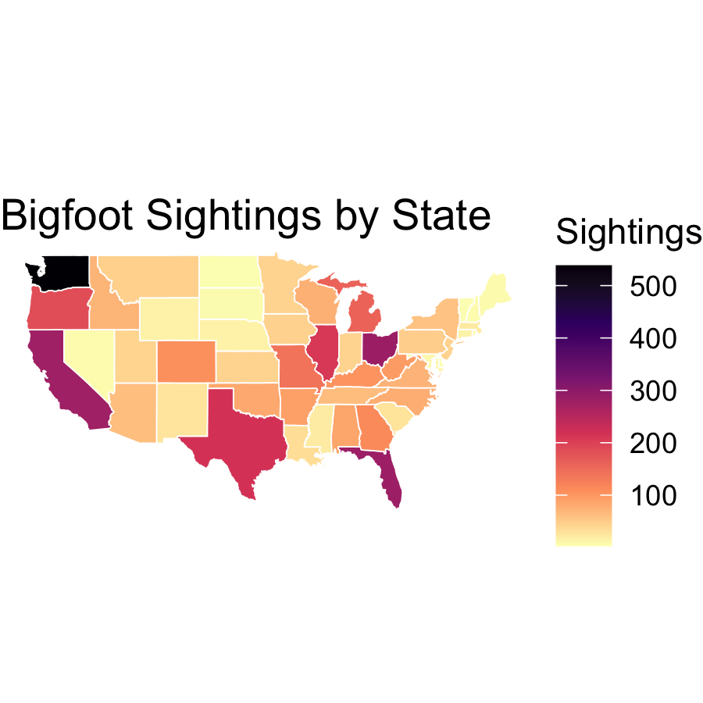
- left_join() keeps every state, filling in its count
- str_remove(ID, ":.*") merges split polygons (e.g. michigan:north)
- geom_sf(aes(fill = sightings)) shades each state
- scale_fill_viridis_c() — a colorblind-safe gradient
This is a choropleth — the map is the bar chart.

🛑 Pause — Do Activity Parts 7–9 Now
Count sightings per state, join them to the map, and shade the choropleth. Predict the top state before you run it.

🧩 Chunk 4 of 4 · Polish & Explore (Day 2)
We will cover: a proper US projection, and a fun exploration — sightings by season.
 Tip
🖐 After this chunk: Activity Parts 10–12 (reproject, then explore).

Reproject for a Proper US Look — coord_sf()
# Albers Equal-Area (EPSG:5070) — the "textbook" US --
ggplot(states_map) +
geom_sf(aes(fill = sightings), color = "white") +
scale_fill_viridis_c(option = "magma", direction = -1) +
coord_sf(crs = 5070) +
labs(title = "Bigfoot Sightings by State (Albers projection)",
fill = "Sightings") +
theme_void()
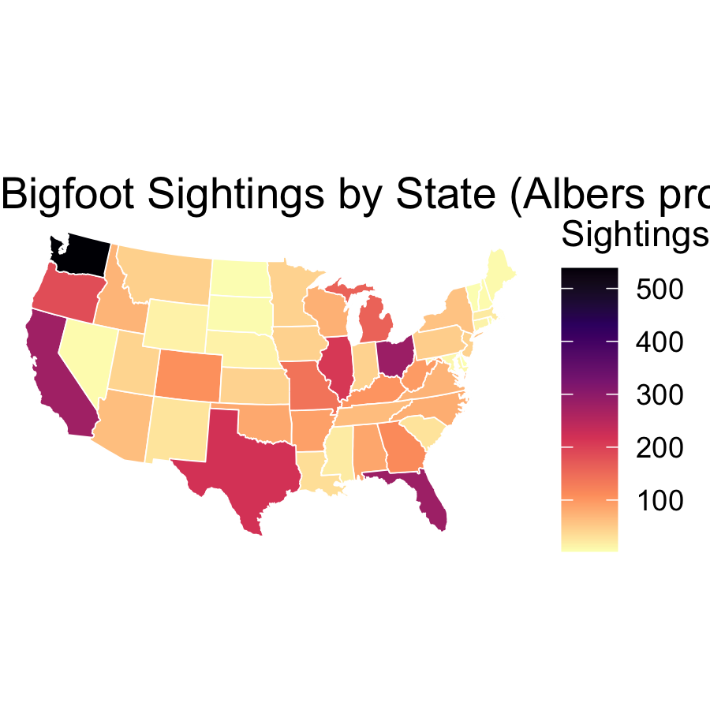
- Lat/long (4326) stretches the US; Albers (5070) is the shape you expect
- coord_sf(crs = 5070) reprojects just for display — your data is unchanged
- One line, and the map suddenly looks professional
 Note
Different jobs use different CRSs — equal-area for choropleths, web maps use 3857.

Explore — Sightings by Season 🍂
 Note
🔮 Predict first: In which season do you think the most sightings are reported? (Think about who is outdoors, and when.)

# Facet the point map by season ----------------------
bigfoot_sf %>%
filter(season %in% c("Spring","Summer","Fall","Winter")) %>%
ggplot() +
geom_sf(data = states_sf, fill = "grey96", color = "grey80") +
geom_sf(alpha = 0.2, size = 0.4, color = "firebrick") +
facet_wrap(~ season) +
coord_sf(crs = 5070) +
theme_void()
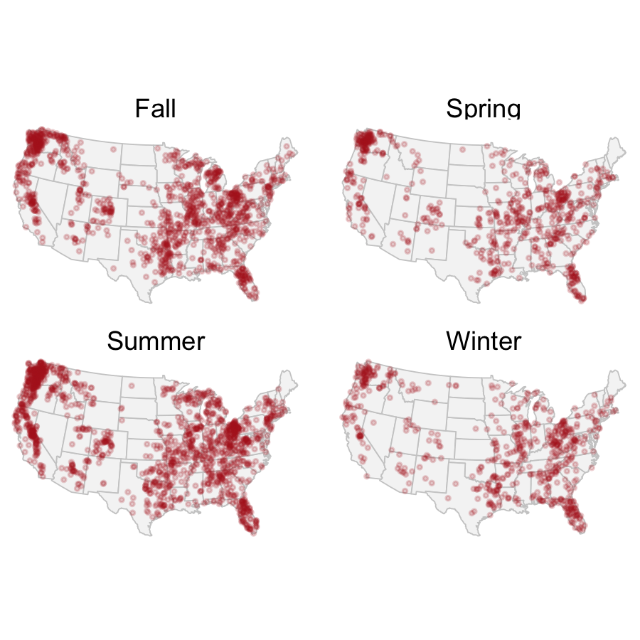
- facet_wrap(~ season) — one small map per season, same skill as any facet
- Summer dominates — more people outdoors = more reports (a sampling story!)
- This is how you’d explore any point dataset: filter, color, facet

What We Learned Today
Concepts:
- Spatial data = points/polygons + a CRS
- sf objects are tibbles with a geometry column
- st_as_sf(coords = c("lon","lat"), crs = 4326) makes points
- geom_sf() draws layers; order matters (basemap first)
- A choropleth = counts joined to polygons, shaded by value
- coord_sf(crs = ...) reprojects for display
R skills:
- st_as_sf(), st_set_crs(), maps::map()
- geom_sf(), scale_fill_viridis_c(), coord_sf()
- count() + left_join() + str_to_lower() for the choropleth
References:
- 🌐 sf package
- 📖 Geocomputation with R
Homework:
- Download your own species from GBIF with the rgbif package and map where it lives — see the assignment.

