Lecture 02 — Meeting R
  - From the console to your first plot

Where we left off (Lecture 01)
- Learning goals — data organization, Excel → R workflow, hypothesis testing, interpretation
- Science fundamentals — falsifiable predictions; null vs. alternate hypotheses
- Our class project — leaf morphology: sunny vs. shady sides of trees
- Design — randomization, replication (multiple trees), sampling limits
- Variables — dependent (leaf mass/size) vs. independent (side of tree)
- Spreadsheet hygiene — metadata, consistent terms, units, clean sheet design
✅ Key idea
Today we take that tidy spreadsheet and bring it to life in R.

Goals for today
- Get R and Positron set up and oriented
- Organize a project so future-you can find things
- Learn how R actually works:
  - using it as a calculator
  - storing things with the assignment operator <-
  - functions, vectors, and data types
- Load our tree data and make a first plot
🖐 Try it yourself
By the end you’ll run real code on our leaf data — not a toy dataset.
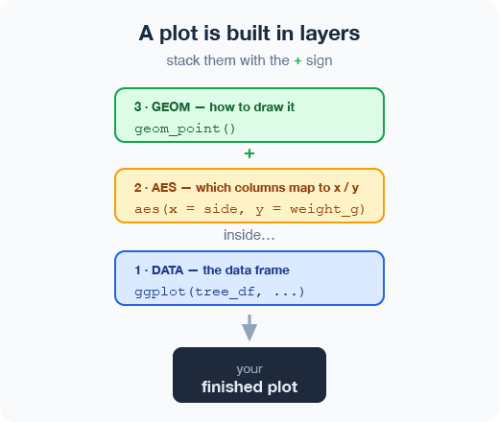

Part 1 · Setting up

What is R, really?
- R is the engine — a free language for data and statistics. On its own it is plain; this plain version is called base R.
- We drive that engine through a friendlier dashboard called an IDE (an editor for code).
- Two good IDEs — you can try both:
  - Positron — what we’ll use (recommended)
  - RStudio — the long-time classic
📖 New word
IDE = Integrated Development Environment. Think of R as the car’s engine and the IDE as the seat, wheel, and dashboard.
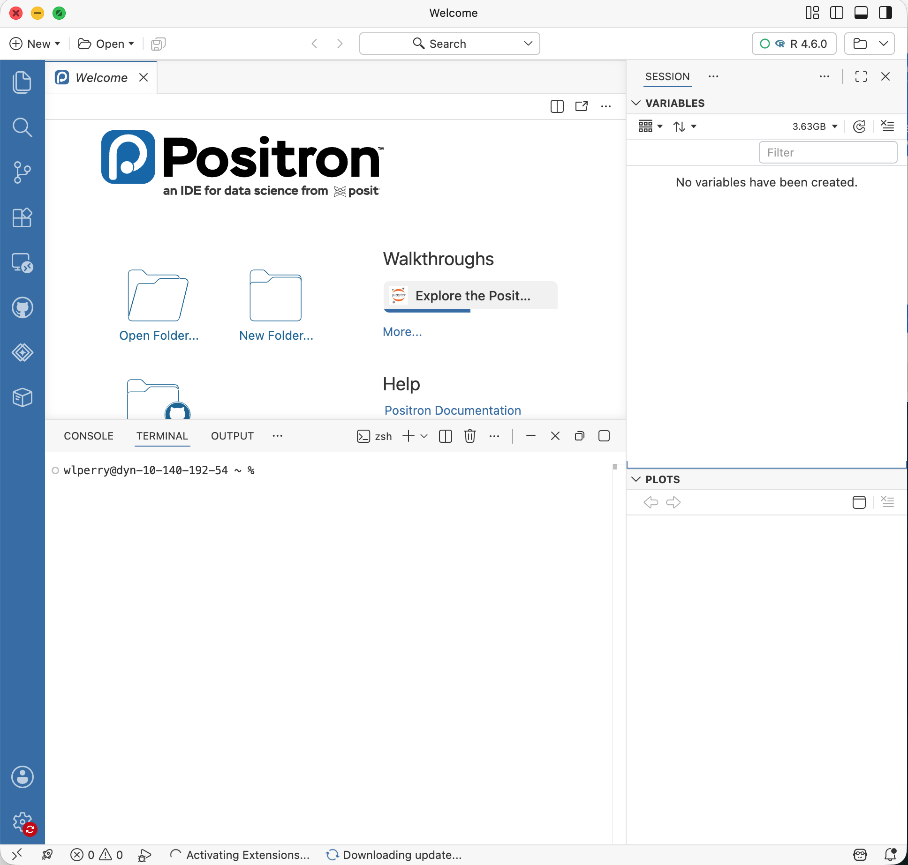

Download the two pieces
- R (the engine) — cran.r-project.org
  - Can you find the file after it downloads?
- Positron (the dashboard) — positron.posit.co
  - Where did it land on your computer?
- (Optional) RStudio, if you want to compare — posit.co
⚠️ Watch out!
Install R first, then Positron. Positron needs to find R already on your machine.


Organize the project before you code
Make one folder per project. Everything for the tree experiment lives together:
tree_project/
├── data_raw/ <- the untouched Excel file
├── scripts/ <- your .R code
├── figures/ <- plots you save
└── data_clean/ <- tidied files you create
- In Positron: File → Open Folder… and pick this folder.
- Now every path is relative to the project — no more C:/Users/.../Desktop/... nightmares.
✅ Key idea
A tidy folder today saves an hour of “where did I put that file?” next week.
📊 Coming from Excel?
In Excel you keep one big file. In R we keep raw data read-only and write new clean files — so you can always trace your steps and never overwrite your original numbers.

A quick tour of Positron
Four panes you’ll use constantly:
- Editor (top-left) — your scripts live here
- Console / Terminal (bottom) — where code runs
- Variables / Session (right) — everything you’ve stored
- Plots (right) — your figures appear here
🖐 Try it yourself
Find each pane on your screen now. Click the Console tab — that’s where we start next.


Part 2 · How R works

R is a calculator
Type math straight into the console and press Enter:
3 + 5
12 / 7
2 ^ 10
R answers immediately. The console is great for quick “what’s the answer?” questions.
⚠️ Watch out!
A + at the start of the console line means R is still waiting for you to finish a command. Press Esc to start over.
📊 Coming from Excel?
This is just like typing =3+5 into an Excel cell — except there are no cells, just a line you type and run.

Storing values: the ladder <-
To keep a value, give it a name with the assignment operator <-:
x <- 7 # store 7 under the name x
x # type the name to read it back
x * 2 # now use it in math
- <- puts the value into your environment (look right!).
- Shortcut: Alt + - (Win) or Option + - (Mac) types <- for you.
📖 New word
Assignment operator <- = “take the thing on the right and store it under the name on the left.”
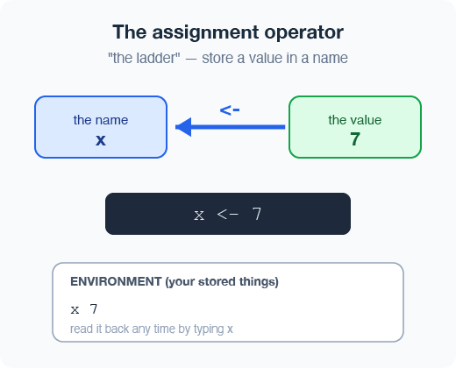

Naming your objects well
Good names make code readable months later:
- Be explicit, not too long: leaf_mass, not x2
- Cannot start with a number — x2 ✅, 2x ❌
- R is case-sensitive — weight_kg ≠ Weight_kg
- Avoid names of built-in functions (mean, data, c)
- Avoid dots; use lower_snake_case like the tidyverse
⚠️ Watch out!
weight_g and weight_G are two different objects. Pick one style and stick with it.
📖 New word
Object (R) = variable (Excel/other languages). Same idea: a named box that holds something.
✅ Key idea
Nouns for objects (tree_df), verbs for functions (filter).

Leave notes with comments #
Anything to the right of # is ignored by R — it’s a note to humans:
# weights of four leaves, in grams
leaf_mass <- c(4, 3, 5, 7)
mean(leaf_mass) # average leaf mass
- Comment generously — your future self will thank you.
- Shortcut to toggle a line: Ctrl/Cmd + Shift + C.
✅ Key idea
If a line confused you while writing it, comment why you did it.
📊 Coming from Excel?
Comments are like the little notes you scribble in a spreadsheet cell — but they never get in the way of the numbers.

Functions and their arguments
A function is a canned script you call by name. You feed it arguments (inputs); it returns a result.
sqrt(10) # one argument
round(3.14159) # default: 0 digits -> 3
round(3.14159, 2) # two digits -> 3.14
round(x = 3.14159, digits = 2) # named
Stuck on a function? Ask R:
?round # open the help page
args(round) # what arguments does it take?
📖 New word
Argument = an input you hand to a function, inside its ( ).
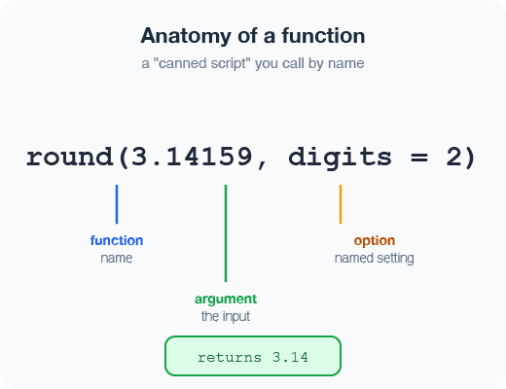

Vectors — a row of values
A vector is a series of values built with c() (“combine”):
weight_g <- c(4, 3, 5, 7) # numbers
side <- c("sunny", "shady") # text needs quotes
Inspect any vector:
length(weight_g) # how many values?
class(weight_g) # what type?
str(weight_g) # quick structure overview
⚠️ Watch out!
Quotes matter: "sunny" is text. Without quotes, R hunts for an object named sunny and errors when it can’t find one.
✅ Key idea
A vector is the workhorse of R. A spreadsheet column is really just a vector.

Data types live inside vectors
Every vector holds one type:
- numeric — 4, 3.5
- character — "sunny"
- logical — TRUE / FALSE
- integer — 2L
Mix types and R quietly coerces them all to one:
c(1, 2, 3, "a") # all become character
c(1, 2, 3, TRUE) # all become numeric
class(c(1, 2, 3, "a"))
📖 New word
Coercion = R automatically converting everything in a vector to a single shared type.
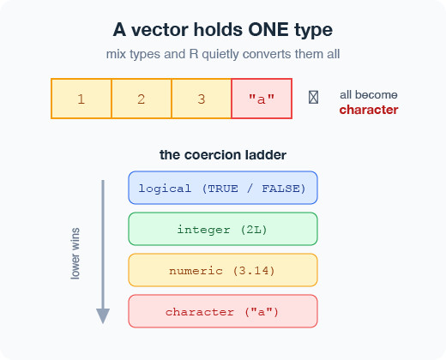

Part 3 · From console to script

Don’t retype — use a script
The console forgets. A script (.R file) remembers and re-runs.
- File → New File → R File opens Untitled-1
- Type your commands, one per line
- Put the cursor on a line and press Ctrl/Cmd + Enter to run it
- Save with Ctrl/Cmd + S — reopen later and rerun everything
x <- 7
y <- 5
text <- "say hello"
x + y
✅ Key idea
Console = scratch paper. Script = the lab notebook you keep.
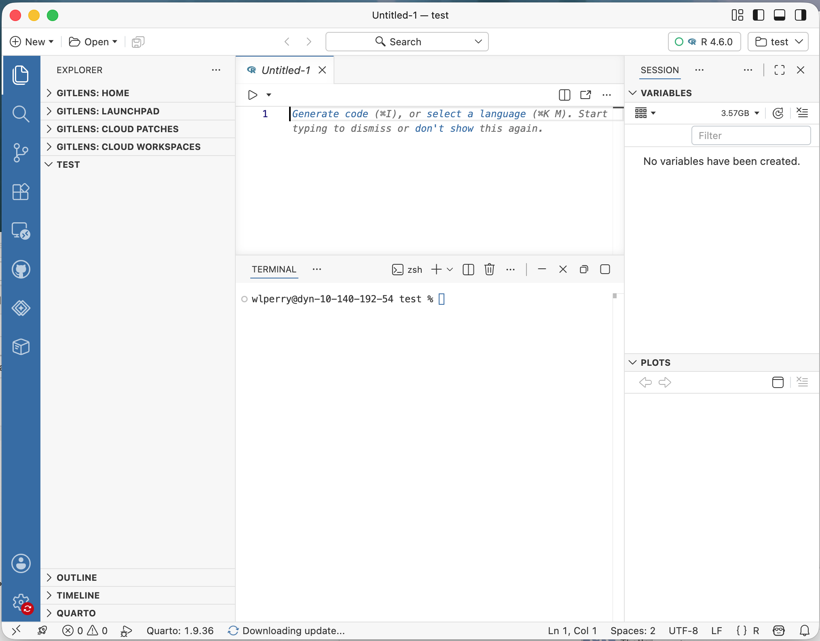

Packages vs. libraries
Like apps for your phone, packages add new abilities to R.
- Install once (download the app):
install.packages("tidyverse")
install.packages("readxl")
- Load every session (open the app):
library(tidyverse) # data wrangling + plotting
library(readxl) # read Excel files
⚠️ Watch out!
A common first-day error: forgetting library(tidyverse). If R says “could not find function read_excel”, you skipped the library() line.
📖 New word
Package = the installed toolbox (one time). Library = loading that toolbox into today’s session (every time).

Load our tree data
Put the Excel file in your project’s data_raw/ folder, then:
library(tidyverse)
library(readxl)
# read the Excel file into a data frame
tree_df <- read_excel("data_raw/2026_06_25_tree_experiment_raw_data.xlsx")
tree_df # print it to the console
🖐 Try it yourself
What did you name your project folder? What did you call your script? Write them down — we’ll reuse them all term.
📊 Coming from Excel?
read_excel() is the bridge from your spreadsheet into R. Your sheet’s first row becomes the column names.

Meet the data frame
A data frame is a table: each column is a vector of one type, and the rows line up.
Our tree_df has five columns:
- index — leaf number (numeric)
- side — "sunny" / "shady" (character)
- weight_g, width_cm, height_cm (numeric)
Pull a single column with $:
tree_df$weight_g # just the weights, as a vector
📖 New word
Data frame = R’s word for a spreadsheet-style table.
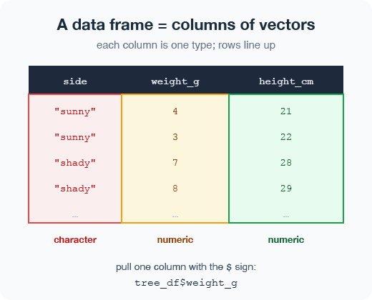

Look at your data before trusting it
Always eyeball a new data frame:
head(tree_df) # first 6 rows
tail(tree_df) # last 6 rows
dim(tree_df) # rows, columns -> 20 5
names(tree_df) # column names
str(tree_df) # type of every column
summary(tree_df) # min/mean/max per column
🖐 Try it yourself
Run str(tree_df). How many rows? What type is side?
✅ Key idea
Check dim() and str() every single time you load data. Typos and wrong types hide here.
⚠️ Watch out!
If a number column shows as character, a stray letter or comma snuck into your spreadsheet.

The chute |> — the pipe
The pipe sends a result straight into the next command. Read it as the word “then”:
tree_df |>
group_by(side) |>
summarise(mean_weight = mean(weight_g))
Take tree_df, then group by side, then average the weights.
📖 New word
Pipe |> = “take what’s on the left and feed it to the function on the right.” You may also see %>% from the tidyverse — same idea.
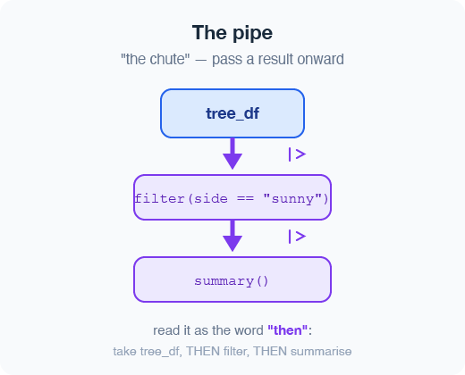

Part 4 · Your first plot

ggplot: build a picture in layers
Plots are built from three core layers, joined with +:
ggplot(tree_df, aes(x = side, y = weight_g))
- data — which data frame (tree_df)
- aes — which columns map to x and y
- geom — how to draw it
Add the geom with +:
ggplot(tree_df, aes(x = side, y = weight_g)) +
geom_point()
⚠️ Watch out!
The + must sit at the end of a line, never the start. + at the start = error.


Improve it one layer at a time
Since side is a category, a boxplot with the raw points on top tells the story well:
ggplot(tree_df, aes(x = side, y = weight_g)) +
geom_boxplot() +
geom_jitter(width = 0.15, alpha = 0.6, color = "tomato") +
labs(x = "Side of tree",
y = "Leaf weight (g)",
title = "Sunny vs. shady leaves")
🖐 Try it yourself
Swap weight_g for height_cm. What changes? Now try geom_violin() instead of geom_boxplot().
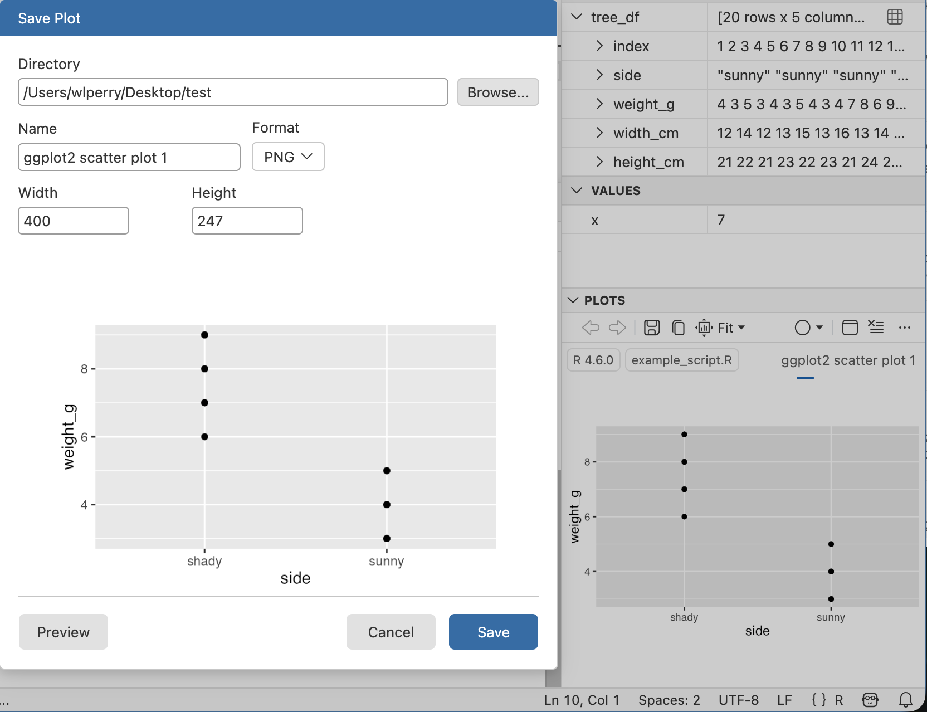

Save your plot and your clean data
Store the plot in an object, then save it:
my_plot <- ggplot(tree_df, aes(x = side, y = weight_g)) +
geom_boxplot()
ggsave("figures/leaf_weight.pdf", plot = my_plot,
width = 6, height = 6, units = "in")
Save a tidy data file too:
write_csv(tree_df, "data_clean/tree_clean.csv")
Or use the disk icon above the Plots pane → the Save dialog.
⚠️ Watch out!
ggsave() wants the filename first, then plot =. Mixing that order is the classic first save error.


Wrap-up

What you can now do
- Set up R + Positron and organize a project
- Use R as a calculator and store values with <-
- Write and run a script, with comments
- Call functions and read their help
- Build vectors, know their types
- Load Excel data into a data frame and inspect it
- Use the pipe |> to summarise
- Make and save a first ggplot
✅ Key idea
You went from a blank console to a saved figure of our data. That’s the whole workflow in miniature.
🖐 Try it yourself
Before next class: load tree_df, run summary(), and make one plot of width_cm by side.

Getting unstuck
When code breaks (it will — that’s normal):
- ?function_name — the built-in help page
- Read the error message out loud; it usually names the line
- Check: did you load library(tidyverse)? spelling? a missing ) or +?
- The posit/tidyverse cheatsheets are gold
- Bring the exact error to class or office hours
✅ Key idea
Every coder googles error messages daily. Getting stuck isn’t failing — it’s the job.
📊 Coming from Excel?
In Excel you fix errors by clicking around. In R you fix them by reading the message and editing one line. Slower at first, far more powerful soon.

