Lecture 03 — Describing Our Data
  - Summaries, statistics, and our first real comparisons
Bill Perry
2026-06-28

Where we left off (Lecture 02)
- Setup — R and Positron installed; project folders created (documents/, data/, output/, figures/, scripts/)
- R as a calculator — arithmetic, order of operations
- Assignment — storing values with <-
- Vectors — c(), indexing, data types (numeric, character, logical)
- Functions — calling built-in functions, passing arguments
- First look — loaded our leaf data with read_excel() and made a first ggplot
 Note
✅ Key idea from Lecture 02
You can get data into R and make a plot. Today we learn to describe and summarize what we actually have.

Goals for Today
- Review what descriptive statistics really mean
  - mean, median, variance, SD, SE
  - a first look at p-values
- Count observations correctly — the NA problem
- Compute stats three ways:
  - base R, tidyverse, and skimr
- Visualize distributions:
  - boxplots with individual points overlaid
  - mean ± SE summary plots
 Tip
🖐 Try it yourself
By the end you will compute and plot descriptive stats on our own leaf data.

Our tools today:
- readxl
- tidyverse
- skimr
References:
- 📖 R4DS Ch 3, 13, 18, 27
- 🌐 Data Carpentry
Naming conventions:
- data frames → _df
- plots → _plot
- models → _model

Our Scientific Question
Biological prediction: Leaves on the shady side of a tree will be larger and heavier to capture more of the limited light.
 | Hypothesis
H₀ — null | No difference in leaf size between sunny and shady sides
Hₐ — alternate | Leaf size differs between sunny and shady sides
Plan for this unit:
- Today — describe the data
- Lecture 04 — formally test the hypotheses with a t-test
Statistics helps us decide which hypothesis is better supported by the data.

Our Data — Long Format
Each row = one leaf
Column | Description
index | leaf number (1–20)
side | "sunny" or "shady"
weight_g | leaf weight (g)
width_cm | leaf width (cm)
height_cm | leaf height (cm)
This is called long format — one measurement per row, group label in a column.
Long vs Wide format:
Shape | Layout
Long | one row per leaf; side in a column
Wide | one row per leaf pair; sunny_wt, shady_wt as separate columns
R and ggplot2 work best with long format. We will convert between the two in a later lecture.
📖 R4DS §5 — Data Tidying

Load Libraries
# Load all packages — always at the top of every script --------
library(readxl) # reading Excel files (.xlsx)
library(tidyverse) # data manipulation + ggplot2
library(skimr) # fast descriptive column summaries
 Note
Install once — load every session
Run in the Console one time only:
install.packages("readxl")
install.packages("skimr")
Then every session: library(readxl) activates it.

Why readxl?
read_csv() reads .csv files. read_excel() reads .xlsx files. Both land the data in an R data frame.
📖 R4DS §7 — Data Import

Load Our Leaf Data
# Read the Excel file from the data folder -----------
tree_df <- read_excel(
"data/2026_06_25_tree_experiment_raw_data.xlsx"
)
# Preview the first rows of the data -----------------
head(tree_df)
# A tibble: 6 × 5
index side weight_g width_cm height_cm
<dbl> <chr> <dbl> <dbl> <dbl>
1 1 sunny 4 12 21
2 2 sunny 3 14 22
3 3 sunny 5 12 21
4 4 sunny 3 13 23
5 5 sunny 4 15 22
6 6 sunny 3 13 23
- Path is relative to your project folder
- "data/..." means: look in the data/ sub-folder
- This path works on any computer, not just yours
- The file stays untouched — R reads; it does not edit

Inspect the Data
# Column names, types, and first values --------------
glimpse(tree_df)
Rows: 20
Columns: 5
$ index <dbl> 1, 2, 3, 4, 5, 6, 7, 8, 9, 10, 11, 12, 13, 14, 15, 16, 17, 1…
$ side <chr> "sunny", "sunny", "sunny", "sunny", "sunny", "sunny", "sunny…
$ weight_g <dbl> 4, 3, 5, 3, 4, 3, 5, 4, 3, 4, 7, 8, 6, 9, 8, 7, 8, 9, 9, 7
$ width_cm <dbl> 12, 14, 12, 13, 15, 13, 16, 13, 14, 15, 9, 18, 17, 18, 19, 1…
$ height_cm <dbl> 21, 22, 21, 23, 22, 23, 21, 24, 23, 23, 28, 29, 27, 28, 27, …
# Rows × columns
dim(tree_df)
[1] 20 5
- <chr> = character (text)
- <dbl> = numeric (decimal)
10 sunny leaves, 10 shady leaves — we have a balanced design.

What Is the Mean?
$$\overset{‾}{x}=\frac{\sum_{i=1}^{n}{x_{i}}}{n}$$
- Add up all values, divide by n
- The balance point of the distribution
- Sensitive to outliers — one very large value pulls the mean up
Example:
Values: 5, 6, 7, 8, 50 → mean = 15.2
Is 15.2 a fair summary? Not really — the outlier dominates!
Why it matters:
- The most commonly reported statistic
- Used in every t-test, ANOVA, and regression
- Always pair it with a measure of spread (SD or SE)
📖 R4DS §13 — Numbers

Calculating the Mean — filter() and pull()
# Extract sunny leaf weights as a plain vector --------
sunny_wt <- tree_df %>%
filter(side == "sunny") %>%
pull(weight_g)
sunny_wt # look at the raw values
[1] 4 3 5 3 4 3 5 4 3 4
# Now calculate the mean of that vector --------------
mean_sunny <- mean(sunny_wt, na.rm = TRUE)
cat("Mean sunny weight:", round(mean_sunny, 2), "g\n")
Mean sunny weight: 3.8 g
- filter(side == "sunny") — keeps only sunny rows
- pull(weight_g) — extracts that column as a vector
- na.rm = TRUE — removes any NA before computing
Key pattern:
filter() → picks rows
pull() → extracts a column as a vector
📖 R4DS §3 — Data Transformation

What Is the Median?
The middle value when data are sorted
Sorted data | Median
5, 6, 7, 8, 50 | 7
5, 6, 7, 8, 50, 51 | (7 + 8) / 2 = 7.5
- Not pulled by outliers → robust
- If mean ≫ median → right-skewed
- If mean ≈ median → roughly symmetric
# Median for each side via filter + pull -------------
shady_wt <- tree_df %>%
filter(side == "shady") %>%
pull(weight_g)
med_sunny <- median(sunny_wt, na.rm = TRUE)
med_shady <- median(shady_wt, na.rm = TRUE)
cat("Median sunny:", round(med_sunny, 2), "\n")
Median sunny: 4
cat("Median shady:", round(med_shady, 2), "\n")
Median shady: 8

What Is Variance?
$$s^{2}=\frac{\sum_{i=1}^{n}{(}x_{i}−\overset{‾}{x})^{2}}{n−1}$$
- For each value, compute distance from mean: $(x_{i}−\overset{‾}{x})$
- Square those distances → all positive
- Sum them up, divide by $n−1$
Dividing by $n−1$ gives an unbiased estimate of population variance.
Larger variance = more spread = more uncertainty
# Variance for each side ----------------------------
var_sunny <- var(sunny_wt, na.rm = TRUE)
var_shady <- var(shady_wt, na.rm = TRUE)
cat("Variance sunny:", round(var_sunny, 2), "\n")
Variance sunny: 0.62
cat("Variance shady:", round(var_shady, 2), "\n")
Variance shady: 1.07
 Note
Variance is in squared units (g²) — hard to interpret. That is why we use SD.

📖 R4DS §13.3

What Is Standard Deviation?
$$s=\sqrt{s^{2}}=\sqrt{\frac{∑(x_{i}−\overset{‾}{x})^{2}}{n−1}}$$
- The square root of variance → back in original units (g) ✓
- For a normal distribution:
  - ~68% of values fall within mean ± 1 SD
  - ~95% fall within mean ± 2 SD
- Reports how spread out individual data points are
# Standard deviation for each side ------------------
sd_sunny <- sd(sunny_wt, na.rm = TRUE)
sd_shady <- sd(shady_wt, na.rm = TRUE)
cat("SD sunny:", round(sd_sunny, 2), "g\n")
SD sunny: 0.79 g
cat("SD shady:", round(sd_shady, 2), "g\n")
SD shady: 1.03 g
Most sunny leaves are within ±0.79 g of the mean.

What Is Standard Error?
$$SE=\frac{s}{\sqrt{n}}$$
- Measures how precisely we know the mean
- Not the spread of raw data — the uncertainty of the mean itself
- Gets smaller as n increases → more data = more precise estimate
 | Describes
SD | spread of individual data points
SE | precision of the sample mean
We report SE when making claims about group means.
# SE = SD / sqrt(n) — need correct n ----------------
n_sunny <- sum(!is.na(sunny_wt))
n_shady <- sum(!is.na(shady_wt))
se_sunny <- sd_sunny / sqrt(n_sunny)
se_shady <- sd_shady / sqrt(n_shady)
cat("n sunny =", n_sunny, "\n")
n sunny = 10
cat("SE sunny =", round(se_sunny, 2), "g\n\n")
SE sunny = 0.25 g
cat("n shady =", n_shady, "\n")
n shady = 10
cat("SE shady =", round(se_shady, 2), "g\n")
SE shady = 0.33 g

A First Look at the p-value
The key question: Could the difference in means be due to random chance alone?
A p-value answers:
“If H₀ were true (no real difference), how likely is it that we would see a difference this large, just by chance?”
- p < 0.05 → data are unlikely under H₀ → reject H₀
- p ≥ 0.05 → data are consistent with H₀ → fail to reject H₀
We will calculate a p-value in Lecture 04.
 Important
Common misconception
A p-value is not the probability that H₀ is true.
It is the probability of observing this data (or more extreme) given that H₀ is true.

Our shady leaves weigh ~7.8 g vs sunny at ~3.8 g.
Could that gap be random chance? We will find out next lecture.

The Problem with length()
# length() counts ALL positions — including NAs ------
x <- c(4, 3, NA, 7, NA) # a vector with missing values
length(x) # returns 5 — but 2 are NA!
[1] 5
sum(is.na(x)) # how many NAs are there?
[1] 2
# Using length() in SE gives the WRONG n and SE ------
wrong_n <- length(x)
wrong_se <- sd(x, na.rm = TRUE) / sqrt(wrong_n)
cat("Wrong n =", wrong_n, "\n")
Wrong n = 5
cat("Wrong SE =", round(wrong_se, 3), "\n")
Wrong SE = 0.931
- length(x) counts all positions in the vector — including NA
- This is a silent error — R will not warn you!
- Using n = 5 in SE = SD / √n when n should be 3 gives the wrong answer
📖 R4DS §18 — Missing Values

Fix — sum(!is.na())
# Break it down step by step --------------------------
x <- c(4, 3, NA, 7, NA)
is.na(x) # TRUE where NA, FALSE where real
[1] FALSE FALSE TRUE FALSE TRUE
!is.na(x) # FLIP: TRUE where real, FALSE where NA
[1] TRUE TRUE FALSE TRUE FALSE
sum(!is.na(x)) # count the TRUEs = number of real values
[1] 3
# Apply to our real leaf data ------------------------
# (Our data has no NAs — but always use this pattern!)
n_sun_check <- sum(!is.na(sunny_wt))
cat("Non-missing sunny weights =", n_sun_check, "\n")
Non-missing sunny weights = 10
How it works step by step:
- is.na(x) → TRUE for each NA
- !is.na(x) → flips it: TRUE for real values
- sum(...) → counts TRUEs
 Tip
Best practice: always use sum(!is.na(x)) when you need n — even when you think there are no NAs.

All Stats — Base R, One Group at a Time
# All stats for the sunny side using our vectors ------
n_s <- sum(!is.na(sunny_wt))
mean_s <- mean(sunny_wt, na.rm = TRUE)
med_s <- median(sunny_wt, na.rm = TRUE)
sd_s <- sd(sunny_wt, na.rm = TRUE)
se_s <- sd_s / sqrt(n_s)
cat("--- Sunny Leaves ---\n")
--- Sunny Leaves ---
cat("n =", n_s, "\n")
n = 10
cat("Mean =", round(mean_s, 2), "\n")
Mean = 3.8
cat("Median =", round(med_s, 2), "\n")
Median = 4
cat("SD =", round(sd_s, 2), "\n")
SD = 0.79
cat("SE =", round(se_s, 2), "\n")
SE = 0.25
- Every function takes na.rm = TRUE
- cat() prints clean labelled output
- This is clear but repetitive for many groups → that is why we use group_by() next

Stats the Tidy Way — group_by() + summarize()
# Calculate all stats for both sides at once ---------
stats_df <- tree_df %>%
group_by(side) %>%
summarize(
n = sum(!is.na(weight_g)),
mean_wt = round(mean(weight_g, na.rm = TRUE), 2),
med_wt = round(median(weight_g, na.rm = TRUE), 2),
sd_wt = round(sd(weight_g, na.rm = TRUE), 2),
se_wt = round(sd_wt / sqrt(n), 2)
)
stats_df
# A tibble: 2 × 6
side n mean_wt med_wt sd_wt se_wt
<chr> <int> <dbl> <dbl> <dbl> <dbl>
1 shady 10 7.8 8 1.03 0.33
2 sunny 10 3.8 4 0.79 0.25
- group_by(side) — splits the data by the side column
- summarize() — collapses each group to one row of stats
- You get both groups in one clean table
- You can reference a column you just created (sd_wt → se_wt)
📖 R4DS §3.5 — summarize()

Multiple Variables at Once
# group_by() works on any numeric column you choose --
size_stats_df <- tree_df %>%
group_by(side) %>%
summarize(
n = sum(!is.na(weight_g)),
mean_wt = round(mean(weight_g, na.rm = TRUE), 2),
mean_ht = round(mean(height_cm, na.rm = TRUE), 2),
mean_wd = round(mean(width_cm, na.rm = TRUE), 2)
)
size_stats_df
# A tibble: 2 × 5
side n mean_wt mean_ht mean_wd
<chr> <int> <dbl> <dbl> <dbl>
1 shady 10 7.8 27.9 17.3
2 sunny 10 3.8 22.3 13.7
With one group_by() pipe you can summarize all three measurements across both sides.
Do the numbers support our hypothesis?
- Shady heavier? → check mean_wt
- Shady taller? → check mean_ht
- Shady wider? → check mean_wd
📖 R4DS §3.3 — mutate()

Fast Summaries with skimr
# skim() grouped by side — full column summaries ------
tree_df %>%
group_by(side) %>%
skim()
Data summary
Name | Piped data
Number of rows | 20
Number of columns | 5
_______________________
Column type frequency:
numeric | 4
________________________
Group variables | side
Variable type: numeric
skim_variable | side | n_missing | complete_rate | mean | sd | p0 | p25 | p50 | p75 | p100 | hist
index | shady | 0 | 1 | 15.5 | 3.03 | 11 | 13.25 | 15.5 | 17.75 | 20 | ▇▇▇▇▇
index | sunny | 0 | 1 | 5.5 | 3.03 | 1 | 3.25 | 5.5 | 7.75 | 10 | ▇▇▇▇▇
weight_g | shady | 0 | 1 | 7.8 | 1.03 | 6 | 7.00 | 8.0 | 8.75 | 9 | ▂▇▁▇▇
weight_g | sunny | 0 | 1 | 3.8 | 0.79 | 3 | 3.00 | 4.0 | 4.00 | 5 | ▇▁▇▁▃
width_cm | shady | 0 | 1 | 17.3 | 3.02 | 9 | 17.25 | 18.0 | 19.00 | 19 | ▁▁▁▂▇
width_cm | sunny | 0 | 1 | 13.7 | 1.34 | 12 | 13.00 | 13.5 | 14.75 | 16 | ▅▇▅▅▂
height_cm | shady | 0 | 1 | 27.9 | 0.88 | 27 | 27.00 | 28.0 | 28.75 | 29 | ▇▁▆▁▆
height_cm | sunny | 0 | 1 | 22.3 | 1.06 | 21 | 21.25 | 22.5 | 23.00 | 24 | ▆▃▁▇▂
Per column and per group: n_missing, mean, sd, percentiles (p0 to p100), and a mini histogram.
 Tip
skim() is your fastest first look at any dataset. Pair it with group_by() to compare groups instantly.

The [[ ]] Notation
# Three ways to extract the same column as a vector --
# 1. Dollar sign notation
tree_df$weight_g
[1] 4 3 5 3 4 3 5 4 3 4 7 8 6 9 8 7 8 9 9 7
# 2. Double bracket with name in quotes
tree_df[["weight_g"]]
[1] 4 3 5 3 4 3 5 4 3 4 7 8 6 9 8 7 8 9 9 7
# 3. Double bracket with a variable holding the name
col_name <- "weight_g"
tree_df[[col_name]] # works!
[1] 4 3 5 3 4 3 5 4 3 4 7 8 6 9 8 7 8 9 9 7
# tree_df$col_name # does NOT work
- All three return an identical vector of all 20 weights
- $ is great for interactive typing
- [[ ]] is more flexible — accepts names stored in variables
- Essential for writing functions and loops later
📖 R4DS §27 — A Field Guide to Base R

Using [[ ]] with filter()
# Combine filter() and [[ ]] to get one group --------
sunny_df <- tree_df %>% filter(side == "sunny")
sun_wt <- sunny_df[["weight_g"]]
n_sun <- sum(!is.na(sun_wt))
m_sun <- mean(sun_wt, na.rm = TRUE)
se_sun <- sd(sun_wt, na.rm = TRUE) / sqrt(n_sun)
cat("Sunny — n:", n_sun,
"| mean:", round(m_sun, 2),
"| SE:", round(se_sun, 2), "g\n")
Sunny — n: 10 | mean: 3.8 | SE: 0.25 g
shady_df <- tree_df %>% filter(side == "shady")
sha_wt <- shady_df[["weight_g"]]
n_sha <- sum(!is.na(sha_wt))
m_sha <- mean(sha_wt, na.rm = TRUE)
se_sha <- sd(sha_wt, na.rm = TRUE) / sqrt(n_sha)
cat("Shady — n:", n_sha,
"| mean:", round(m_sha, 2),
"| SE:", round(se_sha, 2), "g\n")
Shady — n: 10 | mean: 7.8 | SE: 0.33 g
Pattern:
- filter() → subset to one group
- [[ ]] → extract the column as a vector
- Apply mean(), sd(), sum(!is.na())
Do the means match your prediction?
- Sunny: ~3.8 g
- Shady: ~7.8 g
Shady leaves appear heavier — but is the difference statistically significant?

Extension: A Simple Stats Function
# A reusable function using filter() + [[ ]] --------
# We will build functions properly in a later lecture!
describe_side <- function(data, grp, col_name) {
x <- data %>% filter(side == grp) %>% pull(col_name)
n <- sum(!is.na(x))
m <- mean(x, na.rm = TRUE)
s <- sd(x, na.rm = TRUE)
cat(grp, "|", col_name,
"→ n:", n,
"| mean:", round(m, 2),
"| SE:", round(s/sqrt(n), 2), "\n")
}
describe_side(tree_df, "sunny", "weight_g")
sunny | weight_g → n: 10 | mean: 3.8 | SE: 0.25
describe_side(tree_df, "shady", "weight_g")
shady | weight_g → n: 10 | mean: 7.8 | SE: 0.33
describe_side(tree_df, "sunny", "height_cm")
sunny | height_cm → n: 10 | mean: 22.3 | SE: 0.33
describe_side(tree_df, "shady", "height_cm")
shady | height_cm → n: 10 | mean: 27.9 | SE: 0.28
What this function does:
- Accepts data frame, group name, and column name
- Filters to that group with filter()
- Extracts the column with pull()
- Computes n, mean, SE
- Prints a compact labelled summary
For grins 🎉 — we will build these properly in Lecture 08!
📖 R4DS §25 — Functions

Boxplot — Basic Structure
# Basic boxplot — data is ALREADY long format --------
# No reshaping needed!
tree_box_plot <- tree_df %>%
ggplot(aes(x = side, y = weight_g, fill = side)) +
geom_boxplot(alpha = 0.6, outlier.shape = NA) +
labs(
title = "Leaf Weight by Tree Side",
x = "Side of Tree",
y = "Leaf Weight (g)",
fill = "Side"
) +
theme_minimal() +
theme(legend.position = "none")
tree_box_plot
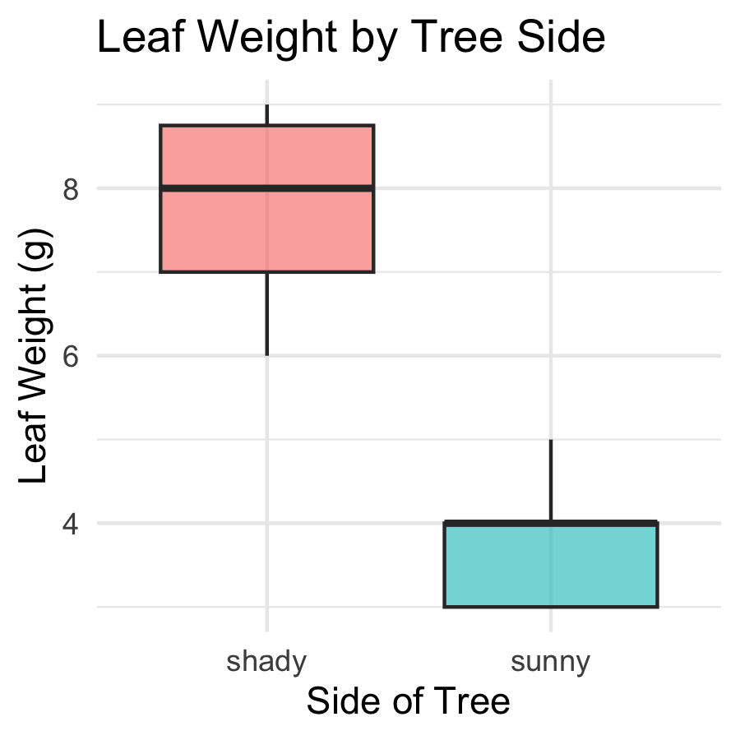
Boxplot anatomy:
- Middle line = median
- Box edges = 25th and 75th percentile (IQR)
- Whiskers = 1.5 × IQR
- Dots beyond whiskers = outliers
Because our data is already in long format, we skip the pivot_longer() step entirely — ggplot2 reads side straight off the x-axis.
📖 R4DS §9 — Layers

Boxplot — Overlay Individual Points
# Add raw data points over the boxplot ---------------
tree_jitter_plot <- tree_df %>%
ggplot(aes(x = side, y = weight_g, fill = side)) +
geom_boxplot(alpha = 0.5, outlier.shape = NA) +
geom_point(
position = position_jitter(width = 0.15, seed = 42),
alpha = 0.6,
size = 2.5
) +
labs(
title = "Leaf Weight by Tree Side",
x = "Side of Tree",
y = "Leaf Weight (g)",
fill = "Side"
) +
theme_minimal() +
theme(legend.position = "none")
tree_jitter_plot
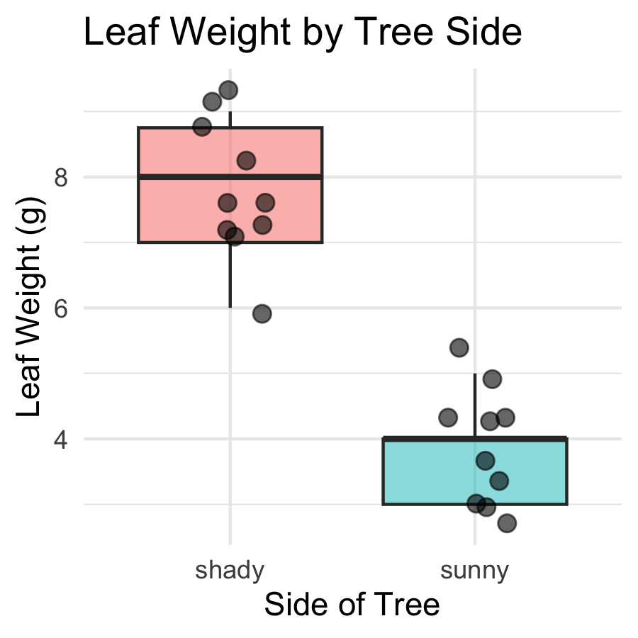
Key arguments:
- position_jitter(width = 0.15) — spreads points a little left and right
- seed = 42 — same jitter layout every render
- alpha = 0.6 — semi-transparent to show overlap
- size = 2.5 — point size
 Tip
Always show raw points with a boxplot — with only 10 leaves per group, every point matters!

Boxplot — Using position_dodge()
# position_dodge() spreads groups apart horizontally -
tree_dodge_plot <- tree_df %>%
ggplot(aes(x = side, y = weight_g,
color = side, fill = side)) +
geom_boxplot(alpha = 0.4, outlier.shape = NA) +
geom_point(
position = position_dodge(width = 0.3),
alpha = 0.7,
size = 2.5
) +
labs(
title = "Leaf Weight by Tree Side",
x = "Side of Tree",
y = "Leaf Weight (g)"
) +
theme_minimal() +
theme(legend.position = "none")
tree_dodge_plot
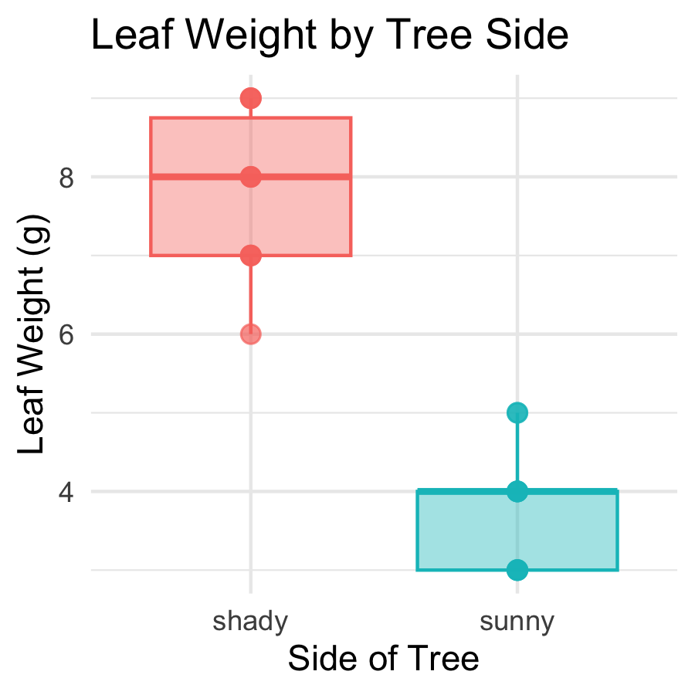
position_dodge(width = 0.3)
- Spreads overlapping geoms horizontally
- Most useful when you have two grouping variables (e.g., x = species, fill = treatment)
- width controls how far apart groups are spread
We will use position_dodge() extensively in future lectures when we have factorial designs.

Mean ± SE Plot — stat_summary()
# stat_summary() computes and plots mean and SE ------
tree_mean_se_plot <- tree_df %>%
ggplot(aes(x = side, y = weight_g, color = side)) +
geom_point(
position = position_jitter(width = 0.15, seed = 42),
alpha = 0.35, size = 2
) +
stat_summary(fun = mean, geom = "point",
size = 4) +
stat_summary(fun.data = mean_se, geom = "errorbar",
width = 0.15, linewidth = 0.9) +
labs(
title = "Mean ± SE Leaf Weight by Tree Side",
x = "Side of Tree",
y = "Leaf Weight (g)",
color = "Side"
) +
theme_minimal() +
theme(legend.position = "none")
tree_mean_se_plot
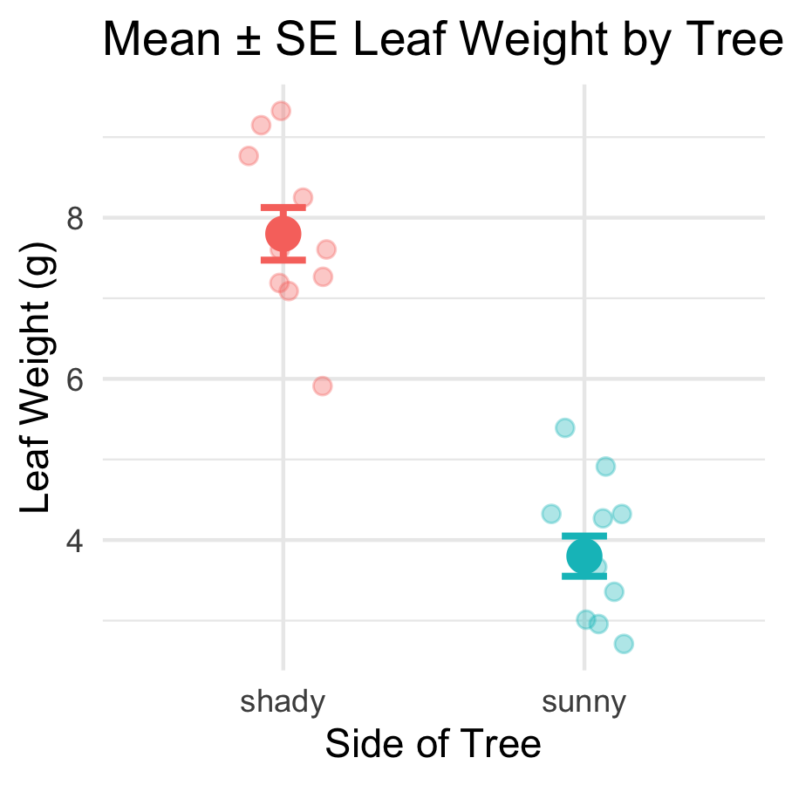
Two stat_summary() layers:
call | what it draws
fun = mean | large point at the mean
fun.data = mean_se | error bars for ± 1 SE
- Individual points in the background (alpha = 0.35)
- Mean shown as a larger foreground point
- Error bars = ± 1 SE
This is the standard comparison figure in biology.

Comparing the Two Plot Types
# Arrange both plots side by side --------------------
library(patchwork)
tree_jitter_plot + tree_mean_se_plot
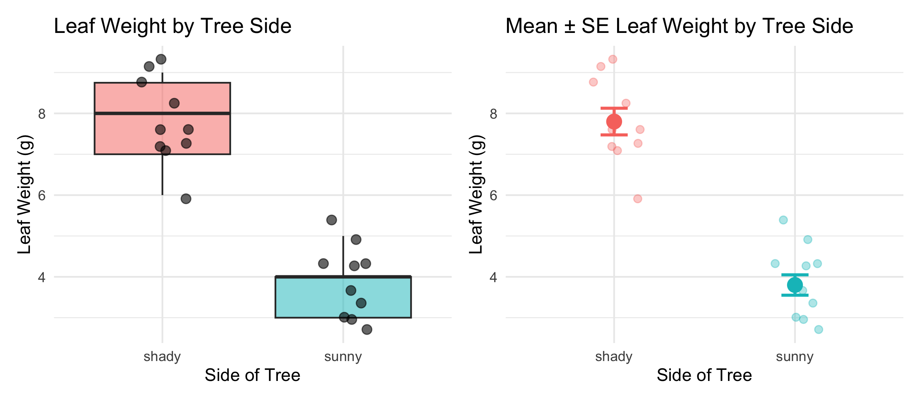
When to use each:
Plot type | Use when
Boxplot + points | showing full distribution
Mean ± SE | making group comparisons
With only n = 10 per group, showing every point is essential — the reader needs to see the raw data.
Boxplots show where data fall. Mean ± SE shows how confident you are in the mean.

What We Learned Today
Statistics concepts:
- Mean — balance point; sensitive to outliers
- Median — middle value; robust
- Variance / SD — spread of individual data
- SE — precision of the sample mean
- p-value — how unlikely are the data if H₀ is true?
R skills:
- read_excel() — load real Excel data
- filter() %>% pull() — extract a group’s values as a vector
- group_by() %>% summarize() — all stats for all groups at once
- sum(!is.na()) — the right way to count n
- skim() — instant full dataset overview
- [[ ]] — flexible column extraction
- geom_boxplot() + geom_point() — no pivot needed with long data!
- stat_summary() — mean ± SE
References:
- 📖 R4DS §3 — Data Transformation
- 📖 R4DS §13 — Numbers
- 📖 R4DS §18 — Missing Values
- 📖 R4DS §27 — Base R
- 🌐 Data Carpentry
Up next — Lecture 04:
- Two-sample t-test
- Checking assumptions (normality, equal variance)
- Interpreting and reporting results

