Lecture 05: Regression Analysis
Bill Perry

Where we left off (Lecture 04)
- Welch’s two-sample t-test — compared mean leaf weight between sunny and shady sides (var.equal = FALSE, two-tailed)
- Five-step framework — hypotheses → normality → variance → run test → report
  - Normality: histogram, QQ plot, Shapiro-Wilk on each group
  - Variance: Levene’s test; Welch’s is safe regardless of the result
- Reading t.test() output — t-statistic, Welch-Satterthwaite df, p-value, 95% CI, group means
- Result — shady leaves were significantly heavier than sunny leaves (Welch’s t-test, p < 0.001)
 Note
✅ Transition
We confirmed that shady and sunny leaves differ in weight. Today we go further — we build a calibration curve to convert that weight into a more biologically meaningful measurement: leaf surface area (cm²).

Goals for Today
- Understand what linear regression does and when to use it
- Learn the equation: $\hat{Y}=a+bX$
  - slope b, intercept a, residuals, R²
- Understand least squares — what the line minimizes
- Fit a model in R with lm() and read every line of summary()
- Apply it: build a calibration curve to predict leaf area from paper tracing mass
- Check all four assumptions of regression
- Use predict() to make predictions with intervals
 Tip
🖐 Try it yourself
By the end you will predict leaf area from a tracing weight.

Tools today:
- readxl, tidyverse
Textbook:
- 📖 Whitlock & Schluter Analysis of Biological Data 2nd ed.
- Chapter 17 — Regression (pp. 539–575)
  - §17.1 Linear regression
  - §17.3 Testing slope hypotheses
  - §17.4 R²
  - §17.5 Assumptions
Naming conventions:
- models → _model (e.g., paper_lm_model)
- plots → _plot

Our Calibration Idea
The problem: measuring leaf surface area without a leaf area meter.
The solution — a calibration curve:
- Cut paper squares of known area (1, 4, 16 … 567 cm²)
- Weigh each square on a precision balance
- Fit a regression line: area ~ mass
- Trace a leaf on the same paper, weigh the tracing
- Plug the tracing mass into the equation → predicted leaf area
Why does this work?
Paper of uniform stock has constant area density (cm² per gram). Mass and area are therefore perfectly linearly related within a sheet.
Known area (cm²) | n replicates
1 | 25
4 | 32
16 | 24
36 | 3
64 | 7
100 | 14
225–567 | 12
Total: 118 paper squares weighed
📖 W&S §17.1, Example 17.1 (lion nose pigmentation as age predictor uses the same logic: measure X, predict Y)

What Is Linear Regression?
Linear regression draws the best straight line through a scatter of points to predict a response variable (Y) from an explanatory variable (X).
Two key roles:
Role | Variable | Our example
Explanatory (X) | on the x-axis; what you measure | mass_g
Response (Y) | on the y-axis; what you want to predict | area_cm2
X is often something easy to measure; Y is what you actually want to know. Regression gives you the equation to convert X → Y.
📖 W&S §17.1 p. 540–541
When to use regression:
- You have two numeric variables
- One variable can reasonably predict or cause the other
- You want an equation to make predictions for new observations
Regression vs. our t-test (Lecture 04):
Test | Question
t-test | Do two group means differ?
Regression | Does X predict Y numerically?
Regression produces a predictive equation. The t-test produces a decision about group means.

The Regression Equation
Population model (W&S §17.1):
$$Y=α+βX+ε$$
Sample estimate (what R calculates):
$$\hat{Y}=a+bX$$
Symbol | Name | Meaning
$\hat{Y}$ | predicted Y | estimated mean area at a given mass
a | intercept | predicted Y when X = 0
b | slope | change in Y per 1-unit increase in X
$ε$ | residual | observed − predicted
Our equation will be:
$$\hat{\text{area}}=a+b×\text{mass_g}$$
Interpreting the slope:
b = the change in area (cm²) for every additional 1 gram of paper
Since 1 g ≈ 130 cm² of paper, the slope is the area density of the paper stock.
Interpreting the intercept:
a = predicted area when mass = 0
Physically this should be 0 (no paper, no area). Small non-zero values reflect measurement error.
📖 W&S §17.1 pp. 543–545

Residuals and Least Squares
Residual for observation i:
$$e_{i}=Y_{i}−{\hat{Y}}_{i}=\text{observed}−\text{predicted}$$
The least-squares line minimizes the sum of squared residuals:
$$\text{minimize}\sum_{i=1}^{n}{(}Y_{i}−{\hat{Y}}_{i})^{2}$$
Squaring serves two purposes: - Makes all deviations positive (no cancellation) - Penalizes large deviations more than small ones
There is only one line that achieves this minimum — it is unique.
📖 W&S §17.1 p. 542 (Figure 17.1-2)
Visual intuition:
Each data point has a vertical residual — the distance from the point to the regression line.
observed Y │ ● ← residual (positive)
│ \
predicted Ŷ│-----●--- regression line
│
└──────────── X
A point above the line has a positive residual. A point below has a negative residual. The sum of all residuals = 0.

R² — How Much Does X Explain?
$$R^{2}=\frac{SS_{\text{regression}}}{SS_{\text{total}}}=1−\frac{SS_{\text{residual}}}{SS_{\text{total}}}$$
- SS_total = total variation in Y around its mean
- SS_regression = variation explained by X
- SS_residual = variation not explained (scatter around the line)
R² ranges from 0 to 1:
R² | Interpretation
1.00 | X explains all variation in Y
0.85 | X explains 85% of variation
0.00 | X explains nothing
📖 W&S §17.4 p. 555
Our calibration data:
Because paper has uniform density, mass and area are nearly perfectly linearly related.
We expect R² ≈ 1.00.
Important: R² tells you how well the line fits the data you have. It does not by itself tell you whether the relationship is statistically significant — that requires a test of the slope.
A significant slope with a low R² is possible (weak but real relationship). A high R² with a non-significant slope is not possible with large n.

Assumptions of Regression
Four assumptions must hold for the p-value and confidence intervals to be valid (W&S §17.5):
# | Assumption | How to check
1 | Linearity — Y changes linearly with X | Residual vs. fitted plot
2 | Independence — observations are independent | Study design
3 | Equal variance (homoscedasticity) — spread of residuals is constant across fitted values | Residual vs. fitted plot
4 | Normality — residuals are normally distributed | QQ plot + Shapiro-Wilk
 Important
Check residuals, not raw data.
The normality assumption is about the residuals (observed − predicted), not the original Y values.
A well-fitted residual plot looks like a random horizontal cloud of points centered at zero — no curves, no funnel shapes.

📖 W&S §17.5 pp. 557–560 (Figures 17.5-1, 17.5-4)

Load Libraries and Data
# Load packages — always at the top of the script ----------
library(readxl) # reading Excel files
library(tidyverse) # data manipulation + ggplot2
library(skimr) # fast data overview
# Load the paper calibration data -------------------------
paper_df <- read_excel("data/paper_area_weights.xlsx")
 Note
The file paper_area_weights.xlsx contains 118 paper squares of known area (1–567 cm²) with their measured masses. This is the calibration dataset we use to predict leaf area from a tracing weight.

Inspect the Data
# Quick overview of the calibration data ------------------
skim(paper_df)
Data summary
Name | paper_df
Number of rows | 118
Number of columns | 2
_______________________
Column type frequency:
numeric | 2
________________________
Group variables | None
Variable type: numeric
skim_variable | n_missing | complete_rate | mean | sd | p0 | p25 | p50 | p75 | p100 | hist
area_cm2 | 0 | 1 | 71.64 | 144.46 | 1 | 4.00 | 16.00 | 64.00 | 567.00 | ▇▁▁▁▁
mass_g | 0 | 1 | 0.55 | 1.11 | 0 | 0.03 | 0.12 | 0.48 | 4.39 | ▇▁▁▁▁
# How many squares per area group? -----------------------
paper_df %>%
group_by(area_cm2) %>%
summarize(
n = n(),
mean_wt = round(mean(mass_g), 5)
)
# A tibble: 10 × 3
area_cm2 n mean_wt
<dbl> <int> <dbl>
1 1 25 0.00677
2 4 32 0.0299
3 16 24 0.121
4 36 3 0.269
5 64 7 0.484
6 100 14 0.760
7 225 1 1.74
8 400 6 3.07
9 500 1 3.77
10 567 5 4.35

First Plot — Scatter
# Scatter plot of area vs mass to check linearity --------
scatter_09_plot <- paper_df %>%
ggplot(aes(x = mass_g, y = area_cm2)) +
geom_point(alpha = 0.5, size = 2) +
labs(
title = "Paper Mass vs. Known Area",
x = "Mass (g)",
y = "Area (cm²)"
) +
theme_minimal()
scatter_09_plot
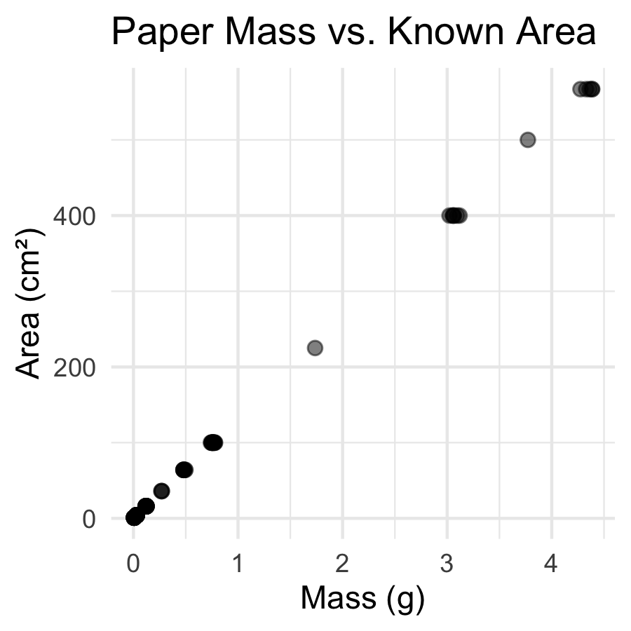
What to look for before fitting:
- Is the relationship linear? → points should follow a straight line
- Is the variance constant? → spread around the trend should look similar at all X values
- Any obvious outliers?
Both variables are continuous and numeric → linear regression is appropriate.
📖 W&S §17.1 p. 541

Fit the Model with lm()
# Fit the least-squares regression line ------------------
# formula: response ~ predictor
paper_lm_model <- lm(area_cm2 ~ mass_g, data = paper_df)
# Full model summary — every number matters --------------
summary(paper_lm_model)
Call:
lm(formula = area_cm2 ~ mass_g, data = paper_df)
Residuals:
Min 1Q Median 3Q Max
-7.2774 -0.3059 -0.1221 0.2264 8.7592
Coefficients:
Estimate Std. Error t value Pr(>|t|)
(Intercept) 0.2792 0.1812 1.541 0.126
mass_g 130.5234 0.1473 885.964 <2e-16 ***
---
Signif. codes: 0 '***' 0.001 '**' 0.01 '*' 0.05 '.' 0.1 ' ' 1
Residual standard error: 1.764 on 116 degrees of freedom
Multiple R-squared: 0.9999, Adjusted R-squared: 0.9999
F-statistic: 7.849e+05 on 1 and 116 DF, p-value: < 2.2e-16
The lm() formula syntax:
lm(Y ~ X, data = df)
- Y goes on the left of ~
- X goes on the right
- ~ reads as “is predicted by”
So area_cm2 ~ mass_g means: “area is predicted by mass”
The result is a model object — we can extract everything from it.
📖 W&S §17.1 p. 543

Reading the summary() Output
# Extract the key numbers from the model -----------------
a_intercept <- coef(paper_lm_model)[1] # intercept
b_slope <- coef(paper_lm_model)[2] # slope
cat("Intercept (a) =", round(a_intercept, 4), "cm²\n")
Intercept (a) = 0.2792 cm²
cat("Slope (b) =", round(b_slope, 2), "cm²/g\n")
Slope (b) = 130.52 cm²/g
Decode the Coefficients table:
Row | What it is
(Intercept) | a — predicted area when mass = 0
mass_g | b — cm² per gram of paper
Std. Error | uncertainty in each estimate
t value | b / SE — tests if slope ≠ 0
Pr(>|t|) | p-value for that t-test
H₀: β = 0 (mass does not predict area)
Hₐ: β ≠ 0 — our slope tests this hypothesis
📖 W&S §17.3 p. 551–553

The Calibration Equation and R²
# Extract R-squared and build the equation label ---------
r2_val <- summary(paper_lm_model)$r.squared
cat("R² =", round(r2_val, 6), "\n\n")
R² = 0.999852
cat("Calibration equation:\n")
Calibration equation:
cat(" area (cm²) =", round(b_slope, 2), "× mass (g) +",
round(a_intercept, 4), "\n\n")
area (cm²) = 130.52 × mass (g) + 0.2792
cat("Interpretation of slope:\n")
Interpretation of slope:
cat(" Every 1 g of paper =", round(b_slope, 1), "cm² of area\n")
Every 1 g of paper = 130.5 cm² of area
What R² = 0.9999 means:
99.99% of the variation in paper area is explained by mass. The remaining 0.01% is measurement noise from the balance.
This is expected — the relationship between mass and area in uniform paper is essentially perfect.
In biological data, R² values of 0.3–0.7 are common and meaningful.
📖 W&S §17.4 p. 555
“R² is a measure of the fit of the line to data.”

Plot the Calibration Curve
# Calibration curve with regression line and 95% CI band -
calibration_plot <- paper_df %>%
ggplot(aes(x = mass_g, y = area_cm2)) +
geom_point(alpha = 0.5, size = 1.8) +
geom_smooth(method = "lm", se = TRUE,
color = "steelblue", fill = "lightblue") +
labs(
title = "Paper Calibration Curve",
subtitle = paste0("area = ", round(b_slope, 2),
" × mass + ", round(a_intercept, 3),
" | R² = ", round(r2_val, 4)),
x = "Paper Mass (g)",
y = "Area (cm²)"
) +
theme_minimal()
calibration_plot
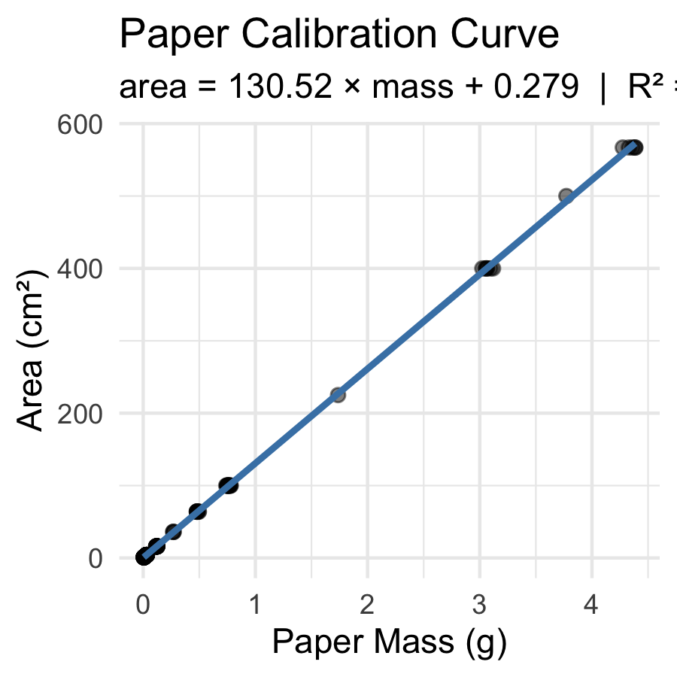
The shaded band = 95% confidence band for the mean predicted area at each mass value.
Key observation: the band is narrowest in the middle of the data range and widens at the extremes — predictions are most precise near $\overset{‾}{X}$.
This is exactly Figure 17.2-1 from W&S (p. 549).
📖 W&S §17.2 p. 548–550

Check Assumptions — Residual Plot
# Add fitted values and residuals to the data frame ------
paper_resid_df <- paper_df %>%
mutate(
fitted = fitted(paper_lm_model),
residuals = residuals(paper_lm_model)
)
# Residuals vs Fitted — checks linearity & equal variance
resid_plot <- paper_resid_df %>%
ggplot(aes(x = fitted, y = residuals)) +
geom_point(alpha = 0.5) +
geom_hline(yintercept = 0, linetype = "dashed", color = "red") +
labs(x = "Fitted Values (cm²)", y = "Residuals (cm²)") +
theme_minimal()
resid_plot
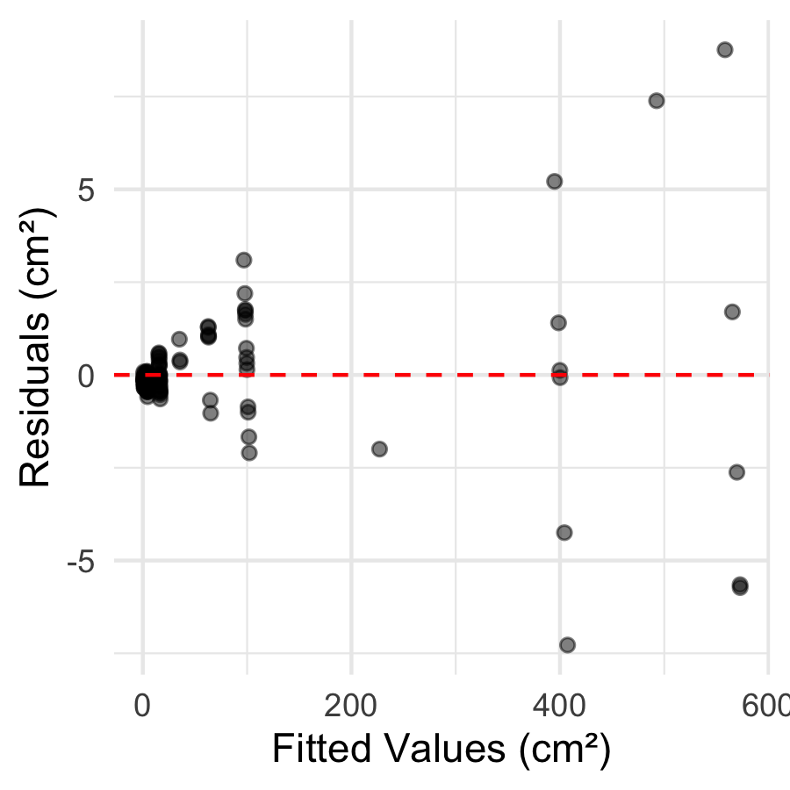
What to look for:
✅ Good: random cloud of points centered at zero; constant spread across all fitted values
❌ Bad: - Curved pattern → linearity violated - Fan shape (funnel) → unequal variance
📖 W&S §17.5 p. 559 (Figure 17.5-4)
 Tip
The residual plot is the most important diagnostic. Always check it before interpreting your results.

Check Assumptions — QQ Plot and Shapiro-Wilk
# QQ plot of residuals — checks normality assumption -----
qq_resid_plot <- paper_resid_df %>%
ggplot(aes(sample = residuals)) +
stat_qq() +
stat_qq_line(color = "red", linewidth = 0.8) +
labs(
title = "Normal QQ Plot of Residuals",
x = "Theoretical Quantiles",
y = "Sample Quantiles (residuals)"
) +
theme_minimal()
qq_resid_plot
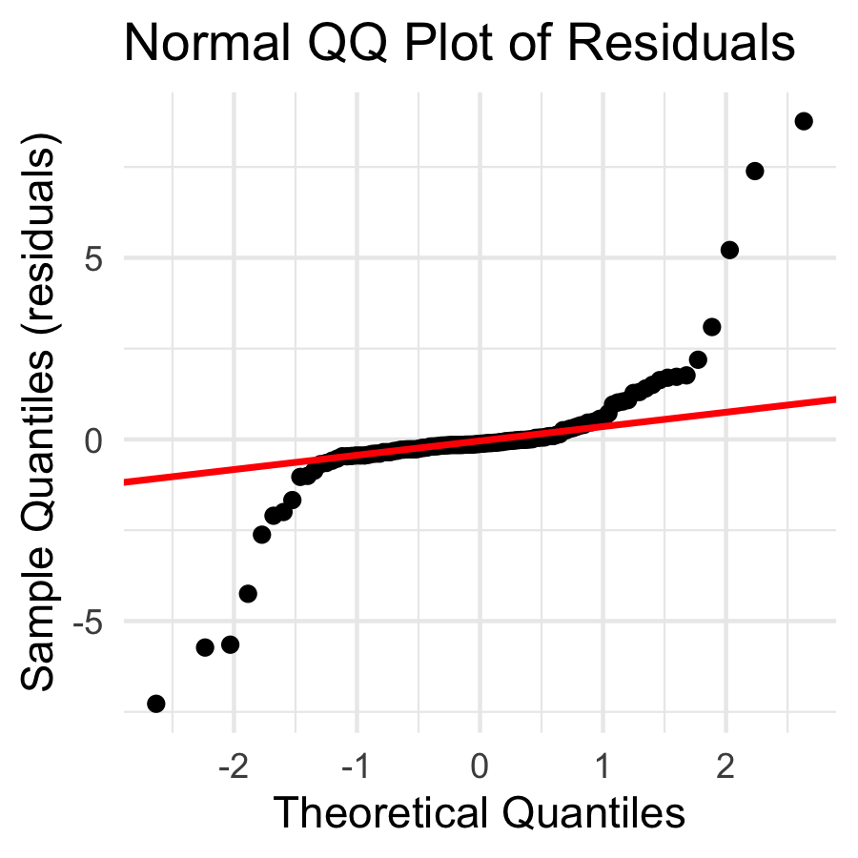
# Shapiro-Wilk test on residuals — formal normality test -
shapiro.test(residuals(paper_lm_model))
Shapiro-Wilk normality test
data: residuals(paper_lm_model)
W = 0.67735, p-value = 9.425e-15
Remember:
- The normality assumption is about residuals, not raw data
- H₀ (Shapiro-Wilk): residuals are normally distributed
- p > 0.05 → proceed with confidence intervals and p-values
📖 W&S §17.5 p. 559

Predict Leaf Area from Tracing Mass
# Plug tracing masses directly into the calibration line -
# Suppose sunny leaf tracing weighs 0.092 g
# and shady leaf tracing weighs 0.138 g
mass_sunny <- 0.092
mass_shady <- 0.138
area_sunny <- b_slope * mass_sunny + a_intercept
area_shady <- b_slope * mass_shady + a_intercept
cat("Sunny tracing mass:", mass_sunny, "g\n")
Sunny tracing mass: 0.092 g
cat("Predicted area: ", round(area_sunny, 2), "cm²\n\n")
Predicted area: 12.29 cm²
cat("Shady tracing mass:", mass_shady, "g\n")
Shady tracing mass: 0.138 g
cat("Predicted area: ", round(area_shady, 2), "cm²\n")
Predicted area: 18.29 cm²
The equation in action:
$$\hat{\text{area}}=130.5×\text{mass}+0.28$$
For a sunny tracing at 0.092 g:
$130.5×0.092+0.28=12.3$ cm²
For a shady tracing at 0.138 g:
$130.5×0.138+0.28=18.3$ cm²
This matches our observation from Lecture 03 — shady leaves are larger!

Using predict() — with Prediction Intervals
# predict() gives uncertainty around each prediction -----
new_masses <- tibble(mass_g = c(0.092, 0.138))
# Confidence interval: for the MEAN area at this mass
predict(paper_lm_model,
newdata = new_masses,
interval = "confidence") %>%
round(3)
fit lwr upr
1 12.287 11.940 12.635
2 18.291 17.948 18.634
# Prediction interval: for a SINGLE new observation
predict(paper_lm_model,
newdata = new_masses,
interval = "prediction") %>%
round(3)
fit lwr upr
1 12.287 8.777 15.798
2 18.291 14.782 21.801
Two types of interval (W&S §17.2 p. 549):
Type | Predicts | Width
Confidence | mean area for all leaves this mass | narrower
Prediction | area of one specific leaf | wider
For predicting a single leaf, use the prediction interval — it captures individual-to-individual variation within the same mass class.
📖 W&S §17.2 pp. 548–550

How to Report Regression Results
# Pull reporting values from the model -------------------
f_stat <- summary(paper_lm_model)$fstatistic
f_val <- round(f_stat[1], 1)
df1 <- f_stat[2]
df2 <- f_stat[3]
p_val <- pf(f_stat[1], df1, df2, lower.tail = FALSE)
cat("--- Results paragraph ---\n")
--- Results paragraph ---
cat("Paper mass was a strong predictor of paper area\n")
Paper mass was a strong predictor of paper area
cat("(linear regression: F(", df1, ",", df2, ") =", f_val, ",\n")
(linear regression: F( 1 , 116 ) = 784932.9 ,
cat("p <", signif(p_val, 1), ", R² =", round(r2_val, 4), ").\n")
p < 5e-224 , R² = 0.9999 ).
cat("The calibration equation is:\n")
The calibration equation is:
cat(" area =", round(b_slope, 2), "× mass +", round(a_intercept, 3), "cm²\n")
area = 130.52 × mass + 0.279 cm²
cat("(slope 95% CI: ", round(confint(paper_lm_model)[2,1], 2),
"to", round(confint(paper_lm_model)[2,2], 2), "cm²/g)\n")
(slope 95% CI: 130.23 to 130.82 cm²/g)
Standard report format:
“Paper area was accurately predicted from paper mass (linear regression: F(df₁, df₂) = F, p < 0.001, R² = 0.9999). The regression equation was area = 130.5 × mass + 0.28 (slope 95% CI: X to Y cm²/g).”
Always include: - F-statistic and both df (or t and df for slope test) - p-value (never “p = 0.000” — write “p < 0.001”) - R² - The actual equation with slope and intercept - 95% CI for the slope
📖 W&S §17.3 p. 553

What We Learned Today
Concepts:
- Regression predicts Y from X using a straight line equation
- Equation: $\hat{Y}=a+bX$ — slope b, intercept a
- Least squares — minimizes sum of squared residuals
- R² — fraction of Y variation explained by X
- Four assumptions — linearity, independence, equal variance, normality of residuals
- Two prediction types — confidence vs. prediction intervals
R skills:
- lm(Y ~ X, data) — fits the model
- summary() — extracts slope, intercept, R², p-values
- coef(), fitted(), residuals() — pull model components
- predict(model, newdata, interval = "prediction") — predictions with uncertainty
- geom_smooth(method = "lm", se = TRUE) — plot the line with CI band
Chapter references:
- 📖 W&S §17.1 — Linear regression
- 📖 W&S §17.2 — Confidence in predictions
- 📖 W&S §17.3 — Testing slope hypotheses
- 📖 W&S §17.4 — R²
- 📖 W&S §17.5 — Assumptions
Up next — Lecture 06:
- Applying the calibration: predicting and comparing leaf area between sides
- Revisiting the t-test on predicted area (cm²) rather than raw weight (g)
- Discussion: which measurement is more biologically meaningful?

