Lecture 03 — Describing Our Data
  - Wrangling, summaries, statistics, and our first real comparisons
Bill Perry
2026-07-02

Where we left off (Lecture 02)
- Setup — R and Positron installed; project folders created (data/, figures/, scripts/)
- R as a calculator — arithmetic, order of operations, assignment with <-
- Vectors — c(), data types (numeric, character, logical)
- Functions — calling built-in functions, reading help with ?
- Loading data — read_excel() and read_csv(); inspecting with glimpse(), head(), dim()
- Pipe — %>% reads as “then”; chains steps together
- First ggplot — boxplot + geom_jitter(), saved as PNG
 Note
✅ Key idea from Lecture 02
You can get data into R and make a plot. Today we learn to wrangle and describe what we actually have.

Goals for Today
Part 1 — Tidyverse wrangling:
- filter() — pick rows by a condition
- select() — pick columns by name
- mutate() — create new columns
- arrange() — sort rows
- Chain them all into a pipeline
Part 2 — Descriptive statistics:
- mean, median, variance, SD, SE
- NA handling — sum(!is.na())
- group_by() + summarize()
- skimr for a fast full overview
- Boxplot + mean ± SE plots
 Tip
🖐 Try it yourself
By the end you will wrangle and describe our leaf data in one connected pipeline.

Our tools today:
- readxl
- tidyverse
- skimr
References:
- 📖 R4DS Ch 3 — Data Transformation
- 📖 R4DS Ch 13 — Numbers
- 📖 R4DS Ch 18 — Missing Values
- 🌐 Data Carpentry
Naming conventions:
- data frames → _df
- plots → _plot
- models → _model

Load Libraries and Data
# Load all packages at the top of every script ----------
library(readxl) # reading Excel files
library(tidyverse) # data wrangling + ggplot2
library(skimr) # fast descriptive summaries
# Read the leaf data from the data folder ---------------
tree_df <- read_excel("data/2026_06_25_tree_experiment_raw_data.xlsx")
 Note
Install once — load every session
- Run in the Console one time only: install.packages("skimr")
- Then every session: library(skimr) activates it.

Inspect the Data
# Preview the first rows ----------------------------
head(tree_df)
# A tibble: 6 × 5
index side weight_g width_cm height_cm
<dbl> <chr> <dbl> <dbl> <dbl>
1 1 sunny 4 12 21
2 2 sunny 3 14 22
3 3 sunny 5 12 21
4 4 sunny 3 13 23
5 5 sunny 4 15 22
6 6 sunny 3 13 23
# Column names, types, first values -----------------
glimpse(tree_df)
Rows: 20
Columns: 5
$ index <dbl> 1, 2, 3, 4, 5, 6, 7, 8, 9, 10, 11, 12, 13, 14, 15, 16, 17, 1…
$ side <chr> "sunny", "sunny", "sunny", "sunny", "sunny", "sunny", "sunny…
$ weight_g <dbl> 4, 3, 5, 3, 4, 3, 5, 4, 3, 4, 7, 8, 6, 9, 8, 7, 8, 9, 9, 7
$ width_cm <dbl> 12, 14, 12, 13, 15, 13, 16, 13, 14, 15, 9, 18, 17, 18, 19, 1…
$ height_cm <dbl> 21, 22, 21, 23, 22, 23, 21, 24, 23, 23, 28, 29, 27, 28, 27, …
# Rows × columns
dim(tree_df)
[1] 20 5
- <chr> = character
- <dbl> = numeric

Part 1 · The Core Tidyverse Verbs
Five functions do most of the work in data wrangling:
Function | What it does
filter() | keep rows matching a condition
select() | keep columns by name
mutate() | add or change a column
arrange() | sort rows
summarize() | collapse rows to a summary
All take a data frame as first input (via %>%) and return a data frame.
📖 R4DS §3 — Data Transformation
 Note
✅ Key idea
These five verbs are the tidyverse grammar for data. Learn them once and you can wrangle almost any dataset.

Think of them as building blocks:
filter() → rows you want
select() → columns you want
mutate() → new columns you need
arrange() → order the rows
summarize()→ collapse to summaries

filter() — Picking Rows
# filter() keeps rows where the condition is TRUE -------
# Keep only sunny leaves
tree_df %>% filter(side == "sunny") %>% head()
# A tibble: 6 × 5
index side weight_g width_cm height_cm
<dbl> <chr> <dbl> <dbl> <dbl>
1 1 sunny 4 12 21
2 2 sunny 3 14 22
3 3 sunny 5 12 21
4 4 sunny 3 13 23
5 5 sunny 4 15 22
6 6 sunny 3 13 23
# Keep only leaves heavier than 5 g
tree_df %>% filter(weight_g > 5) %>% head()
# A tibble: 6 × 5
index side weight_g width_cm height_cm
<dbl> <chr> <dbl> <dbl> <dbl>
1 11 shady 7 9 28
2 12 shady 8 18 29
3 13 shady 6 17 27
4 14 shady 9 18 28
5 15 shady 8 19 27
6 16 shady 7 19 28
# Combine two conditions with & (AND)
tree_df %>% filter(side == "shady", weight_g > 7) %>% head()
# A tibble: 6 × 5
index side weight_g width_cm height_cm
<dbl> <chr> <dbl> <dbl> <dbl>
1 12 shady 8 18 29
2 14 shady 9 18 28
3 15 shady 8 19 27
4 17 shady 8 18 29
5 18 shady 9 17 27
6 19 shady 9 19 27
Common comparison operators:
Symbol | Meaning
== | exactly equal
!= | not equal
> < | greater / less than
>= <= | greater / less than or equal
is.na | return all NA rows
!is.na | return all rows that are NOT NA

 Warning
⚠️ Watch out!
- = assigns a value.
- == tests equality.
- filter(side = "sunny") → error.
- filter(side == "sunny") → correct.

select() — Picking Columns
# select() keeps the columns you name ------------------
# Keep only side and weight
tree_df %>% select(side, weight_g) %>% head()
# A tibble: 6 × 2
side weight_g
<chr> <dbl>
1 sunny 4
2 sunny 3
3 sunny 5
4 sunny 3
5 sunny 4
6 sunny 3
# Drop the index column (use minus sign)
tree_df %>% select(-index) %>% head()
# A tibble: 6 × 4
side weight_g width_cm height_cm
<chr> <dbl> <dbl> <dbl>
1 sunny 4 12 21
2 sunny 3 14 22
3 sunny 5 12 21
4 sunny 3 13 23
5 sunny 4 15 22
6 sunny 3 13 23
# Keep columns that start with a word
tree_df %>% select(starts_with("weight")) %>% head()
# A tibble: 6 × 1
weight_g
<dbl>
1 4
2 3
3 5
4 3
5 4
6 3
- Why select() matters:
  - Real datasets often have 50–100+ columns
  - You rarely need all of them
  - select() keeps your workspace clean
- Useful helpers:
  - starts_with("x") — columns starting with “x”
  - ends_with("_g") — columns ending with “_g”
  - contains("cm") — columns containing “cm”
📖 R4DS §3.3

mutate() — Creating New Columns
# mutate() adds a new column to the data frame ---------
# Convert grams to milligrams
tree_df %>%
mutate(weight_mg = weight_g * 1000) %>%
head()
# A tibble: 6 × 6
index side weight_g width_cm height_cm weight_mg
<dbl> <chr> <dbl> <dbl> <dbl> <dbl>
1 1 sunny 4 12 21 4000
2 2 sunny 3 14 22 3000
3 3 sunny 5 12 21 5000
4 4 sunny 3 13 23 3000
5 5 sunny 4 15 22 4000
6 6 sunny 3 13 23 3000
# Add a size category based on weight
tree_df %>%
mutate(size_class = if_else(weight_g > 5, "large", "small")) %>%
head()
# A tibble: 6 × 6
index side weight_g width_cm height_cm size_class
<dbl> <chr> <dbl> <dbl> <dbl> <chr>
1 1 sunny 4 12 21 small
2 2 sunny 3 14 22 small
3 3 sunny 5 12 21 small
4 4 sunny 3 13 23 small
5 5 sunny 4 15 22 small
6 6 sunny 3 13 23 small
# mutate() can reference multiple existing columns
tree_df %>%
mutate(
weight_mg = weight_g * 1000,
area_approx = width_cm * height_cm # rough area estimate
) %>%
head()
# A tibble: 6 × 7
index side weight_g width_cm height_cm weight_mg area_approx
<dbl> <chr> <dbl> <dbl> <dbl> <dbl> <dbl>
1 1 sunny 4 12 21 4000 252
2 2 sunny 3 14 22 3000 308
3 3 sunny 5 12 21 5000 252
4 4 sunny 3 13 23 3000 299
5 5 sunny 4 15 22 4000 330
6 6 sunny 3 13 23 3000 299
- mutate() keeps all existing columns and adds new ones
- Use if_else(condition, value_if_true, value_if_false) to create categories
 Note
✅ Key idea
mutate() never removes columns — it adds to the right of your data frame.
To overwrite a column, just use the same name on the left: mutate(weight_g = round(weight_g, 1))

📖 R4DS §3.3

arrange() — Sorting Rows
# arrange() sorts rows by one or more columns ----------
# Lightest leaves first
tree_df %>% arrange(weight_g)
# A tibble: 20 × 5
index side weight_g width_cm height_cm
<dbl> <chr> <dbl> <dbl> <dbl>
1 2 sunny 3 14 22
2 4 sunny 3 13 23
3 6 sunny 3 13 23
4 9 sunny 3 14 23
5 1 sunny 4 12 21
6 5 sunny 4 15 22
7 8 sunny 4 13 24
8 10 sunny 4 15 23
9 3 sunny 5 12 21
10 7 sunny 5 16 21
11 13 shady 6 17 27
12 11 shady 7 9 28
13 16 shady 7 19 28
14 20 shady 7 19 29
15 12 shady 8 18 29
16 15 shady 8 19 27
17 17 shady 8 18 29
18 14 shady 9 18 28
19 18 shady 9 17 27
20 19 shady 9 19 27
# Heaviest leaves first (use desc() to reverse)
tree_df %>% arrange(desc(weight_g))
# A tibble: 20 × 5
index side weight_g width_cm height_cm
<dbl> <chr> <dbl> <dbl> <dbl>
1 14 shady 9 18 28
2 18 shady 9 17 27
3 19 shady 9 19 27
4 12 shady 8 18 29
5 15 shady 8 19 27
6 17 shady 8 18 29
7 11 shady 7 9 28
8 16 shady 7 19 28
9 20 shady 7 19 29
10 13 shady 6 17 27
11 3 sunny 5 12 21
12 7 sunny 5 16 21
13 1 sunny 4 12 21
14 5 sunny 4 15 22
15 8 sunny 4 13 24
16 10 sunny 4 15 23
17 2 sunny 3 14 22
18 4 sunny 3 13 23
19 6 sunny 3 13 23
20 9 sunny 3 14 23
# Sort by side, then by weight within each side
tree_df %>% arrange(side, desc(weight_g))
# A tibble: 20 × 5
index side weight_g width_cm height_cm
<dbl> <chr> <dbl> <dbl> <dbl>
1 14 shady 9 18 28
2 18 shady 9 17 27
3 19 shady 9 19 27
4 12 shady 8 18 29
5 15 shady 8 19 27
6 17 shady 8 18 29
7 11 shady 7 9 28
8 16 shady 7 19 28
9 20 shady 7 19 29
10 13 shady 6 17 27
11 3 sunny 5 12 21
12 7 sunny 5 16 21
13 1 sunny 4 12 21
14 5 sunny 4 15 22
15 8 sunny 4 13 24
16 10 sunny 4 15 23
17 2 sunny 3 14 22
18 4 sunny 3 13 23
19 6 sunny 3 13 23
20 9 sunny 3 14 23
- Default: ascending order (smallest first)
- desc(column) → descending order (largest first)
- Very useful before printing a table or checking outliers
 Tip
arrange() is rarely used in the middle of an analysis pipeline — it is most useful at the end when you want to inspect your results in a specific order.

The Full Pipeline
# Chain all the verbs together -------------------------
# Read it top to bottom like a recipe
wrangled_df <- tree_df %>%
filter(weight_g > 0) %>% # remove any zeros
select(side, weight_g, height_cm) %>% # keep only needed cols
mutate(
weight_mg = weight_g * 1000,
size_class = if_else(weight_g > 5, "large", "small")
) %>%
arrange(side, desc(weight_g)) # sort by side, then weight
head(wrangled_df)
# A tibble: 6 × 5
side weight_g height_cm weight_mg size_class
<chr> <dbl> <dbl> <dbl> <chr>
1 shady 9 28 9000 large
2 shady 9 27 9000 large
3 shady 9 27 9000 large
4 shady 8 29 8000 large
5 shady 8 27 8000 large
6 shady 8 29 8000 large
Read the pipeline out loud:
- Take tree_df,
  - then filter to non-zero weights,
    - then select three columns,
      - then add two new columns,
        - then sort by side and weight.
 Note
✅ Key idea
The pipeline %>% is what makes tidyverse readable. You can see every step in order — unlike nested function calls that read inside-out.

Part 2 · Our Scientific Question
Biological prediction: Leaves on the shady side of a tree will be larger and heavier to capture more of the limited light.
 | Hypothesis
H₀ — null | No difference in leaf size between sunny and shady sides
Hₐ — alternate | Leaf size differs between sunny and shady sides
Plan for this unit:
- Today — describe the data
- Lecture 04 — formally test the hypotheses with a t-test
Statistics helps us decide which hypothesis is better supported by the data.

What Is the Mean?
$$\overset{‾}{x}=\frac{\sum_{i=1}^{n}{x_{i}}}{n}$$
- Add up all values, divide by n
- The balance point of the distribution
- Sensitive to outliers — one very large value pulls the mean up
Example:
Values: 5, 6, 7, 8, 50 → mean = 15.2
Is 15.2 a fair summary? Not really — the outlier dominates!
Why it matters:
- The most commonly reported statistic
- Used in every t-test, ANOVA, and regression
- Always pair it with a measure of spread (SD or SE)
📖 R4DS §13 — Numbers

Calculating the Mean — filter() and pull()
# Use filter() + pull() to extract one group's values --
sunny_wt <- tree_df %>%
filter(side == "sunny") %>%
pull(weight_g)
sunny_wt # look at the raw values
[1] 4 3 5 3 4 3 5 4 3 4
# Calculate the mean -----------------------------------
mean_sunny <- mean(sunny_wt, na.rm = TRUE)
cat("Mean sunny weight:", round(mean_sunny, 2), "g\n")
Mean sunny weight: 3.8 g
- filter(side == "sunny") — keeps only sunny rows
- pull(weight_g) — extracts that column as a vector
- na.rm = TRUE — removes any NA before computing
Key pattern:
filter() → picks rows
pull() → extracts a column as a vector
📖 R4DS §3 — Data Transformation

What Is the Median?
The middle value when data are sorted
Sorted data | Median
5, 6, 7, 8, 50 | 7
5, 6, 7, 8, 50, 51 | (7 + 8) / 2 = 7.5
- Not pulled by outliers → robust
- If mean ≫ median → right-skewed
- If mean ≈ median → roughly symmetric
# Median for each side ---------------------------------
shady_wt <- tree_df %>%
filter(side == "shady") %>%
pull(weight_g)
med_sunny <- median(sunny_wt, na.rm = TRUE)
med_shady <- median(shady_wt, na.rm = TRUE)
cat("Median sunny:", round(med_sunny, 2), "\n")
Median sunny: 4
cat("Median shady:", round(med_shady, 2), "\n")
Median shady: 8

What Is Variance?
$$s^{2}=\frac{\sum_{i=1}^{n}{(}x_{i}−\overset{‾}{x})^{2}}{n−1}$$
- For each value, compute distance from mean: $(x_{i}−\overset{‾}{x})$
- Square those distances → all positive
- Sum them up, divide by $n−1$
Dividing by $n−1$ gives an unbiased estimate of population variance.
Larger variance = more spread = more uncertainty
# Variance for each side ------------------------------
var_sunny <- var(sunny_wt, na.rm = TRUE)
var_shady <- var(shady_wt, na.rm = TRUE)
cat("Variance sunny:", round(var_sunny, 2), "\n")
Variance sunny: 0.62
cat("Variance shady:", round(var_shady, 2), "\n")
Variance shady: 1.07
 Note
Variance is in squared units (g²) — hard to interpret. That is why we use SD.

📖 R4DS §13.3

What Is Standard Deviation?
$$s=\sqrt{s^{2}}=\sqrt{\frac{∑(x_{i}−\overset{‾}{x})^{2}}{n−1}}$$
- The square root of variance → back in original units (g) ✓
- For a normal distribution:
  - ~68% of values fall within mean ± 1 SD
  - ~95% fall within mean ± 2 SD
- Reports how spread out individual data points are
# Standard deviation for each side -------------------
sd_sunny <- sd(sunny_wt, na.rm = TRUE)
sd_shady <- sd(shady_wt, na.rm = TRUE)
cat("SD sunny:", round(sd_sunny, 2), "g\n")
SD sunny: 0.79 g
cat("SD shady:", round(sd_shady, 2), "g\n")
SD shady: 1.03 g

What Is Standard Error?
$$SE=\frac{s}{\sqrt{n}}$$
- Measures how precisely we know the mean
- Not the spread of raw data — the uncertainty of the mean itself
- Gets smaller as n increases → more data = more precise estimate
 | Describes
SD | spread of individual data points
SE | precision of the sample mean
We report SE when making claims about group means.
# SE = SD / sqrt(n) — need correct n -----------------
n_sunny <- sum(!is.na(sunny_wt))
n_shady <- sum(!is.na(shady_wt))
se_sunny <- sd_sunny / sqrt(n_sunny)
se_shady <- sd_shady / sqrt(n_shady)
cat("n sunny =", n_sunny, "\n")
n sunny = 10
cat("SE sunny =", round(se_sunny, 2), "g\n\n")
SE sunny = 0.25 g
cat("n shady =", n_shady, "\n")
n shady = 10
cat("SE shady =", round(se_shady, 2), "g\n")
SE shady = 0.33 g

The Problem with length()
# length() counts ALL positions — including NAs -------
x <- c(4, 3, NA, 7, NA) # a vector with missing values
length(x) # returns 5 — but 2 are NA!
[1] 5
sum(is.na(x)) # how many NAs are there?
[1] 2
# Using length() in SE gives the WRONG answer ---------
wrong_n <- length(x)
wrong_se <- sd(x, na.rm = TRUE) / sqrt(wrong_n)
cat("Wrong n =", wrong_n, "\n")
Wrong n = 5
cat("Wrong SE =", round(wrong_se, 3), "\n")
Wrong SE = 0.931
- length(x) counts all positions in the vector — including NA
- This is a silent error — R will not warn you!
- Using n = 5 in SE = SD / √n when n should be 3 gives the wrong answer
📖 R4DS §18 — Missing Values

Fix — sum(!is.na())
# Break it down step by step -------------------------
x <- c(4, 3, NA, 7, NA)
is.na(x) # TRUE where NA, FALSE where real
[1] FALSE FALSE TRUE FALSE TRUE
!is.na(x) # FLIP: TRUE where real, FALSE where NA
[1] TRUE TRUE FALSE TRUE FALSE
sum(!is.na(x)) # count the TRUEs = number of real values
[1] 3
# Apply to our real leaf data ------------------------
n_sun_check <- sum(!is.na(sunny_wt))
cat("Non-missing sunny weights =", n_sun_check, "\n")
Non-missing sunny weights = 10
How it works step by step:
- is.na(x) → TRUE for each NA
- !is.na(x) → flips it: TRUE for real values
- sum(...) → counts TRUEs
 Tip
Best practice: always use sum(!is.na(x)) when you need n — even when you think there are no NAs.

All Stats — Base R, One Group at a Time
# All stats for the sunny side -----------------------
n_s <- sum(!is.na(sunny_wt))
mean_s <- mean(sunny_wt, na.rm = TRUE)
med_s <- median(sunny_wt, na.rm = TRUE)
sd_s <- sd(sunny_wt, na.rm = TRUE)
se_s <- sd_s / sqrt(n_s)
cat("--- Sunny Leaves ---\n")
--- Sunny Leaves ---
cat("n =", n_s, "\n")
n = 10
cat("Mean =", round(mean_s, 2), "\n")
Mean = 3.8
cat("Median =", round(med_s, 2), "\n")
Median = 4
cat("SD =", round(sd_s, 2), "\n")
SD = 0.79
cat("SE =", round(se_s, 2), "\n")
SE = 0.25
- Every function takes na.rm = TRUE
- cat() prints clean labelled output
- This is clear but repetitive for many groups → that is why we use group_by() next

Stats the Tidy Way — group_by() + summarize()
# Calculate all stats for both sides at once ----------
stats_df <- tree_df %>%
group_by(side) %>%
summarize(
n = sum(!is.na(weight_g)),
mean_wt = round(mean(weight_g, na.rm = TRUE), 2),
med_wt = round(median(weight_g, na.rm = TRUE), 2),
sd_wt = round(sd(weight_g, na.rm = TRUE), 2),
se_wt = round(sd_wt / sqrt(n), 2)
)
stats_df
# A tibble: 2 × 6
side n mean_wt med_wt sd_wt se_wt
<chr> <int> <dbl> <dbl> <dbl> <dbl>
1 shady 10 7.8 8 1.03 0.33
2 sunny 10 3.8 4 0.79 0.25
- group_by(side) — splits the data by the side column
- summarize() — collapses each group to one row of stats
- You get both groups in one clean table
- You can reference a column just created (sd_wt → se_wt)
📖 R4DS §3.5 — summarize()

Multiple Variables at Once
# One group_by() pipe summarizes all measurements -----
size_stats_df <- tree_df %>%
group_by(side) %>%
summarize(
n = sum(!is.na(weight_g)),
mean_wt = round(mean(weight_g, na.rm = TRUE), 2),
mean_ht = round(mean(height_cm, na.rm = TRUE), 2),
mean_wd = round(mean(width_cm, na.rm = TRUE), 2)
)
size_stats_df
# A tibble: 2 × 5
side n mean_wt mean_ht mean_wd
<chr> <int> <dbl> <dbl> <dbl>
1 shady 10 7.8 27.9 17.3
2 sunny 10 3.8 22.3 13.7
With one group_by() pipe you summarize all three measurements across both sides.
Do the numbers support our hypothesis?
- Shady heavier? → check mean_wt
- Shady taller? → check mean_ht
- Shady wider? → check mean_wd

Fast Summaries with skimr
# skim() grouped by side — full column summaries ------
tree_df %>%
group_by(side) %>%
skim()
Data summary
Name | Piped data
Number of rows | 20
Number of columns | 5
_______________________
Column type frequency:
numeric | 4
________________________
Group variables | side
Variable type: numeric
skim_variable | side | n_missing | complete_rate | mean | sd | p0 | p25 | p50 | p75 | p100 | hist
index | shady | 0 | 1 | 15.5 | 3.03 | 11 | 13.25 | 15.5 | 17.75 | 20 | ▇▇▇▇▇
index | sunny | 0 | 1 | 5.5 | 3.03 | 1 | 3.25 | 5.5 | 7.75 | 10 | ▇▇▇▇▇
weight_g | shady | 0 | 1 | 7.8 | 1.03 | 6 | 7.00 | 8.0 | 8.75 | 9 | ▂▇▁▇▇
weight_g | sunny | 0 | 1 | 3.8 | 0.79 | 3 | 3.00 | 4.0 | 4.00 | 5 | ▇▁▇▁▃
width_cm | shady | 0 | 1 | 17.3 | 3.02 | 9 | 17.25 | 18.0 | 19.00 | 19 | ▁▁▁▂▇
width_cm | sunny | 0 | 1 | 13.7 | 1.34 | 12 | 13.00 | 13.5 | 14.75 | 16 | ▅▇▅▅▂
height_cm | shady | 0 | 1 | 27.9 | 0.88 | 27 | 27.00 | 28.0 | 28.75 | 29 | ▇▁▆▁▆
height_cm | sunny | 0 | 1 | 22.3 | 1.06 | 21 | 21.25 | 22.5 | 23.00 | 24 | ▆▃▁▇▂
Per column and per group: n_missing, mean, sd, percentiles (p0 to p100), and a mini histogram.
 Tip
skim() is your fastest first look at any dataset. Pair it with group_by() to compare groups instantly.

Boxplot — Basic Structure
# Basic boxplot — data is already long format ---------
tree_box_plot <- tree_df %>%
ggplot(aes(x = side, y = weight_g, fill = side)) +
geom_boxplot(alpha = 0.6, outlier.shape = NA) +
labs(
title = "Leaf Weight by Tree Side",
x = "Side of Tree",
y = "Leaf Weight (g)",
fill = "Side"
) +
theme_minimal() +
theme(legend.position = "none")
tree_box_plot
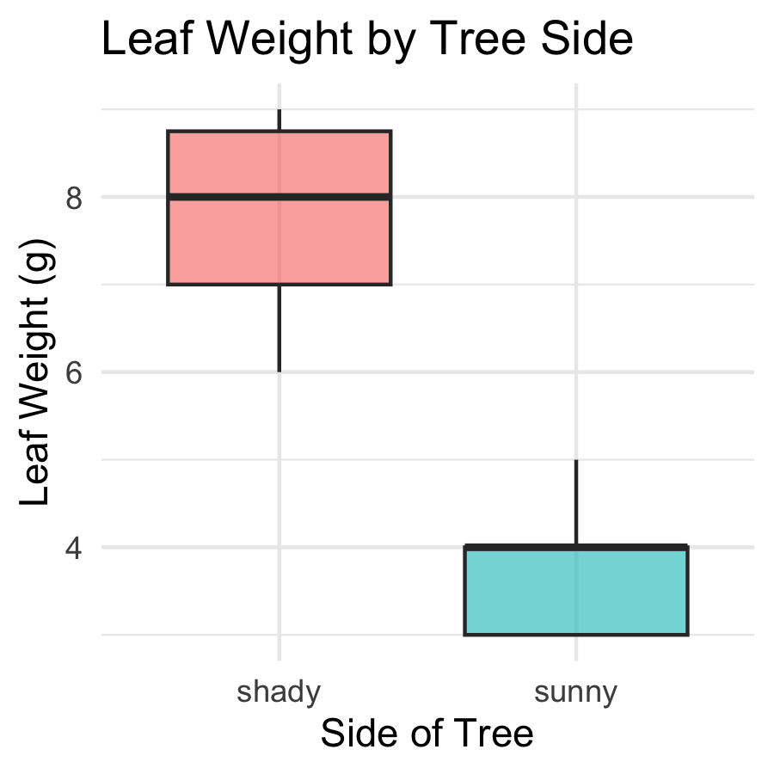
Boxplot anatomy:
- Middle line = median
- Box edges = 25th and 75th percentile (IQR)
- Whiskers = 1.5 × IQR
- Dots beyond whiskers = outliers
Because our data is in long format, ggplot2 reads side straight off the x-axis — no reshaping needed.
📖 R4DS §9 — Layers

Boxplot — Overlay Individual Points
# Add raw data points over the boxplot ----------------
tree_jitter_plot <- tree_df %>%
ggplot(aes(x = side, y = weight_g, fill = side)) +
geom_boxplot(alpha = 0.5, outlier.shape = NA) +
geom_point(
position = position_jitter(width = 0.15, seed = 42),
alpha = 0.6,
size = 2.5
) +
labs(
title = "Leaf Weight by Tree Side",
x = "Side of Tree",
y = "Leaf Weight (g)",
fill = "Side"
) +
theme_minimal() +
theme(legend.position = "none")
tree_jitter_plot
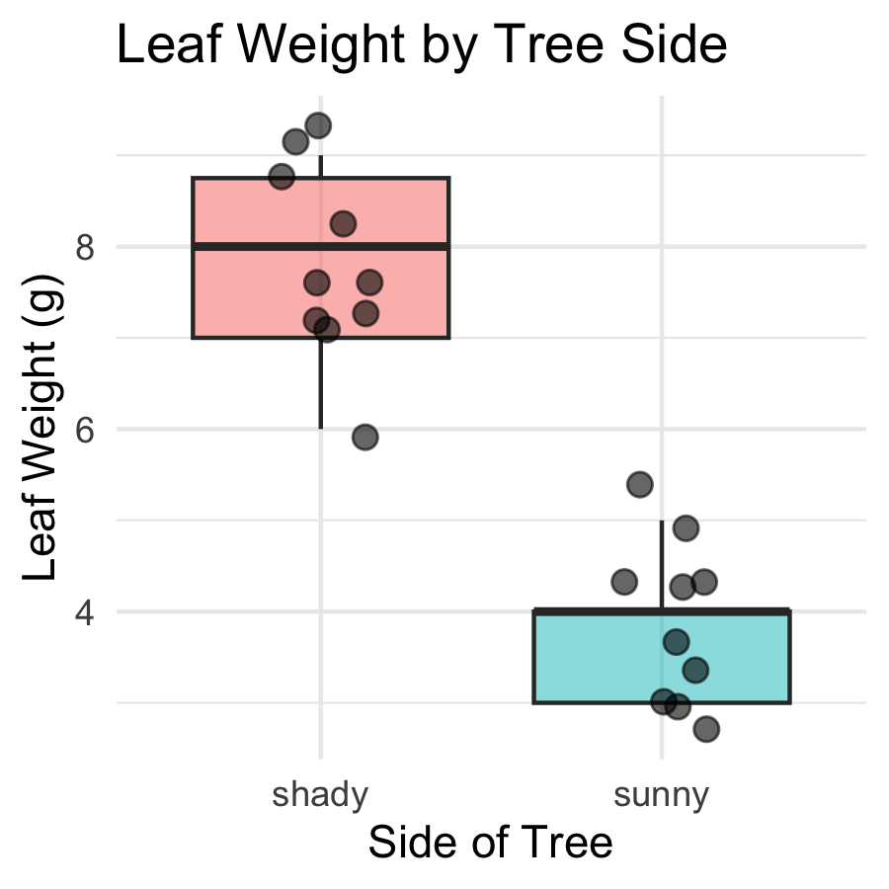
Key arguments:
- position_jitter(width = 0.15) — spreads points left and right
- seed = 42 — same jitter layout every render
- alpha = 0.6 — semi-transparent to show overlap
- size = 2.5 — point size
 Tip
Always show raw points with a boxplot — with only 10 leaves per group, every point matters!

Mean ± SE Plot — stat_summary()
# stat_summary() computes and plots mean and SE -------
tree_mean_se_plot <- tree_df %>%
ggplot(aes(x = side, y = weight_g, color = side)) +
geom_point(
position = position_jitter(width = 0.15, seed = 42),
alpha = 0.35,
size = 2
) +
stat_summary(fun = mean, geom = "point", size = 4) +
stat_summary(
fun.data = mean_se,
geom = "errorbar",
width = 0.15,
linewidth = 0.9
) +
labs(
title = "Mean ± SE Leaf Weight by Tree Side",
x = "Side of Tree",
y = "Leaf Weight (g)",
color = "Side"
) +
theme_minimal() +
theme(legend.position = "none")
tree_mean_se_plot
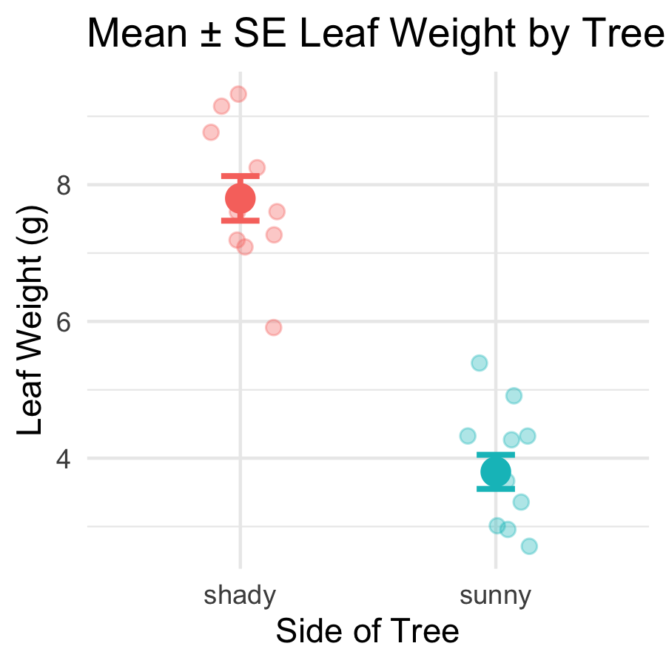
Two stat_summary() layers:
call | what it draws
fun = mean | large point at the mean
fun.data = mean_se | error bars for ± 1 SE
- Individual points in the background (alpha = 0.35)
- Mean shown as a larger foreground point
- Error bars = ± 1 SE

What We Learned Today
- R wrangling skills:
  - filter() — keep rows by condition
  - select() — keep columns by name
  - mutate() — add new calculated columns
  - arrange() — sort rows
  - Full pipeline: chain all verbs with %>%
- Statistics concepts:
  - Mean — balance point; sensitive to outliers
  - Median — middle value; robust
  - Variance / SD — spread of individual data
  - SE — precision of the sample mean
- More R skills:
  - group_by() + summarize() — all stats for all groups at once
  - sum(!is.na()) — the right way to count n
  - skim() — instant full dataset overview
  - geom_boxplot() + geom_point(), stat_summary()
References:
- 📖 R4DS §3 — Data Transformation
- 📖 R4DS §13 — Numbers
- 📖 R4DS §18 — Missing Values
- 🌐 Data Carpentry
Up next — Lecture 04:
- Two-sample t-test
- Checking assumptions (normality, equal variance)
- Interpreting and reporting results

