Lecture 04 — Testing Our Hypothesis
  - The two-sample Welch’s t-test from assumptions to results
Bill Perry
2026-07-02

Where we left off (Lecture 03)
- Wrangling — filter(), select(), mutate(), arrange() as the core tidyverse verbs
- Descriptive stats — mean, median, SD, SE with group_by() + summarize()
- NA handling — sum(!is.na()) is the safe way to count n
- skimr — fast full-dataset overview in one line
- Boxplot + jittered points; mean ± SE with stat_summary()
- Finding: shady leaves appear heavier, taller, and wider than sunny leaves
 Note
✅ Key idea from Lecture 03
We described the pattern in our data. Today we formally test whether that pattern is statistically significant.

Goals for Today
- Understand why comparing means is not enough — we need a test
- State null and alternate hypotheses formally
- Check assumptions before running any test
  - normality: histogram, QQ plot, Shapiro-Wilk
  - variance: Levene’s test
- Run Welch’s two-sample t-test in R
- Read every line of the t.test() output
- Report results in scientific writing format
 Tip
🖐 Try it yourself
By the end you will run and interpret a complete t-test on our leaf data.

Tools added today:
- car — Levene’s variance test
References:
- 📖 R4DS §3
- 🌐 Data Carpentry
Today’s naming:
- test objects → _model
- plots → _plot

Our Hypotheses — A Reminder
Biological prediction:
Shady-side leaves will be larger and heavier — they need more surface area to capture the limited light filtering through the canopy.
 | Formal statement
H₀ — null | $μ_{shady}=μ_{sunny}$ — no difference in mean leaf weight
Hₐ — alternate | $μ_{shady}≠μ_{sunny}$ — mean leaf weight differs by side
We use a two-tailed test — we will detect a difference in either direction.
Why two-tailed?
- We predicted shady > sunny
- A one-tailed test would only reject H₀ in that direction
- Two-tailed is more conservative and more broadly accepted
- If the result is significant two-tailed, it is also significant one-tailed
α = 0.05 — our threshold for rejecting H₀

Load Libraries and Data
# Load all packages at the top ----------------------------
library(readxl) # reading Excel files
library(tidyverse) # data manipulation + ggplot2
library(skimr) # fast summaries
library(car) # Levene's test for variance equality
# Load the leaf data from the data folder -----------------
tree_df <- read_excel("data/2026_06_25_tree_experiment_raw_data.xlsx")
 Note
car is the Companion to Applied Regression package. It contains leveneTest(), which we use to check whether our two groups have similar variance.
Install once: install.packages("car")

What We Know So Far
# Quick recap from Lecture 03 ----------------------------
recap_df <- tree_df %>%
group_by(side) %>%
summarize(
n = sum(!is.na(weight_g)),
mean_wt = round(mean(weight_g, na.rm = TRUE), 2),
sd_wt = round(sd(weight_g, na.rm = TRUE), 2),
se_wt = round(sd_wt / sqrt(n), 2)
)
recap_df
# A tibble: 2 × 5
side n mean_wt sd_wt se_wt
<chr> <int> <dbl> <dbl> <dbl>
1 shady 10 7.8 1.03 0.33
2 sunny 10 3.8 0.79 0.25
- RESULTS:
  - Shady mean: 7.80 g
  - Sunny mean: 3.80 g
  - Difference: 4.0 g — a big gap!
- But is that gap real, or could it just be sampling noise?
- With only n = 10 per group, random chance could produce apparent differences.
- We need a formal test to quantify the probability.

Why Comparing Means Is Not Enough
# Remind ourselves what the data look like ---------------
recap_plot <- tree_df %>%
ggplot(aes(x = side, y = weight_g, color = side)) +
geom_point(
position = position_jitter(width = 0.15, seed = 42),
alpha = 0.5,
size = 2
) +
stat_summary(fun = mean, geom = "point", size = 4) +
stat_summary(
fun.data = mean_se,
geom = "errorbar",
width = 0.15,
linewidth = 0.9
) +
labs(x = "Side", y = "Leaf Weight (g)") +
theme_minimal() +
theme(legend.position = "none")
recap_plot
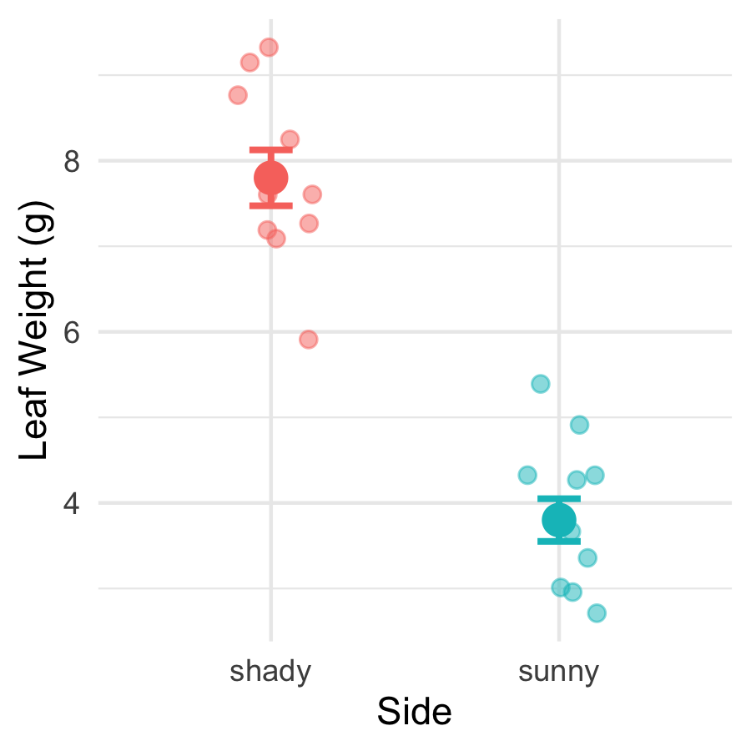
The means look different — but:
- We only have 10 leaves per group
- There is natural variability within each group
- The groups’ ranges overlap somewhat
A p-value tells us:
“If H₀ were true, how often would we see a gap this large just by chance?”
Small p → the gap is unlikely to be chance.

What Is a Two-Sample t-Test?
A two-sample t-test compares the means of two independent groups.
It asks: Could both groups plausibly be drawn from populations with the same mean?
The t-statistic is:
$$t=\frac{{\overset{‾}{x}}_{1}−{\overset{‾}{x}}_{2}}{{\text{SE}}_{\text{diff}}}$$
- Numerator: the observed difference in means
- Denominator: the uncertainty in that difference (SE of the difference)
Large |t| → the difference is large relative to the noise → small p-value
Component | Our context
Group 1 | Shady leaves
Group 2 | Sunny leaves
Measurement | weight_g
H₀ | $μ_{shady}=μ_{sunny}$
Hₐ | $μ_{shady}≠μ_{sunny}$

Why Welch’s? — Don’t Assume Equal Variance
Standard t-test — pools the two variances into one estimate. Requires both groups to have the same population variance.
Welch’s t-test — uses each group’s variance separately. Does not require equal variance.
$$t_{W}=\frac{{\overset{‾}{x}}_{1}−{\overset{‾}{x}}_{2}}{\sqrt{\frac{s_{1}^{2}}{n_{1}}+\frac{s_{2}^{2}}{n_{2}}}}$$
The denominator is the true SE of the difference — no pooling.
Why always use Welch’s?
- When variances are equal: almost identical result — minimal loss of power
- When variances are not equal: standard t-test gives inflated Type I error (false positives)
- Welch’s protects you either way
 Tip
Best practice: use Welch’s as your default for all two-group comparisons.
In R: var.equal = FALSE

The Welch’s Formula in Action
# Pull stats and compute t by hand ----------------------
stats_df <- tree_df %>%
group_by(side) %>%
summarize(
n = sum(!is.na(weight_g)),
m = mean(weight_g, na.rm = TRUE),
s = sd(weight_g, na.rm = TRUE)
)
m_sha <- stats_df$m[stats_df$side == "shady"]
m_sun <- stats_df$m[stats_df$side == "sunny"]
s_sha <- stats_df$s[stats_df$side == "shady"]
s_sun <- stats_df$s[stats_df$side == "sunny"]
n_sha <- stats_df$n[stats_df$side == "shady"]
n_sun <- stats_df$n[stats_df$side == "sunny"]
se_diff <- sqrt((s_sha^2 / n_sha) + (s_sun^2 / n_sun))
t_manual <- (m_sha - m_sun) / se_diff
cat("Difference in means:", round(m_sha - m_sun, 2), "g\n")
Difference in means: 4 g
cat("SE of difference: ", round(se_diff, 4), "\n")
SE of difference: 0.411
cat("t-statistic: ", round(t_manual, 3), "\n")
t-statistic: 9.733
Step by step:
- Difference in means: 7.80 − 3.80 = 4.0 g
- SE of the difference: $\sqrt{\frac{s_{shady}^{2}}{10}+\frac{s_{sunny}^{2}}{10}}$
- t = difference / SE
The observed difference is ~10 standard errors above zero — very far from what we’d expect if H₀ were true.

Five Steps to a Hypothesis Test
We will always follow this sequence:
Step | Action
1 | State H₀ and Hₐ
2 | Check normality — histogram/box plot
3 | Check normality — QQ plot + Shapiro-Wilk
4 | Check variance — Levene’s test
5 | Run the test; interpret and report
 Important
Check assumptions BEFORE running the test.
If your data seriously violate assumptions, the p-value from the t-test is unreliable.
With n = 10 per group, our main concern is gross non-normality. The t-test is quite robust to mild departures.

Step 1 — Hypotheses (Formal)
Null hypothesis:
$$H_{0}:μ_{shady}=μ_{sunny}$$
Shady and sunny leaves have the same mean weight in the population.
Alternate hypothesis (two-tailed):
$$H_{A}:μ_{shady}≠μ_{sunny}$$
The mean leaf weights differ between sides — in either direction.
Significance level: α = 0.05
We will reject H₀ if p < 0.05.
Why state hypotheses first?
- Keeps the analysis honest
- Prevents “HARKing” (Hypothesizing After Results are Known)
- Forces you to commit to a direction (one-tailed) or not (two-tailed) before seeing the data
Our commitment: two-tailed, α = 0.05, before running any test.

Step 2 — Check Normality: Histogram
# Histogram per group to visually check normality -------
hist_norm_plot <- tree_df %>%
ggplot(aes(x = weight_g, fill = side)) +
geom_histogram(binwidth = 1, color = "white", alpha = 0.8) +
facet_wrap(~side, ncol = 2) +
labs(
title = "Leaf Weight Distribution by Side",
x = "Leaf Weight (g)",
y = "Count"
) +
theme_minimal() +
theme(legend.position = "none")
hist_norm_plot
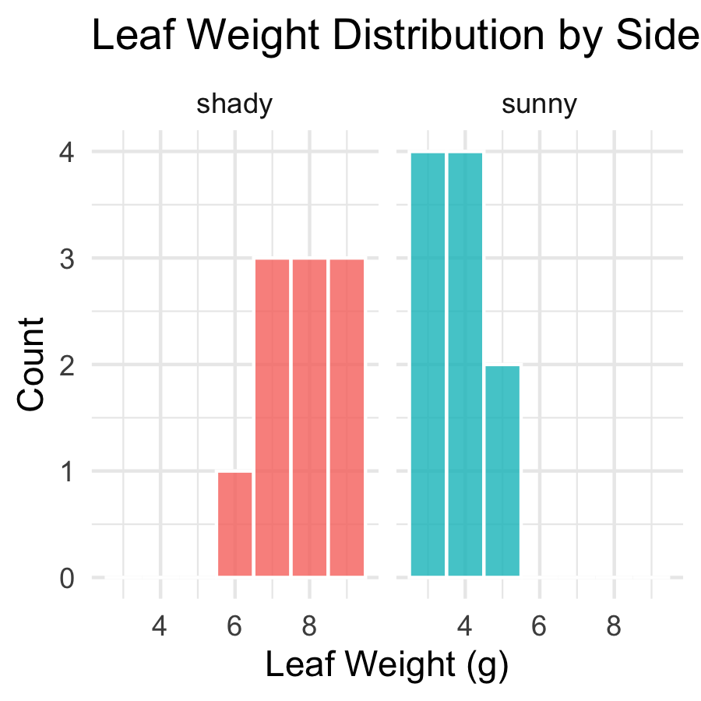
What to look for:
- Roughly bell-shaped — not heavily skewed
- No obvious bimodal peaks
- No extreme outliers
With n = 10 per group, histograms look lumpy — that is normal for small samples.
Histograms are a visual check only. We also use QQ plots and Shapiro-Wilk.

Step 3 — Check Normality: QQ Plot
# Q-Q plot — points should fall along the diagonal line --
qq_norm_plot <- tree_df %>%
ggplot(aes(sample = weight_g, color = side)) +
stat_qq() +
stat_qq_line(color = "black", linewidth = 0.8) +
facet_wrap(~side, scales = "free") +
labs(
title = "Normal Q-Q Plots by Side",
x = "Theoretical Quantiles",
y = "Sample Quantiles"
) +
theme_minimal() +
theme(legend.position = "none")
qq_norm_plot
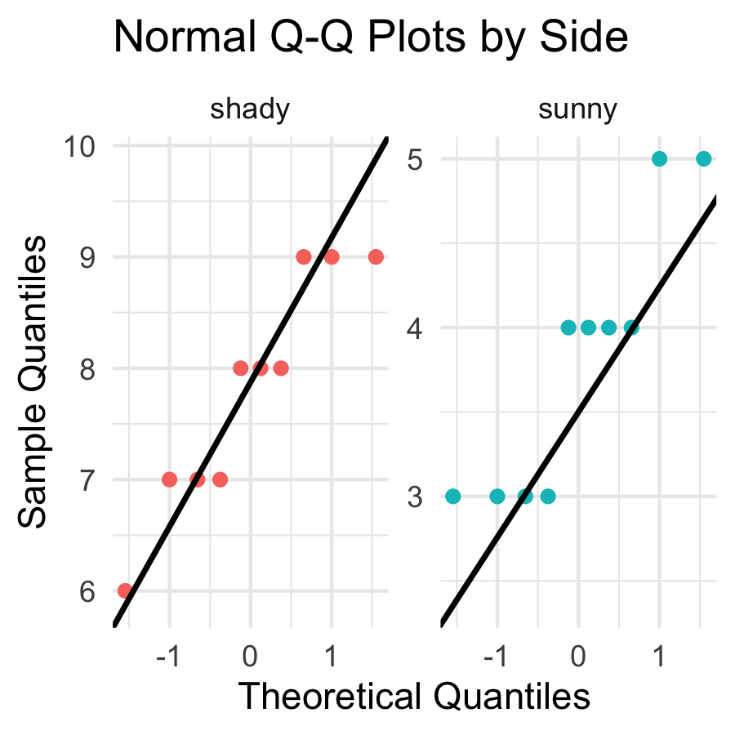
How to read a QQ plot:
- Points on the line → data follow a normal distribution
- Points curving away at ends → heavy tails or skew
- With only n = 10, some deviation is expected and acceptable
If points follow the line roughly, we are comfortable proceeding with the t-test.

Step 3 — Check Normality: Shapiro-Wilk Test
# Shapiro-Wilk test for the sunny side -----------------
tree_df %>%
filter(side == "sunny") %>%
pull(weight_g) %>%
shapiro.test()
Shapiro-Wilk normality test
data: .
W = 0.8197, p-value = 0.02513
# Shapiro-Wilk test for the shady side -----------------
tree_df %>%
filter(side == "shady") %>%
pull(weight_g) %>%
shapiro.test()
Shapiro-Wilk normality test
data: .
W = 0.89461, p-value = 0.191
Shapiro-Wilk H₀: the data are normally distributed.
- p > 0.05 → fail to reject normality → proceed with t-test
- p < 0.05 → evidence of non-normality → consider a non-parametric alternative
 Important
Small-sample caution:
With n = 10, this test has low power — it rarely detects non-normality even when present. The QQ plot is equally important.

Step 4 — Check Variance: Levene’s Test
# Levene's test — are the variances similar? -----------
leveneTest(weight_g ~ side, data = tree_df)
Levene's Test for Homogeneity of Variance (center = median)
Df F value Pr(>F)
group 1 0.6 0.4486
18
Levene’s test H₀: the two groups have equal variance.
- p > 0.05 → variances are not significantly different
- p < 0.05 → variances are significantly different
Our response regardless of the result:
We will use Welch’s t-test (var.equal = FALSE).
Welch’s is valid whether or not the variances are equal. We run Levene’s to understand our data, not to choose our test.

Step 5 — Run the Welch’s t-Test
# Welch's two-sample t-test — unequal variance ---------
leaf_ttest_model <- t.test(
weight_g ~ side, # formula: response ~ grouping variable
data = tree_df,
var.equal = FALSE, # Welch's — no pooled variance
alternative = "two.sided" # two-tailed test
)
leaf_ttest_model
Welch Two Sample t-test
data: weight_g by side
t = 9.7333, df = 16.834, p-value = 2.514e-08
alternative hypothesis: true difference in means between group shady and group sunny is not equal to 0
95 percent confidence interval:
3.132297 4.867703
sample estimates:
mean in group shady mean in group sunny
7.8 3.8
Key arguments:
argument | what it does
weight_g ~ side | compare weight_g between levels of side
var.equal = FALSE | use Welch’s correction
alternative = "two.sided" | two-tailed test
The result is a model object. We decode each line of the output on the next slide.

Reading the t.test() Output
# Extract individual values from the model object ------
cat("t-statistic :", round(leaf_ttest_model$statistic, 3), "\n")
t-statistic : 9.733
cat("df (Welch) :", round(leaf_ttest_model$parameter, 2), "\n")
df (Welch) : 16.83
cat("p-value :", signif(leaf_ttest_model$p.value, 3), "\n")
p-value : 2.51e-08
cat(
"95% CI :",
round(leaf_ttest_model$conf.int[1], 2),
"to",
round(leaf_ttest_model$conf.int[2], 2),
"g\n"
)
95% CI : 3.13 to 4.87 g
cat("Mean shady :", round(leaf_ttest_model$estimate[1], 2), "g\n")
Mean shady : 7.8 g
cat("Mean sunny :", round(leaf_ttest_model$estimate[2], 2), "g\n")
Mean sunny : 3.8 g
Line by line:
output | meaning
t | our calculated t-statistic
df | Welch-Satterthwaite df (non-integer is normal!)
p-value | probability of this result if H₀ is true
95% CI | plausible range for the true difference in means
mean of shady/sunny | the two group means
The 95% CI is the range we could expect to see if we repeated this study many times.

Step 5 — Make a Decision
# State the decision formally --------------------------
# if/else: R checks the condition and runs one of two blocks
# We will learn these formally in the functions lecture
p_val <- leaf_ttest_model$p.value
alpha <- 0.05
if (p_val < alpha) {
cat("p =", signif(p_val, 3), "< α =", alpha, "\n")
cat("Decision: REJECT H₀\n")
cat("Conclusion: leaf weight differs between sides.\n")
} else {
cat("p =", signif(p_val, 3), ">= α =", alpha, "\n")
cat("Decision: FAIL TO REJECT H₀\n")
cat("Conclusion: insufficient evidence of a difference.\n")
}
p = 2.51e-08 < α = 0.05
Decision: REJECT H₀
Conclusion: leaf weight differs between sides.
 Important
What a small p-value means:
If H₀ were true (no real difference), we would get a t-statistic this large or larger less than p × 100% of the time just by chance.
We set α = 0.05 before the test. If p < α, we reject H₀.

What a small p-value does NOT mean:
- It is not the probability that H₀ is true
- Statistical significance ≠ biological importance
- Report the effect size (difference in means) alongside p

Visualize the Result — Boxplot
# Final boxplot with all points -----------------------
leaf_box_04_plot <- tree_df %>%
ggplot(aes(x = side, y = weight_g, fill = side)) +
geom_boxplot(alpha = 0.5, outlier.shape = NA) +
geom_point(
position = position_jitter(width = 0.15, seed = 42),
alpha = 0.6,
size = 2.5
) +
labs(
title = "Leaf Weight by Tree Side",
subtitle = paste0(
"Welch's t-test: t = ",
round(leaf_ttest_model$statistic, 2),
", p = ",
signif(leaf_ttest_model$p.value, 2)
),
x = "Side of Tree",
y = "Leaf Weight (g)"
) +
theme_minimal() +
theme(legend.position = "none")
leaf_box_04_plot
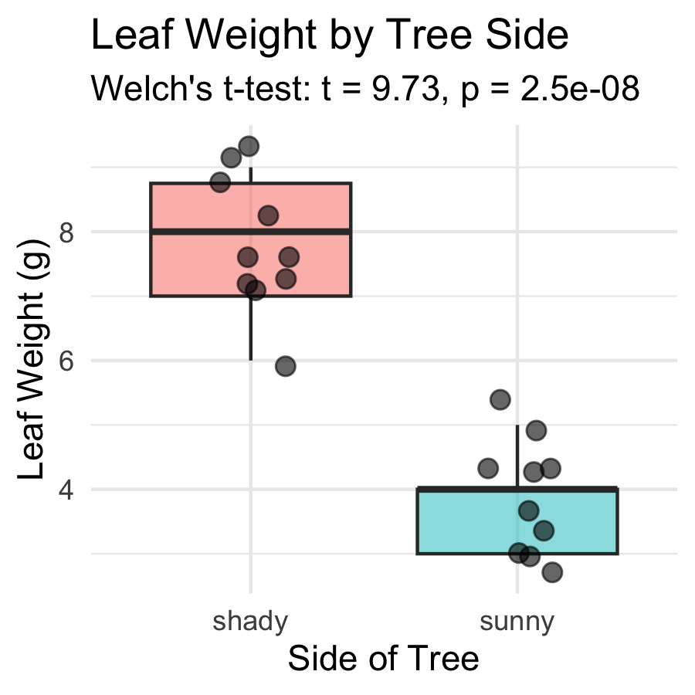
Including the test result in the figure:
- subtitle pulls t and p directly from the model object
- R fills in the actual numbers automatically
- If you re-run with new data, the subtitle updates
 Tip
Embedding test statistics in the plot subtitle saves you from copying numbers by hand — and avoids typos in your report.

Visualize the Result — Mean ± SE
# Mean ± SE plot with individual points ---------------
leaf_mean_se_04_plot <- tree_df %>%
ggplot(aes(x = side, y = weight_g, color = side)) +
geom_point(
position = position_jitter(width = 0.15, seed = 42),
alpha = 0.35,
size = 2
) +
stat_summary(fun = mean, geom = "point", size = 4) +
stat_summary(
fun.data = mean_se,
geom = "errorbar",
width = 0.15,
linewidth = 0.9
) +
labs(
title = "Mean ± SE Leaf Weight by Tree Side",
subtitle = paste0(
"Welch's t: t(",
round(leaf_ttest_model$parameter, 1),
") = ",
round(leaf_ttest_model$statistic, 2),
", p < 0.001"
),
x = "Side of Tree",
y = "Leaf Weight (g)"
) +
theme_minimal() +
theme(legend.position = "none")
leaf_mean_se_04_plot
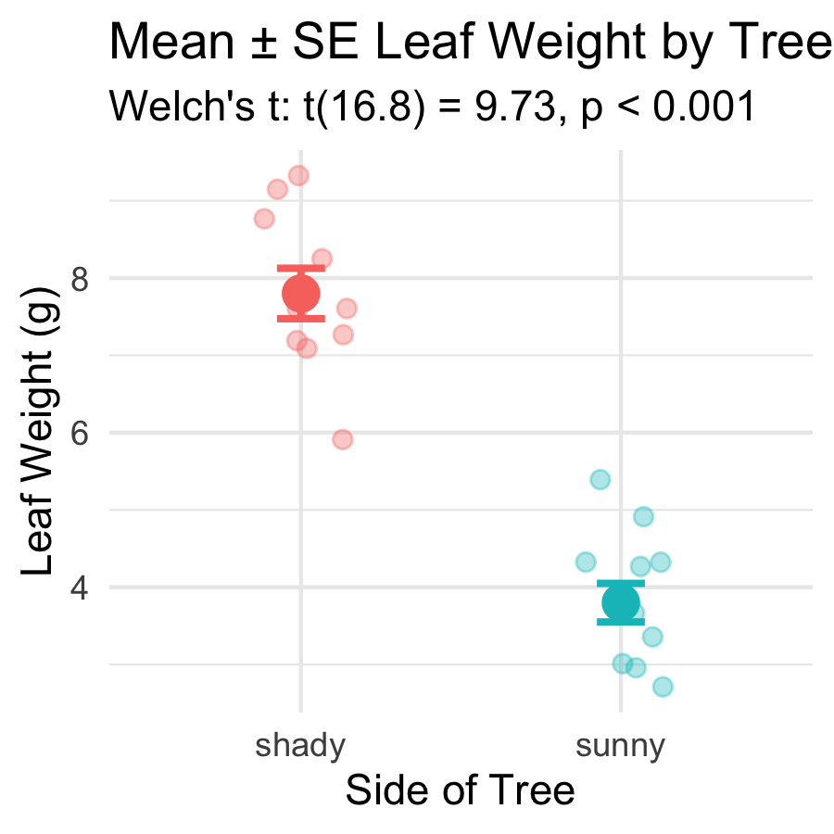
What the error bars tell you:
- Bars show ± 1 SE — precision of the mean estimate
- Non-overlapping bars suggest a significant difference
Rule of thumb:
If error bars overlap by less than half the bar length, the difference is likely significant at α = 0.05. The p-value from the t-test is the definitive answer.

How to Report Results in Science
# Compute reporting values from the model object -------
t_val <- round(leaf_ttest_model$statistic, 2)
df_val <- round(leaf_ttest_model$parameter, 1)
p_val2 <- signif(leaf_ttest_model$p.value, 2)
cat("--- Results sentence ---\n")
--- Results sentence ---
cat("Shady-side leaves were significantly heavier than\n")
Shady-side leaves were significantly heavier than
cat(
"sunny-side leaves (Welch's t-test: t(",
df_val,
") =",
t_val,
", p =",
p_val2,
").\n"
)
sunny-side leaves (Welch's t-test: t( 16.8 ) = 9.73 , p = 2.5e-08 ).
cat(
"Mean ± SE: shady =",
round(leaf_ttest_model$estimate[1], 2),
"±",
round(recap_df$se_wt[recap_df$side == "shady"], 2),
"g,\n"
)
Mean ± SE: shady = 7.8 ± 0.33 g,
cat(
" sunny =",
round(leaf_ttest_model$estimate[2], 2),
"±",
round(recap_df$se_wt[recap_df$side == "sunny"], 2),
"g.\n"
)
sunny = 3.8 ± 0.25 g.
Standard format:
“[Finding] (Welch’s t-test: t(df) = X.XX, p = X.XXX; mean ± SE: group1 = X.X ± X.X units, group2 = X.X ± X.X units).”
Always include:
- Test type (Welch’s t-test)
- t-statistic and df
- Exact p-value (or < 0.001)
- Group means ± SE
- Units
Never report “p = 0.000” — write “p < 0.001” instead.

Save Your Plots
# Save both plots to the figures folder ----------------
ggsave(
"figures/leaf_weight_boxplot_ttest.png",
plot = leaf_box_04_plot,
width = 5,
height = 5,
units = "in",
dpi = 300
)
ggsave(
"figures/leaf_weight_mean_se_ttest.png",
plot = leaf_mean_se_04_plot,
width = 5,
height = 5,
units = "in",
dpi = 300
)
Both plots are now in your figures/ folder with the test statistics embedded in the subtitle — ready for a lab report or paper.
 Tip
dpi = 300 is publication quality. Use it for any figure that will appear in a paper, poster, or formal report.

What We Learned Today
Concepts:
- Why we need a hypothesis test — means alone are not enough
- Welch’s t-test — use var.equal = FALSE as the safe default
- Two-tailed test — detects differences in either direction
- Five-step framework — hypotheses → normality → variance → test → report
- Reading output — t, df, p, CI, group means
R skills:
- library(car) + leveneTest(y ~ group, data) — variance check
- filter() %>% pull() %>% shapiro.test() — normality per group
- t.test(y ~ group, data, var.equal = FALSE, alternative = "two.sided")
- model$statistic, model$p.value, model$conf.int — extract results
- paste0(...) in subtitle — embed test statistics in figures
References:
- 📖 R4DS §3 — Data Transformation
- 📖 R4DS §13 — Numbers
- 🌐 Data Carpentry
Up next — Lecture 05:
- Linear regression — predicting leaf area from paper tracing mass
- Building a calibration curve with lm()
- R², residuals, and assumption checking

