Lecture 03 — GGPlot I
  - Grouped summaries, facets, and the pipe into ggplot
Bill Perry
2026-08-27

Where we left off (Lecture 02 — Meeting R)
- Project structure — data/, scripts/, figures/
- Packages — install.packages() once, library() every session
- Loading data — read_excel(), clean_names()
- The pipe — %>% reads as “then”
- Our first plot — a bare geom_point()
 Note
✅ Key idea from Lecture 02
You can already load data and make one honest point on a page. Today that one geom becomes a whole toolkit: custom colors, side-by-side panels, and a proper mean ± SE summary.

Goals for Today
- Start every plot with the pipe: tree_df %>% ggplot(...)
- Assign colors on purpose with scale_color_manual()
- Split one plot into panels with facet_wrap() and facet_grid()
- Build a mean ± SE plot with stat_summary()
 Tip
🖐 Try it yourself
By the end you will make a publication-style figure: raw leaf data, grouped and colored on purpose, with the mean and its uncertainty layered on top.

References:
- 📖 Whitlock & Schluter, Ch. 2 — Displaying Data
- 📖 R4DS Ch 1 — Data Visualization
- 📖 R4DS Ch 9 — Layers
Both PDFs are in the course readings/ folder.
Naming conventions:
- data frames → _df
- plots → _plot

How to Use These Slides — Predict · Type · Run
This lecture runs in three short chunks. After each chunk you switch to the activity worksheet and type the code yourself.
For every code block, do three things:
- Predict — before it runs, say what you think the output will be
- Type it out by hand — do not copy-paste
- Run it and compare to your prediction
 Note
✅ Why bother?
- facet_wrap() and facet_grid() look interchangeable until you’ve typed both and watched one wrap into rows while the other insists on a strict grid.
- Typing scale_color_manual(values = c(...)) yourself is what makes you notice the color names have to match your group names exactly.

Load Libraries and Data
# Load all packages at the top of every script ----------
library(readxl) # reading Excel files
library(tidyverse) # data wrangling + ggplot2
library(janitor) # cleans up messy column names
# Read the leaf data from the data folder ---------------
tree_df <- read_excel("data/2026_06_25_tree_experiment_raw_data.xlsx") %>%
clean_names()
glimpse(tree_df)
Rows: 20
Columns: 5
$ index <dbl> 1, 2, 3, 4, 5, 6, 7, 8, 9, 10, 11, 12, 13, 14, 15, 16, 17, 1…
$ side <chr> "sunny", "sunny", "sunny", "sunny", "sunny", "sunny", "sunny…
$ weight_g <dbl> 4, 3, 5, 3, 4, 3, 5, 4, 3, 4, 7, 8, 6, 9, 8, 7, 8, 9, 9, 7
$ width_cm <dbl> 12, 14, 12, 13, 15, 13, 16, 13, 14, 15, 9, 18, 17, 18, 19, 1…
$ height_cm <dbl> 21, 22, 21, 23, 22, 23, 21, 24, 23, 23, 28, 29, 27, 28, 27, …

🧩 Chunk 1 of 3 · Piping into ggplot, on Purpose
We will cover: starting a plot with the pipe, and choosing colors with scale_color_manual().
🛑 After this chunk you will do Activity Parts 1–2.

Every Plot Starts the Same Way
# Pipe the data frame straight into ggplot() -----------
tree_df %>%
ggplot(aes(x = side, y = weight_g, fill = side)) +
geom_boxplot(alpha = 0.6, outlier.shape = NA) +
geom_jitter(width = 0.15, alpha = 0.6) +
labs(
title = "Leaf Weight by Tree Side",
x = "Side of Tree",
y = "Leaf Weight (g)",
fill = "Side"
) +
theme_minimal()
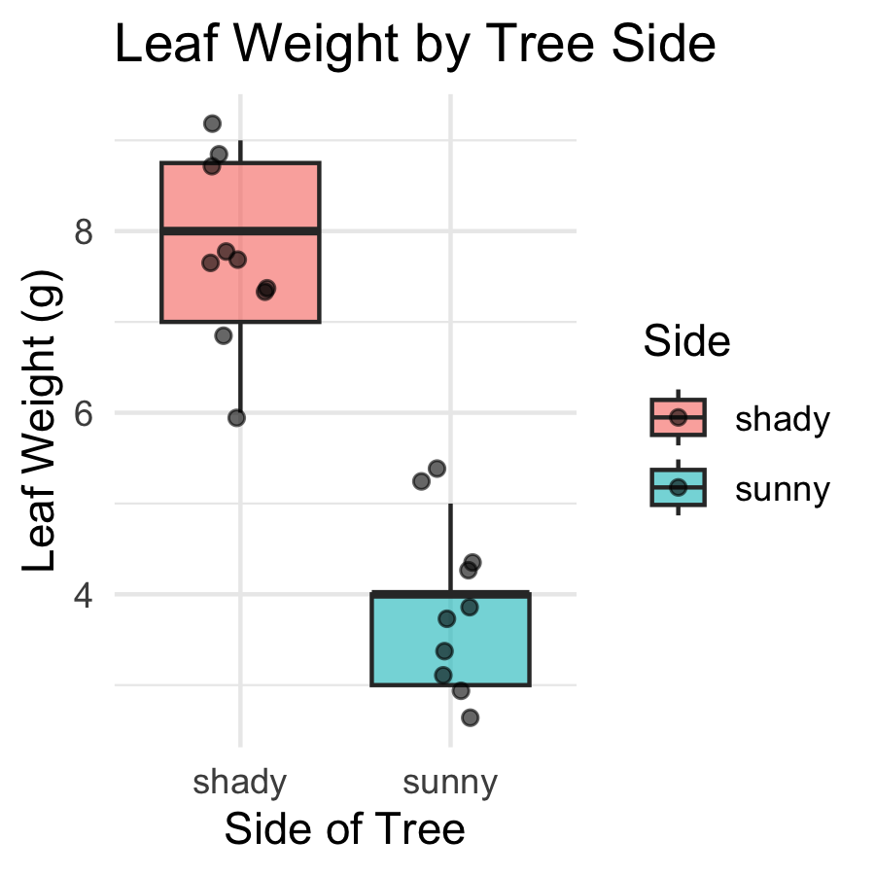
- tree_df %>% ggplot(...) reads as “take tree_df, then plot it” — the same pipe you’ve already used
- Everything after ggplot() is added with +, not %>% — ggplot layers use plus, pipelines use the pipe
- fill = side maps a column to color — ggplot chooses the colors for you
 Warning
⚠️ Watch out!
%>% connects data-wrangling steps. + connects plot layers. Mixing them up is the single most common ggplot error.

Choosing Colors on Purpose — scale_color_manual()
 Note
🔮 Predict first: scale_fill_manual() needs one color per group. We have two groups (sunny, shady). How many colors do we need to supply?

# scale_fill_manual() assigns exact colors to exact groups
tree_df %>%
ggplot(aes(x = side, y = weight_g, fill = side)) +
geom_boxplot(alpha = 0.6, outlier.shape = NA) +
geom_jitter(width = 0.15, alpha = 0.6) +
scale_fill_manual(values = c(
"sunny" = "goldenrod",
"shady" = "forestgreen"
)) +
labs(
title = "Leaf Weight by Tree Side",
x = "Side of Tree",
y = "Leaf Weight (g)",
fill = "Side"
) +
theme_minimal() +
theme(legend.position = "none")
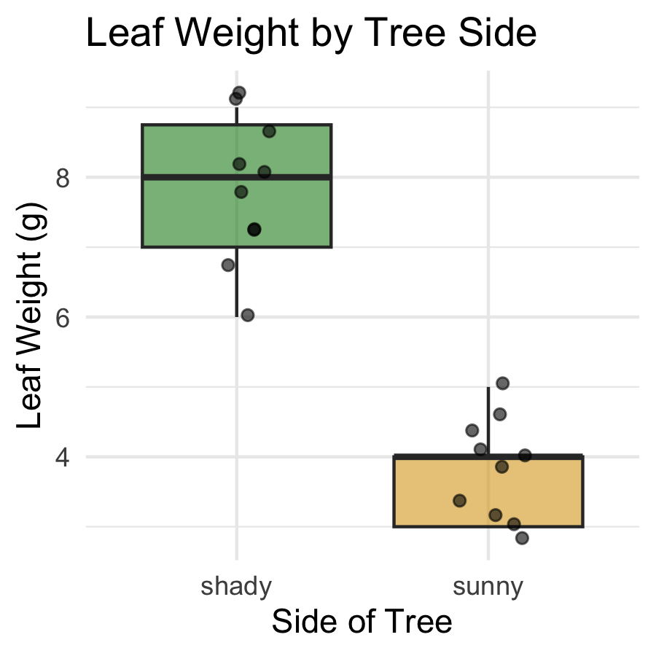
- scale_fill_manual() — for fill = aesthetics (boxes, bars, columns)
- scale_color_manual() — for color = aesthetics (points, lines)
- The names inside c() must exactly match the values in your data ("sunny", "shady") — case and spelling both count
 Warning
⚠️ Watch out!
If a name in values = c(...) doesn’t match a value in your data exactly, that group’s color falls back to grey and ggplot prints a warning.

→ ACTIVITY 3 Parts 1–2 now
🛑 Do Activity Parts 1–2 now
Pipe into ggplot(), then assign sunny/shady their own colors with scale_fill_manual(). Predict, type, run.

🧩 Chunk 2 of 3 · Small Multiples with Facets
We will cover: facet_wrap() and facet_grid() — splitting one plot into a panel per group.
🛑 After this chunk you will do Activity Part 3.

facet_wrap() — One Panel per Group
# facet_wrap() splits into one panel per level ---------
tree_df %>%
ggplot(aes(x = weight_g, fill = side)) +
geom_histogram(binwidth = 1, color = "white") +
facet_wrap(~side) +
scale_fill_manual(values = c("sunny" = "goldenrod", "shady" = "forestgreen")) +
labs(x = "Leaf Weight (g)", y = "Count", title = "Weight Distribution by Side") +
theme_minimal() +
theme(legend.position = "none")
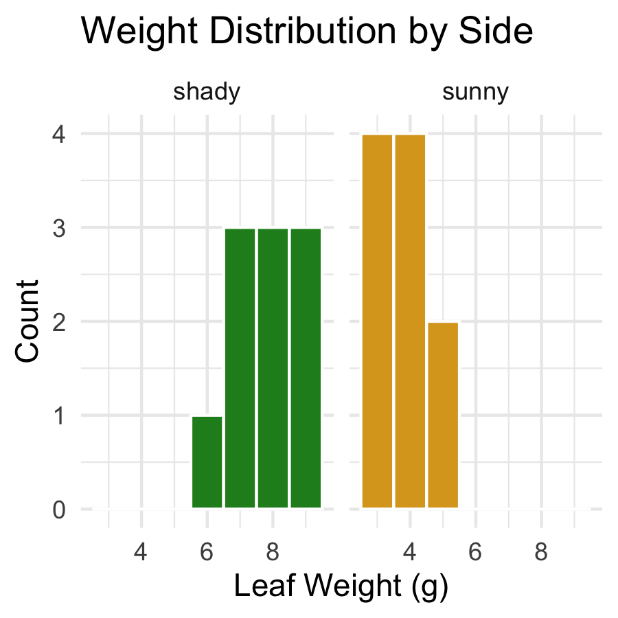
- ~side reads as “by side” — the ~ is required
- Each panel gets its own copy of the plot, filtered to that group
- facet_wrap(~side, scales = "free_y") lets each panel’s y-axis rescale independently
📖 R4DS §9 — Layers

facet_grid() — a Strict Rows-and-Columns Grid
# facet_grid(rows ~ cols) — use "." for "no grouping" --
tree_df %>%
ggplot(aes(x = weight_g, fill = side)) +
geom_histogram(binwidth = 1, color = "white") +
facet_grid(side ~ .) +
scale_fill_manual(values = c("sunny" = "goldenrod", "shady" = "forestgreen")) +
labs(x = "Leaf Weight (g)", y = "Count") +
theme_minimal() +
theme(legend.position = "none")
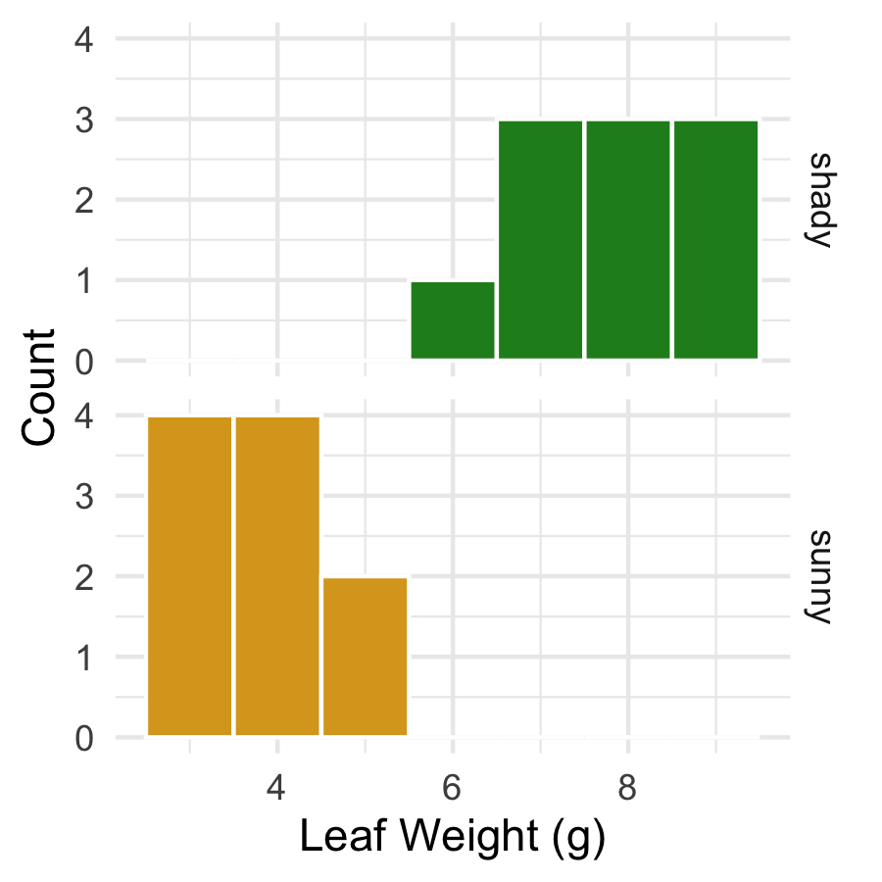
- facet_grid(side ~ .) stacks panels in rows; facet_grid(. ~ side) arranges them in columns
- The dot . means “nothing on this side of the grid”
- facet_grid() really shines with two grouping variables (rows ~ cols) — we only have one (side) today, but you’ll use the two-variable form the moment your data has a second grouping column
 Note
💡 facet_wrap vs facet_grid
Use facet_wrap() for one grouping variable — it wraps panels into a grid automatically. Use facet_grid() when you have two variables and want rows and columns to each mean something specific.

→ ACTIVITY 3 Part 3 now
🛑 Do Activity Part 3 now
Build both a facet_wrap() and a facet_grid() version of the histogram. Predict, type, run.

🧩 Chunk 3 of 3 · Mean ± SE with stat_summary()
We will cover: layering a group mean and its standard error directly on top of raw data — no summary table needed.
🛑 After this chunk you will do Activity Parts 4–5.

stat_summary() — the Mean as a Layer
# stat_summary() computes the mean straight from the data
tree_df %>%
ggplot(aes(x = side, y = weight_g, color = side)) +
geom_jitter(width = 0.15, alpha = 0.4, size = 2) +
stat_summary(fun = mean, geom = "point", size = 4, color = "black") +
scale_color_manual(values = c("sunny" = "goldenrod", "shady" = "forestgreen")) +
labs(
title = "Leaf Weight with Group Means",
x = "Side of Tree", y = "Leaf Weight (g)"
) +
theme_minimal() +
theme(legend.position = "none")
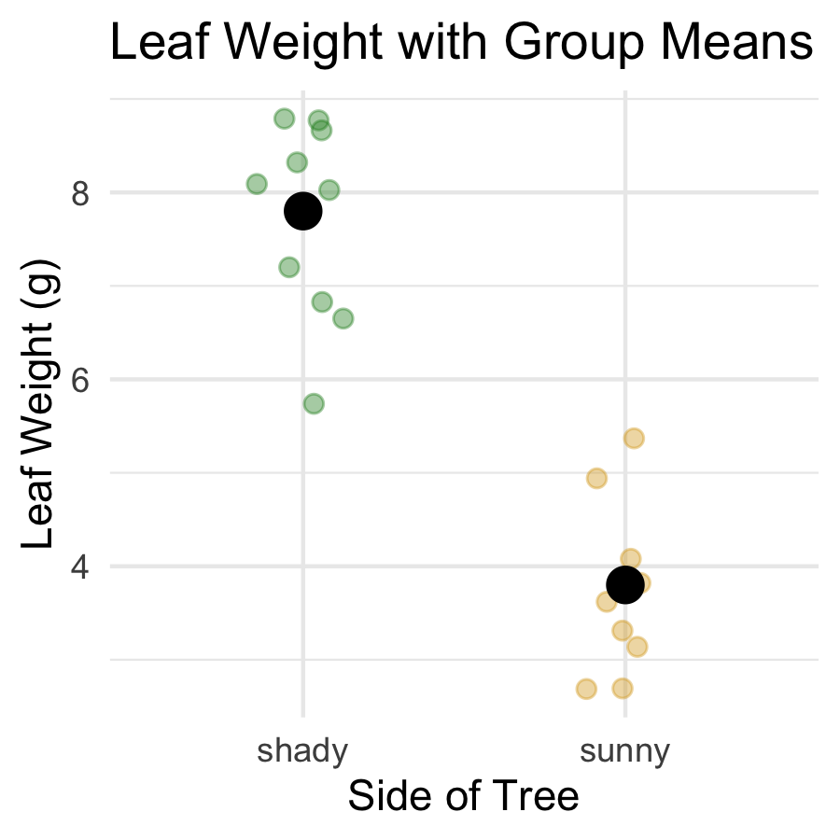
- stat_summary() computes a statistic from the raw data and draws it — no pre-built summary table needed
- fun = mean — any function that returns one number (mean, median, max, …)
- geom = "point" — draw that number as a point
- Put geom_jitter() before stat_summary() so the mean sits on top of the raw points, not buried under them

stat_summary() — Mean ± SE
 Note
🔮 Predict first: fun.data = mean_se returns three numbers per group instead of one (the mean, and the bar’s top and bottom). What do you think those three are called?

# fun.data = returns THREE values: y, ymin, ymax -------
tree_mean_se_plot <- tree_df %>%
ggplot(aes(x = side, y = weight_g, color = side)) +
geom_jitter(width = 0.15, alpha = 0.35, size = 2) +
stat_summary(fun = mean, geom = "point", size = 4) +
stat_summary(
fun.data = mean_se,
geom = "errorbar",
width = 0.15,
linewidth = 0.9
) +
scale_color_manual(values = c("sunny" = "goldenrod", "shady" = "forestgreen")) +
labs(
title = "Mean ± SE Leaf Weight by Tree Side",
x = "Side of Tree", y = "Leaf Weight (g)"
) +
theme_minimal() +
theme(legend.position = "none")
tree_mean_se_plot
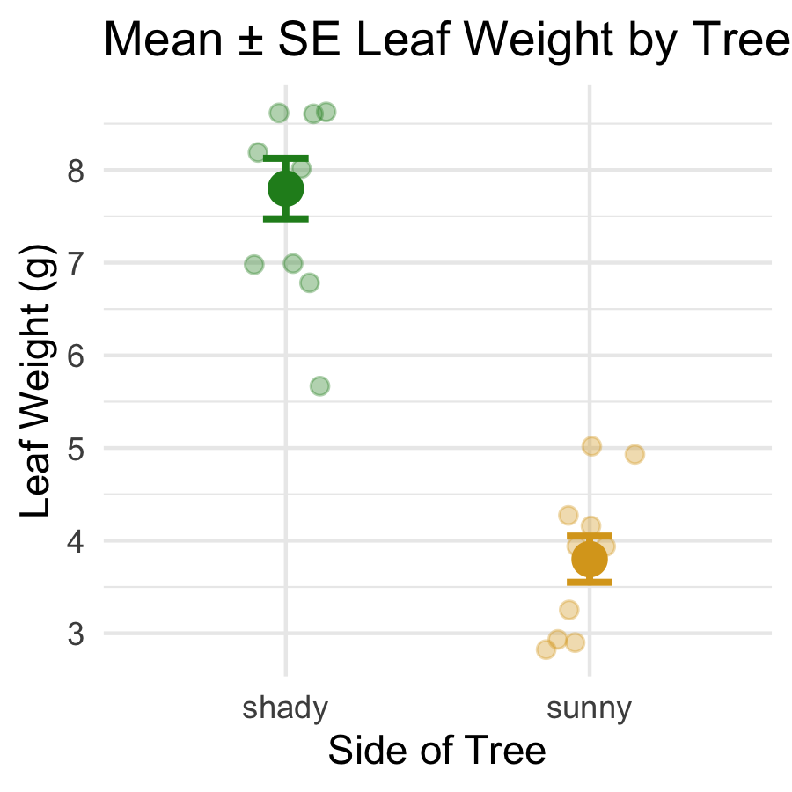
Two stat_summary() layers, stacked:
call | what it draws
fun = mean | a point at the mean
fun.data = mean_se | error bars for ± 1 SE
- Raw points in the background (alpha = 0.35)
- Mean as a larger foreground point
- Error bars = ± 1 SE
📖 Whitlock & Schluter, Ch. 3 — Describing Data

→ ACTIVITY 3 Parts 4–5 now
🛑 Go to Activity 3 — Parts 4–5
Close the slides. Build your own mean ± SE plot, then save it to figures/.

What We Learned Today
- Pipe straight into a plot: tree_df %>% ggplot(...)
- scale_color_manual() / scale_fill_manual() — colors you choose, not colors ggplot guesses
- facet_wrap(~var) — one panel per group, wraps automatically
- facet_grid(rows ~ cols) — strict grid, best with two grouping variables
- stat_summary() — mean and mean ± SE, drawn directly from raw data
References:
- 📖 Whitlock & Schluter, Ch. 2 — Displaying Data
- 📖 R4DS Ch 1 — Data Visualization
- 📖 R4DS Ch 9 — Layers
Up next — Lecture 04, GGPlot II:
- More geoms
- coord_cartesian() vs. xlim()
- Themes

