Lecture 10 — T-Tests II: Running & Reporting the Test
  - Running Welch’s t-test, reading the output, and writing it up
Bill Perry
2026-08-27

Where we left off (Lecture 09 — T-Tests I)
- H₀: $μ_{shady}=μ_{sunny}$ · Hₐ: $μ_{shady}≠μ_{sunny}$ (two-tailed, α = 0.05)
- Normality checked — histogram + Shapiro-Wilk, both sides roughly bell-shaped for n = 10
- Variance checked — Levene’s test run (we use Welch’s either way)
- Decision: proceed with Welch’s two-sample t-test
 Note
✅ Key idea from Lecture 09
Every box is checked. Today we actually run the test, decode what R hands back, and turn it into a sentence a reader can trust.

Goals for Today
- Run Welch’s two-sample t-test in R
- Read every line of the t.test() output
- Decide: reject or fail to reject H₀
- Visualize the result with the test statistics embedded
- Report results in proper scientific writing format
 Tip
🖐 Try it yourself
By the end you will have a complete, reportable t-test result and a publication-style figure to go with it.

References:
- 📖 Whitlock & Schluter, Ch. 4 — Estimating with Uncertainty
- 📖 R4DS §3
Both are in the course readings/ folder.
Today’s naming:
- test objects → _model
- plots → _plot

How to Use These Slides — Predict · Type · Run
This lecture runs in two short chunks. After each chunk you switch to the activity worksheet and type the code yourself.
For every code block, do three things:
- Predict — before it runs, say what you think the output will be
- Type it out by hand — do not copy-paste
- Run it and compare to your prediction
 Note
✅ Why bother?
Guessing “above or below 0.05” before you see t.test() output forces you to reason about the test instead of just reading a number off the screen — that habit is what makes a p-value meaningful instead of magic.

Load Libraries and Data
# Load all packages at the top ----------------------------
library(readxl) # reading Excel files
library(tidyverse) # data manipulation + ggplot2
library(car) # Levene's test for variance equality
# Load the leaf data from the data folder -----------------
tree_df <- read_excel("data/2026_06_25_tree_experiment_raw_data.xlsx")

Quick Recap of Our Assumption Checks
# Rerun the assumption checks quickly for reference -----
recap_df <- tree_df %>%
group_by(side) %>%
summarize(
n = sum(!is.na(weight_g)),
mean_wt = round(mean(weight_g, na.rm = TRUE), 2),
sd_wt = round(sd(weight_g, na.rm = TRUE), 2),
se_wt = round(sd_wt / sqrt(n), 2)
)
recap_df
# A tibble: 2 × 5
side n mean_wt sd_wt se_wt
<chr> <int> <dbl> <dbl> <dbl>
1 shady 10 7.8 1.03 0.33
2 sunny 10 3.8 0.79 0.25
leveneTest(weight_g ~ side, data = tree_df)
Levene's Test for Homogeneity of Variance (center = median)
Df F value Pr(>F)
group 1 0.6 0.4486
18
- Both groups: roughly normal (Lecture 09)
- Levene’s: recorded, but does not change our test choice
- We proceed with Welch’s (var.equal = FALSE)
 Tip
If your Worksheet 09 numbers don’t match exactly, that’s fine — small rounding differences don’t change the conclusion.

🧩 Chunk 1 of 2 · Run & Interpret
We will cover: running Welch’s t.test(), reading every line of the output, and making a formal reject / fail-to-reject decision.
🛑 After this chunk: Activity Parts 1–3 (run, decode, decide).

Step 4 — Run the Welch’s t-Test
 Note
🔮 Predict first: Write down a guess for the p-value before you run t.test() — above or below 0.05? Then see how close you were.

# Welch's two-sample t-test — unequal variance ---------
leaf_ttest_model <- t.test(
weight_g ~ side, # formula: response ~ grouping variable
data = tree_df,
var.equal = FALSE, # Welch's — no pooled variance
alternative = "two.sided" # two-tailed test
)
leaf_ttest_model
Welch Two Sample t-test
data: weight_g by side
t = 9.7333, df = 16.834, p-value = 2.514e-08
alternative hypothesis: true difference in means between group shady and group sunny is not equal to 0
95 percent confidence interval:
3.132297 4.867703
sample estimates:
mean in group shady mean in group sunny
7.8 3.8
Key arguments:
argument | what it does
weight_g ~ side | compare weight_g between levels of side
var.equal = FALSE | use Welch’s correction
alternative = "two.sided" | two-tailed test
The result is a model object. We decode each line of the output on the next slide.

Reading the t.test() Output
# Extract individual values from the model object ------
cat("t-statistic :", round(leaf_ttest_model$statistic, 3), "\n")
t-statistic : 9.733
cat("df (Welch) :", round(leaf_ttest_model$parameter, 2), "\n")
df (Welch) : 16.83
cat("p-value :", signif(leaf_ttest_model$p.value, 3), "\n")
p-value : 2.51e-08
cat(
"95% CI :",
round(leaf_ttest_model$conf.int[1], 2),
"to",
round(leaf_ttest_model$conf.int[2], 2),
"g\n"
)
95% CI : 3.13 to 4.87 g
cat("Mean shady :", round(leaf_ttest_model$estimate[1], 2), "g\n")
Mean shady : 7.8 g
cat("Mean sunny :", round(leaf_ttest_model$estimate[2], 2), "g\n")
Mean sunny : 3.8 g
Line by line:
output | meaning
t | our calculated t-statistic
df | Welch-Satterthwaite df (non-integer is normal!)
p-value | probability of this result if H₀ is true
95% CI | plausible range for the true difference in means
mean of shady/sunny | the two group means
The 95% CI is the range we could expect to see if we repeated this study many times.

Step 5 — Make a Decision
# State the decision formally --------------------------
# if/else: R checks the condition and runs one of two blocks
# We will learn these formally in the functions lecture
p_val <- leaf_ttest_model$p.value
alpha <- 0.05
if (p_val < alpha) {
cat("p =", signif(p_val, 3), "< α =", alpha, "\n")
cat("Decision: REJECT H₀\n")
cat("Conclusion: leaf weight differs between sides.\n")
} else {
cat("p =", signif(p_val, 3), ">= α =", alpha, "\n")
cat("Decision: FAIL TO REJECT H₀\n")
cat("Conclusion: insufficient evidence of a difference.\n")
}
p = 2.51e-08 < α = 0.05
Decision: REJECT H₀
Conclusion: leaf weight differs between sides.
 Important
What a small p-value means:
If H₀ were true (no real difference), we would get a t-statistic this large or larger less than p × 100% of the time just by chance.
We set α = 0.05 before the test. If p < α, we reject H₀.

What a small p-value does NOT mean:
- It is not the probability that H₀ is true
- Statistical significance ≠ biological importance
- Report the effect size (difference in means) alongside p

→ ACTIVITY 10 Parts 1–3 now
🛑 Do Activity Parts 1–3 now
Run the test, decode t / df / p / CI, and state your decision in formal language. Predict the p-value first.

🧩 Chunk 2 of 2 · Visualize & Report
We will cover: embedding the test result in a boxplot and writing a scientific results sentence.
🛑 After this chunk: Activity Parts 4–5 (plot and the results sentence).

Visualize the Result
# Final boxplot with all points -----------------------
leaf_box_10_plot <- tree_df %>%
ggplot(aes(x = side, y = weight_g, fill = side)) +
geom_boxplot(alpha = 0.5, outlier.shape = NA) +
geom_point(
position = position_jitter(width = 0.15, seed = 42),
alpha = 0.6,
size = 2.5
) +
labs(
title = "Leaf Weight by Tree Side",
subtitle = paste0(
"Welch's t-test: t = ",
round(leaf_ttest_model$statistic, 2),
", p = ",
signif(leaf_ttest_model$p.value, 2)
),
x = "Side of Tree",
y = "Leaf Weight (g)"
) +
theme_minimal() +
theme(legend.position = "none")
leaf_box_10_plot
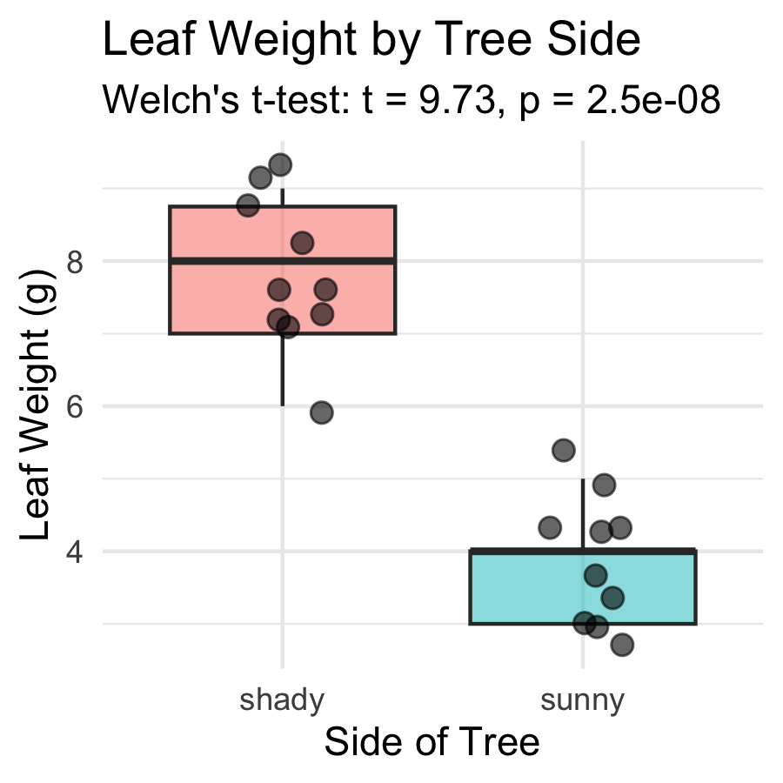
Including the test result in the figure:
- subtitle pulls t and p directly from the model object
- R fills in the actual numbers automatically
- If you re-run with new data, the subtitle updates
 Tip
Embedding test statistics in the plot subtitle saves you from copying numbers by hand — and avoids typos in your report.

How to Report Results in Science
# Compute reporting values from the model object -------
t_val <- round(leaf_ttest_model$statistic, 2)
df_val <- round(leaf_ttest_model$parameter, 1)
p_val2 <- signif(leaf_ttest_model$p.value, 2)
cat("--- Results sentence ---\n")
--- Results sentence ---
cat("Shady-side leaves were significantly heavier than\n")
Shady-side leaves were significantly heavier than
cat(
"sunny-side leaves (Welch's t-test: t(",
df_val,
") =",
t_val,
", p =",
p_val2,
").\n"
)
sunny-side leaves (Welch's t-test: t( 16.8 ) = 9.73 , p = 2.5e-08 ).
cat(
"Mean ± SE: shady =",
round(leaf_ttest_model$estimate[1], 2),
"±",
round(recap_df$se_wt[recap_df$side == "shady"], 2),
"g,\n"
)
Mean ± SE: shady = 7.8 ± 0.33 g,
cat(
" sunny =",
round(leaf_ttest_model$estimate[2], 2),
"±",
round(recap_df$se_wt[recap_df$side == "sunny"], 2),
"g.\n"
)
sunny = 3.8 ± 0.25 g.
Standard format:
“[Finding] (Welch’s t-test: t(df) = X.XX, p = X.XXX; mean ± SE: group1 = X.X ± X.X units, group2 = X.X ± X.X units).”
Always include:
- Test type (Welch’s t-test)
- t-statistic and df
- Exact p-value (or < 0.001)
- Group means ± SE
- Units
Never report “p = 0.000” — write “p < 0.001” instead.

Save Your Plot
# Save the plot to the figures folder ------------------
ggsave(
"figures/leaf_weight_boxplot_ttest.png",
plot = leaf_box_10_plot,
width = 5,
height = 5,
units = "in",
dpi = 300
)
Your plot is now in your figures/ folder with the test statistics embedded in the subtitle — ready for a lab report or paper.
 Tip
dpi = 300 is publication quality. Use it for any figure that will appear in a paper, poster, or formal report.

→ ACTIVITY 10 Parts 4–5 now
🛑 Go to Activity 10 — Parts 4–5
Build the figure with the statistics embedded in the subtitle, then write your results sentence. Predict what the subtitle will say before you run it.

What We Learned Today
Concepts:
- Steps 4–5 of the five-step framework — run, interpret, report
- Reading output — t, df, p, CI, group means
- A results sentence needs: test name, t, df, p, means ± SE, units
R skills:
- t.test(y ~ group, data, var.equal = FALSE, alternative = "two.sided")
- model$statistic, model$p.value, model$conf.int — extract results
- paste0(...) in labs(subtitle = ) — embed test statistics in figures
References:
- 📖 Whitlock & Schluter, Ch. 4 — Estimating with Uncertainty
- 📖 R4DS §3
Up next — Lecture 11:
- Linear regression — predicting leaf area from paper tracing mass
- Building a calibration curve with lm()
- R², residuals, and assumption checking

