Lecture — Telling a Story with ggplot
  - From a plot that shows everything to a figure that says one thing
Bill Perry
2026-08-27

Where we left off
- Basic ggplot — geom_boxplot(), geom_point(), position_jitter()
- Advanced plotting — facet_wrap(), stat_summary(), geom_smooth(), patchwork, log scales
- You can now build almost any figure ggplot is capable of drawing
 Note
✅ Key idea from Advanced Plotting
You now have the mechanics. Today is different: no new geoms. Today is about choosing which mechanics to use, and which to leave out, so your one figure makes one point.

Goals for Today
The problem this lecture solves:
- Your final-project talk is 5 minutes and one figure
- A technically-correct plot can still fail to communicate
- “I made a boxplot” is not the same as “I told a story”
What we’ll practice:
- Start from the question, not the geom
- Cut everything that doesn’t serve the point
- Direct labeling instead of a legend, when you can
- Order categories to match the story, not the alphabet
- Color with intent, and with accessibility in mind
- A title that states the finding, not the variable names
- annotate() to point at the one thing that matters
 Tip
🖐 Try it yourself
By the end you will redesign a technically-correct-but-confusing plot into one that a stranger understands in five seconds.

Our tools today: mostly tools you already know, used differently.
References:
- 📖 R4DS Ch 9 — Layers
- 📖 R4DS Ch 11 — Communication
- 🌐 A Compendium of Clean Graphs in R
Naming conventions:
- plots → _plot
- a redesigned plot → _plot_v2

How to Use These Slides — Predict · Type · Run
Two chunks today. After each, switch to the activity and redesign a plot yourself.
- Predict what’s wrong with a plot before I tell you
- Type the redesign by hand
- Compare your five-second read of the before vs. the after
 Note
✅ Why this lecture matters
Every remaining lecture in this course ends with a plot. This is the only lecture that tells you how to judge whether that plot is any good — a skill no geom teaches by itself.

Load Libraries and Data
# Load all packages at the top of every script ----------
library(readxl) # reading Excel files
library(tidyverse) # data wrangling + ggplot2
library(janitor) # cleans up messy column names
# Reuse our cleaned leaf data ----------------------------
tree_df <- read_excel("data/2026_06_25_tree_experiment_raw_data.xlsx") %>%
clean_names()

🧩 Chunk 1 of 2 · The Rule — One Figure, One Point
We will cover: starting from the question, and the “five-second test.”
 Tip
🖐 After this chunk: Activity Parts 1–3.

Start From the Question, Not the Geom
Before you write one line of ggplot(), answer this in a full sentence:
“This figure shows that ____.”
If you cannot finish that sentence, you are not ready to plot yet — you are still exploring. Exploring is fine, but exploratory plots and the final figure are not the same plot.
Our sentence today:
“Leaves on the shady side of the tree are heavier than leaves on the sunny side.”
 Note
✅ Key idea
A dozen exploratory plots is normal and good. Your final talk gets one. Decide which one earns that slot by asking whether it finishes the sentence above.

The Five-Second Test
Show your plot to a labmate for five seconds, then hide it. Ask: “What did that plot say?”
- If they repeat your sentence back — the plot works
- If they describe the axes instead of the finding — it doesn’t yet
- If they ask “wait, what am I looking at?” — start over
 Tip
This is the same test we asked you to plan for in the final-project worksheet: “Slide 3 — the ONE figure that shows your result.” Today is where you learn to build that slide.

A Plot That Shows Everything (and Says Nothing)
 Note
🔮 Predict first: Before you look at the code, predict what will be wrong with this plot even though every line of code is correct.

# Technically correct — but a poor final figure ---------
tree_busy_plot <- tree_df %>%
ggplot(aes(x = side, y = weight_g, fill = side)) +
geom_boxplot() +
geom_jitter(width = 0.3, size = 1) +
facet_wrap(~ side) +
labs(title = "weight_g by side", x = "side", y = "weight_g") +
theme_gray()
tree_busy_plot
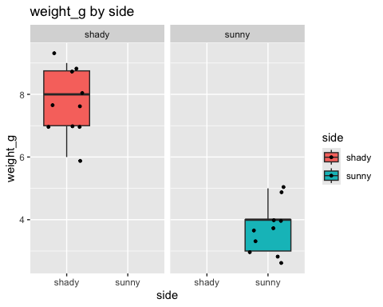
 Warning
⚠️ What’s wrong here
- Faceting by the same variable that’s on the x-axis — pure redundancy
- Legend repeats what the x-axis already says
- Title is a variable name, not a finding
- Axis labels are raw column names, not readable text
- Default gray background adds visual noise

🧩 Chunk 2 of 2 · The Fixes
We will cover: cutting redundancy, direct labeling, deliberate ordering and color, and a finding-based title.
 Tip
🖐 After this chunk: Activity Parts 4–7.

Fix #1 — Cut Anything That Repeats Itself
# Removed the redundant facet_wrap ----------------------
tree_plot_v2 <- tree_df %>%
ggplot(aes(x = side, y = weight_g, fill = side)) +
geom_boxplot(alpha = 0.6, outlier.shape = NA) +
geom_jitter(width = 0.15, alpha = 0.6, size = 2) +
theme_minimal()
tree_plot_v2
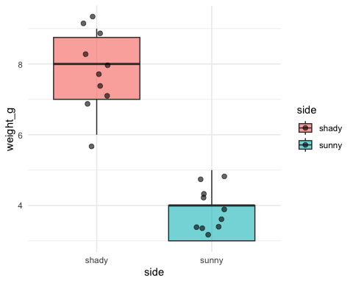
 Note
✅ Key idea
If two elements of your plot show the same information twice (facet + x-axis, legend + x-axis, title + axis label), delete one. Redundancy is not clarity — it’s clutter that looks like effort.

Fix #2 — Direct Labels Instead of a Legend
 Note
🔮 Predict first: Our x-axis already says “sunny” and “shady.” Do we need the fill = side legend at all?

# Drop the legend — the x-axis already tells us the group
tree_plot_v3 <- tree_df %>%
ggplot(aes(x = side, y = weight_g, fill = side)) +
geom_boxplot(alpha = 0.6, outlier.shape = NA) +
geom_jitter(width = 0.15, alpha = 0.6, size = 2) +
theme_minimal() +
theme(legend.position = "none")
tree_plot_v3
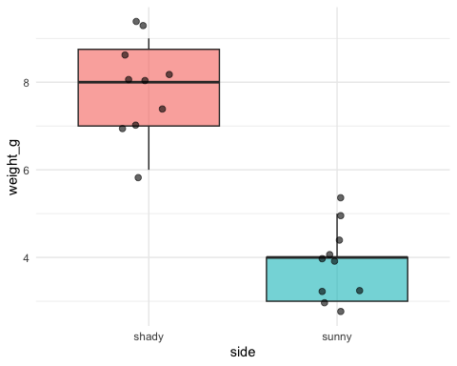
- A legend forces the reader’s eye to travel back and forth
- When the x-axis (or a direct label) already names the groups, the legend is dead weight
- Rule of thumb: if removing the legend loses zero information, remove it

Fix #3 — Order With Intent, Not the Alphabet
# fct_relevel() puts categories in a meaningful order ---
tree_plot_v4 <- tree_df %>%
mutate(side = fct_relevel(side, "sunny", "shady")) %>%
ggplot(aes(x = side, y = weight_g, fill = side)) +
geom_boxplot(alpha = 0.6, outlier.shape = NA) +
geom_jitter(width = 0.15, alpha = 0.6, size = 2) +
theme_minimal() +
theme(legend.position = "none")
tree_plot_v4
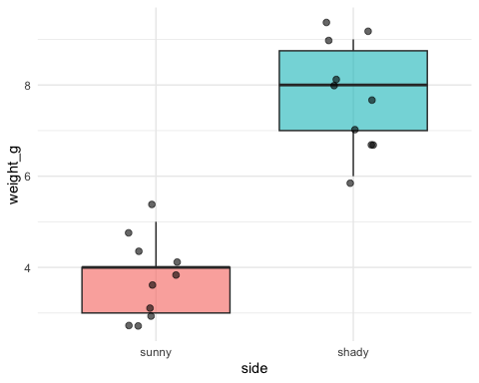
- Alphabetical order (shady before sunny) is an accident of spelling, not a decision
- fct_relevel() lets you choose the order that matches your story: baseline first, then the comparison
- Order becomes especially important with 3+ groups — put them in a logical sequence (low to high, control then treatments, etc.)
📖 R4DS Ch 17 — Factors

Fix #4 — Color With Intent (and Colorblind Safety)
# Choose two colors deliberately, not ggplot's defaults -
tree_plot_v5 <- tree_df %>%
mutate(side = fct_relevel(side, "sunny", "shady")) %>%
ggplot(aes(x = side, y = weight_g, fill = side)) +
geom_boxplot(alpha = 0.7, outlier.shape = NA) +
geom_jitter(width = 0.15, alpha = 0.6, size = 2) +
scale_fill_manual(values = c(sunny = "#E69F00", shady = "#0072B2")) +
theme_minimal() +
theme(legend.position = "none")
tree_plot_v5
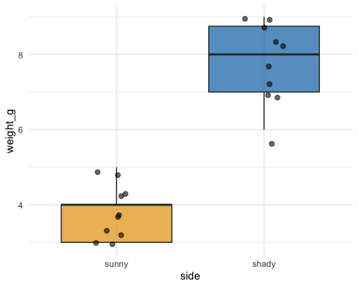
 Warning
⚠️ Watch out!
Red/green combinations are unreadable to ~8% of men with red-green color blindness. #E69F00 (orange) and #0072B2 (blue) are from the Okabe-Ito palette, designed to stay distinguishable for colorblind readers.

 Tip
Colour should encode the group your reader most needs to compare — not just “make it look nice.”

Fix #5 — A Title That States the Finding
 Note
🔮 Predict first: Compare "weight_g by side" to "Shady leaves are heavier than sunny leaves". Which one lets someone understand the plot without ever looking at the axes?

# The title states the finding; labs() explains the rest
tree_final_plot <- tree_df %>%
mutate(side = fct_relevel(side, "sunny", "shady")) %>%
ggplot(aes(x = side, y = weight_g, fill = side)) +
geom_boxplot(alpha = 0.7, outlier.shape = NA) +
geom_jitter(width = 0.15, alpha = 0.6, size = 2) +
scale_fill_manual(values = c(sunny = "#E69F00", shady = "#0072B2")) +
labs(
title = "Shady-side leaves are heavier than sunny-side leaves",
subtitle = "Each point is one leaf; boxes show the median and interquartile range",
x = NULL,
y = "Leaf weight (g)",
caption = "n = 10 leaves per side"
) +
theme_minimal() +
theme(legend.position = "none", plot.title = element_text(face = "bold"))
tree_final_plot
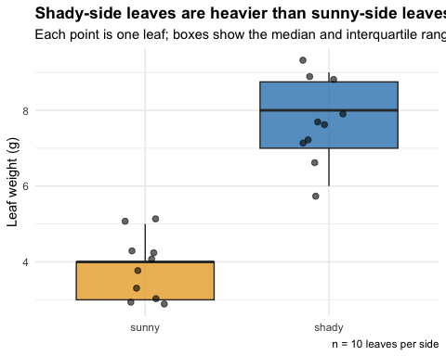
- Title = the finding, in plain English
- Subtitle = one sentence of method/context
- Caption = sample size or data source — small print, not the headline
- x = NULL — when categories are self-explanatory, drop a redundant axis label
📖 R4DS Ch 11 — Communication

Fix #6 — annotate() to Point at the One Thing
# annotate() draws a fixed element, not tied to the data
mean_shady <- tree_df %>% filter(side == "shady") %>%
summarize(m = mean(weight_g, na.rm = TRUE)) %>% pull(m)
tree_final_plot +
annotate(
"text", x = 2.35, y = mean_shady,
label = paste0("Shady mean:\n", round(mean_shady, 1), " g"),
size = 3.2, color = "#0072B2", hjust = 0
)
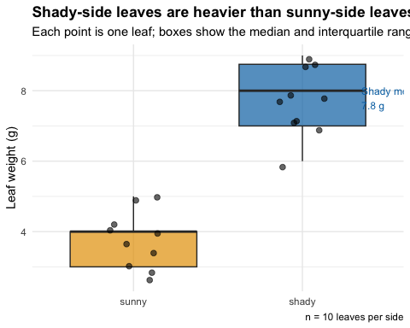
- annotate() places a single fixed label — it does not come from a geom_*() mapped to data
- Use it to call out the one number your audience should leave remembering
- Do not over-annotate — one callout per figure is usually the right number

🛑 Pause — Do Activity Parts 1–7 Now
Take the “busy” plot all the way through every fix, and redesign a second plot on your own using height_cm or width_cm.

What We Learned Today
- Start every final figure from a finished sentence, not a geom
- The five-second test: does a stranger repeat your finding back?
- Cut redundancy: repeated legends, facets, and titles are clutter
- Direct-label when you can; drop the legend when the axis already says it
- Order categories with intent (fct_relevel()), not alphabetically
- Color with intent, and check colorblind safety (Okabe-Ito palette)
- Title = finding. Subtitle = method. Caption = fine print.
- annotate() to point at exactly one number or region that matters
References:
- 📖 R4DS Ch 9 — Layers
- 📖 R4DS Ch 11 — Communication
- 🌐 A Compendium of Clean Graphs in R
Up next:
- Final Project Milestone work — you’ll use every fix from today on your own dataset’s take-home figure

