**AI intro Homework #2**

**NCTU Spring 2018**

0516076 施威綸

1. **Tick-tack-toe min-max**
2. Win (1): 17, 18, 20, 22, 26, 27, 29, 30, 31, 33

Lose (-1): 8, 11, 14, 37, 40, 41, 42

Draw (0): 35, 36, 38, 39

1. Node 1

|  |  |  |  |  |  |  |  |  |  |  |  |
| --- | --- | --- | --- | --- | --- | --- | --- | --- | --- | --- | --- |
| Node # | 1 | 2 | 3 | 4 | 5 | 6 | 7 | 8 | 9 | 10 | 11 |
| Minimax val | 1 | -1 | -1 | -1 | 1 | 1 | 1 | -1 | 0 | 1 | -1 |

|  |  |  |  |  |  |  |  |  |  |  |  |
| --- | --- | --- | --- | --- | --- | --- | --- | --- | --- | --- | --- |
| Node # | 12 | 13 | 14 | 15 | 16 | 17 | 18 | 19 | 20 | 21 | 22 |
| Minimax val | 1 | 1 | -1 | 1 | 1 | 1 | 1 | 0 | 1 | 0 | 1 |

|  |  |  |  |  |  |  |  |  |  |  |  |
| --- | --- | --- | --- | --- | --- | --- | --- | --- | --- | --- | --- |
| Node # | 23 | 24 | 25 | 26 | 27 | 28 | 29 | 30 | 31 | 32 | 33 |
| Minimax val | -1 | 0 | 0 | 1 | 1 | -1 | 1 | 1 | 1 | -1 | 1 |

|  |  |  |  |  |  |  |  |  |  |  |  |
| --- | --- | --- | --- | --- | --- | --- | --- | --- | --- | --- | --- |
| Node # | 34 | 35 | 36 | 37 | 38 | 39 | 40 | 41 | 42 |  |  |
| Minimax val | -1 | 0 | 0 | -1 | 0 | 0 | -1 | -1 | -1 |  |  |

(c) α-β pruning

skipped: 9, 10, 12, 13, 15, 16, 23~34, 37~42

1. **tic-tack-toe evaluate function**
2. Evaluation function F

if terminal, and x wins, F = MIN

, and o wins, F = MAX

If not terminal, X = # of line of x when fill all the blank with x

Y = # of line of o when fill all the blank with o

Evaluate function F = Y – X

The function implies the chance of x and o to make a line(s). The more line it makes, the more chances it wins. And the same rule applies to the opponent.

|  |  |  |  |  |  |  |  |  |  |  |  |  |
| --- | --- | --- | --- | --- | --- | --- | --- | --- | --- | --- | --- | --- |
| Node # | 5 | 6 | 7 | 8 | 9 | 10 | 11 | 12 | 13 | 14 | 15 | 16 |
| F | 1 | 0 | 1 | MIN | 0 | 1 | MIN | 0 | 0 | MIN | 1 | 0 |

1. 1
2. **CSP**

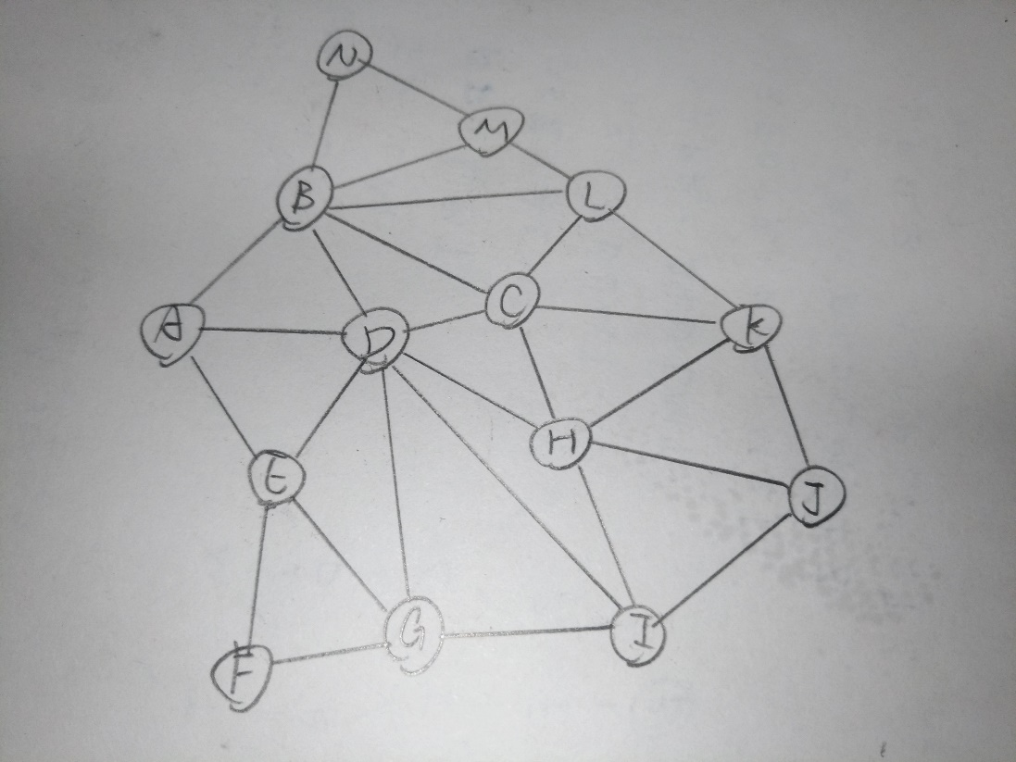

1. Backtrack + forward checking + (MRV, degree heuristic, LCV)

|  |  |  |  |  |  |  |  |  |  |  |  |  |  |  |  |
| --- | --- | --- | --- | --- | --- | --- | --- | --- | --- | --- | --- | --- | --- | --- | --- |
| Reg | Val | A | B | C | D | E | F | G | H | I | J | K | L | M | N |
| x | x | 1234 | 1234 | 1234 | 1234 | 1234 | 1234 | 1234 | 1234 | 1234 | 1234 | 1234 | 1234 | 1234 | 1234 |
| D | 1 | 234 | 234 | 234 | 1 | 234 | 1234 | 234 | 234 | 234 | 1234 | 1234 | 1234 | 1234 | 1234 |
| B | 2 | 34 | 2 | 34 | 1 | 234 | 1234 | 234 | 234 | 234 | 1234 | 1234 | 134 | 134 | 134 |
| C | 3 | 34 | 2 | 3 | 1 | 234 | 1234 | 234 | 24 | 234 | 1234 | 124 | 14 | 134 | 134 |
| H | 2 | 34 | 2 | 3 | 1 | 234 | 1234 | 234 | 2 | 34 | 134 | 14 | 14 | 134 | 134 |
| I | 3 | 34 | 2 | 3 | 1 | 234 | 1234 | 24 | 2 | 3 | 14 | 14 | 14 | 134 | 134 |
| G | 2 | 34 | 2 | 3 | 1 | 34 | 134 | 2 | 2 | 3 | 14 | 14 | 14 | 134 | 134 |
| E | 3 | 4 | 2 | 3 | 1 | 3 | 14 | 2 | 2 | 3 | 14 | 14 | 14 | 134 | 134 |
| A | 4 | 4 | 2 | 3 | 1 | 3 | 14 | 2 | 2 | 3 | 14 | 14 | 14 | 134 | 134 |
| K | 1 | 4 | 2 | 3 | 1 | 3 | 14 | 2 | 2 | 3 | 4 | 1 | 4 | 134 | 134 |
| L | 4 | 4 | 2 | 3 | 1 | 3 | 14 | 2 | 2 | 3 | 4 | 1 | 4 | 13 | 134 |
| J | 4 | 4 | 2 | 3 | 1 | 3 | 14 | 2 | 2 | 3 | 4 | 1 | 4 | 13 | 134 |
| M | 1 | 4 | 2 | 3 | 1 | 3 | 14 | 2 | 2 | 3 | 4 | 1 | 4 | 1 | 34 |
| F | 1 | 4 | 2 | 3 | 1 | 3 | 1 | 2 | 2 | 3 | 4 | 1 | 4 | 1 | 34 |
| N | 3 | 4 | 2 | 3 | 1 | 3 | 1 | 2 | 2 | 3 | 4 | 1 | 4 | 1 | 3 |

1. **Decision tree**

