Lab.10 UART and ADC

0516076 施威綸

# Lab objectives 實驗目的

* Understand the use of UART.
* Understand the use of ADC.

# Steps 實驗步驟

* 1. **Hello World!**

When the blue button on the board is pressed (PC13), use the UART to transfer the “Hello World!” string to the computer. And it can be displayed on the serial monitor of the computer side.

1. Initial GPIO for Tx, Rx.
2. Set up UART registers
3. Pass each characters in the string to the transmit data register(TDR) for serial transmission.

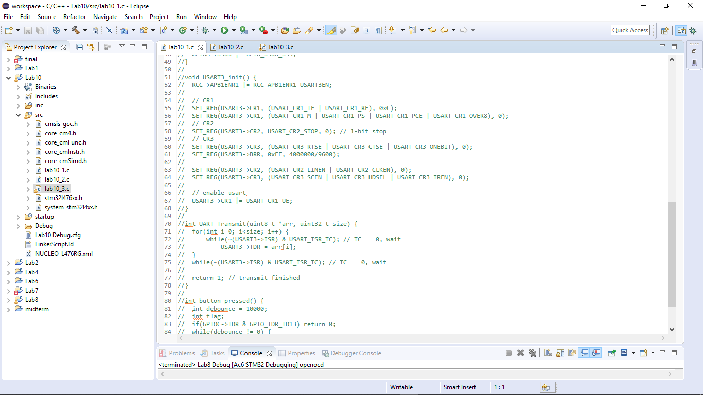

* 1. **Read photo resistor value**

Use the ADC (Analog-to-Digital-Converter) provided on the board to read the value of the photo resistor in 12-bit resolution using Interrupt, and use the UART output value each time the button is pressed.

1. Set up ADC
2. Set up timer for ADC sampling
3. Set up interrupt for button (EXTI, NVIC)
4. Set ADC interrupt handler
5. Transmit value from the protocol in Lab10.1

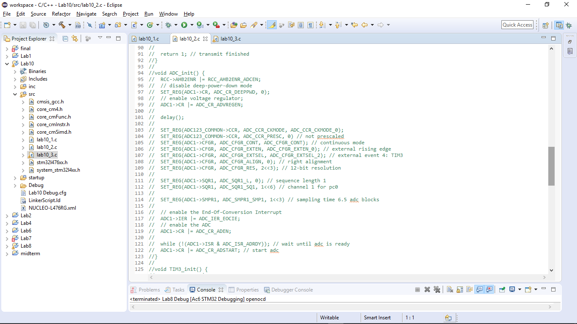

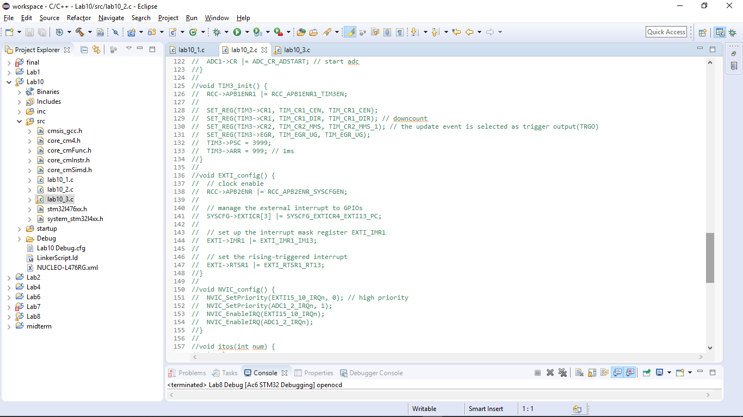



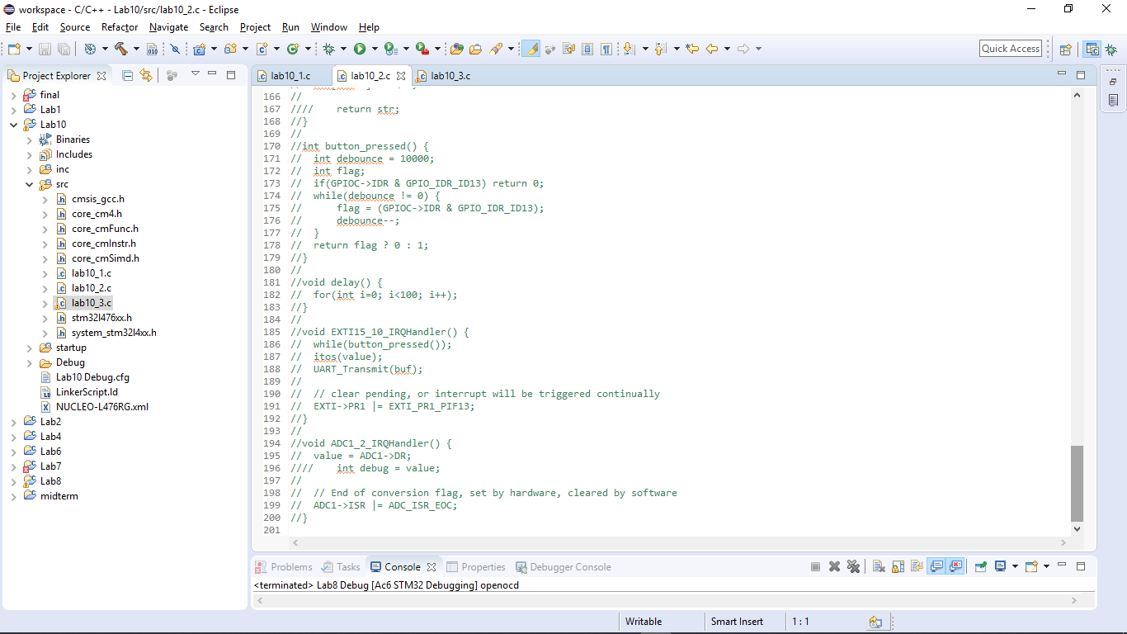

* 1. **Simple shell**

Implement Simple Shell on the board using UART and have three instructions

1) showid

a) show your student ID

2) light

a) Update and display the value of the photoresistor every 0.5 seconds (lab10.2), press 'q' to return to the original shell mode

3) led {on|off}

a) "led on" will turn the PA5 LED on, "led off" will turn off

After the USB to UART is connected to the computer, any characters entered by the computer must be received through the board's UART RX and transmitted back to the computer using TX to achieve echo. The computer runs serial monitor (e.g. putty, pietty, MobaXterm ...) to use the shell.

1. Enable RXNE interrupt
2. Set UART receive
3. Set up SysTick for 0.5 second
4. Set interrupt priority among UART, SysTick, and ADC
5. Implement the simple shell on UART IRQ handler

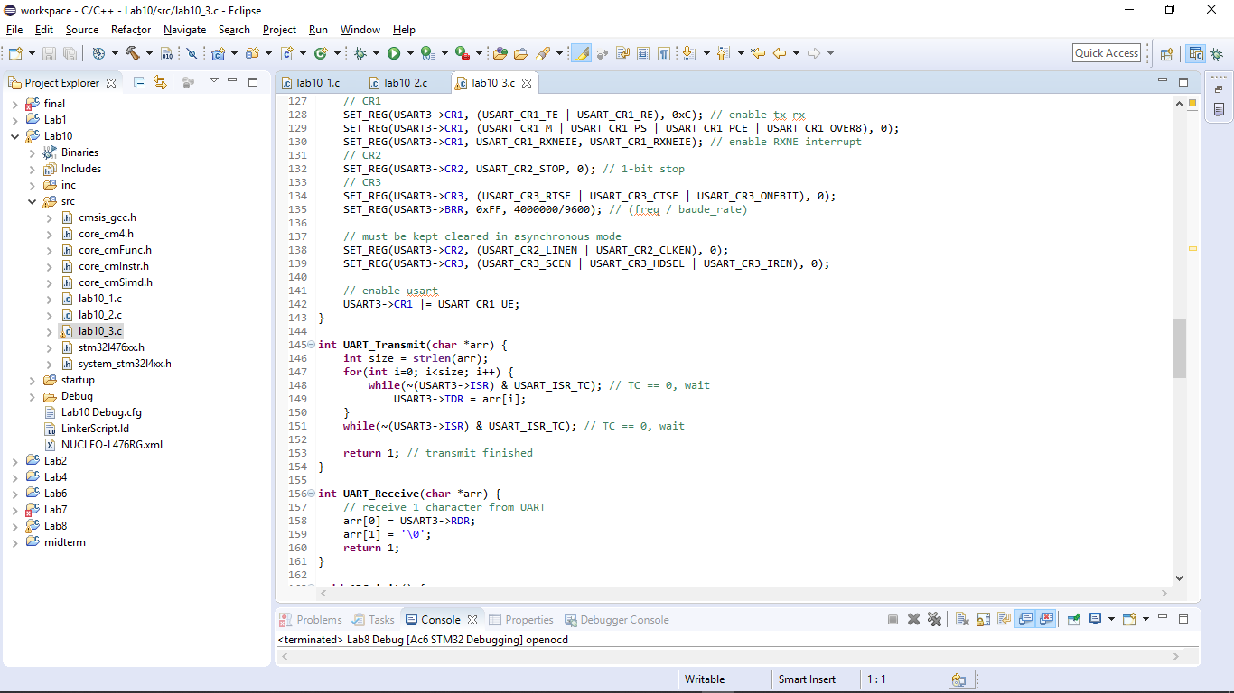



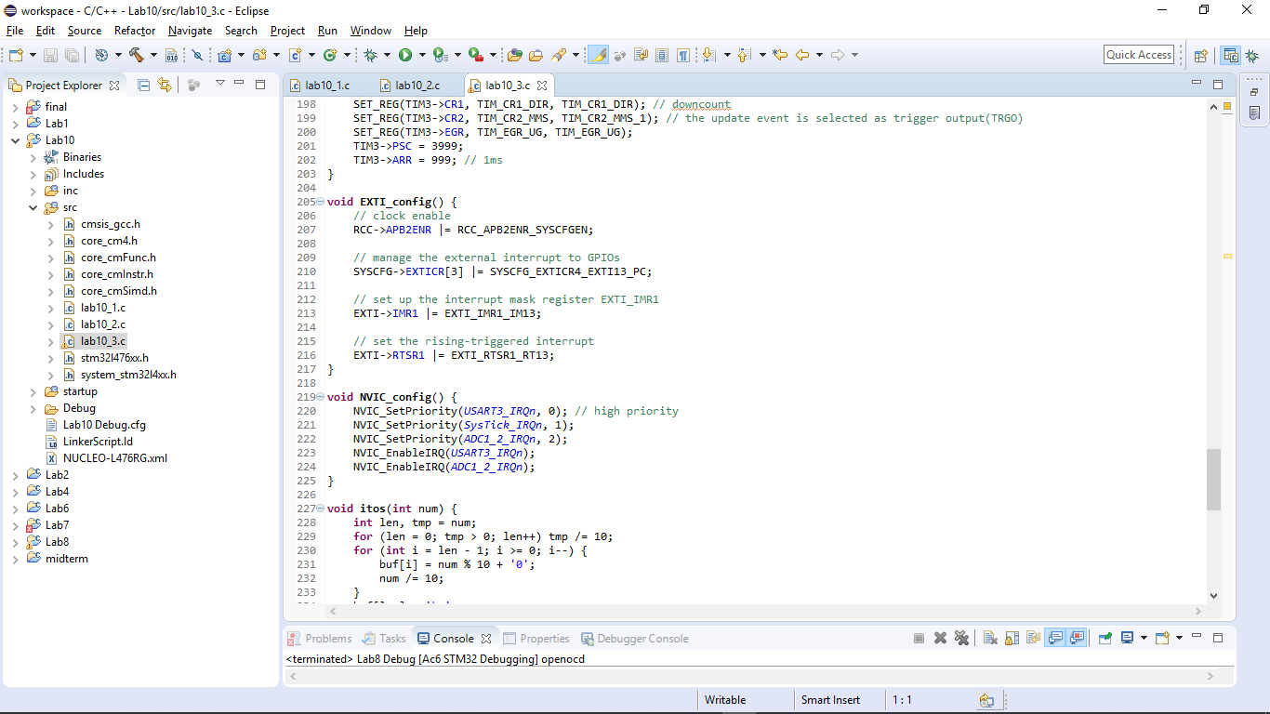

# Results and analysis 實驗結果與分析

ADC converts waveforms to digital data through different sampling rate and resolutions, and it’s a balance between the data size and the accuracy.

1. **Conclusions and ideas 心得討論與應用聯想**

Writing a simple shell is really useful for monitoring the machine status and input commands. This will be useful for projects more complicated in the future.