Lab4 STM32 GPIO System

0516076 施威綸

# Lab objectives 實驗目的

* Understand the principle of using STM32 basic I/O port
* Design a simple LED marquee program
* Understand the use of buttons and DIP switches

# Steps 實驗步驟

* 1. **LED pattern displayer**

Refer to the tutorial on the lecture slide for finishing the initialization of GPIO output and constructing 4 active low LED circuits. (Turn off the LED when GPIO output “1”, and turn on when GPIO output “0”)

Connect the LEDs to PB3, PB4, PB5, PB6 on the board.

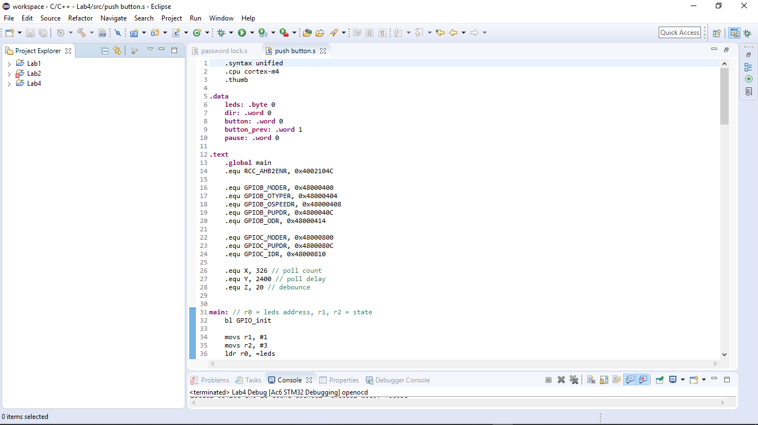

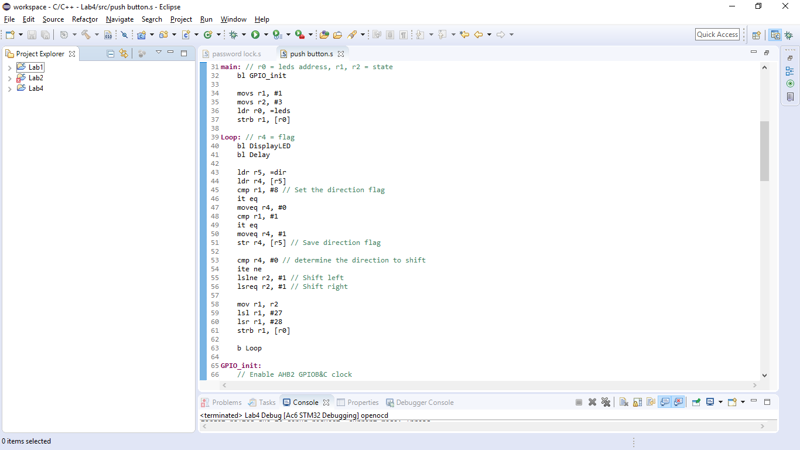

Initial the bus clock and setup the GPIO registers and pins

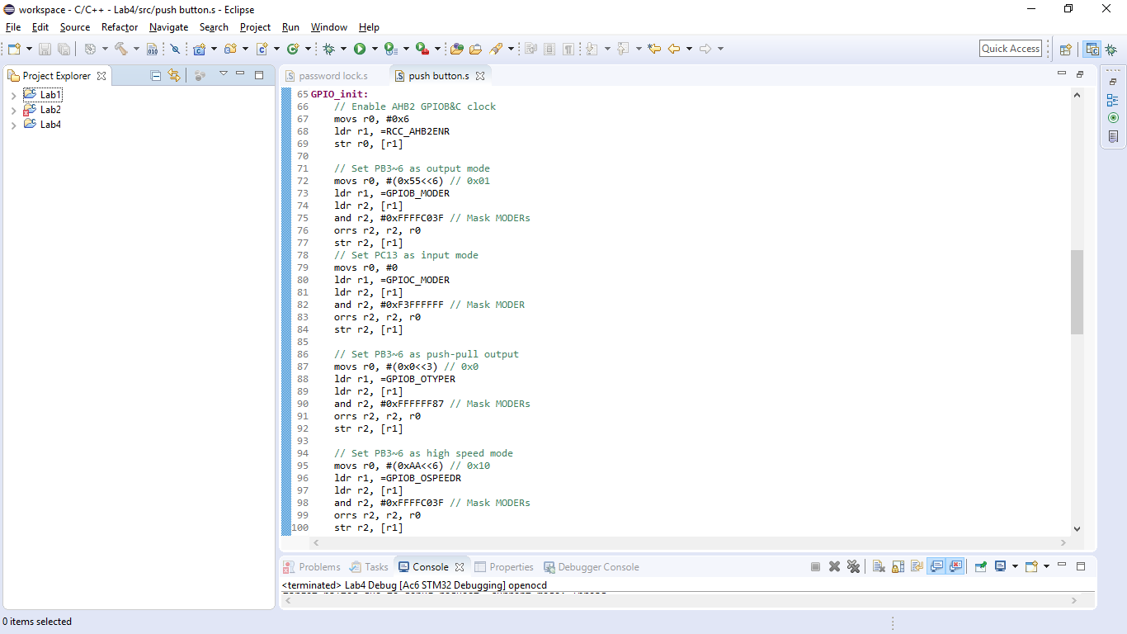

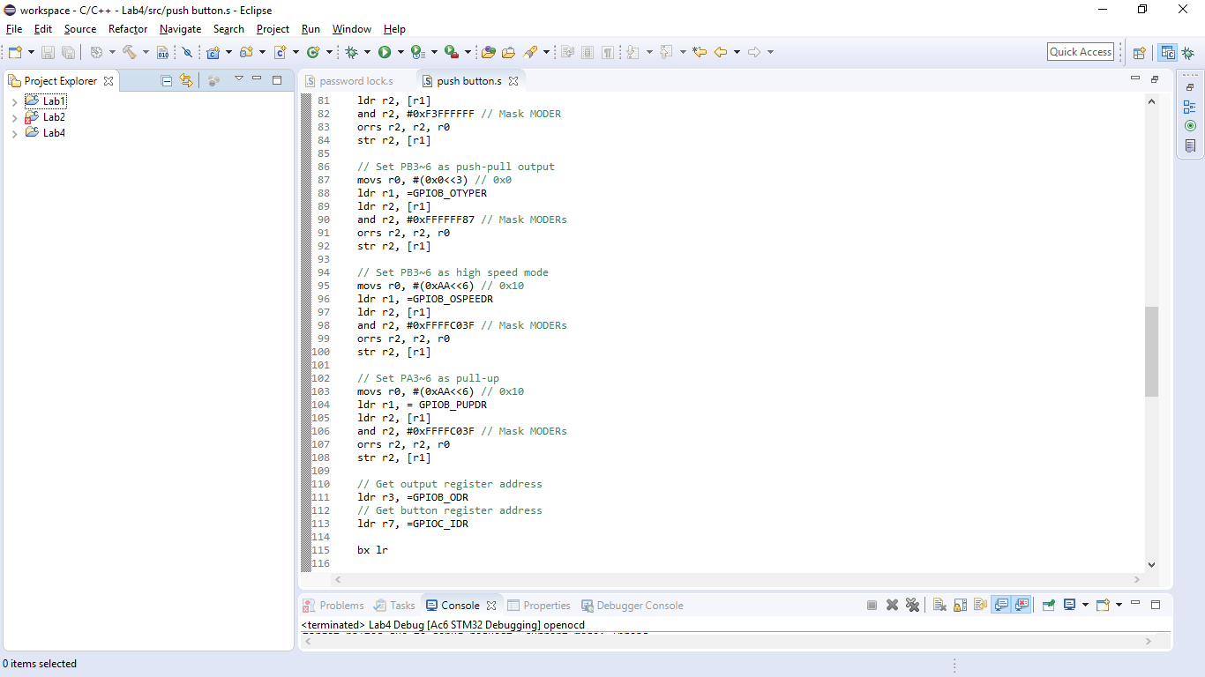

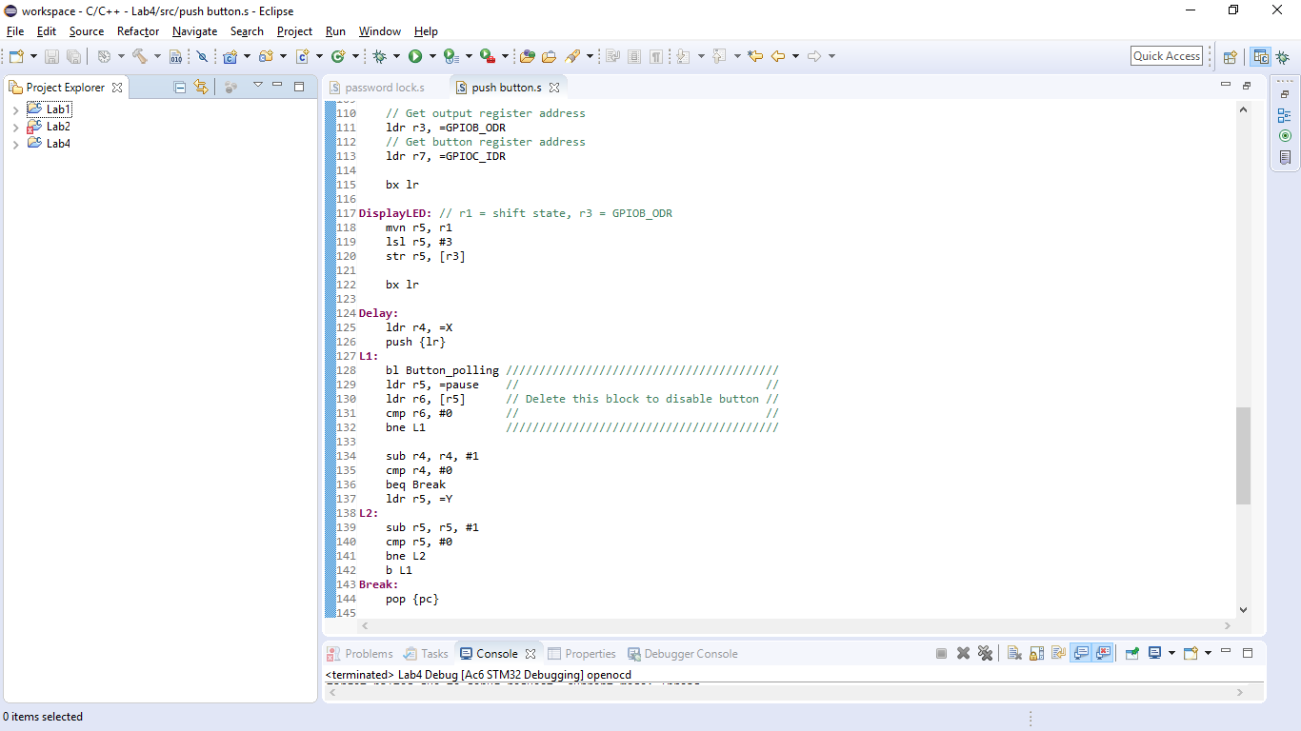

* 1. **Push button**

Initialize GPIO PC13 as pull-up input and design a program to polling the state of the user button on board. Controlling the scrolling of the LEDs (Lab4.1) stop and start by a click on the button. (click once to stop scrolling and once more to start scrolling)

The user button on board is connected to PC13. Refer to the lecture slides or STM32L476 datasheet to complete the initialization of GPIOC.



We use the previous code and add some sections below:

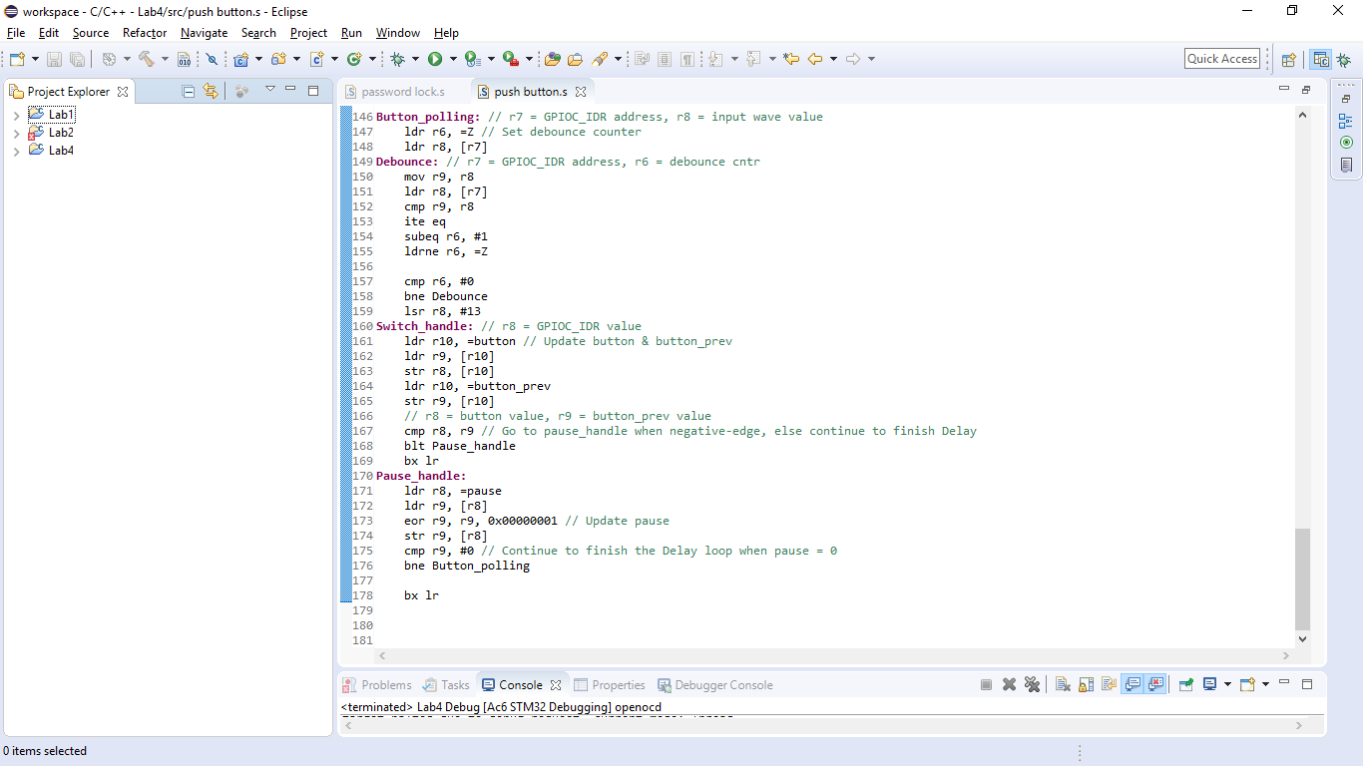

The flow chart of button function.

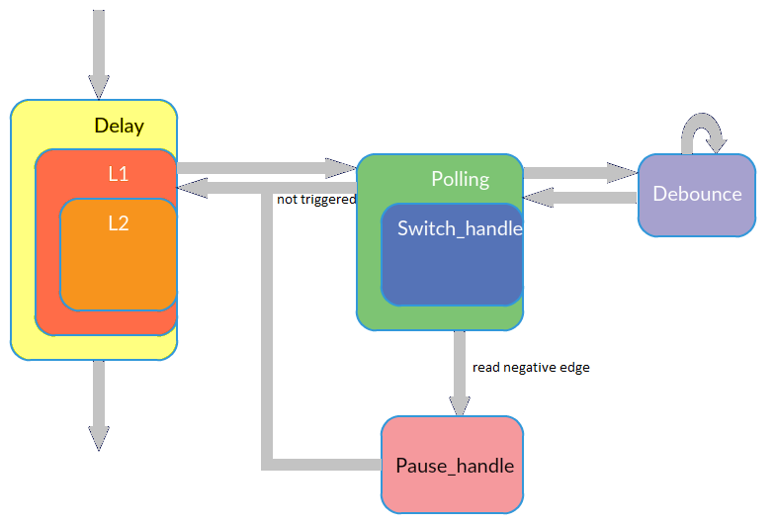

* 1. **Password lock**

Use breadboard to construct an active low DIP switch circuit and connect P0~P3 to GPIO pins on board.

Declare a 1-byte global variable “password” and implement a simple 4 bits coded lock.

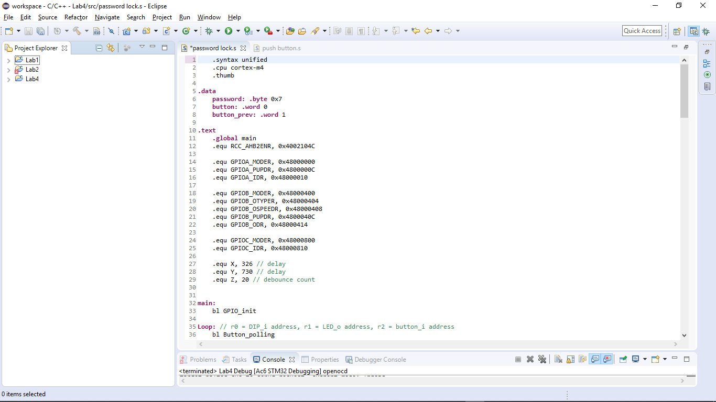

The main loop.

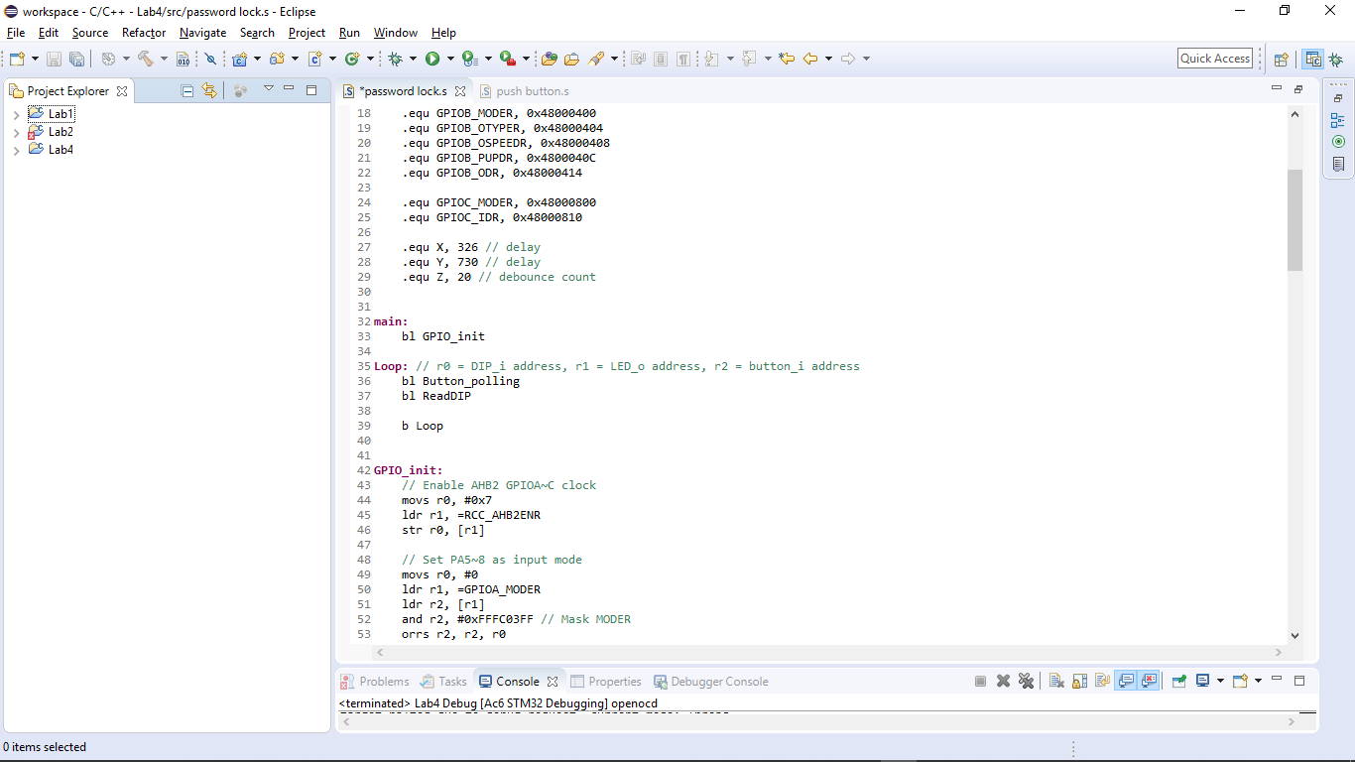

Initialization.

DIP switch connects PA5~8, LEDs connect PB3~6, and button is at PC13.

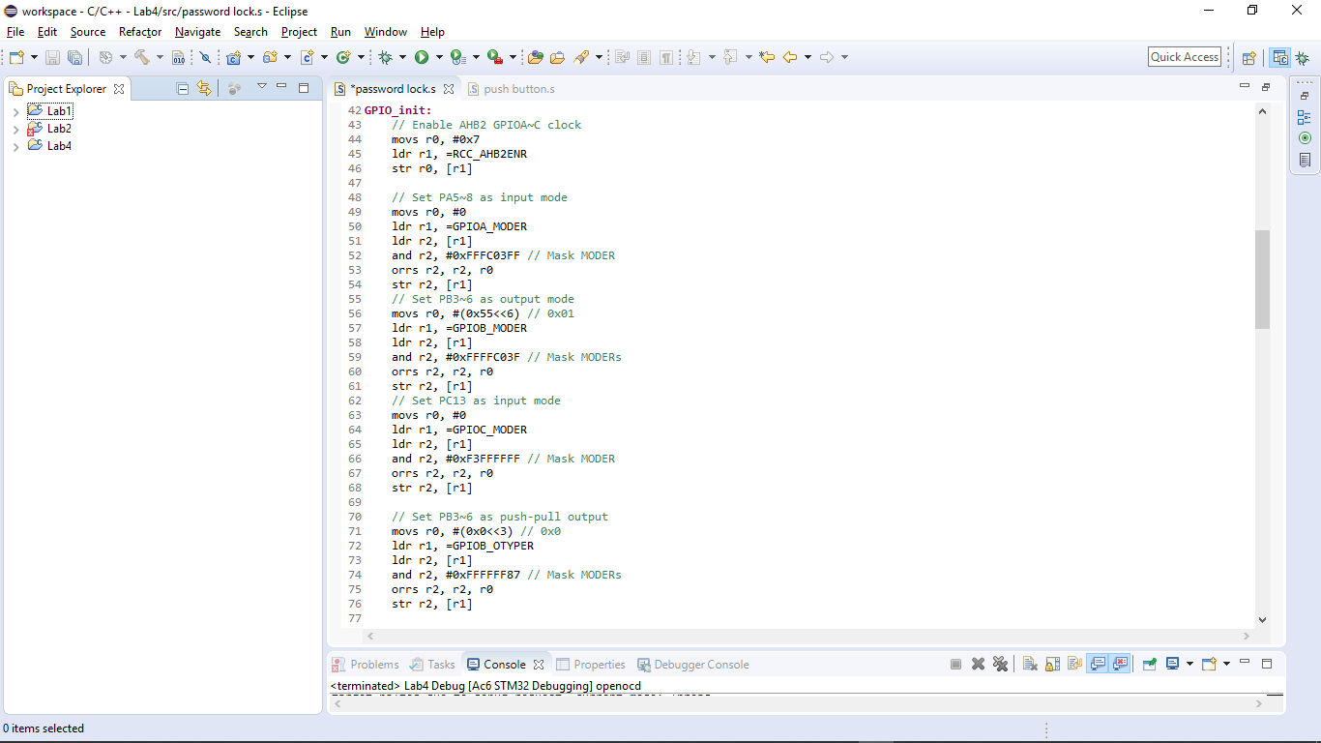



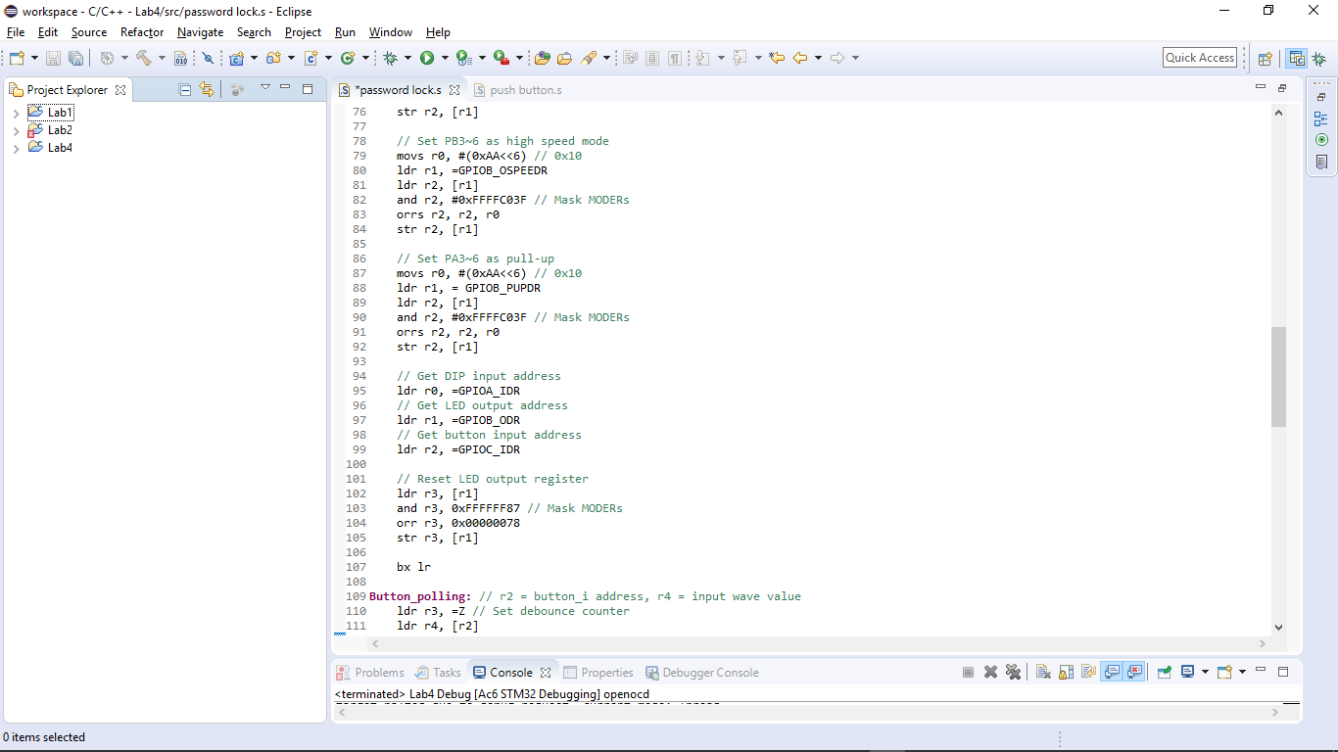

Omit the button part. It’s the part of checking password below.

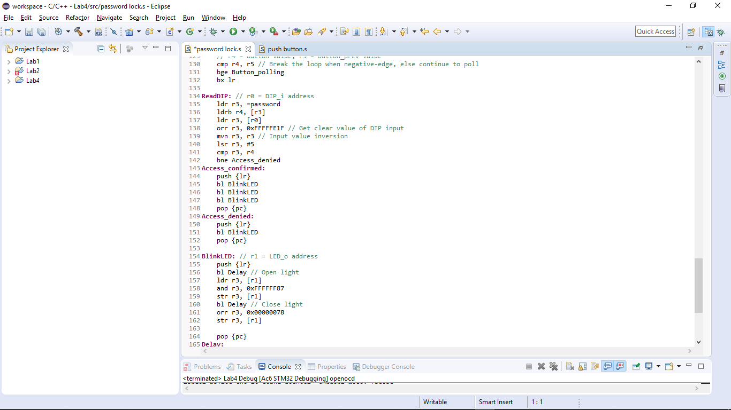



Last but not least, the delay function.

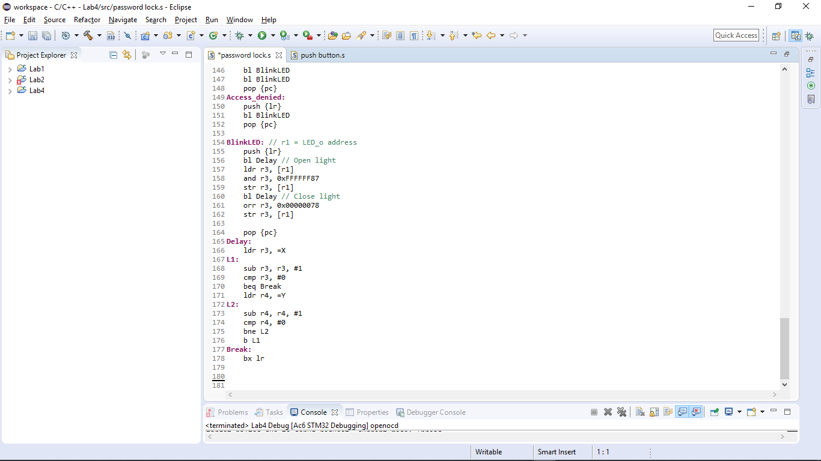

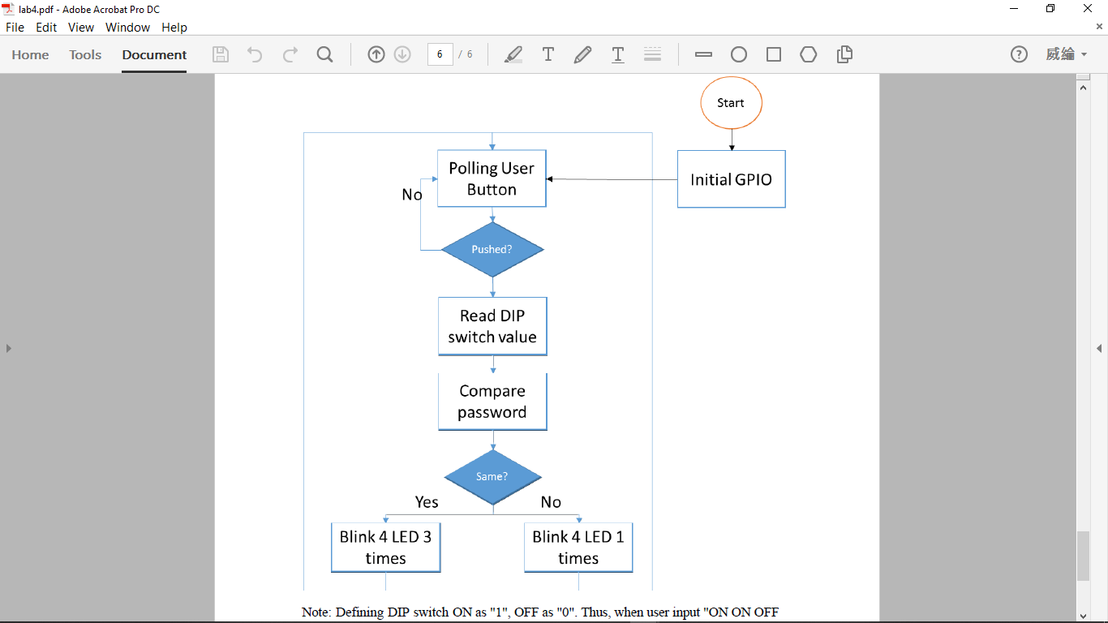

# Results and analysis 實驗結果與分析

Here is the circuit, which LED and DIP switch are active low.

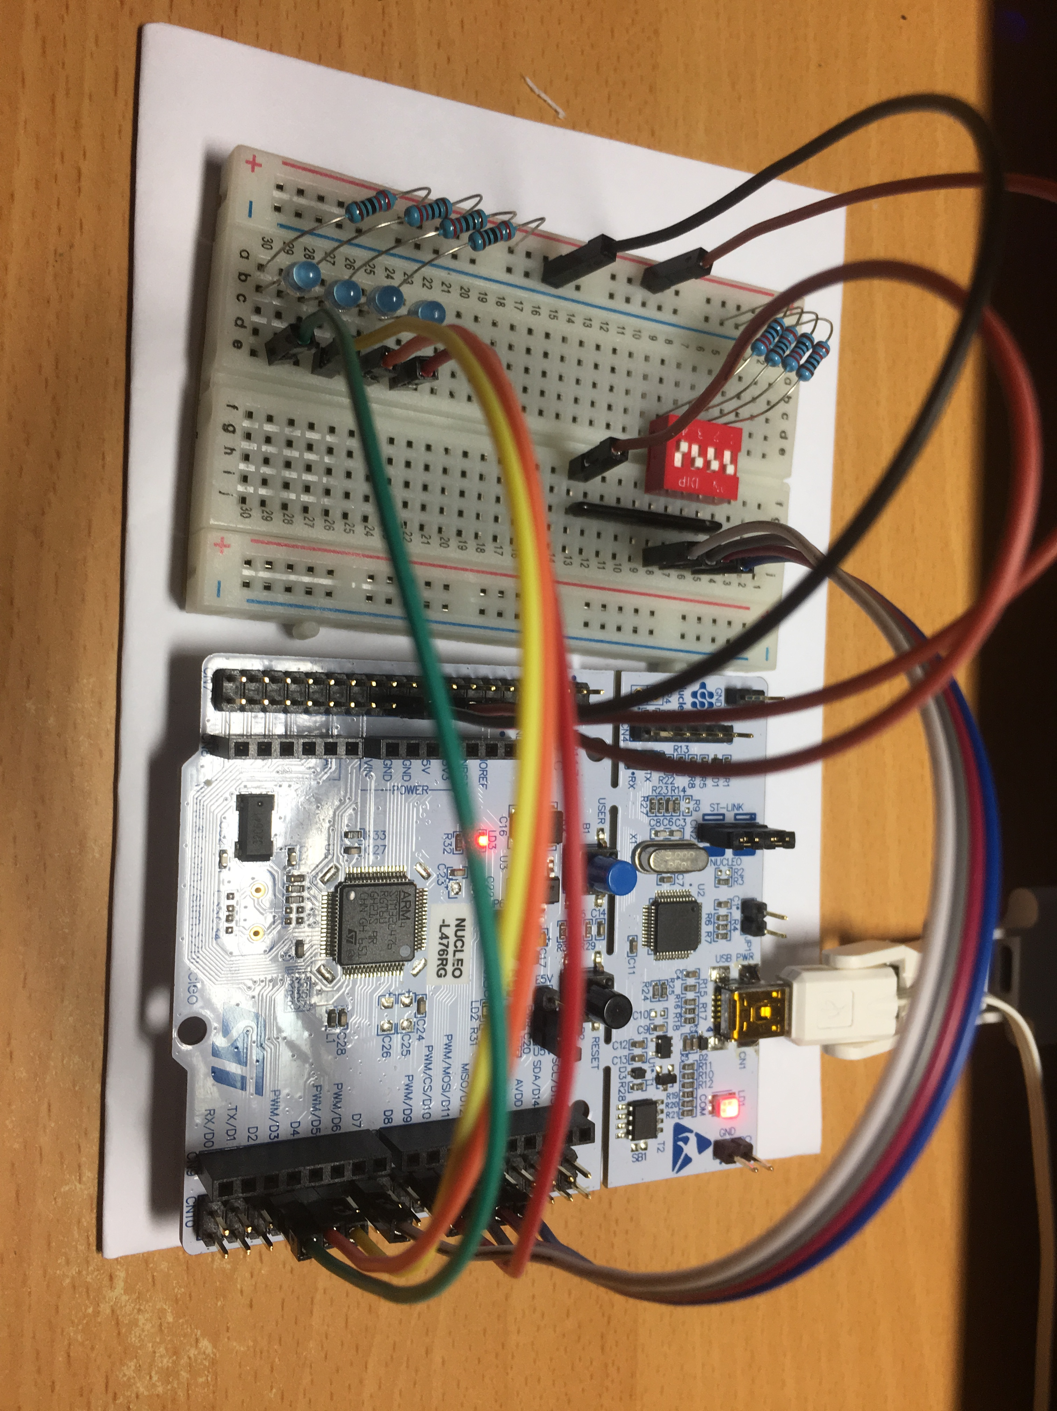

1. **Conclusions and ideas 心得討論與應用聯想**

This lab is a completely different world from previous labs. It took me a lot of time from understanding the circuit to get used of assembly programming logic. It’s hard to believe that I spent nights on it. But it still gave me a large sense of accomplishment after seeing the result.