Lab.6 STM32 Keypad Scanning

0516076 施威綸

# Lab objectives 實驗目的

* Understand the principle of STM32
* Use C code to control STM32
* design program for 7-seg LED and keypad

# Steps 實驗步驟

* 1. **Max7219 displayer**

Modify your code in lab5.2 to make it callable by C. Add a C file to complete the code given below, display your student ID on 7-Seg LED.

Modify the assembly code into standard procedure format:

1. Add push, pop into the function.
2. Using r0~r4 for arguments.
3. Declare the global function name.

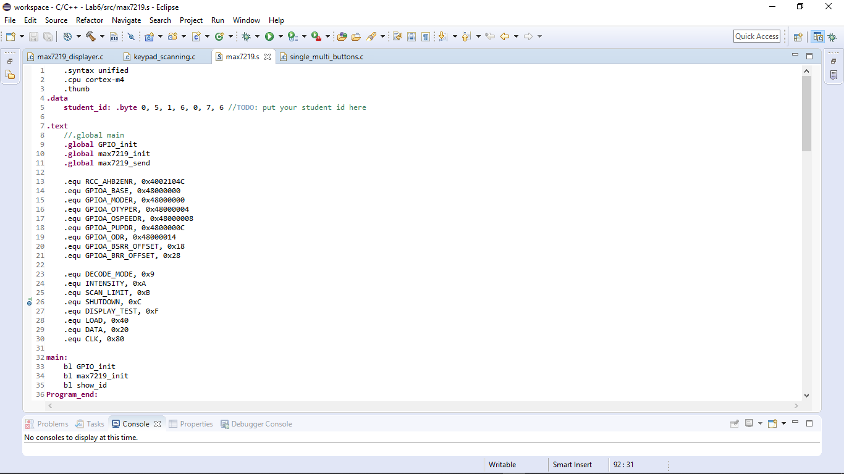

GPIO_INIT():

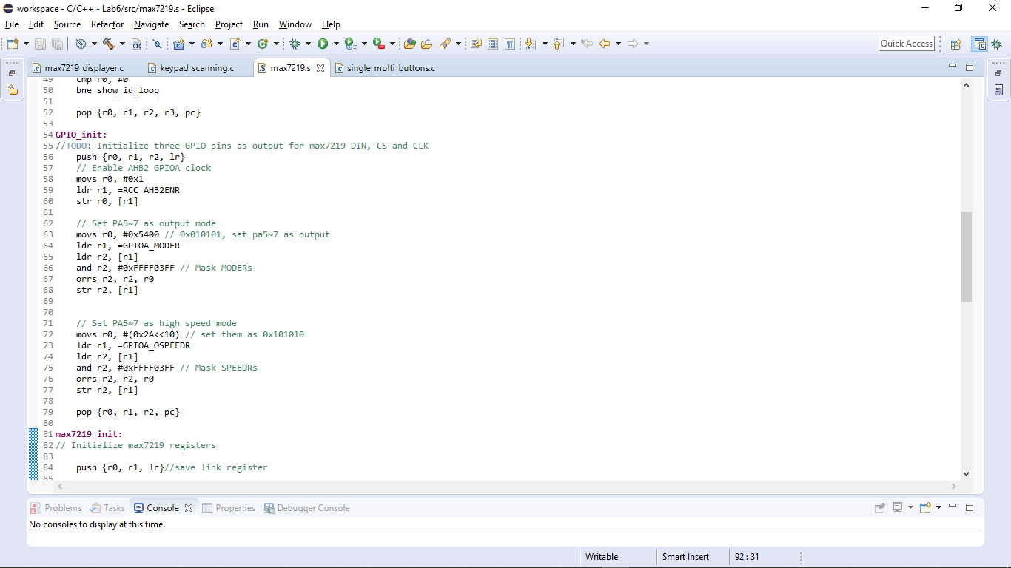

Max7219_init():

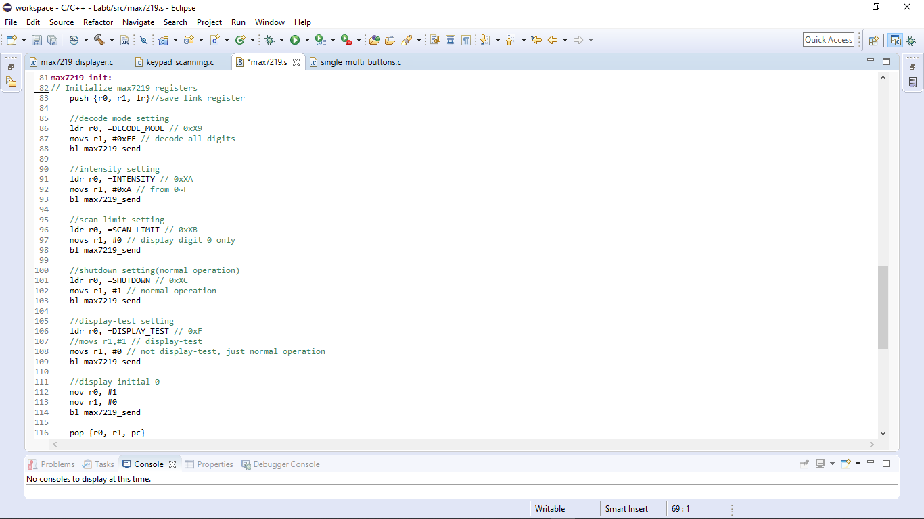

Max7219_send(int address, int data):

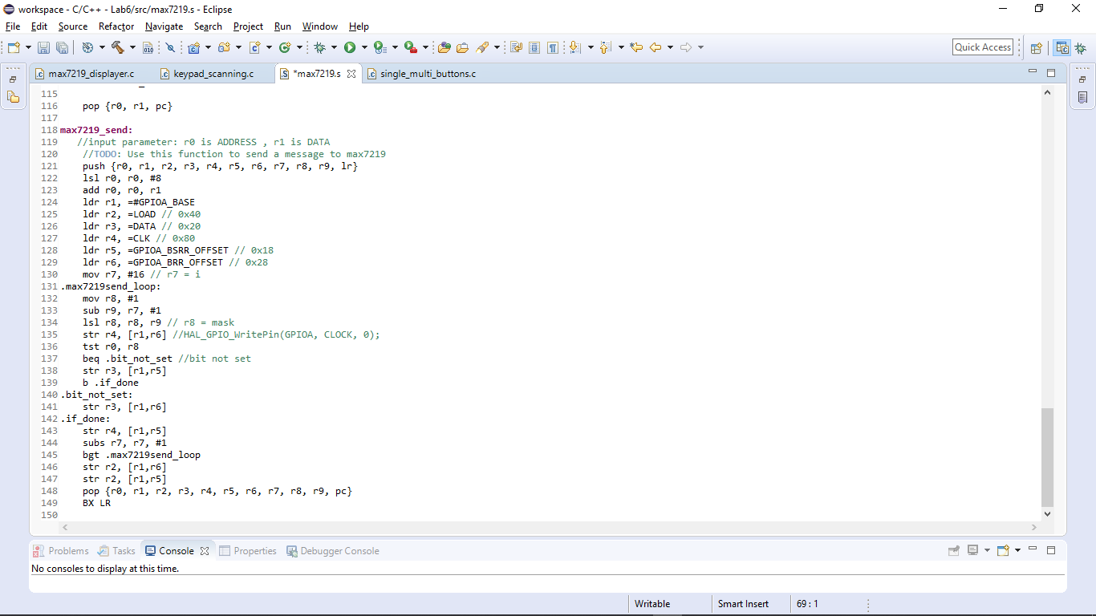

C file:

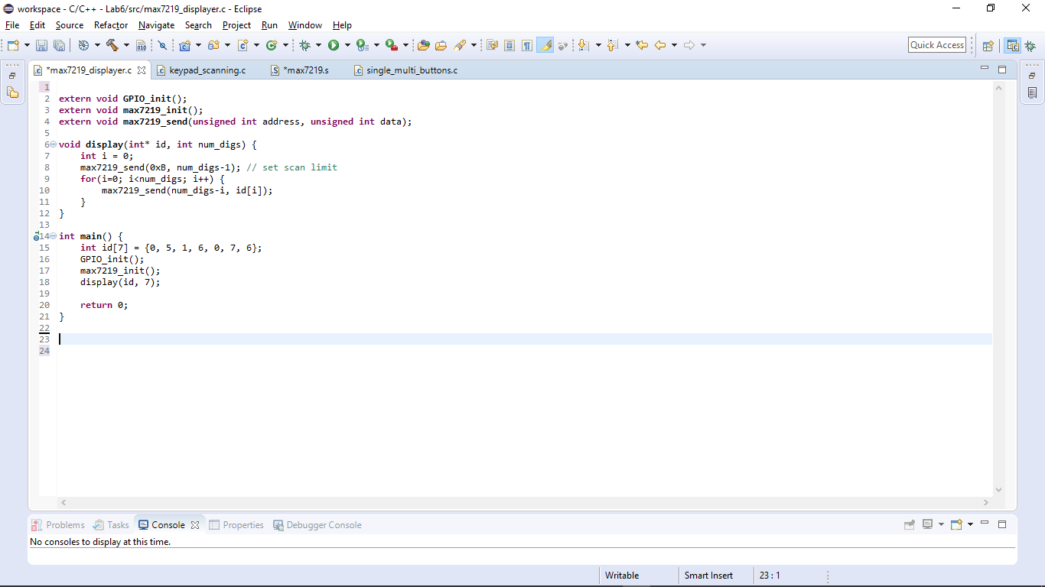

* 1. **Keypad Scanning**

Use 4 input GPIO pins and 4 output GPIO pins to connect with keypad. Show the corresponding number of pressed button on 7-SegLED.

1. Include stm32l476xx.h, and initial GPIO in the c file.
2. Scan the keypad input.
3. Pass the display value into display(), and call max7219_send().

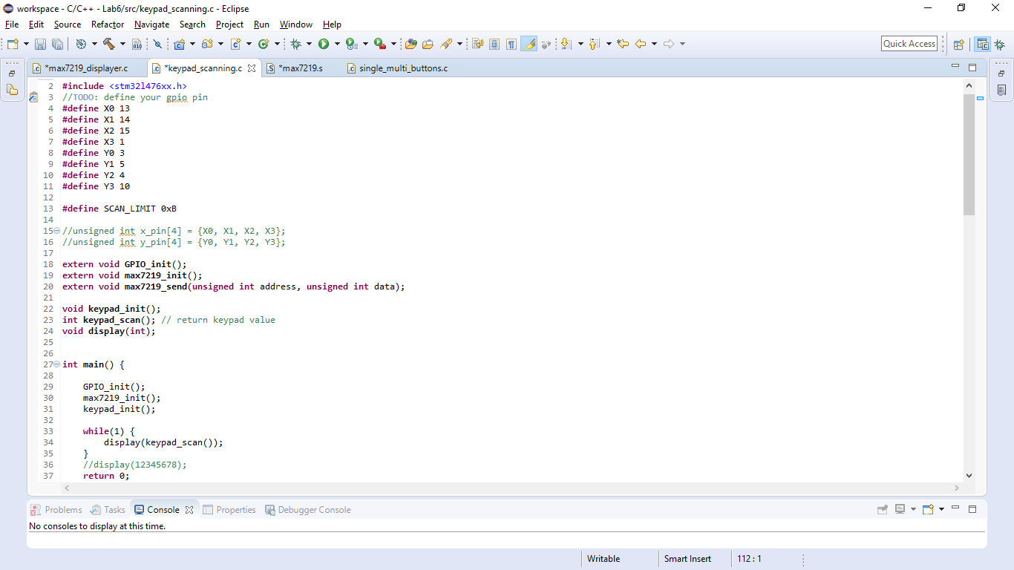

Keypad_init():

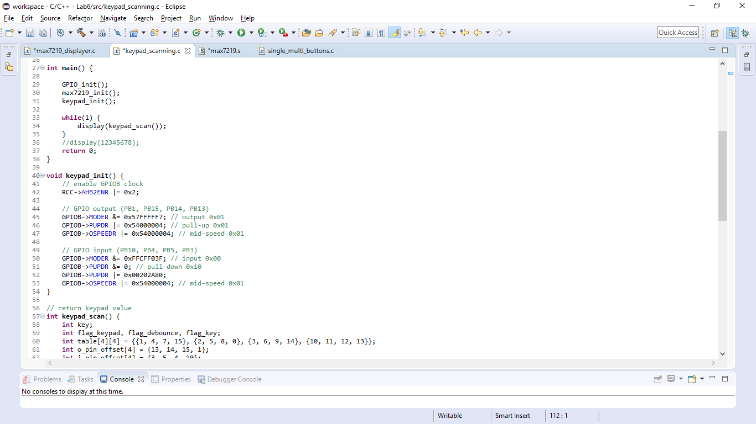

keypad_scan():

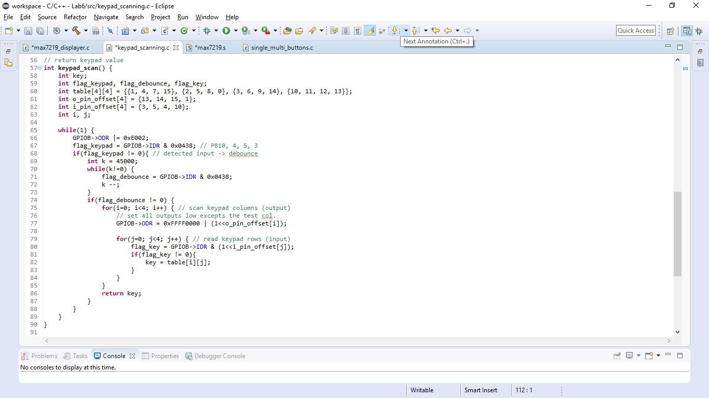

display(int): display the integer through max7219_send()

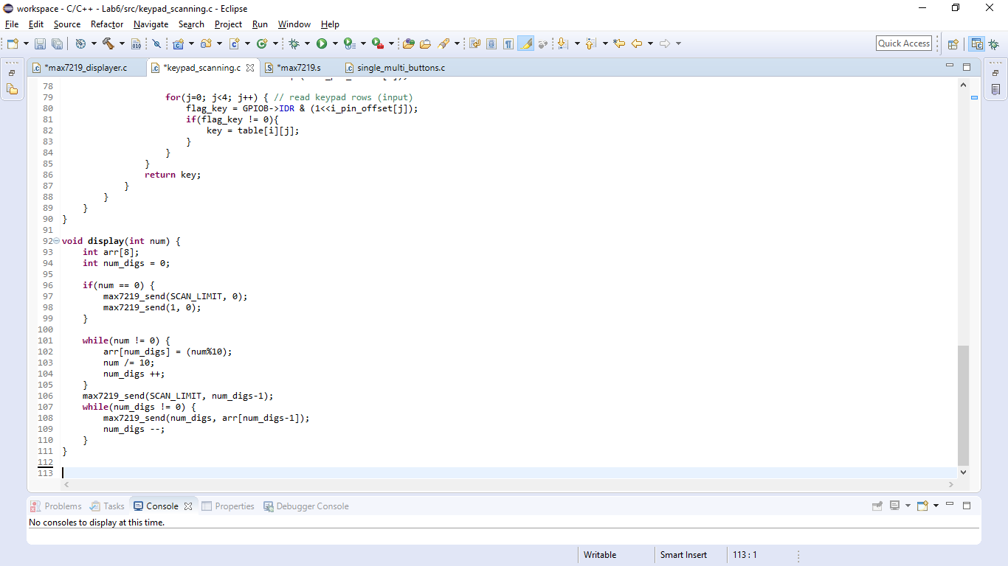

* 1. **Single and multi buttons**

Show pressed button of keypad on 7-Seg LED. Each value of corresponding button is given below.

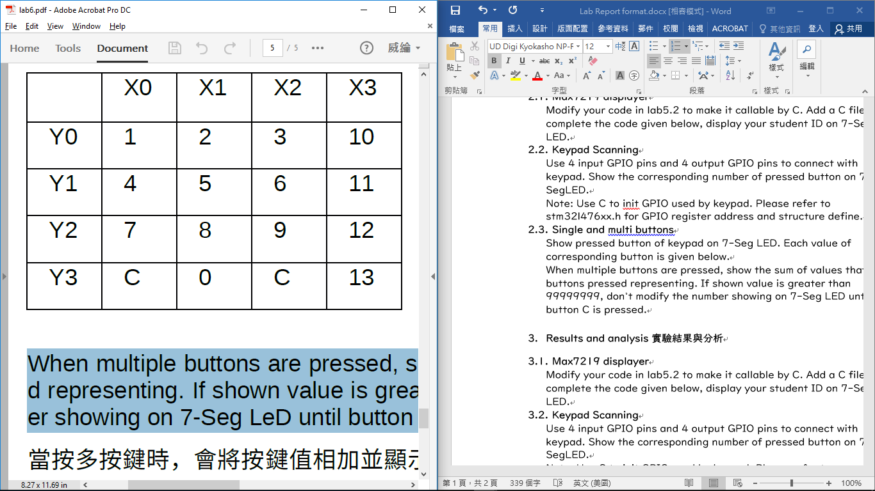

When multiple buttons are pressed, show the sum of values that buttons pressed representing. If shown value is greater than 99999999, don’t modify the number showing on 7-Seg LED until button C is pressed.

1. Same as lab6.2.
2. Modify keypad_scan() and return the sum of multiple buttons.

main():

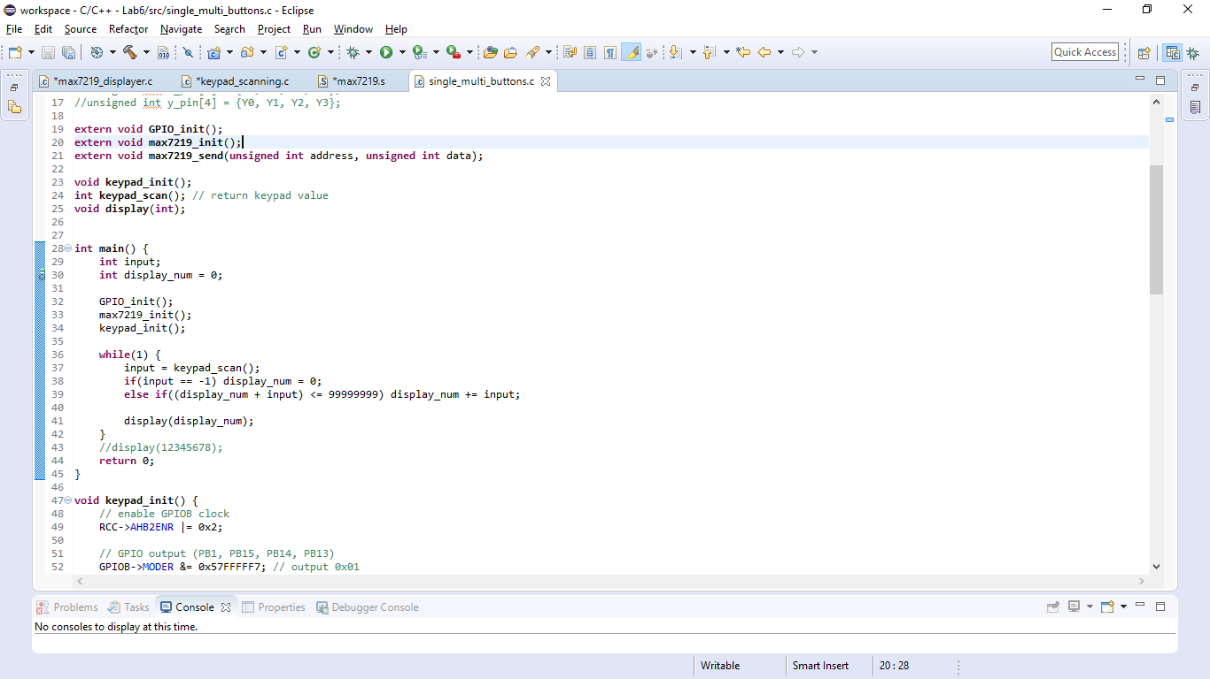

keypad_scan():

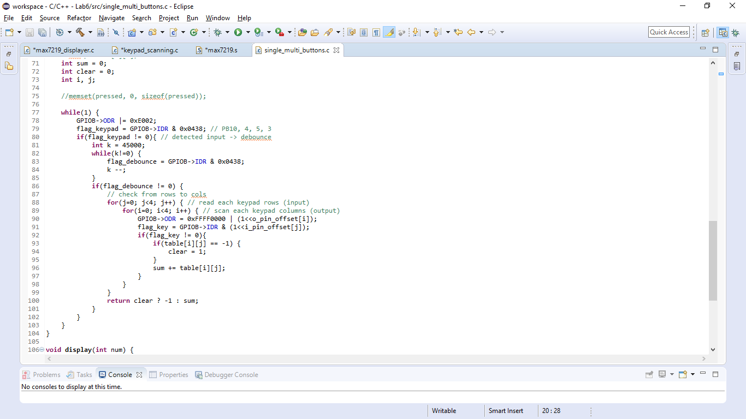

# Results and analysis 實驗結果與分析

* 1. **Max7219 displayer**

At first, I forgot to delete the global declaration of main in the assembly code, which cause multiple define.

* 1. **Keypad Scanning**

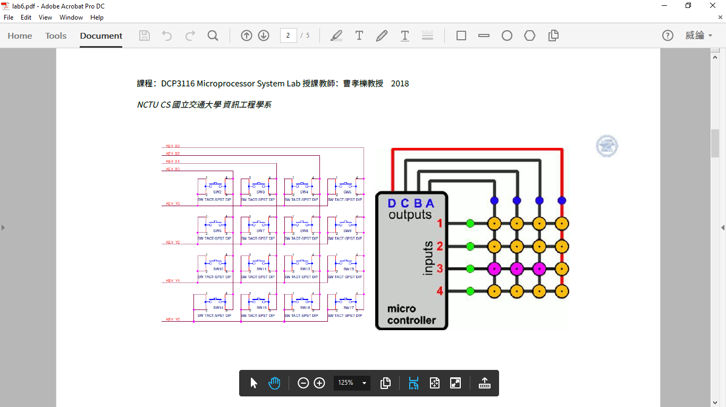

For the keypad, the output pins are PB13, PB14, PB15, PB1, and the input pins are PB3, PB5, PB4, PB10.

* 1. **Single and multi buttons**

Because of the circuit design, the scanning of pressing multi-button on the same row is not successful. We can do it by switching the input and output pin, and scan twice to check if the button is pressed.

1. **Conclusions and ideas 心得討論與應用聯想**

In this lab, I have learned more about other input/output devices. Though writing C seems to be easier, compare to assembly code, this lab still cost me a lot of time, such as clarify the concepts or the code in Lab5. The only thing I hope is that the exam tonight will go well.