STM32 bus architecture notes

Preamble
This article refers to a number of articles for learning and summary, only for personal learning, to provide reference and learning for others, but also to summarize their own learning knowledge, and hope that there are errors, please technical tips to correct, Make progress to each other. If there is any infringement, please contact me immediately to delete it.
Source of learning reference:
Original:https://blog.csdn.net/ivy_reny/article/details/56274412 Author: ivy_reny Source: CSDN
Original:http://www.elecfans.com/emb/danpianji/20180613694692.html Author: Unknown Source: electronic enthusiasts

1.AMBA
AMBA is a SOC (System of Chip) bus standard with AMBA 1.0 / 2.0 / 3.0 standard.
A bus architecture defined by AMBA:
AHB (Advanced High-performance Bus) Advanced High Performance Bus
ASB (Advanced System Bus) Advanced System Bus
APB (Advanced Peripheral Bus) Advanced Peripheral Bus
AXI (Advanced eXtensible Interface) Advanced Expandable Interface
Among them, AHB has high speed and can be connected to chips, or equipped with fast and efficient modules such as memory and DMA.
The APB frequency is low and can be bridged by AHB via BUS-BRIDGE. It is often used for peripheral devices with lower speed requirements and is called peripheral bus.
AXI: A product of the AMBA 3.0 standard, in which the AXI bus is used in the STM32F7. Compared with the AHB, the frequency is not only high, the data width is wide and large, and the data and address channels are separated.

2. The role of the bus
The chip's read module, memory operation, communication between modules, etc. are done through the bus.
where:
address bus: can be used to transfer address values
data bus: can be used to transfer data values
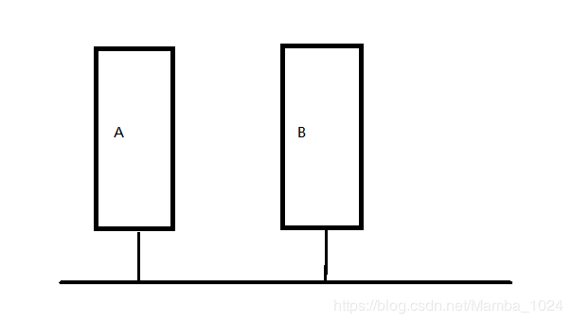
As device A and device B communicate, A sends data to the bus, and B can read A data through the bus.
It can be seen that the A device and the B device belong to the same bus and can directly interpret data and addresses.
So if multiple devices belong to the same bus, how do you distinguish whether different device data is received?
I don't know if it can be considered as a combination of data and address to identify which device is communicating.
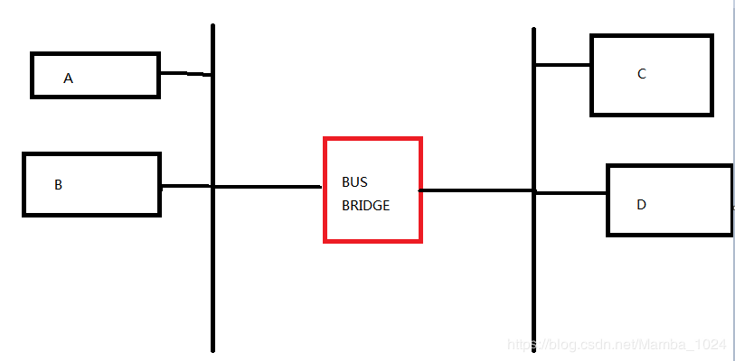
As shown in the figure, AB is on the same bus and CD is on the other bus. If A/B wants to communicate with C/D? Can addresses and data be interpreted directly?
No, a bus bridge is required to act as a translation.
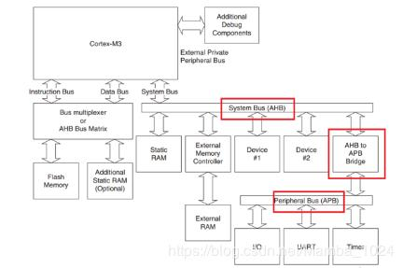
is shown in the bus architecture in m3.
The FLASH and SRAM (Optional) part of the M3 core is connected to the kernel by the instruction bus/data bus via the bus matrix, and the connection between the AHB and the kernel belongs to the system bus, and the SBA is on the AHB bus. Other devices such as external memory controllers can be seen to be connected to the APB bus via the AHB-APB bridge, and other peripherals such as IO and UART are provided on the APB. . . .

3. M7 bus architecture
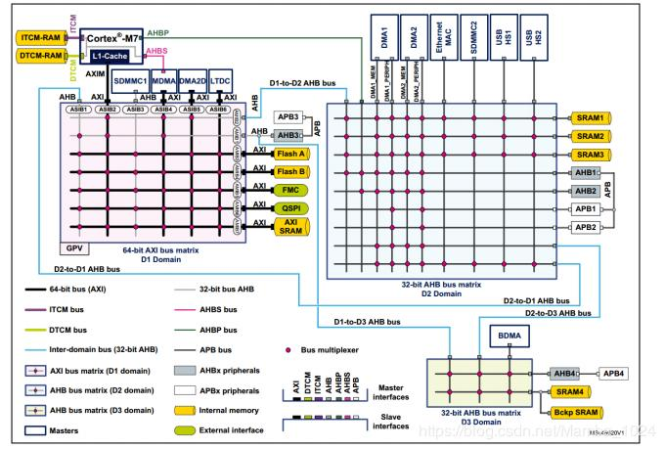
The M7 bus architecture can be divided into multiple domains: D0/D1/D2 domains.
where
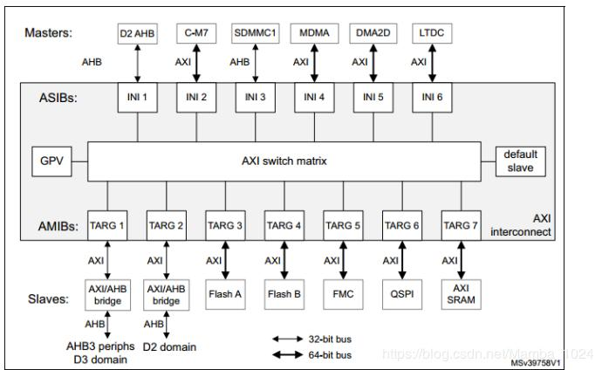
ASIBs: slave interface for connecting to the master device
AMIBs: main interface for connecting slave devices
The master device, such as CPU/DMA/LTDC, can perform the bus operation, that is, the actual read and write operations; and the response to the operation is that the slave device, that is, the master device can access the slave device. .
Take the D1 domain as an example:
The slave device is AHB3/FLASHA, and the master device is LTDC, DMA2D, etc.
access permission: Master device can access slave device
such as:
DMA2D of D1 domain can access FLASHA through 64 matrix;
USB1 of D2 domain can access SRAM1 through AHB matrix;
The DMA2D of the D1 domain can access the master device of the D2 domain via the D1-TO-D2 AHB BUS;
The DMA2 of the D2 domain can access the master device of the D1 domain via the D1-TO-D2 AHB BUS;
(The specific method depends on the point inside the matrix to indicate the connection, and remember that the master device accesses the slave device)

3.1 Matrix
The role of the matrix is ​​to connect the master and slave devices according to the access relationship.
Therefore, multiple slave devices can access the master device in parallel, for example, when multiple slave devices access a master device, how does it work?
Only one slave can access the master at a time, so priority participation is required when multiple slaves access the same master.
There is an arbiter inside the matrix, which can be used to prioritize each slave device according to its priority.

