OpenOCD添加第三方設備支持:HT32F52352 Cortex-M0+
2022-02-18 13:44:59 【CharX】

本項目已開源，倉庫地址:openocd-extension: Fork of openocd-org/openocd(https://github.com/openocd-org/openocd)Openocd with third party target suppporthttps://gitee.com/char-x/openocd-exptension

參加合泰杯比賽的時候拿到了一片HT32F52352開發板，尋思著初賽準備時間比較長正好這個時候我也想在Linux下面進行嵌入式開發；而OpenOCD我很早就已經瞭解，但是一直都沒有使用過，於是就借此機會學習一下在Linux中使用OpenOCD調試ARM設備。
開發板上板載了一個e-link32 Lite，其實就是一個CMSIS-DAP，不過只支持SWD方式。在Holtek官網找到芯片手冊，芯片大致信息:
- 32-bit Arm Cortex-M0+ 處理器內核（基於ARMv6-M）
- 128KB 片上 Flash 存儲器用作指令 / 數據和選項存儲
- 16KB 片上 SRAM
- Flash 存儲器控制器 – FMC
- 內部總線矩陣連接 AHB-Lite 接口，單循環 I/O 口和調試訪問端口 (DAP)
- 串行線調試端口 (SW-DP)
ARM芯片大多數都遵循CMSIS協議，OpenOCD也自帶了調試接口，這也就意味著芯片的DAP不需要我們自己設計。而 HT32F52352芯片沒有被OpenOCD官方分支收錄(怎麼會被收錄呢)，這個其實就是沒有對應的target規則和flash燒寫規則，需要我們自己去編寫，因此本文主要是編寫針對HT32F52352的target文件和flash文件。
要讓OpenOCD能夠找到我們編寫的芯片信息，需要進行如下步驟：(引用)
在./tcl/target中,添加自己設備的.cfg文件,此文件用於編譯後傳遞到scripts中供用戶調用，此文件用於編譯後傳遞到scripts中供用戶調用
在./src/flash/nor中,添加自己設備的.c文件,此文件用於告知openocd你文件的flash燒錄流程，此文件用於告知openocd你文件的flash燒錄流程
在 /src/flash/drivers.c中,添加自己設備的設備名,此處讓openocd知曉你的設備.，此處讓openocd知曉你的設備.
在flash/nor中,更改Makefile.am,令openocd的編譯過程可以引用到你剛剛添加的文件.，令openocd的編譯過程可以引用到你剛剛添加的文件.
ht32f523xx.cfg
target文件參照自帶的stm32l0.cfg來改寫
根據OpenOCD官方的文檔，一個target的cfg文件應該以如下方式開頭：
source [find target/swj-dp.tcl]
source [find mem_helper.tcl]

if { [info exists CHIPNAME] } {
set _CHIPNAME $CHIPNAME
} else {
#stm32l0 refer to your device
set _CHIPNAME stm32l0
}
貼出完整文件:(ht32f523xx.cfg),這個比較簡單，看註釋即可
#
# M0+ devices only have SW-DP, but swj-dp code works, just don't
# set any jtag related features
#

source [find target/swj-dp.tcl]
source [find mem_helper.tcl]

if { [info exists CHIPNAME] } {
set _CHIPNAME $CHIPNAME
} else {
set _CHIPNAME ht32f5xxxx
}

set _ENDIAN little

# Work-area is a space in RAM used for flash programming
# By default use 2kB (max ram on smallest part)
if { [info exists WORKAREASIZE] } {
set _WORKAREASIZE $WORKAREASIZE
} else {
set _WORKAREASIZE 0x0800
}

# JTAG speed should be <= F_CPU/6.
# F_CPU after reset is ~2MHz, so use F_JTAG max = 333kHz
adapter speed 300

adapter srst delay 100

if { [info exists CPUTAPID] } {
set _CPUTAPID $CPUTAPID
} else {
# Arm, m0+, non-multidrop.
# http://infocenter.arm.com/help/index.jsp?topic=/com.arm.doc.faqs/ka16088.html
# you can also find this id in keil MDK
set _CPUTAPID 0x0bc11477
}

swj_newdap $_CHIPNAME cpu -expected-id $_CPUTAPID
dap create $_CHIPNAME.dap -chain-position $_CHIPNAME.cpu

#diffirent of v0.10.x,in OpenOCD v0.11.x it should use -dap instead of -chain-position
set _TARGETNAME $_CHIPNAME.cpu
target create $_TARGETNAME cortex_m -endian $_ENDIAN -dap $_CHIPNAME.dap

$_TARGETNAME configure -work-area-phys 0x20000000 -work-area-size $_WORKAREASIZE -work-area-backup 0

# flash size will be probed
set _FLASHNAME $_CHIPNAME.flash
flash bank $_FLASHNAME stm32lx 0 0x00020000 0 0 $_TARGETNAME

reset_config srst_nogate

#I don't know what the following is
if {![using_hla]} {
# if srst is not fitted use SYSRESETREQ to
# perform a soft reset
cortex_m reset_config sysresetreq
}
$_TARGETNAME configure -event reset-start {

#default speed
adapter speed 300
}

$_TARGETNAME configure -event examine-end {

#close DBG_WDT
mmw 0x40088304 0x00000008 0
}

ht32f523xx.c
此處開始討論flash處理程序
首先要知道芯片片內FLASH的操作外設信息，此處貼出HT32F52352的官網資料:(主要信息)
片內FLASH控制器為FLASH Manage Controller(FMC)，其掛載在AHB總線上，複比特後默認時鐘為開啟。FMC提供頁擦除，整片擦除，字編程，頁保護等功能
操作步驟具體參考芯片廠家的描述，對於HT32F52352的FMC，其字編程流程為:
- 寫入編程地址(4 bytes align)到TADR寄存器(0x000 offset)
- 寫入要寫入的數據(4 bytes)到WRDR寄存器 (0x004 offset)
- 向OCMR寄存器的CMD[3:0]比特寫入操作命令{0x4 字編程；0x8 頁擦除；0xA 整片擦除} (0x00C offset)
- 檢查OPCR寄存器的OPM[4:1]比特 {0x6 第一次前空閒,0xE 操作完成空閒,other FMC繁忙} (0x010 offset)
- 當OPM為0x6活0xE時，向OPM寫入0xA以執行命令
- 完成
在flash中主要要做的是把FMC各個外設寄存器的地址以及操作命令，狀態參數等通過宏定義聲明在文件內。對每個實現構造函數，openocd的編輯腳本採用的是嚴格的編譯檢查，因此每個需要被回調的函數的返回值，參數類型，參數個數都要於openocd聲明的嚴格一致。
參照官方的stm32lx.c（l0系列也是Cortex-M0+）以下是寫出的程序:
程序中其實還有一些部分沒有實現，主要是片內flash保護和info獲取，因為本人覺得這兩個功能不怎麼用得上，需要的話按照手冊上的說明構造對應的函數，在flash_driver結構體的protect元素中賦值對應函數的指針即可。
(可以clone源碼再來看，文件路徑是 src/flash/nor/ht32f523xx.c)
#ifdef HAVE_CONFIG_H
#include "config.h"
#endif

#include "imp.h"
#include <helper/binarybuffer.h>
#include <target/algorithm.h>
#include <target/armv7m.h>
#include <target/cortex_m.h>

/*******HT32F523xx Flash Manager Contorler(FMC) regisister location*******/
#define FMC_REG_BASE 0x40080000 /*FLASH Manager Contorller base addr */
/*************************************************************************/
#define FMC_REG_TADR 0x000 /*FLASH ADDR REG */
#define FMC_REG_WRDR 0x004 /*Data for writing REG */
#define FMC_REG_OCMR 0x00C /*Operation CMD REG */
#define FMC_REG_OPCR 0x010 /*Operation CTRL REG */
#define FMC_REG_OIER 0x014 /*Interrupt ENABLE REG */
#define FMC_REG_OISR 0x018 /*Interrupt STATUS REG */
#define FMC_REG_PPSR 0x020 /*Page erase/Programming protect STATUS REG */
#define FMC_REG_CPSR 0x030 /*Safety protection STATUS REG */
#define FMC_REG_VMCR 0x100 /*Vector mapping CTRL REG */
#define FMC_REG_MDID 0x180 /*Manufacture and Microcontroller ID REG */
#define FMC_REG_PNSR 0x184 /*Pages STATUS REG */
#define FMC_REG_PSSR 0x188 /*Size of page STATUS REG */
#define FMC_REG_CFCR 0x200 /*Cache and pre-read control REG */
#define FMC_REG_CIDR0 0x310 /*User-defined ID REG0 */
#define FMC_REG_CIDR1 0x314 /*User-defined ID REG1 */
#define FMC_REG_CIDR2 0x318 /*User-defined ID REG2 */
#define FMC_REG_CIDR3 0x31C /*User-defined ID REG3 */
/*************************************************************************/

/***************************FMC OPRC regisister***************************/
#define FMC_OPM_MASK 0x1E
#define FMC_COMMIT (0xA << 1)
#define FMC_FINISHED (0xE << 1)
#define FMC_START (0x6 << 1)
/*************************************************************************/

/***************************FMC OCMR regisister***************************/
#define FMC_CMD_MASK 0xF
#define FMC_CMD_WORD_PROG 0x4
#define FMC_CMD_PAGE_ERASE 0x8
#define FMC_CMD_MASS_ERASE 0xA
/*************************************************************************/

/***************************FMC option byte regisister***************************/
#define OPTION_BYTE_BASE 0x1FF00000
#define OPT_OB_PP 0x000
#define OPT_OB_CP 0x010

/*************************************************************************/

#define FLASH_ERASE_TIMEOUT 1000 /*timeout count*/

/*Command flash bank ht32f523xx <base> <size> 0 0 <target>*/
FLASH_BANK_COMMAND_HANDLER(ht32f523xx_flash_bank_command)
{
if(CMD_ARGC < 6)
return ERROR_COMMAND_SYNTAX_ERROR;

bank->driver_priv = NULL;

return ERROR_OK;
}

static inline int ht32f523xx_get_flash_status(struct flash_bank *bank, uint32_t *status)
{
struct target *target = bank->target;
return target_read_u32(target,FMC_REG_BASE + FMC_REG_OPCR, status);
}

static int ht32f523xx_wait_status_busy(struct flash_bank *bank,int timeout)
{
uint32_t status;
int retval = ERROR_OK;

for(;;){
retval = ht32f523xx_get_flash_status(bank,&status);
if(retval != ERROR_OK){
return retval;
}
if( ((status & FMC_OPM_MASK)==FMC_FINISHED) || ((status & FMC_OPM_MASK) == FMC_START) ){
return ERROR_OK;
}
if(timeout-- <= 0){
LOG_DEBUG("Timed out waiting for flash: 0x%04x", status);
return ERROR_FAIL;
}
alive_sleep(10);
}

return retval;
}

static int ht32f523xx_erase(struct flash_bank *bank, unsigned int first, unsigned int last)
{
struct target *target = bank->target;

LOG_DEBUG("ht32f523xx erase: %d - %d", first, last);

if(target->state != TARGET_HALTED){
LOG_ERROR("Target not halted");
return ERROR_TARGET_NOT_HALTED;
}

for(unsigned int i = first ; i <= last; ++i){
/*flash memory page erase*/
int retval = target_write_u32(target, FMC_REG_BASE + FMC_REG_TADR,bank->sectors[i].offset);
if(retval != ERROR_OK){
return retval;
}

retval = target_write_u32(target, FMC_REG_BASE + FMC_REG_OCMR,FMC_CMD_PAGE_ERASE);
if(retval != ERROR_OK){
return retval;
}

retval = target_write_u32(target, FMC_REG_BASE + FMC_REG_OPCR,FMC_COMMIT);
if(retval != ERROR_OK){
return retval;
}

//wait
retval = ht32f523xx_wait_status_busy(bank,FLASH_ERASE_TIMEOUT);
if(retval != ERROR_OK){
return retval;
}

LOG_DEBUG("HT32F523xx erased page %d", i);
bank->sectors[i].is_erased = 1;
}

return ERROR_OK;
}

static int ht32f523xx_protect(struct flash_bank *bank, int set, unsigned int first, unsigned int last)
{
return ERROR_FLASH_OPER_UNSUPPORTED;
}

static int ht32f523xx_write(struct flash_bank *bank, const uint8_t *buffer,uint32_t offset, uint32_t count)
{
struct target *target = bank->target;

LOG_DEBUG("ht32f523xx flash write: 0x%x 0x%x", offset, count);

if(target->state != TARGET_HALTED){
LOG_ERROR("Target not halted");
return ERROR_TARGET_NOT_HALTED;
}
if(offset & 0x03){
LOG_ERROR("offset 0x%" PRIx32 " breaks required 4-byte alignment", offset);
return ERROR_FLASH_DST_BREAKS_ALIGNMENT;
}
if(count & 0x3){
LOG_ERROR("size 0x%" PRIx32 " breaks required 4-byte alignment", count);
return ERROR_FLASH_DST_BREAKS_ALIGNMENT;
}

uint32_t addr = offset;
for(uint32_t i = 0; i < count; i += 4){
uint32_t word = (buffer[i] << 0) |
(buffer[i+1] << 8) |
(buffer[i+2] << 16) |
(buffer[i+3] << 24);

LOG_DEBUG("ht32f523xx flash write word 0x%x 0x%x 0x%08x", i, addr, word);

// flash memory word program
int retval;
retval = target_write_u32(target, FMC_REG_BASE + FMC_REG_TADR, addr);
if (retval != ERROR_OK)
return retval;
retval = target_write_u32(target, FMC_REG_BASE + FMC_REG_WRDR, word);
if (retval != ERROR_OK)
return retval;
retval = target_write_u32(target, FMC_REG_BASE + FMC_REG_OCMR, FMC_CMD_WORD_PROG);
if (retval != ERROR_OK)
return retval;
retval = target_write_u32(target, FMC_REG_BASE + FMC_REG_OPCR, FMC_COMMIT);
if (retval != ERROR_OK)
return retval;

// wait
retval = ht32f523xx_wait_status_busy(bank, FLASH_ERASE_TIMEOUT);
if (retval != ERROR_OK)
return retval;
addr += 4;
}

LOG_DEBUG("ht32f523xx flash write success");
return ERROR_OK;
}

static int ht32f523xx_probe(struct flash_bank *bank)
{
int page_size = 512;
int num_pages = bank->size / page_size;

LOG_INFO("ht32f523xxx probe: %d pages, 0x%x bytes, 0x%x total", num_pages, page_size, bank->size);

if(bank->sectors){
free(bank->sectors);
}

bank->base = 0x0;
bank->num_sectors = num_pages;
bank->sectors = malloc(sizeof(struct flash_sector) * num_pages);

for(int i = 0; i < num_pages; ++i){
bank->sectors[i].offset = i * page_size;
bank->sectors[i].size = page_size;
bank->sectors[i].is_erased = -1;
bank->sectors[i].is_protected = 1;
}

return ERROR_OK;
}

static int ht32f523xx_auto_probe(struct flash_bank * bank)
{
return ht32f523xx_probe(bank);
}

static int ht32f523xx_protect_check(struct flash_bank *bank)
{
struct target *target = bank->target;
uint32_t ob_pp[4];
uint32_t ob_cp;

//read OB_PP REG
for(int i=0; i<4; ++i)
{
target_read_u32(target,(OPTION_BYTE_BASE + OPT_OB_PP) + (i << 2),ob_pp + i);
}

//read OB_CP REG
target_read_u32(target,(OPTION_BYTE_BASE + OPT_OB_CP),&ob_cp);

LOG_INFO("ht32f523xx opt byte: %04x %04x %04x %04x %04x", ob_pp[0], ob_pp[1], ob_pp[2], ob_pp[3], ob_cp);

// Set page protection
for(int i = 0 ; i < 128; ++i){
int bit = (ob_pp[i / 32] << (i % 32)) & 1;
bank->sectors[2*i].is_protected = bit ? 0 : 1;
bank->sectors[(2*i)+1].is_protected = bit ? 0 : 1;
}

return ERROR_OK;
}

static int ht32f523xx_info(struct flash_bank *bank, struct command_invocation *cmd)
{
command_print_sameline(cmd, "ht32f523xx");
return ERROR_OK;
}

static int ht32f523xx_mass_erase(struct flash_bank *bank)
{
struct target *target = bank->target;

if (target->state != TARGET_HALTED) {
LOG_ERROR("Target not halted");
return ERROR_TARGET_NOT_HALTED;
}

//WITHOUT FMC_BUSY CHECK?!

// flash memory mass erase
int retval = target_write_u32(target, FMC_REG_BASE + FMC_REG_OCMR, FMC_CMD_MASS_ERASE);
if (retval != ERROR_OK)
return retval;
retval = target_write_u32(target, FMC_REG_BASE + FMC_REG_OPCR, FMC_COMMIT);
if (retval != ERROR_OK)
return retval;

retval = ht32f523xx_wait_status_busy(bank, FLASH_ERASE_TIMEOUT);
if (retval != ERROR_OK)
return retval;

return ERROR_OK;
}

COMMAND_HANDLER(ht32f523xx_handle_mass_erase_command)
{
if(CMD_ARGC < 6){
return ERROR_COMMAND_SYNTAX_ERROR;
}

struct flash_bank *bank;
int retval = CALL_COMMAND_HANDLER(flash_command_get_bank,0,&bank);
if(retval != ERROR_OK){
return retval;
}

retval = ht32f523xx_mass_erase(bank);
if (retval == ERROR_OK) {
// set all sectors as erased
unsigned int i;
for (i = 0; i < bank->num_sectors; i++)
bank->sectors[i].is_erased = 1;

//command_print(CMD_CTX, "ht32f523xx mass erase complete");
} else {
//command_print(CMD_CTX, "ht32f523xx mass erase failed");
}

return ERROR_OK;
}

COMMAND_HANDLER(ht32f523xx_handle_test_write)
{
if(CMD_ARGC < 6){
return ERROR_COMMAND_SYNTAX_ERROR;
}

struct flash_bank *bank;
int retval = CALL_COMMAND_HANDLER(flash_command_get_bank,0,&bank);
if(retval != ERROR_OK){
return retval;
}

uint8_t buffer[32];
for(int i = 0; i < 32; ++i){
buffer[i] = i;
}

retval = ht32f523xx_erase(bank, 0, 0);
if (retval != ERROR_OK)
return retval;

retval = ht32f523xx_write(bank, buffer, 0, 32);
if (retval == ERROR_OK) {
//command_print(CMD_CTX, "ht32f523xx test write complete");
} else {
//command_print(CMD_CTX, "ht32f523xx test write failed");
}

return retval;
}

static const struct command_registration ht32f523xx_exec_command_handlers[] = {
{
.name = "mass_erase",
.handler = ht32f523xx_handle_mass_erase_command,
.mode = COMMAND_EXEC,
.usage = "bank_id",
.help = "test flash write",
},
{
.name = "test_write",
.handler = ht32f523xx_handle_test_write,
.mode = COMMAND_EXEC,
.usage = "bank_id",
.help = "test flash write",
},
COMMAND_REGISTRATION_DONE
};

static const struct command_registration ht32f523xx_command_handlers[] = {
{
.name = "ht32f523xx",
.mode = COMMAND_ANY,
.help = "ht32f523xx flash command group",
.usage = "",
.chain = ht32f523xx_exec_command_handlers,
},
COMMAND_REGISTRATION_DONE
};

const struct flash_driver ht32f523xx_flash = {
.name = "ht32f523xx",
.commands = ht32f523xx_command_handlers,
.flash_bank_command = ht32f523xx_flash_bank_command,

.erase = ht32f523xx_erase,
.protect = ht32f523xx_protect,
.write = ht32f523xx_write,
.read = default_flash_read,
.probe = ht32f523xx_probe,
.auto_probe = ht32f523xx_auto_probe,
.erase_check = default_flash_blank_check,
.protect_check = ht32f523xx_protect_check,
.info = ht32f523xx_info,
};
其中COMMAND_HANDLER FLASH_BANK_COMMAND_HANDLER COMMAND_HELPER 這三個宏都是定義函數，其接受多參數輸入，上面所有的函數定義最終都是實現最後面三個結構體需要的回調函數。

在編寫好flash的.c文件之後，修改nor目錄下的drivers.c，把ht32f523xx_flash聲明為全局並把其指針加入下面的指針數組。完成後修改nor目錄下的Makefile.am，加入對ht32f523xx.c的編譯。回到主目錄:
user@localhost:./bootstarp && ./configure && make && sudo make install
這樣就安裝完成了。下面放一些運行的效果圖:
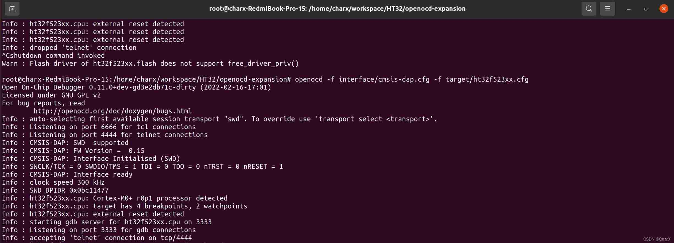
圖:openocd連接設備
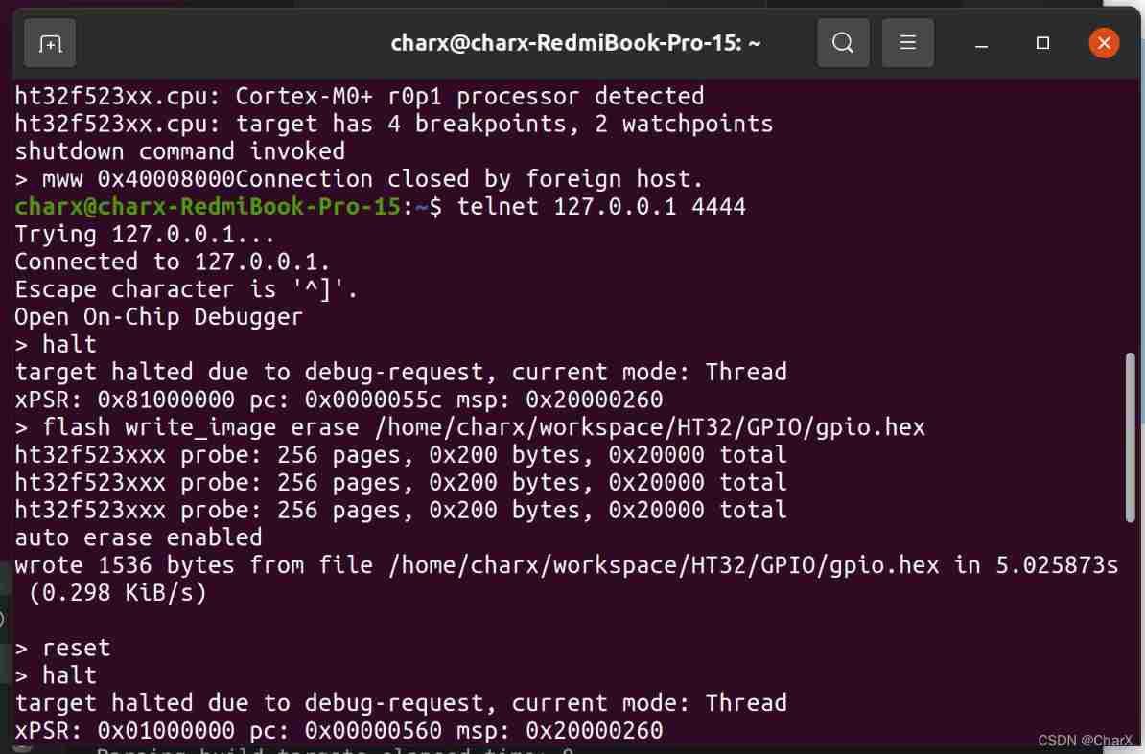
圖:telnet連接openocd服務器並進行燒錄
(可以看到燒錄很慢，即便把adapter speed提高到1MHz也要3.84s，針對這個問題正在設法解決)
在此補充一下openocd在telnet下面的常規燒錄步驟:
#halt the cpu
halt
#write hex
flash write-image erase xxx.hex
#reset
reset
小結：
這個是我第一次為OpenOCD添加設備支持，也是我第一次動手改開源代碼(之前改過一次6relayd的只是修改CMakeLists.txt去使用交叉編譯和靜態鏈接)。前前後後我其實已經用了兩個多星期。因為不管在國內還是國外網站關於OpenOCD的使用大多是基於官方自帶的芯片庫(以STM32為主)，對於添加第三方芯片的教程幾乎沒有，剛開始的時候是一直看芯片手冊，然後是看OpenOCD官方的User's Guide 和 Developer's Guide。不過說實話，OpenOCD官方的文檔中似乎並沒有設計第三方芯片添加需要進行的關鍵操作，其只是在cfg文件格式和命令上有比較大的篇幅。
主要參考資料:(其實參考了很多很多，不過大部分都忘記記錄了)
OpenOCD 官方手冊
HT32F52342_52 UserManuals
OpenOCD RISCV
Ubuntu 下使用OpenOCD進行燒錄
https://github.com/ChaoticEnigma/openocd-ht32
版權聲明
本文為[CharX]所創，轉載請帶上原文鏈接，感謝
https://chowdera.com/2022/02/202202181338169794.html

