How to run demo-printf on simulator?

How to run demo-printf on simulator?
Step1: Import project
Step2: Select your target. For example, choose target AG101P-N968A
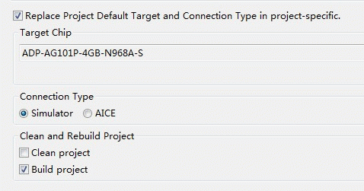
Step3: Modify config.h
(Specify BUILD_MODE to BUILD_SIMU)
Attachment:
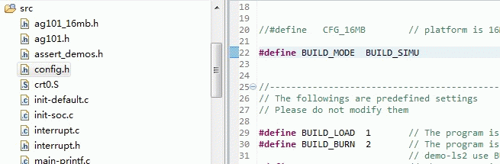
Step4: Build & Run
Step5: Open Device Uart3.
