**Title Document: How to run&debug from RAM without flashing flash STM32 devices (Keil)**

If you would like to debug&run program without flashing the device you can follow this procedure:

In this solution, You don't need to Configure the boot pin. not matter what Boot1, Boot0 are, It just works

step 1. Project->Options for Target STM32...->Target

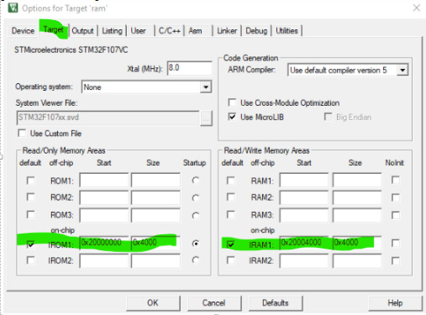

ROM is from 0x2000 0000 - 0x2000 4000 (16KB)

IRAM is from 0x2000 4000 -0x2000 8000 (16KB)

The exact value of ROM and RAM depend on your application.

step 2. Project->Options for Target STM32...->C/C++

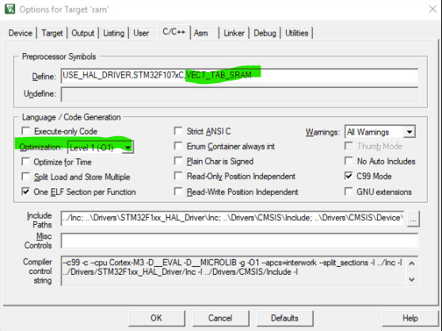

-add the VECT_TAB_SRAM to the define field

-optionally you can change the Optimization to O0 or O1 when you want to avoid optimization at O3 level (this helps debugging code)

step 3.

Project->Options for Target STM32...->Linker

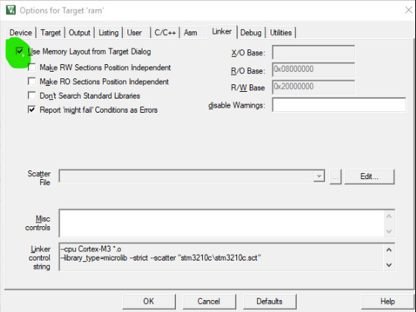

-make sure the Use Memory Layout from Target Dialog is checked.

step 4. Project->Options for Target STM32...->Debug

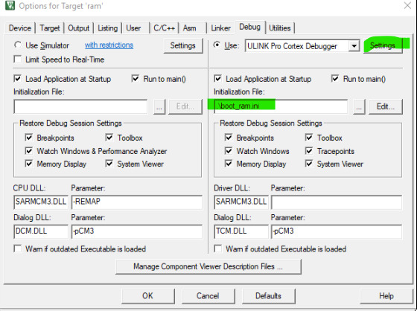-

Copy the boot_ram.ini file to the project folder (e.g. C:\Users\..\MDK-ARM))

-select the boot_ram.ini as initialization file

-go to settings

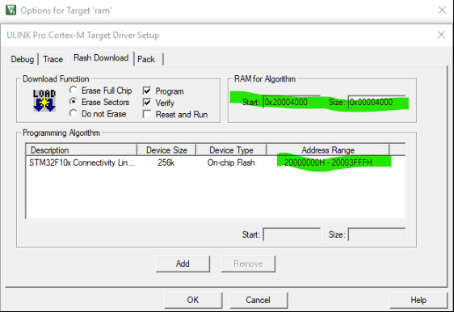

make sure the value high lighted in green is exactly same as step 2 we have made.

Up until now, you are done!

To test it work or not, build the project then press Ctrl + F5.

Here is the boot_ram.ini file.

add the code below and save as **boot_ram.ini** file.

|  |
| --- |
| /*----------------------------------------------------------------------  * Setup() configure PC & SP for RAM Debug  *----------------------------------------------------------------------*/  FUNC void Setup (void) {  SP = _RDWORD(0x20000000); // Setup Stack Pointer  PC = _RDWORD(0x20000004); // Setup Program Counter  _WDWORD(0xE000ED08, 0x20000000); // Setup Vector Table Offset Register  }  FUNC void OnResetExec (void) { // executes upon software RESET  Setup(); // Setup for Running  }  load %L incremental  Setup(); // Setup for Running  g, main |