Feb 8th – 14th
Matter3d POrt
Goal
- Set up MapGPT environment, install dependencies, download dataset, and run scripts/gpt4o.sh (inference).

Environment Setup + Python Dependencies
- Created conda environment and attempted to install repo requirements:
- Commands: conda create -n MapGPT python=3.10; conda activate MapGPT; pip install -r requirements.txt
- Error: requirements.txt contained an invalid pip spec: pytz==2022.6~ (pip rejects this).
- Installed pytz explicitly and verified it worked:
- Command: python -c "import pytz; print(pytz.__version__)" -> 2022.6
- Re-ran: python -m pip install -r requirements.txt -> packages already satisfied / installed.
Repo / File Availability Issue
- Initially only copied commands from GitHub; requirements.txt wasn’t present locally.
- Solution: cloned/downloaded the MapGPT repo so requirements.txt exists and installs can run.
OpenAI API Key Setup
- Set OPENAI_API_KEY via export in terminal.
- Verified environment variable without printing the key:
- Command: python -c "import os; k=os.getenv('OPENAI_API_KEY',''); print('set' if k else 'missing', 'len=', len(k))" -> set len=164
- Note: API keys were accidentally pasted into chat earlier and needed revocation/replacement.
Dataset Download + Placement
- Created a dedicated data folder under Research VLN to store dataset outside the repo:
- Path: ~/Documents/Research VLN/data/MapGPT/{RGB_Observations,annotations}
- Tried unzipping RGB_Observations.zip from Downloads:
- Error: unzip cannot find RGB_Observations.zip (file was not a .zip in Downloads).
- Found RGB observations already present as an extracted folder in Downloads and moved it.
- Issue: extra nested folder RGB_Observations/RGB_Observations.
- Fix: moved inner contents up one level and removed leftover .DS_Store so directory could be removed.
- Verified RGB folder now contains scene-id folders (e.g., 17DRP5sb8fy, 1LXtFkjw3qL, ...).
- Downloaded MapGPT_72_scenes_processed.json from the provided link and moved it to annotations folder.
Running MapGPT Script + Path Issues
- Attempted to run scripts/gpt4o.sh.
- Error: cd: no such file or directory: ~/Documents/Research VLN/MapGPT (repo was actually at ~/MapGPT).
- Script broke because img_root path contains spaces and quoting/flag construction split the path:
- Error: scripts/gpt4o.sh: line 5: ... No such file or directory (path got split at spaces).
- Python import failure when running from wrong directory/without module context:
- Error: ModuleNotFoundError: No module named 'vln'.
- After running from ~/MapGPT, hit simulator dependency:
- Error: ModuleNotFoundError: No module named 'MatterSim'.
Matterport3D Simulator (MatterSim) Build Attempts
- Cloned Matterport3DSimulator repo.
- Tried pip/setup.py install approach:
- Error: requirements.txt and setup.py not found (repo uses CMake build).
- Tried cmake build:
- Error: cmake not found -> installed cmake + make via conda-forge.
- CMake policy/min version issue:
- Error: Compatibility with CMake < 3.5 removed -> used -DCMAKE_POLICY_VERSION_MINIMUM=3.5.
- Dependency chain during CMake configuration and build (installed via conda-forge):
- OpenCV missing -> installed opencv.
- PkgConfig missing -> installed pkg-config.
- jsoncpp missing -> installed jsoncpp.
- GLEW missing -> installed glew.
- pybind11 missing/not initialized -> initialized submodules (git submodule update --init --recursive).
- Missing headers / API fixes:
- glm/glm.hpp missing -> installed glm.
- jsoncpp/json/json.h not found (conda uses json/json.h) -> patched include in include/NavGraph.hpp.
- OpenCV constant CV_LOAD_IMAGE_ANYDEPTH undefined -> replaced with cv::IMREAD_ANYDEPTH in src/lib/NavGraph.cpp.
- OpenMP runtime symbols missing (___kmpc_*) -> installed llvm-openmp and linked with -lomp.
- Linker failures persisted for jsoncpp:
- Error: ld: library 'jsoncpp' not found (while linking MatterSim Python module).
- Tests also failed due to OpenCV constant CV_L2 in tests; intent was to disable tests (BUILD_TESTING=OFF).
What I Tried to Solve (Summary)
- Fix invalid requirement spec so pip installs cleanly (pytz version spec).
- Organize dataset outside repo, move files into consistent paths, and fix folder nesting/.DS_Store issues.
- Update run script paths so spaces do not break arguments (img_root quoting).
- Build and expose MatterSim (native simulator) so MapGPT can import it and run inference.
- Resolve native dependencies one-by-one (OpenCV, pkg-config, jsoncpp, glew, glm, OpenMP) and patch code for modern OpenCV + conda header layouts.
- Resolve final link issues by explicitly pointing CMake to the correct jsoncpp dylib and disabling tests.

VS code
What you have done in code (without testing):
- Built a SLAM skeleton (SlamModule) with the right API:
  - reset() clears pose + map
  - update(observation) updates pose from odom and updates the map using depth
  - get_outputs() returns pose_est, occupancy_grid, explored_ratio
- Implemented a map representation:
  - 2D numpy grid occ sized by (map_size_m / resolution)
  - values: UNKNOWN=-1, FREE=0, OCC=1 (OCC isn’t used yet)
- Implemented pose dead-reckoning:
  - reads odom as (dx, dy, dyaw) (tuple or dict)
  - integrates into (x,y,yaw) using current yaw rotation
- Implemented a baseline “explored” update from depth:
  - if the depth image has any valid depth values,
  - mark the robot’s current cell as FREE (so explored area grows as it moves)
- Implemented explored_ratio:
  - fraction of grid cells that are not UNKNOWN
You’ll add a small “test runner” file that:
- Creates a SLAM object and resets it to a clean state.
- Generates a fake depth image (so SLAM thinks the robot is “seeing” the room each step).
- Simulates motion by feeding a simple odometry change each step (like “move forward 10 cm”).
- Calls your SLAM update repeatedly (e.g., 30 steps), exactly like the real main loop will.
- After each update it reads the outputs:
  - the updated pose estimate should move forward over time
  - the occupancy grid should change from unknown to known at least in some cells
  - the explored ratio should increase or stay the same, never decrease
- Prints periodic progress (every few steps) and ends with a PASS/FAIL so you can prove the module works before integrating it into the full robot code.

Lidar
- Verified you’re running ROS2 Humble on the Jetson Orin NX.
- Found 3 serial devices: /dev/ttyUSB0, /dev/ttyUSB1, /dev/ttyUSB2.
- Confirmed /dev/ttyUSB0 is CP210x (CP2102 USB-UART); /dev/ttyUSB1 and /dev/ttyUSB2 are ch34x.
- Checked whether /dev/ttyUSB0 is busy:
  - sudo lsof /dev/ttyUSB0 → no process shown holding it
  - sudo fuser -v /dev/ttyUSB0 → empty (not in use)
- Confirmed installed ROS2 packages include:
  - sllidar_ros2, ydlidar_ros2_driver (plus converters like depthimage_to_laserscan, etc.)

What you tried that did not work:
- ros2 launch yahboomcar_bringup yahboomcar_bringup_X3_launch.py → fails due to ImportError: PathSubstitution (launch API mismatch).
- ros2 launch sllidar_ros2 sllidar_a1_launch.py ... → launch file not found (wrong filename).
- ros2 launch sllidar_ros2 sllidar_launch.py serial_port:=/dev/ttyUSB0 → driver starts, then SL_RESULT_OPERATION_TIMEOUT and exits.
- Same sllidar_launch.py test on /dev/ttyUSB1 → timeout.
- Same sllidar_launch.py test on /dev/ttyUSB2 → timeout.
- Tried ros2 pkg share ydlidar_ros2_driver → command not available on your ROS2 CLI; you switched to ros2 pkg prefix successfully.

Current status
- Jetson Orin NX is on ROS2 Humble.
- You confirmed 3 serial ports exist: /dev/ttyUSB0, /dev/ttyUSB1, /dev/ttyUSB2.
- SLLIDAR driver failed (timeout on all ports) → likely wrong driver.
- Robot docs show the LiDAR is YDLIDAR 4ROS.
- You confirmed ydlidar_ros2_driver is installed and has launch files (ydlidar_launch.py, etc.).

Feb 22 – 28th

Issues / weak points in the existing notebook

Structure / maintainability
- Repeats the same setup multiple times (imports, scene_id, file loading, graph build) → easy to get inconsistent state.
- Notebook-global variables (G, poses, scene_tasks, true_path, planned_path, etc.) are reused across cells → order-dependent bugs.
- Mixed concerns in one place (loading + planning + evaluation + plotting + exporting) instead of clean functions/modules.

Data / robustness
- Hard-coded scene_id = "2n8kARJN3HM" in multiple cells → not reusable for other scenes unless edited everywhere.
- Assumes specific files exist in the working directory:
  - connectivity/<scene_id>_connectivity.json
  - MapGPT_72_scenes_processed.json
  - perception_model_output.json (optional)
- Little/no error handling if keys are missing (t["scan"], t["path"], connectivity schema, missing poses).

Algorithm / evaluation correctness
- Uses unweighted nx.shortest_path in places → ignores physical distance unless you explicitly switch to weighted planning.
- Path overlap uses set intersection → ignores order (can overstate similarity).
- compute_distance is defined multiple times (global + nested) → inconsistent behavior.
- Potential logic mismatch: some metrics depend on variables from earlier cells (true_distance, pred_distance, goal_accuracy) → breaks if those cells weren’t run.

SLAM / replanning realism
- SimpleSLAM.update(depth_image, delta_pose) doesn’t really use depth (and adds randomness) → not reproducible + not true SLAM.
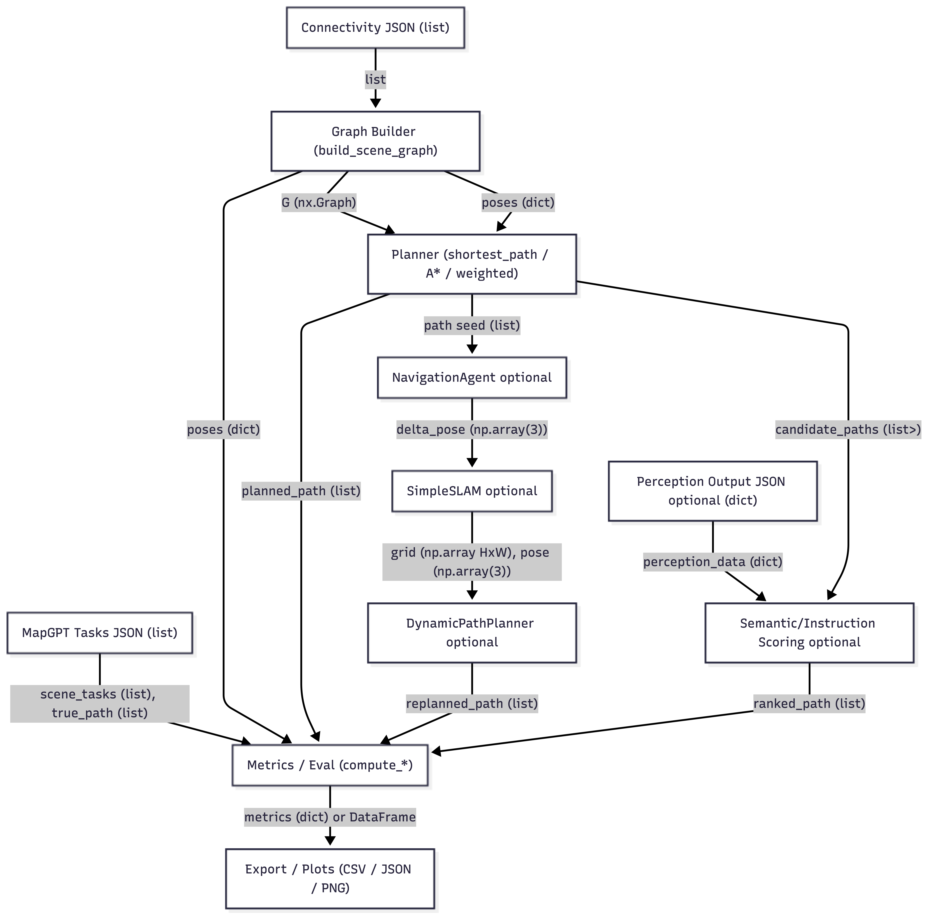
1) Start with the goal
- “This diagram shows the pipeline: read environment + tasks → build a graph → plan a path → evaluate results → export.”

2) Top section (environment)
- “At the top we read the Connectivity JSON (list).
That file describes which viewpoints connect to which.”
- “build_scene_graph converts it into:
  - G (nx.Graph) = nodes + edges for navigation
  - poses (dict) = mapping node_id -> 3D position (used for distances / heuristics).”

3) Middle section (planning)
- “The Planner takes G (and optionally poses) and outputs a navigation route:
  - planned_path (list) of viewpoint IDs.”
- “Planner options are:
  - shortest_path (unweighted)
  - A* (uses poses heuristic)
  - weighted (uses distances from poses).”

4) Optional branches (only if used)
- “Optional Agent + SLAM + Dynamic replanning:
  - Planner gives a path seed (list) to a NavigationAgent
  - Agent produces delta_pose (np.array(3))
  - SimpleSLAM maintains a grid (np.array HxW) + pose
  - DynamicPathPlanner can output replanned_path (list).”
- “Optional Semantic/Instruction scoring:
  - Perception Output JSON (dict) provides perception_data
  - With candidate_paths (list) it ranks them and returns ranked_path (list).”

5) Bottom section (ground truth + evaluation)
- “Separately, we read MapGPT Tasks JSON (list) which gives:
  - scene_tasks (list)
  - true_path (list) = ground-truth route.”
- “Metrics/Eval compares:
  - planned/replanned/ranked path vs true_path
  - plus uses poses for distance-based metrics
and outputs metrics (dict) or DataFrame.”
- “Finally we export results to CSV/JSON and plots.”

One-liner per arrow
- Connectivity JSON → Graph Builder: “raw connectivity records (list)”
- Graph Builder → Planner: “graph + poses”
- Planner → Metrics: “planned path”
- MapGPT JSON → Metrics: “true path”
- Metrics → Export: “metrics table”

Things to use from this notebook
- Graph construction from Matterport connectivity
  - build_scene_graph(...) logic: turning a connectivity JSON into G (nx.Graph) + poses (dict[node_id -> xyz]).
  - This is the cleanest “world model” you can plug into your own planner.
- Baseline planners you can compare against
  - nx.shortest_path baseline (fast sanity check).
  - plan_path_astar(...) (good default if you have poses).
  - plan_path_weighted(...) (best if you want distance-minimizing paths).
- Evaluation metrics + reporting
  - SPL-style calculation, success rate, navigation error, path length.
  - The CSV/JSON export pieces are useful for making progress reports / debugging.
- Multi-task / multi-scene runner
  - Batch loop over tasks and save per-task planned paths + a summary CSV.
  - This is useful for showing “it scales beyond 1 example”.
- Path utilities
  - smooth_path(...) (if you want to reduce zig-zag / simplify).
  - Distance helpers using poses (edge length / path length).

- Took the code from osama and fixed all the connectivity paths and mapgpt paths
- Remade the presentation so It was more accurate for the project.

March 1st – 7th
- Tried to launch LiDAR driver
- Command: ros2 launch ydlidar_ros2_driver ydlidar_launch.py port:=/dev/ttyUSB2
- Error: OSError: [Errno 28] No space left on device when ROS2 tried to create ~/.ros/log/...
- Extra error triggered by that: apport_excepthook also failed with OSError: [Errno 28] No space left on device
- Checked disk space + inodes
- Command: df -h and df -i
- Errors shown twice: df: /tmp/RustDesk/cliprdr-client: Transport endpoint is not connected
- Result: Root filesystem /dev/nvme0n1p1 was 147G used, 0 available (100%)
- Checked ROS log folder size (to see if deleting is safe)
- Command: du -h --max-depth=2 ~/.ros/log | sort -h | tail -n 30
- Finding: ~/.ros/log total size was 4.3M (not the cause of the full disk)
- Checked what folders are using space
- Command: sudo du -h --max-depth=1 / | sort -h | tail -n 30
- Command: du -h --max-depth=1 ~ | sort -h | tail -n 30
- Errors/warnings:
  - du: cannot access '/tmp/RustDesk/cliprdr-client': Permission denied
  - du: cannot access '/tmp/RustDesk/cliprdr-server': Permission denied
  - du: cannot access '/run/user/1000/doc': Permission denied
  - du: cannot access '/run/user/1000/gvfs': Permission denied
  - multiple /proc/... No such file or directory (transient process files)
- Key results:
  - /usr 65G
  - /var 63G
  - /snap 9.7G
  - /home 14G

- Checked Docker disk usage
- Command: docker system df
- Result: 30.17GB reclaimable images + 241.6MB reclaimable volumes (100% reclaimable)

- Listed which Docker images are taking space

- Command: docker images --digests
- Found images:
  - yahboomtechnology/ros-noetic:3.0.5 14.9GB
  - yahboomtechnology/ros-foxy-orbslam2:1.0.0 10.9GB
  - ghcr.io/open-webui/open-webui:main 3.73GB
  - heartexlabs/label-studio:latest 662MB

next steps:
- get the robot to move
- integrate camera to it

March 8th – 14th
2. What was already working at the start
- The original lidar_slam_planner node was running successfully in RustDesk and was able to produce a 2D map in RViz.
- The robot could generate a 2D occupancy-style map, show a robot model in RViz, and produce a planned path.
- The output confirmed basic 2D SLAM and planning worked, but it also showed that the system was only using x, y, and yaw.
- The RViz output showed map streaking/fan-like artifacts, indicating that scan insertion was working but localization quality was still rough and there was no strong loop-closure based correction.
3. Hardware and platform confirmation completed
- Confirmed the exact robot platform as the Yahboom ROSMASTER X3 Plus.
- Recognized that this platform includes a depth camera and supports a more advanced localization stack than the original LiDAR-only script.
- Decided to follow the correct 3D route by using the camera and RTAB-Map instead of trying to force true 3D localization from the old 2D script.
4. Camera hardware detection and package investigation
- Ran lsusb and confirmed that the Orbbec/Astra camera hardware was physically connected and visible to the operating system.
- Observed both an Orbbec USB camera device and an Orbbec depth sensor in the USB device list.
- Checked installed ROS 2 packages and confirmed that the system already had astra_camera, astra_camera_msgs, and yahboomcar_astra available.
- Confirmed that the camera problem was not missing hardware, but missing or incomplete ROS 2 camera node startup.
5. First camera startup error and fix
- Error encountered: the Astra camera node initially failed to launch because a required shared library was missing.
- Exact error observed: libcamera_info_manager.so could not be opened.
- Diagnosis: the camera driver was installed, but some supporting ROS image/camera packages were missing from the system.
- Corrective action taken: installed the missing ROS Humble packages ros-humble-camera-info-manager, ros-humble-image-common, and ros-humble-image-transport.
- Result: after installing the missing packages, the astra_camera_node was able to start.
6. Depth stream brought online
- Launched the Astra camera node successfully after the missing-library fix.
- Observed that the node started the depth stream but not the color stream.
- Verified that the following depth-related topics were now available and publishing:
- /depth/image_raw
- /depth/camera_info
- /depth/points
- Checked topic data directly and confirmed that depth images, camera calibration data, and point cloud data were being published.
- Verified that the depth image encoding was 16UC1, which is expected for raw depth data.
7. Base node and odometry investigation
- Investigated the robot base-side ROS executables and found multiple Yahboom executables, including base_node_X3, which matched the X3 platform.
- Started the robot base node using the correct executable for this hardware: base_node_X3.
- Confirmed that the base node launched and accepted parameters such as linear scale and angular scale.
- Error encountered: /odom appeared in the ROS graph, but no messages were being published on it.
- Observed behaviour: ros2 topic echo /odom --once would hang indefinitely, and ros2 topic info /odom showed zero publishers.
- Diagnosis: the base node was not publishing standard /odom in this system configuration.
- Used ros2 node info /base_node to inspect the actual interfaces of the robot base node.
- Discovered that the base node subscribes to /vel_raw and publishes /odom_raw, not /odom.
- Confirmed that /vel_raw is the velocity command topic and /odom_raw is the odometry output topic for this robot configuration.
8. Odometry publication test
- Problem encountered: /odom_raw also appeared to be inactive when simply echoed with no motion command.
- Diagnostic action taken: published a small test command on /vel_raw and monitored /odom_raw.
- Result: /odom_raw began publishing odometry data once the base node received motion commands.
- Important observation: odometry was alive, but one test output contained an obviously incorrect x position value in the tens of millions, showing that odometry quality/initialization was not fully trustworthy.
9. Camera color stream problem and fix
- Problem encountered: after depth was working, the RGB/color stream was still not publishing.
- Observed log messages from astra_camera_node indicated that color was not enabled, even though the color parameters were intended to be true.
- Investigated camera parameters and confirmed that enable_color, enable_depth, color_width, color_height, and color_fps were set correctly.
- Diagnosis: the node needed the UVC color path enabled for this camera model/configuration.
- Corrective action taken: restarted astra_camera_node with use_uvc_camera:=true while keeping color and depth enabled.
- Result: the color stream started successfully and the following topics became available:
- /color/image_raw
- /color/camera_info
- /depth/image_raw
- Verified that the color image encoding was rgb8, which is valid for RTAB-Map input.
- Verified that the depth image encoding remained 16UC1.
10. RTAB-Map integration work
- Created a custom RTAB-Map launch file and saved it on the Desktop as x3_rtabmap_depth.launch.py.
- Initially attempted to run the launch file using a placeholder path, which caused a launch failure because ROS interpreted the placeholder text as a package name.
- Corrected that issue by launching the real file from its actual Desktop path.
- Updated RTAB-Map remappings to use the real topics from the robot instead of generic examples.
- RGB image topic used: /color/image_raw
- RGB camera info topic used: /color/camera_info
- Depth image topic used: /depth/image_raw
- Base odometry source identified: /odom_raw
11. RTAB-Map odom/TF issue and fix
- Problem encountered: RTAB-Map produced warnings that the odom frame did not exist in TF when trying to get the transform from odom to base_footprint.
- Cause: the Yahboom base node published odometry messages but was not providing the required odom-to-base TF in the way RTAB-Map expected.
- Corrective action taken: redesigned the launch file to use RTAB-Map’s own rgbd_sync and rgbd_odometry nodes, allowing RTAB-Map to generate its own visual odometry and TF chain.
- Result: this removed reliance on the inconsistent Yahboom odometry TF and gave RTAB-Map a cleaner internal odometry source.
12. Synchronization and feature-tracking issues
- After the RTAB-Map stack launched, the next major issue was poor RGB-D synchronization and failed visual odometry tracking.
- Observed warnings showed that the timestamp difference between the RGB and depth frames was relatively high.
- Also observed repeated rgbd_odometry messages with Odom: quality=0, meaning the odometry estimator was not obtaining a usable visual solution.
- The RTAB-Map display showed a red output image and an empty mapping result, indicating that although data was arriving, the visual odometry front-end could not register frames properly.
- Registration errors observed included repeated messages stating: Not enough inliers.
- This means the visual odometry process found some tentative matches between frames, but not enough good inlier matches to estimate a stable transform.
13. Parameter tuning performed
- Adjusted the RTAB-Map launch file multiple times to improve synchronization and make odometry easier to initialize.
- Added rgbd_sync explicitly instead of relying only on direct subscriptions.
- Enabled approximate synchronization.
- Added approx_sync_max_interval to tighten frame pairing between RGB and depth.
- Increased queue_size to improve buffering and synchronization stability.
- Reduced the visual inlier threshold (Vis/MinInliers) to make odometry less strict during startup.
- Adjusted odometry parameters such as Odom/ResetCountdown and Odom/Strategy.
- Adjusted the visual correspondence type parameter to try a more forgiving matching setup.
14. Final technical state reached today
- The system was successfully moved from a simple 2D LiDAR-based RViz demo into a mostly assembled RGB-D + odometry + RTAB-Map pipeline.
- The camera hardware is connected and recognized.
- The depth stream is working.
- The color stream is working.
- The robot base node is running.
- Velocity commands are correctly associated with /vel_raw.
- Odometry messages are available on /odom_raw when the robot base is active.
- RTAB-Map, rgbd_sync, rgbd_odometry, and rtabmap_viz can all be launched successfully.
- The remaining major issue is that visual odometry quality is still 0 because the system is failing to get enough inlier feature matches between frames.
15. Errors shown during the session and how each was addressed
- Missing camera library error: Installed ros-humble-camera-info-manager, ros-humble-image-common, and ros-humble-image-transport so astra_camera_node could start.
- Depth-only camera startup: Confirmed depth stream first, then investigated camera parameters and restarted the camera node with use_uvc_camera:=true to enable the RGB stream.
- No data on /odom: Inspected the running base node and discovered the robot uses /odom_raw rather than /odom.
- No odom TF for RTAB-Map: Changed strategy to use RTAB-Map’s own rgbd_odometry so that RTAB-Map could publish its own odom-based transform chain.
- RTAB-Map waiting for wrong topic names: Updated all remappings to the robot’s real topics: /color/image_raw, /color/camera_info, and /depth/image_raw.
- RGB/depth synchronization warnings: Enabled approximate synchronization, increased queue sizes, and added approx_sync_max_interval.
- Visual odometry registration failure: not enough inliers: Lowered visual matching thresholds and adjusted odometry parameters, but the issue still remains partially unresolved.
16. What remains unresolved
- RTAB-Map still fails to compute stable RGB-D odometry in the current scene.
- The visual odometry quality remains 0.
- The system still reports registration failure due to not enough inliers.
- This indicates that the software stack is now mostly assembled correctly, but the final localization performance still depends on a better live test with a textured scene, stable lighting, and slow controlled robot motion.
17. Overall accomplishment
- The main accomplishment of today’s session was not a finished 3D localization result, but the successful assembly and debugging of the full 3D localization pipeline components.
- At the start, the robot only had a working 2D LiDAR-based map/planner.
- By the end of the session, the robot had a working RGB camera, working depth camera, working base node, confirmed odometry topic, a custom RTAB-Map launch pipeline, and active RTAB-Map nodes processing RGB-D input.
- This represents a major systems-integration step toward full 3D localization, even though final visual odometry robustness still requires additional testing and tuning.

Astar, rrt algorithm for movement
one of the thing to create is the flow chart of total process for what i'm doing

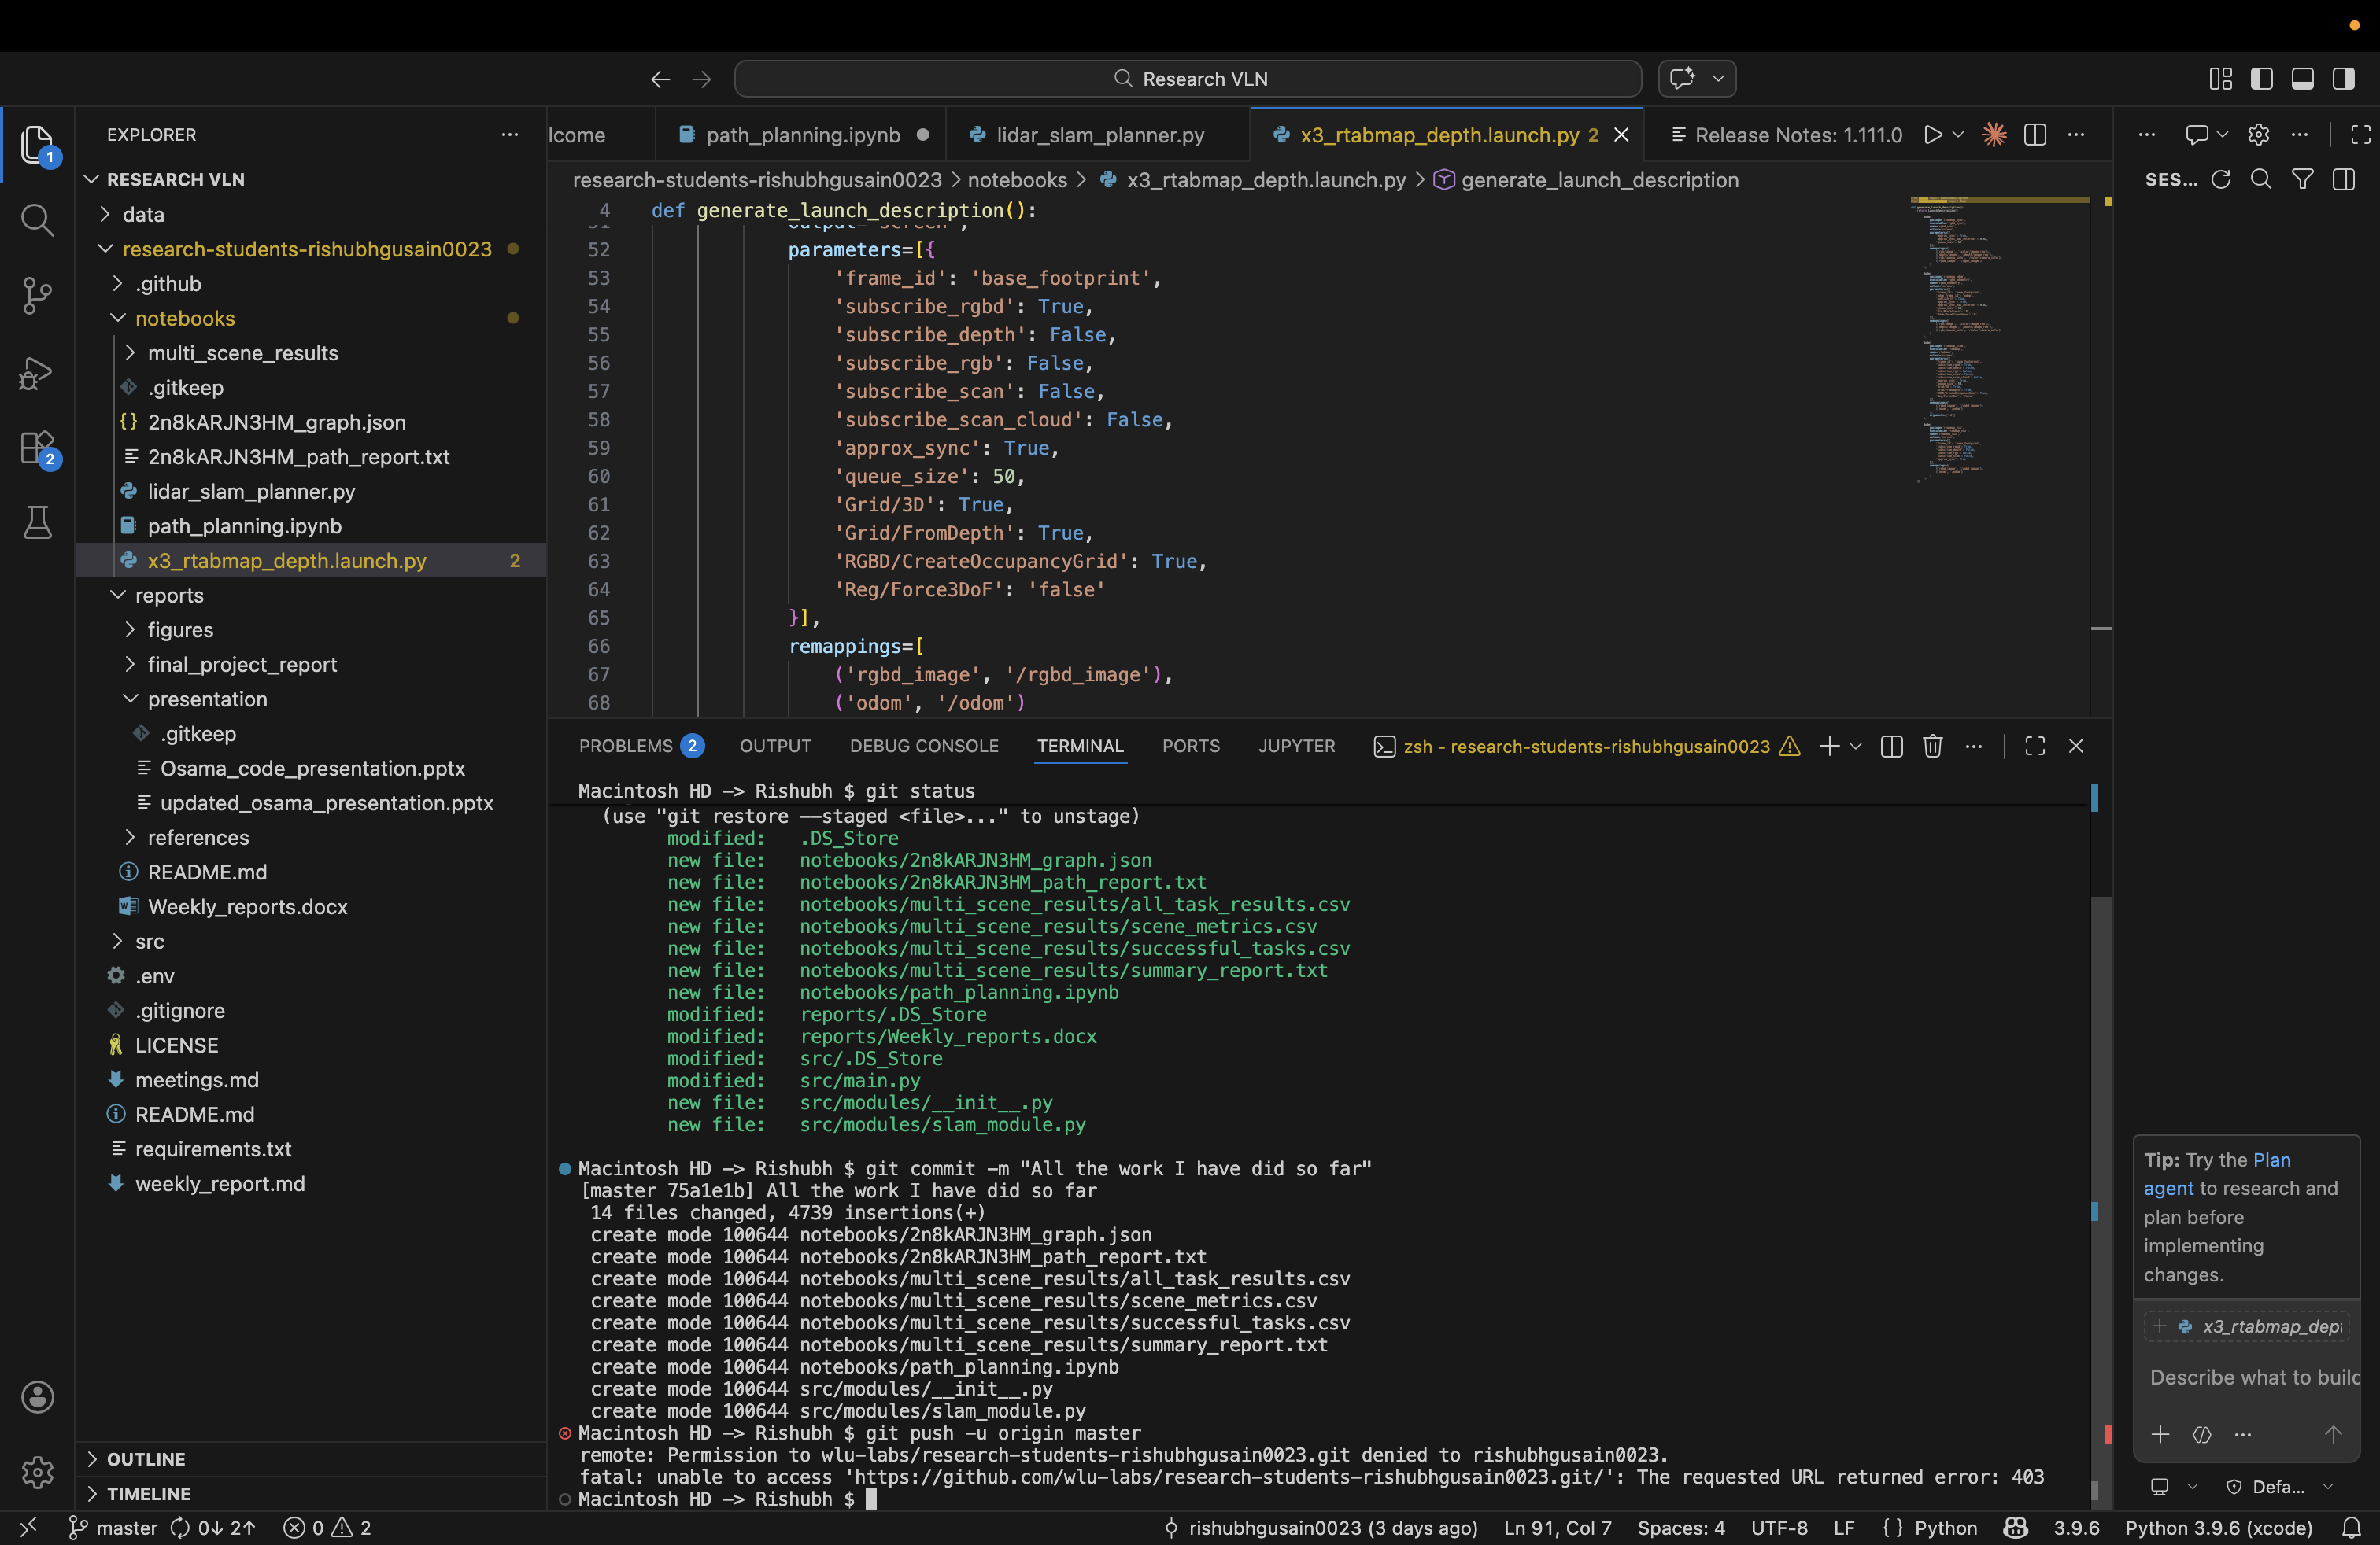

Do virtual movement and proceed with that

Mar 22 - 28
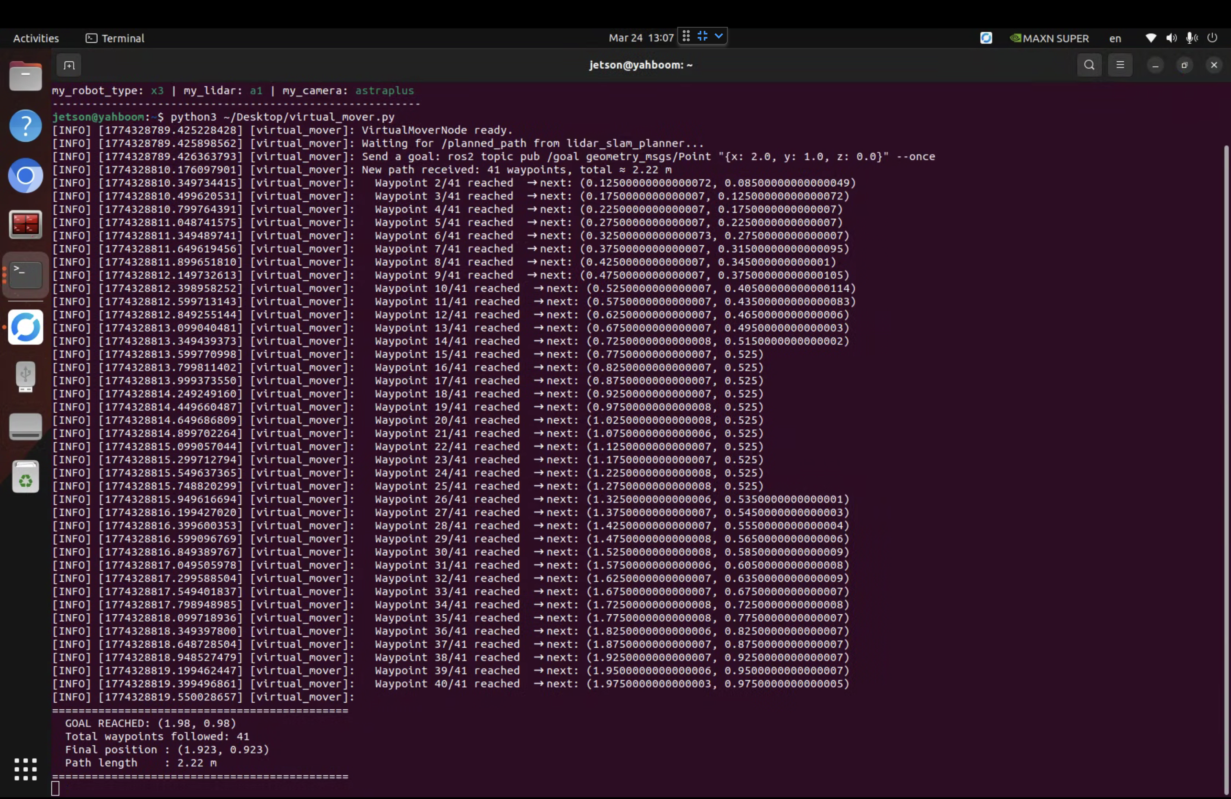

1. Arm Camera Scan Development
Investigated the 6-DOF serial bus servo arm on the ROSMASTER X3 PLUS and developed a camera scanning node. The Rosmaster_Lib Python driver (v3.3.9) was confirmed installed on the Jetson factory image.
- Driver confirmed: Rosmaster_Lib v3.3.9 located at ~/Rosmaster/ on the Jetson factory image.
- Arm API identified: set_uart_servo_angle(servo_id, angle) for single servo, set_uart_servo_angle_array([s1..s6]) for all joints.
- Servo ranges: IDs 1–4 = 0°–180°, ID 5 = 0°–270°, ID 6 (gripper) = 30°–180°.
- arm_camera_scan.py written: Sweeps servo 1 (base) to 45°/90°/135°, captures /color/image_raw at each stop, saves to ~/scan_images/.
- Blocker: Astra camera USB cable physically disconnected — not detected in lsusb. Camera must be reconnected before arm_camera_scan.py can be tested.

2. Path Planning — A* vs RRT* Algorithm Comparison
Two virtual movement systems were developed and tested side-by-side using the same goal coordinates (x: 2.0, y: 1.5). The existing A* grid planner from lidar_slam_planner.py was compared against a newly written RRT* planner (rrt_virtual_mover.py).

Results — Same Goal (x: 2.0, y: 1.5)
- A* result: 41 waypoints | 2.44 m path length | ~0.23s planning time | Final position (1.98, 0.98)
- RRT* result: 5 waypoints | 2.44 m path length | 0.03s planning time | Final position (1.829, 1.460)
- Key finding: Both algorithms found equal path length (2.44 m). RRT* was approximately 7x faster in planning time and produced a significantly cleaner path (5 vs 41 waypoints).
- Note: LiDAR was not connected during testing — both algorithms ran on an empty map. Results must be retested with real obstacle data for a valid performance comparison.

3. Errors Encountered and Fixes Applied
- astra_pro.launch.py not found: Corrected to astra_pro.launch.xml.
- Camera stuck on Waiting for device: Astra camera USB cable physically not plugged into the robot USB hub.
- rosmaster pip package not found: Located Rosmaster_Lib v3.3.9 already installed at ~/Rosmaster/ on the factory image.
- YDLiDAR serial port bind error: LiDAR USB cable physically not connected. Device /dev/ydlidar was not present.
- RRT received goal before map built: Republished /goal topic after node was fully ready.

4. Files Created This Session
- arm_camera_scan.py: Sweeps arm and captures camera images at each position.
- virtual_mover.py: Follows A* planned path from lidar_slam_planner.py, broadcasts TF and odometry for RViz.
- rrt_virtual_mover.py: Standalone RRT* path planner and virtual mover. Builds occupancy map from /scan and moves robot virtually along planned path.

5. Next Session Goals
- Plug in LiDAR and Astra camera USB cables — both physically disconnected on robot.
- Re-run A* vs RRT* comparison with real LiDAR data and obstacles present.
- Run arm_camera_scan.py once camera is physically connected and verified in lsusb.
- Add CSV metrics logger to both planners for automated result recording and professor report.
- Investigate /dev/ydlidar udev rule binding after LiDAR USB is reconnected.

March 29th – April 4th
1. Camera Integration — Rosmaster_Camera
- Obtained camera_rosmaster.py (v4.1.3) from a peer. Confirmed it opens a live feed window on the Jetson at ~7 FPS (low due to dark room lighting, not a hardware fault).
- Commands to run standalone: cd ~/Rosmaster/rosmaster → python camera_rosmaster.py
- arm_camera_scan.py updated to use Rosmaster_Camera as the primary image source (direct OpenCV capture, no Astra required). The /color/image_raw ROS2 topic remains as a silent fallback — activates automatically when the Astra is reconnected.
2. main.py — Task-Driven Visual Navigation Pipeline (Code Only)
- Extended unified main.py with a full task execution pipeline. No physical testing has been done yet — all components are code-complete pending hardware reconnection.
- Added /task subscriber accepting natural language commands (e.g. "cup of water").
- Implemented TaskState machine: IDLE → SCANNING → NAVIGATING → INTERACTING → DONE / FAILED.
- Visual scan pipeline: arm sweeps servo 1 across 45°/90°/135°, YOLOv8 nano runs on each frame, best detection selected by confidence, object world position estimated from bearing + LiDAR range.
- Arm interaction sequence on arrival: reach → close grip → lift → return home.
- All prior components unchanged: SLAM, RRT* primary, A* fallback, virtual movement, NavigationMetrics.
- YOLOv8n (ultralytics 8.3.65) and PyTorch 2.5.0 with GPU confirmed installed on Jetson.
3. Current Blockers
- Arm interaction sequence untested on physical hardware.
- Full /task pipeline untested end-to-end.
4. Next Session Goals
- Reconnect YDLiDAR and Astra Pro camera to USB hub.
- Test arm_camera_scan.py on physical robot.
- Run full /task pipeline end-to-end with a physical object in the workspace.
- Tune arm servo angles based on physical behaviour.
- Push all updated files to GitHub (PAT authentication required).
1. Astra Pro Plus Camera — Correct Driver Identified and Launched
- Previous launch file astra_pro.launch.xml failed with uvc_find_device: No such device — UVC product ID mismatch (0x0501 in config vs 0x050f on hardware).
- Correct launch file identified as astro_pro_plus.launch.xml by searching source tree for matching product ID.
- Both devices confirmed via lsusb: 2bc5:050f (RGB camera) and 2bc5:060f (depth sensor).
- All three streams confirmed publishing: /camera/color/image_raw, /camera/depth/image_raw, /camera/depth/points.
2. RTAB-Map RGB-D SLAM — Successfully Running on Physical Robot
- Updated x3_rtabmap_depth.launch.py remappings to use /camera/color/image_raw and /camera/depth/image_raw to match Astra Pro Plus topic namespace.
- base_footprint TF was missing — RTAB-Map's rgbd_odometry requires this frame. Fixed by launching display_X3.launch.py from yahboomcar_description which runs robot_state_publisher and publishes the full TF tree.
- Full confirmed startup sequence: display_X3.launch.py → base_node_X3 → astro_pro_plus.launch.xml → x3_rtabmap_depth.launch.py
- RTAB-Map 3D map confirmed building in real time — point cloud of room rendered including walls and furniture.
- Odometry panel confirmed showing live RGB camera feed.
3. Motor Control — Diagnosed and Partially Resolved
- Velocity commands to /vel_raw were not physically moving the robot.
- Root cause 1: jetson user not in dialout group — serial port inaccessible. Fixed with sudo usermod -a -G dialout jetson and reboot. Confirmed with Rosmaster Serial Opened! Baudrate=115200.
- Root cause 2: base_node_X3 only computes odometry — it does not send motor commands. Actual motor driver is Mcnamu_driver_X3.py in yahboomcar_bringup, which subscribes to /cmd_vel and calls set_car_motion() via Rosmaster_Lib.
- Robot confirmed physically moving during session — camera feed changed showing different part of room.
- Correct motor topic confirmed as /cmd_vel, not /vel_raw.
4. Errors Encountered and Fixes Applied
- uvc_find_device: No such device: Wrong launch file — fixed by switching to astro_pro_plus.launch.xml.
- base_footprint TF does not exist: Robot description not launched — fixed by adding display_X3.launch.py to startup.
- jetson not in dialout group: Serial port inaccessible — fixed with usermod and reboot.
- Robot not moving on /vel_raw: Wrong topic — actual motor control via /cmd_vel through Mcnamu_driver_X3 node.
Next Session Goals
- Run Mcnamu_driver_X3 and confirm full motor control via /cmd_vel.
- Drive robot around room and build a complete RTAB-Map of the space.
- Save the map using RTAB-Map's file export.
- Connect YDLiDAR and test combined LiDAR + RGB-D SLAM.

1. Motor Control — Direct Rosmaster_Lib Testing
- Confirmed Mcnamu_driver_X3.py receives /cmd_vel commands correctly — topic echo showed linear.x: 0.1 arriving at the node.
- Identified that Mcnamu_driver_X3 was publishing zero to /vel_raw despite receiving /cmd_vel — suspected IMU safety check or serial conflict blocking passthrough.
- Discovered road_following.py and joystick_R2L.py in ~/Rosmaster/auto_drive/ — both use set_car_motion() directly via Rosmaster_Lib, bypassing ROS2 entirely.
- Tested set_car_motion(0.2, 0, 0) directly via Rosmaster_Lib on /dev/ttyUSB0 with debug=True.
- Confirmed serial packets are being sent correctly to hardware:
- Forward: motion: [255, 252, 10, 18, 1, 200, 0, 0, 0, 0, 0, 229]
- Stop: motion: [255, 252, 10, 18, 1, 0, 0, 0, 0, 0, 0, 29]
- Robot did not physically move despite correct serial output — suspected motor power switch is off or main battery is disconnected. Jetson runs on USB power independently from motor battery.
2. Camera Device Conflict Identified
- Rosmaster_Camera (arm camera) cannot open while Astra Pro Plus camera node is running — both compete for /dev/video0.
- Only two video devices present: /dev/video0 (Astra RGB) and /dev/video1 (not a capture device).
- Arm camera visual monitoring during motor testing not possible while full RTAB-Map stack is running.
- RTAB-Map odometry panel used as visual reference instead.
3. Current Status
- Full software stack confirmed working: robot description → base node → motor driver → camera → RTAB-Map.
- Serial communication to motor hardware confirmed — packets sent correctly.
- Physical motor movement blocked — requires physical inspection of robot power state (motor battery / power switch).
4. Next Session Goals
- Physically verify robot motor battery is connected and power switch is on.
- Confirm robot drives using set_car_motion() once power issue resolved.
- Drive robot around room and build complete RTAB-Map of space.
- Save map using RTAB-Map file export.

April 5th – April 11th

1. Motor Control — Serial Port Identified and Physical Movement Confirmed
- Tested set_car_motion() directly via Rosmaster_Lib on /dev/ttyUSB0 — serial packets sent correctly but robot did not move.
- Systematically tested all USB ports — confirmed motor controller is on /dev/ttyUSB1 not /dev/ttyUSB0.
- Robot confirmed physically moving on /dev/ttyUSB1 — forward, turn left, and backward all working correctly.
- Battery confirmed good by physical inspection.
- All three movement directions tested and confirmed:
- Forward: set_car_motion(0.2, 0, 0)
- Turn left: set_car_motion(0, 0, 0.5)
- Backward: set_car_motion(-0.2, 0, 0)

May 31st – June 6th

Work Completed
This week focused on debugging, validating, and achieving a full end-to-end run of the Vision-Language Navigation pipeline on the physical ROSMASTER X3 PLUS robot.

Bug Fixes and Code Changes
- Identified and resolved an interface drift bug between slam_module.py and rrt_virtual_mover.py where _OccupancyMap was missing the inflated_mask() method expected by the RRT* planner. The fix involved adding inflated_mask() to _OccupancyMap using scipy.ndimage.binary_dilation with a configurable inflation radius.
- Added a try/except block around the RRT* planner call in main.py’s _replan() method to ensure any planner exception correctly cascades to the A* fallback rather than crashing the node.
- Corrected the CAM_INDEX parameter in main.py from 1 to 0 to match the wrist camera device assignment on the Jetson (/dev/video0).
- Corrected the ROSMASTER_CAM_INDEX parameter in arm_camera_scan.py from 1 to 0 for the same reason.
- Fixed the Rosmaster() instantiation in main.py to explicitly specify com=’/dev/ttyUSB1’, matching the confirmed serial port for the motor and arm controller on this Jetson image.
- Identified and corrected the orbbec_camera package name to astra_camera, which is the correct installed package on the Yahboom ROS2 workspace.
- Identified that the YDLiDAR requires sudo chmod 777 /dev/ttyUSB0 and an explicit launch via ros2 launch ydlidar_ros2_driver ydlidar_launch.py to start correctly.
- Confirmed and documented the correct six-step startup sequence for the full pipeline.
- Verified all source files between the robot’s Desktop directory and the VS Code development environment are in sync.

Results
Achieved a complete end-to-end pipeline execution on the physical robot for the task “chair”. The pipeline successfully completed all twelve integration points:

- Natural language task received and parsed on /task
- State machine transitioned correctly through IDLE → SCANNING → NAVIGATING → INTERACTING → DONE
- Arm sweep executed at 45°, 90°, and 135°
- YOLOv8 nano detected a chair at 135° with confidence 0.82
- LiDAR-fused bearing estimator produced a world-frame goal of (1.38, 0.58)
- RRT* planner produced a 3-waypoint path in 0.009 seconds
- Robot navigated to goal via virtual mover
- Arm interaction sequence completed — reach, grip close, lift, home

Unresolved Issues
- The YDLiDAR is launching and connecting successfully but returning all-zero range values on /scan. Physical hardware inspection is required to confirm whether the sensor is spinning. This is currently blocking autonomous mapping.

June 14th – June 20th

1. Full Physical Bring-Up — Transform Tree, Motor Driver, and Odometry Confirmed
- Confirmed full transform tree via display_X3.launch.py: base_footprint → base_link → wheels, imu_link, camera_link, laser_link, all publishing live.
- Confirmed Mcnamu_driver_X3 opens serial cleanly on /dev/ttyUSB1; created a symlink (/dev/ttyUSB0 → /dev/ttyUSB1) so the driver’s hardcoded port resolves correctly.
- base_node_X3 confirmed publishing /odom_raw at a steady 10 Hz with sub-millisecond jitter.

2. LiDAR — Root Cause of All-Zero Ranges Identified
- YDLiDAR TG30 connects and reports healthy status (firmware 2.1, serial 2023111100090834), but /scan returns an empty ranges array.
- Found and corrected an “Incorrect Lidar Type setting” warning by switching the launch config from the generic ydlidar.yaml to the model-specific TG.yaml.
- Physical inspection confirmed the LiDAR motor is not sustaining rotation — buzzing and intermittent jolts felt on the housing, consistent with a current-limited USB port. The unit subsequently dropped off the USB bus entirely during testing.
- Root cause identified as insufficient USB power delivery, not a driver or configuration fault. A powered USB hub is required to resolve.

3. Astra Pro Plus and Wrist Camera — Same Power Issue Identified
- Astra Pro Plus does not enumerate on the USB bus at all (confirmed via repeated lsusb checks); the depth-projector laser fires briefly on plug-in then cuts out, indicating a power dropout rather than a cable or driver fault.
- Wrist camera also absent from /dev/video* — same USB power budget issue suspected.

4. Arm — Full Range of Motion Confirmed
- Tested full servo sequence directly via Rosmaster_Lib: base rotation (45°/90°/135°), shoulder up/down, reach pose, gripper open/close, lift, and return to home — all confirmed physically working.

5. Software Verification — inflated_mask() Fix and RRT* Pipeline
- Confirmed the previously identified inflated_mask() interface bug is already resolved in slam_module.py, with a matching call signature in rrt_virtual_mover.py.
- Confirmed the RRT*-to-A* fallback in main.py’s replanning logic correctly wraps the planner call in a try/except and triggers the fallback on failure.
- Ran main.py end-to-end: startup reported SLAM, RRT* primary, A* fallback, YOLO, and Arm all initialised (Camera: NO, as expected with no camera connected).
- Published a direct /goal message; RRT* planned a path in 0.009s (3 waypoints, 1.04 m) and the virtual mover successfully followed it to completion — first confirmed end-to-end RRT* planning success on the unified pipeline.

6. Safety Incident — Unintended Motor Movement, Resolved
- A manual one-off /cmd_vel test command caused the wheels to continue spinning after the publishing terminal was closed. Robot was lifted clear of the ground for safety, and the motor driver node was stopped to cut motor commands, after which the wheels came to a stop.
- Identified that the obstacle_avoider.py safety node was not running during testing and, in any case, depends on /scan data that was unavailable today due to the LiDAR power issue.
- Added an emergency-stop publisher to main.py: a real /cmd_vel publisher alongside the existing /virtual_cmd_vel one, with destroy_node() now sending repeated zero-velocity messages on shutdown. Change committed and pushed to rishubh-updates.

7. Next Session Goals
- Source a powered USB hub to resolve the LiDAR, Astra, and wrist camera power dropouts.
- Create a permanent udev rule for the motor controller port to remove the need for the manual /dev/ttyUSB0 symlink each session.
- Once LiDAR is restored, launch obstacle_avoider.py alongside the unified pipeline as a standing safety layer before any further /cmd_vel testing.
- Re-run the full RRT* end-to-end pipeline with real LiDAR data once hardware is restored, and retest physical /cmd_vel motion with the new emergency-stop safeguard in place.

June 21th – June 27th

1. RRT* Branch Audit
- Audited the feature/hma-rrt branch against the current rrt_virtual_mover.py and slam_module.py, confirming two genuinely implemented and active improvements: a QuadTree-accelerated nearest-neighbour search and a side-retreat collision escape routine.
- Identified that the branch’s adaptive_sample() function, which implements a Goal/Corridor/Global sampling split, is dead code never called by plan(); the active sampler is a separate grid-weighted scheme. Also flagged that collision-density suppression only fires on a randomized ~30% of iterations, weaker than the in-code comments suggest, along with leftover commented-out code and a duplicated line in the main planning loop.
- Documented full findings, including an efficiency assessment, in HMA_RRT_Comparison.md. The QuadTree swap is a genuine O(log n) vs O(n) improvement; the added per-iteration cost of the escape recovery logic is likely worthwhile on cluttered/narrow maps and likely not on open maps, though no formal benchmark has been run yet against identical map data.

2. New Planner Variant — QuadTree Nearest-Neighbour
- Created rrt_virtual_mover_quadtree.py, cherry-picking only the QuadTree spatial index and side-retreat collision escape from the audited branch, leaving sampling, steering, and smoothing unchanged from the original planner.
- The QuadTree index replaces the brute-force O(n) scan in _nearest(), _choose_parent(), and _rewire() with O(log n) average-case lookups. The collision escape, on a failed steer step, now attempts a half-step retreat followed by ±10°–50° side-shifts before discarding the iteration, instead of discarding it immediately as the original planner does.
- Verified the file compiles cleanly via py_compile. Not yet run against live ROS topics or real sensor data.

3. New Planner Variant — Convex Corridor Smoothing
- Created rrt_virtual_mover_convex.py, building on the QuadTree variant, implementing the convex-smoothing half of a “Convex-Neural RRT*” design (the neural component is a separate research effort requiring training data, not implemented here).
- Implemented convex_corridor_smooth(): computes per-waypoint obstacle clearance via a Euclidean distance transform, builds a free-space corridor box around each waypoint while pinning the start and goal, and solves a convex QP (minimizing path curvature subject to the box constraints) using scipy.optimize.minimize with the SLSQP method, avoiding the need for an external QP solver. This replaces the previous averaging/shortcut smoothing entirely.
- Unit-tested standalone with mocked ROS imports: on a sample zig-zag path, the smoother reduced path length from 4.83 m to 3.16 m while respecting clearance constraints and pinning both endpoints. File compiles cleanly; not yet run against live ROS topics or real LiDAR data.

4. Next Session Goals
- Benchmark both new planner variants against the original rrt_virtual_mover.py on identical map/scan data to obtain real timing and path-length numbers.
- Run both variants against virtual LiDAR data once hardware is available, then decide whether to merge the QuadTree variant into the main pipeline.

June 28th – July 4th
======================================================================
SUMMARY
======================================================================
world variant succ% time(ms) wpts len(m) smooth
-----------------------------------------------------------------------
cluttered baseline 100.0 53.7 22.5 15.82 0.1795
cluttered convex 100.0 74.9 22.8 14.45 0.0013
cluttered quadtree 100.0 47.1 22.8 15.84 0.1923

maze baseline 100.0 108.0 20.0 13.33 0.1578
maze convex 100.0 46.6 19.6 12.75 0.0035
maze quadtree 100.0 28.0 19.6 13.14 0.1471

narrow_corridor baseline 100.0 110.5 12.5 8.07 0.1364
narrow_corridor convex 100.0 20.5 12.7 7.94 0.0170
narrow_corridor quadtree 100.0 13.0 12.7 8.03 0.1434

open_room baseline 100.0 26.1 17.6 11.60 0.1386
open_room convex 100.0 42.5 17.6 11.19 0.0000
open_room quadtree 100.0 24.2 17.6 11.60 0.1386

random_dense_seed1 baseline 100.0 36.2 20.9 14.17 0.1656
random_dense_seed1 convex 100.0 55.5 21.4 13.62 0.0036
random_dense_seed1 quadtree 100.0 31.9 21.4 14.23 0.1605

random_dense_seed2 baseline 100.0 64.4 18.4 12.10 0.1883
random_dense_seed2 convex 100.0 45.6 18.9 11.37 0.0287
random_dense_seed2 quadtree 100.0 28.7 18.9 11.77 0.1871

random_dense_seed3 baseline 100.0 41.3 20.5 14.35 0.1532
random_dense_seed3 convex 100.0 54.8 21.5 13.83 0.0068
random_dense_seed3 quadtree 100.0 33.2 21.5 14.28 0.1680

random_dense_seed4 baseline 100.0 167.0 22.0 14.97 0.1941
random_dense_seed4 convex 100.0 73.6 21.7 14.05 0.0211
random_dense_seed4 quadtree 100.0 50.9 21.7 14.72 0.1847

random_dense_seed5 baseline 100.0 45.2 21.6 14.45 0.1472
random_dense_seed5 convex 100.0 54.0 22.5 13.95 0.0162
random_dense_seed5 quadtree 100.0 30.3 22.5 14.43 0.1767

random_medium_seed1 baseline 100.0 38.7 20.4 14.18 0.1501
random_medium_seed1 convex 100.0 52.4 20.3 13.52 0.0009
random_medium_seed1 quadtree 100.0 30.1 20.3 14.07 0.1538

random_medium_seed2 baseline 100.0 28.5 17.3 11.75 0.1565
random_medium_seed2 convex 100.0 41.9 16.6 10.99 0.0039
random_medium_seed2 quadtree 100.0 25.7 16.6 11.46 0.1569

random_medium_seed3 baseline 100.0 42.4 21.5 14.18 0.1654
random_medium_seed3 convex 100.0 55.3 20.8 13.63 0.0029
random_medium_seed3 quadtree 100.0 32.2 20.8 14.01 0.1469

random_medium_seed4 baseline 100.0 36.4 20.2 14.03 0.1497
random_medium_seed4 convex 100.0 50.7 20.6 13.76 0.0051
random_medium_seed4 quadtree 100.0 29.4 20.6 14.25 0.1434

random_medium_seed5 baseline 100.0 195.7 20.3 14.14 0.1581
random_medium_seed5 convex 100.0 69.3 20.4 13.61 0.0037
random_medium_seed5 quadtree 100.0 46.5 20.4 14.08 0.1545

random_sparse_seed1 baseline 100.0 31.0 20.8 14.28 0.1502
random_sparse_seed1 convex 100.0 51.0 20.7 13.49 0.0009
random_sparse_seed1 quadtree 100.0 28.0 20.7 14.12 0.1529

random_sparse_seed2 baseline 100.0 28.2 16.4 11.41 0.1291
random_sparse_seed2 convex 100.0 44.5 16.4 10.94 0.0005
random_sparse_seed2 quadtree 100.0 27.8 16.4 11.42 0.1199

random_sparse_seed3 baseline 100.0 29.2 20.2 14.04 0.1411
random_sparse_seed3 convex 100.0 50.4 20.6 13.48 0.0002
random_sparse_seed3 quadtree 100.0 28.5 20.6 14.01 0.1441

random_sparse_seed4 baseline 100.0 39.4 20.8 13.96 0.1524
random_sparse_seed4 convex 100.0 55.5 21.0 13.52 0.0011
random_sparse_seed4 quadtree 100.0 31.7 21.0 13.98 0.1650

random_sparse_seed5 baseline 100.0 51.4 20.6 14.15 0.1355
random_sparse_seed5 convex 100.0 54.1 20.7 13.52 0.0026
random_sparse_seed5 quadtree 100.0 31.4 20.7 14.09 0.1445

single_obstacle baseline 100.0 17.9 13.1 8.43 0.1864
single_obstacle convex 100.0 33.0 13.1 7.88 0.0001
single_obstacle quadtree 100.0 18.8 13.1 8.43 0.1864

LiDAR Hardware Bring-Up and Live Scan Validation
- Restored remote access to the Jetson after a motor-board power cycle and re-verified device enumeration; identified that the YDLiDAR TG30 had re-enumerated onto /dev/ttyUSB3 rather than ttyUSB0, confirmed via udevadm vendor ID (CP2102, 10c4:ea60).
- Confirmed the /dev/ydlidar udev symlink resolves automatically to the correct port (ttyUSB3), requiring no change to TG.yaml.
- Successfully launched the ydlidar_ros2_driver; driver reported LiDAR connected, health status good, Model TG30, firmware 2.1, scanning at 10 Hz.
- Verified the /scan topic publishes at a stable ~10.16 Hz (min 0.097 s, max 0.100 s, std dev ~0.0004 s over a 100-message window) with no dropped frames.
- Confirmed range data contains valid, structured distance measurements (identifiable wall segments and object returns in meters), correcting an initial all-zeros reading traced to the LiDAR startup frame captured by echo --once.
- Visualized live scan data in RViz2 using a top-down orthographic view, producing a clear 2D floor-plan representation of the room from the TG30 on the Jetson.
- Observed the scan run steadily for 500+ seconds without a USB power dropout under LiDAR-only load, indicating stationary single-sensor operation is stable on the current (non-powered-hub) setup.
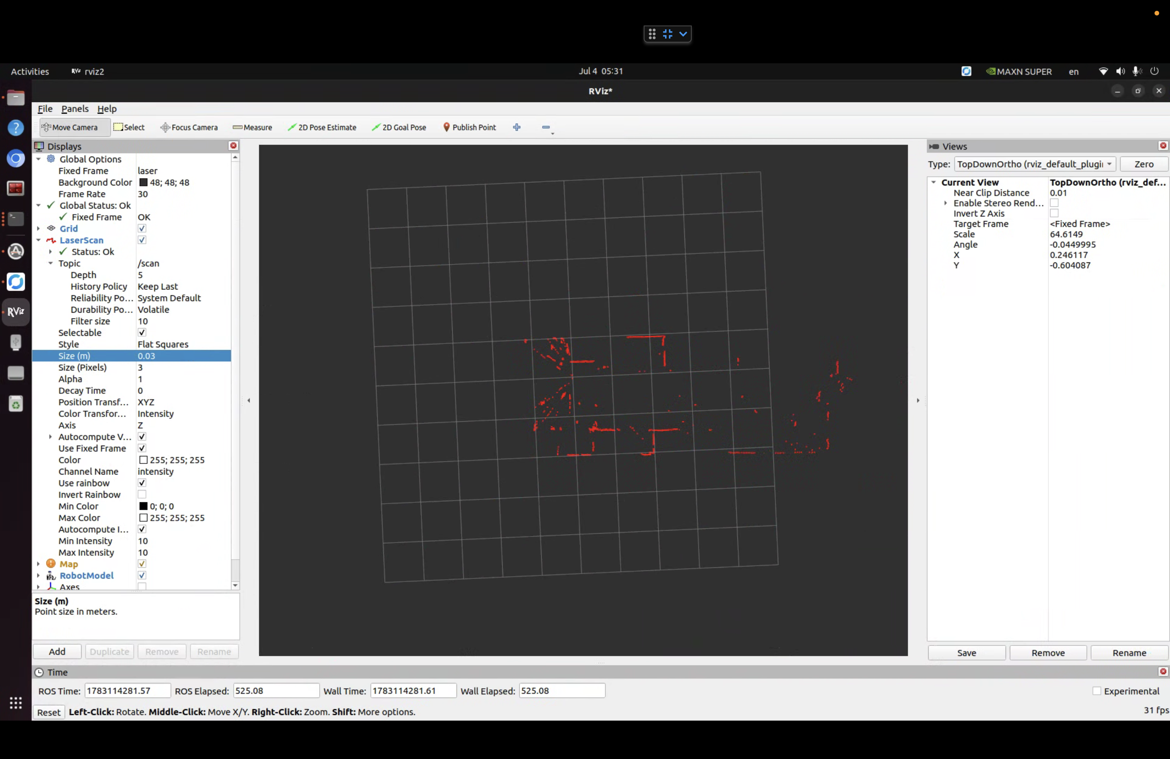
Astra Pro Plus and Wrist Camera Bring-Up and Validation
- Enumerated all connected video devices and confirmed two UVC cameras present: the wrist camera (/dev/video0, YUYV, 640×480) and the Astra Pro Plus RGB stream (/dev/video4, MJPG, up to 2048×1536), distinguished by supported formats and USB bus paths.
- Captured a single frame from each camera and visually confirmed identities: the wrist camera returns a close-range view from the arm, and the Astra RGB returns a wide view of the room from robot height.
- Successfully launched the Astra Pro Plus via astro_pro_plus.launch.xml; driver reported camera opened, depth mode 640×480@30Hz (PIXEL_FORMAT_DEPTH_1_MM), and all three streams started (depth, IR, RGB/UVC).
- Confirmed the full RGB-D topic set publishing: /camera/color/image_raw, /camera/depth/image_raw, /camera/depth/points, /camera/ir/image_raw, and associated camera_info topics.
- Verified the depth stream (/camera/depth/image_raw) publishes at a stable ~21 Hz over a 293-message window — the first confirmed working depth output on the platform.
- Visualized the depth point cloud (/camera/depth/points) in RViz2, producing a 3D reconstruction of the room showing wall surfaces, objects, and floor geometry.
- Confirmed the powered USB hub resolves the USB power insufficiency that had previously prevented the Astra depth stream from operating; depth ran stably for several thousand frames while stationary.
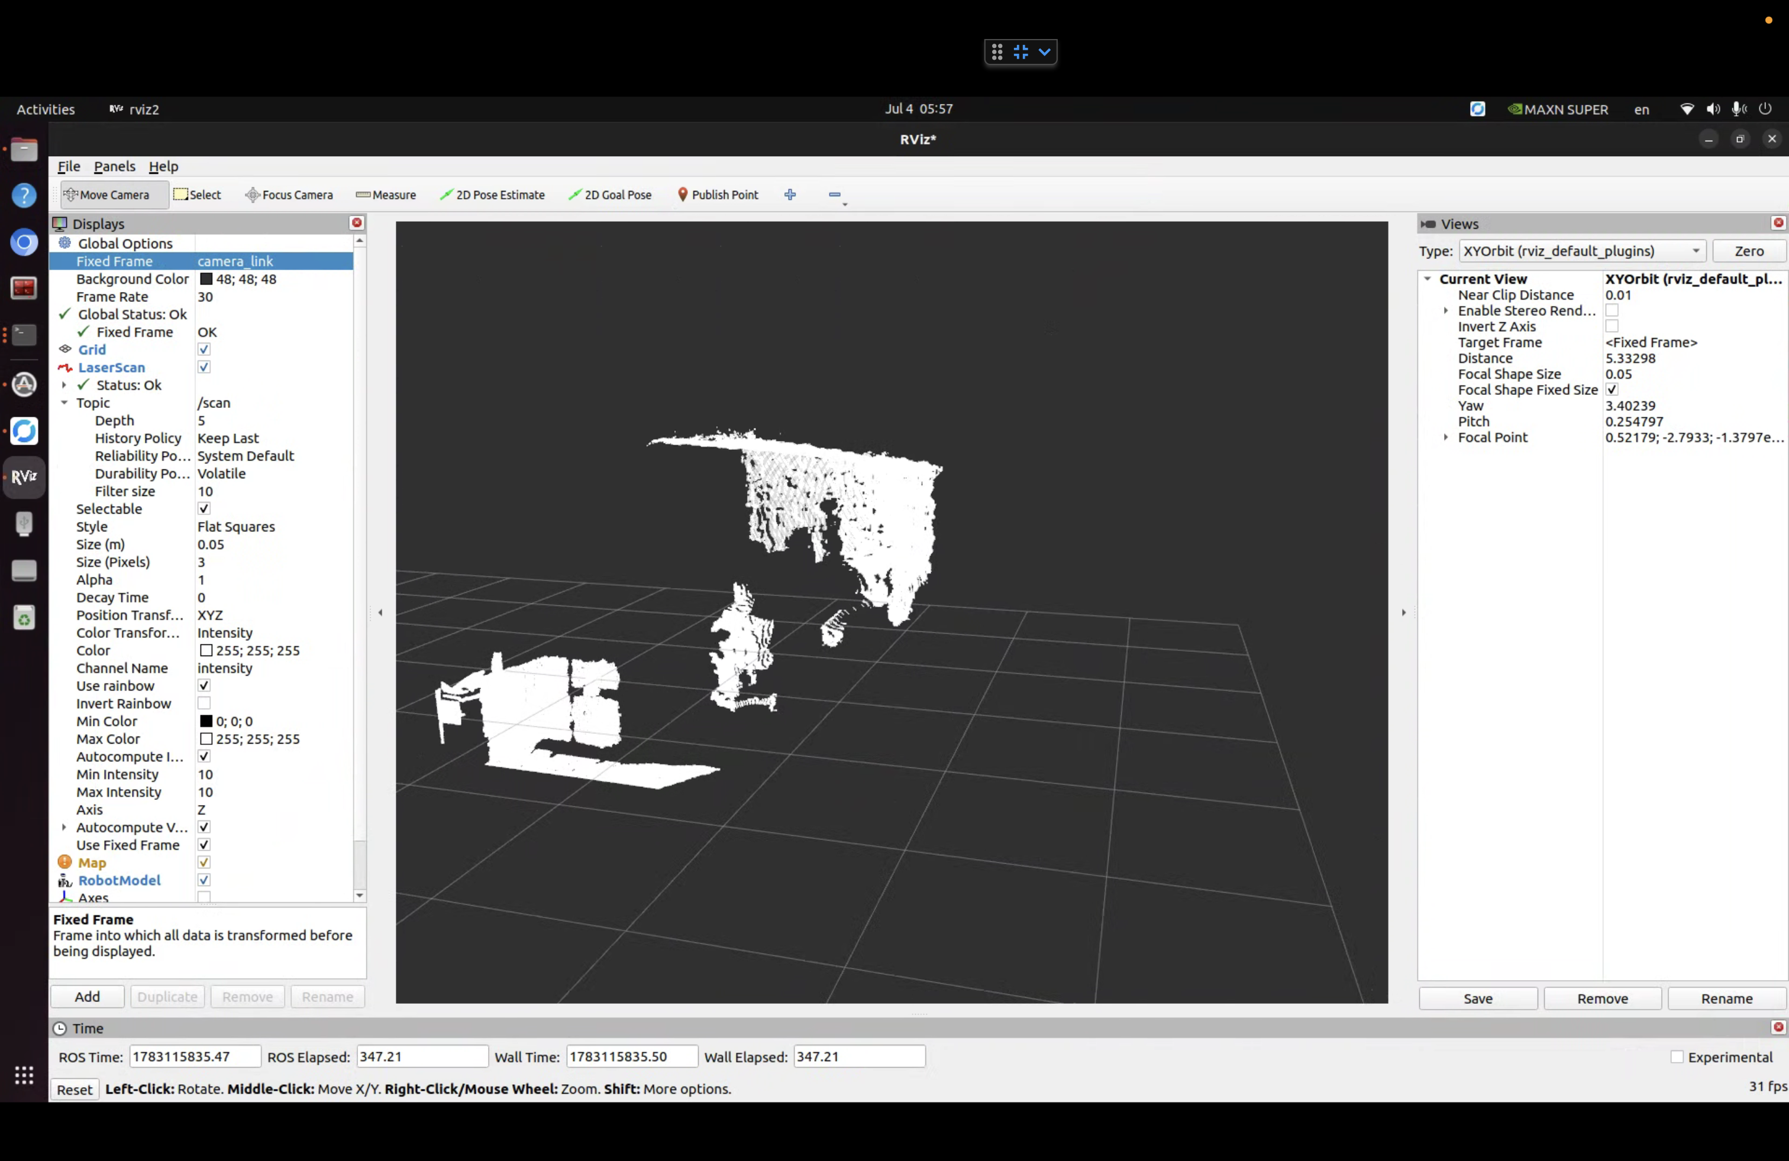
Simultaneous LiDAR and Astra Pro Plus Operation
- Launched the YDLiDAR TG30 driver while the Astra Pro Plus (depth, IR, RGB) was already running, to test whether the powered USB hub sustains both sensors concurrently.
- Confirmed the LiDAR initialized cleanly alongside the running camera with no onDeviceDisconnected event on the Astra, indicating the combined power draw stayed within the hub's capacity.
- Verified both sensors publish simultaneously: /scan at a stable ~10.03 Hz (std dev ~0.001s) and /camera/depth/points at ~18 Hz under combined load.
- Observed a minor depth rate reduction under combined load (~18 Hz vs ~21 Hz with the LiDAR off) with slightly increased jitter, attributable to shared USB bandwidth; no dropout occurred.
- Established that the obstacle-avoidance sensor (LiDAR) and perception/mapping sensor (Astra RGB-D) can run concurrently on the current hardware — the sensor-side prerequisite for full-pipeline operation.
Known Gap / Next Step
- Camera stability under robot self-motion is not yet validated. During this session a physical push of the robot caused an Astra USB disconnect (onDeviceDisconnected), traced to insufficient cable strain relief rather than power. Whether autonomous (/cmd_vel-driven) motion causes the same drop is untested; this requires securing the Astra USB cabling and running a controlled low-speed motion test with a collaborator physically present at the robot.
