STELO CONTINUOUS GLUCOSE MONITOR (CGM)

Device Setup & Onboarding

Who can use the Stelo CGM?
Stelo is designed for adults (18 years and older) who are not on insulin therapy. If you are pregnant or at risk of hypoglycemia (low blood sugar), please consult your healthcare provider before using Stelo.

Where do I insert the Stelo biosensor?
Insert the biosensor on the back of your upper arm. This is the recommended placement for accurate readings. Each time you start a new biosensor session, choose a slightly different spot on your arm to allow previous sites to recover and to reduce the risk of skin irritation.

Does inserting the Stelo biosensor hurt?
Inserting the Stelo biosensor is designed to be simple and essentially painless. Most people experience little to no discomfort during insertion.

How do I insert the biosensor?
Follow these steps for a successful insertion:
- Choose a flat, clean, dry spot on the back of your upper arm. The skin should have some fat layer underneath.
- Avoid areas with hair — if needed, shave with electric clippers (not a razor) first.
- If you have adhesive residue from a previous biosensor, remove it before inserting a new one. A body oil or adhesive remover (such as Uni-solve or Tac Away) can help.
- Press the applicator firmly against your skin until the clear safety guard is pushed in. This activates the button on the side.
- Press the button to insert the biosensor.
- Apply the overpatch (included in the box) immediately. Rub around the entire patch three times, smooth out any wrinkles, and press gently on top of the sensor for 10 seconds.
If you find it difficult to reach or position the applicator, ask a friend or family member.

I can’t press the applicator button — what’s wrong?
The button will not activate until you press the applicator firmly enough against your skin to push in the clear safety guard. Press harder against your skin, and the button should become pressable. Then push it to insert the biosensor.

How do I connect the Stelo to the SynchNeuro app?
The Stelo biosensor connects to your smartphone via the Stelo app which you can then pair to the SynchNeuro app.

Where can I find my Stelo biosensor serial number?
The serial number is printed on the side of the Stelo applicator and on the outside of the product box. When you insert your biosensor, take a photo of the serial number for your records — you may need it if you contact study support or report a product issue. The serial number begins after the characters “(21)” on the label.
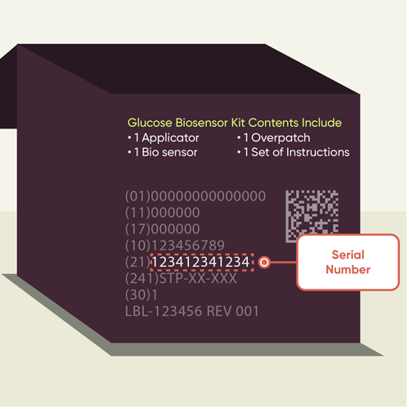
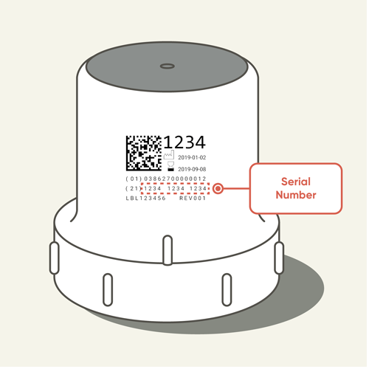

Can I use Stelo internationally?
To use Stelo, your primary residence must be in the US, and your Stelo app and account must be created within the US. Once you’re set up, you can use your Stelo during international travels.

Wearing the Device

How long does each Stelo biosensor last?
Each Stelo biosensor is designed for a single session of up to 15 days.

How do I keep the Stelo biosensor attached throughout the study?
Keeping your biosensor securely attached for the full session is important for complete data collection. Here are the most effective steps:
Before insertion:
- Store unused biosensors at room temperature (36– 86°F) in a dry place.
- Make sure the insertion site is completely flat, clean, and dry.
- Remove any adhesive residue from previous sensors.
- Avoid areas with significant hair growth.
After insertion:
- Rub around the entire patch three times immediately after applying. Smooth out any wrinkles.
- Keep the patch as dry and sweat-free as possible during the first 12 hours — this helps the adhesive bond well.
- When the patch gets wet, gently pat it dry as soon as you can.
- If any edge of the patch starts to peel, trim the lifted part and apply medical tape or an additional overpatch over the edges.
- Avoid sleeping directly on the biosensor if possible.

Can I shower or swim while wearing the Stelo biosensor?
Yes. The Stelo biosensor is water-resistant and can be worn in the shower or while swimming. After getting the patch wet, gently pat it dry. During the first 12 hours after insertion, try to keep the patch as dry as possible to allow the adhesive to bond fully.

Can I use extra tape or patches to help keep the biosensor on?
Yes. If you find the biosensor is beginning to peel, you can apply additional adhesive patches or medical tape over or around the sensor. Some options that work well include:
- Cloth-like patches (such as GrifGrips or Simpatch) — flexible, breathable, and good in wet conditions.
- Hypafix — a fabric-like tape that can be cut to size.
- Transpore Surgical Tape — a clear, porous medical tape, best used to reinforce peeling edges.
If using additional adhesive, do not apply liquid adhesives directly over the biosensor itself, as this can affect accuracy. Instead, apply them around the sensor (forming an oval or picture frame shape) and on the overpatch fabric.
If you cannot tolerate additional adhesive, a loose, non-compressive wrap (such as Coban or Ace bandage) can be used to keep the sensor in place, particularly during physical activity. Remove wraps overnight to avoid compressing the tissue.
This information is based on clinical guidance from independent researchers and has not been formally tested by Dexcom. For detailed insertion instructions, refer to the Stelo User Guide.

What are the Stelo adhesive patches made of?
The Stelo biosensor patch uses a medical-grade, pressure-sensitive, acrylic-based adhesive. It has passed irritation testing and is latex-free.

Troubleshooting

The Stelo app is not pairing with my biosensor
Pairing normally takes less than 5 minutes. If it is taking longer, try the following:
- Keep your phone within 20 feet (6 meters) of the biosensor at all times during pairing.
- Make sure the biosensor is actually inserted in your arm — it will not pair otherwise.
- Check that you are entering the correct pairing code (found on the side of the applicator).
- Move at least 20 feet away from other people who may be wearing a CGM or biosensor.
- The Stelo app must be open on your screen during pairing — do not switch to another app or swipe it closed.
- The biosensor can only pair with one smartphone at a time.

My Stelo app says it is “Searching for sensor” and won’t connect
This can happen after inserting a new biosensor or after a connectivity interruption. Try the steps under “The Stelo app is not pairing with my biosensor.”

There is a gap in my glucose graph in the Stelo app — why?
If your phone was out of range of your biosensor for a period of time (or if Bluetooth was turned off), you may see a gap in your trend graph. This is normal and not a cause for concern. When your phone and biosensor are back within range (within about 20 feet / 6 meters), the missing data will automatically fill in. The biosensor can store up to 24 hours of readings while offline.

I am getting a “Signal Loss” alert
Signal Loss means your phone has temporarily stopped receiving readings from the biosensor. This happens when the phone and sensor are out of range, or when Bluetooth is interrupted. To resolve it (allow up to 5 minutes for each step to take effect):
- Turn Bluetooth off on your phone, wait a few seconds, then turn it back on.
- Keep the Stelo app open on your screen — do not swipe it closed.
- Keep your phone within 20 feet of the biosensor, with nothing between them (including walls, water, or your body).
- Keep your phone on the same side of your body as the biosensor — Bluetooth works best with a clear line of sight.
- If none of the above work, restart your phone and re-open the app.
To help prevent Signal Loss going forward:
- Check the recommended phone settings in the Stelo app (under Settings > Phone Settings).
- Keep your phone battery charged above 20%.

My Stelo app says “Sensor Reconnecting”
This message appears after a few minutes without a biosensor reading. It means your phone has temporarily lost its Bluetooth connection to the biosensor. Follow the same steps as above for Signal Loss. When the connection is restored, up to 24 hours of missed readings will automatically appear in your trend graph.
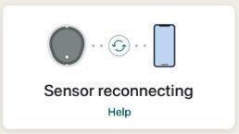

What does “Brief Sensor Issue” mean?
This alert means your biosensor is temporarily unable to determine your glucose reading. This is a known issue that can occur, particularly during the first day of a session, but it can happen at any time. In most cases, it resolves on its own within 3 hours.
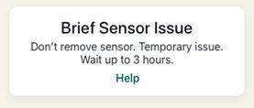
While you see this alert, your glucose readings will be paused. Check your biosensor and, if available, tap Help in the Stelo app for additional guidance.

What does “Session Ended Early” mean?
This means your biosensor has stopped reading before the expected 15-day session is complete. This can happen if the sensor is knocked off or if it becomes unable to detect your glucose. To reduce the chance of this happening:
- Apply the overpatch immediately after insertion and make sure it is smooth and firmly attached.
- Keep the patch dry and sweat-free for the first 12 hours.
- Pat the patch dry after it gets wet.
- If edges peel, trim them and apply medical tape.
- Avoid placing or sleeping on the biosensor.
If your session ends early, submit a sensor issue report in the SynchNeuro app. They can advise on next steps and whether a replacement biosensor should be used.

What does “Sensor Failed” mean?
This alert appears if you try to start a new session using a biosensor that has already been used or has expired. Each biosensor can only be used once. If you see this message, remove the biosensor and submit a sensor issue report in the SynchNeuro app.
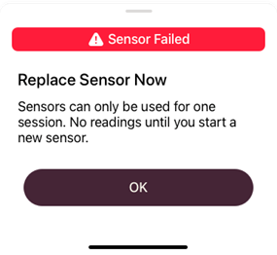

My Stelo app is frozen or crashing
If the app is not responding, close it completely and restart it.
On iPhone (X or later):
- Swipe up from the bottom of the screen and pause briefly in the middle.
- Swipe up on the Stelo app preview to close it.
- Tap the app icon to reopen.
On iPhone 8 or earlier:
- Double-tap the Home button.
- Swipe up on the app preview to close it.
- Tap the icon to reopen.
On Android:
- Close and restart the app using your phone’s recent apps view.
If the app continues to crash, make sure you have the latest version of the Stelo app installed.

I’m no longer receiving Stelo notifications or alerts from the Stelo app
If notifications have stopped, check whether the Stelo app has been placed in a restricted or hidden folder on your phone. Also check that your phone’s notification settings for the Stelo app are turned on (Settings > Stelo > Notifications).

How do I contact Stelo customer support?
For Stelo related question, you can chat with support by tapping the message icon on the Stelo website:
- Start with SteloBot for quick answers
- Request to speak with a live agent if needed
Live agents are available during standard business hours.
For study support, refer to the SynchNeuro app to submit a report.

Connectivity & Phone Settings

How does the Stelo biosensor communicate with my phone?
The Stelo biosensor uses Bluetooth to send glucose readings to the Stelo app on your phone which are then forwarded to the SynchNeuro app once setup is complete. Your phone’s Bluetooth must be turned on at all times. The biosensor connects, sends a reading, and disconnects every 5 minutes — so it is normal for the Bluetooth connection to show as “Not Connected” most of the time. This is expected behavior.

How do I remove old Stelo biosensors from my phone’s Bluetooth list?
Each biosensor you use is saved as a separate device in your phone’s Bluetooth list. Before inserting a new biosensor, it is good practice to remove old entries.
iPhone:
- Go to Settings > Bluetooth.
- Find used biosensors (they start with “DXCM”).
- Tap the “i” icon next to a used biosensor.
- Tap Forget This Device.
Android:
- Go to Settings > Connections > Bluetooth.
- Find used biosensors starting with “DXCM” in the paired devices list.
- Tap Settings next to a used sensor.
- Tap Unpair.
If you need to remove old biosensors while wearing your current one: all biosensors will appear as “Not Connected” in the list. To identify your current biosensor, watch the list for up to 5 minutes — the active one will briefly switch to “Connected” when it transmits a reading. If you accidentally remove the current biosensor, it will reconnect automatically within 15 minutes.

Why am I getting a Bluetooth alert when pairing my biosensor?
On iOS 18 and later, Apple introduced a privacy notification that appears when pairing any Bluetooth device, informing you that your location could theoretically be tracked. You must tap “Allow” for the biosensor to pair successfully. The Stelo app does not track your location based on Bluetooth information.

Recommended Android phone settings for Stelo
Certain Android settings can prevent the Stelo app from running in the background, which means you may miss readings or notifications. Check the following settings on your Android phone:
- Focus Mode: Turn off, or ensure the Stelo app is not on the restricted apps list (Settings > Digital Wellbeing > Focus Mode).
- Battery Saver Mode: Turn off, or select the highest battery performance option (Settings > Battery and Device Care > Battery).
- Adaptive Battery: Turn off to prevent the system from restricting the Stelo app (Settings > Battery > More Battery Settings).
- Battery Optimization: Turn off for the Stelo app specifically (Settings > Apps > Special Access > Battery Optimization > find Stelo).
- Background Restrictions: Turn off for Stelo (Settings > Battery and Device Care > Background Usage Limits).
- Location Permission: Set to “Allow All the Time” for the Stelo app — Android requires location permission to use Bluetooth (Settings > Apps > Stelo > Location Permission). Dexcom does not use this permission to track your location.
- Nearby Device Permission (Android 12+): Make sure Nearby Device Permission is enabled for the Stelo app.
- Notifications: Make sure notifications are turned on for the Stelo app.
- Bluetooth: Must be kept on at all times (Settings > Bluetooth).
Note: Your phone’s Android version and manufacturer may affect where these settings are located. Check your phone’s own instructions if you can’t find a specific setting.

Recommended iPhone settings for Stelo
Some iPhone settings can prevent the Stelo app from working properly. Check the following:
- Screen Time / Downtime / App Limits: Turn off time limits for the Stelo app, or add it to Always Allowed (Settings > Screen Time).
- Low Power Mode: Turn off to prevent delayed notifications (Settings > Battery > Low Power Mode).
- Bluetooth: Must be kept on at all times (Settings > Bluetooth). Also make sure Bluetooth Permission is enabled for the Stelo app (Settings > Stelo > Bluetooth).
- Notifications: Turn on notifications for the Stelo app (Settings > Stelo > Notifications). If you use iOS 15 or later, do not add Stelo to Scheduled Summary.
- StandBy Mode (iOS 17+): Turn on “Show Notifications” to continue receiving alerts while your phone is in StandBy Mode (Settings > StandBy > Notifications).
- Hidden Apps / Locked Apps (iOS 18+): If you have moved the Stelo app to Hidden Apps, notifications will stop. Long-press the app icon and select “Don’t Require Face ID” to restore alerts.
- Focus / Reduce Interruptions Mode: Add Stelo to the Allowed Notifications list in any active Focus settings (Settings > Focus > Allowed Notifications).
- Optimized Battery Charging: This setting can shut down apps during charging. Turn it off if you are missing notifications while your phone charges (Settings > Battery > Battery Health > Optimized Battery Charging).

What operating system is required to use Stelo?
Dexcom continually tests the latest smartphones and Operating Systems (OS). The following is the range of operating systems that have completed testing and proven to be fully functional with Stelo. Stelo will still work with any OS that meets the minimum requirements.
Highest supported OS:
- iOS 26.2.1
- Android 16
Minimum required OS:
- iOS 18.6
- Android 13
Smartwatch information
You can use your smartwatch as an extension of this app. To get sensor readings on your smartwatch, it must be connected to and within range of your phone.
Use any smartwatch that meets the minimum operating system (OS) requirements.
- Apple Watch OS 11.6

Understanding Your Glucose Data in the Stelo app

What do my Stelo glucose readings mean?
The Stelo biosensor measures the glucose in the fluid just under your skin (called interstitial fluid). It provides a reading approximately every 5 minutes. A reading within your target range indicates your glucose is at a healthy level for you at that moment.

Why might my Stelo reading differ from a fingerstick blood glucose meter?
It is normal for your Stelo biosensor reading and a fingerstick blood glucose meter (BGM) reading to show different numbers. Here is why:
- The Stelo measures glucose in the fluid under your skin, while a BGM measures glucose in your blood. These naturally differ slightly.
- On the first day of a new biosensor session, differences between your BGM and Stelo may be greater. Readings generally become more consistent after the first 24 hours.
- If something is pressing on the biosensor (such as lying on it), this can affect readings. Relieve the pressure and the numbers should stabilize.
- If your glucose is changing rapidly, there may be a lag between the biosensor and a blood measurement. Numbers will converge as glucose stabilizes.
- Make sure your test strips are stored correctly and are not expired, and that your hands are thoroughly washed with soap and water before using a BGM.
Stelo glucose data has been shown to be highly accurate when compared to laboratory blood glucose standards.

What if my symptoms don’t match my Stelo readings?
Sometimes how you feel does not match the number shown in the app. If you have symptoms of low or high glucose but your readings look normal, or your readings are unexpected, trust your symptoms. If you need to check your glucose in the moment, a fingerstick blood glucose meter can be used as a backup.

I noticed my glucose level was below 70 mg/dL — should I be concerned?
Glucose levels can fall below 70 mg/dL (a level called hypoglycemia) for a variety of everyday reasons, including skipping a meal, intense physical activity, or alcohol consumption. This is not always a cause for alarm. The Stelo app will flag patterns of low glucose and provide insights to help you understand what may be causing them.
If your glucose levels are consistently below your target range, consult your healthcare provider. If you have symptoms that concern you (such as feeling shaky, confused, or faint), take appropriate action immediately and contact a healthcare professional.

I noticed my glucose level was high — does this mean I have diabetes?
A single high glucose reading does not mean you have diabetes. Stress, certain foods, physical activity, and other factors can temporarily raise glucose levels. Stelo helps you notice patterns over time, not individual data points in isolation.
If you notice that your glucose levels are consistently above your target range, discuss this with your healthcare provider. They can help interpret the patterns in the context of your overall health.

What is my target glucose range in Stelo?
The Stelo app sets a default target range based on the health status you select during setup:
- 70–180 mg/dL — recommended for people with type 2 diabetes who do not use insulin.
- 70–140 mg/dL — recommended for people with prediabetes or without diabetes.
You can customize your target range in the Stelo app at any time (Settings > Target Range) if your healthcare provider recommends a different range for you.

Why doesn’t my Stelo trend graph show below 70 or above 250 mg/dL?
The 70-250 mg/dL trend graph in the Stelo app helps to provide more focus on the recommended target ranges to stay within.
For an extended view of your glucose data, including when your glucose went below 70 mg/dL and/or above 250 mg/dL, visit Dexcom Clarity: clarity.dexcom.com.

Health & Safety

I’m experiencing skin irritation or a rash where the biosensor is attached — what should I do?
Some people are sensitive to the biosensor adhesive. If you notice itching, burning, or a rash at the sensor site:
- Please submit a symptom report in the SynchNeuro app
- Do not apply a new biosensor to the same spot twice in a row. Rotate insertion sites each session.
- Consider moisturizing your skin between biosensor sessions to prevent dryness — but do not apply moisturizer on the day of insertion, and do not get it on the sensor or patch.
- Contact your healthcare provider if you experience significant irritation (notable itching, burning, or rash).

Is the Stelo biosensor safe?
Yes. The Stelo biosensor is FDA-cleared and available over the counter for adults not on insulin. Insertion is minimally invasive and designed to be painless for most people.
If you have any health concerns about using a CGM during the study, discuss them with your healthcare provider.

What if the biosensor wire breaks off or is missing after removal?.
If the biosensor filament is not visible or may have detached beneath the skin, do not attempt to remove it yourself. Monitor the site for signs of infection or irritation—such as redness, swelling, or pain—and contact your healthcare provider if any symptoms occur.

What should I do if I think there is a problem with my biosensor?
If you experience any unexpected physical symptoms (such as pain, unusual skin reaction, or suspected infection) at or near the biosensor site:
- Contact your healthcare provider or seek medical attention.
- Submit a report in the SynchNeuro app so the study coordinators can document the issue and provide support.

