

Operating System
--File System

学 院： 计算机科学与工程学院
班 级： 双语联合班
学生姓名： 林炎厚
学 号： 201130480315
指导老师： 王昊翔

A.Requirements
- Simulate a Unix file system on your Windows Platform
- Understand the file system on Unix system, and the usage of i-nodes
- Implement the function of sub-directory
- The task needs to be completed using C++ or C
B.Tasks/Functionalities
The following functions are required in your file system:
- Allocate 16MB space in memory as the storage for your file system. The space is divided as blocks with block size 1KB
Assume block address length is 32-bit;
Design the information contained in i-node
The i-node should support up to 10 direct block addresses
The i-node should support at least one indirect block address

2． The fist block is used for storing the i-node for the root directory(/). While your program is lunched, two directories (/dir1 and / dir1/dir2) should be created, and also two files need to be
written as /dir1/file1 and /dir1/dir2/file2 (5 marks)

- File 1 and 2 contain the message of “This is file 1.” and “This is file2”.
- Following commands should be supported in your system：
a) Create a file：createFile fileName fileSize (10 marks)
I.e.：createFile /dir1/myFile 1024 (in bytes)
If fileSiz > max file size, print out an error message.
The file content is filled up with filename + repeated digits from 0 - 9
I.e.: “myFile012345678901234567890123….”
b) Delete a file：deleteFile filename (10 marks)
I.e.：deleteFile /dir1/myFile
c) Create a directory：createDir (5 marks)
I.e.：createDir /dir1/sub1
d) Delete a directory：deleteDir (5 marks)
i.e.: deleteDir /dir1/sub1 （The current working directory is not allowed to be
deleted）
e) Change current working direcotry：changeDir (5 marks)
i.e.: changeDir /dir2
f) List all the files and sub-directories under current working directory：dir (5 marks)
You also need to list at least two file attributes. (i.e. file size, time created, etc.)
g) Copy a file : cp (5 marks)
i.e.: file1 file2
h) Display the usage of storage space：sum (10 marks)
Display the usage of the 16MB space. You need to list how many blocks are used
and how many blocks are unused.
i) Print out the file contents: cat (10 marks)
Print out the contents of the file on the terminal
i.e: cat /dir1/file1
5． quit，exit the program and release all the memory occupied；(5 marks) You do not need to
save the contents in memory onto hard disk

C.Main Algorithm and data structure.

超级块
引导块
数据块

没有写
用栈来实现存储空闲块，用栈来实现存储空闲INode

分成两类，一类是INode块，一类是存储文件的块

16M分配：
DataBlock | INodeBlock
15M | 128KB
一共15*1024个Block | 一共128个Block

类图：
INodeBlock

Block

superBlock

FileSystem
DataBlock

Block

.
存储文件
MyDirectory

.
.
存储地址
一个地址4字节
.
.其他变量用户管理文件系统

SuperBlock：
我在硬盘（指分割出来的16M）中没有存放这个，直接放在内存里面，这样就没有了内存和硬盘的存储交换，会简单些，但是没有真正模拟到，不过因为我问过老师你，所以就这么做了 = =

class SuperBlock
{
private:
DataBlock datablock;// 15MB
INodeBlock inodeBlock;// 128KB
int freeINodeStack[1024];//空闲inode号 4KB
int freeBlockStack[1024*15];//空闲的block号 60KB
int freeINodeStackTop;//栈顶
int freeBlockStackTop;//栈顶
int inodeTotalNum;
int blockTotalNum;
int totalKB;
public:
int TotalKB() { return totalKB; }
int FreeINodeStackTop() const;
void FreeINodeStackTop(int val);
int BlockTotalNum() const;
int InodeTotalNum() const;
int FreeBlockStackTop() const;
void FreeBlockStackTop(int val);
int allocNewINode();
void freeINode(int index);
int allocNewBlock();
void freeBlock(int index);
void getINodeFromDisk(INode *inode,int index);
void writeINodeToDisk(INode *inode,int index);
void getBlockFromDisk(Block *block,int index);
void writeBlockToDisk(Block *block,int index);
SuperBlock(void);
~SuperBlock(void);
};

Inode：128B
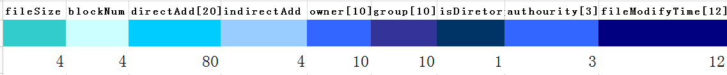
如上图所示，INode一共是128B 一个块是1024B
indirect block address是指拿来存储“块地址”的一个块的地址，在这里，地址是4Byte(32bit) 而块大小是1KB 那这个indirect block address 是可以存256个块地址 所以文件大小可以达到256+20个块
20个直接块地址
INode

在找到这个块
存储块地址的块，可以有256个块地址

class INode
{
private:
//如果是directory只能是一个块也就是1024/32=32个目录取直接地址第台一个
//如果是文件的话可以是21+256块
int fileSize;//文件大小 32bit可以表括示4GB大小 单位Byte 0~3B 4B
int blockNum;//文件占用的块的数量 4GB需要2^22但是用32位表括示浪费10bit 4~7B 4B
//地址一共215*1024块算是2^14 5位是偏移量
int directAdd[20];//直接地址· 小于个块的可以直接存在这里 8~91B 80B
int indirectAdd;// 间接地址· 大于1个块的可以直接存在这里 92~95B 4B
char owner[10];//文件拥有者 96~105B 9B
char group[10];//文件归属的组 106~114B 9B
bool isDiretory;//是否是目录 114~114B 1B
byte authourity[3];//Own Group Others 115~117B 3B
char fileModifyTime[12];//文件修改时间71~80B 117~127B 10B
public:
int FileSize() const;
void FileSize(int val);
int BlockNum() const;
void BlockNum(int val);
int*DirectAdd();
void DirectAdd(int pos,int val);
int IndirectAdd();
void IndirectAdd(int val);
const char*Owner() const;
void Owner(char *val);
const char*Group() const;
void Group(char *val);
bool IsDiretory();
void IsDiretory(bool val);

const char* FileModifyTime() const;
void FileModifyTime(char *val);
INode(void);
~INode(void);
private:
public:
void getTime(int * year, int * month, int * day, int * hour, int * minutes);
};

数据块组：
class DataBlock
{
public:
const static int numOfNlock=15360;//15*1024
Block data[15360];
public:
DataBlock(void);
~DataBlock(void);
};

文件目录：
class MyDirectory
{
private:
char name[12]; //12B
int index; //4B
char fatherName[12]; //12B
int fatherIndex; //4B
public:
MyDirectory(void);
~MyDirectory(void);

const char *Name() const;
void setName(char *val);

int Index() const;
void setIndex(int val);

const char *FatherName() const;
void setFatherName(char *val);

int FaIndex() const;
void setFaIndex(int val);
};

Main function:
void changePassword();
没有写，没时间写 = =
void getCommand();
获取用户的命令行，并且解析
void createDir(char *filename);
创建目录
void deleteDir(char *filename);
删除目录
void dir();
显示目录
void changeDir(char *fileName);
改变目录
void createFile(char *filename,int fileSize);
创建文件
void deleteFile(char *filename);
删除文件
void cat(char *filename);
打印文件
void cp(char *desFilename,char *srcFilename);
拷贝文件
void chmod(char *filename,int mod);
没写
void chown(char *filename,char* toOwner);
没写
void chgrp(char *fileName,char* toGroup);
没写
void chnam(char *filename,char* toFileName);
没写
void sum();
显示硬盘的使用情况

自己额外写的功能：
void logout();
退出登录
void welcome();
打印欢迎的界面
bool login();
用户登陆的函数
void find(char *filename);
查找文件
void help();
获取帮助
int findFileInodeIndex(char* filename);
//-1是找不到 其他是找到了
int FileSystem::findFileInodeIndex(char* filename)
{
if(filename[0]=='/')
{
bool isContinue=true;
char nowCheckFileName[20];
int nowCheckFileNameIndex=0;
int indexOfFileName=1;
while(filename[indexOfFileName]!='/'&indexOfFileName!=strlen(filename))
{
nowCheckFileName[nowCheckFileNameIndex++]=filename[indexOfFileName++];
}
if(indexOfFileName==strlen(filename))isContinue=false;
nowCheckFileName[nowCheckFileNameIndex]='\0';
INode inode0;
Block block0;
int nowInodeIndex=0;
superBlock.getINodeFromDisk(&inode0,nowInodeIndex);
superBlock.getBlockFromDisk(&block0,inode0.DirectAdd()[0]);

//遍历
int fileSize=inode0.FileSize();
MyDirectory dir;
int i;
for(i=0;i<fileSize;i+=32)
{
memcpy(&dir,block0.blockArray+i,sizeof(dir));
if(!strcmp(nowCheckFileName,dir.Name())){
superBlock.getINodeFromDisk(&inode0,dir.Index());
int year,month,dar,hour,minutes;
inode0.getTime(&year,&month,&dar,&hour,&minutes);
if(isContinue==false)
return dir.Index();
nowInodeIndex=dir.Index();
break;
}
}
if(i>=fileSize){isContinue=false;return -1;}
while(isContinue){
////////////////////////////////////!!!!!!!!!
if(!inode0.IsDiretory())
{
return -1;
}
indexOfFileName++;
nowCheckFileNameIndex=0;
while(filename[indexOfFileName]!='/'&indexOfFileName!=strlen(filename))
{
nowCheckFileName[nowCheckFileNameIndex++]=filename[indexOfFileName++];
}
if(indexOfFileName==strlen(filename))isContinue=false;
nowCheckFileName[nowCheckFileNameIndex]='\0';
Block block0;
superBlock.getBlockFromDisk(&block0,inode0.DirectAdd()[0]);
//遍历
int fileSize=inode0.FileSize();
MyDirectory dir;
int i;
for(i=0;i<fileSize;i+=32)
{
memcpy(&dir,block0.blockArray+i,sizeof(dir));
if(!strcmp(nowCheckFileName,dir.Name())){
superBlock.getINodeFromDisk(&inode0,dir.Index());
if(isContinue==false)
return dir.Index();
nowCheckFileNameIndex=dir.Index();
break;
}
}
if(i>=fileSize){isContinue=false;return -1;}
}
}
else
{
bool isContinue=true;
char nowCheckFileName[20];
int nowCheckFileNameIndex=roadStack[nowRoadStackTop];
int indexOfFileName=0;
while(filename[indexOfFileName]!='/'&indexOfFileName!=strlen(filename))
{
nowCheckFileName[nowCheckFileNameIndex++]=filename[indexOfFileName++];
}
if(indexOfFileName==strlen(filename))isContinue=false;
nowCheckFileName[nowCheckFileNameIndex]='\0';
INode inode0;
Block block0;
int nowInodeIndex=0;
superBlock.getINodeFromDisk(&inode0,nowInodeIndex);
superBlock.getBlockFromDisk(&block0,inode0.DirectAdd()[0]);
//遍历
int fileSize=inode0.FileSize();
MyDirectory dir;
int i;
for(i=0;i<fileSize;i+=32)
{
memcpy(&dir,block0.blockArray+i,sizeof(dir));
if(!strcmp(nowCheckFileName,dir.Name())){
superBlock.getINodeFromDisk(&inode0,dir.Index());
int year,month,dar,hour,minutes;
inode0.getTime(&year,&month,&dar,&hour,&minutes);
if(isContinue==false)
return dir.Index();
nowInodeIndex=dir.Index();
break;
}
}
if(i>=fileSize){isContinue=false;return -1;}
while(isContinue){
////////////////////////////////////!!!!!!!!!
if(!inode0.IsDiretory())
{
return -1;
}
indexOfFileName++;
nowCheckFileNameIndex=0;
while(filename[indexOfFileName]!='/'&indexOfFileName!=strlen(filename))
{
nowCheckFileName[nowCheckFileNameIndex++]=filename[indexOfFileName++];
}
if(indexOfFileName==strlen(filename))isContinue=false;
nowCheckFileName[nowCheckFileNameIndex]='\0';
Block block0;
superBlock.getBlockFromDisk(&block0,inode0.DirectAdd()[0]);
//遍历
int fileSize=inode0.FileSize();
MyDirectory dir;
int i;
for(i=0;i<fileSize;i+=32)
{
memcpy(&dir,block0.blockArray+i,sizeof(dir));
if(!strcmp(nowCheckFileName,dir.Name())){
superBlock.getINodeFromDisk(&inode0,dir.Index());
if(isContinue==false)
return dir.Index();
nowCheckFileNameIndex=dir.Index();
break;
}
}
if(i>=fileSize){isContinue=false;return -1;}
}
}
return -1;
}
void printFile(int inodeIndex);
void FileSystem::printFile(int inodeIndex)
{
INode fileINode;
superBlock.getINodeFromDisk(&fileINode,inodeIndex);
if(fileINode.IsDiretory()){printf("The the file is a directory!\n");return;}

int size=fileINode.FileSize();
for(int i=0;i<=((size-1)/1024);i++)
{
int nowBlockNum;
if(i<20)
{
nowBlockNum=fileINode.DirectAdd()[i];
}else
{
int inDirectBlockNum;

inDirectBlockNum=fileINode.IndirectAdd();
Block nowBlock;
superBlock.getBlockFromDisk(&nowBlock,inDirectBlockNum);
memcpy(&nowBlockNum,nowBlock.blockArray+4*(i-20),4);
}
Block nowBlockFile;
superBlock.getBlockFromDisk(&nowBlockFile,nowBlockNum);
for(int j=0;(j<1024)&(j<size-i*1024);j++)
{
printf("%c",nowBlockFile.blockArray[j]);
}
}
printf("\n");
}

void printNowRoad(void);

int findFileInodeFaIndex(char * filename);
//返回-1就是没有找到 其他就是Index的数字
int FileSystem::findFileInodeFaIndex(char * filename)
{
if(filename[0]=='/') //如果是绝对路径
{
bool isContinue=true; //是否找到
char nowCheckFileName[20]; //现在查找的那个名字
int nowCheckFileNameIndex=0;
int indexOfFileName=1;
while(filename[indexOfFileName]!='/'&indexOfFileName!=strlen(filename))
{
nowCheckFileName[nowCheckFileNameIndex++]=filename[indexOfFileName++];
}
if(indexOfFileName==strlen(filename))isContinue=false;
nowCheckFileName[nowCheckFileNameIndex]='\0';
INode inode0;
Block block0;
int nowInodeIndex=0; //当前是路径
superBlock.getINodeFromDisk(&inode0,nowInodeIndex);
superBlock.getBlockFromDisk(&block0,inode0.DirectAdd()[0]);

//遍括历该目录的文件dir
int fileSize=inode0.FileSize();
MyDirectory dir;
int i;
for(i=0;i<fileSize;i+=32)
{
memcpy(&dir,block0.blockArray+i,sizeof(dir));
if(!strcmp(nowCheckFileName,dir.Name())){
superBlock.getINodeFromDisk(&inode0,dir.Index());
if(isContinue==false)
return nowInodeIndex;
nowInodeIndex=dir.Index();
break;
}
}
if(i>=fileSize){isContinue=false;return -1;}
while(isContinue){
////////////////////////////////////!!!!!!!!!
if(!inode0.IsDiretory())
{
return -1;
}
indexOfFileName++;
nowCheckFileNameIndex=0;
while(filename[indexOfFileName]!='/'&indexOfFileName!=strlen(filename))
{
nowCheckFileName[nowCheckFileNameIndex++]=filename[indexOfFileName++];
}
if(indexOfFileName==strlen(filename))isContinue=false;
nowCheckFileName[nowCheckFileNameIndex]='\0';

Block block0;
superBlock.getBlockFromDisk(&block0,inode0.DirectAdd()[0]);

//遍历
int fileSize=inode0.FileSize();
MyDirectory dir;
int i;
for(i=0;i<fileSize;i+=32)
{
memcpy(&dir,block0.blockArray+i,sizeof(dir));
if(!strcmp(nowCheckFileName,dir.Name())){
superBlock.getINodeFromDisk(&inode0,dir.Index());
if(isContinue==false)
return nowInodeIndex;
nowInodeIndex=dir.Index();
break;
}
}
if(i>=fileSize){isContinue=false;return -1;}
}
}
else
{
return 0;
}
return -1;
}

void createDir(char *filename);
void deleteDir(char *filename);
void dir();
void changeDir(char *fileName);
void find(char *filename);
void createFile(char *filename,int fileSize);
void deleteFile(char *filename);
void cat(char *filename);
void cp(char *desFilename,char *srcFilename);
void sum();

D.Running
登录：
ID | Password
adm | 123
lyh | 123

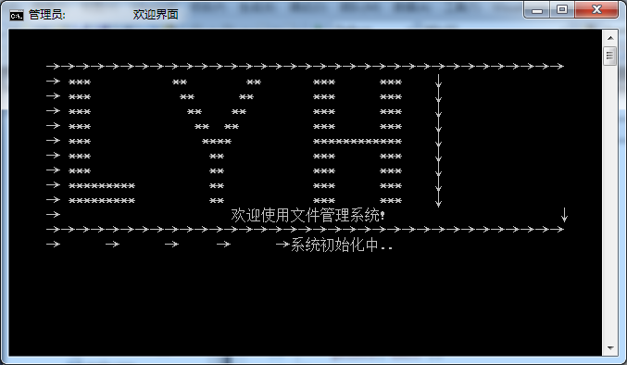
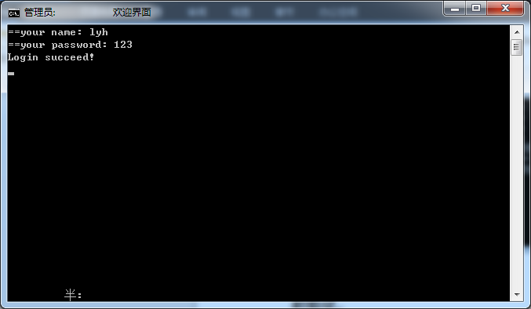

Sum:
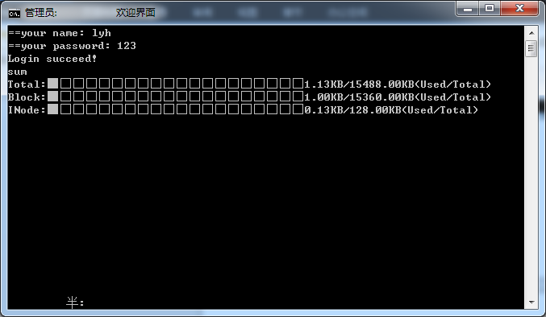
创建目录:
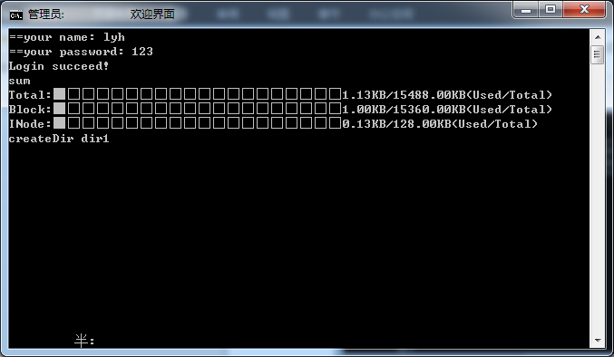
创建文件：
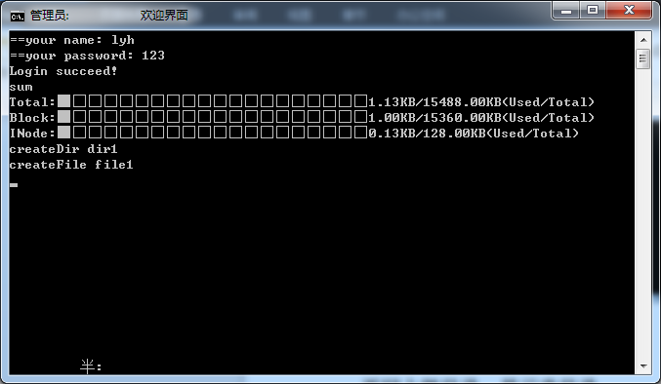
Clear screen：
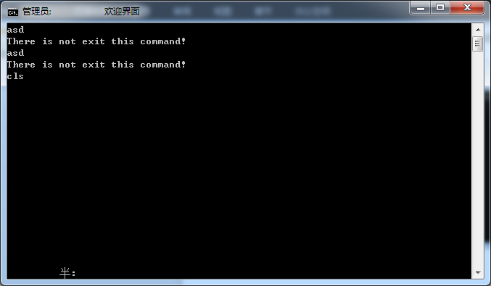
进入目录：
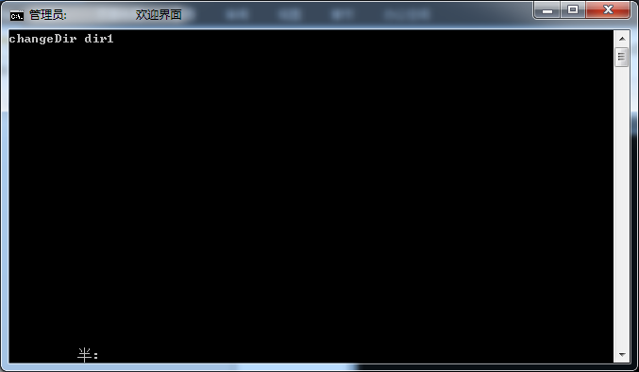

创建目录dir2,文件file2
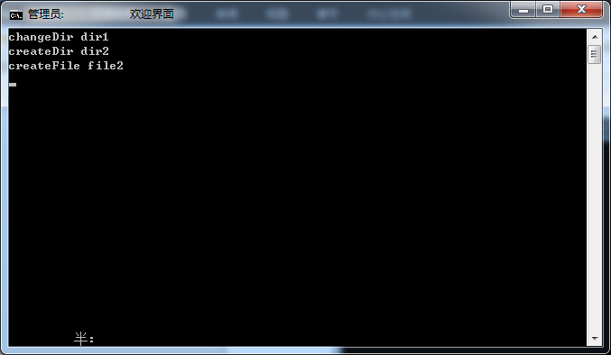
显示当前目录：
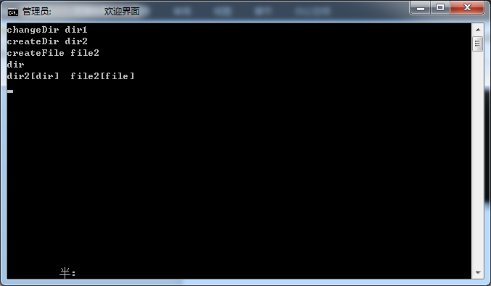

删除目录dir2、删除文件file2:
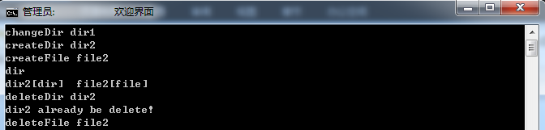
返回根目录、显示根目录：
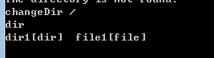
帮助
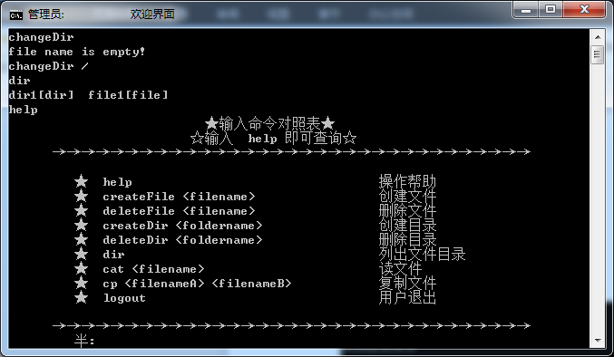
Sum:
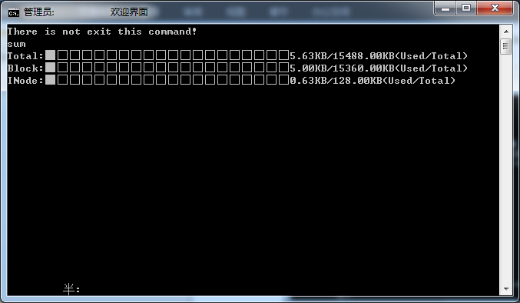
Cat：
