Space Animation

Michael Young - 4245718

Abstract

My choice for the final project was to do an animation. I used the open source c library OpenGL, GLUT, and FreeImage to do all the graphic work. All models were done by me using Milkshape 3D v1.7.4. The models were exported as ASCII text files and were read in through my program. The program was done in C using Microsoft Visual Studio 2008 with Windows 7 64-bit operating system. Consult the ReadMe text file for more in depth information on how to run and execute the program.

I. Introduction

The animation takes place in space and the viewer is shown a spaceship leaving a planet. After this spaceship travels for awhile, an alien spaceship comes from the other side of the planet, approaches the original spaceship, circles it then shoots its laser and the ship explodes. The entire animation is about 35 seconds.

II. Structures and Models

There were numerous structures that had to be created in order to fully manipulate the models and effectively create the animation.

II.a Planet

The planet is a simple sphere, but has rather unique lightining. The vertices and all the other corresponding information or stored in 2D arrays(vector arrays (x,y,z)).

II.b Alien Ship

The alien ship is divided into basically two spheres, but have been transformed to represent a ship. The alien ship structure contains alienShip_cockpit and alienShip_body. Both are similar structures that hold all their own information.

II.c Big Space Ship

The big space ship is divided into 5 models. The cockpit, the body, big engine, left engine and right engine. Each of these models is its own structure and the ship structure is made up of
ship_body, ship_engine_smallx2, ship_engine_big, ship_engine_cockpit.

V. How it all Works

The program starts by initializing the planet, and the two ships. This initialization takes care of all the file reading that has to be in order to get the proper information for the models. The information is read from an exported text file. The vertices, normals, faces, and indices of all the models are stored in their corresponding data structures.

Once everything is initialized, all the glut commands needs to be initialized and the window which is to be displayed is shown. Glut then enters its main loop and each iteration calls render scene. In which case the animation starts and goes until the end.

VI. Added Features

Before I started this animation I knew I wanted to have some sort of an explosion. Initially my idea was to have a bunch of random triangles flying away in different directions. I figured this would give it a more 'life-like' appearance. However, I could not manage to get the triangles working, so I decided to go with normal points instead. My animation doesn't really have the 'life-like' feel anyways. Here is a screen shot of the explosion.

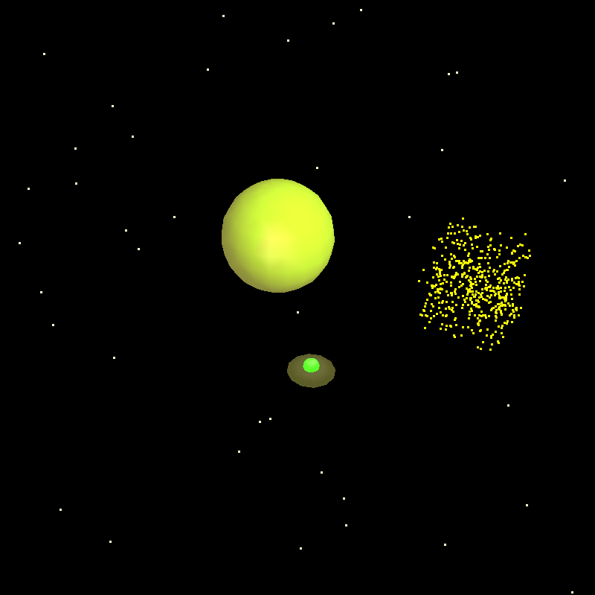
The cluster of yellow points is where the big shup used to be. Each point is represented as a individual particle. Each particle has the same starting position, but their starting direction is completely random. The direction is found by finding a random number between 0 and 1. Then another random is done to get a positive or negative value(50/50 random). This way, on average, particles will travel in every direction.

Another special feature I added in later was the stars. The stars act almost identical to the explosion particles, however when the stars are initialized, their positions are update for a certain amount of time based on their direction vector and their ending position is shown on the screen. All these calculations are done before the animation starts. This gives the feel that the stars originated there, however they really start at the original and they are moved. The stars are in 3D, at first this wasn't completely intentional, however when I saw the animation I thought the stars added a nice depth to the scene.

VI. Problems Encountered

One of the things that took the longest amount of time was figuring out how to get all the information from Milkshape 3D and get it to show up using OpenGL. At first the export file seemed complete gibberish, but after awhile analyzing the numbers and reading up on the issue, it's actually exported in a very excellent way.

Another issue I had was getting the lighting to properly work. Eventually I narrowed the problem down to the normals, and the program wasn't reading the normals in correctly. This is partly linked to the first problem I had. The normals actually had their own indices I didn't know about, I thought they shared their indices with the vertices.

VII. Summary

Milkshape 3D is a rather simple and relatively powerful 3D model creator that has its own great list of
different export types. The ASCII export make reading the information a lot easier and make for easier manipulation of it. OpenGL is capabile of some surprisingly powerful things. I think with more experience one could easily create nice looking animations.

