1) Planning
2) Analysis
3) Design
4) Development
5) Testing
6) Implementation
7) Maintenance

Analysis
Extensive Research to ensure understanding of the problem
Create a set of numbered objectives for the system
Objectives are most important part of the project

Produce a clear statement that describes the problem area and specific problem that is being solved.

For the past 2 years, I have been heavily interested and invested in the Cryptocurrency markets. The crypto markets are ones of high volatility and high risk. Aside from yield farming a stablecoin, there are very few ways to make money in crypto with zero risk. One of the most important aspects in any investors mind is Risk Management. Risk Management is an imperative aspect when dealing with financial gain/loss. For my NEA project, I chose to find a way to programmatically reduce risk while trading cryptocurrency. In order to do this, I had to plan out and research many factors relating to the markets and how they operate.

In the current cryptocurrency markets, there is a large amount of risk involved in investing. This stems from the huge levels of volatility that comes with risk-on assets such as Bitcoin or Ethereum. A study has shown that 97% of cryptocurrency day-traders lose money in an extended period of time. With this project, I aim to reduce the levels of risk that crypto traders face on a day to day basis. My project will have a few different modules that will all ultimately reduce the risk that the individual takes on.

Provide background in sufficient detail for a third party to understand the problem being solved
Look at the problem statement and identify anything that needs further explanation. Pretend they have no clue

At a very basic level, cryptocurrencies are digital assets that hold some form of value and (usually) contain some form of utility. These cryptocurrencies are usually run off of decentralized networks, meaning that no single entity has omnipresent control (there are exceptions to this, that I will touch on at some point later in this project). There exists decentralized exchanges where users or automated tools can buy and sell assets to other interested parties. One example of a decentralized exchange (DEX) is DyDx. DyDx is a decentralized perpetuals platform on the Ethereum blockchain that allows parties to quickly trade perpetuals on different trading pairs. To break down the above sentence, perpetuals are asset pairs that are not structured with an expiry date. Basically meaning that they hold the value of an asset and allow users to trade upon them. In cryptocurrency (and investment) terms, a pair refers to the two assets that are being traded against. For example, you could trade a BTC/USDT perpetual contract on DyDx. As you can infer, you would be trading the value of Bitcoin against the value of Tether, a US Dollar stablecoin.

Whenever I use the word 'Whale', I am referring to crypto wallets that hold a large (>~$1 Million) amount of crypto in their wallets. These Whales are the ones that control and manipulate the majority of the market. What this means is that Whales typically are aware of what is going to happen before it actually does. For example, in early October, right before there was an 11% drop in $BTC, one of the largest crypto whales in the world sold a large amount of their stack. Then on November 12th 2021 at a low point in $BTC's price, they accumulated 1123 BTC, increasing their stack over the coming days by over $100 million. My point in mentioning this is that Whales often see things that the average retail investor doesn't, being able to sell the tops and buy the dips.

Contrary to traditional banking systems, with the majority of cryptocurrency, all transactions and wallet information is stored on the blockchain meaning it can be read and viewed by anyone that has the knowhow to do so. For example, the tool Zerion makes it very easy for anyone to see what someone is currently holding in their wallet. Below is a screenshot from one of the friend's wallets on the Zerion platform. As you can see, the graphical interface is very clean and easily displays all the necessary information. However, Zerion only shows the assets that the wallet is currently holding. There is no historical data easily available to view.

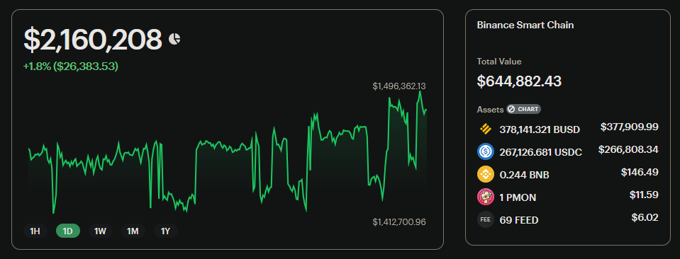

State for whom the problem is being solved for

The main group of people that would benefit from the system that I am creating would be the Retail cryptocurrency investment crowd. Meaning the average everyday person trading with lower amounts of money than the institutional investors on Wall Street or in Shanghai. These investors are usually the ones to lose money while trading, and also are the ones that would feel the losses more because it is usually money stemming from personal savings or a split of a paycheque.
With that being said, depending on the success of the project it could be possible to bundle the system into an enterprise program to lease or sell to investment firms around the world. Any institutional investor is constantly looking for an edge over the market, and if a risk management system such as this works well and generates noticeable profits then large funds will be more likely to pay large sums for access to the system.
And lastly, I would personally use this system to improve my cryptocurrency trading skill and my risk tolerance for my personal portfolio.

Outline how you researched the problem
If there is an existing system, it is essential that you find out details of how things are currently done.

Technical analysis
Price trackers
Lunarcrush
Tradingview
Etoro?

The existing system

One of the best ways at the moment to make informed decisions about possible trades is to perform the act known as Technical Analysis on the price action chart. Technical Analysis is the study of financial market action. The purpose of it is to find patterns in past price action to make a more informed decision about future price action. According to Investopedia:

Technical analysis is a trading discipline employed to evaluate investments and identify trading opportunities by analyzing statistical trends gathered from trading activity, such as price movement and volume.

In the past, I have personally used Technical Analysis to inform my short-term trades in the crypto markets. There is a huge range of different techniques that you can use, and many professionals dedicate their lives to the art of mastering the charts. One of the most important aspects of the charts for predicting future price action are indicators. Indicators are visual tools that you can use to identify trends in price action and possibly indicating future price movement.

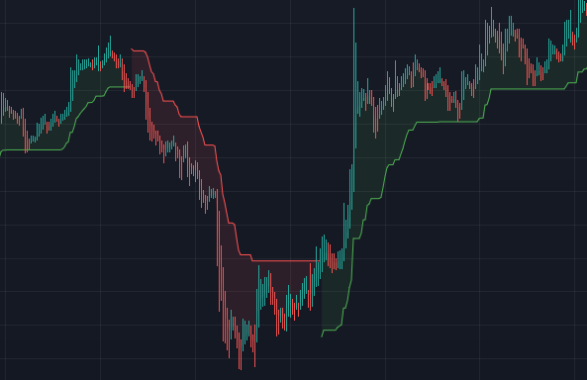

Here is a very basic 15 minute chart with only one indicator used. The indicator shown above is called the Supertrend indicator. Each indicator has a set formula behind it that defines how to display the data. For example, the formula for the Supertrend indicator is as follows:

Up = (high + low / 2 + multiplier x ATR
Down = (high + low) / 2 – multiplier x ATR
Calculation of Average True Range –
[(Prior ATR x 13) + Current TR] / 14
On first glance, this seems like a complicated formula but when broken down the concepts are very simple. The program takes the highest and lowest price points of a certain time frame and compares it with an average range. The specifics of how this works is irrelevant, I am trying to display how indicators take complex mathematics and condenses it into a human-readable view that displays trends. In this project, I will be utilising a large range of different indicators to make more informed decisions on whether to buy or sell an asset.

One crypto trading strategy that has been widely-considered as profitable is to simply follow whatever moves Whales make. A lot of people that I know personally in the crypto space follow this strategy among others and have made consistent profits. However, the process isn't a simple one. Usually, they would go on a website like BSCScan or Etherscan, input a whale's wallet address and manually search through their transactions to find transactions worth copying. However as you can see from the screenshot below, these transactions are difficult to read by the human eye without much effort spent looking through the token addresses, values, fees, Etc. My point is that there needs to be an easier way to track what crypto Whales are buying and selling.
There are already systems in place that will do similar processes but these systems are never open for access to the average investor, they are either hidden behind a disgustingly priced paywall or are kept for use of their creators. One of the reasons I am creating this project is to bring risk management systems to the average retail investor.

EXPAND ON EXISTING SYSTEM

Requirements determined based on the needs stated by the intended users of the system

For this project, I have a few aims of the different modules that I want to have achieved by the end of it. First and foremost, I want my program to have the ability to perform basic Technical Analysis on a given pair and output information including a buy/sell sentiment. I do not have the ability to program a hugely advanced TA machine, however even basic technical analysis will improve the confidence that users will have in each trade. The aim of this project is not to create a money printing machine that can predict the markets 100%, however I aim to improve the confidence users have in their trades and make more informed decisions about their trades.
Another aim of this project is to have a module that can actually execute these trades automatically. This module will take into account the user’s risk tolerance to place trades with low margin, meaning that not a huge amount of funds will be used but with consistent usage profits will build up and be more apparent. I will likely use the DyDx API for this as there is adequate documentation online for this and according to people I’ve spoken to online, it is a reliable program for executing trades programmatically.
Separate to this I want my program to also be able to track the wallets of crypto whales to make informed decisions about what moves the whales are making. As stated above, large money are the ones that control the market meaning that a solid investment strategy (and one that hugely outperforms the market) is to rote copy the trades that whales make.
Lastly, I will have a section of my program dedicated to generating and adapting a long-term crypto portfolio for the less advanced investor to make money long term with. I will personally use this to create a portfolio that I will Dollar Cost Average (DCA) into. Dollar Cost Averaging is the process of investing on a regular basis to average out the price of an asset over time. This means that if you believe that the price of an asset will be worth more in the future than it is at this current moment in time, DCA means that you are less susceptible to short-term price volatility.

Requirements:
The ability to track whale wallets and find tokens that are popular amongst whales
The ability to perform technical analysis on a chart when given parameters to work against
The ability to place trades based on the confidence of the technical analysis
The ability to generate and recommend a cryptocurrency portfolio based on the users’ risk tolerance

Objectives
SMART Objectives

1 - The program will perform Technical Analysis on a given asset’s price chart
1.1 – The program will ask the user to input the trading pair that they would like to analyses
1.2 – The program will ask the user to input the requested time interval. They can pick from either Short term (1m - 5m), M for Mid term (15m - 30m) or L for Long term (1h - 4h)
1.3 – The program will scrape the necessary data from online sources of the historical price action of the given asset against the specified time frame
1.4 – The program will use a library to get indicator values and store them in a database
1.5 – The program will format the data into a format that is human-readable and display the necessary information in plaintext for the user
1.6 – The program will generate visual data for the user to view (charts and graphs)
1.7 – The program will output a % value of its confidence based upon buy/sell signals listed
2 – The program will execute actual trades based off of this information
2.1 – The program will connect to the DyDx API and succeed verification
2.2 – The program will select the necessary trading pair and verify its validity
2.3 – The program will place an initial limit order on the trading pair with a “safe” price value
2.4 – The program will place a small market order on the pair if there is enough confidence in the trade
2.5 – The program will fade the entry of the position to negate any opposite price action before a reversal
2.6 – The program will place a stop loss for the position to mitigate risk
2.7 – The program will place a take profit which is weighted depending on the confidence in the trade
2.8 – The program will monitor the trade and give the user alerts depending on the price action
3 – The program will track the movements of crypto whales. Find tokens that have buy-side correlations between different addresses. E.g. If you have a list of 20 addresses, is there a specific token that at least 2 of them have bought in the last 5 days? If this is a new project, it might be a good one to investigate further and potentially buy.
3.1 – The program will iterate through a list of wallet addresses, gathering transaction history from each of them and storing them in a computer-readable file format (JSON or CSV)
3.2 – The program will store recent transactions in a dedicated section of the dataset
3.3 – The program will check recent ‘purchases’ against other wallet’s transaction history to find correlations between them
3.4 – The program will be able to do this for singular addresses or multiple at once
3.5 – The program will be able to give an arbitrary ‘significance’ value to a wallet address, computing its profitability over time
3.6 – The program will scrape price history of each token that there is proven whale interest in
3.7 – The program will record each transaction and the date in which each TX was executed
3.8 – The program will aggregate this data to reveal the Return on Investment of that address
3.9 – The program will store a Watchlist for the user to input addresses into to watch consistently over time

EXPAND ON OBJECTIVES

Report any modelling of the problem that will inform the design stage

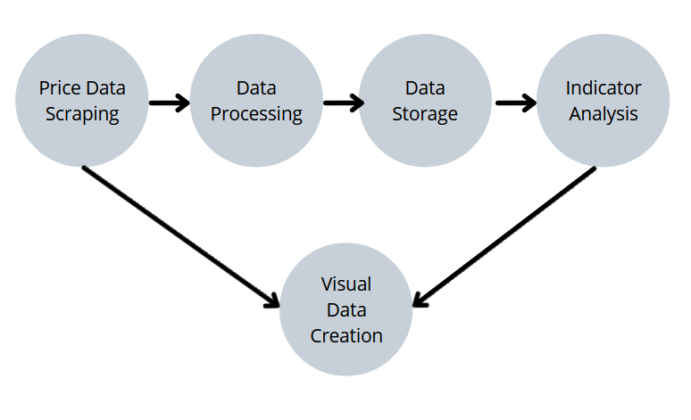

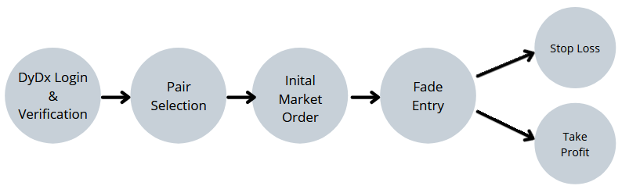

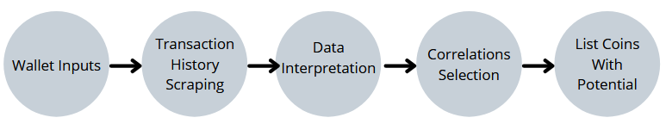

Things to explain and research
- Limit orders
- Market orders
- Previous Txs are easy because they are stored on chain compared with banking systems
- perpetuals are synthetic derivatives usually with lower costs
- leverage

Design

This high-level overview will depend on the type of system that you are developing and it is up to you to pick the most appropriate method(s). These are some commonly used techniques:

This project will not have a user interface. Initially it will be run 100% from the command line.

Overview
Describe overall structure and tools used

My program contains 3 main functions in the main process.
The first is the Technical Analysis Module. This function serves as an engine for obtaining an outlook on how potentially profitable a certain trade would be on a specific trading pair. For example, if the user were to input the trading pair of BTC/USDT the engine would scrape historical price action from online sources whilst overlaying indicators on top of the price chart to display the likely future movement of the asset. EXPAND

The second main function of my program is the Trade Execution Module. This function’s sole purpose is to programmatically and automatically place the trades that the above Technical Analysis Module is most confident in. This module uses the DyDx API to execute trades. PRIVATE KEY

The third module

Functions

Whale Tracker
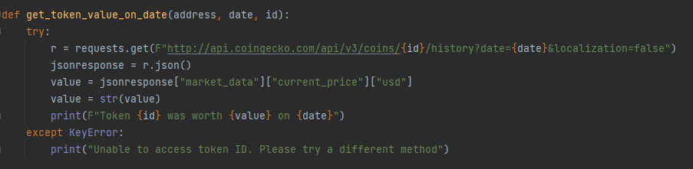

Sources:
https://www.investopedia.com/terms/t/technicalanalysis.asp

