Computer Science NEA: CryptoBucket – An Automated Algorithmic Cryptocurrency Risk Management System

AQA A-Level

Will Macintosh
Candidate Number 133678
Centre No. 22147
Hills Road Sixth Form College

Contents
Analysis - 3
Design - 12
Technical Solution - 17
Testing - 23
Implementation - 28
Maintenance – 30
Evaluation - 33

Analysis

Brief Introduction

In the current state of the cryptocurrency markets, there is a huge amount of risk involved with investing in these types of assets. This stems from the huge levels of volatility that comes with risk-on assets such as Bitcoin or Ethereum. An extensive study has shown that 97% of cryptocurrency day-traders lose money in an extended period of time. With this project, I aim to reduce the levels of risk that crypto traders face on a day to day basis. My project will have a few different modules that will all ultimately reduce the risk that the individual takes on.

For the past 2 years, I have been heavily interested and invested in the Cryptocurrency markets. The crypto markets are ones of high volatility and high risk. Aside from yield farming a Stablecoin, there are very few ways to make money in crypto with zero risk. One of the most important aspects in any investors mind is Risk Management. Risk Management is an imperative aspect when dealing with financial gain/loss. For my NEA project, I chose to find a way to programmatically reduce risk while trading cryptocurrencies. In order to do this, I had to plan out and research many factors relating to the markets and how they operate.

Currently, there is a limited amount of risk management software available to the retail investment crowd. This project aims to remedy this situation through the production of CryptoBucket, an Automated Algorithmic Cryptocurrency Risk Management System.

Project Problem Definition

The main group of people that would benefit from the system that I am creating would be the Retail cryptocurrency investment crowd. Meaning the average everyday person trading with lower amounts of money than the institutional investors on Wall Street or in Shanghai. These investors are usually the ones to lose money while trading, and also are the ones that would feel the losses more because it is usually money stemming from personal savings or a split of a paycheque.

With that being said, depending on the success of the project it could be possible to bundle the system into an enterprise program to lease or sell to investment firms around the world. Any institutional investor is constantly looking for an edge over the market, and if a risk management system such as this works well and generates noticeable profits then large funds will be more likely to pay large sums for access to the system.

And lastly, I would personally use this system to improve my cryptocurrency trading skill and my risk tolerance for my personal portfolio.

Background To The Problem

At a very basic level, cryptocurrencies are digital assets that hold some form of value and (usually) yield some form of utility. These cryptocurrencies are usually run off of decentralized networks, meaning that no single entity has omnipresent control (there are exceptions to this, that I will touch on at some point later in this project). There exists decentralized exchanges where users or automated tools can buy and sell assets to other interested parties. One example of a decentralized exchange (DEX) is DyDx. DyDx is a decentralized perpetuals platform on the Ethereum blockchain that allows parties to quickly trade perpetuals on different trading pairs. To break down the above sentence, perpetuals are asset pairs that are not structured with an expiry date. Basically meaning that they hold the value of an asset and allow users to trade upon them. In cryptocurrency (and investment) terms, a pair refers to the two assets that are being traded against. For example, you could trade a BTC/USDT perpetual contract on DyDx. As you can infer, you would be trading the value of Bitcoin against the value of Tether, a US Dollar Stablecoin.

Whenever I use the word 'Whale', I am referring to crypto wallets that hold a large (>~$1 Million) amount of crypto in their wallets. These Whales are the ones that control and manipulate the majority of the market. What this means is that Whales typically are aware of what is going to happen before it actually does. For example, in early October, right before there was an 11% drop in $BTC, one of the largest crypto whales in the world sold a large amount of their stack. Then on November 12th 2021 at a low point in $BTC's price, they accumulated 1123 BTC, increasing their stack over the coming days by over $100 million. My point in mentioning this is that Whales often see things that the average retail investor doesn't, being able to sell the tops and buy the dips.

Contrary to traditional banking systems, with the majority of cryptocurrency, all transactions and wallet information is stored on the blockchain meaning it can be read and viewed by anyone that has the knowhow to do so. For example, the tool Zerion makes it very easy for anyone to see what someone is currently holding in their wallet. Below is a screenshot from one of the friend's wallets on the Zerion platform. As you can see, the graphical interface is very clean and easily displays all the necessary information. However, Zerion only shows the assets that the wallet is currently holding. There is no historical data easily available to view.
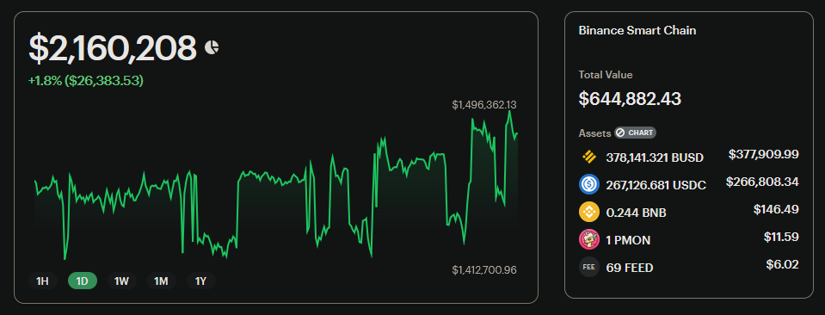

Research

Observations of the Existing System

Technical Analysis

One of the best ways at the moment to make informed decisions about possible trades is to perform the act known as Technical Analysis on the price action chart. Technical Analysis is the study of financial market action. The purpose of it is to find patterns in past price action to make a more informed decision about future price action. According to Investopedia:

Technical analysis is a trading discipline employed to evaluate investments and identify trading opportunities by analyzing statistical trends gathered from trading activity, such as price movement and volume.

In the past, I have personally used Technical Analysis to inform my short-term trades in the crypto markets. There is a huge range of different techniques that you can use, and many professionals dedicate their lives to the art of mastering the charts. One of the most important aspects of the charts for predicting future price action are indicators. Indicators are visual tools that you can use to identify trends in price action and possibly indicating future price movement.

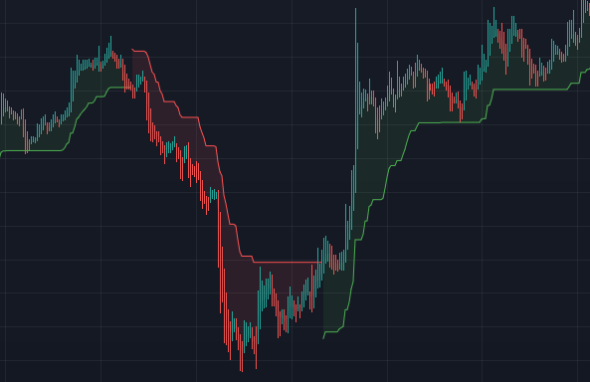

Here is a very basic 15 minute chart with only one indicator used. The indicator shown above is called the Supertrend indicator. Each indicator has a set formula behind it that defines how to display the data. For example, the formula for the Supertrend indicator is as follows:

Up = (high + low / 2 + multiplier x ATR
Down = (high + low) / 2 – multiplier x ATR
Calculation of Average True Range –
[(Prior ATR x 13) + Current TR] / 14
On first glance, this seems like a complicated formula but when broken down the concepts are very simple. The program takes the highest and lowest price points of a certain time frame and compares it with an average range. The specifics of how this works is irrelevant, I am trying to display how indicators take complex mathematics and condenses it into a human-readable view that displays trends. In this project, I will be utilising a large range of different indicators to make more informed decisions on whether to buy or sell an asset.

Whales

One crypto trading strategy that has been widely-considered as profitable is to simply follow whatever moves Whales make. A lot of people that I know personally in the crypto space follow this strategy among others and have made consistent profits. However, the process isn't a simple one. Usually, they would go on a website like BSCScan or Etherscan, input a whale's wallet address and manually search through their transactions to find transactions worth copying. However as you can see from the screenshot below, these transactions are difficult to read by the human eye without much effort spent looking through the token addresses, values, fees, Etc. My point is that there needs to be an easier way to track what crypto Whales are buying and selling.

There are already systems in place that will do similar processes but these systems are never open for access to the average investor, they are either hidden behind a disgustingly priced paywall or are kept for use of their creators. One of the reasons I am creating this project is to bring risk management systems to the average retail investor.

Existing Similar Solutions

Objectives for the Proposed System

For this project, I have a few aims of the different modules that I want to have achieved by the end of it. First and foremost, I want my program to have the ability to perform basic Technical Analysis on a given pair and output information including a buy/sell sentiment. I do not have the ability to program a hugely advanced TA machine, however even basic technical analysis will improve the confidence that users will have in each trade.
The aim of this project is not to create a money printing machine that can predict the markets 100%, however I aim to improve the confidence users have in their trades and make more informed decisions about their trades.
Another aim of this project is to have a module that can actually execute these trades automatically. This module will take into account the user’s risk tolerance to place trades with low margin, meaning that not a huge amount of funds will be used but with consistent usage profits will build up and be more apparent. I will likely use the DyDx API for this as there is adequate documentation online for this and according to people I’ve spoken to online, it is a reliable program for executing trades programmatically.
Separate to this I want my program to also be able to track the wallets of crypto whales to make informed decisions about what moves the whales are making. As stated above, large money are the ones that control the market meaning that a solid investment strategy (and one that hugely outperforms the market) is to rote copy the trades that whales make.
Lastly, I will have a section of my program dedicated to generating and adapting a long-term crypto portfolio for the less advanced investor to make money long term with. I will personally use this to create a portfolio that I will Dollar Cost Average (DCA) into. Dollar Cost Averaging is the process of investing on a regular basis to average out the price of an asset over time. This means that if you believe that the price of an asset will be worth more in the future than it is at this current moment in time, DCA means that you are less susceptible to short-term price volatility.

1 - The program will perform Technical Analysis on a given asset’s price chart
1.1 – The program will ask the user to input the trading pair that they would like to analyses
1.2 – The program will ask the user to input the requested time interval. They can pick from either Short term (1m - 5m), M for Mid term (15m - 30m) or L for Long term (1h - 4h)
1.3 – The program will scrape the necessary data from online sources of the historical price action of the given asset against the specified time frame
1.4 – The program will use a library to get indicator values and store them in a database
1.5 – The program will format the data into a format that is human-readable and display the necessary information in plaintext for the user
1.6 – The program will generate visual data for the user to view (charts and graphs)
1.7 – The program will output a % value of its confidence based upon buy/sell signals listed

2 – The program will execute actual trades based off of this information
2.1 – The program will connect to the DyDx API and succeed verification
2.2 – The program will select the necessary trading pair and verify its validity
2.3 – The program will place an initial limit order on the trading pair with a “safe” price value
2.4 – The program will place a small market order on the pair if there is enough confidence in the trade
2.5 – The program will fade the entry of the position to negate any opposite price action before a reversal
2.6 – The program will place a stop loss for the position to mitigate risk
2.7 – The program will place a take profit which is weighted depending on the confidence in the trade
2.8 – The program will monitor the trade and give the user alerts depending on the price action

3 – The program will track the movements of crypto whales. Find tokens that have buy-side correlations between different addresses. E.g. If you have a list of 20 addresses, is there a specific token that at least 2 of them have bought in the last 5 days? If this is a new project, it might be a good one to investigate further and potentially buy.
3.1 – The program will iterate through a list of wallet addresses, gathering transaction history from each of them and storing them in a computer-readable file format (JSON or CSV)
3.2 – The program will store recent transactions in a dedicated section of the dataset
3.3 – The program will check recent ‘purchases’ against other wallet’s transaction history to find correlations between them
3.4 – The program will be able to do this for singular addresses or multiple at once
3.5 – The program will be able to give an arbitrary ‘significance’ value to a wallet address, computing its profitability over time
3.6 – The program will scrape price history of each token that there is proven whale interest in
3.7 – The program will record each transaction and the date in which each TX was executed
3.8 – The program will aggregate this data to reveal the Return on Investment of that address
3.9 – The program will store a Watchlist for the user to input addresses into to watch consistently over time

Design

Overview

My program solution contains 3 functions in the main process. These functions will each have a different use-case and each will interact with the other in a different way. Each module has a different individual purpose but when combined with one another it creates a fully fledged risk management system that is “profitable”. This project will not have a user interface. It will be a command-line run tool. The reason for this is that if I were to develop a web interface for example, the website design and API functionality would take up an immense amount of programming time and would take away from my focus on the functionality and profitability of the actual key modules that will be used the most by the users.

The first main function in the program is the Technical Analysis Module. This function serves as an engine for obtaining a specific market outlook on how potentially profitable a certain trade would be on a specific trading pair. For example, if when prompted the user were to input the trading pair of BTC/USDT the engine would scrape historical price action from online sources whilst overlaying indicators on top of the price chart to display the likely future movement of the asset. ...

The second main function of my program is the Trade Execution Module. This function’s sole purpose is to programmatically and automatically place the trades that the above Technical Analysis Module is most confident in. This module uses the DyDx API to execute trades. There are some limitations for using this method of trade placement that prevent it from being fully functional for public release. For example, in order to use the DyDx API, you need to already have a working account with their DEX whilst also inputting your wallet private key into the program. This is a big privacy risk for not only potential users of the system but also myself, while using my own private key whilst developing the project.

The third module in my program is the cryptocurrency Whale Wallet Tracker. This is possibly the module that I believe has the most potential for the largest profits whilst also having the highest win rate. The reason for this is partially stated in my research above when I discuss the concept of crypto Whales and the way that they seem to manipulate the markets. These whales tend to be institutional investors such as big banks or investment firms as these are the players that tend to have the most money in the markets, other than individual billionaire investors (Cough Musk).

System Flowcharts

Technical Analysis Module
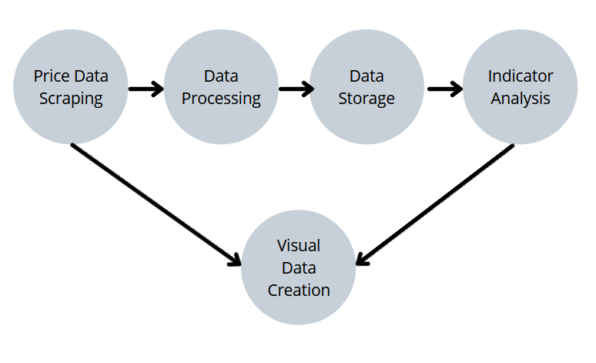
Above is the flowchart for my Technical Analysis Module. This flowchart displays at a basic level what processes the program will go through to output the final data product at the end.

First, a library such as the CoinMarketCap API or the CoinGecko API will scrape historical price data from online sources to define price action over time for the selected trading Pair. For example if the user were to input BTC/USDT as the selected trading pair, the module would scrape historical price data for Bitcoin from CMC or CoinGecko. It will then store this data in a JSON format for an equal mix of Human-readability and also machine-readability. I am using the python JSON library to help store this information.
Next, the data will be processed through a selection of different data processing techniques in order to only highlight the necessary information from the huge amount of data scraped from each library.
After this, the data is stored in JSON format in a local file in order to be read from later. These will be stored locally in the current directory that the program is being run from. I will implement a data removal system to avoid excess clutter being stored on the user’s system.
After data storage, the module will begin the analysis of the price data using Technical Indicators. I will be using the Python library TradingView_TA for the Technical Indicators. This is the best library for me to be using for this project as it is the one with the most in-depth indicator analysis.
Finally, the program will display this data in a visual format for the user to be able to read from. I will be using the Python library Pandas for this. Pandas is universally the most utilised Python library for displaying numerical data visually.

Trade Placement Module

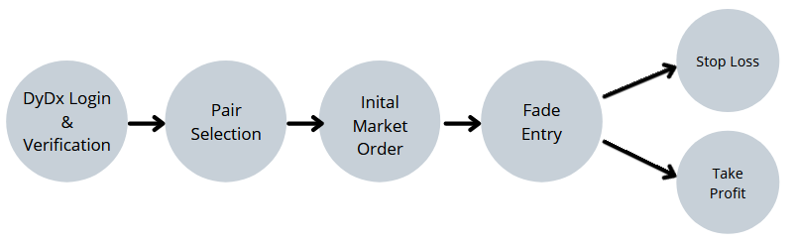
Shown above is the Trade Placement Module of my Risk management
system. This flowchart displays the process in which decentralized perpetual trades are placed. The opening strategy that I have chosen to utilise with this project is a Fade Open Entry. This will increase the position size as the price moves in the opposite direction in order to maximise position profits once the price action inevitably flips.
First, DyDx requires login and verification. This process is relatively simple as it is handled in the majority by the DyDx API that I am using. The only necessary inputs is the wallet’s private key and a link to a valid Ethereum Node (has to be Live, can be any as long as it is valid).
Next is a simple user input stored as a variable. The program asks the user which trading pair they would like to utilise (with the default being BTCUSDT). This input is stored as the variable “pair”.
Then there is an initial market order placed on the trading pair. This position is determined by a variety of different variables including the confidence levels that the Technical Analysis Module has in the program.

Whale Tracker Module
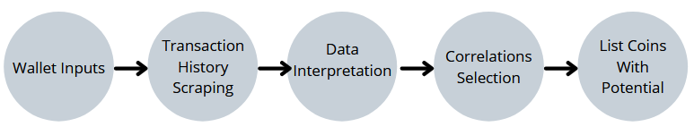

Technical Solution

The Code
