马蔚坤（Michael Ma)

Duke大学

研一

Computer Science MS

本科毕业于NC State University

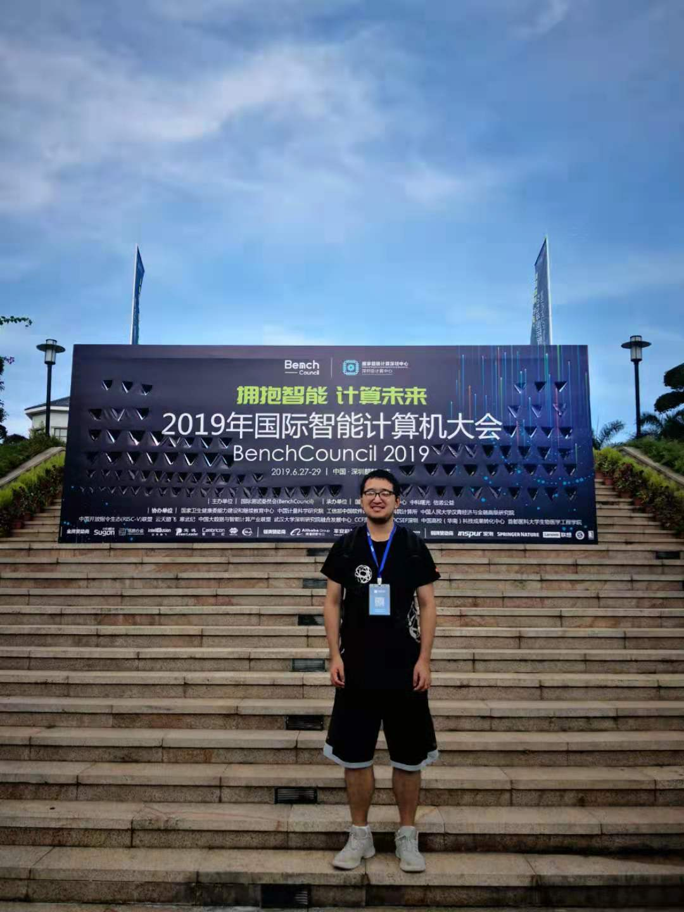

GPA：本科GPA3.90, 专业3.84

CSC116 A Intro to computing -- Java

CSC216 A Programming concept -- Java

CSC226 A+ Discrete Math

CSC316 A- Data Structure & Algorithm

CSC236 A Assemble Language

CSC246 B+ Operating System

CSC326 A- Software Engineering

CSC422 A Data Mining

CSC461 A+ Computer Graphic