BOSTON UNIVERSITY

SCHOOL OF MEDICINE

Dissertation

**NEURAL PATTERNS OF HIPPOCAMPUS AND AMYGDALA SUPPORTING MEMORY OVER LONG TIMESPANS**

by

**WILLIAM MAU**

B.A., Cornell University, 2014

Submitted in partial fulfillment of the

requirements for the degree of

Doctor of Philosophy

2019

**©** 2019

WILLIAM MAU

All rights reserved

Approved by

First Reader _________________________________________________________

Name of First Reader, Ph.D.

Professor of .................

Second Reader _________________________________________________________

Name of Second Reader, Ph.D.

Associate Professor of .................

Third Reader _________________________________________________________

Name of Third Reader, Ph.D.

Professor of .................

Harvard University, School of Medicine

*[This is where your epigraph goes, if you are to have one. If you are not inserting an epigraph, please delete this page. DO NOT DELETE THE SECTION BREAK. Just back space until the section break appears on the approval page.]*

# DEDICATION

I would like to dedicate this work to my patient spouse Landry, my wonderful children Charlie and Phoenix, and my dog Armani.

*(Delete this page if you don't need it. Be sure to delete all the text on the page, and the page break after it, not the section break before it. To see the section and page breaks, click the "show all nonprinting characters" button in the Word toolbar.)*

# ACKNOWLEDGMENTS

Sometimes, a dissertation or thesis will have an acknowledgments page. Here's where you thank the people who helped you write this work. Your advisor and committee, archivists and librarians, your best friends, your spouse, your study buddy.

*(Delete this page if you don't need it. Be sure to delete all the text on the page, and the page break after it, not the one before it. To see the section and page breaks, click the "show all nonprinting characters" button in the Word toolbar.)*

**THE TITLE OF THE DOCTORAL DISSERTATION**

**IN ALL CAPITAL LETTERS BOLD**

**AND CENTERED**

**WILLIAM MAU**

Boston University School of Medicine, 2019

Major Professor: Type the name of your first reader, Professor of ............ *(wrap around to this point if name and title are too long for one line)*

# ABSTRACT

The body of the abstract begins here and is typed double spaced. A doctoral dissertation abstract is limited to 350 words.

# PREFACE

It was a dark and stormy night; the rain fell in torrents — except at occasional intervals, when it was checked by a violent gust of wind which swept up the streets (for it is in London that our scene lies), rattling along the housetops, and fiercely agitating the scanty flame of the lamps that struggled against the darkness.

*(Delete this page if you don't need it. Be sure to delete all the text on the page and the page break after it, not the one before it. To see the section and page breaks, click the "show all nonprinting characters" button in the Word toolbar.)*

# TABLE OF CONTENTS

Contents

DEDICATION vii

ACKNOWLEDGMENTS viii

ABSTRACT ix

PREFACE x

TABLE OF CONTENTS xi

LIST OF TABLES xv

LIST OF FIGURES xvi

LIST OF ILLUSTRATIONS xvii

LIST OF ABBREVIATIONS xviii

GLOSSARY xix

CHAPTER ONE 1

1.1. Historical considerations of the hippocampal formation and amygdalar complex in learning and memory 1

1.2. Anatomical connections of the hippocampal formation 2

1.2.1. Dentate gyrus 3

1.2.2. CA3 4

1.2.3. CA1 6

1.2.4. Subicular complex 8

1.2.5. CA2 9

1.2.6. Medial septum 10

1.2.7. Lateral entorhinal cortex 11

1.2.8. Medial entorhinal cortex 11

1.2.9. Amygdala 13

1.3. Hippocampal function 14

1.3.1. Place cells and allocentric spatial representation 15

1.3.2. Theta sequences 17

1.3.3. Replay events 20

1.3.4. Behavioral-timescale temporal sequences 21

1.3.5. Population “drift” and instability 25

1.3.6. “Engrams” 27

1.3.7. Hippocampal interactions with the amygdala 33

1.3.8. Integrating hippocampal literature 34

CHAPTER TWO 36

2.1. Introduction 36

2.2. Methods 39

2.2.1. Animal Subjects 39

2.2.2. Viral Constructs 39

2.2.3. Stereotactic Surgeries 39

2.2.4. Treadmill Running Behavior 41

2.2.5. Freely-Moving Calcium Imaging and Mouse Tracking 41

2.2.6. Histology and Epifluorescent Microscopy 44

2.2.7. Time Cell Selection 44

2.2.8. Within-Session Trial Bias Score 45

2.2.9. Population Correlations 46

2.2.10. Naïve Bayes Classifiers 46

2.2.11. Statistical Tests 47

2.3. Results 48

2.3.1. Behavioral Task and Epifluorescence Imaging of Calcium Transients 48

2.3.2. Reconstructing Temporal Information from Ordered Neuronal Firing 49

2.3.3. Evolution of Time Cell Sequences on the Scale of Minutes 50

2.3.4. Longitudinal Tracking of Time Cell Sequences 52

2.3.5. Evolution of Time Cell Sequences on the Scale of Days 54

2.4. Discussion 56

2.4.1. Robustness of Sequential Firing over Days 56

2.4.2. Advantages of Neural Instability in an Unstable World: Drift as a Mechanism for Timestamping Events 57

2.4.3. A Unified Framework of Event Sequence Coding in Hippocampus over Long Timescales 60

2.4.4. Formation of Schemata via Integration of Experiences across Macrotime 61

2.4.5. Outstanding Questions in Long-Term Sequence Representations 62

CHAPTER THREE 63

3.1. Introduction 63

3.2. Methods 64

3.2.1. Subjects 64

3.2.2. Activity-dependent viral constructs 65

3.2.3. Stereotaxic surgeries 65

3.2.4. Optogenetic methods 67

3.2.5. Behavioral tagging 68

3.2.6. Behavior 68

3.2.7. Immunohistochemistry 71

3.2.8. Cell counting. 72

3.2.9. In vivo calcium imaging 72

3.2.10. Data Analysis 73

3.3. Results 74

3.3.1. Behavioral Model of Fear Relapse 74

3.3.2. Reactivation of DG and BLA Ensembles during Fear Relapse 74

3.3.3. Relapse-Associated Longitudinal Population Dynamics with Calcium Imaging 76

3.3.4. Optogenetic Manipulation of Ensembles Controlling Fear Reinstatement and Relapse 77

3.4. Discussion 79

CHAPTER 4 81

APPENDIX 82

BIBLIOGRAPHY 83

CURRICULUM VITAE 104

# LIST OF TABLES

Table 1. My First Table. **Error! Bookmark not defined.**

Table 2. My Other Table. 6

*(Delete this page if you don't need it. Be sure to delete all the text on the page, and the page break after it, not the one before it. To see the section and page breaks, click the "show all nonprinting characters" button in the Word toolbar.)*

# LIST OF FIGURES

Placeholder for the first figure. 7

*(Delete this page if you don't need it. Be sure to delete all the text on the page, and the page break after it, not the one before it. To see the section and page breaks, click the "show all nonprinting characters" button in the Word toolbar.)*

# LIST OF ILLUSTRATIONS

Placeholder for the first illustration 10

*(Delete this page if you don't need it. Be sure to delete all the text on the page, and the page break after it, not the one before it. To see the section and page breaks, click the "show all nonprinting characters" button in the Word toolbar.)*

# LIST OF ABBREVIATIONS

BU Boston University

ISO International Standards Organization

RCMP Royal Canadian Mounted Police

*(Delete this page if you don't need it. Be sure to delete all the text on the page, and the page break after it, not the one before it. To see the section and page breaks, click the "show all nonprinting characters" button in the Word toolbar.)*

# GLOSSARY

This is my glossary. This is my glossary. This is my glossary. This is my glossary. This is my glossary.

*(Delete this page if you don't need it. Be sure to delete all the text on the page, and the page break* ***before*** *it, not the section break* ***after*** *it. THIS IS DIFFERENT FROM INSTRUCTIONS FOR ABOVE PAGES. To see the section and page breaks, click the "show all nonprinting characters" button in the Word toolbar.)*

***(DO NOT DELETE THE SECTION BREAK BELOW. Seriously.)***

# CHAPTER ONE

**The Hippocampal Formation, Amygdala, and Associative Memory**

One central function of a complex nervous system is to perceive stimuli from the external environment, perform internal computations, and output actions that ensure survival. To do so, the brain must have machinery to store and retrieve that information as well as its associated behaviors. For example, a street mouse needs to remember where in the city it might find food scraps and seek them at appropriate times of day. The ability for an organism to learn and recall relationships such as these is called associative memory. Although other types of learning and memory exist, in this thesis, I will focus solely on how associative and “episodic” memories are supported by structures in the temporal lobe. In particular, I will pay special attention to the hippocampal formation and the amygdalar complex.

## Historical considerations of the hippocampal formation and amygdalar complex in learning and memory

One of the earliest theorists of human memory function was a German scientist named Richard Semon. He was one of the first thinkers to put forth the idea that memory resided on a physical substrate rather than in the intangible psyche (Semon, 1921). Thus, he proposed the term “engram” as the physical manifestation of a memory trace, despite no apparent means for observing such an entity. Years later, the synaptic plasticity mechanisms endorsed by Donald Hebb (Hebb, 1949) provided the foundations for how an engram could form and exist, as a network of coactive neurons via potentiated connections. However, early attempts to localize the engram in the rat brain proved difficult (Lashley, 1950). A few years later, the neuropsychological patient H.M. attracted much attention after his medically mandated hippocampal resection left him with profound anterograde amnesia and temporally graded retrograde amnesia despite retention of most other intellectual faculties (Scoville and Milner, 1957). This serendipitous finding propelled the field into investigating the medial temporal lobe (MTL) as the brain’s center for episodic memory encoding.

The investigations surrounding H.M. and related patients’ memory deficits launched a search for an animal model of amnesia. It was eventually found that in nonhuman primates the MTL, but not the amygdala, was required for normal performance at a memory probe called the delayed non-match to sample task (Squire and Zola-Morgan, 1991). Instead, the amygdala is involved in “emotional” memory, such as that elicited by fear conditioning (Ledoux, 1995), and facial recognition of fear in humans (Adolphs et al., 1994). Thus, research on the amygdala has generally been focused on how it is involved in forming associations between environmental cues and aversive stimuli.

## Anatomical connections of the hippocampal formation

The anatomy of the MTL has been thoroughly studied throughout the years and extensive literature exists on its connectivity within itself and between other cortical and subcortical regions. In rodents, the MTL consists of the hippocampal formation, entorhinal cortex (EC), perirhinal cortex, and postrhinal cortex. The hippocampus is a laminated structure that can be further subdivided into the dentate gyrus (DG) and Cornu Ammonis (CA) fields, CA1, CA2, and CA3. The output region of the hippocampus is the subicular complex, which is comprised of the subiculum proper, presubiculum, and parasubiculum.

When referring to circuitry in the hippocampal formation, there are two canonical pathways originating from its primary input region, the EC. However, recent studies have uncovered novel connections that are just beginning to be investigated (Kitamura et al., 2014; Kohara et al., 2014; Rajasethupathy et al., 2015; Witter, 1993). The first canonical circuit is commonly referred to as the “trisynaptic loop”, where neurons from layer II of EC (ECII) project to granule cells in the DG, which in turn send axons called mossy fibers to pyramidal cells in CA3. CA3 Schaffer collaterals then synapse onto CA1, which finally sends projections to layer V/VI of EC (ECV/VI). The second circuit, the temporammonic pathway, is a monosynaptic pathway from layer III of EC (ECIII) that synapses directly onto CA1.

### Dentate gyrus

The principal cell type of the DG is the granule cell, which is glutamatergic. These receive excitatory input from ECII, a projection often referred to as the perforant path. Granule cells are the only cell type in the DG that have axons leaving the DG to project to CA3, though contacts are also made onto DG mossy cells in the hilus. Until recently, it was thought that DG innervation halted at the CA3/CA2 border, but optogenetic studies have since found that granule cell mossy fibers also contact neurons in CA2 (Kohara et al., 2014). Another major cell type in the DG is the mossy cell, which is large and sends axons exclusively to the contralateral DG onto granule cells. The remaining cell types in the DG are a heterogeneous population of GABAergic interneurons that have various axonal ramification patterns onto distributed domains of postsynaptic granule and mossy cells.

The DG is known for its sparse activity and for being one of few brain regions that exhibit adult neurogenesis (Gonçalves et al., 2016; Jung and McNaughton, 1993). These features are thought to synergistically support “pattern separation”, or the neural orthogonalization of similar events (Leutgeb et al., 2007; Neunuebel and Knierim, 2014; Yassa and Stark, 2011). Recently, two-photon imaging experiments in the DG found evidence for a pattern separation mechanism supported by mossy cells and adult-born granule cells (Danielson et al., 2016a, 2017). In a general sense, information from cortical inputs may be parsed by the DG into discrete events to then be funneled into CA3 for additional processing.

### CA3

From the DG, mossy fibers synapse onto pyramidal cells of CA3, though there is also a direct EC-CA3 projection (van Strien et al., 2009) as well as inhibitory synapses from local interneurons. DG-CA3 mossy fiber boutons are uncharacteristically large and their contacts are known as “detonator synapses” for their ability to reliably discharge the postsynaptic cell in the absence of dendritic summation from other compartments (Henze et al., 2002). Thus, mossy fibers inputs from DG into CA3 have been hypothesized to serve as an unmitigated source of depolarization necessary for synaptic strengthening between DG and CA3 (McNaughton and Morris, 1987).

CA3 itself is widely acknowledged to have bountiful excitatory autoassociative connections originating from both ipsilateral and contralateral CA3 (via the hippocampal commissure). This feature is believed to support episodic memory through an autoassociative network possibly involving neuronal sequences (Levy, 1996; Rolls, 1996; Salz et al., 2016). The theory suggests that the highly recurrent connectivity of CA3 is conducive for establishing a synaptic matrix that would enable retrieval of a detailed representation given minimal input. Thus, a small cue could trigger the recall of a larger memory, a process called pattern completion (Rolls, 1996; Treves and Rolls, 1994). It has been recently discovered that CA3-CA3 synapses have unusually large plasticity windows which may support a specialized role of this circuit for associative recall (Mishra et al., 2016). Knierim and colleagues have shown that pattern completion occurs in CA3 (Lee et al., 2004; Neunuebel and Knierim, 2014), though more recent work from their lab suggests that this process is topologically heterogeneous along the transverse axis (Lee et al., 2015). Early modeling theories proposed that pattern completion could be mechanistically realized via cell sequences (Levy, 1996; Wallenstein et al., 1998). Indeed, a recent tour de force *in vitro* recording study showed that CA3 exhibited connectivity motifs that supported its role as a network of sequentially activated cells that could enable pattern completion (Guzman et al., 2016). Furthermore, work from our laboratory confirmed cell sequences in CA3 (Salz et al., 2016).

In addition to its recurrent outputs, CA3 also sends projections to CA2 and CA1. The CA3-CA2 projection’s functional implications have been almost entirely unexplored, but there has been more attention paid to the CA3-CA1 connection. The CA3 axons that innervate CA1 are called the Schaffer collaterals and are the primary inputs into the pyramidal cells of CA1.

### CA1

The principal cell in CA1 is the pyramidal neuron, which has been extensively studied by the neuroscience field. CA1 pyramidal cells receive input from CA3 Schaffer collaterals as well as ECIII (temporoammonic path) and local inhibitory interneurons. However, a recent study observed a subpopulation of clustered cells in ECII, termed “island” cells, that also sent projections to CA1, onto inhibitory interneurons that regulated ECIII excitatory input (Kitamura et al., 2014). Additional monosynaptic inputs come from the nucleus reuniens of the thalamus (Ito et al., 2015), CA2 (Hitti and Siegelbaum, 2014; Kohara et al., 2014), and anterior cingulate cortex (Rajasethupathy et al., 2015). Also prevalent is a reciprocal connection between basolateral amygdala (BLA) and ventral CA1 (Herry et al., 2008; Pikkarainen et al., 1999).

In contrast with CA3, CA1 pyramidal cells form very limited connections with themselves. Instead, CA1 is viewed as the primary output region of the hippocampus, with much of its information conveyed to extrahippocampal structures through the subiculum, with which it also has reciprocal connections (Amaral et al., 1991; Xu et al., 2016). Other notable output regions include ECV/VI, retrosplenial cortex (Wyss and Van Groen, 1992), medial prefrontal cortex (Jay and Witter, 1991; Kim and Cho, 2017), and the BLA (Kim and Cho, 2017; Kishi et al., 2006). CA1 pyramidal cells also contact local inhibitory neurons, which then synapse onto other CA1 pyramidal neurons.

The role of CA1 is under active research, and many functions have been ascribed to this highly-studied subregion. Its claim to fame is that it was the region where “place cells” were first discovered (O’Keefe and Dostrovsky, 1971). These are pyramidal neurons that exhibit spatial selectivity patterns, prompting early theories on the hippocampus as the locus of a “cognitive map” (O’Keefe and Nadel, 1978), although contemporary scholars now mostly agree that the hippocampus is involved in cognition beyond the spatial domain (Eichenbaum, 2004, 2017; Eichenbaum and Cohen, 2014; Smith and Bulkin, 2014; Squire, 1992).

CA1 seems suited for processing conjunctive inputs, possibly acting as an input comparator or coincidence detector for multiple sources of incoming information. Evidence for this theory comes from intracellular recordings that demonstrate CA1 neurons integrating inputs from CA3 (presumably containing internally stored information) and EC (presumably containing external sensory information) to drive firing (Bittner et al., 2015). Additionally, our lab has observed complex conjunctive responses in CA1 pyramidal cells to combinations of objects, locations, and contexts (Komorowski et al., 2009; McKenzie et al., 2014, 2016). However, this view is complicated by the fact that CA1 consists of multiple parallel processing streams within its radial axis (Danielson et al., 2016b; Soltesz and Losonczy, 2018). Another open question is the role of the temporal organization of CA1 pyramidal cell firing patterns in its mnemonic function (Buzsáki and Tingley, 2018; Eichenbaum, 2014).

### Subicular complex

The subicular complex is comprised of the subiculum, presubiculum (the dorsal aspect being called the postsubiculum), and parasubiculum. CA1 sends a dense, topographical projection to subiculum (Amaral et al., 1991), which then is relayed to ECV, mirroring the CA1-ECV projection. While it has long been thought that this intrahippocampal connection was unidirectional, there has been accumulating evidence that there is also a subiculum-CA1 backprojection (Berger et al., 1980; Sun et al., 2014; Xu et al., 2016). The subiculum also sends projections to the pre- and parasubiculum, subcortical regions such as the amygdala (Kishi et al., 2006), and numerous neocortical targets, one notable example being the retrosplenial cortex (Wyss and Van Groen, 1992).

The subiculum proper is regarded as one of the primary outputs of the hippocampal formation, but despite this important role, not much is known about its function. A recent study dissected the CA1-subiculum-EC circuit and suggested that the CA1-subiculum-ECV projection was involved in memory retrieval, whereas the CA1-ECV direct projection was essential for memory formation (Roy et al., 2017). On the other hand, there is a respectable amount of literature on the pre- and parasubiculum, most of which focus exclusively on its contributions to spatial navigation via head-direction cells, which were first discovered by Jeffrey Taube in these regions (Taube et al., 1990).

### CA2

CA2 is a small subregion that rests in between CA1 and CA3. It receives bilateral inputs from CA3 (Lorente de Nó, 1934), as well as newborn granule cells from DG (Kohara et al., 2014; Llorens-Martín et al., 2015). Extrahippocampal inputs also arise from subcortical areas such as the EC (Hitti and Siegelbaum, 2014), hypothalamus, medial septum, diagonal band of Broca, supramammillary nuclei, and median raphe nucleus (Cui et al., 2013). The primary output of CA2 is into CA1.

In part, due to the difficulty of reliably and accurately recording from the narrow band of cells in CA2, it has mostly been overlooked until recently. As a result, the function of CA2 is unclear and is currently being pursued from many different directions. One prominent theory suggests that CA2 is important for “social” memory (Dudek et al., 2016), an idea supported by high expression of a receptor for the “social” neuropeptide vasopressin in CA2 (Young et al., 2006) and the finding that CA2 lesions impact the ability to recognize familiar conspecifics (Hitti and Siegelbaum, 2014). Others propose a specialized role of CA2 in tracking changes in context and time due to its unusually high remapping rate (Mankin et al., 2015; Wintzer et al., 2014). Additional studies recently identified the role of CA2 in initiating oscillatory activity associated with an local field potential (LFP) complex called the sharp-wave (Kay et al., 2016; Oliva et al., 2016). The diversity of research in CA2 is apparent and the search for a common explanation for this diverse set of phenomena is currently ongoing.

### Medial septum

The medial septum provides GABAergic, cholinergic, and glutamatergic innervations onto the hippocampus and also receives GABAergic input from CA1 and CA3. In the rat, GABAergic cells exclusively synapse onto hippocampal GABAergic interneurons (Freund and Antal, 1988). However, recent optogenetic experiments in mice have found evidence for GABAergic and glutamatergic synapses onto both interneurons and pyramidal cells (Sun et al., 2014). Septal cholinergic projections also terminate onto CA1 pyramidal cells.

The medial septum is intimately involved in the generation of the theta rhythm in the hippocampus. Theta is often characterized by a continuous 4-12 Hz LFP oscillation in rodents, which is thought to be important for temporal organization of neural activity and coordination of synaptic modifications (Buzsáki, 2002; Hasselmo et al., 2002). An interesting phenomenon is also exhibited by hippocampal place cells, which spike at progressively earlier phases of theta at each theta cycle as the place field is traversed. “Phase precession” might provide an additional channel of information for spatial location based on spike-phase timing (O’Keefe and Recce, 1993; Skaggs et al., 1996). In addition, theta may play a role in arranging cell assemblies into temporally compressed sequences to inform previously visited versus upcoming locations (Colgin, 2013; Dragoi and Buzsáki, 2006; Foster and Wilson, 2007; Hasselmo, 2005; Lisman and Redish, 2009). Disrupting this theta rhythm has been shown to be detrimental to firing patterns in MTL structures (Brandon et al., 2011; Wang et al., 2015).

### Lateral entorhinal cortex

The EC can be regarded as the gateway to the hippocampus and the lateral entorhinal cortex (LEC) is a subdivision of the EC that is distinct from the medial entorhinal cortex (MEC) on the basis of cytoarchitecture and connectivity. As a general rule, the EC sends axons bound for hippocampal targets and receives neocortical input at layers I-III, while it receives hippocampal input and delivers neocortical ouputs at layers IV-VI. The LEC has reciprocal connections with the MEC, amygdala, perirhinal cortex, piriform cortex, subicular complex, and CA1, as well as afferents to DG (Burwell and Amaral, 1998; Kerr et al., 2007; Köhler, 1988; van Strien et al., 2009).

The function of the LEC is unclear, though some hypotheses proposed its role as a relay station for “what” information to be integrated with “where” information, originating from the MEC, at the hippocampal junction (Eichenbaum, 2016; Eichenbaum et al., 2012). This view is consistent with experimental findings of LEC showing sensitivity to objects (Deshmukh and Knierim, 2011; Deshmukh et al., 2012; Keene et al., 2016; Tsao et al., 2013). However, a recent study demonstrated that LEC might also support the associations of events across episodic timescales (Tsao et al., 2018). Due to the fact that its selectivity properties are hard to decipher, the LEC remains an active area of research.

### Medial entorhinal cortex

The medial entorhinal cortex (MEC), in contrast, receives most of its cortical inputs from the postrhinal and piriform cortex, but is also connected with the retrosplenial cortex, posterior parietal cortex, visual association areas, CA1, and DG (Burwell and Amaral, 1998; van Strien et al., 2009). Its connectivity to these regions has guided researchers towards studying the MEC as a spatial association structure and the supplier of “where” information to complement the “what” stream from LEC.

The MEC is perhaps most well-known for being the home of “grid cells”, which are (mostly pyramidal) neurons that fire in a hexagonal-lattice pattern tiling the environment (Hafting et al., 2005; Tang et al., 2014). Thus, many subsequent studies have focused on MEC contributions to spatial navigation, in particular on how it could create spatial firing fields in the hippocampus (Hasselmo, 2009; Rolls et al., 2006; Solstad et al., 2006). However, there have been multiple demonstrations that MEC is not required for hippocampal place cell formation (Hales et al., 2014; Kanter et al., 2017; Rueckemann et al., 2016; Schlesiger et al., 2015), leaving the field perplexed on its true function. Other efforts have focused on the temporal correlates of the MEC and downstream hippocampal spiking patterns. The MEC itself contains neurons that exhibit temporal firing fields during a delay (Heys and Dombeck, 2018; Kraus et al., 2015), and inhibiting MEC disrupts hippocampal sequences and temporal associative memory (Kitamura et al., 2014; Robinson et al., 2017; Schlesiger et al., 2015). A more recent hypothesis has suggested that the MEC might define a coordinate system of cognitive space for abstract associations, which would extrapolate the role of the MEC to beyond that of the spatial domain (Bellmund et al., 2018).

### Amygdala

The amygdala is an almond-shaped subcortical structure known to be involved in emotional learning and memory, and is studied most commonly in the context of fear conditioning (Ledoux, 1995). Approximately 80% of the cells are glutamatergic spiny projection neurons, with the remainder being GABAergic interneurons (McDonald, 1982, 1985; Rainnie et al., 2006). The amygdala’s basolateral nucleus is reciprocally connected with ventral CA1, subiculum, and medial prefrontal cortex (mPFC), as well as the central nucleus of the amygdala (McDonald, 1991; McDonald et al., 1996; Pitkänen et al., 2000). To contrast, the central amygdala sends inhibitory projections to the periaqueductal gray and the hypothalamus (Tovote et al., 2015).

Numerous mechanisms may be responsible for fear expression and extinction (decrease in fear expression), which involve amygdalar circuitry as well as interactions with other structures such as the medial prefrontal cortex and the ventral hippocampus. Locally, amygdalar microcircuitry is highly dependent on inhibitory and disinhibitory control of projection neurons via interneurons, which also modulate plasticity on their postsynaptic targets (Tovote et al., 2015; Trouche et al., 2013). Specific projection neurons in the amygdala drive fear expression, and perisomatic inhibition by parvalbumin (PV)-expressing interneurons are important for regulating which neurons are assigned this role (Davis et al., 2017; Grewe et al., 2017; Rashid et al., 2016; Yokose et al., 2017). Though strides have been made on understanding how single neurons in the amygdala support fear expression and anxiety, this region does not drive behavior in isolation.

In addition to local circuitry, oscillatory dynamics between the amygdala and mPFC/ventral CA1 also influence fear-associated behavior. The amygdala exhibits a theta rhythm similar to that of the hippocampus, and hippocampal-amygdalar theta synchrony has been shown to be important for communication between these two regions and consequent freezing behavior (Herry et al., 2008; Seidenbecher et al., 2003). Theta entrainment between mPFC and amygdala is also predictive of discrimination between averse and safe environments (Likhtik et al., 2014), though there is an important distinction between two subregions of the mPFC, infralimbic (IL) and prelimbic cortex (PL) (Davis et al., 2017; Senn et al., 2014); PL is associated with high fear, whereas IL is recruited after extinction. The specifics behind these oscillatory interactions are still under active investigation.

## Hippocampal function

With the discovery of place cells in the 1970’s, early neuroscientists studying the hippocampus focused on its role as a “cognitive map” of the environment (O’Keefe and Dostrovsky, 1971; O’Keefe and Nadel, 1978). However, many have recognized its role in relational memory, not necessarily in the spatial domain (Buzsáki and Tingley, 2018; Cohen and Eichenbaum, 1993; Davachi and DuBrow, 2015; Eichenbaum, 2017; Eichenbaum and Cohen, 2014; Friston and Buzsáki, 2016; Howard and Eichenbaum, 2015; Morton et al., 2017; Ranganath and Hsieh, 2016; Smith and Bulkin, 2014). In the spatial navigation view, place cells identify spatial locations within an allocentric reference frame, overlaid on a Euclidean coordinate system provided by entorhinal grid cells (Hartley et al., 2014; Moser et al., 2008). However, this mechanism could be extrapolated and generalized to nonspatial features as well. Rather than representing strictly spatial location, neurons in the hippocampus could also model spatiotemporally-related events (Eichenbaum and Cohen, 2014). Indeed, memory researchers are approaching the hippocampus from multiple avenues of investigation. In general, theories converge on a flexible role of the hippocampus for discovering associations across time and space, enabling forecasting given sparse cues (Howard and Eichenbaum, 2015; Levy et al., 2005; Lisman and Redish, 2009). For the remainder of this chapter, I will broadly review these branches in the context of rodent neurophysiology and how they relate to associative memory.

### Place cells and allocentric spatial representation

Edward Tolman first proposed the idea of a “cognitive map” when he discovered that rats are able to use a global representation of a maze to navigate via shortcuts (Tolman, 1948). However, at the time, there was no indication that the brain was capable of producing any such representation. Decades later, hippocampal place cells were found to exhibit spatial selectivity in a fixed environment, thus providing Tolman with the neural substrate supporting his idea of a cognitive map (O’Keefe and Dostrovsky, 1971; O’Keefe and Nadel, 1978). Shortly after, it was confirmed that hippocampal cells display spatially-modulated activity in an open field (Muller et al., 1987a) and that those cells also track the position of distal cues in the environment (Muller et al., 1987b) establishing the hippocampus as a locus for processing spatial information.

Place cells are intimately involved in spatial memory. Place cells reliably fire in the same locations over repeated exposures to an environment over long periods of time (Thompson and Best, 1990; Ziv et al., 2013), demonstrating that they can store spatial information to form associations between places or between locations and events. Sequences of place cells are also reactivated during rapid eye movement sleep, perhaps supporting rehearsal of ensemble dynamics encoding spatial layouts (Louie and Wilson, 2001). Using large-scale recordings, the animal’s spatial position can be reliably inferred based on place cell ensemble activity (Wilson and McNaughton, 1993; Ziv et al., 2013). In a broader context, place fields form a coherent relational structure that persists across time (Kinsky et al., 2018), suggesting that real-world spatial relationships are mapped onto place cell ensembles. Spatial features in the environment can also be linked to other variables, such as reward. In one intriguing study, the authors paired offline place cell reactivations (during sleep) with rewarding stimulations in the medial forebrain bundle. This procedure induced a behavioral place preference for the location of the place cell’s firing field and established a causal role for place cells in spatial navigation (de Lavilléon et al., 2015).

Place cell populations in the hippocampus are also responsible for spatial planning. Place cell firing predicts errors in navigation (O’Keefe and Speakman, 1987) and place field locations predict goal-seeking behavior (Dupret et al., 2010; Keinath et al., 2017). During spatial navigation, temporally compressed place cell sequences depict future trajectories that are enacted shortly after the sequence (Pfeiffer and Foster, 2013; Wikenheiser and Redish, 2015). Place cell ensemble activations also correlate with mental exploration of space. Early in learning spatial decision tasks, rats will deliberate at the choice point, where they would pause and consider future possible routes (Redish, 2016). These “vicarious trial-and-error” (VTE) events are often associated with place cell activity that “sweeps” down possible paths (Johnson and Redish, 2007), suggesting that the hippocampus is exploring decision space and subsequently selecting beneficial routes.

In spite of all the evidence showing the hippocampus is involved in spatial memory, the term “place cell” might be a misnomer. For example, during navigation, hippocampal units disambiguate prospective (and retrospective) turns when the rat is at a spatial location that is shared between different turns (Ferbinteanu and Shapiro, 2003; Wood et al., 2000). That is, despite the rat being in the same spatial location, hippocampal cells fire differently depending on the rat’s past and future trajectories. This finding refutes the idea that the hippocampus is devoted purely to storing spatial representations and instead suggests a broader role in organization of experience along any conceivable dimension (Buzsáki and Tingley, 2018; Howard and Eichenbaum, 2015).

Notably, neurons in the hippocampus have been found to encode a huge host of stimuli. For one, they exhibit firing fields during temporal intervals within a delay (MacDonald et al., 2011; Mau et al., 2018; Modi et al., 2014; Pastalkova et al., 2008; Terada et al., 2017). Hippocampal neurons also show selectivity towards sound frequencies (Aronov et al., 2017), odors (Allen et al., 2016; MacDonald et al., 2013; Terada et al., 2017), and the spatial locations of conspecifics (Danjo et al., 2018; Mou and Ji, 2016; Omer et al., 2018). CA2 in particular is especially sensitive to social contexts (Hitti and Siegelbaum, 2014). Overall, hippocampal responses are extremely diverse (McKenzie et al., 2014), and not specifically bound to the spatial dimension.

### Theta sequences

Though the majority of the hippocampal literature in the past five decades has focused on spatial correlates, the function of hippocampal spikes may be more accurately described by their temporal organization. The first discussion of temporal relationships between hippocampal spikes originates from the initial observations of phase precession (O’Keefe and Recce, 1993). During active exploration, there is a prominent 4-12 Hz oscillation in the rodent hippocampus called the theta rhythm (Buzsáki, 2002; Hasselmo, 2005), which entrains hippocampal pyramidal cells. Because pyramidal cells burst at slightly higher frequencies than theta, this causes phase precession whereby spikes occur at progressively earlier phases of theta as the animal passes through a place field (O’Keefe and Recce, 1993). Phase precession has been hypothesized to serve a variety of functions, one of which is that high-resolution spatial location can be encoded in the theta phase information of pyramidal spikes (Skaggs et al., 1996). Also, because multiple place cells with overlapping fields are undergoing precession simultaneously, within a single theta cycle, place cells with fields early on the track will tend to fire before ones with fields later on the track. Consequently, place cell assemblies are organized into “theta sequences” that encode time-compressed, discrete units of traversals through multiple place fields (Dragoi and Buzsáki, 2006; Foster and Wilson, 2007; Jezek et al., 2011).

Theta sequences are the ordered firing patterns of a place cell population occurring within single theta cycles. While the mechanistic relationship between phase precession and theta sequences is still unclear, early theories suggested that the temporal compression of place cell sequences afforded by phase precession helps to give rise to theta sequences (Skaggs et al., 1996). Because they fit into single theta cycles, theta sequences are temporally compressed (into milliseconds) relative to behavioral-timescale (seconds) place cell sequences. This temporal compression enables a variety of physiological mechanisms. By condensing a sequence of place field traversals down to biophysical timescales, it falls under canonical temporal windows for plasticity and the strengthening of synaptic contacts (Bliss and Collingridge, 1993; Mehta et al., 2002). Under this framework, temporally coordinated place cells with adjacent fields can be bound together via Hebbian plasticity over learning (Leibold et al., 2008). Then, as a result, each sweep of the theta sequence can predict immediate future spatial locations ahead of the animal (Gupta et al., 2012). This requires learning, which is consistent with findings that theta sequences take a number of trials to fully mature (Feng et al., 2015; Mehta et al., 2002) despite phase precession being present on the very first trial (Schmidt et al., 2009). Additionally, under controlled circumstances where the rat is moving backwards in space, theta sequences appropriately flip to predict upcoming locations in reverse order (Cei et al., 2014). Finally as mentioned earlier, VTE events are accompanied by theta sequences with each sequence sweeping through possible future trajectories, enabling the rat to use learned knowledge about spatial layout to guide future decisions (Johnson and Redish, 2007).

Phase precession is also present during the formation and activity of cell assembly sequences outside of the spatial domain. During stationary running, where spatial input is fixed, cells with temporally-locked firing fields during the run still phase precess (Pastalkova et al., 2008). Inhibiting the theta pacemaker, the medial septum, disrupts these behavioral-timescale hippocampal sequences during stationary running, demonstrating that these sequences require theta modulation (Wang et al., 2015). CA1 neurons also form discrete theta sequences for distinct non-spatial events, such as odor-tone-reward pairings and jump events (Lenck-Santini et al., 2008; Terada et al., 2017). As these studies show, the theta oscillation and phase precession may be organizing structured information from the external environment through various modalities to inform upcoming behavior.

### Replay events

Sequences of hippocampal spikes are also played out during another LFP signature, the sharp wave (SPW). SPWs are large, transient deflections in the LFP that are often accompanied by a high frequency oscillation (110-200 Hz) called the ripple, and collectively this complex is often referred to as a sharp wave ripple (SPW-R). In contrast to the theta state which is present during rapid eye movement (REM) sleep, locomotion, rearing and sniffing, SPW-Rs occur primarily during slow-wave sleep (SWS), immobility, eating, and grooming (Buzsáki, 2015; Buzsáki et al., 1983, 1992; O’Keefe and Nadel, 1978) and co-occur with large, synchronous spiking events from single units.

Early observations of CA1 pyramidal cells dramatically increasing their firing rate during SPW-Rs attracted attention to this LFP signature and SWS (O’Keefe and Nadel, 1978). Owing to improvements in electrode array design, *in vivo* electrophysiologists were able to capture larger and larger populations of cells, allowing examination of complex spiking relationships between neurons. Pairs of place cells with overlapping fields are co-activated during SWS and these correlations persist post-sleep (Skaggs and McNaughton, 1996; Wilson and McNaughton, 1994), implying a consolidation mechanism whereby co-active cells undergo synaptic modification. As ensemble analyses grew more sophisticated, a link was discovered between these co-activation events and SPW-Rs. CA1 pyramidal cells fired in fast (~20 ms), recurring sequences during SWS SPW-Rs that mirrored their activity during active wakefulness (Lee and Wilson, 2002; Nádasdy et al., 1999). These fast sequences during SPW-Rs were termed “replay” events in the sense that they repeatedly replayed previous experiences (usually place field traversals) in sequential order in the absence of external stimuli. Later, others found that these replay events occur also during awake SPW-Rs with the caveat that sometimes the sequence fires in reverse order, in which case the event is called “reverse replay” (Diba and Buzsáki, 2007; Foster and Wilson, 2006). Reverse replay is not to be confused with “preplay”, which is the phenomenon of hippocampal neurons firing in a preconfigured order, pre-experience, and later firing in a similar order within place cell sequences for future experiences (Dragoi and Tonegawa, 2011).

SPW-Rs also predict performance on memory tasks. Goal-directed replay events were strongly associated with memory performance (Dupret et al., 2010; Singer et al., 2013) and replay event reliably preceded avoidance maneuvers in a fear memory retrieval task (Wu et al., 2017). Though these findings provided strong correlational evidence for the role of SPW-Rs and replay events in memory, there had been a lack of a causational link. Using a closed-loop stimulation protocol, SPW-Rs were suppressed during sleep after learning a spatial navigation task, which interfered with memory performance the following day (Ego-Stengel and Wilson, 2009; Girardeau et al., 2009). Similar results were found when SPW-Rs during awake states were suppressed (Jadhav et al., 2012). Thus, SPW-Rs, and presumably the replay events that occur within them, are important for memory consolidation.

### Behavioral-timescale temporal sequences

While the previous sections discussed neural sequences occurring on the timescale of milliseconds, hippocampal cells also fire sequentially over a behavioral timescale (seconds). The diversity of timescales at which these sequences can be played out might reflect the flexibility of the brain’s computational prowess for retrieving information within a sequential context at a variety of requisite speeds (Buzsáki and Tingley, 2018; Friston and Buzsáki, 2016). At the behavioral timescale, CA1 pyramidal cells were found to reliably fire one after another over a 15 second delay (Pastalkova et al., 2008). In this experiment, rats ran on a fixed running wheel, thus eliminating optic flow and effectively “clamping space” (Czurkó et al., 1999). Yet, rather than place cells sensitive to the location of the running wheel continuously firing during running in place, different cells fired sequentially despite no apparent change in sensory cues. Thus, over a behavioral timescale, these cells collectively comprised a temporally-organized sequence initiated by the start of running.

The sequential activity of these cells also produced temporal fields such that each cell fired at specific time intervals, spanning the entire delay. This property earned them the moniker, “time cells”, as a reference to well-known “place cells” (Eichenbaum, 2013, 2014; Kraus et al., 2013; MacDonald et al., 2011). The difference, though, is that time cells fire in the absence of spatial cues (because the animal’s spatial location is fixed) at specific moments in a temporal delay. Therefore their activity is internally generated rather than externally driven. In an extreme case, mice running in complete darkness still exhibit sequentially active neurons, demonstrating their disengagement from sensory input apart from vestibular cues (Villette et al., 2015). The precise information content of behavioral-timescale hippocampal sequences is still under active study, but one possibility is that they represent the flow of time as a separate dimension parallel to space (Eichenbaum, 2013, 2014). However, others have proposed that spatial location should be regarded as a special instance of time and that neural sequences operate as syntactical units for representing temporal succession of events (Buzsáki and Llinás, 2017; Buzsáki and Tingley, 2018; Friston and Buzsáki, 2016; Liu et al., 2018). They argue that neural sequences over a delay period might simply be progression of network states that construct predictive models about the outside world (Friston and Buzsáki, 2016), namely the expectations of what would occur post-delay. Regardless, both views emphasize the importance of time as an organizing principle around which these sequences are built upon.

Especially considering the importance of the hippocampus in encoding associations between events separated by a temporal gap (Bangasser et al., 2006), time cells may be binding disparate events by sequentially firing over a delay (Eichenbaum, 2014; Levy, 1996; MacDonald et al., 2011; Wallenstein et al., 1998). These temporal relationships are likely stored via synaptic connections or delayed locking to an instantiating cue (Howard et al., 2014; Itskov et al., 2011; Levy, 1996; Rajan et al., 2016; Tiganj et al., 2015). But how do these temporal relationships develop? Importantly, behavioral timescale time cell sequences do not emerge *de novo* (though preplay of neural sequences during running in place have yet to be tested; Dragoi and Tonegawa, 2011). Rather, repeated experience and learning incrementally increases the number of neurons participating in the sequence (Gill et al., 2011; Modi et al., 2014; Taxidis et al., 2018). Increased network correlations are seen between cells that eventually enter the sequence, suggesting that plasticity contributes to stabilizing temporal (Modi et al., 2014), perhaps utilizing plasticity rules at the behavioral timescale (Bittner et al., 2017). Only after this information is stored in the network can particular contexts launch specific sequences, thus enabling precise prediction (Rajan et al., 2016).

In support of the idea that time cell sequences predict upcoming events, neural trajectories diverge depending on the initial conditions, suggesting that specific external states trigger separate sequences for predicting different outcomes. Pastalkova et al. (2008) used a spatial alternation task where the rats were required to alternate between left and right turns every trial. They observed a different set of cells active prior to left turn trials compared to right turn trials, demonstrating that these neural sequences corresponded to behavior. In line with this framework, error trials evoked the “incorrect” neural sequence (Pastalkova et al., 2008). Relatedly, on delayed olfactory tasks, distinct odors activated different sequences (MacDonald et al., 2013; Taxidis et al., 2018; Terada et al., 2017) and on a goal seeking task, different behavioral contexts launched unique sequences (Gill et al., 2011).

Despite strong correlative evidence for time cell sequences being critical for memory across time, experiments attempting to establish a causal relationship are scarce due to the spatiotemporal intricacy of manipulation required. As such, hippocampal time cell sequences have not yet been perturbed nor simulated in a targeted manner, though other experiments have inhibited upstream structures, resulting in behavioral deficits and disrupted CA1 sequences. Muscimol inactivation of medial septum disrupts theta sequence generation, CA1 time cell sequences, and behavior in a delayed spatial alternation task (Wang et al., 2015). Additionally, optogenetic inhibition of MEC produces similar results (Robinson et al., 2017), perhaps unsurprisingly given that time cell sequences are also present in MEC (Kraus et al., 2015), which CA1 may be inheriting via the temporoammonic pathway. With the advent of holographically-guided optical stimulation (Rickgauer et al., 2014), precise spatiotemporally actuation and inhibition experiments are eagerly awaited to determine the behavioral contributions of hippocampal time cell sequences.

### Population “drift” and instability

Conventional thought presumes that the adult brain stores relatively stationary representations for later retrieval. Consequently, early experiments focused on the stability of hippocampal place cells in an environment over time (Kentros et al., 1998; Thompson and Best, 1990). However, others have found that hippocampal responses are surprisingly dynamic (Mankin et al., 2012, 2015), albeit using electrode recordings which are susceptible to physical drift through tissue. Recent advances in chronic imaging have enabled longitudinal tracking of functional activity and synaptic structure. Though not without their disadvantages, these techniques have overall enabled more robust methods of identification of neurons and synapses over long timescales. Chronic imaging experiments have produced some surprising results, namely that variance and instability are largely present in multiple brain structures, including the hippocampus (Chambers and Rumpel, 2017; Clopath et al., 2017). At the synaptic level, computational models based on *in vivo* imaging data have estimated complete CA1 dendritic spine turnover over a few weeks (Attardo et al., 2015). At the ensemble level, tuning fields are highly variable over days (Kinsky et al., 2018; Mau et al., 2018; Ziv et al., 2013) and there even appear to be differences in spatial stability profiles along the radial axis of the hippocampus (Danielson et al., 2016b).

Interestingly, these dynamics might support the formation of temporal associations. In a task involving repeated presentations of odors, hippocampal activity changed gradually over trials, and those dynamics were necessary for correct selection of an odor presented earlier in time (Manns et al., 2007). Notably, these results are consistent with the temporal context model, which predicts that the brain contains gradually shifting representations for encoding the evolution of temporal context (Howard et al., 2005). Even when presented with a fixed stimulus, the activity of hippocampal neurons “drifts” over time (Mankin et al., 2012; Mau et al., 2018; Rubin et al., 2015; Ziv et al., 2013), which may be a mechanism for organizing memory along a long timeline of experiences. Thus, differences in the ensemble activity from two separate time points could contain information about temporal proximity of those epochs. In support of this idea, neural ensemble overlap is significantly higher between events close in time compared to ones far apart in time (Cai et al., 2016; Mau et al., 2018; Rashid et al., 2016). Similar population drift has been observed recently in the LEC (Tsao et al., 2018).

Population “drift” might also be useful for assembling neuronal ensembles and binding them to specific experiences. Because the population state is constantly shifting, new cells ramping up their excitability may be recruited to join the network for promoting learning and temporally linking memories via modification of synaptic connections (Lisman et al., 2018; Rogerson et al., 2014). Indeed, dendritic “hotspots” with high synaptic turnover have been found to be closely associated with learning (Frank et al., 2018). Circuit remodeling that occurs as a result of this process might selectively recruit neurons with particular firing rate characteristics (Buzsáki and Mizuseki, 2014; Grosmark and Buzsáki, 2016) to represent episodic experiences. It fits that cells expressing immediate-early genes in response to a novel context tend to have higher mean firing rates and better theta modulation (but surprisingly, less spatial precision; Tanaka et al., 2018). On the other hand, another study reported contradictory findings. In this study, neurons entering a replay ensemble after exposure to a novel context had low firing rates, high spatial specificity, and higher coactivation with ripples during sleep (Grosmark and Buzsáki, 2016). Evidently, much remains to be known about how cell excitability might contribute to its involvement in a neural ensemble representing a memory trace.

### “Engrams”

Richard Semon hypothesized the existence of a physical substrate of memory, which he called the engram (Semon, 1921). Two postulates arose from the engram theory. One was the Law of Engraphy, which states that the engram endures as the material storage site of memory. Second was the Law of Ecphory, which states that the engram is capable of retrieving an experience based on partial presentation of cues. At the time, there was no basis for how engrams could be manifested in the brain. However, Donald Hebb later described synaptic plasticity, which permitted the formation of neuronal assemblies to store information (Hebb, 1949). Thus, mechanisms such as long-term potentiation (LTP) could functionally link neurons by virtue of strengthening synaptic connections (Bliss and Collingridge, 1993; Holtmaat and Caroni, 2016), allowing memory to be retrieved from combinatorial patterns of neuronal activation. Indeed, inhibiting protein synthesis, a hallmark of late-LTP, disrupts normal recall and the synaptic properties of engram cells (Ryan et al., 2015).

Early attempts at locating the engram ended inconclusively (Lashley, 1950). However, at the same time, neurosurgical case studies found that stimulation of the temporal lobe triggered recall of vivid episodic memories (Penfield and Rasmussen, 1950) and that hippocampal resection caused profound amnesia (Scoville and Milner, 1957). These case studies showed that episodic memory was closely tied to the temporal lobe, so why did Lashley fail to locate engram cells? One possibility was that his lesions lacked the resolution to detect these highly specific populations. Instead, in Lashley’s experiments, memory performance correlated with the extent of cortical damage, leading him to believe that memories were uniformly distributed throughout the brain. Fortunately, developments in the past decade have provided improved imaging and optogenetic technology, allowing unprecedented control in cellular labeling and targeting strategies and the capability to detect and activate neuronal engrams (Tonegawa et al., 2015b, 2015a).

In recent years, sophisticated genetic tagging protocols have enabled the localization of functionally critical cells (engram cells) for the storage and retrieval of episodic-like memories. These strategies, in a sense, hijack the transcriptional activities of individual neurons to enable fluorescent labeling and subsequent manipulation via opsins. Engram labeling exploits the expression of immediate-early genes (IEGs), such as *c-fos* and *arc*. IEGs are upregulated in neurons exhibiting high activity (Greenberg and Ziff, 1984), making them reasonable targets for labeling neurons that are highly responsive to a particular experience (Tonegawa et al., 2015b, 2015a). Thus, one could use a *c-fos* promoter to drive expression of fluorophores or opsins for later manipulation of this specific subpopulation of cells. Under this framework, temporal specificity is still required; else basal *c-fos* expression would simply drive rampant fluorophore expression over the animal’s lifetime. To accomplish this, the labeling mechanism can be inhibited with a regulatory element active under doxycycline (DOX), thus limiting *c-fos*-driven reporter expression to temporal windows when the organism is not under an enforced DOX-infused diet (Reijmers et al., 2007). With this, exquisite spatiotemporal specificity is achieved, allowing identification of highly specific cell populations associated with experimenter-defined episodic experiences (Reijmers et al., 2007).

The next logical step after identification of these engrams is manipulation. In one experiment, ablation of this specific sparse population impaired expression of a fear memory, whereas ablation of a similarly sized random population had no effect (Han et al., 2009). Conversely, activation of this population induced expression of a fear memory (Garner et al., 2012; Liu et al., 2012; Ramirez et al., 2013). Labeling the engram representing a footshock experience and subsequently activating those cells caused freezing, suggesting that the experimenters forced retrieval of the fear memory in order to influence behavior (Garner et al., 2012; Liu et al., 2012). It follows that the environmental cues involved in memory formation can be bypassed by activating a predefined subpopulation in lieu of a contextual presentation during an aversive experience to artificially fabricate an association. Ramirez et al. (2013) tagged an engram representing a particular context A, then footshocked mice in a different context B while activating the engram for context A. This caused synchronous activity among the context A engram and neurons encoding the shock experience, linking them and forming a “false memory” between context A and shock. Indeed, mice will then freeze in response to context A despite having never experienced a footshock in that context. Going even further, labeling two separate engrams, one for a contextual representation and another for a shock experience, and simultaneously stimulating both in the home cage creates a qualitatively new association between two experiences (Ohkawa et al., 2015). This study implies that synchronous activation of engrams can create arbitrary linkages through the generation of an engram complex consisting of specific neuronal ensembles across brain regions.

An outstanding question is the mechanism through which engrams are formed. Sophisticated optogenetic and imaging studies have found that associative memories involve intricate networks of synchronously active neurons within and across brain regions (Choi et al., 2018; Ohkawa et al., 2015; Ryan et al., 2015), supporting the cell assembly hypothesis first put forth by Hebb (1949). In accordance with the idea that cell assemblies are formed through plasticity, engram cells appear to have exceptional morphological and neurophysiological properties compared to non-engram cells. Namely, engram cells tended to have increased dendritic spine density as well as higher synaptic efficacy (enhanced excitatory postsynaptic potentials; Ryan et al., 2015). Furthermore, *c-fos­+* cells after exposure to a novel environment were shown to have higher mean firing rates and theta modulation (Tanaka et al., 2018).

Given that engram cells have unique physiological properties, what determines which cells would exhibit these properties? In a parallel line of research, special attention is being paid to cyclic AMP-responsive element-binding protein (CREB) as a biomarker for memory allocation to specified neuronal ensembles (Josselyn et al., 2015). Neurons in the lateral amygdala expressing CREB are more likely to be allocated to an engram encoding fear memories (Han et al., 2007; Zhou et al., 2009), and similar results have been shown in other brain regions and under other behavioral paradigms (Hsiang et al., 2014; Sano et al., 2014; Sekeres et al., 2012). Neurons expressing CREB have higher excitability than their non-expressing neighbors such that they outcompete the latter for integration into an engram (Han et al., 2007; Josselyn et al., 2015; Kim et al., 2013; Yiu et al., 2014; Zhou et al., 2009). Indeed, artificially increasing the excitability or CREB expression of an arbitrary population of neurons biases allocation of memories to that population (Han et al., 2007; Yiu et al., 2014). In the place cell literature, similar effects have been reported. Place cells tend to have lower spiking thresholds than silent cells (Epsztein et al., 2011) and direct stimulation of cells during spatial navigation induces place field formation and remapping (Bittner et al., 2015; Diamantaki et al., 2018).

Numerous studies have shown how memories can be allocated to CREB-expressing neurons, but diving deeper, what determines CREB levels in specific cells? CREB expression in neural populations is likely dynamic, with non-overlapping populations see-sawing their expression (and resultant excitability) over time. This constant flux would mean that neurons are perpetually competing for the privilege to encode present experience. Consequently, different experiences over time are preserved in a continuously rotating cast of neurons. This idea would explain the population “drift” phenomena explained in the previous section (Mankin et al., 2012; Mau et al., 2018; Rubin et al., 2015). Population drift may reflect snapshots of the overall heterogeneous excitation levels of neurons, with some increasing and others decreasing their activity over hours and days (Mau et al., 2018; Rubin et al., 2015; Ziv et al., 2013). These basal dynamics also explain why co-allocation of memories is dependent on temporal distance (Cai et al., 2016; Rashid et al., 2016; Yokose et al., 2017). Those with ramping CREB levels become preferentially selected for inclusion into an engram, linking memories across time (Lisman et al., 2018). Interestingly, recent findings that memory retrieval increases the excitability of engram cells provides a mechanism for linking memories from the distant past to present experience (Pignatelli et al., 2019). Dynamic excitability also fits with observations of a different population of neurons “filling in” for those that have been experimentally suppressed (Han et al., 2007; Rashid et al., 2016; Trouche et al., 2016). In cases where “winner” neurons are inhibited, a secondary population emerges to assume encoding responsibilities as if the would-be winners had endogenously decreased in excitability.

### Hippocampal interactions with the amygdala

In some ways, the mechanisms supporting memory in both the hippocampus and the amygdala are highly similar. Both require LTP to form associative memories (Bliss and Collingridge, 1993; Nabavi et al., 2014; Rogan et al., 1997; Schafe and LeDoux, 2000) and both utilize specific populations of cells to encode information (Josselyn et al., 2015; Tonegawa et al., 2015b). Conveniently, the reliable behavior controlled by amygdalar circuits has enabled robust detection of neuronal engrams supporting expression of fear memories. Arguably the first engram ensembles were detected (Reijmers et al., 2007) and manipulated (Han et al., 2007, 2009) in the BLA.

Amygdala circuits communicate with the hippocampus to support memory. There exist bidirectional monosynaptic connections between the ventral hippocampus and the BLA (Felix-Ortiz et al., 2013; Pitkänen et al., 2000; Yang et al., 2016) and manipulating this circuit influences emotional memories (Yang et al., 2016). Induction of an associative memory in the hippocampus recruits neurons in the BLA (Ramirez et al., 2013; Redondo et al., 2014; Roy et al., 2017). Furthermore, formation of both appetitive and aversive memories involves functional connections between engram cells in the DG and BLA (Redondo et al., 2014). Optogenetically manipulating neural responses to negative or positive associations is most effective at the level of the hippocampus, but not the amygdala, suggesting that the hippocampus gates valence information to the BLA (Redondo et al., 2014). Intriguingly, interactions between these two regions are even more nuanced than at first glance. Oscillatory patterns in the amygdala and hippocampus also seem to play a role in long-range functional connectivity.

Temporally-restricted amygdalohippocampal communication occurs via oscillatory synchronization between the two regions. After fear conditioning, oscillations in the theta range (4-8 Hz) are transiently present in the amygdala (Seidenbecher et al., 2003). Coupling at this bandwidth with the ventral hippocampus has been found to be correlated to fear memory expression during presentation of conditioned stimuli (Seidenbecher et al., 2003). Theta coupling with mPFC also appears to regulate fear expression (Davis et al., 2017; Karalis et al., 2016; Likhtik et al., 2014; Stujenske et al., 2014) and interestingly, induction of theta in the mPFC is sufficient to elicit freezing in trained mice (Karalis et al., 2016). This effect is seemingly at odds with the BLA encoding both positive and negative valence (Redondo et al., 2014). How can activity at a frequency bandwidth, which is presumably non-specific, target and activate specific BLA engram cells encoding a fearful experience? One possibility is that engram cells undergo synaptic changes that transform it into a resonator with the theta band (Davis et al., 2017) such that entrainment to a theta rhythm outside of the BLA (such as in ventral hippocampus) can selectively drive relevant neurons for retrieval.

### Integrating hippocampal literature

In this chapter, I briefly described multiple areas of study in the hippocampal field, ranging from sequence activity at multiple timescales to identification and manipulation of neuronal assemblies associated with memory (“engrams”). Much work remains to paint a complete picture of how episodic memory operates in this system. For one, how do engram manipulations relate to the well-known role of the hippocampus as a sequence generator given that optogenetic stimulations usually activate populations synchronously? How do neural patterns in different brain regions collectively represent an experience? Along other lines, recent imaging technology has only just enabled longitudinal recordings of neural activity. How do different representations interact and evolve over time? In the next two chapters, I will attempt to address this last question to understand how neural patterns unfold across long timescales.

Placeholder for the first figure.

# CHAPTER TWO



## Introduction

The mammalian hippocampus is critical for linking spatiotemporally-defined events to form episodic memories (Cohen and Eichenbaum, 1993; Scoville and Milner, 1957). Numerous experiments in both rodents and humans have shown that representations of temporal delays or temporal order are generated in the hippocampus (Ezzyat and Davachi, 2014; Fortin et al., 2002; Kraus et al., 2013a; MacDonald et al., 2011; Modi et al., 2014; Pastalkova et al., 2008; for reviews see Davachi and DuBrow, 2015; Eichenbaum, 2014; Ranganath and Hsieh, 2016). In a particularly striking example, CA1 pyramidal cells reliably spike in sequence during defined temporal intervals within experimentally-imposed delays of up to 20 seconds (Eichenbaum, 2014; Kraus et al., 2013; MacDonald et al., 2011; Modi et al., 2014; Pastalkova et al., 2008). Sequences of this nature had been predicted in computational models of hippocampal function (Levy, 1996; Wallenstein et al., 1998), suggesting that the “time cells” that comprise these sequences provide temporal information about successive events at a behavioral timescale (i.e., “microtime”; Eichenbaum, 2017). In support of this, time cell sequences differentiate goal locations (Pastalkova et al., 2008), odors (MacDonald et al., 2013), tones, and behavioral decisions (Terada et al., 2017). After learning, time cell sequences are required for appropriate memory for past events, supported by evidence that interruption of these sequences impairs performance in memory tasks (Robinson et al., 2017; Wang et al., 2015). Furthermore, CA1 temporal structure is compromised in the time periods before erroneous decisions (MacDonald et al., 2013; Manns et al., 2007; Pastalkova et al., 2008; Terada et al., 2017), reflecting their importance in maintaining task-relevant information about the past.

Time cell sequences span seconds, making them well-suited to encode temporal information in microtime, but for timescales exceeding seconds, the hippocampus appears to utilize a different mechanism. Representations of memories occurring minutes to days apart (“macrotime”) differ in order to support accurate retrieval. For instance, in a recent human functional imaging study, the neural similarity of the activation in the anterior hippocampus evoked by remembered events tracked objective distance in time over the scale of hours, days, and weeks (Nielson et al., 2015). In analogous animal studies, the hippocampus exhibits population “drift” whereby neuronal outputs gradually and continuously change. For example, the spatial code in CA1 has been found to progressively differ with increasing temporal distance under constant conditions (Mankin et al., 2012; Rubin et al., 2015; Ziv et al., 2013). One purported role for population drift is the timestamping of mnemonic representations via indexing within neuronal engrams that continuously turnover (Chambers and Rumpel, 2017; Clopath et al., 2017; Rubin et al., 2015). That is, memories of events within a certain temporal window are allocated to subpopulations of cells, with memories that occur proximally in time residing in overlapping populations (Cai et al., 2016; Lisman et al., 2018; Rashid et al., 2016; Rogerson et al., 2014; Yokose et al., 2017). Those populations ultimately underlie memory representations during subsequent retrieval (Liu et al., 2012; Rashid et al., 2016). This so-called temporal context model has powerful implications for how neural circuits distinguish between events occurring far apart in time (Howard and Eichenbaum, 2013; Howard et al., 2005) and would require macroscopic-timescale basal dynamics in the brain. Indeed, population drift is required to support memory tasks with a temporal demand (Jenkins and Ranganath, 2010; Manns et al., 2007).

Theories of hippocampal function have hypothesized its role in binding events into a spatiotemporal configuration for memory storage and retrieval (Cohen and Eichenbaum, 1993; Davachi and DuBrow, 2015; Ranganath and Hsieh, 2016). Hippocampal time cell sequences, in conjunction with spatial responses (i.e., place cells) (O’Keefe and Dostrovsky, 1971), are thought to fulfill this role and represent events for informing future behavior (Eichenbaum, 2014). Thus, it is imperative to examine the long-term activity of cell sequences representing temporal order in particular, as this would elucidate how the brain encodes time along multiple scales. One popular prediction is that the hippocampus must distinguish between events occurring minutes or hours apart via population drift (Chambers and Rumpel, 2017; Mankin et al., 2012), but this not yet been explicitly observed in hippocampal time cell sequences. Fortunately, recent advances in imaging technology permit longitudinal recording of brain regions at cellular resolution (Ghosh et al., 2011; Hamel et al., 2015), allowing us to track long-term evolution of these sequences. In this study spanning four days, we demonstrated that on each day, time cell sequences retain a semblance of the previous day’s structure while also systematically varying, producing temporal signals over multiple timescales.

## Methods

### Animal Subjects

All procedures were in compliance with the guidelines of the Boston University Animal Care and Use Committee. Subjects were 4 healthy adult male C57BL/6J mice (Jackson Laboratories), 5 – 10 months of age and weighing 25 – 33 g. Mice were initially socially housed with 1 – 3 cagemates in a vivarium with a 12 hr/12 hr light/dark cycle and lights on at 7am. After surgery, mice were singly housed.

### Viral Constructs

For calcium imaging, virus (AAV9-Syn-GCaMP6f.WPRE.SV40) was supplied by U Penn Vector Core at a titer of ~4 x 1013 GC/mL, which was diluted down to ~5-6 x 1012 GC/mL with 0.05 M phosphate buffered saline prior to surgical infusion into CA1.

### Stereotactic Surgeries

Naïve mice underwent two stereotactic surgeries and one base plate implant for calcium imaging (Ghosh et al., 2011; Resendez et al., 2016; Ziv et al., 2013). All surgeries were performed on mice anesthetized with ~1% isoflurane with mixed oxygen and 0.05 mL/kg buprenorphine. Mice also received injections of 5.0 mL/kg anti-inflammatory Rimadyl (Pfizer) and 400 mL/kg antibiotic Cefazolin (Pfizer). First, mice received infusions of AAV9-syn-GCaMP6f (U Penn Vector Core). A small craniotomy was performed (AP -2.0 mm, ML +1.5 mm, DV -1.5 mm relative to bregma) and an infusion needle was inserted. The viral vector was injected at 40 nL/min and allowed 15 min to diffuse and minimize backwash prior to removing the needle. Three weeks after viral infusion, mice were implanted with a gradient index (GRIN) lens (1 mm diameter, 4 mm length; Inscopix, Inc.). A 2 mm-diameter circular craniotomy centered on AP -2.25 mm, ML +1.8 mm was opened. The neocortex underneath this craniotomy was aspirated until vertical white fiber tracts were visible. Bleeding was controlled via irrigation with cold 0.9% saline solution and GelFoam (Pfizer, Inc.). Once bleeding was arrested, the GRIN lens was carefully lowered into the craniotomy using a stereotactic device until the bottom of the lens was 200 microns dorsal to the infusion site. Gaps between the lens and the skull were filled in using a non-bioreactive silicone polymer, Kwik-Sil (World Precision Instruments). After the Kwik-Sil set, the lens was affixed to the skull using dental cement Metabond (Parkell) and the top of the lens was covered with a Kwik-Cast cap (World Precision Instruments) to protect the lens and occlude light until base plate attachment. Mice were allowed one week of convalescence before they were implanted with a base plate for camera attachment. The Kwik-Cast cap on the lens of the mouse was removed and a plastic base plate (Inscopix, Inc.) was magnetically attached to the bottom of the camera. The camera objective was then aligned to the GRIN lens and lowered until visible and focused fluorescence was observed on nVista recording software (Inscopix, Inc.). Adjustments were manually made to maximize focus of GCaMP6f expressing cells. After an optimal image was obtained, the camera was raised ~50 microns to account for dental cement shrinkage during curing. The base plate was then affixed to the Metabond surrounding the lens using Flow-It ALC Flowable Composite (Pentron), cured with light, and finally covered with an additional layer of Metabond. The plastic cap of the base plate was then screwed on and the mouse awoken.

### Treadmill Running Behavior

A week after recovery, mice were introduced to a 40 cm x 60 cm rectangular track with an embedded motorized mouse treadmill (Columbus Instruments) as one of its long sides. Mice were acclimated to the environment until they reliably sought 20% sucrose water solution (3-4 days), delivered by a gravity feed. Then, they were trained to run in place on the treadmill for increasing intervals of time in between laps starting with 6 s. For the beginning sessions, running speed was titrated up from ~10 cm/s to 12-24 cm/s depending on the running speed of the subject. Once a stable velocity was reached, run duration was increased every two days by 1 s until the mouse was running for 10 s on the treadmill per lap. Once mice would reliably run for ~30 laps per day, data was then collected for 4 days, with each session lasting approximately 30 minutes and consisting of ~30 laps of 10 s treadmill running and water retrieval.

### Freely-Moving Calcium Imaging and Mouse Tracking

*Calcium imaging.* A commercially available miniaturized epifluorescence microscope (Inscopix, Inc.) was used to collect imaging movies of CA1 activity at a frame rate of 20 Hz. Digital gain (1.0-1.75) and LED intensity (~10%) was adjusted for each mouse to maximize dynamic range. Frames were spatially down-sampled from 1440 x 1080 pixels to 720 x 540 pixels (1.1 microns/pixel) to accelerate post-acquisition processing steps. Microscope attachment was done on awake, restrained mice. Optical focus and recording settings were kept consistent for each mouse each day. TIF movies collected via nVista were saved and transferred to a permanent workstation for preprocessing steps. First, movies were motion corrected and cropped using Mosaic (Inscopix, Inc.). Cropping excluded areas with no GCaMP6f activity (usually resulting in 500 x 500 pixel movies).

Movies were then passed through a custom image segmentation algorithm called Tenaspis (software available at https://github.com/SharpWave/TENASPIS) that has been optimized to reduce optical crosstalk between regions of interest (ROIs) (Sullivan et al., 2017). ROI-based segmentation algorithms detect events based on threshold crossings within an ROI, which is susceptible to Ca2+ transients bleeding in from a nearby overlapping cell. To contrast, Tenaspis detects events frame by frame, separates overlapping fluorescent regions first, and then afterwards assigns these events to neuronal ROIs. Briefly, Tenaspis utilizes heuristics about neuron shape and size, and then iteratively (by frame) detects fluorescent regions that fit the description of a neuron. After identifying these regions, Tenaspis collects timestamps for the rising phase of each Ca2+ transient (ΔF/F > 2 standard deviations above the mean) and allocates them to a neuronal ROI, then collapses images into ROI masks. Thus, all Ca2+ transients described in this article refer to times of increasing fluorescence, ignoring the slow decay of the Ca2+ indicator, the former more accurately reflecting action potentials in neurons.

*Longitudinal cell tracking.* In order to track neurons captured during recording sessions one or more days apart, neuron ROIs were registered across days. First, the minimum time projection for each session was computed to utilize vasculature as stationary landmarks during image alignment. Using these landmarks, each session’s field of view was aligned to the first session’s minimum projection via image registration software from Matlab’s Image Processing Toolbox, assuming rigid geometric transformation and rotation. Then, we successively took each session (reference sessions) and registered the neurons from that session to the next day’s neurons (registered sessions; i.e., we would register Day 1 to Day 2, Day 2 to Day 3, etc.). Cell registration was done by searching for the nearest ROI, with a threshold that the displacement between ROI centroids must be under 3.3 microns. In rare cases where multiple neurons on the registered session were the same distance away from a neuron in the reference session, a spatial correlation was done for each candidate mask and the neuron with the higher correlation coefficient was ultimately matched to the reference neuron. To ensure that neurons did not drift excessively over the course of the experiment, for each mouse, the first day’s neurons were registered to the last day’s neurons to check for large deviations. Any neuron registrations from this condition (Day 4 vs. Day 1) that differed from the first condition (Day 4 vs. Day 3) were discarded. Additionally, in analyses involving neurons across multiple days, if a neuron on one day did not have a corresponding registered neuron on the subsequent day, it was discarded from the analysis.

*Mouse tracking.* The mouse’s position was recorded using an overhead camera (30 Hz) and video tracking software CinePlex (Plexon). The tracking video was synchronized to the imaging using a TTL signal from Cineplex to trigger data acquisition on the microscope. Frames were linearly interpolated to match the sampling rate of the microscope. Position tracking was carefully reviewed and errors were manually corrected using a custom Matlab script.

### Histology and Epifluorescent Microscopy

After data collection, mice were perfused transcardially with 10% phosphate buffered formalin. Brains were extracted and then submerged in formalin for an additional two days, followed by 30% sucrose solution in phosphate buffered saline for another two days. Brains were then flash-frozen and sliced into 40 µm sections on a cryostat (Leica CM 3050S). Sections were mounted and cover slipped with Vectashield Hardset mounting medium with DAPI (Vector Laboratories) to visualize cell nuclei. Slides were imaged on a widefield epifluorescence microscope (Nikon Eclipse Ni-E) with a 10x and 20x objective to verify viral expression and lens tract localization to the CA1 region. Viral expression was confirmed by examining native fluorescence of the GCaMP6f fluorophore under the anterior-posterior and medial-lateral extent of the lens tract.

### Time Cell Selection

Tuning curves were constructed using temporally binned (250 ms) activity profiles of each cell during treadmill running and taking the mean across treadmill run trials. Time-shuffled tuning curves were also constructed by circularly shuffling activity timestamps for each trial 1,000 times and averaging across these trials. Temporal information (TI) was computed using the following equation:

$$TI= \frac{1}{λ}\sum_{i}{λ_{i}}\log_{2}\left(\frac{λ_{i}}{λ}\right)P_{t_{i}}$$

where:

- λ is the average transient rate of the cell.

- λi is the average transient rate of the cell in time bin *ti* (50 ms bins from 0-10 s).

- is the probability the mouse is in time bin *ti*.

The TI was then computed 1,000 times for iterations of shuffled calcium event timestamps within the treadmill run epochs. A neuron was called a time cell if it met the following criteria:

1. The neuron’s TI was higher than 99% of the shuffled TIs.
2. The neuron fired for at least a quarter of the total completed treadmill runs.
3. The neuron had at least two consecutive time bins where its tuning curve exceeded the time shuffled tuning curve’s 99% of the time.

### Within-Session Trial Bias Score

To quantify trial preference, and thus characterize the within-session activity dynamics of single cells, we calculated each cell’s trial bias score. This score was the mean of all the trial numbers that the cell was active within its temporal receptive field, divided by the total number of runs. Thus, a lower trial bias score indicated more activity closer to the beginning of the session whereas higher scores indicated more activity near the end of the session. Cells that were consistently active over the course of the entire session had a trial bias score of 0.5 or near 0.5. Examples in **Figure 3A,B** had trial bias scores in the 5th (early-session cells) or 95th (late-session cells) percentiles of the distribution. Similar results were found when this analysis was repeated with data that excluded even-numbered trials to verify that it was not being driven by noise.

### Population Correlations

To measure the similarity of the time and place cell population across trials and days, normalized Ca2+ transient traces for each trial were correlated with each other (Pearson correlation), and the correlation coefficients averaged across the population.

### Naïve Bayes Classifiers

Naïve Bayes classifiers were built around the Matlab function fitcnb with population activity as predictors and temporal variables as response variables, within each mouse and session. To avoid overfitting and to assess classifier performance, we utilized a cross-validation scheme where we trained the classifier on Ca2+ transient activity from a random 50% of available treadmill runs and tested it the other 50%. Below are the procedures we used for temporal decoding on the scale of seconds, minutes, and days:

*Seconds* **(Figure 2)**:We trained the classifier on Ca2+ transient timings from a random 50% of treadmill runs each session, and tested on the remaining 50%. Chance was calculated by training classifier on same data with cell identities shuffled 50 times each per mouse and session.

*Trials* (**Figure 3F**): We trained the classifier on the number of Ca2+ transients on each treadmill run from a random 50% of treadmill runs sampled evenly from each of six trial blocks and tested on the remaining 50%. Trials were categorized into blocks due to technical restraints on the classifier. Chance was calculated by shuffling treadmill run blocks 50 times each per mouse and session. Analyses were repeated on different numbers of trial blocks and similar results were found for two trial blocks up to and including seven trial blocks.

*Seconds across days* (**Figure 4G**): We trained the classifier on Ca2+ transient timings on all treadmill runs from one session, and tested on all the treadmill runs from the other session. Chance was calculated by training classifier on same data with cell identities shuffled 50 times each per mouse and session.

*Days* (**Figure 5F**): We trained the classifier on the number of Ca2+ transients each treadmill run from a random 50% of treadmill runs sampled evenly from each of four recording sessions and tested on the remaining 50%. Chance was calculated by shuffling day identities 50 times each per mouse.

### Statistical Tests

All statistics were done with one- or two-way ANOVAs, Mann-Whitney U tests, or permutation tests by shuffling data along one dimension. All critical p-values were corrected for multiple comparisons with Bonferroni corrections when applicable.

## Results

### Behavioral Task and Epifluorescence Imaging of Calcium Transients

Due to the strong place selectivity of hippocampal neurons and the direct relationship between space and time, it is necessary to control for spatial variables when observing temporal sequences. To do this, we utilized forced treadmill running as a method for clamping position while measuring neural activity as a function of time, as done in previous studies (Kraus et al., 2013; Robinson et al., 2017). Mice were trained to traverse a rectangular track followed by running in place on a motorized treadmill for 10 s at a constant velocity to receive sucrose water reward after traversing an additional part of the track (**Figure 1A**). Thus, a “trial” in this study refers to a 10 s treadmill running interval. We virally transfected dorsal CA1 neurons with the calcium indicator GCaMP6f using a synapsin promoter (**Figure S1A,B**) and used *in vivo* one-photon microscopy to image calcium (Ca2+) transient activity and reliably capture the activity patterns of hundreds of cells simultaneously (Ghosh et al., 2011; Resendez et al., 2016; Ziv et al., 2013) in each of four adult mice during laps around the track and treadmill running (**Figure 1B,C**). Optical recording began after training ensured that mice reliably ran ~30 laps per day at a constant velocity on the treadmill. To extract fluorescence traces and infer Ca2+ transient events, we utilized an image segmentation algorithm designed to minimize optical crosstalk between overlapping neurons (see **STAR Methods**) (Sullivan et al., 2017). To identify sequentially active time cells, we aligned fluorescence traces to the treadmill’s onset and averaged across trials to characterize putative temporal receptive fields. Fields for each cell were then compared to surrogate receptive fields generated by shuffling Ca2+ transient timestamps along the 10 s delay for each run. We identified a large population of cells whose receptive fields were statistically significant compared to the randomized fields (*p* < 0.01, *n* = 1,111 time cells/10,315 neurons recorded over four days, 10.8% of total population of cells that fired at least 1 Ca2+ transient, **Figure 1D-F**;see also **Supplementary Movie** and **Fig. S1C**). As described in previous literature, these cells reliably fire during specific moments relative to the start of the treadmill run (**Figure 1D,E**) and span the entirety of the 10 s delay (**Figure 1F**). Similar to observations in previous studies (Kraus et al., 2013; MacDonald et al., 2011; Pastalkova et al., 2008), the distribution of temporal receptive fields along the delay is skewed towards the beginning of the delay onset, possibly reflecting the relative salience of the treadmill turning on and scalar representation of time (Howard and Eichenbaum, 2013). A sizeable percentage of time cells also exhibited place fields (*n* = 164/1,111 time cells, 17.0% of the time cell population, example shown in **Figure S2**). The overlap in time and place cells was not significantly different from chance, calculated via random sampling (Mann-Whitney U test, *p* = 0.15), suggesting that temporal and spatial information are interchangeably encoded by the neuronal population (Eichenbaum, 2017).

### Reconstructing Temporal Information from Ordered Neuronal Firing

Though these cells exhibited temporal firing fields, a separate question concerns whether temporal sequence information was embedded in the ensemble activity. To test this, we investigated our ability to reconstruct elapsed time from Ca2+ transient population vectors derived from the time cell ensemble. For each session, we trained a naïve Bayesian classifier with all the time cells’ Ca2+ transient activity on that day from a random 50% of the trials and used the trained classifier to predict elapsed time relative to the treadmill onset from the activity on the other 50% of the session. We found that we were able to accurately decode elapsed time on individual trials (**Figure 2A**) and over all sessions (**Figure 2B**). Interestingly, the classifier’s error increased as a function of time relative to the treadmill onset (one-way ANOVA, F15,639 = 16.79, *p* < 3.4 x 10-37; **Figure 2C**), reflecting the uncertainty associated with scalar representation of time (Howard et al., 2015). To assess the performance of our classifier compared to chance, we trained it on a dataset with shuffled cell identities and found that this dramatically increased the classifier’s error (Mann-Whitney U test, *p* < 7.5 x 10-10), reinforcing the idea that the order of neuronal firing is necessary to generate accurate representation of temporal information (**Figure 2C,D**). This effect was extremely robust, and even a small percentage of cells contributed to encoding temporal information (**Figure S3**).

### Evolution of Time Cell Sequences on the Scale of Minutes

While numerous studies have primarily characterized population changes across days (Mankin et al., 2012; Rubin et al., 2015; Ziv et al., 2013), it is also informative to observe these changes at a finer temporal resolution. We hypothesized that if population differences are apparent at timepoints hours apart, they might also be visible at timepoints minutes apart. Therefore, we explored how the time cell ensemble evolved over minutes by tracking its activity profile throughout the course of a recording session. To quantify when cells were actively encoding temporal information during the session, we identified the trial numbers on which a cell fired in its receptive field and computed the average of those trial numbers, then normalized by the number of trials in that session. Using this method, cells that fired on every trial would receive a “within-session trial bias score” of 0.5 whereas cells that fire only early in the session would have lower scores and cells that fire only later in the session would have higher scores. Scores were centered around 0.5 (0.53 ± 0.0029), but extremes in either direction were also prevalent, as reflected in scores that were lower and higher than expected by chance compared to a distribution derived from randomized trial numbers (**Figure S4C**). We identified cells that were disproportionately active earlier in the session (permutation tests, *p* < 0.05, *n* = 109, 9.8% of the time cell population, e.g., **Figure 3A**) or later in the session (*n* = 167, 15.0% of the time cell population, e.g., **Figure 3B**). The proportion of early-active cells versus late-active cells were not significantly different (Mann-Whitney U test *p* > 0.92). This trial-modulated activity was not a result of shifting the plane of focus on the microscope because Ca2+ transients were still detected in early-cells at later timepoints, but not during the delay (**Figure S4A**) and same for late-cells at early timepoints (**Figure S4B**). This indicates that, despite the treadmill running task being highly familiar, the hippocampus nonetheless showed changes in its activity patterns, with cells forming and losing temporal receptive fields throughout each session.

Our single cell observations prompted us to investigate whether the hippocampal population as a whole exhibited global changes in temporal coding over the course of a session. To do this, we performed pairwise correlations between fluorescence traces on single trials for each cell, then averaged across all cells to find the global population similarity for each pair of treadmill runs (**Figure 3C**). Trials that occurred farther apart in time became gradually more decorrelated, revealing continuous population drift over the entire recording session (one-way ANOVA F23,4799 = 8.77, *p* < 8.8 x 10-30; **Figure 3D,E**). The time cells participating in the sequence also changed as a function of time (**Figure S4D**). To test the possibility that temporal information on the scale of minutes could be encoded in this systematic variance, we designed another naïve Bayes classifier to decode approximate trial number (trial blocks with each session split into six blocks, ~5 runs per block) from the collective Ca2+ transient activity of the time cell ensemble on each treadmill run. Again, we trained this classifier on 50% of each session’s treadmill runs then tested on the other 50% and asked it to predict which blocks those runs belonged to. The classifier was able to predict trial blocks significantly better than chance (calculated by shuffling trial blocks; Mann-Whitney U test, *p* < 9.0 x 10-6; **Figure 3F**). Different sized trial blocks were tested with similar results (see **Methods**). This demonstrates that temporal information on the order of minutes (across trials) can be extracted from population drift occurring over the course of a recording session in the same subset of neurons that also encode sequential structure within each trial.

### Longitudinal Tracking of Time Cell Sequences

Next, we sought to define how the time cell ensemble developed over macroscopic time on the order of days. We exploited the ability of *in vivo* calcium imaging to track neurons over long timescales and examined time cell sequences longitudinally. Across-day cell registration was performed by first aligning the minimum projection of the field of view for each pair of days via rigid translations and rotations, utilizing vasculature as landmarks (**Figure 4A;** see also **Figure S5A-D**). Then neuronal regions of interest (ROIs) on one day were matched to the closest ROI on another day based on distance between ROI centroids (all matches < 3.3 microns away; **Figure 4B**). After determining which cells were the same across days, we were able to visualize time cell ensembles over the duration of the experiment (**Figure 4C**). Although a different subset of the CA1 population encoded relative time on the scale of 10 s each day (**Figure 4D**), there was substantial overlap in time cells on one day compared to time cells up to three days later (**Figure 4E**). This overlap was significantly different from chance as calculated by ensemble overlap when random cells were drawn from the population instead (two-way ANOVA F1,1211= 611.88, *p* < 0.001; post-hoc Tukey HSD test, *p* < 0.001). We next inquired whether this partial overlap was sufficient to preserve temporal information. Indeed, training the Bayesian classifier on activity rate vectors from one day allowed us to accurately decode elapsed time within the 10 s delay interval one day later (**Figure 4F**). This was true even the classifier was trained using data from three days prior (chance calculated by performance trained on data with shuffled cell identity; two-way ANOVA F1,1223 = 206.35, *p* < 0.001; post-hoc Tukey HSD test, *p* < 0.001; **Figure 4G**). Collectively, this evidence suggests that despite our observations that a different subpopulation of neurons participate in the time cell ensemble each day, the activity of the sequence is preserved to allow for extraction of meaningful temporal information.

### Evolution of Time Cell Sequences on the Scale of Days

After establishing that the time cell sequence remains sufficiently intact over days, we focused on the content of all cells that were classified as a time cell at any point during the experiment. Out of that pool of cells (*n* = 486 time cells), we characterized longitudinal sequence coding by correlating tuning curves relative to the treadmill run. Time cells that were consistently correlated across all sessions and had statistically significant temporal receptive fields (Pearson correlation *p* < 0.01, Bonferroni-corrected) were considered stable (**Figure 5A**, left), whereas cells that lost or gained temporal firing fields between a pair of sessions were designated exiting (i.e., had a temporal receptive field on one day but not the next as defined by permutation tests described in **Figure 1**; **Figure 5A**, center) or entering (i.e., had no significant temporal receptive field on one day but gained one on the next; **Figure 5A**, right) respectively. A modest percentage (12.5% ± 2.5%) of time cells were stable throughout the entire 4-day experiment, while most either entered (35.3% ± 4.5%) or exited the ensemble (44.7% ± 2.2%; **Figure 5E**). A minority of cells (7.5% ± 2.0%) both lost and gained temporal tuning at least once over the experiment, and as such their activity was considered “transient”. These observations were unlikely to be due to shifts in the focal plane due to consistently high spatial correlation of cell masks (**Figure S5C**) and virtually no change in ROI movement or orientation across days (**Figure S5D**).Furthermore, to address the possibility that entering and exiting cells might reflect erroneous across-days cell registration, we computed the ROI displacements of those cells across days and compared them to stable cells. ROI displacements of entering and exiting cells were indistinguishable from those of stable cells, discrediting the possibility that our registration threshold allowed inaccurate matching of different cells across days (**Figure S5E**). Interestingly, we also found time cells with higher temporal information were more likely to be stable over two consecutive days (**Figure S5F**), which parallels previous findings that reliability of dendritic branch spiking predicts place field stability (Sheffield and Dombeck, 2015). Turnover of the activity of single cells contributed to the evolution of the time cell ensemble day by day, gradually introducing variance to the system (**Figure 5B**) while simultaneously, a reliable time signal persisted (**Figure 4G**). This population drift was quantified by correlating fluorescence traces in the same manner as in **Figure 3C** then averaging across trials to calculate the overall level of difference between pairs of days (**Figure 5C**). Similar to our results across trials during single sessions, we found a significant and systematic decorrelation in ensemble activity across days (one-way ANOVA F3,39 = 9.43, *p* < 0.025; **Figure 5D**). Analogous to our minutes-timescale analysis, to determine whether macroscopic temporal information on the order of days was present in this population drift, we built a third type of classifier to predict on which day a sample of population activity occurred. Just as the minutes-timescale classifier was able to correctly identify trial blocks, our day-scale classifier could accurately distinguish between recording days (Days 1-4) based on population activity better than chance (Mann-Whitney U test, *p* < 7.0 x 10-4; **Figure 5F**). These results imply that temporal information on the order of days can be derived from macrotime-scale drift from the same population that encodes sequence order on the order of seconds.

## Discussion

We showed that time cell sequences spanning 10 s durations occur in CA1 neurons of mice running in place during a simple goal-seeking task (**Figure 1**). There was sufficient temporal information contained in those sequences for a Bayesian classifier to faithfully decode elapsed time (**Figure 2**). Interestingly, notwithstanding the lack of salient cues for temporal intervals, this information is preserved over multiple days, as we can successfully train and test a classifier to decode elapsed time with data collected on different days (**Figure 4**). Despite stability in its overall temporal structure, the time cell ensemble systematically varied with the passage of minutes (**Figure 3**) and days (**Figure 5**). This time-dependent variance similarly contained temporal information, in parallel with and on larger scales compared to the content of time cell sequences. In doing so, minutes-scale and days-scale Bayesian classifiers were capable of accurately inferring temporal position within and between imaging sessions. Collectively, these data demonstrate that the hippocampus has the capacity to encode temporal information along multiple timescales in support of episodic memory.

### Robustness of Sequential Firing over Days

A key finding of this study was that of a heterogeneous population of CA1 neurons that displayed diverse stability patterns over days. While some cells retained stable temporal receptive fields throughout the experiment, others gradually acquired and lost firing fields. Our observations that a time cell can change its temporal receptive field while not completely disrupting the downstream sequence reveals flexibility in the CA1 temporal coding regime, ruling out a simple synfire chain model for time cell sequence generation (Eichenbaum, 2014). Instead, the evidence presented here suggests a more complex system where CA1 continuously reassigns encoding responsibilities to distributed ensembles of cells during population drift. This mechanism is manifested in time cells that lost their temporal receptive fields. Such a strategy, termed “dropout” by neural network researchers, is utilized in artificial intelligence by randomly removing single units during encoding to prevent the network from becoming disproportionately dependent on particular neurons. Dropout had been previously explored and successfully implemented to prevent overfitting in artificial neural networks by the deep learning community (Srivastava et al., 2014). Thus, in a biological neural network, population drift might serve multiple different purposes – (1) to facilitate the formation of neural associations in a diverse and resilient population of neurons, (2) to timestamp neural events along an extended timeline, and (3) to assimilate experiences across multiple timescales.

### Advantages of Neural Instability in an Unstable World: Drift as a Mechanism for Timestamping Events

Why might a system continuously vary its activity patterns at the population level? Intuition leads one to believe that stability would be preferable in order for neural circuits to preserve and promote consistent outcomes at the behavioral level. Following this line of thought, early experiments focused disproportionately on how hippocampal ensembles remained stable over long time periods (Kentros et al., 1998; Thompson and Best, 1990). However, recent studies have begun to appreciate the potential benefits and advantages of an “unstable” system (Chambers and Rumpel, 2017; Clopath et al., 2017; Mankin et al., 2012; Rubin et al., 2015). Such a strategy might enable dynamic allocation of memories to distributed networks of neurons for mentally separating experiences in time (Cai et al., 2016; Mankin et al., 2012; Rashid et al., 2016; Rubin et al., 2015) while simultaneously providing a mechanism for avoiding interference during retrieval (Colgin et al., 2008). From the results presented here, we concluded that this mechanism is prominent in a population of neurons that encode sequential information. Through Bayesian decoding analyses, we found that this was true for minute- to day-level timescales, opening up the prospect that sequences of events occurring at different timepoints could be disambiguated based on the active population. This disambiguation might be performed by a downstream reader interpreting the network state to infer time.

A question triggered by our findings is the mechanism by which population drift manifests and how it might subserve memory encoding. One conspicuous possibility is plasticity via synaptic changes in the cellular network. Despite the reputation of the hippocampus for being a long-term memory storage unit, it is not uncommon to observe ample synaptic turnover. A recent imaging experiment has estimated the lifetime of CA1 dendritic spines in live mice to be only 1-2 weeks (Attardo et al., 2015). The impermanence of hippocampal synapses may be due to a perpetual rotation of cells constantly forming and eliminating potentiated connections (Rogerson et al., 2014). These dynamics at the synaptic level seem to be modulated by expression of key plasticity proteins such as cAMP response element-binding protein (CREB), where cells with high levels of CREB are more likely to be potentiated and recruited into a memory trace (Rogerson et al., 2014). CREB also modulates cellular excitability (Zhou et al., 2009), and endogenous cycling of CREB in cells could explain emergence and decay of time cell activity over both minute- and day-timescales through their impact on time cell excitability. The time course of CREB phosphorylation, which occurs over minutes (Bito et al., 1996), is consistent with our observations of changes in time cell responses over similar timescales, and *stability* of time cell responses is likely the byproduct of sustained synaptic potentiation mediated by CREB (Rogerson et al., 2014). On the other hand, *changes* in time cell sequences over days could reflect competitive processes (Rashid et al., 2016), where cells with ramping CREB dominate over existing time cells.

CREB-induced excitability may underlie the emergence of firing fields in the hippocampus (Sheffield et al., 2017) as well as other structures (Zhou et al., 2009). Therefore, it is conceivable that the hippocampus routinely recruits neurons into sequential patterns to establish associative connections (Grosmark and Buzsáki, 2016) based on CREB expression. Furthermore, recent findings of synaptic plasticity windows in CA1 that occur on the behavioral timescale (Bittner et al., 2017) lend credence to the idea that constituents of time cell ensembles, which activate over seconds, could be linked in this manner, yielding a neural storage unit for sequential information across long timescales, as observed in our study.

Another possible mechanism for hippocampal time cell generation and the population’s neural drift could originate from mathematical model utilizing a two-layer feedforward network (Howard and Eichenbaum, 2013; Howard et al., 2014). According to this model, one set of cells responds to a salient event and then decays exponentially with different cells decaying with a range of time constants. A second set of cells receives and filters input from the exponentially-decaying ensemble to generate sequentially-activated time cells. The sequence extends over a range of times controlled by the range of time constants in the exponentially-decaying population. Previous modeling work has suggested that a calcium-activated non-specific cation (CAN) current dependent on muscarinic receptor activation may be sufficient to generate the observation of drifting time cells presented in this study (Tiganj et al., 2015).

### A Unified Framework of Event Sequence Coding in Hippocampus over Long Timescales

While it has been shown that population drift serves to timestamp place cells in CA1 (Mankin et al., 2012; Rubin et al., 2015), until now, no studies have shown that population drift also applies to sequence coding in the hippocampus. This finding is a novel demonstration of a unified representation of temporal order along many scales, which is critical for episodic memory. Here, we observed time cell ensembles that fired in sequence but also rode on top of a basal and continuous population-level dynamic that changed with the passage of minutes and days. Drifting time cell ensembles synthesize different regimes of temporal coding in the hippocampus by describing a population of neurons that simultaneously reflects temporal information about microtime within a 10 s delay interval and much longer timescales of minutes and even days (macrotime). This framework could potentially allow events occurring in sequence (including episodic features beyond that of spatial features) to be encoded while simultaneously providing a signal for distinguishing broad temporal context within a common subpopulation of neurons (Howard and Eichenbaum, 2013). In addition, sequential firing could enable these neurons to reactivate, generating predictions of the future to inform behavioral decisions (Lisman and Redish, 2009).

### Formation of Schemata via Integration of Experiences across Macrotime

The paradigm of continuous neural drift might also support the integration of novel information during learning. Accumulation of knowledge occurs as a function of time as organisms continuously sample their environment. In a psychological context, this evidence accumulation is harnessed for the assimilation of concepts into a pre-existing mental “schema” (Piaget, 1952). The biological basis of assimilation might rest in the merging of neural representations, likely manifested in neural sequences such as time cell assemblies. In support of this, new neurons become incorporated into established sequences during learning and sleep (Grosmark and Buzsáki, 2016; Lewis and Durrant, 2011). These “incoming” neurons may be primed by the continuously-shifting hippocampal network to encode potentially useful new data. Furthermore, by amalgamating neurons into a sequence network, this places the brain in an advantageous position to make associative links to pre-existing memories and thus form cognitive schemata (McKenzie et al., 2014; Tse et al., 2007). Indeed, memories may be linked physically by the overlap in ensembles encoding them (Cai et al., 2016; Lewis and Durrant, 2011; Rashid et al., 2016). Our study recorded longitudinally from time cells, which by their very nature, are critical for representing temporally separated events (MacDonald et al., 2011). In the resulting analyses, we presented a key piece of evidence for this mechanism of schema formation by demonstrating that individual time cells insert and remove themselves from existing sequences from previous days.

### Outstanding Questions in Long-Term Sequence Representations

Persistence and variance of temporal information across long timescales support the idea that the hippocampus stores and modifies firing patterns to support memory. However, several questions remain. The constant flux of excitable neurons situates the hippocampus in an ideal position for integrating new information into existing schemata (Grosmark and Buzsáki, 2016; Lewis and Durrant, 2011), but this has yet to be explicitly demonstrated. Promising recent advances in imaging technology have permitted other groups to longitudinally track network states of various brain regions across macroscopic time (Hamel et al., 2015), but few have addressed the evolution of hippocampal cell assembly sequences during learning. Given that sequence generation appears to be the default activity of the hippocampal network (Buzsáki, 2006; Villette et al., 2015), future investigation into this domain promises fruitful gains in knowledge about how learning is imprinted onto the neural substrate.

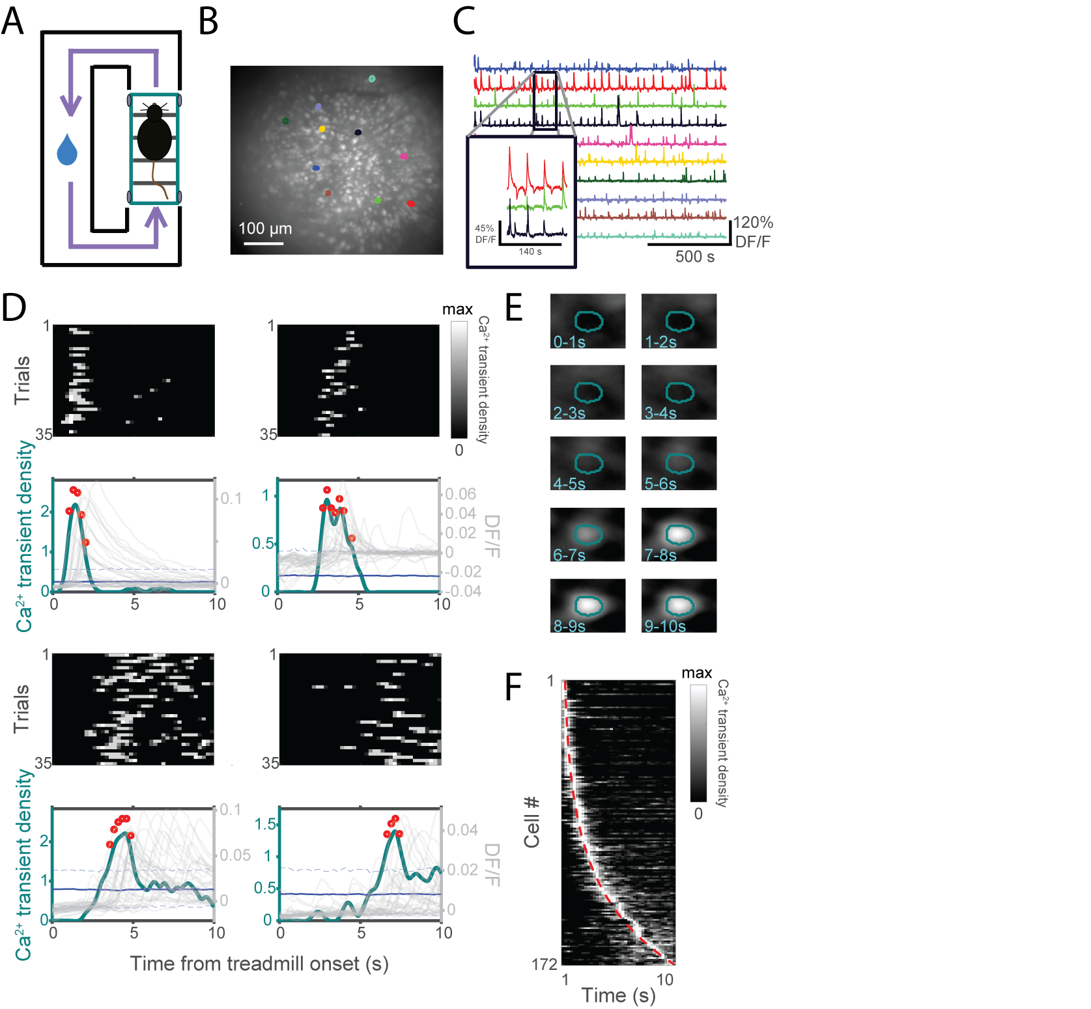

Figure . Sequentially-activated time cells were observed using calcium imaging.

1. Task schematic. Mice run for 10 s on a motorized treadmill then turn left to retrieve a sucrose water reward at a well.
2. Example of the field of view through an implanted lens aimed at CA1, depicted as the maximum temporal projection of fluorescence activity. Ten neuron ROIs highlighted.
3. Fluorescence traces of highlighted neurons in (B). Inset, zoom.
4. Activity patterns of four representative time cells. Top plots are Ca2+ transient density maps, aligned to treadmill onset. Bottom plots are temporal receptive fields, averaged across treadmill runs (teal). Also shown are receptive fields of time-shuffled data (blue, solid) with 95% confidence intervals (blue, dashed), regions where empirical data are statistically significant from time-shuffled data (red dots), and fluorescence traces from individual treadmill runs (gray).
5. Trial-averaged time lapse images of last cell in (D).
6. Receptive fields (grayscale) of all classified time cells in one mouse during one session, sorted by location of field peaks (red line).

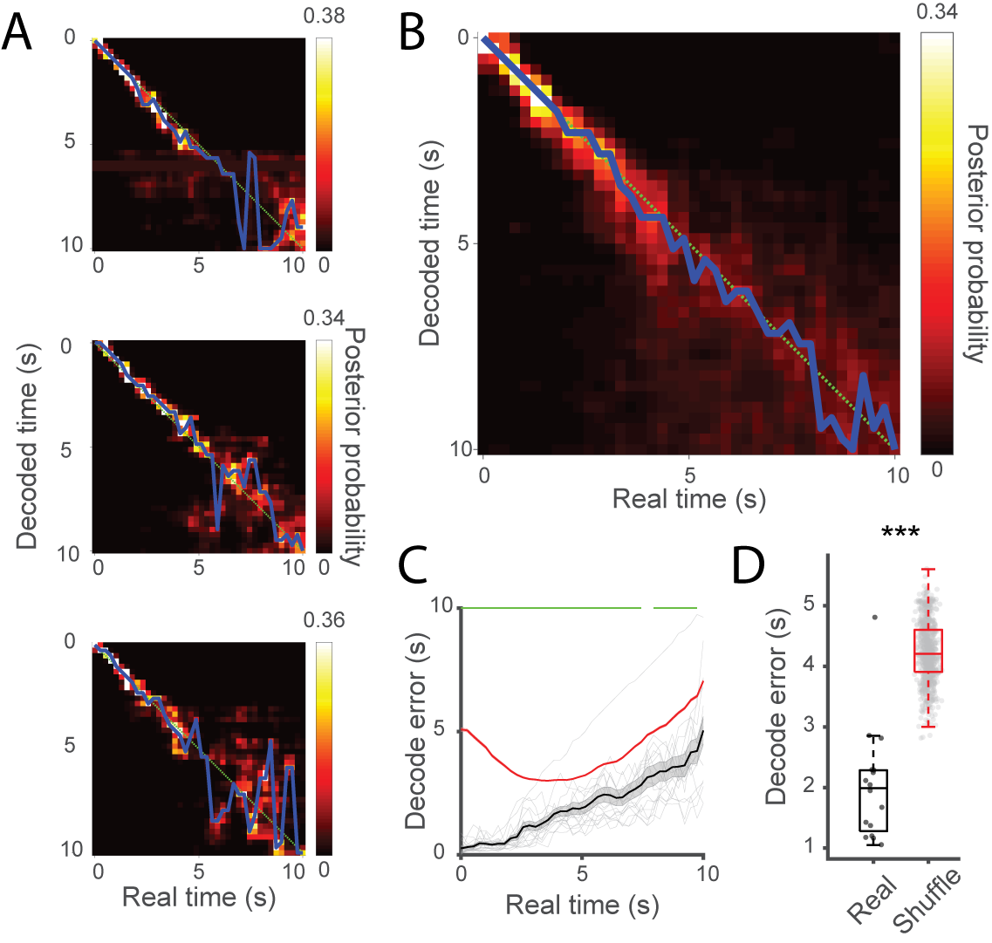

Figure . Time cell sequences contained information about relative time on the scale of seconds.

1. Decoding results of individual treadmill runs. Color bar indicates posterior probabilities and blue lines denote decoder’s most confident estimation. Green lines signify hypothetical perfect decoding.
2. Decoding results of all sessions, averaged.
3. Average decoding error as a function of elapsed time. Chance (red) calculated by shuffling cell identity. Decoder performs better than chance for the majority of the temporal delay (green, p < 0.05). Data are represented as means ± S.E.M.
4. Average decoding error for each mouse and session compared to chance (Mann-Whitney U test, *p* < 7.5 x 10-10).

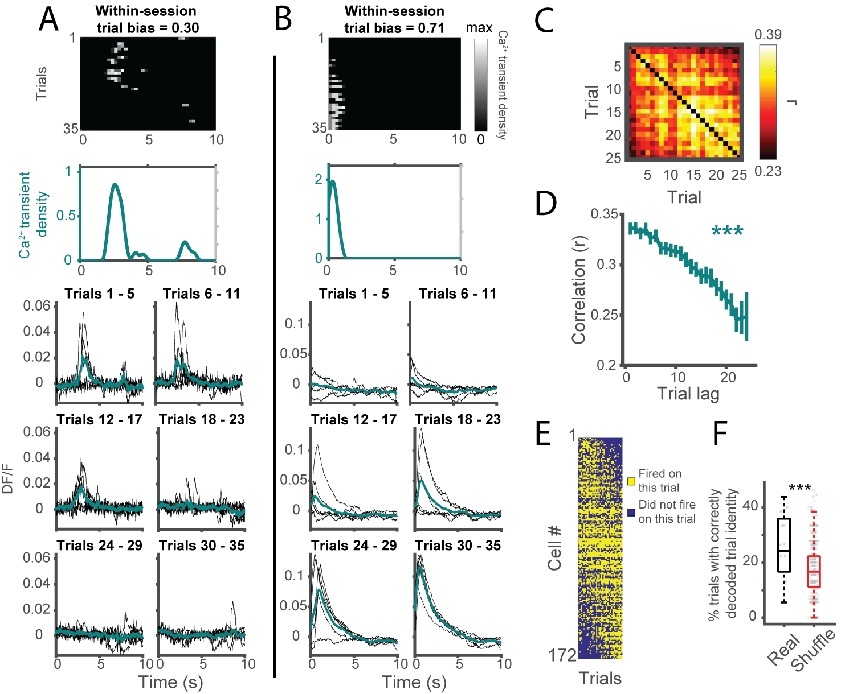

Figure . Time cells encoded information about elapsed time on the scale of minutes.

1. Activity profile of example time cell active early in the session. Top plots are Ca2+ transient density maps and trial-averaged receptive field. Bottom plots are fluorescence traces from individual runs (black), divided into treadmill run blocks and averaged within a block (teal).
2. Same as (A) but for a time cell active late in the session.
3. Run-by-run correlation matrix of fluorescence traces.
4. Correlation as a function of run lag, averaged from off-diagonals of matrix in (C). Data are represented as means ± S.E.M.
5. Trial-by-trial activity of time cells during one session. Yellow indicates trials where that cell fired in its receptive field. Blue indicates trials where it did not. Sorted by within-session trial bias scores.
6. Treadmill run block decoder performance compared to chance (shuffling run identity, Mann-Whitney U test, *p* < 9.0 x 10-6).

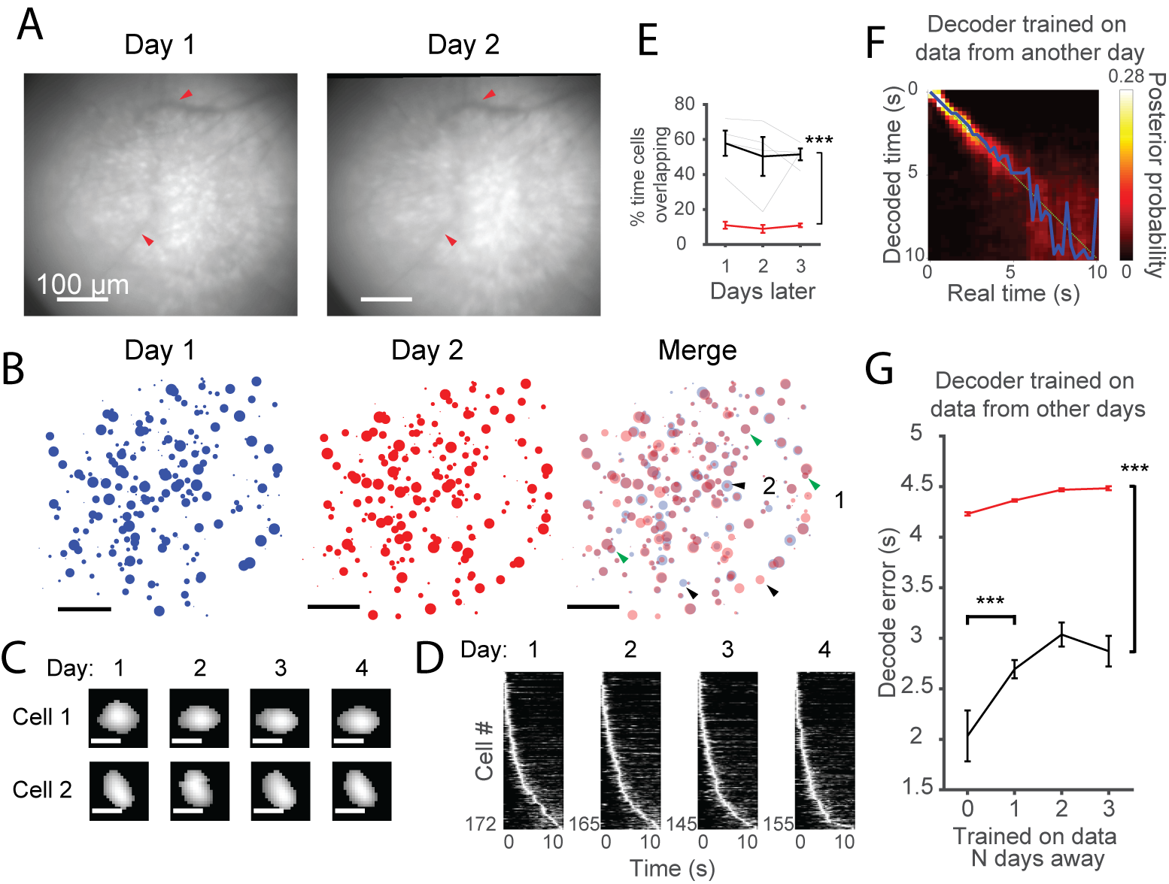

Figure . Time cell sequences were stably recorded over days.

1. Example fields of view for image alignment from the same mouse, on different days. Visible vasculature indicated by red arrows.
2. Time cell ensembles on two consecutive days (left, middle), individual ROIs sized by temporal position in time cell sequence (larger = later in sequence) and overlaid (right). Green arrows indicate cells with similar temporal tuning curves across the two days, black arrows indicate otherwise. Scale bars = 100 microns.
3. Cell masks of neurons marked in (B) over all four days. Scale bars = 10 microns.
4. Ensemble plots of time cell ensembles, filtered day-by-day. Rows in each panel represent different neurons. For rows representing the same neuron, see Fig. 5B.
5. Ensemble overlap (black) as a function of temporal distance compared to chance (red; two-way ANOVA F1,1211= 611.88, *p* < 0.001; post-hoc Tukey HSD test, *p* < 0.001). Gray lines indicate separate mice. Data are represented as means ± S.E.M.
6. Decoded output of Bayesian classifier trained and tested on different days. Same plotting conventions as Fig. 2.
7. Seconds-level decoder performance from training decoder on data from a day different from the test set. Decoder error (black) is significantly below chance (red) for all temporal distances here (two-way ANOVA F1,2039 = 483.19, *p* < 0.001; post-hoc Tukey HSD tests, p < 0.001). Decoder performs better when trained on data from the same day (post-hoc Tukey HSD test, p < 0.001). Data are represented as means ± S.E.M.

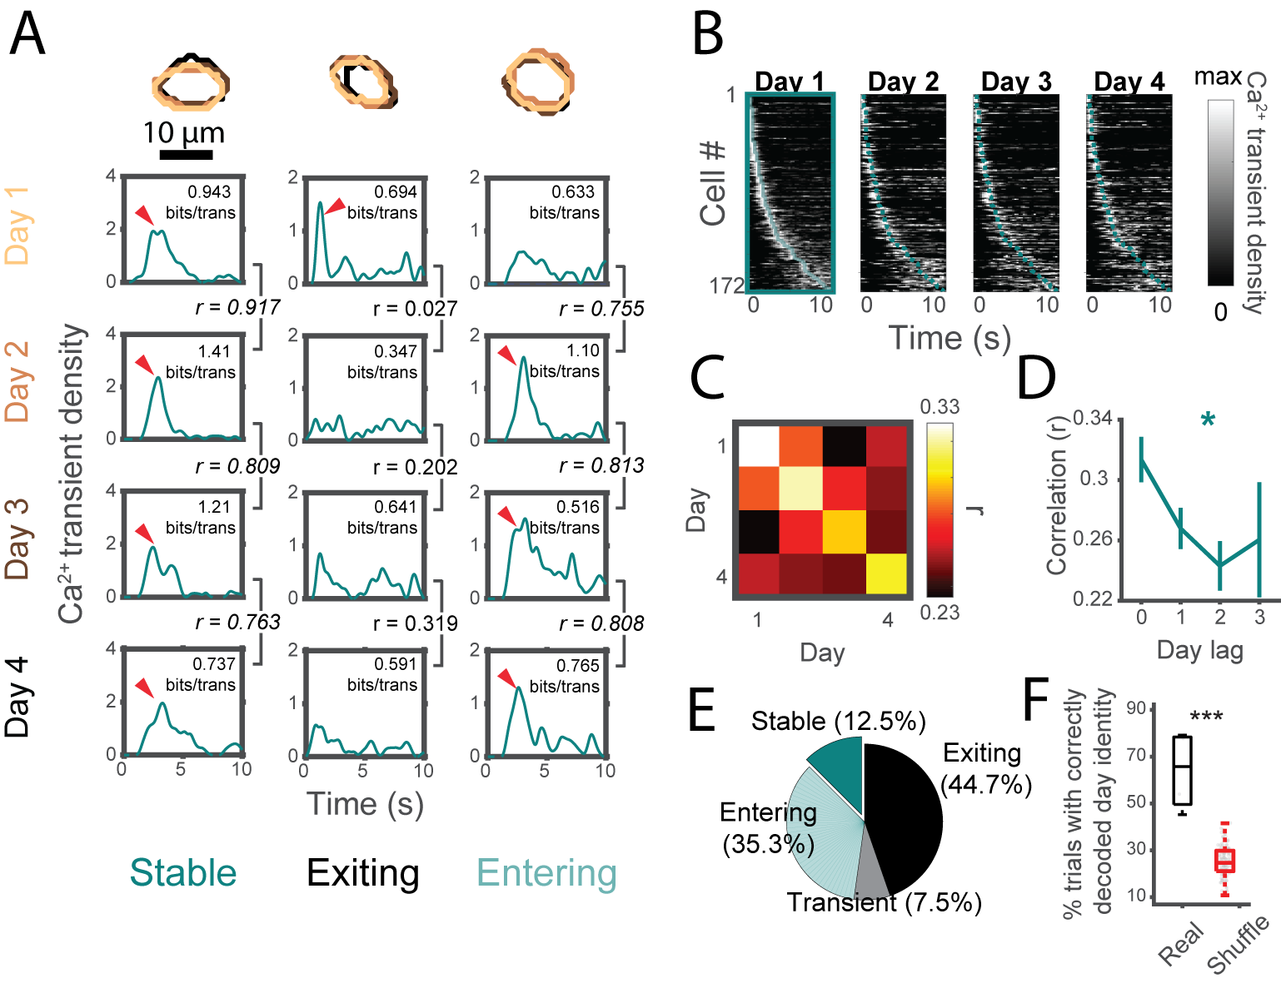

Figure . Time cell sequences carried information about relative time on the scale of days.

1. Receptive fields of three example cells exhibiting different across-days dynamics with accompanying ROI masks across days (top). Red arrows denote significant temporal receptive field peaks. Also shown: temporal mutual information (bits per transient for each cell) and tuning curve Pearson correlations. Italicized coefficients indicate statistically significant correlations.
2. Time cell ensemble on Day 1 of one mouse across four days. Teal line outlines the peaks on Day 1 across all successive days.
3. Correlation matrix of population similarity for all day pairs. Each value in the matrix represents the grand average of population correlations between all trials in that day pair for all animals.
4. Correlation as a function of day lag, data from (C). Data are represented as means ± S.E.M.
5. Proportion of time cells exhibiting stability characteristics described in (A), *n* = 486 unique time cells.
6. Performance of Bayesian decoder trained to decode day compared to chance from shuffling days (Mann-Whitney U test, *p* < 7.0 x 10-4).

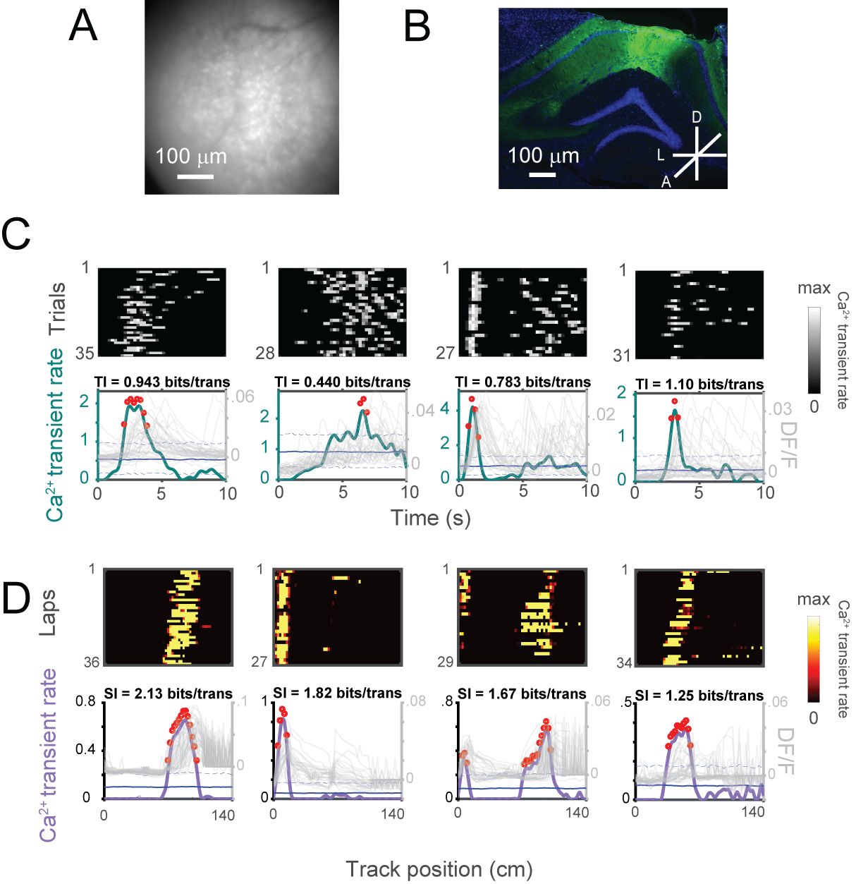

Figure S1. Visualizing activity using calcium dynamics. Related to Figure 1.

1. Example field of view during an imaging session (minimum projection).
2. GCaMP6f expression (green) in dorsal CA1 stained with DAPI (blue).
3. Additional time cell examples (one from each mouse). TI, temporal mutual information.
4. Example place cells on rectangular track (one from each mouse). SI, spatial mutual information.

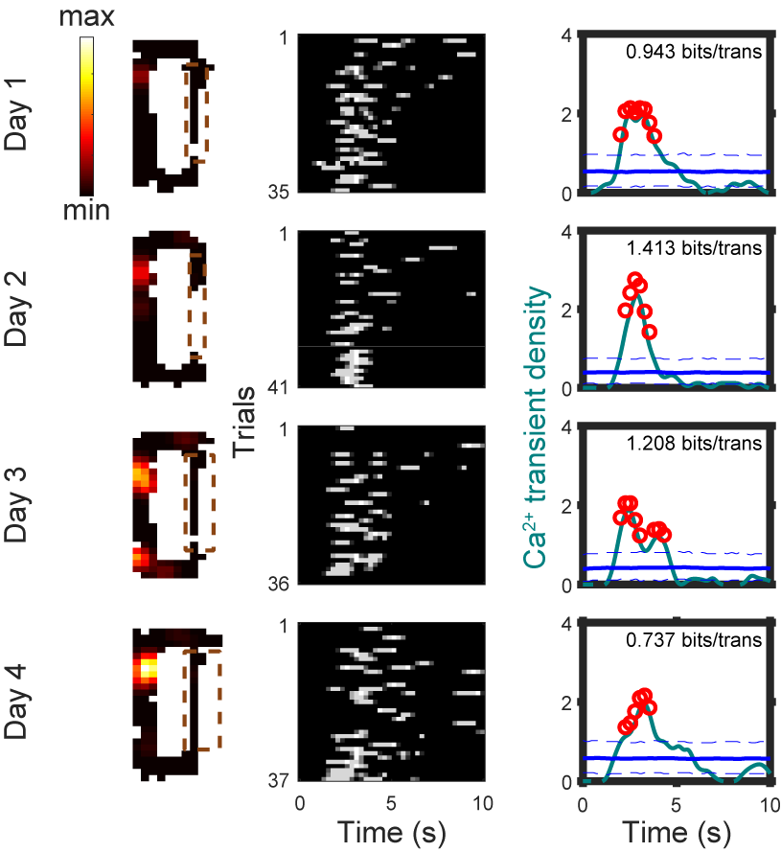

Figure S2. Example time cell with place co-occurring place field. Related to Figure 1.

Some time cells also exhibited spatial tuning. Shown here is one such example cell that was held across four days. In addition to its temporal tuning on the treadmill (middle, rasters and right, tuning curve, plotted in the same conventions as Figure S1), this cell also had a place field on the rectangular track outside the treadmill that developed over four days (left, heat map of Ca2+ transient activity normalized by spatial occupancy). Dotted brown box indicates treadmill position. Timestamps where treadmill was active were omitted from this plot.

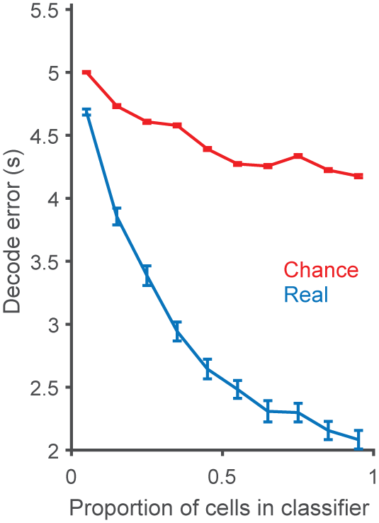

Figure S3. Classifier dependence on cell count in training set. Related to Figure 2.

Only a small percentage of cells are required for encoding temporal information above chance (real versus chance: two-way ANOVA *p* < 1.52 x 10-206). Data are means ± S.E.M.

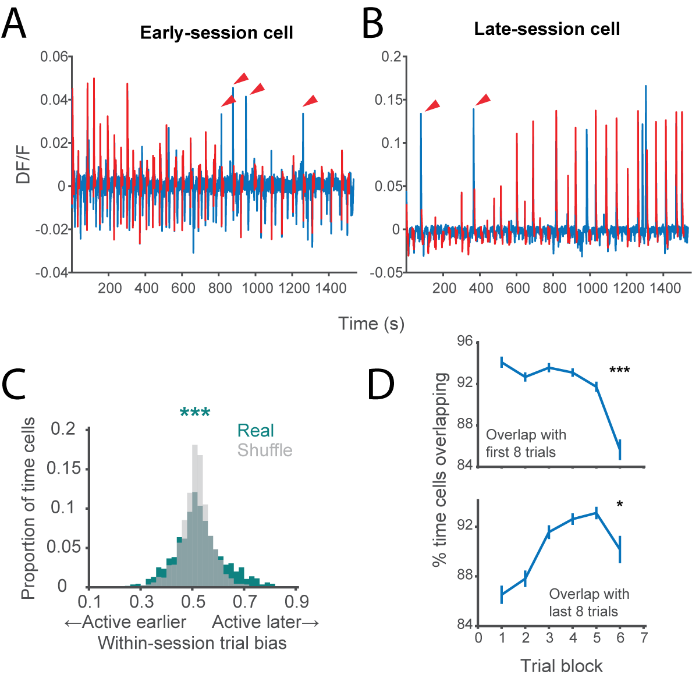

Figure S4. Distribution of within-session trial bias scores. Related to Figure 3.

1. Fluorescence trace of cell in Figure 3A over entire session, a cell that fires on early trials of the session (trial epochs in red). This effect was not due to gradual loss of the cell from the focal plane since we capture robust Ca2+ transients (red arrows) during periods off the treadmill in the later half of the session (blue).
2. Same as (A) but for cell in Figure 3B, which fires on late trials of the session.
3. Distribution of within-session trial bias scores for all time cells (teal) compared to control distribution of within-session trial bias scores where activity was shuffled between treadmill runs (gray). Note the skewed tails in the empirical distribution compared to control. Variance of empirical distribution is highly greater than chance (p < 0.001).
4. Overlap of active time ensemble on each trial block with subset of the session’s time cell ensemble. Top: overlap of active time cell ensemble on each trial block (5 trials per block) with the initial time cell ensemble for that session (defined as the active time cells in the first 8 trials). The overlap decreases over the course of the session (one-way ANOVA *F*5,94 = 4.65, p = 0.0008). Bottom: overlap of active time cell ensemble on each trial block with the final time cell ensemble for that session (defined as the active time cells in the last 8 trials). The overlap increases over the course of the session (one-way ANOVA *F*5,94 = 2.49, *p* = 0.037). Data are means ± S.E.M.

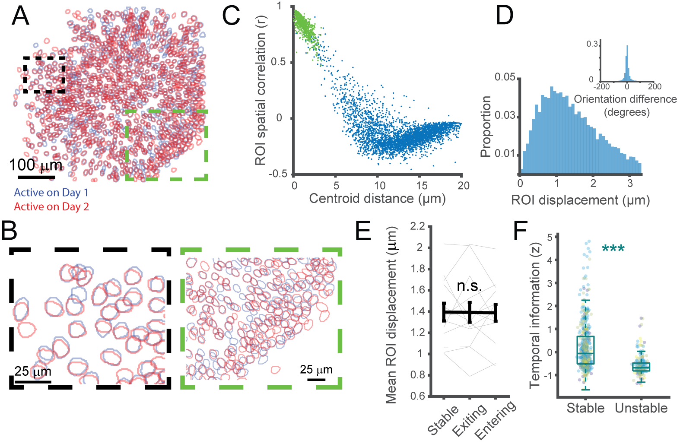

Figure S5. Statistical measures of across-day cell registration. Related to Figures 4 and 5.

1. ROIs of all recorded cells on one day (blue) overlaid on top of all cells on the next day (red).
2. Zoom of dashed boxes in (A) in regions of low cell density (left) and high cell density (right).
3. Spatial correlation of cell mask pairs across one day as a function of anatomical distance for a pair of sessions in one mouse. For each cell pair, we plotted the distance between the two cells versus the correlation coefficient of their cell mask spatial correlation to determine whether cells were packed too closely together for reliable cell registration. A distinct cluster of data points (each data point is a cell pair) at high spatial correlation and low distance would indicate a truly separable population of cell pairs that can be correctly matched during registration. On the other hand, a uniform distribution of spatial correlations at all distances would suggest that registration would not reliably match the same cells across days. We observed the former, a distinct cluster of data points at the top left quadrant. Pairs that we matched via cell registration (using a centroid distance cut-off of 3.3 microns, green dots) fell squarely in this cluster, demonstrating that matched cell pairs were (1) in the same location in the field of view and (2) were highly spatially correlated across days. Cell pairs that we determined were distinct cells (blue dots) fell outside this cluster.
4. Distribution of ROI centroid distances and orientation differences (inset) of registered cells across days.
5. We characterized cells as stable, exiting, or entering based on their change (or lack of change) in their activity on the treadmill/track. As an alternative, this change could be a result of erroneous registration due to the distance threshold of 3.3 microns being too high. For example, a nearby place cell on day 2 might be falsely registered to a silent cell on day 1, thus erroneously classifying that cell as an “entering” cell. If our distance threshold is too high, it would be reflected in entering or exiting cells having higher ROI displacement relative to stable cells (i.e., if stable cells were correct registrations whereas exiting and entering cells were false registrations due to nearby neurons). Instead, the ROI displacements of all three categories were indistinguishable, making this possibility very unlikely (one-way ANOVAs, *p* > 0.05).
6. Time cells with high temporal information were more likely to be stable across a day. For each session, we correlated tuning curves of time cells on Day 1 with their matched counterparts on Day 2 and labeled them “stable” if *p* < 0.01 after Bonferonni correction and stable if not statistically significant. We found that stable time cells generally have higher temporal information than unstable time cells (Mann-Whitney U test, *p* = 7.37 x 10-33).

# CHAPTER THREE



## Introduction

The biological capacity to produce adaptive behavioral responses in actively changing environments is critical to an animal’s survival. Contextual fear conditioning (CFC) is a form of learning whereby an animal learns to associate a conditioned stimulus (e.g. a context) with an unconditioned aversive stimulus (e.g. foot shocks) to produce a conditioned response to the conditioned stimulus (e.g. freezing). Conditioned responses can be mitigated through extinction learning, via repeated exposure to the conditioned context in the absence of the foot shock. However, while extinction learning can be effective at attenuating fear, animals are susceptible to fear relapse under several conditions, including exposure to stressors, the passage of time, and re-exposure to the unconditioned stimulus (Goode et al., 2018). Despite an extant rich literature investigating the neural substrates of fear in rodents (Maren, 2001), how discrete neuronal populations causally contribute to fear relapse remains elusive.

Previous studies have demonstrated that cells in the dorsal dentate gyrus of the hippocampus (DG) and in the basolateral amygdala (BLA) that are active during fear conditioning (hereafter referred to as the DG and BLA fear ensembles) are preferentially active during fear memory recall (Liu et al., 2012; Ramirez et al., 2013; Reijmers et al., 2007), and are necessary and sufficient for the expression of defensive behaviors such as freezing (Denny et al., 2014; Redondo et al., 2014). Additionally, recent evidence has indicated that extinction learning may be mediated by BLA fear ensemble suppression by local inhibitory interneurons (Davis et al., 2017), while a new set of extinction-promoting cells simultaneously emerges in both the hippocampus (Tronson et al., 2009) and BLA (Grewe et al., 2017; Herry et al., 2008). However, whether fear relapse re-engages the original set of cells processing a fear memory or gives rise to a new representation remains unclear.

## Methods

### Subjects

Wildtype male C57BL/6 mice (6-8 weeks of age; Charles River Labs) were housed in groups of 4-5 mice per cage. The animal facilities (vivarium and behavioral testing rooms) were maintained on a 12:12-hour light cycle (lights on at 0700). Mice were placed on a diet containing 40 mg/kg doxycycline (Dox) for a minimum of two days before receiving surgery with access to food and water *ad libitum*. Mice recovered for at least ten days after surgery. Dox-containing diet was replaced with standard mouse chow (*ad libitum*) 48 hours prior to behavioral tagging to open a time window of activity-dependent labeling (Ramirez et al., 2013; Reijmers et al., 2007).

All procedures relating to mouse care and treatment conformed to the institutional and National Institutes of Health guidelines for the Care and Use of Laboratory Animals. No statistical methods were used to predetermine sample size; however, sample sizes were chosen based on sample sizes in previous studies (Ramirez et al., 2013). Data collection and analysis were not performed blind to the conditions of the experiments.

### Activity-dependent viral constructs

pAAV9-cFos-tTA, pAAV9-TRE-eYFP, and pAAV 9 -TRE-ArchT-eYFP were constructed as previously described . pAAV9-c-Fos-tTA was combined with pAAV9-TRE-eYFP or pAAV9-TRE-ArchT-eYFP prior to injection at a 1/1 ratio.

### Stereotaxic surgeries

*Opsin injections and optic fiber implants*: Stereotaxic injections and optical fiber implants followed methods previously reported. All surgeries were performed under stereotaxic guidance and subsequent coordinates are given relative to Bregma (in mm). Mice were mounted into a stereotaxic frame (Kopf Instruments, Tujunga, CA, USA) and anesthetized with 3% isoflurane during induction and lowered to 1-2% to maintain anesthesia (oxygen 1L/min) throughout the surgery. Ophthalmic ointment was applied to both eyes to prevent corneal desiccation. Hair was removed with scissors and the surgical site was cleaned with ethanol and betadine. Following this, an incision was made to expose the skull. Bilateral craniotomies involved drilling windows through the skull above the injection sites using a 0.5 mm diameter drill bit. Coordinates were -1.35 anteroposterior (AP), ±3.45 mediolateral (ML), and -5.15 dorsoventral (DV) for BLA (Davis et al., 2017), and -2.2 AP, ±1.3 ML, and -2.0 DV for dDG (Ramirez et al., 2015). All mice were injected with a volume of 0.3 μL of AAV9 cocktail per site at a control rate of 0.1 μL min-1 using a mineral oil-filled 33-gage beveled needle attached to a 10 μL Hamilton microsyringe (701LT; Hamilton) in a microsyringe pump (UMP3; WPI). The needle remained at the target site for two minutes post-injection before removal. For dDG optogenetic experiments, a bilateral optic fiber implant (200 μm core diameter; Doric Lenses) was chronically implanted above the injection site (-1.6 DV). For BLA optogenetic experiments, monofibers were implanted above each injection site (-4.9 DV). Jewelry screws secured to the skull acted as anchors. Layers of adhesive cement (C&B Metabond) followed by dental cement (A-M Systems) were spread over the surgical site. Mice that did not receive implants had their incision sutured. Mice received 0.1 mL of 0.3 mg/ml buprenorphine (intraperitoneally) following surgery and were placed on a heating pad during recovery.

*GCaMP6f injections and lens implants*: Mice in Ca2+ imaging experiments underwent three separate serial surgeries. First, mice received unilateral infusions of AAV9-Syn-GCaMP6f (U Penn Vector Core) into either right CA1 (AP -2.0 mm, ML +1.5 mm, DV -1.5 mm) or right BLA (AP -1.35 mm, ML +3.45 mm, DV -5.05 mm). The viral vector was injected at a rate of 40 nL/min and allowed 10 min to diffuse before the scalp was sutured.

Two to four weeks after viral infusion, mice were implanted with a gradient index (GRIN) lens into either CA1 (1 mm diameter, 4 mm length, Inscopix; AP -2.25 mm, ML +1.8 mm, DV -1.3 mm) or BLA (0.65 mm diameter, 7.3 mm length; AP -1.25 mm, ML +3.15 mm, DV -4.85 mm). For CA1 implants, overlying neocortex was aspirated under continuous irrigation with cold 0.9% saline until vertical white fibers were visible (Resendez et al., 2016). For BLA implants, a tract was created using a stereotaxically lowered 27-gauge needle (0.5 mm diameter) into the craniotomy prior to insertion of the lens. Gaps between the lens and the skull were filled using Kwik-Sil (World Precision Instruments) and the lens was then adhered to the skull using Metabond. The surface of the lens was covered with a protective cap made of Kwik-Cast (World Precision Instruments) until base plate attachment.

Finally, one week after the lens implant, mice were implanted with a base plate for microscope attachment. A plastic base plate was magnetically attached to the bottom of the microscope. The microscope objective was then aligned to the GRIN lens and lowered until cells came into focus, as observed via nVista recording software (Inscopix). The base plate was then adhered to the surrounding Metabond on the animal’s skull using a dental composite (Flow-It ALC, Pentron) and strengthened with an additional layer of Metabond.

Histological assessment verified viral targeting and fiber/lens placement. Data from off-target injections and implants were not included in analyses.

### Optogenetic methods

Optic fiber implants were plugged into a patch cord connected to a 520nm green laser diode controlled by automated software (Doric Lenses). Laser diode output was tested at the beginning of every experiment to ensure that at least 10 mW of power was delivered at the end of the optic fiber tip (Doric lenses). Mice began the stimulation trial with a 2-min light-off epoch, followed by 2-min optical stimulation (15 ms pulse width, 20 Hz), and then repeated, such that the mice underwent a light-OFF/ON/OFF/ON pattern for a total of 8-min.

### Behavioral tagging

Dox diet was replaced with standard lab chow (*ad libitum*) 48-hours prior to behavioral tagging. *Female exposure*: One female mouse (PD 30-40) was placed into a clean home cage with a clear cage top, which was used as the interaction chamber. The experimental male mouse was then placed into the chamber and allowed to interact freely for one hour (Ramirez et al., 2015). *Fear conditioning*: Mice were placed into a conditioning chamber and received fear conditioning (see below) over a 500-second training session (including exposure to four 0.5 mA foot shocks). Following behavioral tagging, the male mouse was returned to their home cage with access to Dox diet (Reijmers et al., 2007).

### Behavior

All behavior assays were conducted during the light cycle of the day (0730–1930). Mice were handled for 1-2 days, 2 min per day, before all behavioral experiments, and were run by cage. The entire behavioral schedule includes female exposure, fear conditioning, extinction, reinstatement, and recall (described below). Which of these behaviors the mice underwent depended on the experiment.

*Female exposure*: One female mouse (PD 30-40) was placed into a clean home cage with a clear cage top and no bedding, which was used as the interaction chamber. The experimental male mouse was then placed into the chamber and allowed to interact freely for one hour (Ramirez et al., 2015).

*Fear conditioning*: Fear conditioning occurred in one of four mouse conditioning

chambers (Coulbourn Instruments, Whitehall, PA, USA) with metal-panel side walls, Plexiglas front and rear walls, and a stainless-steel grid floor composed of 16 grid bars. The grid floor was connected to a precision animal shocker (Coulbourn Instruments, Whitehall, PA, USA) set to deliver a 2-second 0.5 mA foot shock unconditioned stimulus (US). A ceiling-mounted video camera recorded activity and fed into a computer running FreezeFrame3 software (Actimetrics, Wilmette, IL, USA). The software controlled stimuli presentations and recorded videos from four chambers simultaneously. The program determined movement as changes in pixel luminance. Context alterations included changes to spatial, olfactory, tactile, and lighting cues. The conditioning chamber with room lights off was designated as Context A. Context B involved modifications to the conditioning chamber, including vertical black and white strips spaced ~ 3 cm apart obscuring the front and rear walls, black inserts placed between grids to slightly alter dimensions of the box, 1 mL of almond extract in a plastic container positioned below the grid floor, and room lights on. Context C also involved modifications to the conditioning chamber, with a plastic sheet with a cross-hatch texture placed over the shock grid to change tactile cues, a black sheet obscuring the front walls, 1 mL of orange extract in a plastic container position below the grid floor, and room lights on. The chambers were cleaned with 70% ethanol solution prior to animal placement. Contextual fear conditioning occurred in Context A. Briefly, mice were placed into the conditioning context for a 500-second acquisition session, including a 180-second baseline period followed four 0.5 mA, 2-second foot shock USs (interstimulus interval [ISI] equals 80-sec). In optogenetic experiments, mice had patch cords attached near the conditioning chamber by the experimenter, and were run two mice at a time.

Fear conditioning data are collected using FreezeFrame3 software (Actimetrics, Wilmette IL) with the bout length set at 1.25-sec and the freezing threshold initially set as described in the program instructions. Freezing is defined as changes in pixel luminance falling below a threshold. An experimenter adjusted the threshold so that freezing behavior involves the absence of all movement except those needed for respiration as previously described. Freezing behavior was scored as the percentage of time spent freezing during a given bout of time. Statistical analyses involved paired t-tests comparing within subject differences (i.e. light off vs light on epochs), unpaired t-tests comparing across experimental groups (e.g. ArchT group vs. eYFP group), and one-sample t-tests comparing freezing differences scores to a µ0 = 0.

*Extinction*: Extinction occurred in Context A (described above) the day following fear conditioning. Mice were placed in Context A for 30-min sessions once per day, for two days. As in fear conditioning, cages of four mice were run simultaneously, and cages of five mice were run as three mice first, then the remaining two.

*Reinstatement*: Reinstatement occurred in Context B (described above) the day following the second day of extinction. Mice were placed in Context B and given a 0.5mA, 2-second foot shock 1-second into the trial. Mice were left in the chamber for another 60-seconds before being removed. As opposed to being run four mice simultaneously as in fear conditioning and extinction, each mouse in a cage was run individually for reinstatement.

*Recall*: Recall for behavioral and overlap experiments involved placement in a context for 5-min. In this case, as in fear conditioning and extinction, cages of four mice were run simultaneously while cages of five mice were run as three mice first, then the remaining two. In optogenetic experiments, recall involved an 8-min session consisting of 2-min epochs of alternating light off and light on. In this case, mice were run one or two at a time.

### Immunohistochemistry

Mice were anesthetized with 3% isoflurane and perfused transcardially with cold (4° C) phosphate- buffered saline (PBS) followed by cold 4% paraformaldehyde (PFA) in PBS. Brains were extracted and stored overnight in PFA at 4°C. Fifty μm coronal sections were collected in serial order using a vibratome and collected in cold PBS (100 μm coronal sections were collected when solely verifying injection site and implant placement). Immunostaining involved washing sections in PBS with 0.2% triton (PBST) for 10-minutes (x3). Sections were blocked for 1 hour at room temperature in PBST and 5% normal goat serum (NGS) on a shaker. Sections were transferred to wells containing primary antibodies (1:5000 rabbit anti-c-Fos [SySy]; 1:500 chicken anti-GFP [Invitrogen]) and allowed to incubate on a shaker overnight at 4°C. Sections were then washed in PBST for 10-min (x3), followed by 2-hour incubation with secondary antibody (1:200 Alexa 555 anti-rabbit [Invitrogen]; 1:200 Alexa 488 anti-chicken [Invitrogen]). Following three additional 10-min washes in PBST, sections were mounted onto micro slides (VWR International, LLC). Vectashield Hard Set Mounting Medium with DAPI (Vector Laboratories, Inc) was applied, slides were cover slipped, and allowed to dry overnight.

### Cell counting.

The number of eYFP- or c-Fos-immunoreactive neurons in the dentate gyrus and basolateral amygdala were counted to measure the number of active cells during defined behavioral tasks per mouse. Only animals that had accurate bilateral injections were selected for counting. Fluorescence images were acquired using a confocal microscope (Zeise LSM800, Germany) with a 20X objective. All animals were sacrificed 90 minutes post-assay or optical stimulation for immunohistochemical analyses. The number of eYFP-positive and c-Fos-positive cells in a set region of interest were quantified with ImageJ and averaged within each animal.

To calculate the percentage of re-activated cells we counted the number of eYFP-positive, c-Fos-positive cells, and both eYFP- and c-Fos-positive (Overlapped) cells. Re-activation was calculated as either (Overlap/eYFP*100) or (Overlap/Area). Overlap was compared across groups using unpaired t-test (two-groups) and one-way ANOVA (more than two groups).

### In vivo calcium imaging

A miniaturized microscope (Inscopix) was used to collect Ca2+ imaging videos in mice undergoing the fear reinstatement schedule. Videos were captured using nVista (Inscopix) at 20 Hz in a 720 x 540 pixel field of view (1.1 microns/pixel). Microscope attachments were done while the mice were awake and restrained.

Ca2+ imaging videos were cropped, spatially bandpass filtered, and motion corrected offline using Inscopix Data Processing Software v1.1. A ΔF/F movie was computed using the mean fluorescence of the movie as the baseline and PCA/ICA was used for automated segmentation of cell masks (Mukamel et al., 2009). PCA/ICA putative cell masks were each manually inspected to verify that cells were accurately captured with high fidelity. Cells across imaging sessions were aligned and registered to each other using the automated CellReg software in Matlab (Sheintuch et al., 2017).

Population vectors (PVs) were computed for the entirety of the CFC session by taking the average Ca2+ transient rate for each cell while the mouse was in the fear conditioning chamber. PVs for EXT1, EXT2, and Recall were defined as the average Ca2+ transient rate for each 30 s time bin while the mouse was in the chamber. As a measure of the similarity of the population to the CFC network state, Pearson correlations were performed between each 30 s PV to the CFC PV. As a control, we also performed correlations between PVs from a neutral context to the CFC PV.

### Data Analysis

Data were analyzed using Prism (GraphPad) as well as Inscopix nVista in conjunction with custom-made Python and Matlab scripts. Data were analyzed using paired t-tests (two factors) or with one-way and repeated measures ANOVAs (more than two factors), and Mann-Whitney U tests (two-tailed, corrected for multiple comparisons using false discovery rate adjustments). Post-hoc analyses (Newman-Keuls) were used to characterize treatment and interaction effects, when statistically significant (alpha set at p<0.05, two-tailed).

## Results

### Behavioral Model of Fear Relapse

We first developed a behavioral protocol for fear reinstatement as a model of fear relapse in rodents (Rescorla and Heth, 1975). Mice underwent CFC and subsequently, two extinction (EXT) sessions over two days, followed by an immediate shock (IS) in a novel context to reinstate the original fear memory (Figure 1a, bottom behavioral schedule). Reinstatement led to an increase in freezing in the original conditioned context (Supplementary Figure 1a-e) and was largely context specific (Supplementary Figure 2a,b), but was not produced when an alternative stressor was utilized (Supplementary Figure 1f-h).

### Reactivation of DG and BLA Ensembles during Fear Relapse

Next, we determined if the cells active during fear conditioning were preferentially re-activated throughout our behavioral schedule. We tagged cells active during fear conditioning by expressing an inducible, activity-dependent viral cocktail of AAV9-c-Fos-tTA and AAV9-TRE-eYFP in the DG and BLA of adult male mice (Figure 1b,c). We then measured c-Fos immunoreactivity and calculated overlap between the set of cells active during CFC (eYFP+ cells) and recently active cells (c-Fos+ cells) (Figure 1d,e).

We observed significant overlap between the set of cells active during CFC and cells active during fear memory recall in the DG (Ramirez et al., 2013; Figure 1f). In support of the notion that the dorsal hippocampus processes changes in environmental contingencies (Fanselow and Dong, 2010), this overlap substantially decreased after EXT. While overlap remained low after IS, it significantly increased when mice were given the IS and placed back into the original conditioned context the following day, suggesting that fear reinstatement may re-engage the set of cells originally active during CFC (Figure 1f). Additionally, freezing behavior correlated with overlaps in the DG across the FC-Recall, EXT-Recall, and IS-Recall groups (Figure 1g), indicating that DG fear ensemble re-activation is predictive of freezing.

Previous reports have shown that the number of BLA cells active during both fear conditioning and fear memory recall correlates with freezing levels. Thus, we reasoned that if reinstatement re-engages the fear ensemble, the set of cells active during fear conditioning would be active again following reinstatement, and freezing during recall would correlate with cellular overlap. We found that, compared to EXT-Recall, mice exhibited more overlap in the BLA during the reinstating shock compared to the next day during IS-Recall (Figure 1h). However, we found no significant relationship between overlap in the BLA and freezing (Figure 1i).

### Relapse-Associated Longitudinal Population Dynamics with Calcium Imaging

Whereas our c-Fos-based labeling system allowed for comparisons between activity of cells across two discrete timepoints, we next utilized an *in vivo* calcium (Ca2+) imaging approach to record real-time neuronal activity in an intact hippocampus (dorsal CA1) and BLA in freely moving mice (Ghosh et al., 2011; Figure 2a-d). We tracked these cells longitudinally over the course of the reinstatement schedule (Sheintuch et al., 2017; Figure 2e; see also Supplementary Figure 3). To define initial population states, we constructed Ca2+ transient rate population vectors (PV) from the CFC session for each mouse (Figure 2f). Then, to compare extinction and post-reinstatement recall states to CFC, we correlated PVs from EXT and IS-Recall (in 30 s non-overlapping time windows) to the CFC PV. We found that over EXT, the population states in both CA1 and BLA gradually deviated from their states during CFC, supporting the idea of a network-wide transformation over EXT (Grewe et al., 2017; Herry et al., 2008; Tronson et al., 2009; Figure 2g,h). However, during IS-Recall, the population rebounded towards the CFC network state after the reinstatement shock. These effects were absent during exposure to a neutral context, demonstrating that the conditioned context drove these dynamics (Supplementary Figure 4). Moreover, our BLA calcium imaging data successfully reveal a real-time rebound towards the CFC network state that, we speculate, our Fos-based tagging and overlap analyses failed to capture due to the indirect relationship between calcium influx and Fos expression that is contingent on firing frequencies, cell-types, and brain area (Figure 1h). Overall, these data support the idea that the fear ensemble is physiologically involved in real-time during fear expression following fear relapse.

### Optogenetic Manipulation of Ensembles Controlling Fear Reinstatement and Relapse

Finally, we sought to determine whether the activity of cells active during fear conditioning was necessary for expression of reinstated fear. To do this, we bilaterally injected mice in either the DG or the BLA with a virus cocktail of AAV9-c-Fos-tTA and AAV9-TRE-ArchT-eYFP to drive expression of the light-sensitive protein archaerhodopsin (ArchT) in cells active during CFC, and subsequently implanted optic fibers above the injection sites (Figure 3a,b). Mice then underwent two EXT sessions, the reinstating shock, and recall the following day (Figure 3c). Mice in both the DG and BLA experimental groups showed significant suppression of freezing during optical inhibition. This manipulation was reversible, as freezing increased again in the following light-off epoch (Figure 3d,e). eYFP controls did not show this decrease in freezing during optical inhibition, confirming that the behavioral effect was dependent on expression of ArchT (Figure 3f,g).

Since the BLA fear ensemble was most highly active during the reinstating shock (Figure 1h), we next probed whether activity of the BLA fear ensemble during the reinstating shock is necessary or sufficient for fear reinstatement. To test necessity, we adopted a similar approach as above in order to express ArchT selectively within the BLA fear ensemble, and then implanted optic fibers bilaterally above BLA (Supplementary Figure 5a,b). Mice underwent FC and EXT, had the BLA fear ensemble inhibited during the reinstating shock, and were returned to the original conditioned context to assess whether reinstatement could be prevented (Supplementary Figure 5c). Surprisingly, mice that had the BLA fear ensemble inhibited did not freeze any less during Recall than eYFP controls (Supplementary Figure 5d). To test sufficiency, we selectively expressed ChR2 in the BLA fear ensemble in a separate group of mice. Mice underwent FC and EXT, were then placed in a novel chamber, and rather than receiving the reinstating shock, mice had the BLA fear ensemble stimulated for 60 seconds. The next day, they were placed back in the original conditioned context to assess whether the stimulation could mimic reinstatement (Supplementary Figure 6a). Mice that had the BLA fear ensemble stimulated did not freeze any more than eYFP controls (Supplementary Figure 6b,c). These results indicate that despite heightened activity of the BLA fear ensemble during shock reinstatement, activity of that population is neither necessary nor sufficient for fear reinstatement.

To test whether the functional role for these cells emerged only after reinstatement or if inhibition of the fear ensemble could suppress freezing after extinction, we inhibited the DG or BLA fear ensemble during an extinction recall session—when low levels of freezing were still present—and observed that inhibition of the DG fear ensemble led to a mild reduction in freezing, while inhibition of the BLA fear ensemble did not disrupt freezing (Supplementary Figure 7). These results suggest that extinction modifies the BLA and DG fear ensembles differently, such that BLA ensemble inhibition can no longer disrupt freezing, while DG ensemble inhibition still does.

To determine whether nonspecific manipulation of DG or BLA cells can reduce freezing responses, as opposed to being driven by discrete neuronal populations, we tagged cells either in the DG or the BLA that were active during female exposure—an unrelated experience, which has previously been shown to label similar proportions of neurons in both the DG and BLA (Ramirez et al., 2013; Redondo et al., 2014)—and inhibited those cells during post-reinstatement recall (Figure 3h). Interestingly, whereas this manipulation in the BLA did not cause behavioral changes, inhibition of non-fear cells in the DG led to a modest light-induced reduction in freezing (Figure 3i,j). These results are consistent with the notion that perturbing DG dynamics can produce a general modulation of freezing responses, while only inhibition of BLA fear cells disrupts freezing. Difference scores between freezing during light-on vs light-off epochs revealed that inhibition of DG fear cells led to moderately less freezing during light-on epochs compared to eYFP controls (Figure 3k), while inhibition of BLA fear cells led to significantly less freezing during light-on epochs (Figure 3l).

## Discussion

Together, these data suggest that both hippocampal and amygdala ensembles active during fear conditioning are necessary for fear reinstatement, providing new insight into the neural components underlying fear relapse. Further work exploring the competing interactions of networks of cells across fear learning and fear suppression could provide important insight into how the brain competes for the expression of fear throughout fear extinction and relapse (Clem and Schiller, 2016). Moreover, identification of memory representations in the brain–or, engrams–that process aversive experiences that subsequently re-emerge during fear relapse could introduce a plausible route for treating trauma-related disorders, and these findings point to DG- and BLA-mediated engrams as key nodes contributing to the re-emergence of a contextual fear memory.

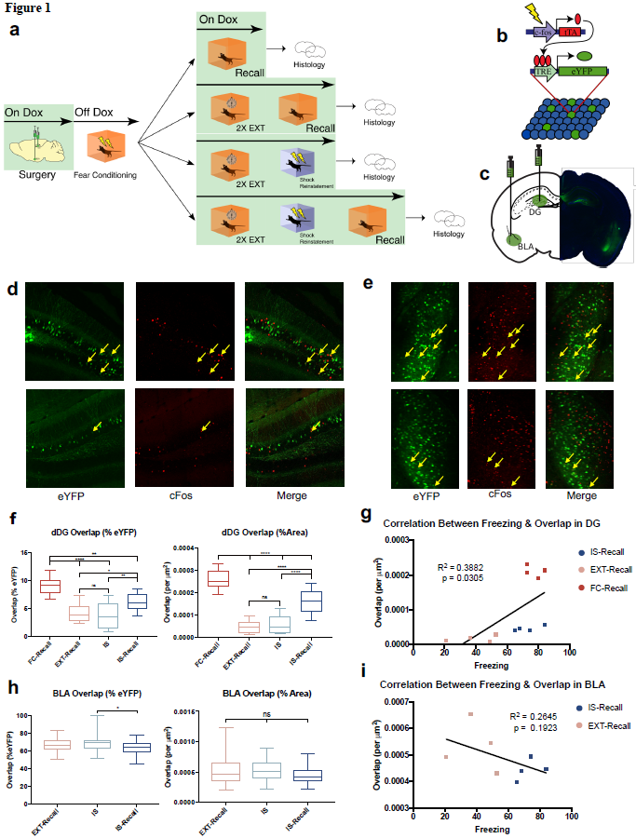

Figure 1. Histological characterization of fear reinstatement schedule.

1. Behavioral design for fear reinstatement. Mice underwent fear conditioning, and were then sacrificed at different points in the behavioral schedule and had tissue stained for c-Fos.
2. Schematic of viral strategy. A viral cocktail of AAV9-c-Fos-tTA and AAV9-TRE-eYFP was infused into the DG and BLA for activity-dependent induction of eYFP.
3. Representative microscope image for the injection sites.
4. Example confocal images of DG sections. Images from left to right: virus-labeled cells (eYFP), c-Fos+ cells (cFos), merged green and red channels (Merge). Yellow arrows designate double-positive cells. Top images are representative of high overlap, and bottom are representative of low overlap.
5. Same as d but for BLA sections.
6. Quantitative analysis of overlap between FC-tagged cells and c-Fos+ cells in each group. Overlap between FC-tagged cells and c-Fos+ cells was high after FC and significantly decreased following EXT. While overlap remained low during the reinstating shock, it significantly increased during Recall after reinstatement. (n = 12 sections per group, i.e. 4 mice and 3 sections per mouse; *P < 0.05, **P < 0.01, ***P < 0.001, ****P < 0.0001; left graph: F3,44 = 24.16; right graph: F3,44 = 68.25; one-way ANOVA followed by Tukey’s test). Counts were normalized to % of eYFP+ cells in the left graph and to ROI area size in the right graph.
7. Linear regression between average freezing during Recall and overlap in the DG demonstrates that overlap in the DG is predictive of freezing (n = 12 mice; F1,10 = 6.344; *P = 0.0305; R2 = 0.3882; linear regression).
8. Same as quantification in f, but for BLA. When counts were normalized to % of eYFP+ cells, there was significantly higher overlap in the BLA immediately after the shock, compared to the next day during Recall (from left to right: n = 34 slices from 4 mice, n = 37 slices from 4 mice, n = 42 slices from 4 mice; *P < 0.05; left graph: F2,110 = 2.271; right graph: F2,110 = 4.405; one-way ANOVA followed by Tukey’s test).
9. Linear regression between average freezing during Recall and overlap in the BLA across the IS-Recall and EXT-Recall groups. There was no significant relationship between the two measures (n = 8 mice; F1,6 = 2.158; linear regression).

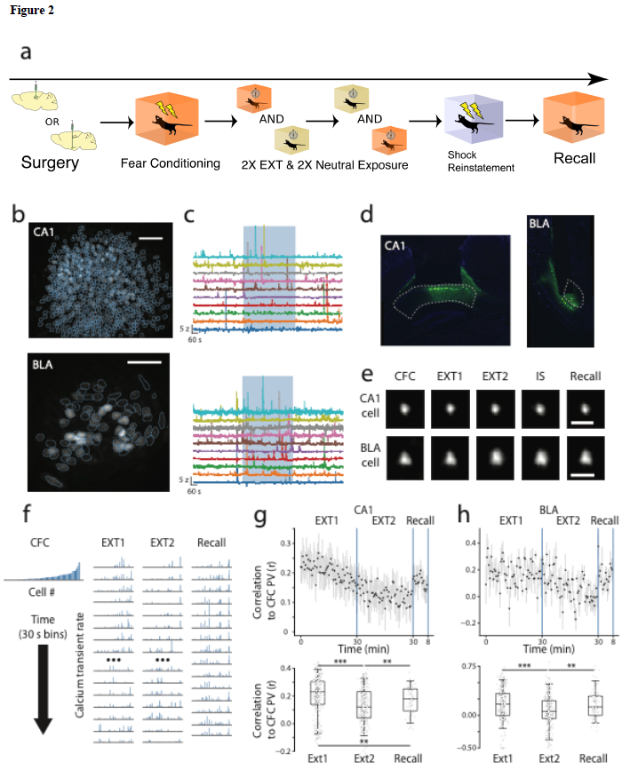

Figure 2. *In vivo* calcium imaging in mice undergoing fear reinstatement paradigm.

1. Behavioral schedule for calcium imaging cohort.
2. Example fields of view in CA1- (top) and BLA-implanted mice (bottom), depicted as maximum projections of CFC imaging session. Blue outlines indicate cell masks. Scale bars = 100 microns.
3. Fluorescence traces of 10 example cells in CA1 (top) and BLA (bottom). Blue shaded region indicates when the mouse was in the fear conditioning chamber. Non-shaded region indicates when mouse was in its home cage.
4. Implant tracts in CA1 (left) and BLA (right). Regions highlighted by white dotted line. Green cells are GCaMP6f-infected.
5. Example aligned and registered cell from CA1 (top row) and BLA (bottom row) during different imaging sessions. Scale bars = 50 microns.
6. Example PV analysis. Left, PV of CFC session, cells sorted by average Ca2+ transient rate. Subsequent columns, PVs of 30 s time bins during EXT and Recall.
7. Top, correlation coefficients between CA1 CFC Ca2+ transient PVs and windowed PVs over EXT and Recall (n = 6 mice). Bottom, box plots of correlation coefficients binned by session type. Each dot represents an individual correlation coefficient from a PV during one 30 s time bin to the CFC PV. EXT1 vs. EXT2, Mann-Whitney U test *p* = 5.03 x 10-14; EXT1 vs. Recall, *p* = 3.08 x 10-3; EXT2 vs. Recall, *p* = 3.29 x 10-3.
8. Same as g, but for BLA (n = 6 mice). EXT1 vs. EXT2, Mann-Whitney U test *p* = 1.35 x 10-6; EXT1 vs. Recall, *p* = 0.21; EXT2 vs. Recall, *p* = 0.0025. All *p* values were adjusted for false discovery rate from multiple comparisons.

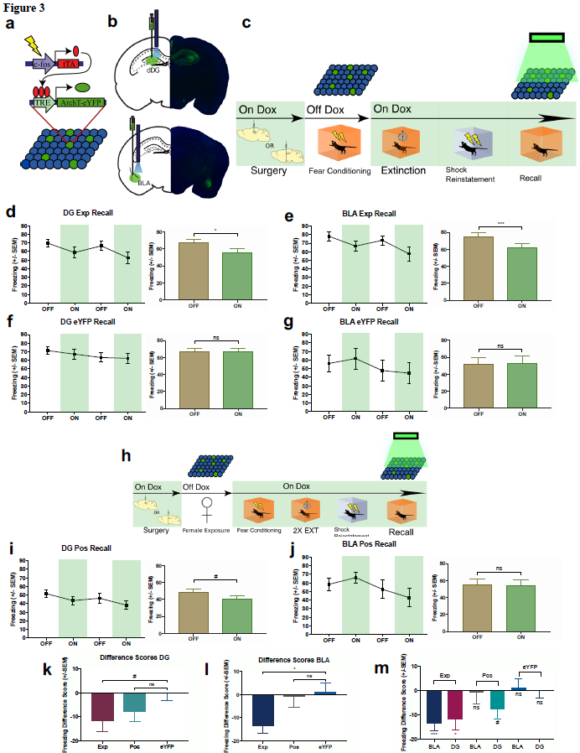

Figure 3. Optical inhibition of the DG or BLA fear ensemble disrupts reinstated fear.

1. Schematic of viral strategy. A virus cocktail of AAV9-c-Fos-tTA and AAV9-TRE-ArchT-eYFP was infused into either the DG or BLA for activity-dependent expression of ArchT-eYFP.
2. Representative microscope images of injection sites for the DG and BLA groups of mice.
3. Reinstatement behavioral schedule. Mice had the fear ensemble labeled in either the DG or BLA and inhibited during Recall after Shock Reinstatement.

(d-g) Line graphs: 2-minute light OFF and ON epochs during Recall for the two experimental ArchT groups (DG Exp & BLA Exp) and the two control no-opsin groups (DG eYFP & BLA eYFP). Bar graphs: Quantification of average freezing between light OFF vs. light ON epochs for each group.

1. DG Exp Recall (t24 = 2.781, *P = 0.0104; paired t-test; n = 25 paired epochs from 13 mice).
2. BLA EXP Recall (t17 = 4.277, ***P = 0.0005; paired t-test; n = 18 paired epochs from 9 mice).
3. DG eYFP Recall (t21 = 0.05067, n.s., P = 0.9600; paired t-test; n = 22 paired epochs from 11 mice).
4. BLA eYFP Recall (t15 = 0.3915, n.s., P = 0.7010; paired t-test; n = 16 paired epochs from 8 mice).
5. Behavioral schedule to test for specificity of DG and BLA fear ensemble in disrupting reinstatement-induced fear. Mice had cells active during Female Exposure labeled in either the DG or BLA, and then underwent FC, EXT, Shock Reinstatement, and had the labeled cells inhibited during Recall. (i,j) Same line and bar graphs as in d-g, but for the behavioral design in h.
6. DG Pos Recall (t23 = 2.053, n.s., P = 0.0516; paired t-test; n = 24 paired epochs from 12 mice).
7. BLA Pos Recall (t15 = 0.1986, n.s., P = 0.8452; paired t-test; n = 16 paired epochs from 8 mice).
8. Freezing difference scores across the three DG groups (Exp, Pos, eYFP), calculated as freezing in light ON epoch – freezing in light OFF epoch, for each set of epochs for each mouse. There was a strong trend towards a decrease in freezing in the light ON epoch in the Exp group vs. the eYFP group, and there was no difference in the Pos vs. eYFP groups (from left to right: n = 25 scores from 13 mice, 24 scores from 12 mice, 22 scores from 11 mice; F2,68 = 2.351, P = 0.1030; DG Exp vs. DG eYFP, n.s., P = 0.0658; DG Pos vs. DG eYFP, n.s., P = 0.2682; one-way ANOVA followed by Dunnett’s test).
9. Same as k but for BLA groups. The BLA Exp group showed significantly lower freezing during the light ON epoch compared to the BLA eYFP group (*p* = 0.0122), whereas there was no difference in the BLA Pos vs. BLA eYFP groups (*p* = 0.8797) (from left to right: n = 18 scores from 9 mice, 16 scores from 8 mice, 16 scores from 8 mice; F2,47 = 4.811, P = 0.0126; BLA Exp vs. BLA eYFP, *P = 0.0122; BLA Pos vs. BLA eYFP, n.s., P = 0.8797; one-way ANOVA followed by Dunnett’s test).
10. Summary graph of freezing difference scores across all groups in Figure 3. While mice in the BLA and DG Exp groups show significantly less freezing during light ON epochs, the BLA and DG Pos groups and BLA and DG eYFP groups show no difference in freezing between light ON and light OFF epochs (from left to right: n = 18 scores from 9 mice, 25 scores from 13 mice, 16 scores from 8 mice, 24 scores from 12 mice, 16 scores from 8 mice, 22 scores from 12 mice; BLA Exp, t17 = 4.277, ***P = 0.0005; DG Exp, t24 = 2.781, *P = 0.0104; BLA Pos, t15 = 0.1986, n.s., P = 0.8452; DG Pos, t23 = 2.053, n.s., P = 0.0516; BLA eYFP, t15 = 0.3915, n.s., P = 0.7010; DG eYFP, t21 = 0.05076, n.s., P = 0.9600; one-sample t-tests, µ0 = 0).

# CHAPTER 4

# APPENDIX

*[This is where your appendix goes. You can have as many appendices as you wish. If you have additional appendices, insert a Section Break (Next Page) between them and apply the Heading 1 style to the heading of each appendix. Don’t forget to update the Table of Contents.]*

# BIBLIOGRAPHY

Adolphs, R., Tranel, D., Damasio, H., and Damasio, A. (1994). Impaired recognition of emotion in facial expressions following bilateral damage to the human amygdala. Nature *372*, 669–672.

Allen, T.A., Salz, D.M., McKenzie, S., and Fortin, N.J. (2016). Nonspatial sequence coding in CA1 neurons. J. Neurosci. *36*, 1547–1563.

Amaral, D.G., Dolorfo, C., and Alvarez-Royo, P. (1991). Organization of CA1 projections to the subiculum: A PHA-L analysis in the rat. Hippocampus *1*, 415–435.

Aronov, D., Nevers, R., and Tank, D.W. (2017). Mapping of a non-spatial dimension by the hippocampal–entorhinal circuit. Nature *543*, 719–722.

Attardo, A., Fitzgerald, J.E., and Schnitzer, M.J. (2015). Impermanence of dendritic spines in live adult CA1 hippocampus. Nature *523*, 592–596.

Bangasser, D.A., Waxler, D.E., Santollo, J., and Shors, T.J. (2006). Trace conditioning and the hippocampus: the importance of contiguity. J. Neurosci. *26*, 8702–8706.

Bellmund, J.L.S., Gärdenfors, P., Moser, E.I., and Doeller, C.F. (2018). Navigating cognition: Spatial codes for human thinking. Science *362*, eaat6766.

Berger, T.W., Swanson, G.W., Milner, T.A., Lynch, G.S., and Thompson, R.F. (1980). Reciprocal anatomical connections between hippocampus and subiculum in the rabbit evidence for subicular innervation of regio superior. Brain Res. *183*, 265–276.

Bito, H., Deisseroth, K., and Tsien, R.W. (1996). CREB Phosphorylation and Dephosphorylation: A Ca2+- and Stimulus Duration–Dependent Switch for Hippocampal Gene Expression. Cell *87*, 1203–1214.

Bittner, K.C., Grienberger, C., Vaidya, S.P., Milstein, A.D., Macklin, J.J., Suh, J., Tonegawa, S., and Magee, J.C. (2015). Conjunctive input processing drives feature selectivity in hippocampal CA1 neurons. Nat. Neurosci. *18*, 1133–1142.

Bittner, K.C., Milstein, A.D., Grienberger, C., Romani, S., and Magee, J.C. (2017). Behavioral time scale synaptic plasticity underlies CA1 place fields. Science (80-. ). *357*, 1033–1036.

Bliss, T.V.P., and Collingridge, G.L. (1993). A synaptic model of memory: long-term potentiation in the hippocampus. Nature *361*, 31–39.

Brandon, M.P., Bogaard, A.R., Libby, C.P., Connerney, M.A., Gupta, K., and Hasselmo, M.E. (2011). Reduction of Theta Rhythm Dissociates Grid Cell Spatial Periodicity from Directional Tuning. Science (80-. ). *332*, 595–599.

Burwell, R.D., and Amaral, D.G. (1998). Cortical afferents of the perirhinal, postrhinal, and entorhinal cortices of the rat. J. Comp. Neurol. *398*, 179–205.

Buzsáki, G. (2002). Theta oscillations in the hippocampus. Neuron *33*, 325–340.

Buzsáki, G. (2006). Rhythms of the Brain (New York, NY, US: Oxford University Press).

Buzsáki, G. (2015). Hippocampal sharp wave-ripple: A cognitive biomarker for episodic memory and planning. Hippocampus *25*, 1073–1188.

Buzsáki, G., and Llinás, R. (2017). Space and time in the brain. Science (80-. ). *358*, 482–485.

Buzsáki, G., and Mizuseki, K. (2014). The log-dynamic brain: how skewed distributions affect network operations. Nat. Rev. Neurosci. *15*, 264–278.

Buzsáki, G., and Tingley, D. (2018). Special Issue: Time in the Brain Space and Time: The Hippocampus as a Sequence Generator.

Buzsáki, G., Leung, L.W., and Vanderwolf, C.H. (1983). Cellular bases of hippocampal EEG in the behaving rat. Brain Res. *287*, 139–171.

Buzsáki, G., Horváth, Z., Urioste, R., Hetke, J., and Wise, K. (1992). High-frequency network oscillation in the hippocampus. Science *256*, 1025–1027.

Cai, D.J., Aharoni, D., Shuman, T., Shobe, J., Biane, J., Song, W., Wei, B., Veshkini, M., La-Vu, M., Lou, J., et al. (2016). A shared neural ensemble links distinct contextual memories encoded close in time. Nature *534*, 115–118.

Cei, A., Girardeau, G., Drieu, C., Kanbi, K. El, and Zugaro, M. (2014). Reversed theta sequences of hippocampal cell assemblies during backward travel. Nat. Neurosci. *17*, 719–724.

Chambers, A.R., and Rumpel, S. (2017). A stable brain from unstable components: Emerging concepts and implications for neural computation. Neuroscience *357*, 172–184.

Choi, J.-H., Sim, S.-E., Kim, J.-I., Choi, D. Il, Oh, J., Ye, S., Lee, J., Kim, T., Ko, H.-G., Lim, C.-S., et al. (2018). Interregional synaptic maps among engram cells underlie memory formation. Science *360*, 430–435.

Clem, R.L., and Schiller, D. (2016). New Learning and Unlearning: Strangers or Accomplices in Threat Memory Attenuation? Trends Neurosci. *39*, 340–351.

Clopath, C., Bonhoeffer, T., Hübener, M., and Rose, T. (2017). Variance and invariance of neuronal long-term representations. Philos. Trans. R. Soc. Lond. B. Biol. Sci. *372*, 20160161.

Cohen, N.J.J., and Eichenbaum, H. (1993). Memory, Amnesia, and the Hippocampal System (Cambridge, MA: MIT Press).

Colgin, L.L. (2013). Mechanisms and Functions of Theta Rhythms. Annu. Rev. Neurosci. *36*, 295–312.

Colgin, L.L., Moser, E.I., and Moser, M.-B. (2008). Understanding memory through hippocampal remapping. Trends Neurosci. *31*, 469–477.

Cui, Z., Gerfen, C.R., and Young, W.S. (2013). Hypothalamic and other connections with dorsal CA2 area of the mouse hippocampus. J. Comp. Neurol. *521*, 1844–1866.

Czurkó, A., Hirase, H., Csicsvari, J., and Buzsáki, G. (1999). Sustained activation of hippocampal pyramidal cells by “space clamping” in a running wheel. Eur. J. Neurosci. *11*, 344–352.

Danielson, N.B., Kaifosh, P., Zaremba, J.D., Lovett-Barron, M., Tsai, J., Denny, C.A., Balough, E.M., Goldberg, A.R., Drew, L.J., Hen, R., et al. (2016a). Distinct Contribution of Adult-Born Hippocampal Granule Cells to Context Encoding. Neuron *90*, 101–112.

Danielson, N.B., Zaremba, J.D., Kaifosh, P., Bowler, J., Ladow, M., and Losonczy, A. (2016b). Sublayer-Specific Coding Dynamics during Spatial Navigation and Learning in Hippocampal Area CA1. Neuron *91*, 652–665.

Danielson, N.B., Turi, G.F., Ladow, M., Chavlis, S., Petrantonakis, P.C., Poirazi, P., and Losonczy, A. (2017). In Vivo Imaging of Dentate Gyrus Mossy Cells in Behaving Mice. Neuron *93*, 552–559.e4.

Danjo, T., Toyoizumi, T., and Fujisawa, S. (2018). Spatial representations of self and other in the hippocampus. Science *359*, 213–218.

Davachi, L., and DuBrow, S. (2015). How the hippocampus preserves order: the role of prediction and context. Trends Cogn. Sci. *19*, 92–99.

Davis, P., Zaki, Y., Maguire, J., and Reijmers, L.G. (2017). Cellular and oscillatory substrates of fear extinction learning. Nat. Neurosci. *20*, 1624–1633.

Denny, C.A., Kheirbek, M.A., Alba, E.L., Tanaka, K.F., Brachman, R.A., Laughman, K.B., Tomm, N.K., Turi, G.F., Losonczy, A., and Hen, R. (2014). Hippocampal Memory Traces Are Differentially Modulated by Experience, Time, and Adult Neurogenesis. Neuron *83*, 189–201.

Deshmukh, S.S., and Knierim, J.J. (2011). Representation of Non-Spatial and Spatial Information in the Lateral Entorhinal Cortex. Front. Behav. Neurosci. *5*, 69.

Deshmukh, S.S., Johnson, J.L., and Knierim, J.J. (2012). Perirhinal cortex represents nonspatial, but not spatial, information in rats foraging in the presence of objects: Comparison with lateral entorhinal cortex. Hippocampus *22*, 2045–2058.

Diamantaki, M., Coletta, S., Nasr, K., Zeraati, R., Laturnus, S., Berens, P., Preston-Ferrer, P., and Burgalossi, A. (2018). Manipulating Hippocampal Place Cell Activity by Single-Cell Stimulation in Freely Moving Mice. Cell Rep. *23*, 32–38.

Diba, K., and Buzsáki, G. (2007). Forward and reverse hippocampal place-cell sequences during ripples. Nat. Neurosci. *10*, 1241–1242.

Dragoi, G., and Buzsáki, G. (2006). Temporal Encoding of Place Sequences by Hippocampal Cell Assemblies. Neuron *50*, 145–157.

Dragoi, G., and Tonegawa, S. (2011). Preplay of future place cell sequences by hippocampal cellular assemblies. Nature *469*, 397–401.

Dudek, S.M., Alexander, G.M., and Farris, S. (2016). Rediscovering area CA2: unique properties and functions. Nat. Rev. Neurosci. *17*, 89–102.

Dupret, D., O’Neill, J., Pleydell-Bouverie, B., and Csicsvari, J. (2010). The reorganization and reactivation of hippocampal maps predict spatial memory performance. Nat. Neurosci. *13*, 995–1002.

Ego-Stengel, V., and Wilson, M.A. (2009). Disruption of ripple-associated hippocampal activity during rest impairs spatial learning in the rat. Hippocampus *20*, NA-NA.

Eichenbaum, H. (2004). Hippocampus: Cognitive processes and neural representations that underlie declarative memory. Neuron *44*, 109–120.

Eichenbaum, H. (2013). Memory on time. Trends Cogn. Sci. *17*, 81–88.

Eichenbaum, H. (2014). Time cells in the hippocampus: a new dimension for mapping memories. Nat. Rev. Neurosci. *15*, 1–13.

Eichenbaum, H. (2016). What Versus Where: Non-spatial Aspects of Memory Representation by the Hippocampus. (Springer, Cham), pp. 101–117.

Eichenbaum, H. (2017). On the Integration of Space, Time, and Memory. Neuron *95*, 1007–1018.

Eichenbaum, H., and Cohen, N.J. (2014). Can We Reconcile the Declarative Memory and Spatial Navigation Views on Hippocampal Function? Neuron *83*, 764–770.

Eichenbaum, H., Sauvage, M., Fortin, N., Komorowski, R., and Lipton, P. (2012). Towards a functional organization of episodic memory in the medial temporal lobe. Neurosci. Biobehav. Rev. *36*, 1597–1608.

Epsztein, J., Brecht, M., and Lee, A.K. (2011). Intracellular Determinants of Hippocampal CA1 Place and Silent Cell Activity in a Novel Environment. Neuron *70*, 109–120.

Ezzyat, Y., and Davachi, L. (2014). Similarity breeds proximity: pattern similarity within and across contexts is related to later mnemonic judgments of temporal proximity. Neuron *81*, 1179–1189.

Fanselow, M.S., and Dong, H.-W. (2010). Are the dorsal and ventral hippocampus functionally distinct structures? Neuron *65*, 7–19.

Felix-Ortiz, A.C., Beyeler, A., Seo, C., Leppla, C.A., Wildes, C.P., and Tye, K.M. (2013). BLA to vHPC Inputs Modulate Anxiety-Related Behaviors. Neuron *79*, 658–664.

Feng, T., Silva, D., and Foster, D.J. (2015). Dissociation between the Experience-Dependent Development of Hippocampal Theta Sequences and Single-Trial Phase Precession. J. Neurosci. *35*, 4890–4902.

Ferbinteanu, J., and Shapiro, M.L. (2003). Prospective and retrospective memory coding in the hippocampus. Neuron *40*, 1227–1239.

Fortin, N.J., Agster, K.L., and Eichenbaum, H. (2002). Critical role of the hippocampus in memory for sequences of events. Nat. Neurosci. *5*, 458–462.

Foster, D.J., and Wilson, M.A. (2006). Reverse replay of behavioural sequences in hippocampal place cells during the awake state. Nature *440*, 680–683.

Foster, D.J., and Wilson, M.A. (2007). Hippocampal theta sequences. Hippocampus *17*, 1093–1099.

Frank, A.C., Huang, S., Zhou, M., Gdalyahu, A., Kastellakis, G., Silva, T.K., Lu, E., Wen, X., Poirazi, P., Trachtenberg, J.T., et al. (2018). Hotspots of dendritic spine turnover facilitate clustered spine addition and learning and memory. Nat. Commun. *9*, 422.

Freund, T.F., and Antal, M. (1988). GABA-containing neurons in the septum control inhibitory interneurons in the hippocampus. Nature *336*, 170–173.

Friston, K., and Buzsáki, G. (2016). The Functional Anatomy of Time: What and When in the Brain Good Enough Brains and Good Enough Models. Trends Cogn. Sci. *20*, 500–511.

Garner, A.R., Rowland, D.C., Hwang, S.Y., Baumgaertel, K., Roth, B.L., Kentros, C., and Mayford, M. (2012). Generation of a Synthetic Memory Trace. Science (80-. ). *335*, 1513–1516.

Ghosh, K.K., Burns, L.D., Cocker, E.D., Nimmerjahn, A., Ziv, Y., Gamal, A. El, and Schnitzer, M.J. (2011). Miniaturized integration of a fluorescence microscope. Nat. Methods *8*, 871–878.

Gill, P.R., Mizumori, S.J.Y., and Smith, D.M. (2011). Hippocampal episode fields develop with learning. Hippocampus *21*, 1240–1249.

Girardeau, G., Benchenane, K., Wiener, S.I., Buzsáki, G., and Zugaro, M.B. (2009). Selective suppression of hippocampal ripples impairs spatial memory. Nat. Neurosci. *12*, 1222–1223.

Gonçalves, J.T., Schafer, S.T., and Gage, F.H. (2016). Adult Neurogenesis in the Hippocampus: From Stem Cells to Behavior. Cell *167*, 897–914.

Goode, T.D., Jin, J., and Maren, S. (2018). Neural circuits for fear relapse. In Neurobiology of Abnormal Emotion and Motivated Behaviors, S. Sangha, and D. Foti, eds. pp. 182–202.

Greenberg, M.E., and Ziff, E.B. (1984). Stimulation of 3T3 cells induces transcription of the c-fos proto-oncogene. Nature *311*, 433–438.

Grewe, B.F., Gründemann, J., Kitch, L.J., Lecoq, J.A., Parker, J.G., Marshall, J.D., Larkin, M.C., Jercog, P.E., Grenier, F., Li, J.Z., et al. (2017). Neural ensemble dynamics underlying a long-term associative memory. Nature *543*, 670–675.

Grosmark, A.D., and Buzsáki, G. (2016). Diversity in neural firing dynamics supports both rigid and learned hippocampal sequences. Science (80-. ). *351*, 1440–1443.

Gupta, A.S., van der Meer, M.A.A., Touretzky, D.S., and Redish, A.D. (2012). Segmentation of spatial experience by hippocampal theta sequences. Nat. Neurosci. *15*, 1032–1039.

Guzman, S.J., Schlögl, A., Frotscher, M., and Jonas, P. (2016). Synaptic mechanisms of pattern completion in the hippocampal CA3 network. Science *353*, 1117–1123.

Hafting, T., Fyhn, M., Molden, S., Moser, M.-B., and Moser, E.I. (2005). Microstructure of a spatial map in the entorhinal cortex. Nature *436*, 801–806.

Hales, J.B., Schlesiger, M.I., Leutgeb, J.K., Squire, L.R., Leutgeb, S., and Clark, R.E. (2014). Medial Entorhinal Cortex Lesions Only Partially Disrupt Hippocampal Place Cells and Hippocampus-Dependent Place Memory. Cell Rep. *9*, 893–901.

Hamel, E.J.O., Grewe, B.F., Parker, J.G., and Schnitzer, M.J. (2015). Cellular Level Brain Imaging in Behaving Mammals: An Engineering Approach. Neuron *86*, 140–159.

Han, J.-H., Kushner, S.A., Yiu, A.P., Cole, C.J., Matynia, A., Brown, R.A., Neve, R.L., Guzowski, J.F., Silva, A.J., and Josselyn, S.A. (2007). Neuronal Competition and Selection During Memory Formation. Science (80-. ). *316*, 457–460.

Han, J.-H., Kushner, S.A., Yiu, A.P., Hsiang, H.-L., Buch, T., Waisman, A., Bontempi, B., Neve, R.L., Frankland, P.W., and Josselyn, S.A. (2009). Selective Erasure of a Fear Memory. Science (80-. ). *323*, 1492–1496.

Hartley, T., Lever, C., Burgess, N., and O’Keefe, J. (2014). Space in the brain: how the hippocampal formation supports spatial cognition. Philos. Trans. R. Soc. Lond. B. Biol. Sci. *369*, 20120510.

Hasselmo, M.E. (2005). What is the function of hippocampal theta rhythm?—Linking behavioral data to phasic properties of field potential and unit recording data. Hippocampus *15*, 936–949.

Hasselmo, M.E. (2009). A model of episodic memory: Mental time travel along encoded trajectories using grid cells. Neurobiol. Learn. Mem. *92*, 559–573.

Hasselmo, M.E., Bodelón, C., and Wyble, B.P. (2002). A Proposed Function for Hippocampal Theta Rhythm: Separate Phases of Encoding and Retrieval Enhance Reversal of Prior Learning. Neural Comput. *14*, 793–817.

Hebb, D. (1949). The Organization of Behavior (New York: Wiley & Sons).

Henze, D.A., Wittner, L., and Buzsáki, G. (2002). Single granule cells reliably discharge targets in the hippocampal CA3 network in vivo. Nat. Neurosci. *5*, 790–795.

Herry, C., Ciocchi, S., Senn, V., Demmou, L., Müller, C., and Lüthi, A. (2008). Switching on and off fear by distinct neuronal circuits. Nature *454*, 600–606.

Heys, J.G., and Dombeck, D.A. (2018). Evidence for a subcircuit in medial entorhinal cortex representing elapsed time during immobility. Nat. Neurosci. *21*, 1574–1582.

Hitti, F.L., and Siegelbaum, S.A. (2014). The hippocampal CA2 region is essential for social memory. Nature *508*, 88–92.

Holtmaat, A., and Caroni, P. (2016). Functional and structural underpinnings of neuronal assembly formation in learning. Nat. Neurosci. *19*, 1553–1562.

Howard, M.W., and Eichenbaum, H. (2013). The hippocampus, time, and memory across scales. J. Exp. Psychol. Gen. *142*, 1211–1230.

Howard, M.W., and Eichenbaum, H. (2015). Time and space in the hippocampus. Brain Res. *1621*, 345–354.

Howard, M.W., Fotedar, M.S., Datey, A. V, and Hasselmo, M.E. (2005). The temporal context model in spatial navigation and relational learning: toward a common explanation of medial temporal lobe function across domains. Psychol. Rev. *112*, 75–116.

Howard, M.W., MacDonald, C.J., Tiganj, Z., Shankar, K.H., Du, Q., Hasselmo, M.E., and Eichenbaum, H. (2014). A Unified Mathematical Framework for Coding Time, Space, and Sequences in the Hippocampal Region. J. Neurosci. *34*, 4692–4707.

Howard, M.W., Shankar, K.H., Aue, W.R., and Criss, A.H. (2015). A distributed representation of internal time. Psychol. Rev. *122*, 24–53.

Hsiang, H.-L., Epp, J.R., van den Oever, M.C., Yan, C., Rashid, A.J., Insel, N., Ye, L., Niibori, Y., Deisseroth, K., Frankland, P.W., et al. (2014). Manipulating a “Cocaine Engram” in Mice. J. Neurosci. *34*, 14115–14127.

Ito, H.T., Zhang, S.-J., Witter, M.P., Moser, E.I., and Moser, M.-B. (2015). A prefrontal–thalamo–hippocampal circuit for goal-directed spatial navigation. Nature *522*, 50–55.

Itskov, V., Curto, C., Pastalkova, E., and Buzsáki, G. (2011). Cell assembly sequences arising from spike threshold adaptation keep track of time in the hippocampus. J. Neurosci. *31*, 2828–2834.

Jadhav, S.P., Kemere, C., German, P.W., and Frank, L.M. (2012). Awake Hippocampal Sharp-Wave Ripples Support Spatial Memory. Science (80-. ). *336*, 1454–1458.

Jay, T.M., and Witter, M.P. (1991). Distribution of hippocampal CA1 and subicular efferents in the prefrontal cortex of the rat studied by means of anterograde transport ofPhaseolus vulgaris-leucoagglutinin. J. Comp. Neurol. *313*, 574–586.

Jenkins, L.J., and Ranganath, C. (2010). Prefrontal and medial temporal lobe activity at encoding predicts temporal context memory. J. Neurosci. *30*, 15558–15565.

Jezek, K., Henriksen, E.J., Treves, A., Moser, E.I., and Moser, M.-B. (2011). Theta-paced flickering between place-cell maps in the hippocampus. Nature *478*, 246–249.

Johnson, A., and Redish, A.D. (2007). Neural Ensembles in CA3 Transiently Encode Paths Forward of the Animal at a Decision Point. J. Neurosci. *27*, 12176–12189.

Josselyn, S.A., Köhler, S., and Frankland, P.W. (2015). Finding the engram. Nat. Rev. Neurosci. *16*, 521–534.

Jung, M.W., and McNaughton, B.L. (1993). Spatial selectivity of unit activity in the hippocampal granular layer. Hippocampus *3*, 165–182.

Kanter, B.R., Lykken, C.M., Avesar, D., Weible, A., Dickinson, J., Dunn, B., Borgesius, N.Z., Roudi, Y., and Kentros, C.G. (2017). A Novel Mechanism for the Grid-to-Place Cell Transformation Revealed by Transgenic Depolarization of Medial Entorhinal Cortex Layer II. Neuron *93*, 1480–1492.e6.

Karalis, N., Dejean, C., Chaudun, F., Khoder, S., Rozeske, R.R., Wurtz, H., Bagur, S., Benchenane, K., Sirota, A., Courtin, J., et al. (2016). 4-Hz oscillations synchronize prefrontal–amygdala circuits during fear behavior. Nat. Neurosci. *19*, 605–612.

Kay, K., Sosa, M., Chung, J.E., Karlsson, M.P., Larkin, M.C., and Frank, L.M. (2016). A hippocampal network for spatial coding during immobility and sleep. Nature *531*.

Keene, C.S., Bladon, J., McKenzie, S., Liu, C.D., O’Keefe, J., and Eichenbaum, H. (2016). Complementary Functional Organization of Neuronal Activity Patterns in the Perirhinal, Lateral Entorhinal, and Medial Entorhinal Cortices. J. Neurosci. *36*, 3660–3675.

Keinath, A.T., Julian, J.B., Epstein, R.A., and Muzzio, I.A. (2017). Environmental Geometry Aligns the Hippocampal Map during Spatial Reorientation. Curr. Biol. *27*.

Kentros, C., Hargreaves, E., Hawkins, R.D., Kandel, E.R., Shapiro, M., and Muller, R. V. (1998). Abolition of Long-Term Stability of New Hippocampal Place Cell Maps by NMDA Receptor Blockade. Science (80-. ). *280*, 2121–2126.

Kerr, K.M., Agster, K.L., Furtak, S.C., and Burwell, R.D. (2007). Functional neuroanatomy of the parahippocampal region: The lateral and medial entorhinal areas. Hippocampus *17*, 697–708.

Kim, W. Bin, and Cho, J.-H. (2017). Synaptic Targeting of Double-Projecting Ventral CA1 Hippocampal Neurons to the Medial Prefrontal Cortex and Basal Amygdala. J. Neurosci. *37*, 4868–4882.

Kim, D., Paré, D., and Nair, S.S. (2013). Assignment of Model Amygdala Neurons to the Fear Memory Trace Depends on Competitive Synaptic Interactions. J. Neurosci. *33*, 14354–14358.

Kinsky, N.R., Sullivan, D.W., Mau, W., Hasselmo, M.E., and Eichenbaum, H. (2018). Hippocampal Place Fields Maintain a Coherent and Flexible Map across Long Timescales. Curr. Biol. *28*, 3578–3588.e6.

Kishi, T., Tsumori, T., Yokota, S., and Yasui, Y. (2006). Topographical projection from the hippocampal formation to the amygdala: A combined anterograde and retrograde tracing study in the rat. J. Comp. Neurol. *496*, 349–368.

Kitamura, T., Pignatelli, M., Suh, J., Kohara, K., Yoshiki, A., Abe, K., and Tonegawa, S. (2014). Island Cells Control Temporal Association Memory. Science (80-. ). *343*, 896–901.

Kohara, K., Pignatelli, M., Rivest, A.J., Jung, H.-Y., Kitamura, T., Suh, J., Frank, D., Kajikawa, K., Mise, N., Obata, Y., et al. (2014). Cell type–specific genetic and optogenetic tools reveal hippocampal CA2 circuits. Nat. Neurosci. *17*, 269–279.

Köhler, C. (1988). Intrinsic connections of the retrohippocampal region in the rat brain: III. The lateral entorhinal area. J. Comp. Neurol. *271*, 208–228.

Komorowski, R.W., Manns, J.R., and Eichenbaum, H. (2009). Robust Conjunctive Item-Place Coding by Hippocampal Neurons Parallels Learning What Happens Where. J. Neurosci. *29*, 9918–9929.

Kraus, B.J., Robinson II, R.J., White, J.A., Eichenbaum, H., and Hasselmo, M.E. (2013). Hippocampal “Time Cells”: Time versus Path Integration. Neuron *78*, 1090–1101.

Kraus, B.J., Brandon, M.P., Robinson, R.J., Connerney, M.A., Hasselmo, M.E., and Eichenbaum, H. (2015). During Running in Place, Grid Cells Integrate Elapsed Time and Distance Run. Neuron *88*, 578–589.

Lashley, K. (1950). In search of the engram. In Society of Experimental Biology Symposium, pp. 454–482.

de Lavilléon, G., Lacroix, M.M., Rondi-Reig, L., and Benchenane, K. (2015). Explicit memory creation during sleep demonstrates a causal role of place cells in navigation. Nat. Neurosci. *18*, 493–495.

Ledoux, J.E. (1995). Emotion: Clues from the Brain. Annu. Rev. Psychol. *46*, 209–235.

Lee, A.K., and Wilson, M.A. (2002). Memory of sequential experience in the hippocampus during slow wave sleep. Neuron *36*, 1183–1194.

Lee, H., Wang, C., Deshmukh, S.S., and Knierim, J.J. (2015). Neural Population Evidence of Functional Heterogeneity along the CA3 Transverse Axis: Pattern Completion versus Pattern Separation. Neuron *87*, 1093–1105.

Lee, I., Yoganarasimha, D., Rao, G., and Knierim, J.J. (2004). Comparison of population coherence of place cells in hippocampal subfields CA1 and CA3. Nature *430*, 456–459.

Leibold, C., Gundlfinger, A., Schmidt, R., Thurley, K., Schmitz, D., and Kempter, R. (2008). Temporal compression mediated by short-term synaptic plasticity. Proc. Natl. Acad. Sci. *105*, 4417–4422.

Lenck-Santini, P.-P., Fenton, A.A., and Muller, R.U. (2008). Discharge properties of hippocampal neurons during performance of a jump avoidance task. J. Neurosci. *28*, 6773–6786.

Leutgeb, J.K., Leutgeb, S., Moser, M.-B., and Moser, E.I. (2007). Pattern Separation in the Dentate Gyrus and CA3 of the Hippocampus. Science (80-. ). *315*, 961–966.

Levy, W.B. (1996). A sequence predicting CA3 is a flexible associator that learns and uses context to solve hippocampal-like tasks. Hippocampus *6*, 579–590.

Levy, W.B., Hocking, A.B., and Wu, X. (2005). Interpreting hippocampal function as recoding and forecasting. Neural Networks *18*, 1242–1264.

Lewis, P.A., and Durrant, S.J. (2011). Overlapping memory replay during sleep builds cognitive schemata. Trends Cogn. Sci. *15*, 343–351.

Likhtik, E., Stujenske, J.M., A Topiwala, M., Harris, A.Z., and Gordon, J.A. (2014). Prefrontal entrainment of amygdala activity signals safety in learned fear and innate anxiety. Nat. Neurosci. *17*, 106–113.

Lisman, J., and Redish, A.D.D. (2009). Prediction, sequences and the hippocampus. *364*.

Lisman, J., Cooper, K., Sehgal, M., and Silva, A.J. (2018). Memory formation depends on both synapse-specific modifications of synaptic strength and cell-specific increases in excitability. Nat. Neurosci. *21*, 309–314.

Liu, K., Sibille, J., and Dragoi, G. (2018). Generative Predictive Codes by Multiplexed Hippocampal Neuronal Tuplets. Neuron *99*, 1329–1341.e6.

Liu, X., Ramirez, S., Pang, P.T., Puryear, C.B., Govindarajan, A., Deisseroth, K., and Tonegawa, S. (2012). Optogenetic stimulation of a hippocampal engram activates fear memory recall. Nature *484*, 381–385.

Llorens-Martín, M., Jurado-Arjona, J., Avila, J., and Hernández, F. (2015). Novel connection between newborn granule neurons and the hippocampal CA2 field. Exp. Neurol. *263*, 285–292.

Lorente de Nó, R. (1934). Studies on the structure of the cerebral cortex. II. Continuation of the study of the ammonic system. J. Für Psychol. Und Neurol.

Louie, K., and Wilson, M.A. (2001). Temporally Structured Replay of Awake Hippocampal Ensemble Activity during Rapid Eye Movement Sleep. Neuron *29*, 145–156.

MacDonald, C.J., Lepage, K.Q., Eden, U.T., and Eichenbaum, H. (2011). Hippocampal “time cells” bridge the gap in memory for discontiguous events. Neuron *71*, 737–749.

MacDonald, C.J., Carrow, S., Place, R., and Eichenbaum, H. (2013). Distinct hippocampal time cell sequences represent odor memories in immobilized rats. J. Neurosci. *33*, 14607–14616.

Mankin, E.A., Sparks, F.T., Slayyeh, B., Sutherland, R.J., Leutgeb, S., and Leutgeb, J.K. (2012). Neuronal code for extended time in the hippocampus. Proc. Natl. Acad. Sci. U. S. A. *109*, 19462–19467.

Mankin, E.A., Diehl, G.W., Sparks, F.T., Leutgeb, S., and Leutgeb, J.K. (2015). Hippocampal CA2 Activity Patterns Change over Time to a Larger Extent than between Spatial Contexts. Neuron *85*, 190–201.

Manns, J.R., Howard, M.W., and Eichenbaum, H. (2007). Gradual changes in hippocampal activity support remembering the order of events. Neuron *56*, 530–540.

Maren, S. (2001). Neurobiology of Pavlovian Fear Conditioning. Annu. Rev. Neurosci. *24*, 897–931.

Mau, W., Sullivan, D.W., Kinsky, N.R., Hasselmo, M.E., Howard, M.W., and Eichenbaum, H. (2018). The Same Hippocampal CA1 Population Simultaneously Codes Temporal Information over Multiple Timescales. Curr. Biol.

McDonald, A.J. (1982). Neurons of the lateral and basolateral amygdaloid nuclei: A golgi study in the rat. J. Comp. Neurol. *212*, 293–312.

McDonald, A.J. (1985). Immunohistochemical identification of gamma-aminobutyric acid-containing neurons in the rat basolateral amygdala. Neurosci. Lett. *53*, 203–207.

McDonald, A.J. (1991). Organization of amygdaloid projections to the prefrontal cortex and associated striatum in the rat. Neuroscience *44*, 1–14.

McDonald, A.J., Mascagni, F., and Guo, L. (1996). Projections of the medial and lateral prefrontal cortices to the amygdala: a Phaseolus vulgaris leucoagglutinin study in the rat. Neuroscience *71*, 55–75.

McKenzie, S., Frank, A.J., Kinsky, N.R., Porter, B., Rivière, P.D., and Eichenbaum, H. (2014). Hippocampal representation of related and opposing memories develop within distinct, hierarchically organized neural schemas. Neuron *83*, 202–215.

McKenzie, S., Keene, C.S., Farovik, A., Bladon, J., Place, R., Komorowski, R., and Eichenbaum, H. (2016). Representation of memories in the cortical–hippocampal system: Results from the application of population similarity analyses. Neurobiol. Learn. Mem. *134*, 178–191.

McNaughton, B.L., and Morris, R.G.M. (1987). Hippocampal synaptic enhancement and information storage within a distributed memory system. Trends Neurosci. *10*, 408–415.

Mehta, M.R., Lee, A.K., and Wilson, M.A. (2002). Role of experience and oscillations in transforming a rate code into a temporal code. Nature *417*, 741–746.

Mishra, R.K., Kim, S., Guzman, S.J., and Jonas, P. (2016). Symmetric spike timing-dependent plasticity at CA3–CA3 synapses optimizes storage and recall in autoassociative networks. Nat. Commun. *7*, 11552.

Modi, M.N., Dhawale, A.K., and Bhalla, U.S. (2014). CA1 cell activity sequences emerge after reorganization of network correlation structure during associative learning. Elife *3*, e01982.

Morton, N.W., Sherrill, K.R., and Preston, A.R. (2017). Memory integration constructs maps of space, time, and concepts. Curr. Opin. Behav. Sci. *17*, 161–168.

Moser, E.I., Kropff, E., and Moser, M.-B. (2008). Place Cells, Grid Cells, and the Brain’s Spatial Representation System. Annu. Rev. Neurosci. *31*, 69–89.

Mou, X., and Ji, D. (2016). Social observation enhances cross-environment activation of hippocampal place cell patterns. Elife *5*.

Mukamel, E.A., Nimmerjahn, A., and Schnitzer, M.J. (2009). Automated analysis of cellular signals from large-scale calcium imaging data. Neuron *63*, 747–760.

Muller, R.U., Kubie, J.L., and Ranck, J.B. (1987a). Spatial firing patterns of hippocampal complex-spike cells in a fixed environment. J. Neurosci. *7*, 1935–1950.

Muller, R.U., Kubie, J.L., Hirase, H., Leinekugel, X., Dragoi, G., and Buzsáki, G. (1987b). The effects of changes in the environment on the spatial firing of hippocampal complex-spike cells. J. Neurosci. *7*, 1951–1968.

Nabavi, S., Fox, R., Proulx, C.D., Lin, J.Y., Tsien, R.Y., and Malinow, R. (2014). Engineering a memory with LTD and LTP. Nature *511*, 348–352.

Nádasdy, Z., Hirase, H., Czurkó, A., Csicsvari, J., and Buzsáki, G. (1999). Replay and time compression of recurring spike sequences in the hippocampus. J. Neurosci. *19*, 9497–9507.

Neunuebel, J.P., and Knierim, J.J. (2014). CA3 Retrieves Coherent Representations from Degraded Input: Direct Evidence for CA3 Pattern Completion and Dentate Gyrus Pattern Separation. Neuron *81*, 416–427.

Nielson, D.M., Smith, T.A., Sreekumar, V., Dennis, S., and Sederberg, P.B. (2015). Human hippocampus represents space and time during retrieval of real-world memories. Proc. Natl. Acad. Sci. *112*, 11078–11083.

O’Keefe, J., and Nadel, L. (1978). The hippocampus as a cognitive map (Clarendon Press).

O’Keefe, J., and Recce, M.L. (1993). Phase relationship between hippocampal place units and the EEG theta rhythm. Hippocampus *3*, 317–330.

O’Keefe, J., and Speakman, A. (1987). Single unit activity in the rat hippocampus during a spatial memory task. Exp. Brain Res. *68*, 1–27.

O’Keefe, J.M., and Dostrovsky, J.O. (1971). The hippocampus as a spatial map. Preliminary evidence from unit activity in the freely-moving rat. Brain Res. *34*, 171–175.

Ohkawa, N., Saitoh, Y., Suzuki, A., Tsujimura, S., Murayama, E., Kosugi, S., Nishizono, H., Matsuo, M., Takahashi, Y., Nagase, M., et al. (2015). Artificial Association of Pre-stored Information to Generate a Qualitatively New Memory. Cell Rep. *11*, 261–269.

Oliva, A., Fernández-Ruiz, A., Buzsáki, G., and Berényi, A. (2016). Role of Hippocampal CA2 Region in Triggering Sharp-Wave Ripples. Neuron *91*, 1342–1355.

Omer, D.B., Maimon, S.R., Las, L., and Ulanovsky, N. (2018). Social place-cells in the bat hippocampus. Science (80-. ). *359*, 218–224.

Pastalkova, E., Itskov, V., Amarasingham, A., and Buzsáki, G. (2008). Internally generated cell assembly sequences in the rat hippocampus. Science (80-. ). *321*, 1322–1327.

Penfield, W., and Rasmussen, T. (1950). The cerebral cortex of man; a clinical study of localization of function (Oxford, England: Macmillan).

Pfeiffer, B.E., and Foster, D.J. (2013). Hippocampal place-cell sequences depict future paths to remembered goals. Nature *497*, 74–79.

Piaget, J. (1952). The origins of intelligence in children. (New York, NY, US: W W Norton & Co).

Pignatelli, M., Ryan, T.J., Roy, D.S., Lovett, C., Smith, L.M., Muralidhar, S., and Tonegawa, S. (2019). Engram Cell Excitability State Determines the Efficacy of Memory Retrieval. Neuron *101*, 274–284.e5.

Pikkarainen, M., Rönkkö, S., Savander, V., Insausti, R., and Pitkänen, A. (1999). Projections from the lateral, basal, and accessory basal nuclei of the amygdala to the hippocampal formation in rat. J. Comp. Neurol. *403*, 229–260.

Pitkänen, A., Pikkarainen, M., Nurminen, N., and Ylinen, A. (2000). Reciprocal connections between the amygdala and the hippocampal formation, perirhinal cortex, and postrhinal cortex in rat. A review. Ann. N. Y. Acad. Sci. *911*, 369–391.

Rainnie, D.G., Mania, I., Mascagni, F., and McDonald, A.J. (2006). Physiological and morphological characterization of parvalbumin-containing interneurons of the rat basolateral amygdala. J. Comp. Neurol. *498*, 142–161.

Rajan, K., Harvey, C.D., and Tank, D.W. (2016). Recurrent Network Models of Sequence Generation and Memory.

Rajasethupathy, P., Sankaran, S., Marshel, J.H., Kim, C.K., Ferenczi, E., Lee, S.Y., Berndt, A., Ramakrishnan, C., Jaffe, A., Lo, M., et al. (2015). Projections from neocortex mediate top-down control of memory retrieval. Nature *526*, 653–659.

Ramirez, S., Liu, X., Lin, P.A., Suh, J., Pignatelli, M., Redondo, R.L., Ryan, T.J., and Tonegawa, S. (2013). Creating a false memory in the hippocampus. Science (80-. ). *341*, 387–391.

Ramirez, S., Liu, X., MacDonald, C.J., Moffa, A., Zhou, J., Redondo, R.L., and Tonegawa, S. (2015). Activating positive memory engrams suppresses depression-like behaviour. Nature *522*, 335–339.

Ranganath, C., and Hsieh, L.-T. (2016). The hippocampus: a special place for time. Ann. N. Y. Acad. Sci. *1369*, 93–110.

Rashid, A.J., Yan, C., Mercaldo, V., Hsiang, H.-L.L., Park, S., Cole, C.J., De Cristofaro, A., Yu, J., Ramakrishnan, C., Lee, S.Y., et al. (2016). Competition between engrams influences fear memory formation and recall. Science (80-. ). *353*, 383–387.

Redish, A.D. (2016). Vicarious trial and error. Nat. Rev. Neurosci. *17*, 147–159.

Redondo, R.L., Kim, J., Arons, A.L., Ramirez, S., Liu, X., and Tonegawa, S. (2014). Bidirectional switch of the valence associated with a hippocampal contextual memory engram. Nature *513*, 426–430.

Reijmers, L.G., Perkins, B.L., Matsuo, N., and Mayford, M. (2007). Localization of a Stable Neural Correlate of Associative Memory. Science (80-. ). *317*, 1230–1233.

Rescorla, R.A., and Heth, C.D. (1975). Reinstatement of fear to an extinguished conditioned stimulus. J. Exp. Psychol. Anim. Behav. Process. *1*, 88–96.

Resendez, S.L., Jennings, J.H., Ung, R.L., Namboodiri, V.M.K., Zhou, Z.C., Otis, J.M., Nomura, H., McHenry, J.A., Kosyk, O., and Stuber, G.D. (2016). Visualization of cortical, subcortical and deep brain neural circuit dynamics during naturalistic mammalian behavior with head-mounted microscopes and chronically implanted lenses. Nat. Protoc. *11*, 566–597.

Rickgauer, J.P., Deisseroth, K., and Tank, D.W. (2014). Simultaneous cellular-resolution optical perturbation and imaging of place cell firing fields. Nat. Neurosci. *17*, 1816–1824.

Robinson, N.T.M., Priestley, J.B., Rueckemann, J.W., Garcia, A.D., Smeglin, V.A., Marino, F.A., and Eichenbaum, H. (2017). Medial Entorhinal Cortex Selectively Supports Temporal Coding by Hippocampal Neurons. Neuron *94*, 677–688.e6.

Rogan, M.T., Stäubli, U. V., and LeDoux, J.E. (1997). Fear conditioning induces associative long-term potentiation in the amygdala. Nature *390*, 604–607.

Rogerson, T., Cai, D.J., Frank, A., Sano, Y., Shobe, J., Lopez-Aranda, M.F., and Silva, A.J. (2014). Synaptic tagging during memory allocation. Nat. Rev. Neurosci. *15*, 157–169.

Rolls, E.T. (1996). A theory of hippocampal function in memory. Hippocampus *6*, 601–620.

Rolls, E.T., Stringer, S.M., and Elliot, T. (2006). Entorhinal cortex grid cells can map to hippocampal place cells by competitive learning. Netw. Comput. Neural Syst. *17*, 447–465.

Roy, D.S., Kitamura, T., Okuyama, T., Ogawa, S.K., Sun, C., Obata, Y., Yoshiki, A., and Tonegawa, S. (2017). Distinct Neural Circuits for the Formation and Retrieval of Episodic Memories. Cell *170*, 1000–1012.e19.

Rubin, A., Geva, N., Sheintuch, L., and Ziv, Y. (2015). Hippocampal ensemble dynamics timestamp events in long-term memory. Elife *4*, e12247.

Rueckemann, J.W., DiMauro, A.J., Rangel, L.M., Han, X., Boyden, E.S., and Eichenbaum, H. (2016). Transient optogenetic inactivation of the medial entorhinal cortex biases the active population of hippocampal neurons. Hippocampus *26*, 246–260.

Ryan, T.J., Roy, D.S., Pignatelli, M., Arons, A., and Tonegawa, S. (2015). Engram cells retain memory under retrograde amnesia. Science *348*, 1007–1013.

Salz, D.M., Tiganj, Z., Khasnabish, S., Kohley, A., Sheehan, D., Howard, M.W., and Eichenbaum, H. (2016). Time Cells in Hippocampal Area CA3. J. Neurosci. *36*, 7476–7484.

Sano, Y., Shobe, J.L., Zhou, M., Huang, S., Shuman, T., Cai, D.J., Golshani, P., Kamata, M., and Silva, A.J. (2014). CREB Regulates Memory Allocation in the Insular Cortex. Curr. Biol. *24*, 2833–2837.

Schafe, G.E., and LeDoux, J.E. (2000). Memory consolidation of auditory pavlovian fear conditioning requires protein synthesis and protein kinase A in the amygdala. J. Neurosci. *20*, RC96.

Schlesiger, M.I., Cannova, C.C., Boublil, B.L., Hales, J.B., Mankin, E.A., Brandon, M.P., Leutgeb, J.K., Leibold, C., and Leutgeb, S. (2015). The medial entorhinal cortex is necessary for temporal organization of hippocampal neuronal activity. Nat. Neurosci. *18*, 1123–1132.

Schmidt, R., Diba, K., Leibold, C., Schmitz, D., Buzsáki, G., and Kempter, R. (2009). Single-Trial Phase Precession in the Hippocampus. J. Neurosci. *29*, 13232–13241.

Scoville, W.B., and Milner, B. (1957). Loss of recent memory after bilateral hippocampal lesions. J. Neurol. Neurosurg. Psychiat *20*, 103–113.

Seidenbecher, T., Laxmi, T.R., Stork, O., and Pape, H.-C. (2003). Amygdalar and Hippocampal Theta Rhythm Synchronization During Fear Memory Retrieval. Science (80-. ). *301*, 846–850.

Sekeres, M.J., Mercaldo, V., Richards, B., Sargin, D., Mahadevan, V., Woodin, M.A., Frankland, P.W., and Josselyn, S.A. (2012). Increasing CRTC1 Function in the Dentate Gyrus during Memory Formation or Reactivation Increases Memory Strength without Compromising Memory Quality. J. Neurosci. *32*, 17857–17868.

Semon, R. (1921). The Mneme (London: George Allen & Unwin).

Senn, V., Wolff, S.B.E., Herry, C., Grenier, F., Ehrlich, I., Gründemann, J., Fadok, J.P., Müller, C., Letzkus, J.J., and Lüthi, A. (2014). Long-Range Connectivity Defines Behavioral Specificity of Amygdala Neurons. Neuron *81*, 428–437.

Sheffield, M.E.J., and Dombeck, D.A. (2015). Calcium transient prevalence across the dendritic arbour predicts place field properties. Nature *517*, 200–204.

Sheffield, M.E.J., Adoff, M.D., and Dombeck, D.A. (2017). Increased Prevalence of Calcium Transients across the Dendritic Arbor during Place Field Formation. Neuron *96*, 490–504.

Sheintuch, L., Rubin, A., Brande-Eilat, N., Geva, N., Sadeh, N., Pinchasof, O., and Ziv, Y. (2017). Tracking the Same Neurons across Multiple Days in Ca2+ Imaging Data. Cell Rep. *21*, 1102–1115.

Singer, A.C., Carr, M.F., Karlsson, M.P., and Frank, L.M. (2013). Hippocampal SWR Activity Predicts Correct Decisions during the Initial Learning of an Alternation Task. Neuron *77*, 1163–1173.

Skaggs, W.E., and McNaughton, B.L. (1996). Replay of neuronal firing sequences in rat hippocampus during sleep following spatial experience. Science *271*, 1870–1873.

Skaggs, W.E., McNaughton, B.L., Wilson, M.A., and Barnes, C.A. (1996). Theta phase precession in hippocampal neuronal populations and the compression of temporal sequences. Hippocampus *6*, 149–172.

Smith, D.M., and Bulkin, D.A. (2014). The form and function of hippocampal context representations. Neurosci. Biobehav. Rev. *40*, 52–61.

Solstad, T., Moser, E.I., and Einevoll, G.T. (2006). From grid cells to place cells: A mathematical model. Hippocampus *16*, 1026–1031.

Soltesz, I., and Losonczy, A. (2018). CA1 pyramidal cell diversity enabling parallel information processing in the hippocampus. Nat. Neurosci. *21*, 484–493.

Squire, L.R. (1992). Memory and the hippocampus: a synthesis from findings with rats, monkeys, and humans. Psychol. Rev. *99*, 195–231.

Squire, L.R., and Zola-Morgan, S. (1991). The Medial Temporal Lobe Memory System Downloaded from.

Srivastava, N., Hinton, G., Krizhevsky, A., Sutskever, I., and Salakhutdinov, R. (2014). Dropout: A Simple Way to Prevent Neural Networks from Overfitting. J. Mach. Learn. Res. *15*, 1929–1958.

van Strien, N.M., Cappaert, N.L.M., and Witter, M.P. (2009). The anatomy of memory: an interactive overview of the parahippocampal–hippocampal network. Nat. Rev. Neurosci. *10*, 272–282.

Stujenske, J.M., Likhtik, E., Topiwala, M.A., and Gordon, J.A. (2014). Fear and Safety Engage Competing Patterns of Theta-Gamma Coupling in the Basolateral Amygdala. Neuron *83*, 919–933.

Sullivan, D.W., Kinsky, N.R., Mau, W., and Eichenbaum, H. (2017). TENASPIS: A fast, accurate, and improved tool for detecting ROIs and calcium transients from in-vivo single photon fluorescence microscopy. In Society for Neuroscience Abstracts, p. #253.08/SS6.

Sun, Y., Nguyen, A.Q., Nguyen, J.P., Le, L., Saur, D., Choi, J., Callaway, E.M., and Xu, X. (2014). Cell-Type-Specific Circuit Connectivity of Hippocampal CA1 Revealed through Cre-Dependent Rabies Tracing. Cell Rep. *7*, 269–280.

Tanaka, K.Z., He, H., Tomar, A., Niisato, K., Huang, A.J.Y., and McHugh, T.J. (2018). The hippocampal engram maps experience but not place. Science *361*, 392–397.

Tang, Q., Burgalossi, A., Ebbesen, C.L., Ray, S., Naumann, R., Schmidt, H., Spicher, D., and Brecht, M. (2014). Pyramidal and Stellate Cell Specificity of Grid and Border Representations in Layer 2 of Medial Entorhinal Cortex. Neuron *84*, 1191–1197.

Taube, J.S., Muller, R.U., and Ranck, J.B. (1990). Head-direction cells recorded from the postsubiculum in freely moving rats. II. Effects of environmental manipulations. J. Neurosci. *10*, 436–447.

Taxidis, J., Pnevmatikakis, E., Mylavarapu, A.L., Arora, J.S., Samadian, K.D., Hoffberg, E.A., and Golshani, P. (2018). Emergence of stable sensory and dynamic temporal representations in the hippocampus during working memory. BioRxiv 474510.

Terada, S., Sakurai, Y., Nakahara, H., and Fujisawa, S. (2017). Temporal and Rate Coding for Discrete Event Sequences in the Hippocampus. Neuron *94*, 1248–1262.e4.

Thompson, L.T., and Best, P.J. (1990). Long-term stability of the place-field activity of single units recorded from the dorsal hippocampus of freely behaving rats. Brain Res. *509*, 299–308.

Tiganj, Z., Hasselmo, M.E., and Howard, M.W. (2015). A simple biophysically plausible model for long time constants in single neurons. Hippocampus *25*, 27–37.

Tolman, E.C. (1948). Cognitive maps in rats and men. Psychol. Rev. *55*, 189–208.

Tonegawa, S., Liu, X., Ramirez, S., and Redondo, R. (2015b). Memory Engram Cells Have Come of Age. Neuron *87*, 918–931.

Tonegawa, S., Pignatelli, M., Roy, D.S., and Ryan, T.J. (2015a). Memory engram storage and retrieval. Curr. Opin. Neurobiol. *35*, 101–109.

Tovote, P., Fadok, J.P., and Lüthi, A. (2015). Neuronal circuits for fear and anxiety. Nat. Rev. Neurosci. *16*, 317–331.

Treves, A., and Rolls, E.T. (1994). Computational analysis of the role of the hippocampus in memory. Hippocampus *4*, 374–391.

Tronson, N.C., Schrick, C., Guzman, Y.F., Huh, K.H., Srivastava, D.P., Penzes, P., Guedea, A.L., Gao, C., and Radulovic, J. (2009). Segregated Populations of Hippocampal Principal CA1 Neurons Mediating Conditioning and Extinction of Contextual Fear. J. Neurosci. *29*, 3387–3394.

Trouche, S., Sasaki, J.M., Tu, T., and Reijmers, L.G. (2013). Fear Extinction Causes Target-Specific Remodeling of Perisomatic Inhibitory Synapses. Neuron *80*, 1054–1065.

Trouche, S., Perestenko, P. V, van de Ven, G.M., Bratley, C.T., McNamara, C.G., Campo-Urriza, N., Black, S.L., Reijmers, L.G., and Dupret, D. (2016). Recoding a cocaine-place memory engram to a neutral engram in the hippocampus. Nat. Neurosci. *19*, 564–567.

Tsao, A., Moser, M.-B., and Moser, E.I. (2013). Traces of Experience in the Lateral Entorhinal Cortex. Curr. Biol. *23*, 399–405.

Tsao, A., Sugar, J., Lu, L., Wang, C., Knierim, J.J., Moser, M.-B., and Moser, E.I. (2018). Integrating time from experience in the lateral entorhinal cortex. Nature *561*, 57–62.

Tse, D., Langston, R.F., Kakeyama, M., Bethus, I., Spooner, P. a, Wood, E.R., Witter, M.P., and Morris, R.G.M. (2007). Schemas and Memory Consolidation. *316*, 76–82.

Villette, V., Malvache, A., Tressard, T., Dupuy, N., and Cossart, R. (2015). Internally Recurring Hippocampal Sequences as a Population Template of Spatiotemporal Information. Neuron *88*, 357–366.

Wallenstein, G. V, Eichenbaum, H., and Hasselmo, M.E. (1998). The hippocampus as an associator of discontiguous events. Trends Neurosci. *21*, 317–323.

Wang, Y., Romani, S., Lustig, B., Leonardo, A., and Pastalkova, E. (2015). Theta sequences are essential for internally generated hippocampal firing fields. Nat. Neurosci. *18*, 282–288.

Wikenheiser, A.M., and Redish, A.D. (2015). Hippocampal theta sequences reflect current goals. Nat. Neurosci. *18*, 289–294.

Wilson, M.A., and McNaughton, B.L. (1993). Dynamics of the hippocampal ensemble code for space. Science *261*, 1055–1058.

Wilson, M.A., and McNaughton, B.L. (1994). Reactivation of hippocampal ensemble memories during sleep. Science *265*, 676–679.

Wintzer, M.E., Boehringer, R., Polygalov, D., and McHugh, T.J. (2014). The Hippocampal CA2 Ensemble Is Sensitive to Contextual Change. J. Neurosci. *34*, 3056–3066.

Witter, M.P. (1993). Organization of the entorhinal—hippocampal system: A review of current anatomical data. Hippocampus *3*, 33–44.

Wood, E.R., Dudchenko, P. a, Robitsek, R.J., and Eichenbaum, H. (2000). Hippocampal neurons encode information about different types of memory episodes occurring in the same location. Neuron *27*, 623–633.

Wu, C.-T., Haggerty, D., Kemere, C., and Ji, D. (2017). Hippocampal awake replay in fear memory retrieval. Nat. Neurosci. *20*, 571–580.

Wyss, J.M., and Van Groen, T. (1992). Connections between the retrosplenial cortex and the hippocampal formation in the rat: A review. Hippocampus *2*, 1–11.

Xu, X., Sun, Y., Holmes, T.C., and López, A.J. (2016). Noncanonical connections between the subiculum and hippocampal CA1. J. Comp. Neurol. *524*, 3666–3673.

Yang, Y., Wang, Z.-H., Jin, S., Gao, D., Liu, N., Chen, S.-P., Zhang, S., Liu, Q., Liu, E., Wang, X., et al. (2016). Opposite monosynaptic scaling of BLP–vCA1 inputs governs hopefulness- and helplessness-modulated spatial learning and memory. Nat. Commun. *7*, 11935.

Yassa, M.A., and Stark, C.E.L. (2011). Pattern separation in the hippocampus. Trends Neurosci. *34*, 515–525.

Yiu, A.P., Mercaldo, V., Yan, C., Richards, B., Rashid, A.J., Hsiang, H.-L.L., Pressey, J., Mahadevan, V., Tran, M.M., Kushner, S.A., et al. (2014). Neurons Are Recruited to a Memory Trace Based on Relative Neuronal Excitability Immediately before Training. Neuron *83*, 722–735.

Yokose, J., Okubo-Suzuki, R., Nomoto, M., Ohkawa, N., Nishizono, H., Suzuki, A., Matsuo, M., Tsujimura, S., Takahashi, Y., Nagase, M., et al. (2017). Overlapping memory trace indispensable for linking, but not recalling, individual memories. Science (80-. ). *355*, 398–403.

Young, W.S., Li, J., Wersinger, S.R., and Palkovits, M. (2006). The vasopressin 1b receptor is prominent in the hippocampal area CA2 where it is unaffected by restraint stress or adrenalectomy. Neuroscience *143*, 1031–1039.

Zhou, Y., Won, J., Karlsson, M.G., Zhou, M., Rogerson, T., Balaji, J., Neve, R., Poirazi, P., and Silva, A.J. (2009). CREB regulates excitability and the allocation of memory to subsets of neurons in the amygdala. Nat. Neurosci. *12*, 1438–1443.

Ziv, Y., Burns, L.D., Cocker, E.D., Hamel, E.O., Ghosh, K.K., Kitch, L.J., Gamal, A. El, and Schnitzer, M.J. (2013). Long-term dynamics of CA1 hippocampal place codes. Nat. Neurosci. *16*, 264–266.

# CURRICULUM VITAE

*[This is where your CV goes. You may place a Vita here instead, and change the heading. If you do a Vita, it should be a third-person narrative; change the paragraph spacing to double.]*